Amazon KM System

Programme: BA (Hons) Leadership and Management Skills for the Workplace
Module: Knowledge and Information Management Skills for the Workplace
Student: Mihai Arhire (2030027)
Lecturer: Toyin Adisa

Executive Summary
The main purpose of ways is to examine the Amazon Knowledge Management system and its importance for organizational development. The report has demonstrated the Knowledge management process for organizational success in the changing environment. The Company mainly focuses on the KM system is important for any organization and supports people to satisfy the customer to achieve the desired outcome. The report has demonstrated Knowledge Management System and model to increase awareness in the competitive marketplace. The Company focuses on the KM system and exchanging knowledge based across Amazon for better customer experience. The report has explained the Wiig Model, and Zack model with the process to enhance the organizational value among customer mindset. It has illustrated the KM techniques used by Amazon to increase the importance of the SOP procedure for organizational development. The report has illustrated the areas of Amazon to improve in the future to overcome the upcoming challenges.

Table of Contents
Introduction 4
Company Background (Amazon) 4
Main Body 5
Section1: Knowledge and Information Management 5
Section2: Evaluation of Knowledge and Information Management Models 9
Section3: Investigating of KM technique used by Amazon 14
Conclusion and Recommendation 16
Reference List 17

Introduction
The primary purpose of this report is to examine the KM System to share valuable information with team members to take the right action (Yu et al., 2022). The report has demonstrated the KM system important for organizational growth. Moreover, the KM system helps an organization to satisfy the customer to achieve the desired goals to meet the customer needs effectively. The report has illustrated the Knowledge and Information Management System model and theories to increase awareness and service concepts to achieve the desired outcome. It has described the products or services with a systematic approach to enhancing the knowledge across the world for the right decision effectively. The Company mainly focuses on explicit conversion and decision-making model for future development. The report has highlighted the SOP tool of Amazon to manage the operation smoothly. Amazon focuses on areas to improve organizational performance to overcome challenges.

Company Background (Amazon)
Amazon has made its astonishing presence regarding e-commerce platforms. Apart from that, the company is required to abide by giant competition existing in the marketplace. 1,298,000 persons were hired by the firm in its workspace in the year 2020 alone. Further adding to it, Amazon had its furthermost yearly proceeds of just about US$386.064 billion in the year 2020. The Company mainly focuses on online and offline channels to improve organizational growth effectively. Amazon export sales from online channel to improve the customer experience for future success.

Source: (Paredes and Kaulard, 2022)

Main Body

Section1: Knowledge and Information Management
Most people consider Amazon to be one of the world's most successful e-commerce enterprises, and they are correct. Amazon determined early on that the user experience—the capacity of its consumers to discover what they want, when they want it, swiftly and easily—was critical to success. That, however, was insufficient. If the system could assist clients in achieving their goals in an intuitive and personalized manner, the experience would be enhanced even further.
Amazon is mainly structured to develop current and former employees to improve the organizational value effectively. The Company focuses on internal process, and customer experience to maximize customer value and organizational efficiency. In changing environment, Amazon's focus on a Knowledge management system is the best way to share information with employees and customers for managerial success in the marketplace. The Company mainly focuses on the process KMS used to investigate its properties and tailor the particular needs for organizational growth (Londres et al., 2023). Amazon allows people to support services like home delivery and shipping for better success in the online business. The Company employs 1,465,000 people to improve organizational development smoothly. Amazon Knowledge management system depth analysis, contribution, and social acceptability by peer groups. Amazon Lex revolutionizes the best way to manage information and support their customer effectively. In changing time, the Company always tries to update the goods or service to accomplish the demand of customer (Bresciani et al., 2023).
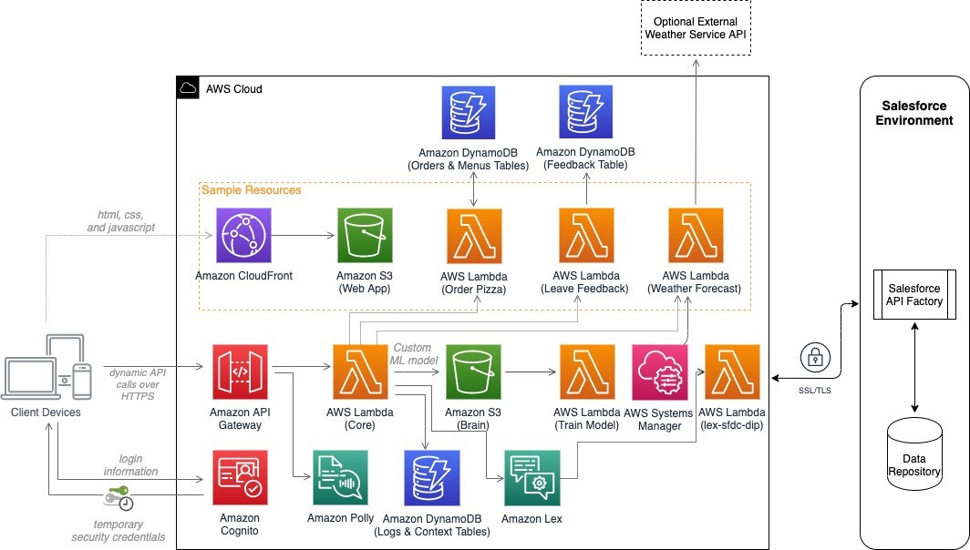
Source: (Tiwari, 2022)
The manager of Amazon focuses on the implementation of artificial intelligence to manage the business operation smoothly. The Company focuses on the development of technology intervention in the market for significant growth and development. Amazon focuses on the implementation of information into business processes to make the right decisions for organizational enlargement. The Company focuses on the integrated database to improve the organizational efficiency and delivery of the business process. The system is highly advanced with web service to improve the organizational value. Amazon Web Service is a distinct system with different functionality to promote efficiency in information systems and growth in the competitive marketplace. Managers of Amazon focus on CRM software to provide optimal service based on customer profiles for organizational development (Mohanta, 2021). The Company mainly focuses on staff changes position within the organization with additional skillset and expertise to match the new roles for organizational success. The manager of Amazon focuses on the information management system to share to maintain a strong position in the marketplace.

Importance of Knowledge Management System
The knowledge management system is an important way to boost organizational efficiency and make the right decisions for future development. To ensure organizational growth, Managers of Amazon make sure the staff member have access to the overall expertise held within the organization to make decisions. Knowledge Management systems help to innovate to grow within the organization and increased access to best practices for future success (Londres et al., 2023). The knowledge Management system is the best way of growing in the upcoming years for organizational growth. The knowledge management system is importance discussed as under:
- Reduce the Cost of Customer Service: To make it easier, the Manager of KMS helps Amazon to maintain contacts to find accurate information for organizational development (Yu et al., 2022). The Company's main purpose is to reduce the average handling time to resolve customer service issues. Managers of Amazon focus on faster resolution to make their customers happy and the efficiency of their staff members.
- Help Customer to Serve: The Company focuses on AI-powered KMS support customers to find answers to questions, even outside business hours. The Company mainly focuses on the working hour with or without the support of agents for organizational success.
- Problem-Solving Skill: The manager of Amazon focus on listening to question or queries about customer service issues and advising other to maintain contact as well as answering staff member question for organizational development . The Company's focus on KMS is to improve service to improve the organizational performance effectively. Amazon focuses on the channel to deliver a positive experience to gain a competitive edge.
- Training and Onboarding of Employees: Amazon conducts training and development programs to improve the performance of employees effectively (Mohanta, 2021). The Company focuses on a knowledge management system to reduce the need for training and development to protect onboarding and speed up the employee's performance smoothly.
- Improve Business Operation: The manager of Amazon mainly focuses on the development of a KM system to search for information and more time using time. The Company focuses on learning and relearning information to improve productivity. Amazon focuses on knowledge management systems to become more productive and improve business operations.
- Enhance Workplace Collaboration: Amazon focuses on the development of a team to support a knowledge management system. The Company always focuses on transparency and ease to access wide information leaders to share understanding. Amazon mainly focuses on creating alignment to accomplish common goals.
Knowledge Management Helps Amazon to Achieve Competitive Advantages
Amazon mainly focuses on a knowledge management system to improve the relationship with their valuable customer to gain loyal clients and obtain a competitive edge (Londres et al., 2023). The Company focuses on the creation of new ideas to improve the service for organizational enlargement. The manager of Amazon focuses on CRM systems to tailor the experience of people for organizational development. Therefore, knowledge management is the best way to offer great customer service like operating, fast, and online orders to fulfill the changing demand of the customer. Amazon has unique and build competitive differences among the customer. The Company mainly focuses on the development of a knowledge management system to reduce the cost for a better customer experience. Initially, Amazon focuses on low pricing differences to grab the attention of potential customers. The Company mainly focuses on the knowledge management system to Amazon to accomplish a competitive edge. The Company focuses on the development of new ways to enhance the overall performance and customer experience.
- Accessible Information: Managers of Amazon mainly focus on the development of new ways to improve the customer experience. The Company focuses on finding information about the organization from websites and other social media channels that support customers to purchase it.
- Automated Customer Service: Amazon mainly focuses on brand with multiple inquiries and some customer receive delayed service. The Company always focuses on handling the situation with the support of Automated Technology, Chabots to answer queries and interact with people for organizational growth. Amazon automated customer service chatbots with relevant data for the right action.
- Data Circulation: Amazon focuses on KMS to deliver the data from one system to another for the right action smoothly (Sahoo et al., 2023). The Company focuses on strategies to enhance customer satisfaction and experience effectively. Amazon's main purpose is to increase the ability to build long-lasting relationships with current customers and get potential clients faster.
- Support Employee Growth: Managers of Amazon mainly focus on knowledge management systems to retain top talent and get motivated for organizational growth (Yu et al., 2022). The Company being motivated and ambitious employees needs opportunities to grow and expand their skill sets within the organization. With a knowledge management system, Amazon focuses on knowledge management initiative with adds value to understanding the market opportunities and future growth.

Section2: Evaluation of Knowledge and Information Management Models
Amazon mainly focuses on Knowledge and Information Management system models and theories to improve organizational performance. To deal with enormous strides in organization, Amazon focuses on strong collaboration, and knowledge sharing to hinder the organizational workflows for effective management. The Company mainly focuses on active challenges and reshaping hierarchical tendencies and creating an inclusive culture to encourage knowledge-sharing and decentralized decision-making. For long-term development, Amazon focuses on a knowledge management system to improve organizational performance (Bresciani et al., 2023). The Company focuses on the KM model to improve performance, and powerful resources to manage the activities smoothly.
- Explicit Knowledge: Managers of Amazon focus on knowledge codified to bound books, documents, and databases to manage the information effectively (Perz et al., 2021). The Company always tries to extract the information and handled the knowledge management system effectively.
- Tacit Knowledge: The Company mainly focuses on knowledge intuition in nature for organizational growth. The manager of Amazon focuses on practice to achieve long-term goals effectively (Paredes and Kaulard, 2022). The Company always try to update the products or service with the task in writing for organizational development. Amazon focuses on tacit knowledge to identify the right ways to manage the information or develop leadership skills to meet customer needs.
- Embedded Knowledge: The Company focuses on embedded ways to manage the systematic process, routines, manuals, and organizational culture. The manager of Amazon focuses on using organizational information to take the right decision with explicit sources for organizational success. The Company mainly focuses on certain ways to manage the organizational activities to fulfill the changing demand of customers (Bresciani et al., 2023).
SECI Model
This model of Knowledge Management is responsible to improve the performance of the Knowledge creation process of the organization. The Company used the knowledge for the conversion process for the organization to improve performance effectively (Mohanta, 2021). The manager of Amazon used transferable knowledge using distinct forms and codified, assessed, and verbalized. The ultimate objective focuses on a continuous process to improve organizational performance.
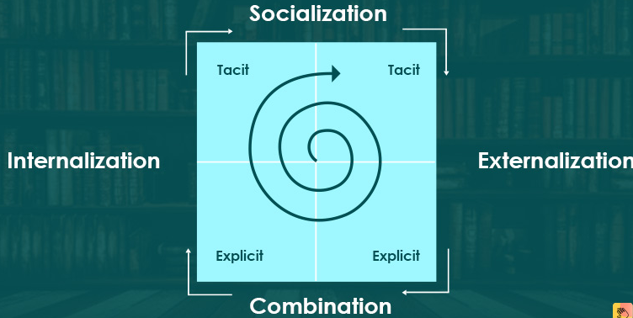
Source: (Paredes and Kaulard, 2022)
- Socialization: It helps to share knowledge using observation, imitation, practice, and participation in formal and informal growth (Mohanta, 2021). The Company mainly focuses on the development of virtual space to manage organizational performance effectively.
- Externalization: It is a complex and essential mechanism of knowledge conversion (Yu et al., 2022). The Company mainly focuses on tacit knowledge to new explicit knowledge for the conversion of the process takes place. Amazon uses the document to share information with others to perform smoothly.
- Combination: The Company mainly focuses on the collection of information collected, modified, and processing in the form of a complicated and systematic knowledge management system. Managers of Amazon focus on complicated systems to spread the network for organizational success.
- Internalization: In this step, the Manager of Amazon focuses on the creation of space to deal with the uncertain environment (Sahoo et al., 2023). The Company mainly focuses on the development of new channels to deal with changes in information technology.
Wiig Model
It method helps to manage the condition and needs of organizational success. The manager of Amazon commodities, and customers, as well as resources, is to manage the organizational performance smoothly. Wiig's cycle shows that knowledge is built and used by individuals for organizational success in the e-commerce marketplace. The Company mainly focuses on the Wiig model to use knowledge and information system for organizational growth (Bresciani et al., 2023). Amazon focuses on internal and external sources to store valuable information to take the right decision. In a competitive environment, Amazon focuses on Wiig cycle internal knowledge and know-how to improve organizational performance.
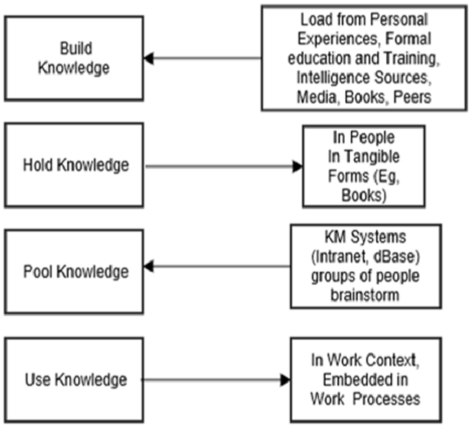
Source: (Yu et al., 2022)
This knowledge management model was developed by Karl Wiig to depict that the knowledge management process is perfect and reasonable to make useful and valuable knowledge. The Company focuses on a highlighted dimension like holding, pooling, building, and applying knowledge for organizational success. Amazon needs to be aware of complete knowledge and knowledge-sharing ability using an efficient way of KM model for a completeness approach. To deal with the changing environment, Amazon focuses on a knowledge management system to gain a competitive edge.
Zack Model
The Company mainly focuses on the design and deployment of information products for organizational development. The manager of Amazon designed the network to be logical and standardized (Mohanta, 2021). In this cycle, Amazon focuses on the development of a knowledge repository and mapped the stages of the model to distribute information for organizational enlargement. The Company focuses on guiding principles with intellectual products to fulfill customer needs effectively.
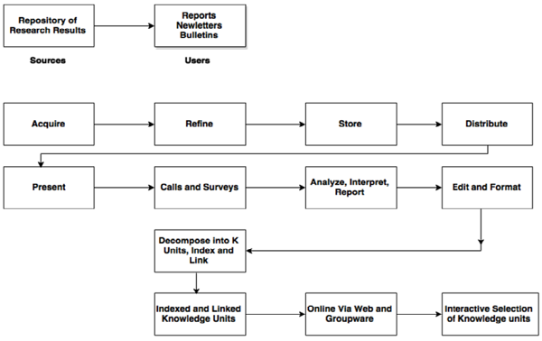
Source: (Paredes and Kaulard, 2022)
The manager of Amazon defined the standardized to practice the lesson used for specific organizational growth. The Company mainly focuses on the development of a knowledge management model to manage the information to gain a competitive edge. Amazon always focuses on delivering the right information for delivering quality products to meet the demand effectively. The Company mainly focuses on value-added steps to refine the valuable information to improve organizational performance (Perz et al., 2021). The manager of Amazon always creates a good impression by continuously renewing the repository and refining the data for the right action for organizational growth. Zack's model of knowledge management system helps to create a complete image and renew the repository to avoid elimination for future success. The Company used this model to share valuable information to take the right.

Section3: Investigating of KM technique used by Amazon
Amazon mainly focuses on the development of Amazon SOP to manage organizational activities smoothly (Sahoo et al., 2023). The Company always tries to update the information and achieve goals with the use of effective resources. Amazon focuses on Software Operating procedures to boost its success in the retail sector and e-commerce landscape. The Company mainly focuses on the development of new ways to operate process in place of organizational risk. In this way, Amazon focuses on SOP to improve the organizational image among customer mindset. In simple terms, SOP is a document to describe the brand business procedure for organizational growth. In a competitive workplace, the Manager of Amazon focuses on business activities with effective skill and knowledge to gain a competitive edge.
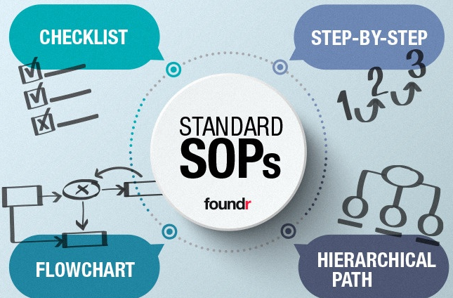
Source: (Bresciani et al., 2023)
Amazon focuses on standard inventory to manage the operation smoothly. The Company mainly focuses on customer service procedure an SOP is the best way to create a new process or system to deal with valuable information (Gardeazabal et al., 2023). SOP helps Amazon to save time, deliver timely, and mitigate risks for organizational growth. The Company mainly focuses on a performance-centered model to find out new ways to perform the jobs more effectively.

The Areas of Amazon Improve in the Future to Overcome Challenges
Amazon has profoundly altered our way of life. It has radically revolutionized how people shop, according to e-commerce pros. Amazon is a powerhouse, with a growing 45% share of the US e-commerce market. So, if people want a piece of the marketplace giant's success, they must establish an Amazon e-commerce plan. In e-commerce development, Amazon focuses on the development of an e-commerce platform to overcome challenges. The Company mainly focuses on the development of a global corporate strategy to gain a competitive edge (Yu et al., 2022). Amazon always focuses on diversification to generate total revenue, and a large portion of revenue comes from the support of third-party business selling on its platform for organizational success. To deal with the changing environment, the Manager of Amazon focuses on digital channels to fulfill customer demand and deal with challenges. The areas of improvement for Amazon for organizational growth are discussed as under:
- Cloud-Based Service: The manager of Amazon mainly focuses on the development of cloud-based services to expand the business. The Company always focuses on strategic alternatives or options to satisfy complementary needs. Amazon focuses on the expansion of Amazon Web Service including data management, storage space, hosting service, and other cloud service to meet customer needs effectively. The manager of Amazon focuses on the driver of corporate strategy to shatter the growth rates.
- Autonomous Robots: To deal with the changing environment, Amazon focuses on autonomous mobile robots and AMRs to incorporate robotics into areas of facilities in the physical space. The Company mainly focuses on testing to autonomously navigate the facilities for organizational growth. Amazon focuses on mobile robot facilities placed to avoid irrelevant activities for future success. In changing situations, Amazon focuses on several sites with advanced technologies to reduce the burden of employees within the warehouse of Amazon. Robotics and advanced technologies play crucial roles only in innovation for the customer, and my team member.

Conclusion and Recommendation
The multi-billion dollar company Amazon spent years perfecting its web-based services. Although most of us may not be able to afford this, that does not mean we shouldn't think about the model. Imagine how much more beneficial our online resources could be for both business and education if we simply infused a little bit of Amazon creativity into the mix. In conclusion, the report has examined the best way to find the knowledge management system to improve organizational value. The report has evaluated the KM system and its importance to support people for better growth in the competitive marketplace. It has explained detailed information about the organization's knowledge management system and ways to satisfy the goals for future success. The report has examined the knowledge and information management system of Amazon to achieve the desired outcome. It has demonstrated the Wiig model and Zack model of KM for organizational success. The report has analyzed the Amazon SOP with essential resources to improve the organizational value effectively.
Amazon mainly focuses on the development of the knowledge management system of Amazon to improve organizational performance. The Company should focus on new channels to share information to gain competitive information. The manager of Amazon focuses on developing and implementing a KM system for future development.

Reference List
Bresciani, S., Rehman, S.U., Giovando, G. and Alam, G.M., 2023. The role of environmental management accounting and environmental knowledge management practices influence on environmental performance: mediated-moderated model. Journal of Knowledge Management, 27(4), pp.896-918.
Gardeazabal, A., Lunt, T., Jahn, M.M., Verhulst, N., Hellin, J. and Govaerts, B., 2023. Knowledge management for innovation in agri-food systems: a conceptual framework. Knowledge management research & Practice, 21(2), pp.303-315.
Londres, M., Salk, C., Andersson, K.P., Tengö, M., Brondizio, E.S., Lopes, G.R., Siani, S.M., Molina-Garzón, A., Gonzales, T., Montoya, D.R. and Futemma, C., 2023. Place-based solutions for global social-ecological dilemmas: An analysis of locally grounded, diversified, and cross-scalar initiatives in the Amazon. Global Environmental Change, 82, p.102718.
Mohanta, R.K., 2021. Discover insights and relationships in text using Amazon Comprehend. International Journal of Trend in Innovative Research, (2582-0354).
Paredes, M. and Kaulard, A., 2022. Forest as ‘nature’or forest as territory? Knowledge, power, and climate change conservation in the Peruvian Amazon. The Journal of Peasant Studies, pp.1-22.
Perz, S.G., Arteaga, M., Baudoin Farah, A., Brown, I.F., Mendoza, E.R.H., de Paula, Y.A.P., Perales Yabar, L.M., Pimentel, A.D.S., Ribeiro, S.C., Rioja-Ballivián, G. and Rosero Peña, M.C., 2021. Participatory action research for conservation and development: experiences from the Amazon. Sustainability, 14(1), p.233.
Sahoo, S., Kumar, A. and Upadhyay, A., 2023. How do green knowledge management and green technology innovation impact corporate environmental performance? Understanding the role of green knowledge acquisition. Business Strategy and the Environment, 32(1), pp.551-569.

