10/21/2021
Leading and Implementing Change in PepsiCo


Suhail Miah 1808197
Module Code: BMSW 6103
Module: Leading and Implementing Workplace Change
Lecturer: Nauman Ali

Introduction
This paper will analyse a chosen organizations current status and environmental impact. Five key components will be analysed to form a portfolio, which will explore various difficulties to consider regarding meeting the climate pledge goal of achieving net zero emissions by 2040.
The first part will analyse the current status of PepsiCo with the purpose of environmental scanning to gain more information. The second section will recognize important stakeholders and their importance in the organizations to help lead change. The next section will conduct a change management plan will be developed to help create a plan for the organization to implement strategic change to help meet its carbon emission goals. The organization structure will be analysed with purpose to meet the objective. Finally, a reflection of the portfolio from the author’s perspective will conclude the last part of this portfolio to provide authors understanding.
What is the Paris climate agreement?
The Paris climate agreement is an internationally binding treaty formed by 196 UNFCCC parties at the COP 21 in Paris on 12th December 2015. The treaty has been viewed as a landmark agreement due to the large number of organizations and countries involved (UNFCCC, 2021). The main objective is to take a unified approach to tackle the huge climate change problems caused by many factors such as greenhouse gases, pollution, plastics and non-renewable energy etc. The main goal is to have net zero carbon emissions by 2050, through using more reusable energy, implementing greener processes and creating carbon offsets to neutralize the impact of global warming. Currently over 210 companies have signed the climate pledge to achieve the net zero carbon goals by 2040, 10 years earlier than planned (TheClimatePledge, 2021).

Table of Contents
Introduction 1
Table of Contents 2
Table of Figures 4
1. Current situation 5
1. 1 Internal Environment 6
1.2 SWOT Analysis on PepsiCo 6
1.3 Strengths of PepsiCo 7
1.4 Opportunities 8
1.5 Threats of PepsiCo 9
1.6 Business Canvas on PepsiCo 10
2.0 External Environment 12
2.1 Political 12
2.2 Environmental factors 12
2.3 Technological 13
2.4 Porters’ forces of PepsiCo 14
3.0 Section 2 Stakeholder Analysis 15
3.1 Stakeholders and Change 15
3.2 Internal Stakeholders of Pepsi 15
3.3 External stakeholders of PepsiCo 16
3.4 Power/Interest grid 17
3.4 PepsiCo Power Interest/Influence Grid 18
3.5 Important stakeholders 19
3.6 Why is change needed? 20
Strategic Change 21
4.0 Section 3 Change management 22
4.1 Kúbler- Ross Change curve model 23
4.2 Strategic Fit Option 24
4.3 Kotter’s Eight Steps 25
4.4 Leadership Style Importance to leading change 28
5.0 Section 4 Organization Culture 29
5.1 Organization Development Cube 31
5.2 Organization Culture Importance 32
5.3 Incorporate a learning culture in the workplace 32
6.0 Section 5 Reflection 34
6.1 Organizational Perspective 34
6.2 Consultant Perspective 36
For PepsiCo to meet the climate pledge objectives few areas to address are: 37
References 38

Table of Figures
Figure 1 PEPSICO Source: pepsico.com 5
Figure 2 Pepsico business canvas 10
Figure 3 Internal Stakeholders of Pepsico 15
Figure 4 External Stakeholders of Pepsico 16
Figure 5 Power/Interest grid source: Solitaire consulting ltd 17
Figure 6 Power Interest Grid 18
Figure 7 Top 10 Plastic POLLUTERS SOURCE: brand report 2021 20
Figure 8 Kúbler-Ross model SOURCE: Psycom.net 22
Figure 9 Kotter’s 8 Step Model - Source: Slide Bazaar 24
Figure 10 Mckinsey's 7-S Framework Source: CGMA 28
Figure 11 OD Learning CUBE 30

PepsiCo
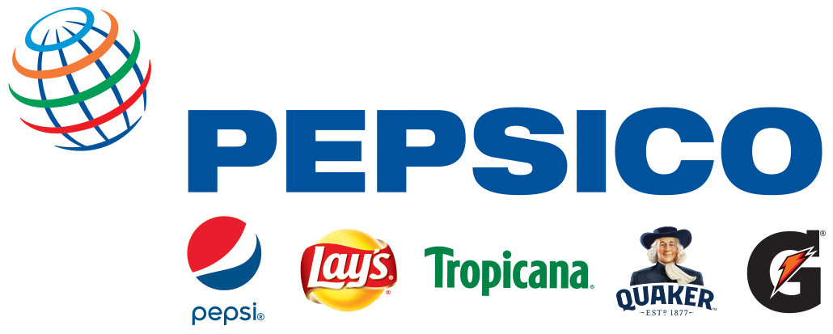
Figure 1 PEPSICO Source: pepsico.com
About the company
PepsiCo is one of the world’s leading beverage and food brands, in 2020 it generated over $70 billion in net revenue from its large range of brands which include Gatorade, Frito-Lay, Pepsi-Cola, Quaker and Tropicana etc. Pepsi-co has 23 brands which each generate over $1 billion in annual retail sales (PEPSICO, 2021).

1. 0 Current situation
To help understand current status of the organization this section will conduct environmental scanning to better understand the organization. Environmental scanning consists of both internal and external factors. Internal factors include aspects such as communication of employees, management, organization structure, brand awareness and operational potential. Understanding an organizations strengths and weaknesses can be assessed. As an organization grows and expands the external factors become important to consider. External forces can influence how affect how a company adapts in order to survive and is crucial to long term organizational growth. Analysing the space, the organization operates in and help discover the strengths and weaknesses of the industry and also discover potential challenges which could arise in the future. Studying the macro- environment will provide a larger view of the organizations from a wider lens, whilst addressing areas such as social, political, environmental, legal and technological (CFI, 2021).

1. 1 Internal Environment

1.2 SWOT Analysis on PepsiCo

INTERNAL FACTORS
STRENGTHS (+) | WEAKNESSES (-)
Strong branding, world recognized  Diverse portfolio of brands (23 of which generate $1 billion dollars per annum)  Strong advertising  Strong market share  Focus on Corporate Social Responsibility | Over reliance on food and drink market  Products perceived as unhealthy snacks  Advertisements being controversial  No.2 plastic polluter worldwide
EXTERNAL FACTORS
OPPORTUNITIES (+) | THREATS (-)
Expand into healthier markets  New flavours  Reduce carbon emissions further  More recyclable products  Product diversification  E-commerce  Partnerships with other brands | Losing market share to rivals  Government Laws and regulations  Rivals potentially gaining better technologies  Recession or Economic downturn

1.3 Strengths of PepsiCo
Worldwide recognized brand
PepsiCo is a worldwide recognized brand with a diverse portfolio of brands with over 23 brands generating $1bn dollars every year. PepsiCo is very popular and is consumed over a billion times a day and in over 200 countries worldwide (PEPSICO, 2021).
Strong Media Adverts and Partnerships
Pepsi targets to be a fun, youthful brand to connect to younger audiences. Having a good relationship with sports sponsors which help promote brand awareness on live television worldwide. It has many well-known sporting partners to advertise its products such as the NBA, NFL and UEFA champions league (UEFA, 2021).
Weaknesses of PepsiCo
Excessively focused on drinks and snacks
Pepsi’s products are excessively reliant on the beverage and snack markets. Customer’s preferences can change over time which can reduce profits in the business. Research by ADM has discovered that customers preferences are changing due to the covid19 pandemic and 77% of customers intend to make more attempts at staying healthy in future. Food and beverage manufacturers who best balance customer health and affordability are most likely to win with customers (ADM, 2020).
Big impact on plastic pollution
PepsiCo’s environmental impact has been huge, in fact the organization has been named second biggest plastic polluter three years running research from Break Free From Plastic (BFFP) has found (BFFP, 2020).
Controversial advertisements
Controversial advertisements have received negative press on the organization and forced to be pulled. Trying to be daring the organization created an ad with Kendal Jenner which received negative reactions and forced public apology by PepsiCo as it was very controversial amongst the black lives matters movement (NBC NEWS, 2017).

1.4 Opportunities
Healthier products
PepsiCo’s dependency on snacks and soft drink beverages can be perceived as unhealthy and considered junk food, this will prevent the brands from attracting health-conscious consumers. Creating more healthier products can attract new customers to the organisation. Brands Tropicana, Naked Juice, Izze and SodaStream are a step in the right direction to build a collection of healthier brands (PEPSICO, 2021).
Product diversification
The organization can delve into new products and markets outside of soft drinks and snacks. The company is considering entering the alcoholic drinks market after rivals Coca-Cola announced launching an alcoholic sparkling water in the US in 2021 (Reuters, 2020).
Increase partnerships with third parties to help climate pledge
PepsiCo’s strong philanthropic policy involves partnerships with many non-profit organizations can help to grow further impact the goal of tackling climate change. It has many involvements with organizations to tackle plastic waste such as Recycling Partnership, Circulate Capital and New plastics Economy and many more (Pepsico, 2021).

1.5 Threats of PepsiCo
Cutthroat Rivalry
There is fierce competition and rivalry in the beverage and snack industry. Alternatives from main rivals Coca-Cola, Nestle, Unilever etc. can threaten to overtake and eat into profits. This will require the organization to advertise strongly and invest more to remain market relevance (Gutierrez, 2021).
Government Regulations
Laws such as sugar taxes can affect lower trades and profits margins, as people’s attention is raised regarding unhealthy amounts of sugar in their drinks.
Customer preferences change
With Customers becoming more health conscious it can harm profits as people switch to healthier alternatives. Providing more healthier options is crucial in the current post covid19 market where people have increased attention to their health and eating habits (ADM, 2020).
Rivals adopting improved technology
Rivals getting access to better emerging technology can be harmful to maintain the competitive edge of Pepsi. Gaining better methods to make an efficient value chain can decrease costs and provide a competitive edge against rivals (Porter & Millar, 1985).

1.6 Business Canvas on PepsiCo
The business canvas allows a quick glance at the organization on a single sheet of paper. This shows key information such as the type of markets the organization is competing in and also the key resources that the organizations may be reliant upon.
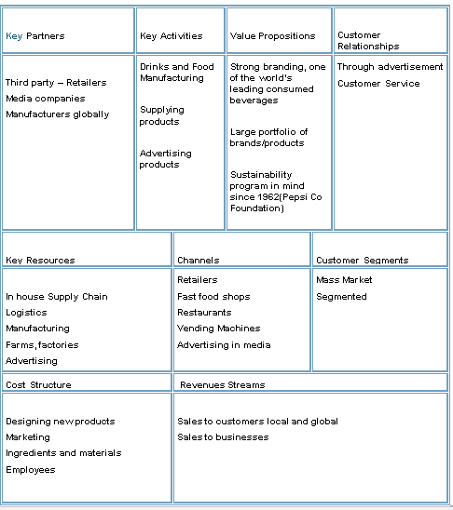
Figure 2 Pepsico business canvas

PepsiCo Business Canvas environment focus

Logistics
One of the key assets of PepsiCo is that the organization offers effective Direct Store delivery – essentially cutting out third parties, this basically can lower the pollution and environment impact due to streamlining the process (SC Digest, 2019).
In house supply chain
Resource gathering is a huge positive for PepsiCo attempts to sustainably gather most their ingredients due to the strong philanthropic movement with sustainability in mind, which the organisation believes in (Pepsico, 2021).
Manufacturing
PepsiCo has a large supply chain meaning it can control various processes and design, manufacturing of products. Increasing recyclable content in its packaging is an outcome of this level of control (Pepsico, 2021).
Strong Advertising
Strong advertising in sports and media can help raise customer awareness of the climate pledge issues through its product lines and encourage recycling.

2.0 External Environment

PepsiCo External factors

2.1 Political
The governments of countries can have impact on the trade of products. Organizations are forced to pay tariffs such as “sugar tax” in the UK since 2018 for drinks containing over 5g of sugar per 100ml, in order to reduce sugar customers intake as soft drinks are viewed as unhealthy (SKY NEWS, 2021).
The climate pledge doesn’t have mandatory requirements to meet the climate goals but however things can escalate where political parties may decide to enforce target emissions and reduce waste in order to continue trading. The Cop26 had requested for organizations to increase their ambition in their goals because the actions won’t be enough to meet the previous Paris climate agreement (The Guardian, 2021).

2.2 Environmental factors
The food industry contributes to over 26% of carbon emissions annually. When targeting climate change in food production, the focus shifts towards using methods such as renewable energy, improvements made in efficient use of energy and transportation. Supply chains are responsible for approximately 18% of food emissions. Food production involves many processes such as transport, packaging and production of which all require energy to produce (Poore & Nemecek, 2018).
Agriculture has been seen as a huge problem and contributor to climate change as 50% of the world’s habitable lands are used in farming. Agriculture has huge impact on the environment when producing carbon emissions, it counts for over 26% of all human produced greenhouse gases. Agriculture releases a lot of harmful gases such as methane and nitrous oxide which have a huge impact on pollution. Farming has harmed natural resources such as 78% of the global oceans and water eutrophication, as a direct consequence of this (Poore & Nemecek, 2018). Deforestation resulted in reduction in biodiversity and natural habitats being destroyed due to expanding of agriculture and around 24000 mammals on IUCN red list of endangered species, are at risk of facing extinction with agriculture being a threat (IUCN, 2019). Most of the livestock outnumber wild mammals (excluding humans) 15-to-1 which represents the huge problem of society on over consumption of meat. Dietary changes and improved technology to develop plant-based alternatives can reduce this impact (Yinon, et al., 2018).
PepsiCo has pledged to take greener approaches to many aspects of its operations with the purpose of meeting the climate pledge goal of net zero carbon by 2040. The company aims to reduce greenhouse gases by 75% within its direct operations (Scope 1 and 2) and its indirect value chain (Scope 3) by 40% by 2030 (comparison to a 2015 baseline). The prediction of this action will reduce greenhouse gases by 26 million tons, which is equivalent to taking off five million cars off the roads for a whole year (PepsiCo, 2021).
PepsiCo has pledged to reduce greenhouse gases by reducing the single use plastics and increase recycling packaging. Currently 88% of the companies’ plastics are recyclable, or biodegradable with a goal of reaching 100% by 2025 (PepsiCo, 2021).

2.3 Technological
PepsiCo creates products in its 100% recycled plastic (rPet) packaging in 22 global markets. PepsiCo has an ambitious goal of elimination all use of virgin plastics in its Pepsi brand beverage bottles, sold in nine European Union (EU) markets by 2022. Switching to rPet bottles will eliminate over 70,000 tons of single use plastic per year, and lower GHG by over 40%. (PEPSICO, 2020)
Agriculture accounts for a third of PepsiCo’s greenhouse gas emissions, which means using sustainable methods for agriculture in order reduce emissions, reduce deforestation and improve soil health and biodiversity. PepsiCo has pledged ambition goals in its agricultural approaches. The goal by 2030 to spread regenerative practices across 7 million acres to promote biodiversity, soil health and to reduce GHG by further three million tons. By use of innovative technology and farming methods the goal is to sustainably source 100% of their key ingredients (PEPSICO, 2020).

2.4 Porters’ forces of PepsiCo
Some external forces will be considered with the Porters framework.
Threat of Substitution (High)
PepsiCo’s customers have many different alternatives to their snacks and beverages. Perhaps cheaper and healthier alternatives can be found in rival competitors. Pepsi will need to focus on its quality to ensure customers are highly satisfied with their many products. Focusing on the customers preferences towards healthier choices and environmental conscious products will help retain customers. PepsiCo’s brands such as Tropicana, Naked Juice aims to target the health-conscious demographics (PEPSICO, 2021).
Bargaining Power of Suppliers (Low)
PepsiCo’s major strength is in its own large complex supply chain, which operates in over 50 markets and 60 manufacturing plants, with hundreds of distribution centers worldwide (Manufacturing Global, 2020). The large supply chain structure allows PepsiCo more control and therefore weakens external supplier power. The large number of raw materials can be available from many alternatives suppliers therefore limiting the overall effect of supplier coercion on the organization.

3.0 Section 2 Stakeholder Analysis

3.1 Stakeholders and Change
Stakeholders are described as any group or individual who can affect or is affected by achievement of the organization’s objectives (Freeman, 1984). Stakeholders of PepsiCo will be explored because it is important to assess the influence priority stakeholders will have on implementing change.

3.2 Internal Stakeholders of Pepsi
Board of directors
Figure 3 Internal Stakeholders of Pepsico

3.3 External stakeholders of PepsiCo
Figure 4 External Stakeholders of Pepsico
Media
Regulation Authority
Consumers
Creditors
Contractors

3.4 Power/Interest grid
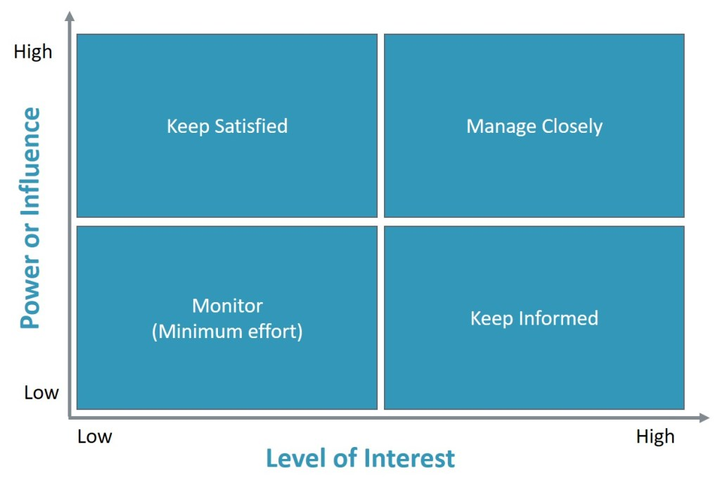
Figure 5 Power/Interest grid source: Solitaire consulting ltd
Identifying the key stakeholders allows early allows more maneuverability, and gaining high power stakeholders support will increase chances of being successful with important decisions and strategic change (MindTools, 2021). The stakeholder power interest/influence grid (Also known as the Mendelow Matrix) allows easy understanding of how much power and influence key stakeholders may have on the business and how closely they should monitor them (Mendelow, 1981).
The stakeholders are categorized into four categories:
1. High Power / High Interest (Manage closely)
2. High Power/ Low Interest (Kept satisfied)
3. Low Power / High Interest (Kept Informed)
4. Low Power / Low Interest (Monitor)

Once the key stakeholders of the organization have been brainstormed and considered the next step is to place them on a power influence table.

3.4 PepsiCo Power Interest/Influence Grid
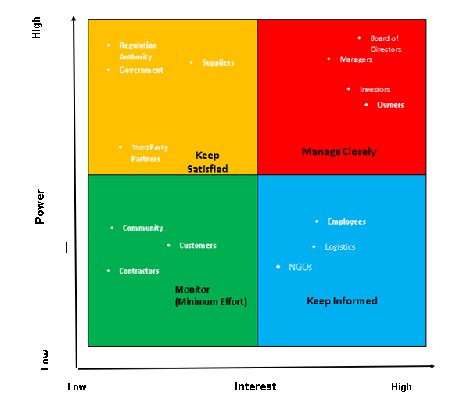
Figure 6 Power Interest Grid

3.5 Important stakeholders
The important stakeholders with the most power and influence are the owners, managers investors, board of directors and creditors. This group needs to be managed closely in order for change to happen, and are the key players that need to be on board with the important decisions and changes in order for proposed plans to come into action. Failure to have major stakeholders support can hinder, delay or prevent progress in the project (Adewale & Esther, 2012).
Governments and regulation authorities may yield a high degree of power but have low interest in the business. Managing these with stakeholders by keeping informed and following regulations in order to be successful in moving forward with new plans and changes.
Low interest and power groups such as customers, media do not need excessive communication but just monitored. However, it is important to recognize parties such as the media can shift from low power to high, as Pepsi has used controversial advertisements and this can be used in a negative manner to cause challenges and harm the brand. A recent example of this is the ad with Kendal Jenner in 2017 echoing the black lives matters movement, received public outcry and Pepsi was forced to remove the ad and publicly apologize (NBC NEWS, 2017).
Customers of PepsiCo is somewhere in the middle where they don’t have a lot of power or interest but are an important aspect of the company to consider, as social trends and norms can differ globally and ultimately affect how successful a particular brand or product is worldwide. An example of the importance of customers is; the global fast-food chain McDonalds altered its Singapore menu due to cultural differences. The Nasi Lemak burger, which is a fragrant rice dish cooked in coconut milk made into a burger, which is unique to branches in Singapore (Matousek, 2018).
Employees fall under keep informed, while they don’t have a high degree of influence and power, need to be made aware of what the organization is trying to achieve. They are involved in the daily operations of the business and can impact the goal of Pepsi’s reaching the climate pledge goal of net zero carbon. Employees that are not sold on the idea of new changes may resist and make it really difficult for adapting new methods and technologies (Gagnon, et al., 2008).

3.6 Why is change needed?
For all its efforts PepsiCo have stated, it has shown that there is more that needs to be done. Pepsi is ranked the world’s 2nd plastic polluters fourth year in a row, behind rivals Coca-Cola and shows that being overly reliant on single use plastics is the reason behind this (Ho, 2021).
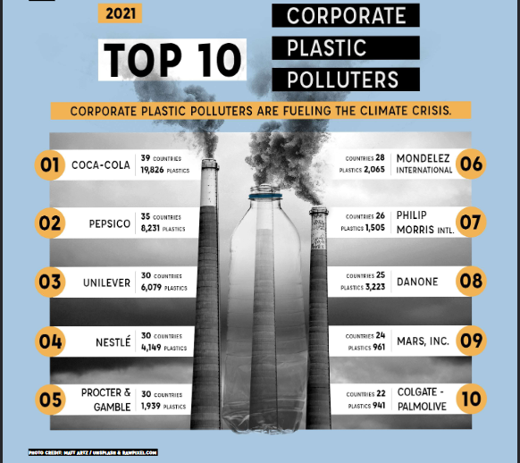
Figure 7 Top 10 Plastic POLLUTERS SOURCE: brand report 2021

Climate pledge goal unrealistic
The climate action tracker discovered that the main climate pledge goal of limiting the planets rise to 1.5 degrees will not be possible as enough action hasn’t been done to meet the goal. Whilst many countries have signed up for net zero carbon pledges, enough action has not been done to make this a reality and therefore targets and strategies must be revised. (ClimateActionTracker, 2021). The Climate action tracker (CAT) discovered that at the Glasgow COP26 the new 2030 targets are inconsistent with net zero goals. The CAT discovered an optimistic of 1.8 degrees warming by 2100 and is not Paris Climate agreement of 1.5 degree sustainable and that temperatures of 2.4 degrees cannot be ruled out. (ClimateActionTracker, 2021).

4.0 Section 3 Change management

What is Change Management?
Organizational change is broad term and can be restructuring departments, acquisition of new knowledge and technologies, also creating different new ways of working (Harvard Business School Online, 2021). An example of successful change management is the streaming giant Netflix, which originally started as a DVD rental only service in 1997 but changed its business model to streaming content, so customers don’t need to wait for movies in the mail. Netflix is a huge accomplishment and now has over 200m subscribers worldwide and reported $25 billion dollar in revenue and almost $2.8bn dollar in profit in 2021 (BBC NEWS, 2021).
Challenges are faced by organizations management to successfully facilitate change in the work environment. Employees are actually at the core of change management and providing support and enabling them is key to thrive with new changes. The positives of successfully implementing change in the organization leads to continued growth and evolution of company, increased morale and productivity (Caldwell, et al., 2008). Therefore, training and carefully developing personnel is key to the accomplishing the goals. Failure to provide help and guidance to employees through organizational change will not only lead to monetary loss, decreased staff morale and also make the change plans unsuccessful (Hayes, 2018). Employees can be barriers to change as they may not adapt or refuse to embrace the organizations new goals or methods.

4.1 Kúbler- Ross Change curve model
The Kübler-Ross change curve model named after its creator Elisabeth Kübler-Ross is an effective change management model designed to help understand the stages of change. The tool can be used by managers to help train and adapt its workforce in a structured manner to achieve their objectives. The model consists of five stages of grief (also referred to as DABDA) include Denial, Anger, Bargaining, Depression and Acceptance (Kübler-Ross, 1969).
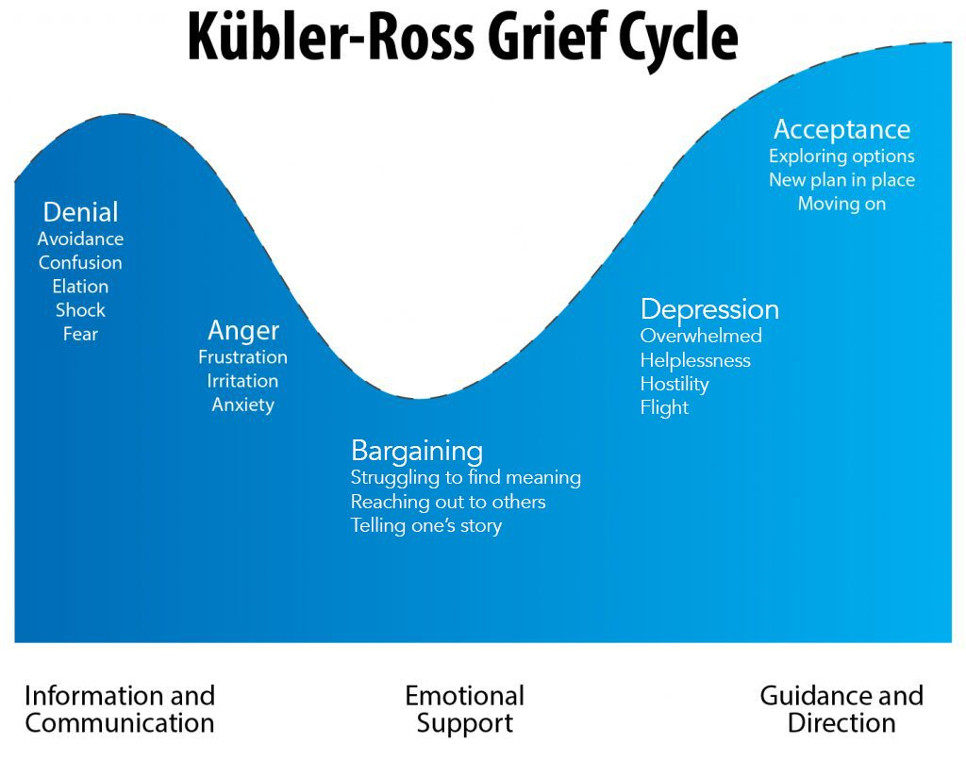
Figure 8 Kúbler-Ross model SOURCE: Psycom.net
The diagram shows how employees would feel through the organizational change; therefore, organizations need to help guide their employees through the steps to make a smoother transition.

4.2 Strategic Fit Option
PepsiCo is a large global organization with various different brands, so the purpose of this paper the change management will mainly only focus on the UK branch of PepsiCo brand of the organization. When making a decision of carrying out change management it is important to consider the type of strategic fit option. Large organizations can vary in structure depending on the various regions, divisions and branches. The contingency approach also known as situational approach to change management focus on the principle that all management is often situational. There is no clear obvious method that is best choice to address the situation. Managers must therefore take into account these contingencies when making decisions as it will impact the organization. With the contingency method managerial decision making is dependent on the situation (Alves, et al., 2017).

4.3 Kotter’s Eight Steps
Kotter’s Eight Steps named after the author John Kotter a Harvard Business school professor who created the 8-step plan of change management in his 1955 book, “Leading Change” (Kotter, 1996). Kotter’s change model will be applied to the PepsiCo climate pledge goal to create a plan for the change required.
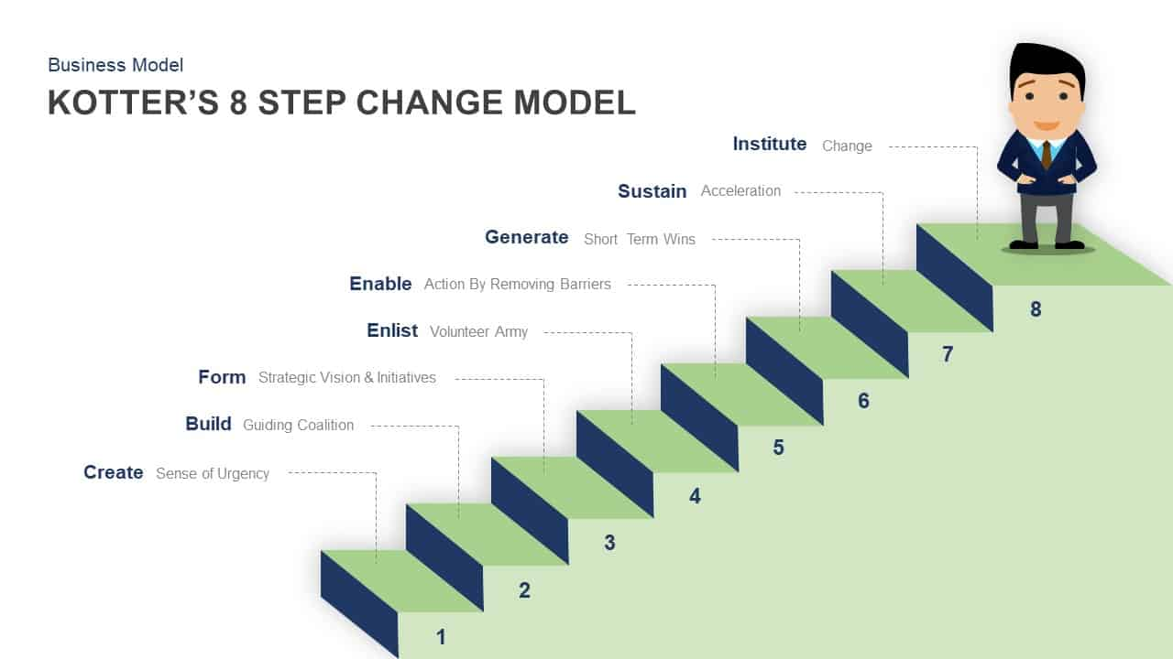
Figure 9 Kotter’s 8 Step Model - Source: Slide Bazaar
8 Step change management process
- Create Urgency
Create honest and clear discussions about potential threats and challenges which are affecting the organization currently. Encourage participation of important people in the process such as customers, industry experts, key stakeholders can help highlight weak areas and create a goal (Kotter, 1998).With the recent COP26 in Glasgow, leaders have stated the current pledges of companies are not enough to limit global warming to the 1.5 degrees outlined in Paris Climate agreement and more drastic action is needed from everyone (Maizland, 2021). PepsiCo including the important key stakeholders can refer to the climate pledge and critically assess where key changes and plans needed to meet the climate pledge goals by 2040.

- Build a guiding coalition
Identifying strong leaders in the organization and building strong teams is the next step. Request involvement of key stakeholders through the change management plan. Pepsi can create multi-diverse teams from its different divisions and branches to create a strong team with different skillsets. Many partnerships with third parties can help provide assistance in communicating new methods and strategies.
- Developing a Vision and a Strategy
Defining the core values to create clear strategic goals and recognize the aspects that require change. Organization needs to develop a clear vision which can be easily understood and explained by change leaders. PepsiCo will need to revise their strategies to meet the climate pledge objectives and have clear vision as noted by the Cop26 enough action hasn’t been done to limit global warming to 1.5 degrees Celsius by 2050.
- Communicating the Vision
The vision needs to be powerful and connect with the parties involved to be successful. Clear communication and honestly is required with people involved. Creating a link between the organizational aspects such as performance and training is required. PepsiCo could provide the training required to employees to get them properly equipped to achieve the company goals.
- Removing barriers
Recognizing barriers such as people refusing to change is crucial. Practical approaches need to be taken to remove the barriers once they have been identified. PepsiCo can reward those who endorse change will assist the goal and boost morale.
- Create Short Term Wins
. Creating multiple short term achievable goals is better than long term goal which are more expensive. PepsiCo aim towards the smaller achievable aspects of their pledge which will help provide morale boost and work closer to the goal. An example is Pepsi has used 100% recycled rPET bottles in 22 markets, the aim is to continue this in other countries (PEPSICO, 2021).
- Consolidating Gains
Sustain acceleration by analysing short term wins and strive to improve from those success stories. Achieving multiple small objectives will help PepsiCo strive towards reaching the climate pledge goal. Pepsi can look at the progress it has made since few years ago, this will help show progress and advancements made towards the climate goals.
- Make Change Stick Discuss the success stories of the company related to change goals to further reinforce key players. Making sure change is integral to the organizational culture and visible within every facet of the organization. To ensure change “sticks” it is crucial to continue to seek support of the key parties involved and of new leaders towards the change transformation. PepsiCo will need to maintain the progress and accomplishments by implementing it as part of the culture, to ensure that changes can be long term and not a temporary phase. Placement of good leadership and empowering employees can help the change stick (Latham, 2016).

4.4 Leadership Style Importance to leading change
All organizations are unique and can take on many different sizes and structural shapes which will require understanding in order for management to prepare for organizational change. Organizational structures can indirectly affect the organizational work culture through the process of how communication travels and is expected (HofstedeInsights, 2021).
Leadership styles
Effective leadership is vital to implement and communicate the changes in an organization. The leadership style involved is also very critical to lead the change in the organization. A democratic leadership approach can be considered a good approach because employees can feel confusion initially and may have concerns and questions. The democratic leader can be willing to discuss and encourage employees about new approaches of the organization. Asking employees for their input and thought processes can lead to empowerment and employees more willing to be on board with supporting the new changes in the organization. (Jan DeBell, 2019) There are other types of leadership however, laissez-faire leadership wouldn’t be most appropriate to lead change in PepsiCo because it is too passive and most employees may not be willing to take action if there aren’t any pressures to. Autocratic leadership could work initially however it is a very dominating type of leadership and assumes a lot of control (Kibbe, 2019). This wouldn’t help in situations where employees may be obstacles and resisting changes, it could further damage employee relations which make it unlikely to gain support in future for the changes.

5.0 Section 4 Organization Culture
This chapter will focus on the importance of organization development and culture.

McKinsey’s 7- S Model

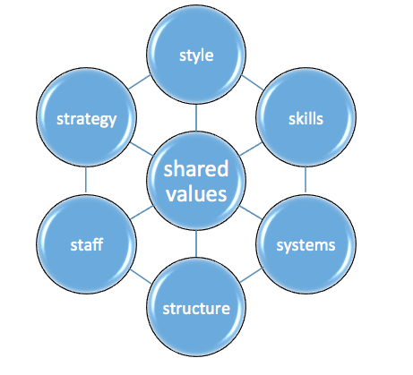

Figure 10 Mckinsey's 7-S Framework Source: CGMA
McKinsey 7- S framework was created in late 1970s by Tom Peters and Robert Waterman who were two consultants at McKinsey & Company. The framework argues that just having an organization and structure in place doesn’t carry the organizations strategies efficiently. Instead, the framework analyses 7 factors which are all connected together, which are key to helping organizations operate effectively (CGMA, 2021).
McKinsey’s 7 Step Model – Applied to Pepsi environmental scenario to meet climate pledge goals.
1. Style
Style represents the work culture and the way a company does things. The leadership style can influence how employees behaves. A leader who visibly embraces and demonstrates cost transformations, and management then it is likely their employees will also follow suit (CGMA, 2021).

2. Skills
Possessing the correct skills to achieve the strategy is crucial. Havin a skills or knowledge gap can prevent change or targets to be met. PepsiCo can utilize their employees and provide training to improve knowledge gap and learn processes.
3. Systems
The systems need to be sufficient enough to carry out the goals and desired outcomes. Systems and procedures are increasingly becoming automated and being up to date is required for optimal efficiency.
4. Structure
The organizational structure and hierarchy are important and should be easy to understand for everyone. Accountability is easily understood and not confused if the structure isn’t over complicated. Democratic leadership style was chosen as this would enable discussions and management can provide assistance to aid understanding and any difficulties faced.
5. Staff
The personnel in the organization which are required to operate the business tasks to ensure smooth daily operations. Recognizing if there are any gaps or numbers needed in positions to increase efficiency currently or in future at PepsiCo. Empowering and rewarding staff can help boost morale and work performance.
6. Strategy
Business environment can be very unpredictable, so organizations need to be adaptive and able to change in any circumstances. The climate pledge goal shows ambition in PepsiCo, it is a very challenging goal and strategies will need be adapted and changed depending what phase the plan is currently at.
7. Shared Values
Understanding the goals of the organizations can help achieve this. The shared values are at the central of the framework, meaning that understanding the clear goals and purpose shapes the rest of the steps in the framework. PepsiCo encouraging and rewarding employees to have shared values can provide good results towards the climate pledge.

5.1 Organization Development Cube
Management in organisations can apply organizational development cube model to help develop employees in an organization. The “OD” cube was created by Schmuck and Miles in 1976, with the aim of helping management create interventions in the organizations when leading change (Schmuck & Miles, 1976).
Interventions are designed to purposely disrupt the status quo in an attempt to create more effective solutions or improve work performance (Cummings & Worley, 2001).
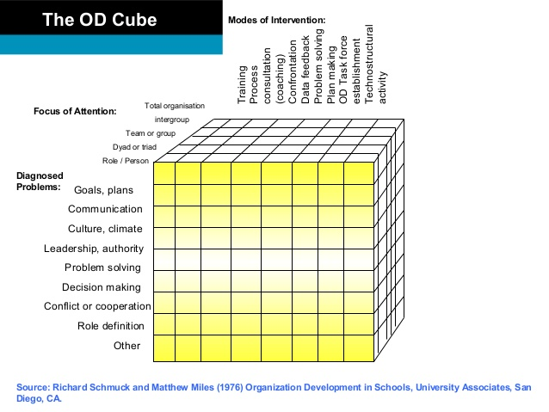
Figure 11 OD Learning CUBE
The focus was on three different areas:
1.The Diagnosed Problem
2. Focus on Attention
3. Mode of Intervention
The OD cube allows discovering where the problems can originate from and the level of intervention required to address this. The focus of attention can apply anywhere between individuals, teams and the whole organization. The options are vast and levels of intervention can vary which allows flexibility for use with multitude of problems in nearly any organization. Change practitioners and management at PepsiCo can use this framework to explore how deep the problems can go and determine the level of intervention required to improve organizational performance.

5.2 Organization Culture Importance
Innovations don’t happen overnight and employees are the most important aspect of an organization, so it is important to create a culture where learning and sharing is encouraged and nurtured. Engaged employees asking questions, challenges the organization and identifies potential problems early on, which allows organization to adapt and evolve in the long term (Augustsson, et al., 2017). There is no best organizational structure to aim for as it is highly contextual per organization. However, a few key steps to encourage learning can impact how employees learn and engage (HofstedeInsights, 2021).

5.3 Incorporate a learning culture in the workplace
These following factors can be applied by PepsiCo, to create a positive learning culture for their workforce, which will aid the change process for achieving the climate pledge goals.
1. Reward learning
Rewarding employees for their hard work will further motivate and engage employees to self-learning and promotions. Putting in a formal reward to achieving goals can improve work performances and efficiency (CIPD, 2021 ). Encouraging employees to think outside the box and challenge authority even if it means disagreements.
2. Give Constructive feedback
Management may avoid difficult conversations and only focus on positive feedback which is a problem. Managers need to give clear feedback to employees, not only positive but also include constructive criticism. Giving negative feedback must be done with grace and caution as it can impact employees undesirably. Employees may be unaware of their limitations and weaknesses which can give something to improve and work towards (Chamorro-Premuzic & Bersin, 2018).
3. Leading by Example
Management must not only state the goals and changes in behaviors they expect from employees but also demonstrate such behaviors themselves. If asking employees to learn and develop themselves, the management should showcase this and willingly engage about these things to further motivate the workforce (Yaffe & Kark, 2011) .
4. Hiring Attentive People
When hiring talent focus on hiring enquiring individuals who ask questions and are more involved in their roles. Hiring the correct type of candidate will put less pressure for these people to learn from the organizational learning. Inquiring individuals will be more willing to think critically, and be more open to new ways of doing things and adapting (Chamorro-Premuzic & Bersin, 2018).

6.0 Section 5 Reflection
This section will discuss from the author’s reflective view of what has been learnt about the organization in meeting the climate pledge objective.

6.1 Organizational Perspective
PepsiCo was analysed from author’s perspective and some knowledge was gained of some challenges the organization faced in regards to the climate pledge. Intel was gathered from the company website to help build background knowledge before addressing the challenges faced by the company. An internal scan revealed some strengths and weaknesses of PepsiCo. External scan was carried out to gain further knowledge on the macro-environment and external factors that affect the organization.
PepsiCo Inc is one of the largest companies in the world and operates in over 200 countries worldwide. Across its many branches and divisions worldwide implementing transitional change can be very difficult globally. It is a large multinational country and there won’t be a “one size fits all” approach. The contingency approach for implementing change will fit well in this scenario as it will require careful consideration of the environment that the organization operates in will be different in each region. To meet the climate pledge objective of net zero carbon by 2040, there will be more challenges inside the organizations which can make achieving the goal difficult.
Challenges of strategic change in PepsiCo
Challenges in PepsiCo of meeting climate goals.
- Difficulty sourcing locally - Sourcing different ingredients for recipes worldwide can vary in areas of difficulty such as supply and logistics. It may not be realistic to source resources locally due geographical location challenges. Sticking to the preferred option of creating snacks and beverages may be difficult depending on region and products. Reliance on its suppliers is how PepsiCo address this issue (Manufacturing Global, 2020).
- Company Structure – PepsiCo’s subsidiaries will differ in size, organization structure and culture across the companies branches, whether local or worldwide. Not possible to recommend a simple solution to apply across different divisions as different level of challenges and resource management is required (HofstedeInsights, 2021).
- Different level of skill in staff - The personnel can vary across its many PepsiCo’s many subsidiaries such as Frito-Lay, Tropicana, and Pepsi cola for example. The processes and methods are very different so being cautious when trying to implement change to meet the climate goal, may not be similar in another organizational environment. A McKinsey survey found; employers are hiring new people to address skill gaps or re-skilling it’s current workers to address this (McKinsey and Co, 2020).
- Different technologies and machinery – The issues in worldwide organization is that the level of technology may not be of equal quality everywhere. First world countries may have an advantage over its less well-off countries branches in many aspects such as staff, machinery and knowledge, thus affecting the overall output quality of product (‘Utoikamanu, 2021).

6.2 Consultant Perspective
The climate pledge objective was studied from the point of view of the author through a consultant lens, to analyse and examine the organization’s current status. The issues were that all sources where primarily gathered through company website and other sources. This gives an external viewpoint but which is quite restricted without proper access to the organization resources which would have further aided in more detailed knowledge of PepsiCo. Through various research the understanding was built upon examination of the company sustainability reports for useful data. The objective of meeting the climate pledge is quite complex and vast, so there are no easy simple solutions. The climate pledge has over 210 participants and some of these challenges other organizations are attempting to address.
Multiple frameworks were applied to further analyse PepsiCo and prepare potential solutions and fixes to the challenges. Stakeholder importance was studied in the process and examining who were the key players who were important in the change plans. Change management process was also investigated to help realise how in order for organizational change to occur, there must be certain procedures to follow to ensure it is successful. Change can occur in many different ways but it allowed exploration of a possible strategic fit and how it can be applied in this context.
Using a framework such as Kotter’s 8 steps showed an example of how change management can be carried out in an organization. The importance of culture and organizational design allowed understanding that change just doesn’t happen without proper intervention and guidance. The organizational design influences and shapes the culture so it is important to consider role of culture in organization when implementing change. The leadership style chosen for PepsiCo was democratic for leading change strategy as it allowed most open communication and it allowed leaders to provide employees input and reassure them of any issues and doubts. The suggestions given for PepsiCo plan were provided on author’s understanding of the limited context scenario of PepsiCo’s climate pledges, more detailed knowledge is required from internal sources to provide more in-depth strategies and recommendations.

For PepsiCo to meet the climate pledge objectives few areas to address are:

1. Increased Recycling.
Even though they have swapped to rPet bottles they are still second most polluters of plastic waste, behind rivals Coca-Cola. Building more partnerships with recycling companies is a step forward, even working together to recycle more. Improvements in recyclable packaging across its products will help recycling therefore reducing single use plastics waste.
2. Revise strategies in meeting emissions goal
Continue commitment to cut carbon emissions in multiple key aspects such as packaging, water, waste, agriculture as pledged and discover more greener ways to do so in future. Adapting strategies to meet pledge goals, and being accountable to meet each milestone provided by the COP26 and future conferences.
3. Invest in emerging technologies
New emerging technologies can help develop more benefits in the fight to reduce emissions, such as modular wind, clean hydrogen, solar energy and carbon negative technologies. Modular floating wind could be cheaper than regular wind within ten years. Clean hydrogen can potentially be a huge element in the net zero future, there is multiple ways of getting clean hydrogen using renewable energy but technology is still unproven on a large scale and very expensive currently (Collins, 2019).
4. Regenerative practices for agriculture
Continue organization efforts in regenerative methods in agriculture, as this is a step in the right direction. In US PepsiCo helped farmers plant crops on nearly 85,000 acres, which led to an average net reduction of 38% on farm greenhouse gases, including soil carbon sequestration. The current goal is to work with multiple partners to expand regenerative agricultural methods to more than 500,000 acres of land by end of 2021 (Pepsico, 2021).
5. Provide learning and training
Pepsi can upskill its employees to further boost knowledge gaps and improve employee engagement. Employees who are part of the organization vision will want succeed and share ideas which will increase work performance (Nawaz, 2021).

References
‘Utoikamanu, F., 2021. Closing the Technology Gap in Least Developed Countries. [Online]
Available at: https://www.un.org/en/chronicle/article/closing-technology-gap-least-developed-countries
[Accessed 29 11 2021].
Adewale, A. R. & Esther, M. M., 2012. The Relationship Between Stakeholders Involvement In Strategic Planning And Organisations Performance A Study Of The University Of Venda.. International Business & Economics Research Journal (IBER), 11(11), pp. 1175-1190.
ADM, 2020. Emerging Consumer Behavior Shifts: Six Ways Food & Beverage Innovation Is Evolving in the Face of COVID-19. [Online]
Available at: https://www.adm.com/news/news-releases/emerging-consumer-behavior-shifts-six-ways-food-beverage-innovation-is-evolving-in-the-face-of-covid-19-2
[Accessed 18 11 2021].
Alves, M., de Sousa Jabbour, A., K. D. & Jabbour, C., 2017. Contingency theory, climate change, and low-carbon operations management.. Supply Chain Management: An International Journal , 22(3), pp. 223-236.
Augustsson, H., R. A., Hasson, H. & von Thiele Schwarz, U., 2017. he need for dual openness to change: a longitudinal study evaluating the impact of employees’ openness to organizational change content and process on intervention outcomes.. The Journal of Applied Behavioral Science, 53(3), pp. 349-368.
BBC NEWS, 2021. Netflix: Four things which have driven its success. [Online]
Available at: https://www.bbc.co.uk/news/business-55723926
[Accessed 12 11 2021].
BFFP, 2020. The Coca-Cola Company, PepsiCo and Nestlé named top plastic polluters for the third year in a row. [Online]
Available at: https://www.breakfreefromplastic.org/2020/12/02/top-plastic-polluters-of-2020/
[Accessed 18 11 2021].
Caldwell, D. et al., 2008. Implementing strategic change in a health care system: The importance of leadership and change readiness.. Health care management review, 33(2), pp. 124-133.
CFI, 2021. Macro Environment. [Online]
Available at: https://corporatefinanceinstitute.com/resources/knowledge/economics/macro-environment/
[Accessed 27 11 2021].
CGMA, 2021. What is it?. [Online]
Available at: https://www.cgma.org/resources/tools/cost-transformation-model/mckinsey-framework.html
[Accessed 19 11 2021].
CGMA, 2021. What is it?. [Online]
Available at: https://www.cgma.org/resources/tools/cost-transformation-model/mckinsey-framework.html
[Accessed 25 11 2021].
Chamorro-Premuzic, T. & Bersin, J., 2018. 4 Ways to Create a Learning Culture on Your Team. [Online]
Available at: https://hbr.org/2018/07/4-ways-to-create-a-learning-culture-on-your-team
[Accessed 27 11 2021].
CIPD, 2021 . Reward: an introduction. [Online]
Available at: https://www.cipd.co.uk/knowledge/fundamentals/people/pay/reward-factsheet#7544
[Accessed 27 11 2021].
ClimateActionTracker, 2021. Glasgow’s 2030 credibility gap: net zero’s lip service to climate action. [Online]
Available at: https://climateactiontracker.org/publications/glasgows-2030-credibility-gap-net-zeros-lip-service-to-climate-action/
[Accessed 18 11 2021].
Collins, L., 2019. Seven emerging technologies that will be vital for fighting climate change. [Online]
Available at: https://www.rechargenews.com/transition/seven-emerging-technologies-that-will-be-vital-for-fighting-climate-change/2-1-727169
[Accessed 29 11 2021].
Cummings, T. & Worley, C. G., 2001. Organization Development and Change. 7th ed. Ohio: South-Western College Pub.
Freeman, R., 1984. Strategic Management: A Stakeholder Approach. 1 ed. Boston: MA:Pitman.
Gagnon, M., Jansen, K. & Michael, J., 2008. Employee alignment with strategic change: A study of strategy-supportive behavior among blue-collar employees.. Journal of Managerial Issues, pp. 425-443.
Gutierrez, C., 2021. Coke vs. Pepsi: The 2021 Cola Wars. [Online]
Available at: https://www.greenbook.org/mr/brand-impact/coke-vs-pepsi-the-2021-cola-wars/
[Accessed 19 11 2021].
Harvard Business School Online, 2021. Organizational Change Management: What It Is & Why It’s Important. [Online]
Available at: https://online.hbs.edu/blog/post/organizational-change-management
[Accessed 29 11 2021].
Hayes, J., 2018. The theory and practice of change management. 5th ed. London: Palgrave.
HofstedeInsights, 2021. ORGANISATIONAL CULTURE. [Online]
Available at: https://hi.hofstede-insights.com/organisational-culture
[Accessed 20 11 2021].
Ho, S., 2021. Coca-Cola and PepsiCo Blasted As World’s Top Plastic Polluters For 4th Straight Year. [Online]
Available at: https://www.greenqueen.com.hk/break-free-from-plastic-2021-brand-audit/
[Accessed 27 11 2021].
IUCN, 2019. Summary Statistics. [Online]
Available at: https://www.iucnredlist.org/resources/summary-statistics
[Accessed 30 10 2021].
Jan DeBell, C., 2019. Democratic leadership.. Dental Assistant, 88(2), pp. 6-7.
Kibbe, M., 2019. Leadership theories and styles.. 2 ed. London: Springer, Cham.
Kotter, J., 1996. Leading Change. 18 ed. Boston MA: Harvard Business Press.
Kotter, J., 1998. Winning at change. Leader to leader, 10(Fall), pp. 27-33.
Kübler-Ross, E., 1969. On Death and Dying. 1 ed. New York: Macmillan.
Latham, A., 2016. 5 Secrets For Making Change Stick. [Online]
Available at: https://www.forbes.com/sites/annlatham/2016/05/29/5-secrets-for-making-change-stick/?sh=1eef2bf930b8
[Accessed 29 11 2021].
Maizland, L., 2021. COP26: Here’s What Countries Pledged. [Online]
Available at: https://www.cfr.org/in-brief/cop26-heres-what-countries-have-pledged
[Accessed 27 11 2021].
Manufacturing Global, 2020. PepsiCo: keeping supply chains resilient. [Online]
Available at: https://manufacturingglobal.com/procurement-and-supply-chain/pepsico-keeping-supply-chains-resilient
[Accessed 26 11 2021].
Matousek, M., 2018. Here's what it's like to eat at McDonald's in 7 countries around the world. [Online]
Available at: https://www.businessinsider.com/what-mcdonalds-is-like-around-the-world-2017-11?r=US&IR=T#japan-5
[Accessed 11 11 2021].
McKinsey and Co, 2020. Beyond hiring: How companies are reskilling to address talent gaps. [Online]
Available at: https://www.mckinsey.com/business-functions/people-and-organizational-performance/our-insights/beyond-hiring-how-companies-are-reskilling-to-address-talent-gaps
[Accessed 29 11 2021].
Mendelow, A., 1981. Environmental Scanning-The Impact of the Stakeholder Concept. ICIS.
MindTools, 2021. Stakeholder Analysis. [Online]
Available at: https://www.mindtools.com/pages/article/newPPM_07.htm
[Accessed 23 07 2021].
Nawaz, S., 2021. 5 Reasons Your Employees Don’t Understand Your Company’s Vision. [Online]
Available at: https://hbr.org/2021/09/5-reasons-your-employees-dont-understand-your-companys-vision
[Accessed 29 11 2021].
NBC NEWS, 2017. Pepsi Pulls Controversial Kendall Jenner Ad After Outcry. [Online]
Available at: https://www.nbcnews.com/news/nbcblk/pepsi-ad-kendall-jenner-echoes-black-lives-matter-sparks-anger-n742811
[Accessed 11 11 2021].
PEPSICO, 2020. 2020 Sustainability Report: Focus Areas. [Online]
Available at: https://www.pepsico.com/sustainability-report/packaging
[Accessed 06 11 21].
Pepsico, 2021. 2020 Sustainability Report: Focus Areas. [Online]
Available at: https://www.pepsico.com/sustainability-report/agriculture
[Accessed 29 11 2021].
PEPSICO, 2021. 2020 Sustainability Report: Focus Areas. [Online]
Available at: https://www.pepsico.com/sustainability-report/packaging
[Accessed 27 11 2021].
PEPSICO, 2021. About the. [Online]
Available at: https://www.pepsico.com/about/about-the-company
[Accessed 28 10 2021].
PEPSICO, 2021. Our Nutrition. [Online]
Available at: https://www.pepsico.com/brands/nutrition
[Accessed 26 11 2021].
PepsiCo, 2021. PepsiCo Doubles Down on Climate Goal and Pledges Net-Zero Emissions by 2040. [Online]
Available at: https://www.pepsico.com/news/press-release/pepsico-doubles-down-on-climate-goal-and-pledges-net-zero-emissions-by-204001142021
[Accessed 28 10 2021].
Pepsico, 2021. Philanthropy. [Online]
Available at: https://www.pepsico.com/sustainability/philanthropy
[Accessed 19 11 2021].
Poore, J. & Nemecek, T., 2018. Reducing food’s environmental impacts through producers and consumers.. Science, 360(6392), pp. 987-992.
Porter, M. & Millar, V., 1985. How information gives you competitive advantage.. Harvard Business Review, 63(4), p. 149.
Reuters, 2020. RPT-PepsiCo to consider entering alcoholic beverages business. [Online]
Available at: https://www.reuters.com/article/pepsico-alcohol/rpt-pepsico-to-consider-entering-alcoholic-beverages-business-idUSL4N2GS2KH
[Accessed 19 11 2021].
SC Digest, 2019. Supply Chain News: Will the Direct Store Delivery Model Survive?. [Online]
Available at: https://www.scdigest.com/ontarget/19-06-04-1.php?cid=15536
[Accessed 27 11 2021].
Schmuck, R. A. & Miles, M., 1976. Organizational Development in Schools. 1 ed. California: University Associate.
SKY NEWS, 2021. Sugar tax: Consumption of sugar from soft drinks falls by 10%. [Online]
Available at: https://news.sky.com/story/sugar-tax-consumption-of-sugar-from-soft-drinks-falls-by-10-12242372
[Accessed 19 11 2021].
The Guardian, 2021. The truth behind corporate climate pledges. [Online]
Available at: https://www.theguardian.com/environment/2021/jul/26/climate-crisis-green-light
[Accessed 19 11 2021].
TheClimatePledge, 2021. Net Zero Carbon by 2040. [Online]
Available at: https://www.theclimatepledge.com/
[Accessed 18 11 2021].
UEFA, 2021. PepsiCo renews UEFA Champions League partnership until 2024. [Online]
Available at: https://www.uefa.com/insideuefa/about-uefa/news/0264-10fc0592b7da-fae575fccc7c-1000--pepsico-renews-uefa-champions-league-partnership-until-2024/
[Accessed 18 11 2021].
UNFCCC, 2021. Key aspects of the Paris Agreement. [Online]
Available at: https://unfccc.int/process-and-meetings/the-paris-agreement/the-paris-agreement/key-aspects-of-the-paris-agreement
[Accessed 21 10 2021].
Yaffe, T. & Kark, R., 2011. Leading by example: The case of leader OCB.. Journal of Applied Psychology, 96(4), pp. 806-826.
Yinon, B.-O., Phillips, R. & Milo, R., 2018. The biomass distribution on Earth. The biomass distribution on Earth, 25(6506-6511), p. 115.

