

LEARNING IN THE DIGITAL ERA COMPLETED ON: 25.11.2022

Chrysanthos Bikos

STUDENT NUMBER: 2210947

Contents INTRODUCTION.......................................................................................................................................2 MAIN FINDINGS ......................................................................................................................................2 TASK 2 – ACADEMIC WRITING ................................................................................................................3 TASK 3 – CRITICAL WRITING....................................................................................................................4 TASK 4 – SENSE OF PLACE VIDEO............................................................................................................4 CONCLUSION...........................................................................................................................................6 REFERENCE LIST ......................................................................................................................................6

INTRODUCTION
The introduction accomplishes several things. It includes a summary of the article, introduces the topic and goals of your study, and provides background information. A strong opening will lay the groundwork for your paper's key sections—the methods, findings, and discussion—and entice readers to read on (Zepernick).

The introduction is also there to help the reader comprehend the issue you are addressing and define your specialized topic and give them any background information they might need. The basis for a strong assignment or article will be set by the opening, which needs to catch the reader's interest.

MAIN FINDINGS

Main Findings are essentially the investigation's main conclusion. It is essentially crucial knowledge that can be learned through research. The results of the study are facts and phrases, observations, and experimental data (My Research Topic, 2021).

The major goal of the findings section in a research report is to logically present or showcase the results using tables, graphs, and charts. The goal of research findings is to present a comprehensive picture of the most recent discoveries in connected fields.

TASK 2 – ACADEMIC WRITING

When we think of academic writing, we usually think there is a particular way of thought and communicating ideas that we must copy. Therefore, we settle for authoritative viewpoints and employ their styles of expression, which leads to poor thinking and writing.
If you can however manage to find your own way of thinking and writing, you will find freedom and not be fearful when doing an exercise.
You’ll start to write in a manner that is more conversational and informal, and this will give you the confidence to get your views across in a clear and efficient manner. (Greetham, 2018)
Academic Writing is a tool for knowledge and learning. Writing in an academic style is very important for academic performance and is essential for academic learning.
In academic writing, you must communicate your thoughts, but they must be presented as a reaction to another person or group. Your ideas must also be thoroughly developed, strongly supported, logically organised, and rigorously reasoned (Routledge, 2021)
You can remember more by writing. You are retaining a record of that interaction when you take notes or from some other source. You are being careful in what you record. Your mental thoughts are centered around that experience. Making notes during that encounter helps with memory. In real life, many of us would have forgotten that experience if we didn’t take notice to review it afterward. Taking notes is essential in keeping records and by doing so, our knowledge and understanding will increase (Day, 2018)
Since writing is one of the key methods of scholarly communication, academic writing may be the most important skill in a learning setting. Writing that seeks to communicate scientific or other knowledge in a clear and succinct manner is known as academic writing (Priya, 2021)

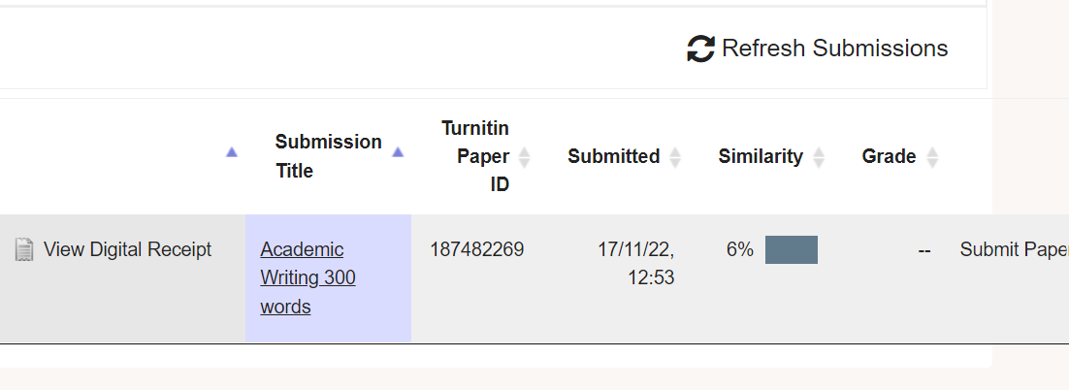

I would say that over the previous two to three weeks, I have practiced a lot, and I feel like I have greatly progressed. Even so, I still need to pay more attention as I revise my writing and structure strategies. I could write better, and I would be very grateful for advice going ahead. Finding the appropriate article to paraphrase and reference might be difficult, especially considering advice from The Harvard Handbook.

TASK 3 – CRITICAL WRITING

This cycle of producing and envisioning includes critical writing. It can affect how and what can be made, seen, done, and said by actively influencing the circumstances in which writing is produced and received. It is meant to be a helpful manual that writers or workshop facilitators can use to develop their own critical writing projects and to spark creative thought about writing and dialogue as independent creative activities (Schmidt, 2018)

Through an examination of action, this essay examines the connection between training practice and critical writing on performance (Damian Martin, 2016)

It is crucial that students get over their writing phobia. The willingness of a student to write is greatly influenced by us as teachers, thus we must support the practice of writing in the classroom. Students can think about their opinions, beliefs, ethical standards, and design principles through writing while using design terms and guidelines. As they progress, students become more self-assured in their choices, depending less on the instructor's endorsement and more on their own goals (Coorey, Jillian, Rinnert and Caldwell, 2013)

“The writing skill, in which both physical and mental skills are used, is an active skill area that combines and integrates the conscious and subconscious” (Covey, 2006, p. 153)

Critical thinking is necessary for academic writing; it is not sufficient to simply explain or summarise the facts; you must also analyse and assess the data to utilize it to support your own claims. For higher grades, critical writing is crucial because this is where you demonstrate your own ideas based on the data at hand.

Strong writing abilities are needed for critical writing. You must have a solid grasp of the subject and its problems. You must create an essay structure and paragraph structure that enables you to evaluate several interpretations and create your own, evidence-based argument.

TASK 4 – SENSE OF PLACE VIDEO

Dear Sir/Madam

Please find attached (below) a link to my powerpoint presentation for your consideration.
Recording-20221119_183632.webm

Kind Regards,
Chris Bikos

CONCLUSION

There should be a conclusion since it gives the reader something to consider and acts as a reminder of the importance and content of the article. To do this, it steps back from the specifics to focus on the document's general structure (Walden University)

A solid ending is crucial because it gives the speaker one more opportunity to emphasize the significance of the message and allows them to both announce the end of the speech and aid the audience in recalling the key points.

REFERENCE LIST

- Coorey, Jillian, Rinnert, Caldwell G 2013, Critical Writing Strategies to Improve Class Critiques, ProQuest, Vol. 47, Iss. 3, p. 30-51
- Covey, S. R. (2006). Seven habits of effective people. Osman & Filiz Nayır Deniztekin (Trans.). (29th ed.). Varlık Publishing.
- Damian Martin, D 2016, Unpeeling Action: Critical Writing, training and process, Routledge, Vol. 7 (2), p. 195-211
- Day, T 2018, Success in Academic Writing, Bloomsbury Publishing Plc, ProQuest Ebook Central
- Greetham, B 2018, How to Write Better Essays, Bloomsbury Publishing Plc, ProQuest Ebook Central
- Hsiao, A 2012, Why Sense Of Place Is Worth Caring About, Planetizen

My Research Topic, 2021, Research Findings – Objectives, Importance and Techniques
- Priya, K 2021, What is Academic Writing – Everything You Need To Know, SCISPACE
- RHOD, 2022, The importance of identity, Ellis Jones
- Routledge, 2021, What is Academic Writing (and Other Burning Questions About It), Routledge Taylor and Francis Group
- Schmidt, T 2018, How We Talk About The Work Is The Work: Performing Critical Writing, Routledge, Vol.23, p.37-43
- Seddon, G 1972, Sense of place: a response to an environment: the Swan Coastal Plain, Western Australia
- Walden University, Conclusions – Writing a Paper – Academic Guides
- Zepernick, J, 10 tips for writing an effective introduction to original research papers, Think Science

