
ECAD 4008
Cycle 1 Professional and pedagogical studies: Leading the learning: what, how and why am I teaching?

Charlene Griffiths
Student Number 1904882

Contents

ECAD4008 Cycle 1 Professional and pedagogical studies: 2
Leading the learning: what, how and why am I teaching? 2
Appendices 10
Appendix 1- My Foundation Phase pamphlet for Parents (2020) 10
Appendix 2- Impact wales (2019) 12 Pedagogical Principles 10
Appendix 3- My Easter lesson 11
Appendix 4- My lesson plan for year 2 looking at philosophy 4 children. 11
Appendix 5 – My letter to the class parents 11
Appendix 6- Here are the story boxes the children created for the ‘Express Event’ 12
Appendix 7 St Patrick’s Day planning 12
References 13

Gallwch ychwanegu’ch targedau o’ch aseiniad diwethaf (Ond yn berthnasol os yr ydych wedi cwblhau aseiniad) / Please add your targets from the previous assignment (Only relevant if you have completed an assignment)
Targed/Target 1 | Prioritise the quality of your written expression in future assignments; it'll make a difference.
Targed/Target 2 | Sentence errors are fairly common. Proofread to remove them.
Targed/Target 3 | Make sure that all ideas are explained in depth.
Targed/Target 4
Targed/Target 5

ECAD4008 Cycle 1 Professional and pedagogical studies:

Leading the learning: what, how and why am I teaching?

Good teaching and learning means employing a blend of approaches including direct teaching.

Good teaching and learning sets tasks and select’s resources that build on previous knowledge and experience and engage interest.

Good teaching and learning ranges within and across areas of learning and experience.
(Donaldson, 2015:68)

Consider the 3 pedagogic principles outlined above. Discuss these principles in relation to your experience in school showing secure understanding, identifying strengths and areas for development for each principle.

Pedagogy is very important within teaching and learning and is the how we teach and how we get the best outcome when teaching (Hirsh et al, 2012) . Barnes (2011) believes pedagogy is the fusion of knowledge theory, practical experiences, environment management and showing the children responses every minute in the practice of ‘good teaching’. Pollard (2010) says the word pedagogy is the ‘art and craft’ of teaching. In this written account I will be concentrating on three pedagogy principles when talking about my knowledge of the curriculum, the experiences I have gained and seen on placement and the research I have made during this module and to help me complete my teaching practice. The three pedagogy principles I will be looking at are:
- Good teaching and learning means employing a blend of approaches including direct teaching.
- Good teaching and learning sets tasks and select’s resources that build on previous knowledge and experience and engage interest.
- Good teaching and learning ranges within and across areas of learning and experience.
These pedagogy principles can be found in Donaldson’s new curriculum Successful Futures (2015), Donaldson created twelve pedagogy principles that he believed is the how we teach and how we get the best outcome in teaching. During my teaching practice I believe I stayed true to myself and emphasised on giving all the children the best experiences, to help them develop more confidently over all areas of learning.
Moore (2000, P. 121) believes
“It is axiomatic that, in the end, though teaching may always be something of an ‘act’, the successful teacher has to remain true to ‘who they are’.”
I was placed in a school in Clydach, Swansea for my placement where I needed to research the area, backgrounds of the children and families and what to teach and how. My bridging days helped me research the school, children and how to teach. I also saw what strategies the teacher used that produced the best outcome for the children. My placement school was in a deprived area with 47.7% of pupils having free school meals (My Local School, 2019) but the school was very much about giving the children different life experiences, this is backed by the theory of Froebel who was the first person to formulate a theory of pre-school education with a planned curriculum based on key learning experiences (Welsh Government, 2008) and also Piaget’s constructivist theory where he believes that the children are active participants who construct learning by interacting with their environment and make connections between new experiences and previous learning (Welsh Government, 2008). Also my placement school are very for the pupils voice and choices which incorporates with the UN Convention on the Rights of the child (UNICEF, 2020) article 12 respect- the views of the child, where the children are very much involved in the planning of what to teach and how the school is run, the school have very good links to the community and parents, Froebel believed that parents should be closely involved in the children’s development and education (Pound, 2005). The children’s voice is very important when they create ‘Express Events’ which include different stakeholders and the involvement of the community and who they would like to raise money for (school ‘X’ website, 2019). This is shown in Bronfenbrenner’s ecological system theory (Pound, 2009), where the child is in the centre of the system and all the environment around the child influences their development, and that all the environments are all interlinked in getting the best outcome for the child. Whilst on placement I have been planning using the Foundation Phase Framework (2015) as it still works well and it is the current curriculum but my placement school has started to introduce Successful Futures (2015) into the planning, as was noted in the OECD report (2017) as my placement school was one of the schools chosen to be included in the report.
Our education system has changed drastically over the last 40 years. The Education Reform Act of 1988 established the National Curriculum for England, Wales and Northern Ireland. The National Curriculum was established to promote the spiritual, moral, cultural, mental and physical development of pupils at the school and society and prepare such pupils for experiences, opportunities and responsibilities of adult life(Telegraph, 2011).The Government of Wales Act 1998 devolved to the national Assembly of Wales gaining their own education curriculum, where they innovated new policies and designed to improve the delivery of service. Wales had exercised devolved powers to improve the status of the Welsh language (Reynolds, 2008). Reynolds (2008) stated that the Welsh Government believed that working ‘with’, rather than ‘on’ or ‘to’, the educational professionals were more likely to be effective than what the community thought about their accountability. In 2001 the Welsh Government wanted the education system to transform society, but there was still need for improvement, where the Foundation Phase Framework was implemented in Autumn 2008 (Reynolds, 2008). The Foundation Phase was introduced to schools, replacing key stage 1 for all 3 to 7year olds, it was implemented in the nursery first, then reception and as it was introduced to each class it was monitored. The Foundation Phase Framework is split into 7 learning areas- Mathematical Development, Language, Literacy and Communication Development, Creative Development, Physical Development, Personal and Social Development, Well-Being and Cultural Diversity, Welsh Language Development and Knowledge and Understanding of the World. Within these areas the children can explore and learn through play and gain different experiences (Welsh Government, 2015). During this module we had a task to create a pamphlet for parents about the Foundation Phase (See Appendix 1). Kingston and Siraj (2017) show their support as they have written a Welsh journal of education supporting the implementation of the Foundation Phase through effective professional development, where the use of pedagogy principles must be used and shown in in good practice to be effective and have the best outcomes. Steiner believed learning through play and imitation were important, and that play strengthens the imagination and supports all aspects of development and enabled the children to concentrate, be inventive and adaptable. Steiner believed this was the main way of learning for children from birth to seven (Pound, 2005). The foundation phase is a blend of adult and child led play where the teacher will plan what activities are out in the area and the children will explore and use their imagination to play and learn. All children are different and will explore activities differently (Donaldson, 2015).
Unfortunately, in 2009, PISA results showed disappointing results, showing the children’s performance was lower than average, which resulted in a broad consensus on the need for change(OECD, 2009). In 2011 Wales started a large school improvement reform and placed many policies to improve the quality and equity of the school system. The Foundation Phase Framework has evolved over time and has been developed further by the Welsh Government in 2015 (OECD, 2017). This OECD Report (2017) came at a crucial time in Welsh education, as the education system was changing drastically which included a whole new curriculum reform, a reform of teacher education and the revision of its education strategies. The OECD (2017) states that Wales wanted a new education system where all learners have an equal opportunity to reach their potential and strengthen individuals, and for the societies capacity to contribute to economic growth and social conclusion. This is where the new curriculum reform will help Wales to achieve this, Donaldson has stated that the Foundation Phase Framework did work well, and he has integrated some features into Successful Futures (2015). Donaldson’s (2015) New Curriculum for Wales, includes a vision for all children. This vision includes four main purposes where the children will develop as
• Ambitious, capable learners, ready to learn throughout their lives.
• Enterprising, creative contributors, ready to play a full part in life and work.
• Ethical, informed citizens of Wales and the world
• Healthy, confident individuals, ready to lead fulfilling lives as valued members of society.
These purposes will help develop the children by using different teaching approaches which include 12 pedagogical principles and how a teacher uses them regarding their teaching strategies. These pedagogies have been created and researched by different educational theorists and psychologists and are now helping to support the Foundation Phase Framework and Successful Futures (Barnes, 2012).
These pedagogical principles are shown in appendix 2 (Impact Wales, 2018). Impact Wales (2018) believes we need to identify our pupils needs, then match the pupils need with the most appropriate pedagogical approach and then assess the impact of the teaching approach through pupil progress and repeat each time when identifying the pupil’s needs.
Evaluating the first pedagogy principle ‘Good teaching and learning means employing a blend of approaches including direct teaching’ this is looking at different teaching approaches in the classroom, as I was based in a year 2 class, the class wasn’t set up like a traditional foundation phase classroom, it had 5 different areas- mathematics, creative, roleplay, construction and reading garden. The children had 5 discovery dog challenges to complete each week, which helped the children explore the area with purpose, these challenges were chosen by the children which included a blend of different approaches. For example, in one week the epic challenge was to create a Mother’s day card, the children had independent measuring work -a follow on from a direct task with the teacher from the week before, record two welsh sentences about fairy tale characters on see-saw- following on from a written task with a teacher, create a Lego flower for mam and create a poem using the words mother. As you can see there are different type of challenges available each week and these run alongside the direct tasks too with the teacher and teaching assistants. I found I had the best outcome from the children when I used different resources which the children could look at in a humanities lesson about Easter, where we explored different artefacts and looked at the Easter story and then wrote some facts that we learnt about Easter in our topic book (See Appendix 3) or use during a physical focus task like measuring where the children had activity sheets to measure different objects in the classroom using a metre rule or ruler. I believe this theory would correspond to Fredrick Froebel theory who created a carefully planned curriculum based on key learning experiences, offering structured teacher – directed activities where the children also had the opportunity to play(Welsh Government, 2008). Hattie (2012) believes in visible learning, making student learning visible to teachers and that the students become their own teachers which is a main attribute of lifelong learning. Barnes (2011) has also looked at Gardner’s theory for effective teaching where we should take account of the child’s world and Gardner suggested three ways children learn from adults: direct or unmediated learning, when the child observes the adult; imitation, where the child rein acts the adults actions; outside the context where a skill is introduced and practiced under adults supervision. Another blend of teaching used in my placement school is Philosophy 4 children an enquiry-based learning to open the children’s learning and exploration ideas (P4C, 2020). This worked well in my year 2 class, they would have a session every week related to the theme currently fairy tales, we looked at who would we invite to the ball and why? When in the house would we answer the door to an unknown person and why? What would you do if a troll came to school and why? I had the opportunity to plan a P4C lesson we looked at ‘Was the Woodman right to kill the Wolf at the end of the Little Red Riding Hood story?’, this opened the children’s mind to right and wrong but the reasoning given was very different (See Appendix 4).
When looking at ‘Good teaching and learning sets tasks and selects resources that build on previous knowledge and experience and engage interest’ Katz suggests that a project which is researched by children is determined by the children’s interests and is based on their ideas, questions and experiences. (Pound, 2009). This is shown in my placement school as I explained earlier the children choose what their ‘Express Event’ will include going by their interests and what they enjoy doing. The ‘Express Event’ works well within the school and gets all the parents involved and the community, I was lucky enough to be part of the last ‘Express Event’ where I set a task for the children to do a story box at home with their parents as the theme was Fairy Tales (See Appendix 5 for letter and Appendix 6 for story boxes) and these would be on display for the children to show along with what the children decided to include- cookies made by the children, a fractured fairy tale created by year 2 will be on sale and the children would get to display their other work on fairy tales throughout the ‘Express Event’. When creating the fractured fairy tale book my class teacher used a brilliant method to create and make sure that all the children had an input when creating the story and illustrating the story. My class teacher used the strategy of stylistic modelling. Firstly she asked the class what ideas they had for which story they were going to change into a fractured story, then the children got to vote for their favourite new title and in groups worked with the class teacher to create the story, using the same structure as the original story, but changing the perspective of characters and what happened on the end. The class created a brilliant story and then they all worked together to illustrate the story. This is a strategy I would use in the classroom as a teacher because it had the best outcome and all children were involved. Carter (2012) believed that this strategy of writing can interpret what the reader understands and develops in reasoning. Dewey also agrees with this pedagogy principle as he states teachers should have good general knowledge, know their children well and observe children and plan from what they learn of them (Pound, 2005). Dewey also found fun was not enough, he wanted children to have opportunities to develop their own interests, work in ways that match their age and stage of development and engage in activities and experiences which contribute to their understanding and appreciation of the world (Pound, 2005). For teachers to get to know their children and their interests Isaacs believed the teachers must observe the children and reflect on the children’s learning to reach a better understanding of the children’s learning (Pound, 2005). Barnes (2011) believes the teacher should balance respect for the child’s world with a craftsperson’s skill at their subject. We can also look at Vygotsky’s theory the zone of proximal development, where in a classroom the teacher, teaching assistant or peers can be the knowledgeable other (Gray and MacBlain, 2012). In my placement school the class teacher had split the class into mixed ability groups within all areas where there can be peer teaching as well as direct teaching which follows Vygotsky’s theory. Malaguzzi (Pound 2005) believed the environment was the third teacher and that the parents and community are also educators, people who visited Regio Emilia were so impressed by the quality of work presented by the children due to the involvement of the community and support of all the families.
When looking at ‘Good teaching and learning ranges within and across areas of learning and experiment’ this is looking at cross- curricular teaching and learning. Steiner believed that teaching is by example and learning is cross-curricular without subject boundaries. Lynch (2019) believes cross curricular teaching has the potential to change the way the students learn and process information in a dramatic way. However, he does believe that the schools need to change their daily structure and how the teachers plan their lessons. In my placement school, they have many outsiders from the local community to teach the children during teachers PPA time for example Zak’s Dance School, Clydach choir, a music teacher and also the Ospreys Rugby and Swansea City Football come in regular once a week to teach all classes giving the teachers time to plan lessons and to collaborate with other teachers. I collaborated with my year 2 teacher and the year 1 teacher for planning special events. The two classes come together and have 6 different activities offering the children different experiences and would rotate the children around the activities on a carousel movement, so that all the children could explore different experiences. I planned a St Patrick’s day collaboration day as we recently had a family from Ireland move to the school (see appendix 7). Montessori’s theory includes education of the senses and exploration of the wider world, and for the children to explore individually and learn through exploration (Pound ,2005). Barnes (2011) believes that one-size-fits-all approaches to teaching is still evident today but the ‘standards’ for Qualified Teacher Status have become more pragmatic in the approach to prepare teachers for teaching and learning, but Barnes (2011) believes that there are many books on how to achieve the QTS standards but there is less help as to how to make the curriculum choices that promote learning and thinking. During our teaching practice we had to use the QTS Standards when looking for targets to achieve during our lesson plans and whilst on teaching practice (EWC, 2019) . Malaguzzi’s theory is very similar to the Foundation Phase in the way he values all aspects of children’s development, and the children are given opportunities to represent their experiences, ideas, thoughts and feelings in a variety of ‘languages’. For example, if a child was asked to draw a lion from the town square, the children would be encouraged to act like a lion, move like a lion, create a sculpture of a lion and talk about lions (Pound, 2005). This is a perfect example of cross-curricular teaching.
To conclude I believe during my teaching practice I have seen a great amount of different strategies and theory used everyday for effective teaching and learning. I have enjoyed seeing different blends of teaching as I said previously the philosophy 4 children (P4C, 2019) and stylistic modelling (Carter,2012) to get all the children involved in the learning. My placement school has started to adapt the Successful Futures Curriculum (2015) including the purposes and principles when planning for effective teaching. My placement school uses pupil’s voice according to article 12 (UNCRC, 2020) when planning and giving the children to express ideas and thinking of different tasks. My class used enhanced provision through challenges where children would build on previous knowledge of a focus task and use on an independent task. This is supported by Piaget ‘Scaffolding’ Theory and Bruner’s ‘Spiral Curriculum’, where children will engage in previous knowledge to carry out other activities (Gray and MacBlain, 2012). I think this was a great way of building the children’s confidence to complete independent challenges, because it shows them they have learnt from a focus task and built on prior knowledge which is one of our pedagogical principles ‘good teaching and learning sets tasks and selects resources that build on previous knowledge and experience and engage interest’. I also thought that the way the children reflected on their work with smiley faces using green- good, orange- I had to think and red- hard using self-assessment to help them set their own targets, alongside the teachers which showed a great way of Self-Assessment (Royce Sadler, 1989). This style of assessment is included in the 10 principles of Assessment for Learning (magicmaths.org, 2020).

Appendices

Appendix 1- My Foundation Phase pamphlet for Parents (2020)
Welsh Government (2019) How is my child doing in the Foundation Phase https://gov.wales/sites/default/files/publications/2019-07/how-is-my-child-doing-in-the-foundation-phase-a-guide-for-parents-and-carers.pdf
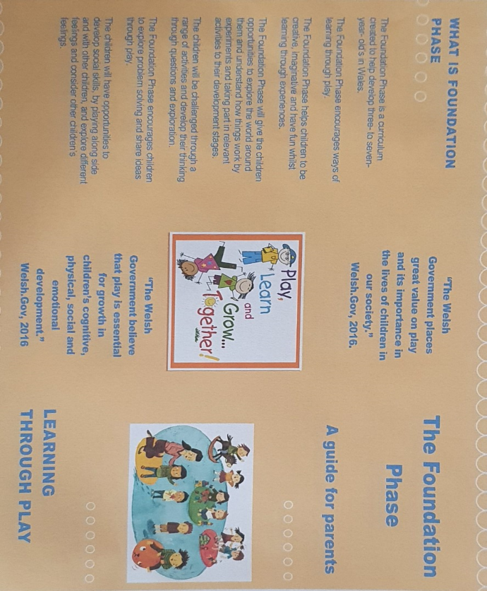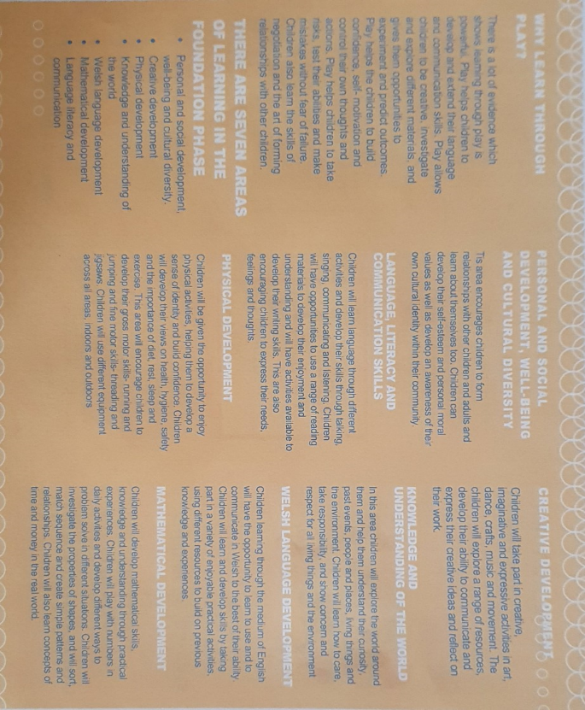

Appendix 2- Impact wales (2019) 12 Pedagogical Principles (Accessed 25th March) https://www.impact.wales/wp-content/uploads/2018/01/12-Pedagogical-Principles-1.pdf
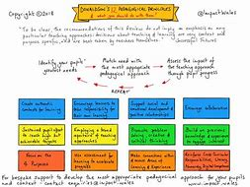

Appendix 3- My Easter lesson
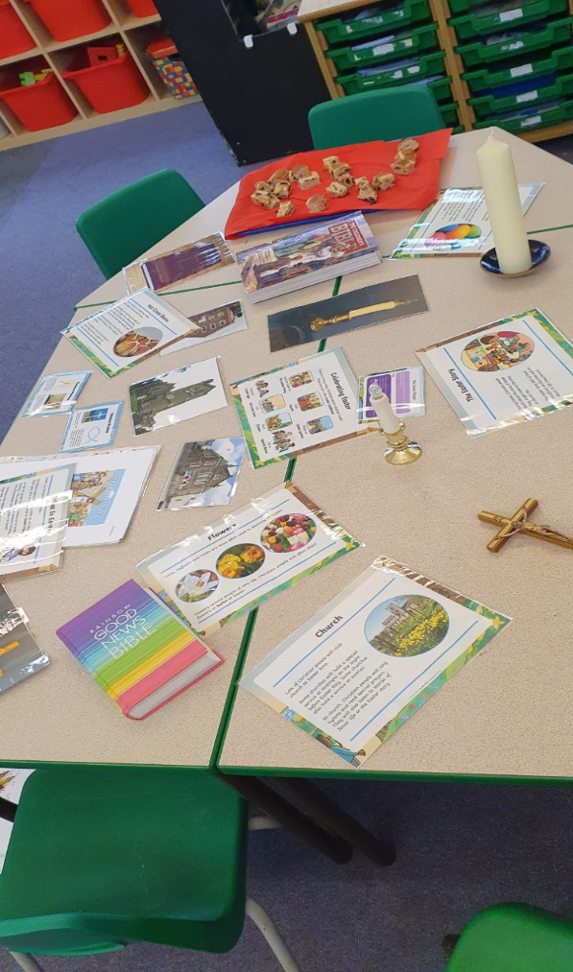
Source : My personal picture, 2019

Appendix 4- My lesson plan for year 2 looking at philosophy 4 children.
www.philosophy4children.co.uk (Accessed 25th March 2020)
Here is the link to my lesson plan https://uowtsd-my.sharepoint.com/:w:/g/personal/1904882_student_uwtsd_ac_uk/Ebfp2CKlkqJCs34Qorx8iwkBk7iKuJKEYgc9y6ARwCz0Gw?e=n7lz4p

Appendix 5 – My letter to the class parents
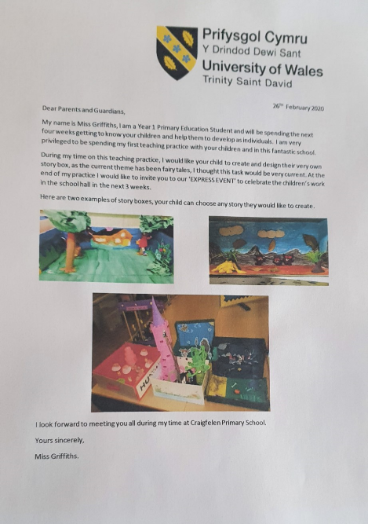

Appendix 6- Here are the story boxes the children created for the ‘Express Event’
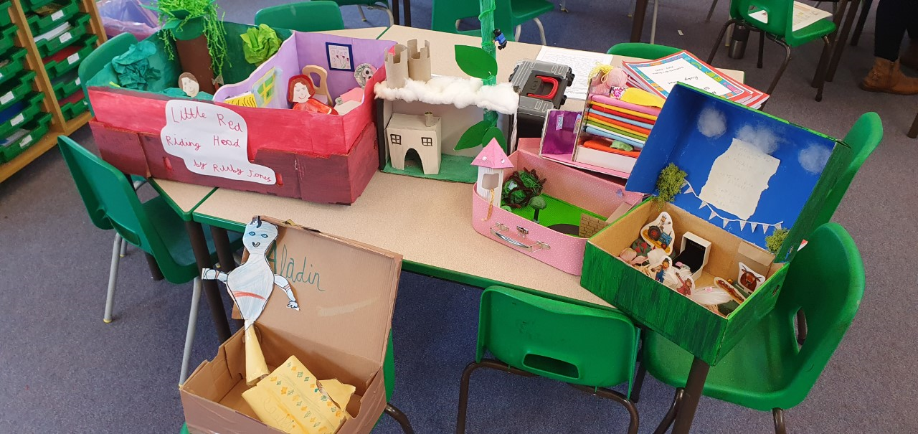
Source: My personal photograph.

Appendix 7- St Patrick’s Day planning
Here is the link to my St Patricks Day planning that I collaborated with a year 1 class teacher.
https://uowtsd-my.sharepoint.com/:f:/g/personal/1904882_student_uwtsd_ac_uk/EsrgD2mdO05OqNvZTzo57T0BLfl_1KaEZeHZHtCcSodcfA?e=tSMuI4

References

Barnes, J. (2011) Cross - Curricular Learning 3-14. 2nd edition. London: SAGE Publications Ltd.

Carter, R. (2012) methodologies for stylistic analysis : practice and pedagogies. Available at:
https://teach-grammar.com/wp-content/uploads/2012/07/2010+-Grammar-and-Stylistics.pdf (Accessed 24th March 2020)

Donaldson, G. (2015). Successful Futures: Independent Review of Curriculum and Assessment Arrangements in Wales. (Accessed 24th March 2020) Available at:
http://gov.wales/sites/default/files/publications/2018-03/successfull-futures.pdf

EWC (2019) Available at:
file:///C:/Users/clgri/AppData/Local/Packages/Microsoft._8wekyb3d8bbwe/TempState/Downloads/J16540%20EWC%20Code%20of%20Professional%20Conduct_E_Web%20(1).pdf (Accessed 25/03/2020)

Gray, C. and MacBlain, S. (2012). Learning Theories in Childhood. London: SAGE Publications Ltd.

Hattie, J. (2012) Visible Learning for Teachers. Maximizing impact on learning. Oxon: Routledge

Hirsh, B.D. et al (2012) Digital Humanities pedagogy: Practices, principles and politics. Cambridge: Open Book Publisher.

Impact Wales (2018) 12 pedagogical principles (Accessed 17th March 2020) Available at:
https://www.impact.wales/wp-content/uploads/2018/01/12-Pedagogical-Principles-1.pdf

Kingston, D. and Siraj, I. (2017) Supporting the Implementation of the Foundation Phase through Effective Professional Development (Accessed 20th March 2020) Available at : https://discovery.ucl.ac.uk/id/eprint/1536969/1/Siraj_00%20Corrected%2003KingstonSiraj_19_1%20(2)%20(1).pdf

Lynch, M. (2019) Pros and Cons of Cross-Curricular Teaching (Accessed 24th March 2020) Available at : https://www.theedadvocate.org/pros-and-cons-of-cross-curricular-teaching/

Moore, J. (2000) teaching and learning. Pedagogy, curriculum and culture. London: Routledge Falmer

Magicmaths.org, (2020) 10 Principles of assessment for Learning (Accessed 24th March 2020) Available at: http://www.magicalmaths.org/what-are-the-10-principles-of-assessment-for-learning-afl/

My Local School, (2019) Available at:
http://mylocalschool.gov.wales/School/6702215?lang=en (Accessed 13th March 2020)

OECD, (2017) Developing schools as learning organisations in Wales. Available at:
https://hwb.gov.wales/storage/3c7ac963-4059-4f15-bdf9-368b16c3ecf7/developing-schools-as-learning-organisations-in-waleshighlights_0.pdf (Accessed 10th March 2020)

OECD (2009) The PISA Report (Accessed 24th March 2020) Available at:
http://www.oecd.org/pisa/pisaproducts/46619703.pdf

OECD (2017) The Welsh Education Reform Journey (Accessed 20th March 2020) Available at : http://www.oecd.org/education/The-Welsh-Education-Reform-Journey.pdf

P4C (2020) Available at : www.philosophy4children.co.uk (Accessed 25th March 2020)

Pollard, A. (2010) Professionalism and Pedagogy: A Contemporary opportunity: a commentary by TLRP and GTCE. London: TLRP

Pound, L. (2005) How children learn. London: Step Forward Publishing Ltd.

Pound, L. (2009) How children learn 3 Contemporary thinking and theorists. London: Practical Pre-school Books.

Reynolds, D. (2008) New Labour, Education and Wales: The devolution decade. Oxford: Review of Education. https://doi.org/10.1080/03054980802519019

Royce Sadler, D. (1989) Formative assessment and the design of instructional systems. Instructional Science 18:(19-144)

School ‘X’ website, (2019) Available at: http://www.edunet.link/craigfelen/
(Accessed 17th March 2020)

The Telegraph (2011) How the national curriculum has evolved (Accessed 22nd March 2020) Available at:
https://www.telegraph.co.uk/.../8270189/How-the-national-curriculum-has-evolved.html

Welsh Government (2008) Learning and Teaching Pedagogy. Available at:
https://hwb.gov.wales/storage/8f0b360f-f1f6-4bec-b11a-df88168007f9/learning-and-teaching-pedagogy.pdf (Accessed 23rd March 2020)

Welsh Government (2015) The Foundation Phase Framework. (Accessed 20th March 2020) Available at: https://gov.wales/sites/default/files/publications/2018-02/foundation-phase-framework-revised-2015.pdf

UNCRC (2020) UN Convention on the rights of the child (Accessed 24th March 2020) Available at:
https://www.unicef.org.uk/what-we-do/un-convention-child-rights

