

LEVEL 4 ASSESSMENT SPECIFICATION
Student name: | Hamzah Hussain | Student ID number: | 1914401
Programme: | CertHE Computing Skills for Workplace
Module: | Introduction to Web and Database Concepts
Module code: | ACCA4023 | Contribution to Overall Module Assessment (%): | 50%
Lecturer: | Sadhana Jha, Shah Room | Internal Verifier: | Abida Perveen
Assignment Title: | Design and Implementation of a Relational Database System | Word count (or equivalent): | 2000
Submission deadline: | 09th July, 2026, 2:00PM | Return date of provisional marks & written feedback: | 14th -August-2026, 2:00PM

Table of Contents
1. Introduction 3
2. Scenario Analysis 4
2.1 Customer Entity 4
2.2 Vehicle Entity 4
2.3 Parking Site Entity 5
2.4 Parking Slot Entity 5
2.5 Booking Entity 6
2.6 Payment Entity 6
2.7 Relationships between Entities 7
3. Entity Relationship Diagram (ERD) 8
4. Data Structure Development 9
5. Normalisation Compliance 10
5.1 First Normal Form (1NF) 10
5.2 Second Normal Form (2NF) 10
5.3 Third Normal Form (3NF) 10
6. Sample Data Population 11
7. Query Development 13
8. Validation and Testing 15
9. Design Decisions and Reflection 16
10. Conclusion 17
References 19

Introduction
The use of database systems is necessary for modern companies since they allow storing, managing and retrieving data efficiently. When compared to manual record keeping, relational databases increase accuracy, reduce redundancy, ensure security and assist in making good decisions through queries and reporting. Access is an appropriate database for designing small and medium database applications as it provides features for designing tables, relationship, queries, forms and reports.
This report gives details about the design and implementation of AutoPark Management System that is a relational database designed to automate the process of managing parking operations. The database was created in order to automate manual processes that are currently being used to record customer information, vehicle information, parking sites, parking slots, bookings and payments. Using principles of relational database, such as primary key, foreign key and normalization to 3NF, the database can maintain data integrity and retrieve information efficiently. The report explains how the database was designed, implemented, tested and evaluated for efficient parking management.
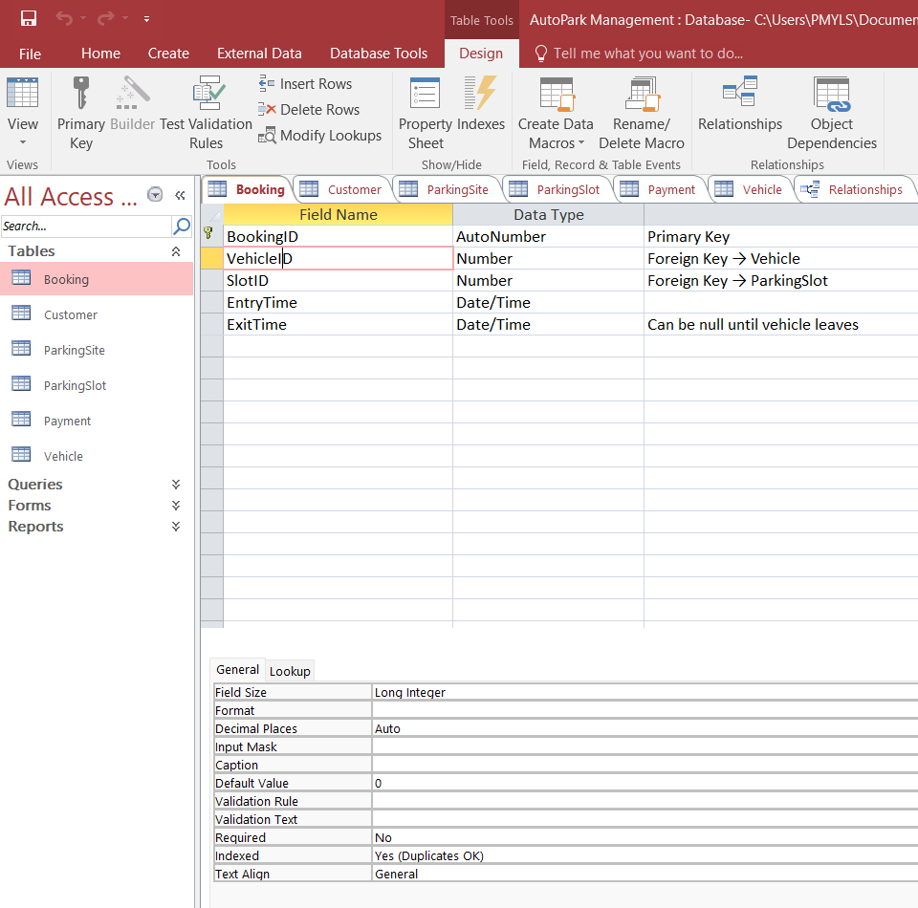
Figure 1: Microsoft Access Home Screen of the Completed AutoPark Management Database

Scenario Analysis
AutoPark Management System is developed to automate management of various parking sites where manual record keeping is substituted by relational database. The organization needs a central database system that would store information related to the customers, vehicles, parking sites, available slots, bookings, and payments. This will help the staff to manage the process of parking efficiently as well as improve data accuracy and avoid any kind of redundancies (Connolly and Begg, 2020).
Six major primary entities were identified during the analysis of the case scenario. They represent main processes performed in the organization. Every entity contains information related to particular process and links to other entities using primary and foreign keys.

2.1 Customer Entity
The Customer entity contains details about customers using the parking lots. Every customer has a unique ID known as the CustomerID, which is used as the primary key. Other properties include the customer's first name, last name, contact number, and email. The customer can have one or several registered vehicles and can make various bookings in the future.
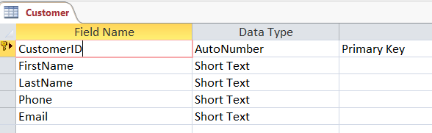
Figure 2: Customer Entity design view

2.2 Vehicle Entity
The Vehicle entity holds information about the registered vehicles. Every vehicle has a unique VehicleID along with other details such as the registration number, vehicle type, color, and CustomerID. In this case, every vehicle will belong to only one customer, hence the CustomerID becomes a foreign key to connect the Vehicle table to the Customer table. This will ensure that ownership details are not duplicated.
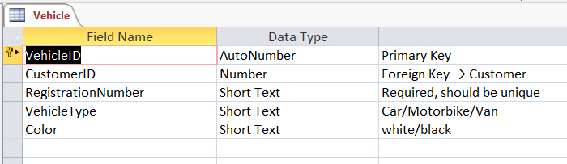
Figure 3: Vehicle Entity design view

2.3 Parking Site Entity
The Parking Site entity captures information regarding each individual parking lot belonging to the organization. The attributes in this entity are SiteID, SiteName, Location, and TotalSlots. A parking site can have many parking spaces in it and, therefore, there will be a one-to-many relationship between Parking Site and Parking Slot entities.
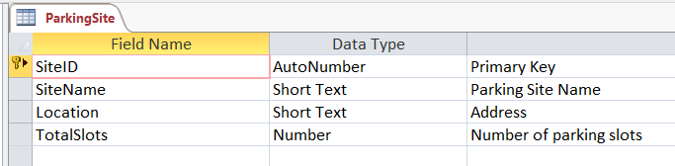
Figure 4: Parking site Entity design view

2.4 Parking Slot Entity
A parking site has a number of parking slots within it. The Parking Slot entity captures information such as SlotID, SiteID, Slot Number, SlotType, and Status (Available or Occupied). The SiteID will be the foreign key of the Parking Site entity. Separation of slot details gives the organization the advantage of knowing its availability in real-time.
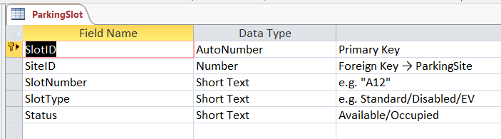
Figure 5: Parking slot design view

2.5 Booking Entity
The Booking entity consists of all the bookings or the parking of any car in the park lot. This entity has the fields such as BookingID, VehicleID, SlotID, Entry Time, and Exit Time. The Booking entity acts as a link between all the other entities and hence is the transactional entity.
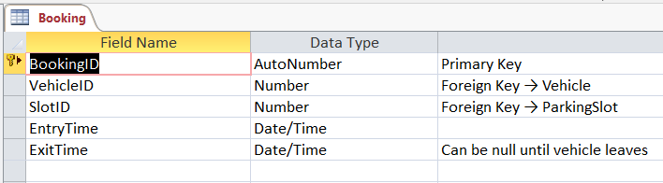
Figure 6: Booking design view

2.6 Payment Entity
The Payment entity includes all the monetary details associated with the booking. This entity has the fields such as PaymentID, BookingID, Payment Date, Payment Method, and Amount. The foreign key field of Booking ID helps in achieving referential integrity of all the data in the database.
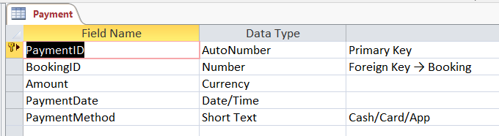
Figure 7: Payment design view

2.7 Relationships between Entities
The AutoPark Management System makes use of the Relational Database Model whereby tables are interconnected by the means of the Primary Keys and Foreign Keys to ensure integrity of the information and reduction of redundancy. There is a one-to-many (1:M) relationship between Customer and Vehicle, meaning that one Customer can register many Vehicles whereas each Vehicle is registered only to one Customer. The same 1:M relationship can be traced between ParkingSite and ParkingSlot, meaning that one ParkingSite contains many ParkingSlots. The ParkingSlot and Booking tables are also interconnected by a 1:M relationship, meaning that a ParkingSlot can be associated with many Bookings at different times while each Booking is associated with one Slot. In addition, there is a 1:M relationship between Vehicle and Booking, meaning that one Vehicle can have many Bookings. Finally, the Booking and Payment tables are interconnected by a 1:M relationship, meaning that each Payment is related to one Booking.
Table 1: Main Entities and Attributes
Entity | Primary Key | Important Attributes
Customer | CustomerID | CustomerID, customer's first name, last name, contact number, and email
Vehicle | VehicleID | CustomerID, registration number, vehicle type, color, and VehicleID
Parking Site | SiteID | SiteID, SiteName, Location, and TotalSlots
Parking Slot | SlotID | SlotID, SiteID, Slot Number, SlotType, and Status
Booking | BookingID | BookingID, VehicleID, SlotID, Entry Time, and Exit Time
Payment | PaymentID | PaymentID, BookingID, Payment Date, Payment Method, and Amount

Entity Relationship Diagram (ERD)
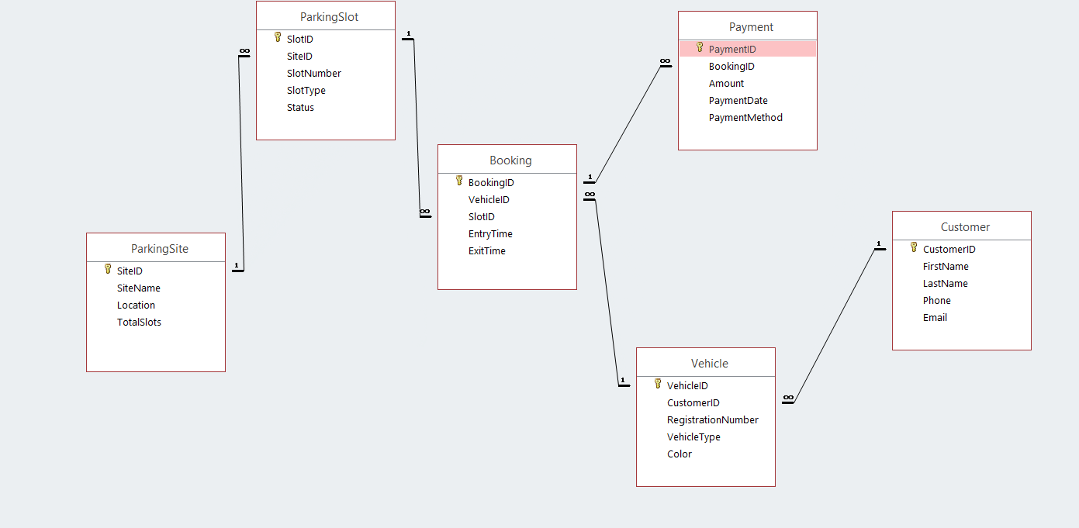
Figure 8: ERD diagram of Autopark management System
ERD shows the logical structure of Autopark Management System database. It represents entities, their attributes, primary keys, foreign keys and the relationship between entities along with cardinality.
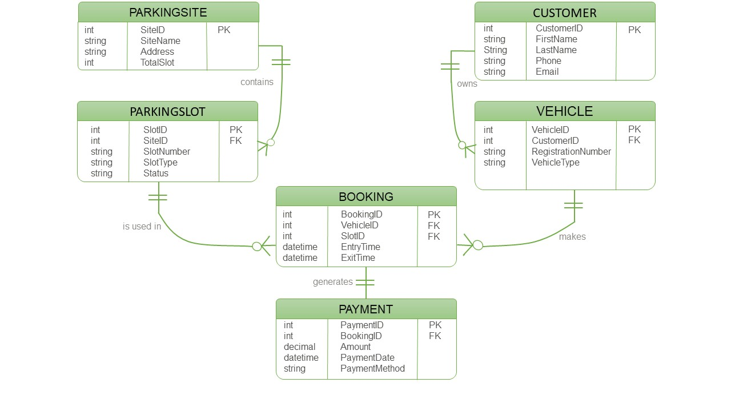
Figure 9: ERD diagram of Autopark management System (Crow's foot notation)

Data Structure Development
Data Structure of AutoPark Management System was created using Microsoft Access from the ERD. The database comprises six interrelated tables namely Customer, Vehicle, ParkingSite, ParkingSlot, Booking, and Payment. Each table has a unique primary key that identifies a record and foreign key to build a relationship between different entities. This data structure provides data integrity and removes redundant data and makes the process of data search effective (MS Access Database, 2016).
Customer Table stores personal information of all parking. CustomerID is the primary key of the table that uniquely identifies each customer in the database.
Vehicle Table contains all the information of the vehicles owned by the customers. In this table, VehicleID acts as the primary key while the CustomerID is the foreign key. This enables one client to have more than one car without entering the client information again.
The ParkingSite table stores information about parking sites.
The ParkingSlot table stores information about parking slots. It is necessary to separate slots from sites so that the availability of parking slots can be monitored.
The Booking table acts as the transaction table of the database. The foreign keys in the table include VehicleID and SlotID.
The Payment table captures financial transactions made on bookings.

Table 2: Database Structure
Table | Primary Key | Foreign Key | Purpose
Customer | CustomerID | — | Stores customer information
Vehicle | VehicleID | CustomerID | Stores vehicle details linked to customers
ParkingSite | SiteID | — | Stores parking site information
ParkingSlot | SlotID | SiteID | Stores parking slot details
Booking | BookingID | VehicleID, SlotID | Stores parking booking records
Payment | PaymentID | BookingID | Stores payment transactions

Normalisation Compliance
Normalization is the approach that is used in the design of the relational database in order to ensure that the data is stored efficiently through the reduction of redundant data and dependency on data that is not necessary. The primary objective is to enhance the efficiency of the database management system by ensuring integrity and avoidance of redundancy. The AutoPark Management System database has been normalized up to 3NF.

5.1 First Normal Form (1NF)
The database follows the First Normal Form criteria by ensuring that all tables consist of atomic data elements, each record of which is uniquely identified. There are no repeating columns or multiple data in a single column in the database. For example, the details of the customers such as first name, last name, phone number, and e-mail are stored in the Customer table. In the same way, vehicle number, parking slot, and mode of payment are stored separately in individual fields.

5.2 Second Normal Form (2NF)
The database adheres to the standards of Second Normal Form since there are no partial dependencies among the non-key attributes that depend on their individual primary keys. The database tables use single field primary keys to avoid any partial dependencies. Information about the customers will be recorded in the Customer table whereas information about vehicles will be recorded in the Vehicle table using CustomerID as the foreign key. In addition, information about the sites is kept separate from the parking slot information in order to avoid repetition of the same information in the slots.

5.3 Third Normal Form (3NF)
Further normalization of the database has been done to the Third Normal Form to eliminate transitive dependencies from the database. Each and every non-primary key field is solely dependent upon the primary key of that particular table only and not on any other non-primary key fields. In our case, the payment details are available in the Payment table itself through BookingID, and the customer details can be found indirectly through Vehicle Table instead of repeating in the booking details.
Table 3: Summary of the Normalisation Process:
Normal Form | Implementation in the AutoPark Management System
First Normal Form (1NF) | All attributes contain atomic values, and each table has a unique primary key.
Second Normal Form (2NF) | All non-key attributes depend entirely on the primary key, with no partial dependencies.
Third Normal Form (3NF) | Transitive dependencies have been removed, and each non-key attribute depends only on the primary key.

Figure 10: Crow's Foot ERD

Sample Data Population
In order to ensure that the AutoPark Management System functions properly, some data samples were added to all six database tables. There are at least five entries in each table that will imitate the actual process of parking, and all the tables will be related using the use of primary and foreign keys (Coronel and Morris, 2022).
The Customer and Vehicle tables contain data about the customers and the vehicles, respectively,
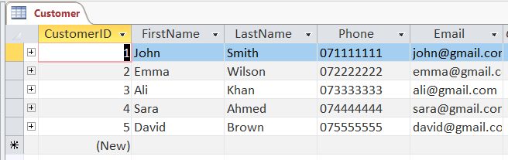
Figure 11: Data set view of Customer table

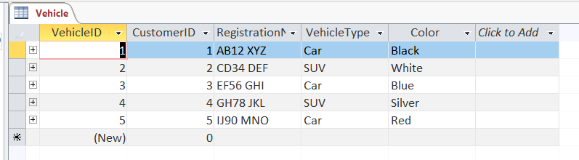
Figure 12: Data set view of Vehicle table
Whereas the ParkingSite and ParkingSlot tables contain data about the sites of parking and spots of parking, respectively.
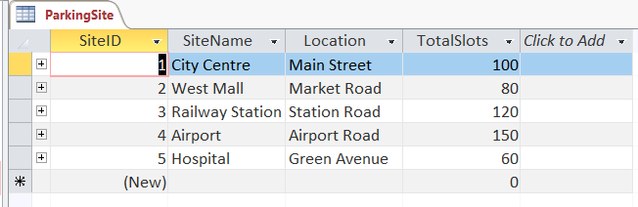
Figure 13: Data set view of ParkingSite table
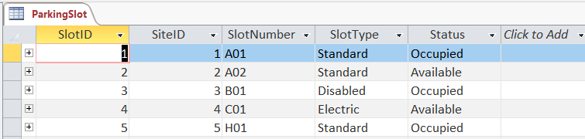
Figure 14: Data set view of ParkingSlot table
The Booking table contains information about booking.
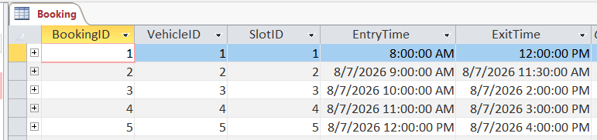
Figure 15: Data set view of booking table
The Payment table holds information about payments made.
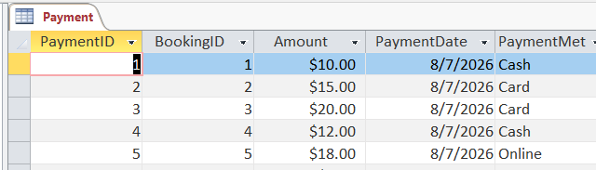
Figure 16: Data set view of Booking table
Table 4: Sample Data Summary:
Table | Number of Sample Records | Description
Customer | 5 | Customer personal information
Vehicle | 5 | Registered vehicles linked to customers
ParkingSite | 5 | Parking locations
ParkingSlot | 5 | Parking slot details and status
Booking | 5 | Parking booking records
Payment | 5 | Payment transactions

Query Development
Query is one of the important features of relational database systems since they help users to effectively extract, sort and analyze information. In the case of AutoPark Management System, Microsoft Access Queries were designed to offer useful information in regards to parking management. The queries help in the daily operations by showing parking availability, booking information, customer information and transactions made. Moreover, the queries assist the management in tracking down the usage and performance of the parking slots.
The Customer Vehicle Query brings together the Customer table and the Vehicle table to show customer information along with their vehicles. This enables the user to track the ownership of the vehicles and customer information easily.
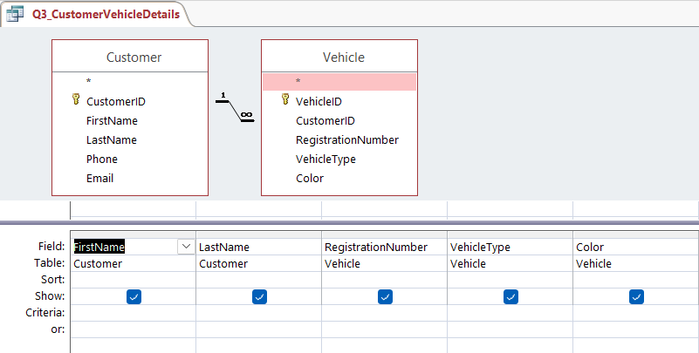
Figure 17: Customer Vehicle Query
The Parking Slot Availability Query extracts parking slots according to their availability. Through the query, the management is able to see whether the parking slots are available or taken up.

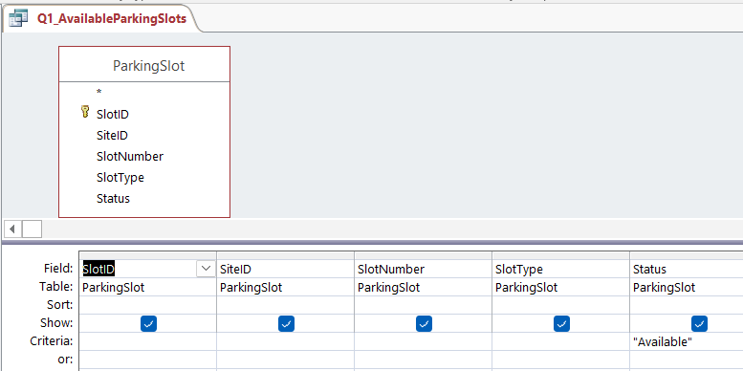
Figure 18: Parking Slot Availability Quer
Booking Details Query extracts the data from the Booking, Vehicle, and ParkingSlot table and presents complete information on the booking such as the registration of the vehicle, parking slot allocation, time of entry, and time of exit.
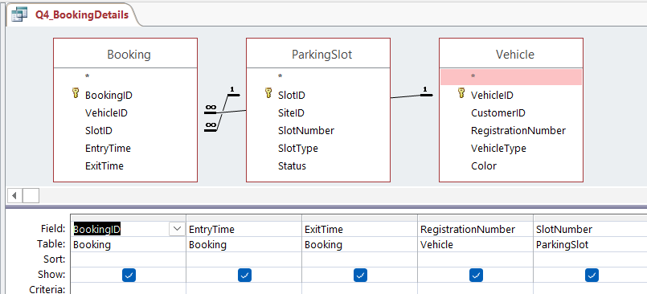
Figure 19: Booking Details Query
Payment Details Query relates the Payment and Booking tables to present the details of payments in terms of amount, date, and method for each individual booking. In this way, it is possible for staff to keep track of payments and ensure that there is an entry in the payment table for each booking.
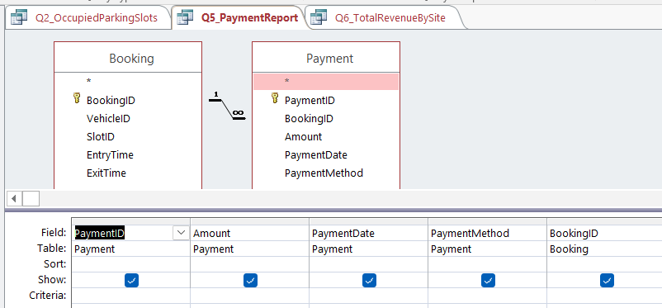
Figure 20: Booking Details Query

The last query is the Parking Site Summary Query which presents information from both ParkingSite and ParkingSlot table and displays the locations along with the number of parking slots at each location. It helps the management in tracking the capacity of parking space at various sites.

Successful execution of the above queries proves that relational database has been implemented properly. The data extraction from multiple tables confirms the correctness of relationships between different entities.

Validation and Testing
Testing and validation were done to ensure that the AutoPark Management System is able to meet the required functional requirements and runs effectively. Database testing was done through the use of samples to confirm the relationships between tables, data integrity, performance of queries, and accuracy of data entry and extraction. The relationships between the tables were ensured such that each vehicle belongs to a particular customer, each parking slot belongs to an existing parking site and that each payment corresponds to an existing booking. In Microsoft Access, referential integrity was ensured to prevent any invalid or orphan records from entering into the database. Queries were run successfully to give accurate results on the details of customers, vehicles, parking slot information, bookings, and payments. Data validation was done to ensure that the field properties, primary keys and foreign keys ensure data integrity. In general, the testing process showed that the database is working properly, can provide efficient parking management, and provides accurate, secure, and reliable data management.
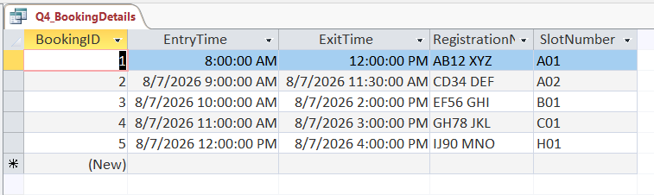
Figure 21: Booking Details Query

Design Decisions and Reflection

The AutoPark Management System was developed according to the rules of relational database and provides an efficient and reliable database for parking operation management. It comprises six tables: Customer, Vehicle, ParkingSite, ParkingSlot, Booking, and Payment which are linked to each other through primary and foreign keys. By splitting data into separate tables, we can achieve Third Normal Form (3NF) which will allow us to manage the database efficiently and make changes to it easily. The major problem in the course of the work was the establishment of correct relationships between tables and correct referencing foreign keys to primary keys. We solved this problem by developing the Entity Relationship Diagram (ERD) and testing database relationships. Now we have an efficient database for customer management, vehicle registration, booking and payments. Further improvements could be made in the form of creating forms for users and automated reporting of the occupancy and income of the parking site (Hernandez, 2020).
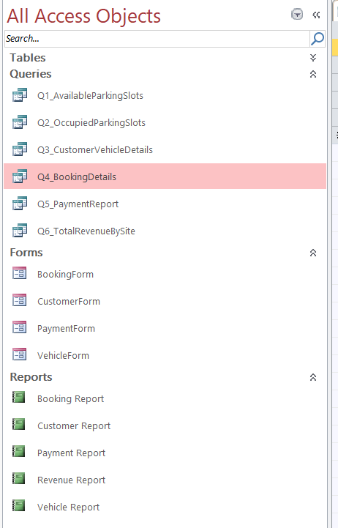
Figure 22:

Conclusion
In fact, the AutoPark Management System has shown the successful use of the basic concepts of designing the relational database for automating the processes of parking management. Using the developed Microsoft Access database allows structuring the process of managing customers, vehicles, parking areas, parking lots, bookings and payments by means of six interconnected tables. Using the concept of primary and foreign keys along with the normalization of the database up to Third Normal Form (3NF) allows minimizing the data redundancy without losing the integrity and consistency of the database. The creation of relevant queries helps to get the needed operational data quickly, which is important for making the right decisions and improving parking management. The validation and testing of the database showed that the database satisfies all the requirements and functions properly. Even though the database performs all the needed actions, there can be some improvements in the future like the creation of more friendly forms and reports as well as providing advanced security for the database. On the whole, the developed database is a good solution to handling parking processes in the AutoPark Management System.

References
MS Access Database Objects Explained, Available at: https://www.scribd.com/document/960186168/Group-6-Assignment [Accessed: 7-Jul-2026].
T. Connolly and C. Begg, Database Systems A Practical A - Thomas Connolly, 7th ed. Harlow, UK: Pearson, 2020.
[2] C. Coronel and S. Morris, Database Systems: Design, Implementation, and Management, 19th ed. Boston, MA, USA: Cengage Learning, 2022.
[3] M. Hernandez, Database Design for Mere Mortals, 4th ed. Boston, MA, USA: Addison-Wesley, 2020.
[4] Microsoft, "Create a database in Access," Microsoft Support. Available: https://www.oracle.com/database/what-is-a-relational-database [Accessed: 7-Jul-2026].
[5] Oracle, "What Is a Relational Database?" Available: https://www.oracle.com/database/what-is-a-relational-database/ [Accessed: 7-Jul-2026].

