Network Programmability:

The increased emphasis on software and the shift towards cloud computing in the field of computer networks.

Joseph Evans

University of Wales Trinity St David, Swansea, Wales

2216851@student.uwtsd.ac.uk

Introduction
In a drive for increased efficiency led by a move towards greater automation within the IT industry as a whole, the field of computer networks has undergone significant change over recent years, particularly in its transition towards cloud computing. The implementation of cloud computing paradigms has been widespread throughout the industry with the scalability and efficiency of cloud technology proving unparalleled by on-premises networks; as well as the cost saving opportunities presented by offloading on premises server and networking hardware to cloud providers, along with the responsibility of maintaining data integrity and security.
However, the advancement of cloud computing has led to changes in the core job role of network engineers, as well as adaptations in the key workflow of computer networking teams. In addition to scripting, network teams now require additional programming skills to leverage REST APIs within software defined networks (SDNs) to deploy configurations and retrieve network data. The modern network engineer requires an ever-increasing set of skills that lean in towards the DevOps branch, such as programming, working with cloud platforms like Azure and AWS, and building and managing virtual network environments. Whilst these changes are likely to prompt some disruption to network engineers and IT departments as they upskill to meet new demands, the boost to network efficiency and the speed at which patches, upgrades and installations can be rolled out will provided great long-term benefits. In theory, network engineers could configure an entire network of machines without needing to physically touch devices on site or even establishing a remote connection – the patches can instead be pushed out remotely using technology such as Ansible to deploy JSON payloads containing configuration data. These progressions to the computer networks workflow combined with the emergence of cloud ‘as a service’ products have created a dynamic industry environment, in which many long-standing network engineers may find themselves needing to adapt to new technologies and working practices.
Cloud Computing Paradigms
Cloud Computing as a term encapsulates many paradigms of cloud technology. Generally, each branch of cloud technology carries similar benefits to the modern enterprise – it’s often cheaper, offers greater scalability, and reduces a company’s workload by shifting responsibility for maintaining hardware or securing data to the cloud provider [1].
Software-as-a-Service (SaaS) products like Microsoft 365, G-suite and Salesforce have become hugely popular due in part to their ease of deployment and convenience. They’re usable as web-based products accessed through the browser that do not need to store data locally, instead keeping everything in the cloud, allowing them to be accessible from almost any device and performing well regardless of specification due to minimum hardware requirements. These SaaS solutions are also more scalable than traditional solutions. They allow for more users to be added at any time with the purchase of more licenses, and for storage capacity to be easily increased as required, allowing cost savings compared to purchasing large amounts of physical on-premises storage that will require maintenance and backups. As mentioned earlier, the responsibility for this data storage is on the cloud provider, meaning less workload and cost for the enterprise.
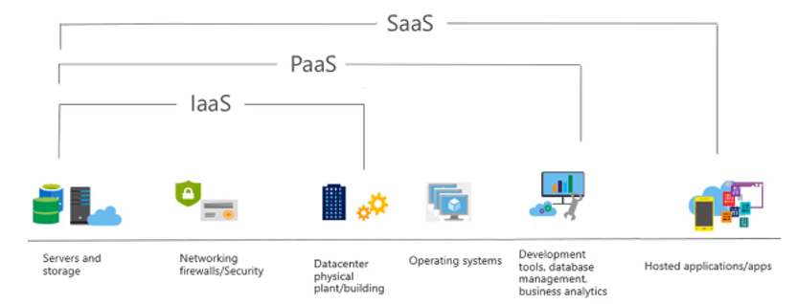
As the above diagram depicts [2], another model under the SaaS umbrella that enterprises can leverage are Infrastructure-as-a-Service (IaaS) models. Platforms such as Microsoft Azure and Amazon Web Services (AWS) offer IaaS capabilities for a subscription fee, once again allowing for potential cost saving due to the lack of hardware requirements, and painless dynamic scalability. These IaaS models provide the ability to spin virtual servers, utilise storage, and configure network devices in a virtual or cloud-based environment which engineers can administer via a graphical user interface [3]. This allows for remote policy and configuration changes, and less time spent configuring network hardware devices on site. It also allows for cost savings as no physical space is required for on-site devices such as servers, firewalls, and load balancers, meaning lower expenditure on electricity and cooling, as well as no cost of resources being spent on maintenance and failovers. The IaaS paradigm essentially allows for complete control and flexibility with regards to network configuration remotely whilst shifting all responsibility for hardware maintenance and data security to the cloud provider. Additionally, this model provides the ability to scale the up or down as required at a fraction of the price of purchasing additional on premises machines to accommodate potential higher traffic.
Sitting somewhere between the two aforementioned models are Platform-as-a-Service (PaaS) models. Examples of such as Microsoft Azure and Google App Engine, PaaS is primary utilized by DevOps engineers to test and deploy applications and offers a similar service to IaaS in that cloud resources such as servers can be spun, but without the actual networking backend. Instead, PaaS offers an environment to develop, test and deploy APIs and resources on virtual machines, with a GUI to manage development in a shared environment [4].
Alongside the IaaS model covering the virtual network devices, there are also Virtual Desktop Infrastructure (VDI) and Desktop-as-a-Service (DaaS) models available that spin up and host virtual client machines, again reducing the need for the up-front investment in physical machines and providing opportunities for seamless remote working. VDIs allow an enterprise to host virtual machines on on-premises or cloud servers, with an internally distributed image and configuration policy on each client, an advantage of this is that a client VM configured on an internal VLAN can offer similar use case to a VPN tunnel for remote working, allowing the remote user to access on site resources like intranet once authenticated and logged into the VM. VDI environments offer total control to the network engineers over the configuration and build of VMs, this being the key difference between VDI and DaaS client infrastructure. DaaS is a very similar concept to a VDI environment, but the cloud vendor hosts the client VMs themselves and also manages configuration such as the build image applied to clients as well as load balancing and other network tasks [5]. The benefit of DaaS over VDI for some enterprises would be that it is a more scalable model, often priced as one license per machine, which could also help to keep costs at a minimum compared to the VDI model which offers more control but at more cost, plus the upfront cost of hardware in addition to maintenance and electricity costs associated with hosting on premises.
Infrastructure-as-Code (IaC) principles can optimise workflow toward automation in any kind of network, although in tandem with cloud-based infrastructure provides a platform for optimum automation and efficiency. Infrastructure-as-Code utilises software development practices to automate the provisioning and configuration of network devices [6]. In order to remove the tedious and repetitive task of device configuration, Application Programming Interfaces (APIs) can be used to automatically apply configurations to network devices remotely. This is handled by tools such as Ansible and Chef which leverage JSON to deploy modules to devices in order to apply configuration or installations. These configuration management tools can also integrate with SDN controllers in software defined networks to retrieve network information and establish orchestration.
Software Defined Networking & REST APIs
Software Defined Networking (SDN) separates the control plane from the data plane of the network, instead having a central SDN controller that controls devices on the data plane. This allows administrators to control the network via the graphical interface of the SDN controller, giving them a view of network topology and monitoring capabilities as well as the ability to centrally apply configuration to network devices. SDN offers flexibility to network engineers by allowing them to configure the network and manage capacity centrally; in theory SDN also offers greater security due to its monitoring capabilities, however with one central point of control it is vital that access is secure as it’s a potential network vulnerability [7].
In order to control devices on the data plane of the network, the SDN controller uses Application Programming Interfaces (APIs). APIs serve as a vehicle of communication between the SDN controller and other devices, allowing the controller to both push out configurations and retrieve monitoring data. To maximise interoperability, the vast majority of APIs used in SDNs and the web are RESTful APIs; these are stateless APIs that use HTTP operations to interact with resources. Being of a stateless architecture, RESTful APIs keep no data on the client between requests, and receive all relevant data needed to compute the request every time [8]. This, along with its simplicity and interoperability with other systems is why RESTful APIs are so widely used in industry. To communicate with a device on the network, the SDN controller will send a HTTP request to the API, which then points to the relevant location by following its Universal Resource Indicator (URI).
If a network engineer needs to push a configuration to a device on SDN, they would send a HTTP PUT request to the API with a JSON payload containing the configuration data. JSON, like REST for APIs has become a standard for interoperability reasons, along with being an easy format to work with being both machine and human readable. Once the HTTP request is sent, the API will PUT to the device and the configuration will be changed to the contents of the JSON payload. A HTTP code will then be sent back to the client to state the status of the request – the below diagram visualises the process [9].
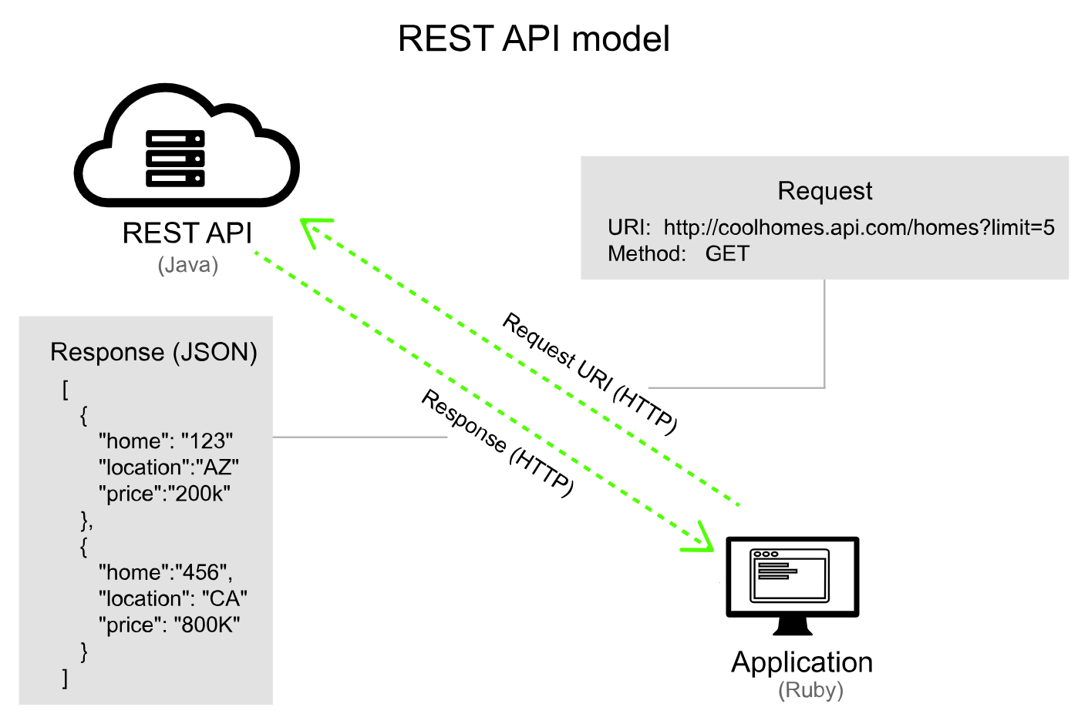
Fig 2. General model of a REST API
Configuration management tools such as Ansible, Puppet and Chef allow the configuration of devices to be implemented more efficiently and on a large scale. These tools allow the administrator to store commands as modules which act in the same manner as scripts. A module that runs certain install commands can be pushed out to the entire network with one user request to the API. This level of efficiency is far superior to what is possible with a traditional on premises physical network, hence why software defined networks have become so popular in industry, resulting in network engineers requiring to adapt their skills to utilize infrastructure as code. Some network engineers would argue that the new set of skills that they’re expected to develop are closer to DevOps than the traditional networking role – however the benefits of the cloud are so compelling to business that engineers will have little choice but to adapt. In comparison to a traditional on-premises network, an IaaS software defined network utilizing Ansible for configuration management at scale is efficient beyond comparison. This in addition to the potential cost savings due to a lack of need for on-premises servers and network hardware, as well as the shifting of responsibilities regarding data security and backup solutions to the cloud provider, makes the cloud IaaS SDN network an increasingly attractive proposition to any enterprise.
Conclusion
It is clear that advancements in cloud technology and the field of cloud computing have opened the door to new forms of computer networks that offer huge benefits over the established on-premises infrastructure, not only in terms of efficiency and performance but also in cost saving which is a huge consideration for any company weighing up their IT budget. Software-as-a-Service structures allow companies to invest in web-based application suites for their users at a lower price than traditional device-based licensing, whilst also being able to take advantage of cloud storage allocations as well as the reduced workload of the responsibility to securely store data, instead shifting that responsibility to the cloud provider. This in addition to the scalability and flexibility of the model rounds off an attractive package. This principle also applies to the PaaS and IaaS, offering an entire cloud infrastructure as a pay-as-you-go service saving the customer the substantial upfront cost of network hardware.
With many workplaces opting to remain with a remote or hybrid working model post-pandemic, its likely that more organisations will opt for cloud infrastructure going forward, harnessing IaaS and DaaS or VDI environments due to the falling requirements for client desktops in the workplace. Some of the potential drawbacks around these models include the relative lack of control over the network due to hardware being remotely sourced, the reliance on the could provider for service, as well as susceptibility to provider price increases which could unexpectedly raise operating costs. As a whole, platforms such as Microsoft Azure and Amazon Web Services are widely used throughout industry and offer developers as well as network administrators a wide array of tools to remotely develop, test and deploy applications and configurations whilst keeping everything contained in a central graphical interface for ease of use.
RESTful APIs have allowed the transition to an automated cloud-based infrastructure to take place. The ability to configure, monitor and carry out installations on devices remotely, and to target potentially hundreds of devices at once with a JSON payload is a huge efficiency upgrade to the tedious CLI method. RESTful APIs along with the JSON format are both largely interoperable and their language is accessible to read by humans. These use cases coupled with the ease of centralised control delivered by software-controlled networking present great opportunities for automation and orchestration. Going forward, it is reasonable to assume that that SDNs will make up a large proportion of networking infrastructure; SDNs will likely change the way network teams think about managing infrastructure, configuring from a centralised controller rather than on individual devices.
As a network engineer, it would be prudent to develop the skills surrounding software defined networks and APIs, and potentially leaning into DevOps skills in general as the computer networks field continues to move ever closer to the cloud. Whilst there may be disruption to network professionals in learning new skills and workflows, the temporary disturbance will lead to long term productivity and efficiency increases as well as a reduction in operating costs, resulting is businesses shifting to these models despite the adaptation required by network engineers and the changes to their job roles.

Bibliography
[1] J. Shayan, A. Azarnik, S. Chuprat, S. Karamizadeh, and M. Alizadeh, “Identifying Benefits and Risks Associated with Utilizing Cloud Computing,” The International Journal of Soft Computing and Software Engineering, vol. 3, Mar. 2013,
arXiv:1401.5155
[2] A. Jain, SaaS, Pass and IaaS. 2021. Accessed: Dec. 12, 2023. [Online]. Available: https://technoname.com/index.php/2021/02/22/what-is-cloud-computing-everything-you-need-to-know-is-explained/
[3] D. Rani and R. Ranjan, “A Comparative Study of SaaS, PaaS and IaaS in Cloud Computing,” International Journal of Advanced Research in Computer Science and Software Engineering, vol. 4, no. 6, Jun. 2014, Accessed: Dec. 10, 2023. [Online]. Available: https://www.academia.edu/29455291/A_Comparative_Study_of_SaaS_PaaS_and_IaaS_in_Cloud_Computing
[4] IBM, “IaaS vs. PaaS vs. SaaS | IBM,” www.ibm.com, 2023. https://www.ibm.com/topics/iaas-paas-saas
[5] N. Deo, “VDI vs. DaaS: Which is better for your virtual desktop and app environment?,” VMware End-User Computing Blog, Sep. 22, 2022. https://blogs.vmware.com/euc/2022/09/vdi-vs-daas-which-is-better-for-your-virtual-desktop-and-app-environment.html
[6] S. Achar, “Enterprise SaaS Workloads on New-Generation Infrastructure-as-Code (IaC) on Multi-Cloud Platforms”, Global Disclosure of Economics and Business, vol. 10, no. 2, pp. 55–74, Jul. 2021, doi: 10.18034/gdeb.v10i2.652.
[7] VMWare, “What is Software-Defined Networking (SDN)? | VMware Glossary,” VMware, Aug. 09, 2022. https://www.vmware.com/uk/topics/glossary/content/software-defined-networking.html
[8] “What is RESTful API? - RESTful API Explained - AWS,” Amazon Web Services, Inc. https://aws.amazon.com/what-is/restful-api/#:~:text=Statelessness (accessed Dec. 11, 2023).
[9] General model of a REST API. 2020. Accessed: Dec. 13, 2023. [Online]. Available: https://idratherbewriting.com/learnapidoc/docapis_what_is_a_rest_api.html

