
CertHE Computing Skills for Workplace
Computer Architecture and Operating Systems
ACCA4022_LON
Anum Paracha (Lecturer)
University of Wales Trinity Saint David (London Campus)
Student Name: Gamze Sertkaya
Student Number: 2529589
Group: 03
Date: 12.08.2026

Table of Contents
1. Introduction 1
2. Key functions of general Operating Systems 1
2.1 Process and Processor Management 1
2.2 Memory Management 2
2.3 File System Management 2
2.4 Device and Network Management 3
2.5 Security and User Management 3
3. Use of Windows OS CLI commands. 3
4. Use of Linux OS CLI commands. 8
5. Use of Windows OS Scripts. 12
5.1 Windows OS Script 1 12
5.2 Windows OS Script 2 14
6. Use of Linux OS scripts. 15
6.1 Linux OS Script 1 15
6.2 Linux OS Script 2 16
7. Conclusion 17
8. References 18
9. Appendices 19
9.1 Appendix 3 – Online Certified Course Evidence 19

Introduction
This report explores the main functions and practical use of general-purpose operating systems, focusing on Windows, Linux and macOS. It examines key OS functions such as process management, memory management, file and directory management, networking, user management and security. Practical activities are also included to demonstrate the use of PowerShell commands in Windows and Bash commands in Linux. Screenshots are provided as evidence to show how different operating system functions can be monitored and managed through graphical and command-line interfaces.

Key functions of general Operating Systems
An operating system (OS) is essential system software that provides an interface between computer hardware, application software and the user. General-purpose operating systems such as Microsoft Windows, Linux and Apple macOS perform several important functions to ensure that computer resources are used efficiently, securely and reliably. Although these operating systems have different interfaces and architectures, they provide similar core services, including process management, memory management, file management, device management, networking and security.

Process and Processor Management

One of the main responsibilities of an operating system is process management. A process is a running program, and the operating system controls how CPU resources are allocated between different processes. In Windows, Task Manager allows users to view running applications and background processes, together with their CPU, memory, disk and network usage [1]. Processes can also be terminated when an application becomes unresponsive.
Linux provides similar functionality through command-line tools such as ps and top. The top command provides a real-time view of running processes and system resource usage. macOS provides Activity Monitor, which allows users to monitor processes, CPU usage and other system activities. Apple explains that Activity Monitor can display information about individual processes, including their CPU time and memory consumption [2].

Memory Management

Operating systems are also responsible for managing Random Access Memory (RAM). Memory management determines how much memory is allocated to applications and system processes. Windows provides memory information through Task Manager, particularly within the Performance section. Microsoft provides documentation describing how Windows exposes memory performance information and allows memory usage to be monitored [3].
Linux uses a memory management subsystem that supports virtual memory, memory allocation and demand paging. The Linux Kernel documentation explains that the memory-management subsystem is responsible for managing physical and virtual memory resources [4]. Commands such as free -h can be used to display available and used memory.
In macOS, Activity Monitor provides a dedicated Memory section that displays information such as memory pressure, physical memory and swap usage. This allows users to identify applications and processes that are consuming large amounts of memory [5].

File System Management

File management is another fundamental operating-system function. Windows provides File Explorer for creating, organising, moving and deleting files and folders. Linux provides graphical file managers as well as command-line utilities such as ls, cd, mkdir and df. macOS provides Finder for similar file-management activities. These functions allow users and applications to access and organise data stored on secondary storage devices.
Operating systems therefore provide both graphical interfaces and command-line tools for managing files and storage resources. The availability of command-line utilities is particularly important in Linux because many administrative and system-management tasks can be performed directly through the terminal.

Device and Network Management

Operating systems also manage hardware devices such as keyboards, displays, storage devices and network adapters. Windows provides tools such as Device Manager and Network Settings to view and configure hardware and network components. Linux can use commands such as ip addr to inspect network interfaces, while macOS provides System Information and Network settings for monitoring connected hardware and network configurations.
Networking is an important operating-system responsibility because modern computers need to communicate with other devices and networks. Windows provides built-in networking functionality and security features, including Windows Firewall, to help manage and protect network communications [6].

Security and User Management

Security is a key function of modern operating systems. Windows provides authentication, user permissions, Windows Security and firewall functionality. Microsoft describes access control as a security mechanism that determines which authenticated users and computers can access resources [7].
Linux uses users, groups and file permissions to control access to files and system resources. Commands such as whoami, id and ls -l can be used to identify the current user and examine file permissions. Similarly, macOS provides user accounts, permissions and integrated security mechanisms to protect system resources and user data.

Use of Windows OS CLI commands.
- tasklist, displays the processes currently running on the Windows operating system. The /v switch means verbose mode, which provides additional information about each process, such as the Process ID (PID), session name, session number, memory usage, and status.
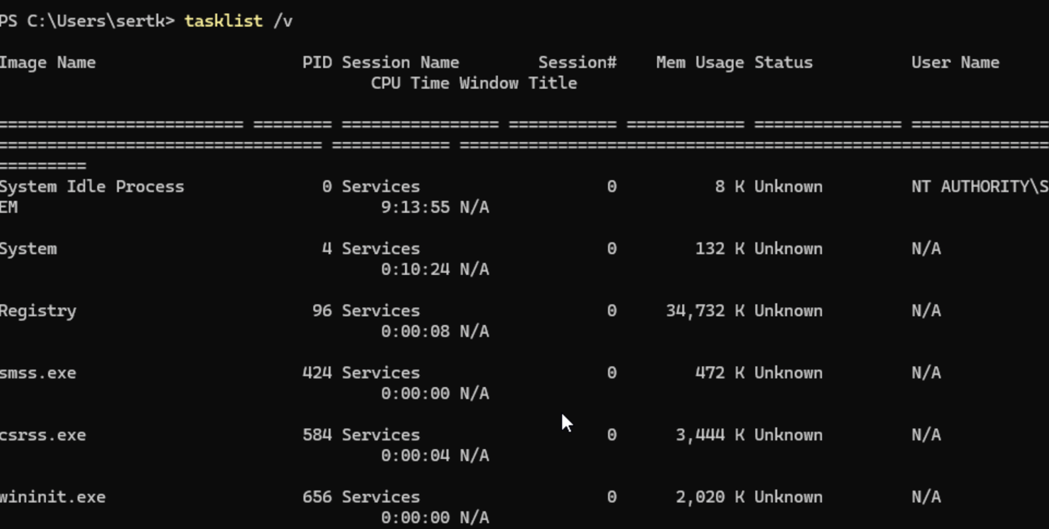

- taskkill, command is used to terminate a running process. The /PID option identifies the specific process using its Process ID, while the /F switch forces the selected process to terminate. In this example, Notepad was used as a safe test process.
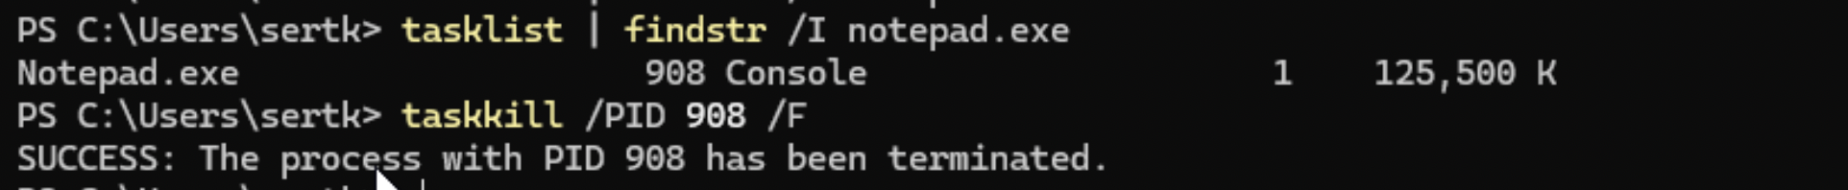

- The mkdir command was used to create new directories named CLI_Assignment, Documents, and Backup. This demonstrates how directories can be created and organised directly from the command line.
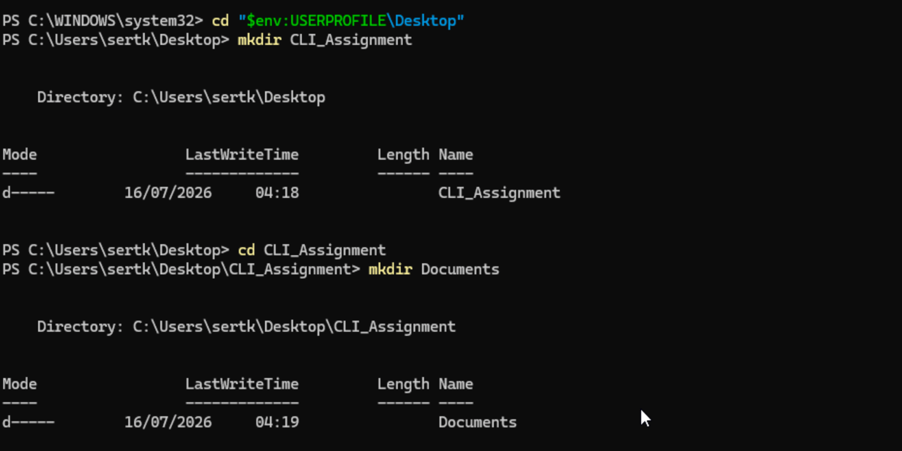
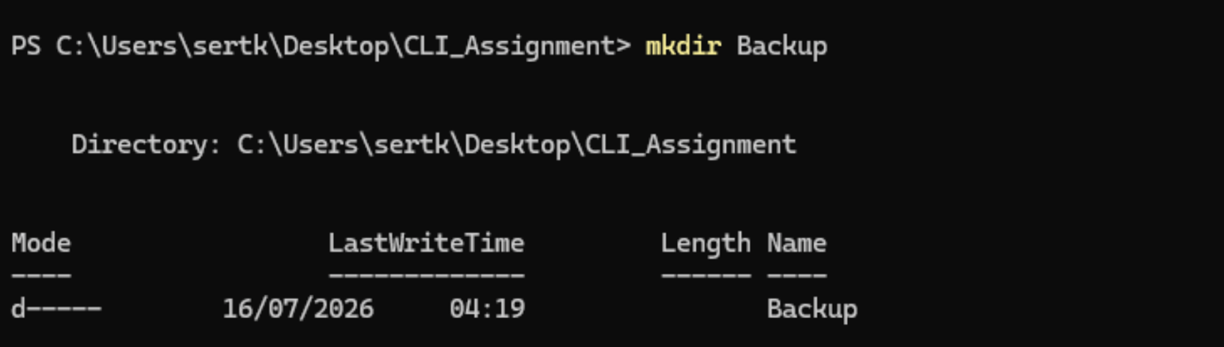

- The echo command was used to create a text file containing a short test message. The output redirection operator (>) was used to save the text directly into the specified file.
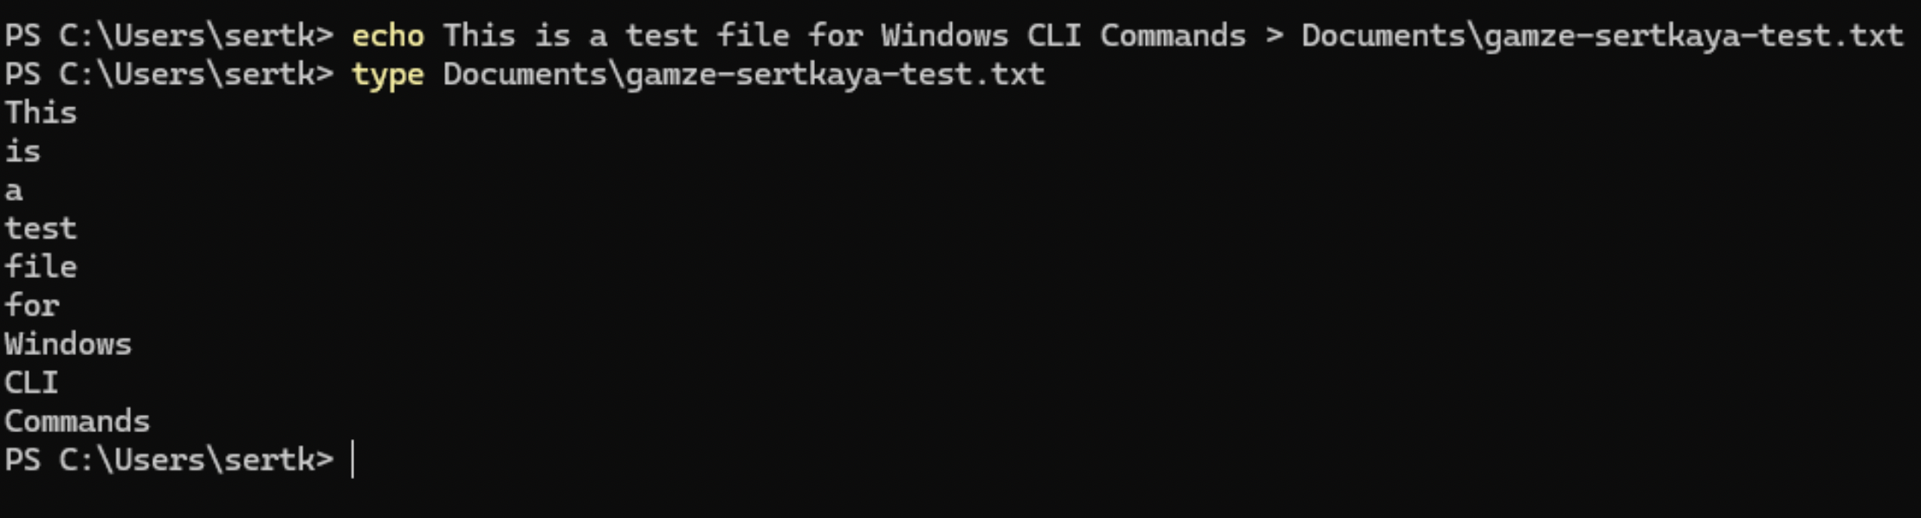

- The type command was used to display the contents of the created text file directly in the command-line interface. This provides a simple way to inspect the contents of a text file without opening a graphical text editor.
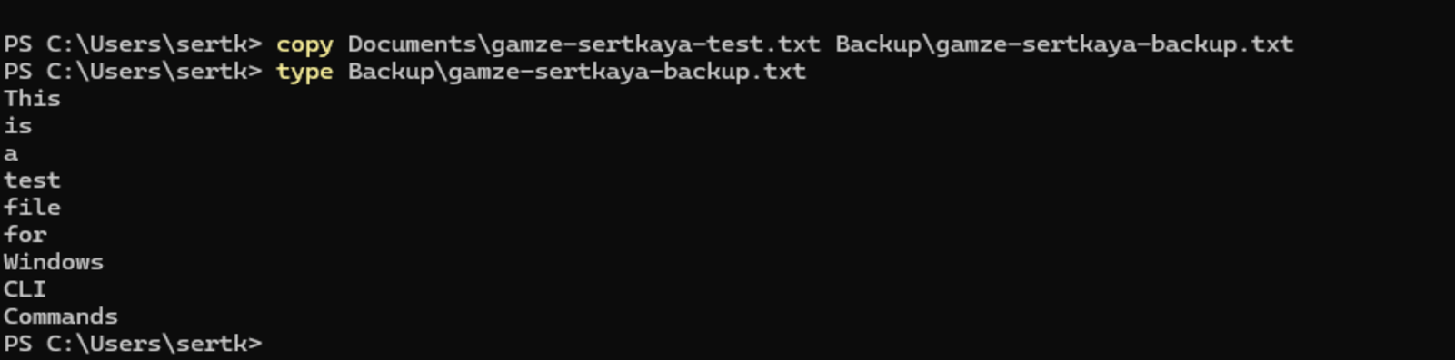

- The ipconfig command is used to display and manage the IP configuration of a Windows computer. The /all switch provides detailed information about network adapters, including the IPv4 address, default gateway, DNS servers, DHCP configuration and physical address. This command is useful for identifying network configuration problems.
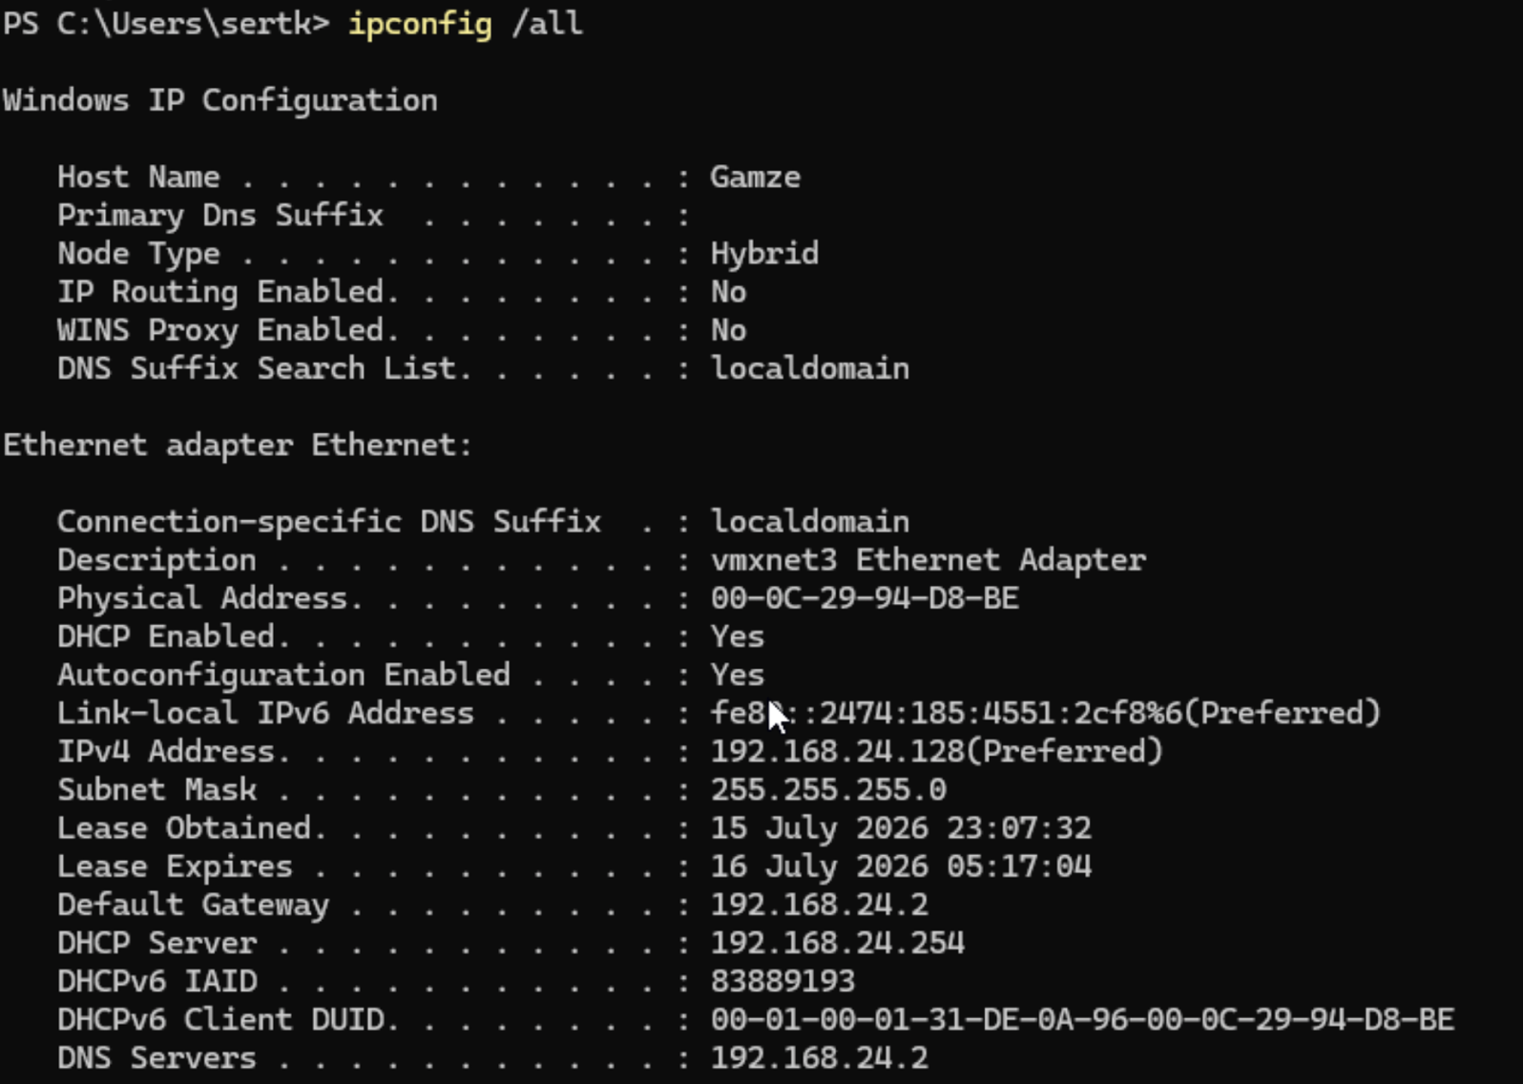

- The ping command is used to test connectivity between the local computer and a remote network device. The -n 4 option specifies that four ICMP echo requests should be sent. The response times and packet-loss statistics can be used to determine whether the destination is reachable and whether network communication is stable.
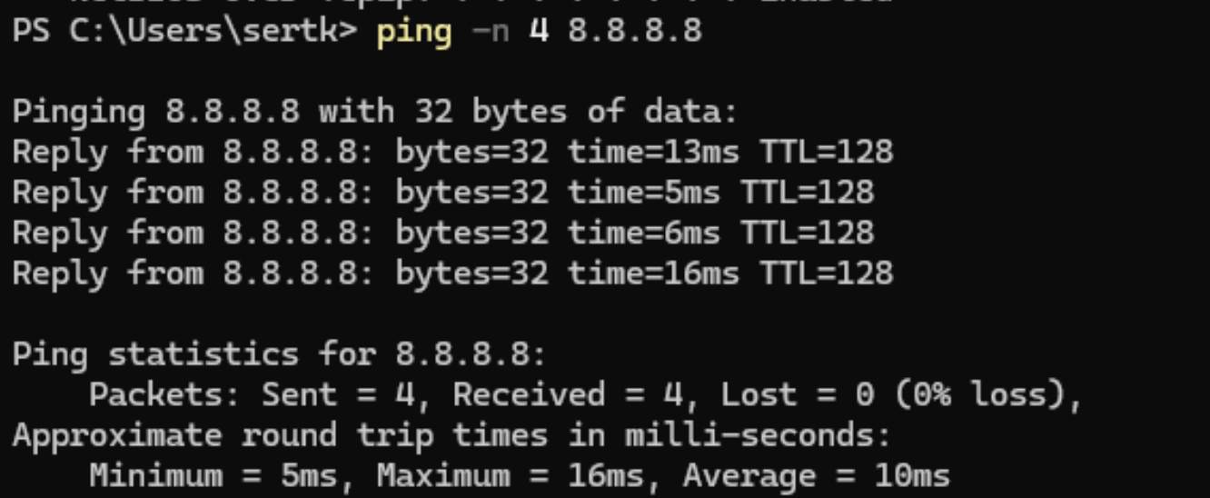

- The tracert command is used to identify the path taken by network packets from the local computer to a specified destination. It displays each network hop along the route and provides response times for the individual hops. This can help identify where delays or connectivity problems occur within a network.
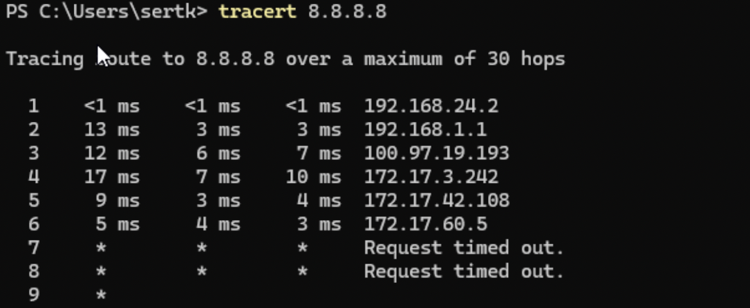

- The whoami command is used to identify the currently logged-in user account. The /user option provides additional information by displaying the user's Security Identifier (SID). This command can be useful for verifying the current account and its security identity when managing user permissions and system resources.
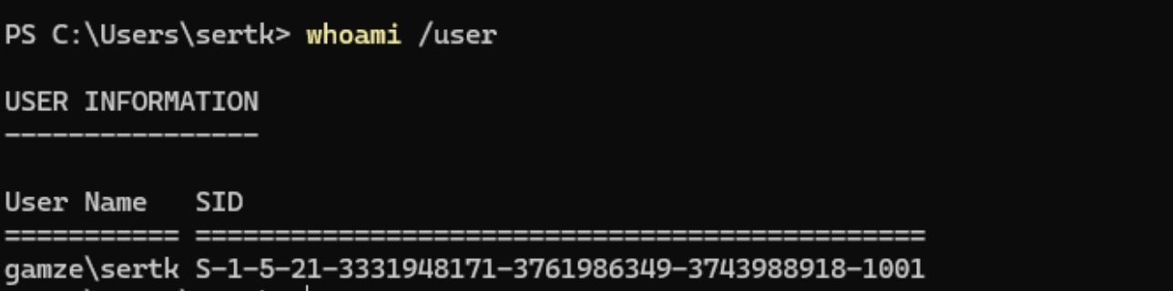

- The net user command is used to display and manage user accounts on a Windows computer. When used without specifying a username, it displays the user accounts available on the local system. A specific username can also be provided to display detailed information about that account. This command demonstrates how user account management can be performed through the Windows command line.
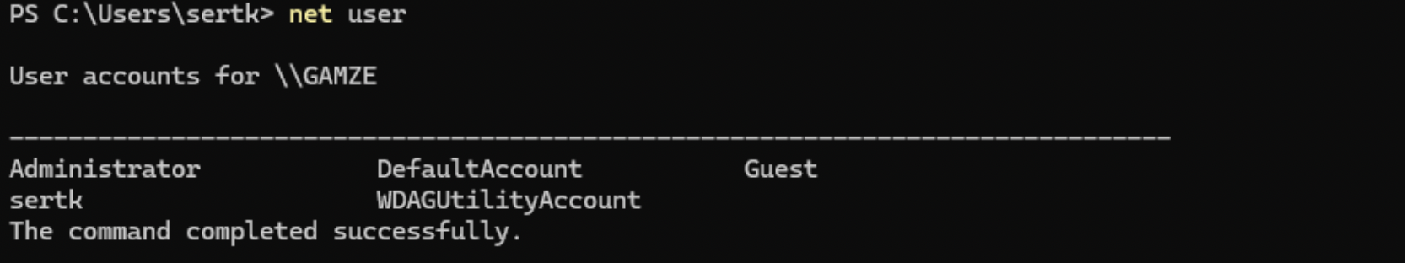

- The schtasks command is used to view and manage scheduled tasks in Windows. The /query option retrieves information about existing scheduled tasks, while /fo LIST specifies a detailed list format for the output. This command is useful for monitoring tasks that are configured to run automatically at specific times or under particular conditions.
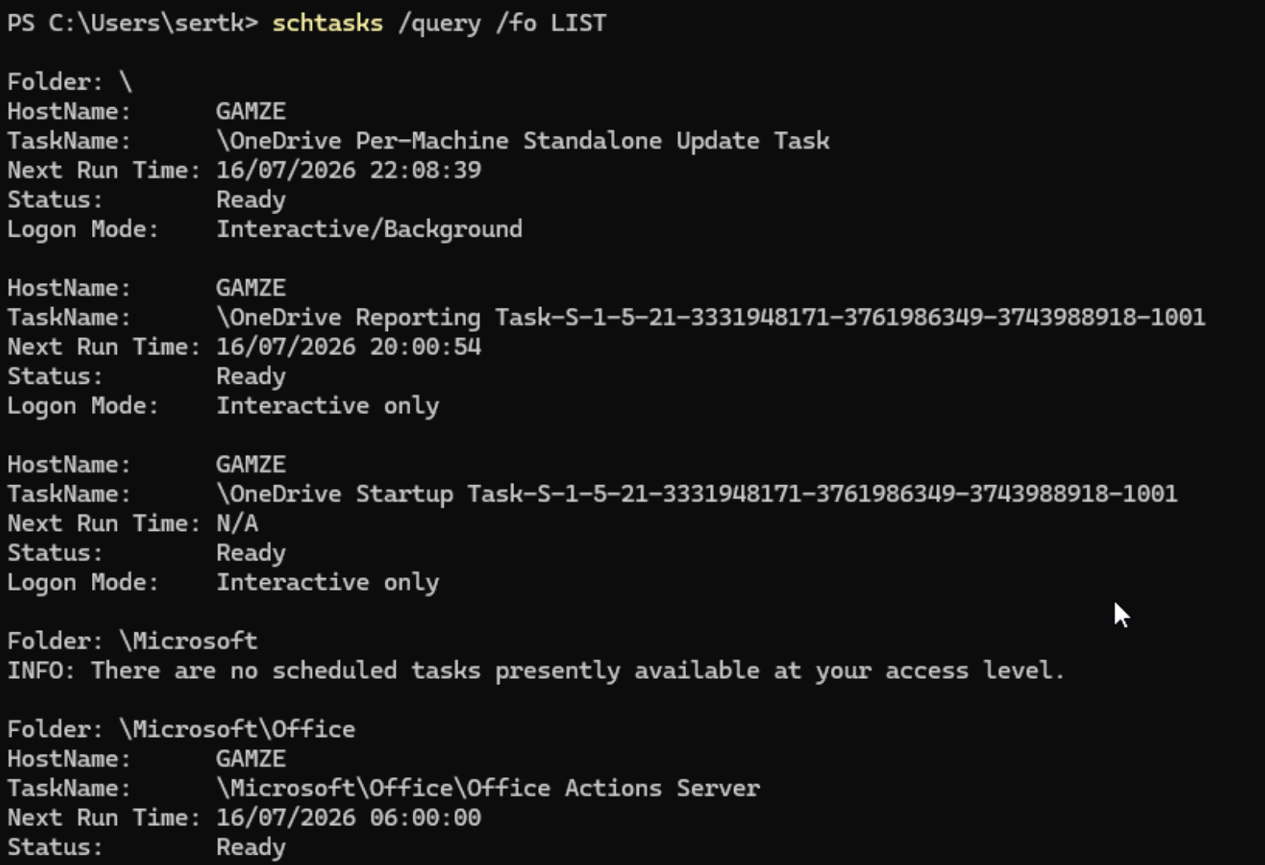

Use of Linux OS CLI commands.
- The ps aux command displays detailed information about running processes, including the user, Process ID (PID), CPU usage and memory usage.
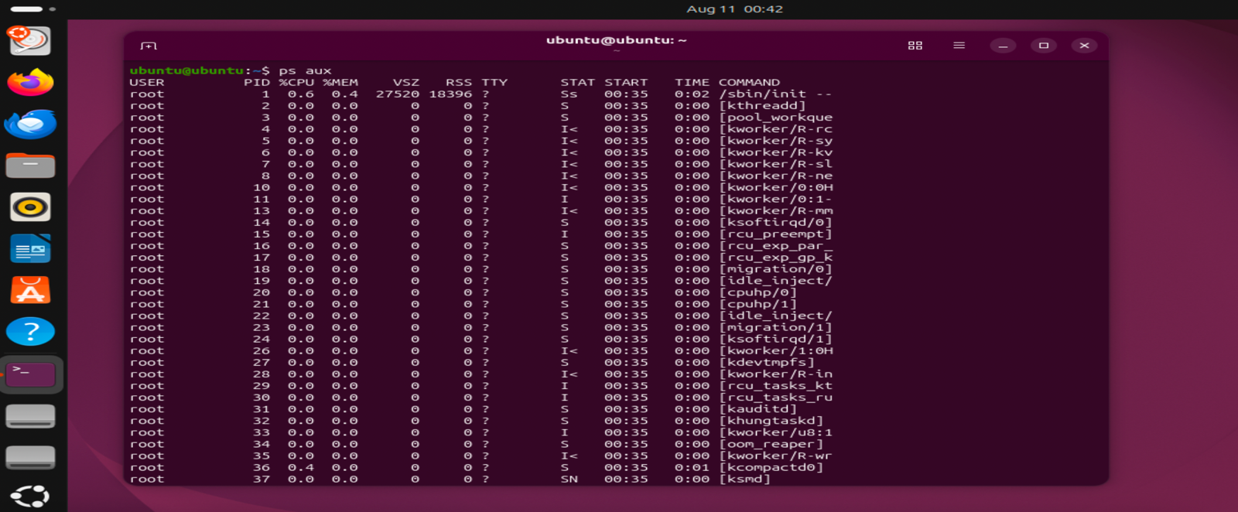

- The top command monitors running processes and system resource usage. The -b and -n 1 options produce one snapshot of the current processes.
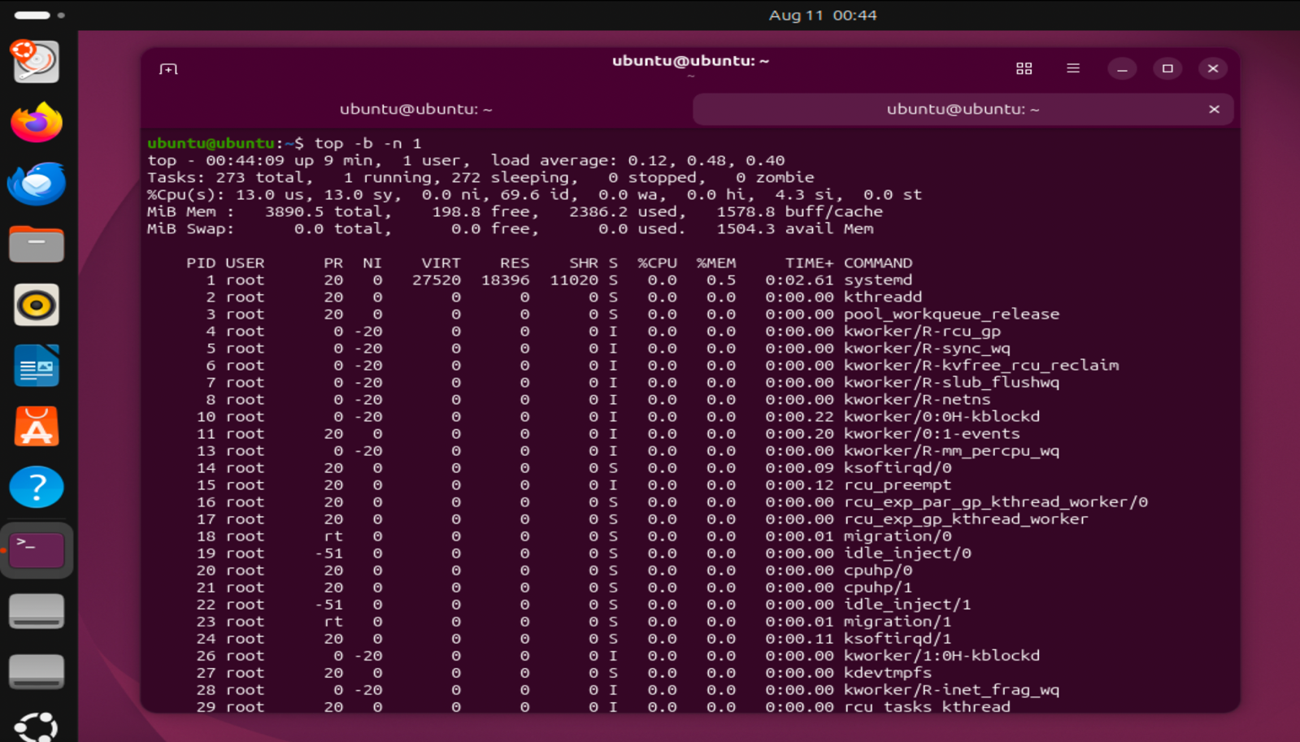

- The ls -la command lists files and directories. The -l option provides detailed information, while -a includes hidden files.
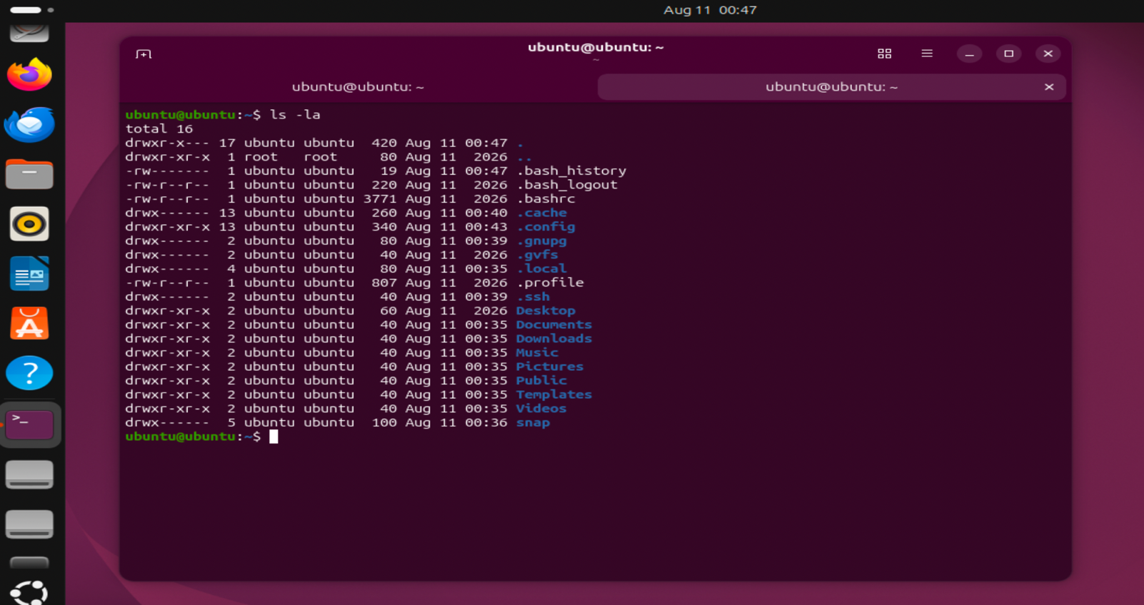

- ip addr show, this command displays network interfaces and their IP address configuration.
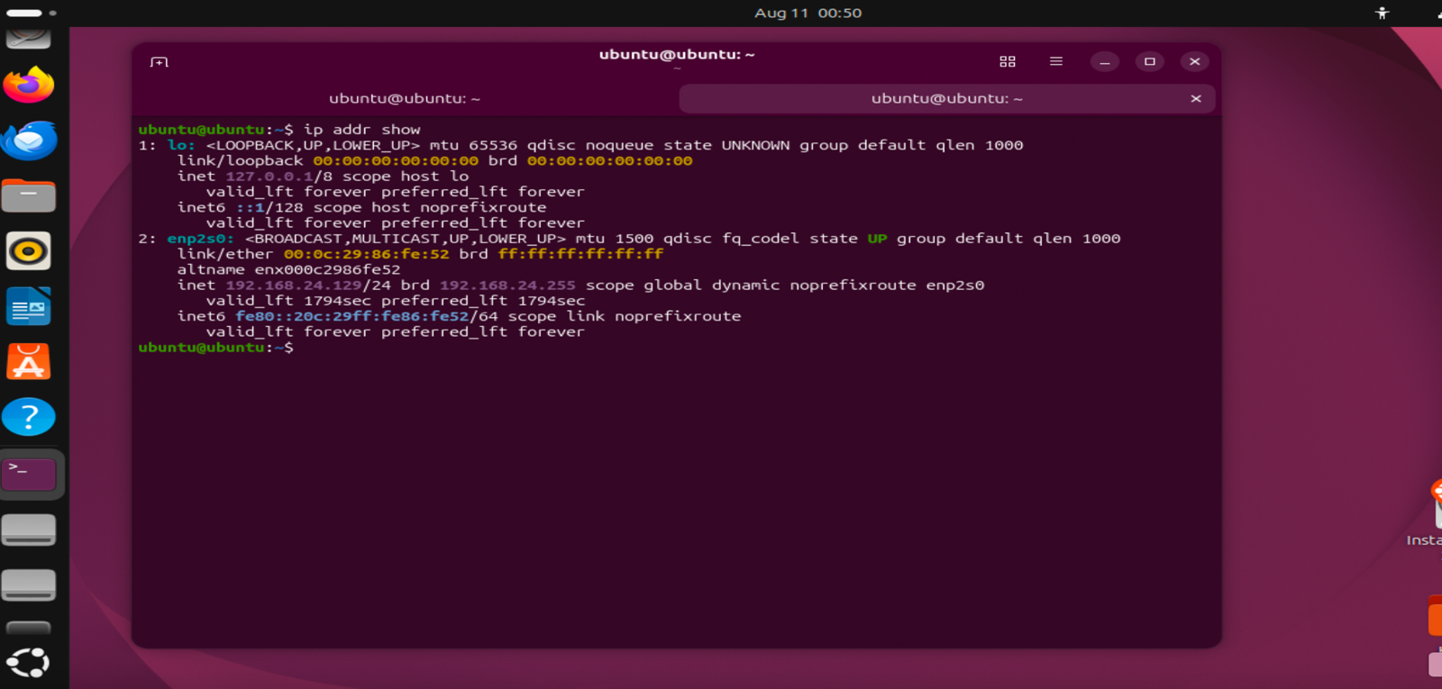

- ping -c 4 8.8.8.8, this ping command tests network connectivity. The -c 4 option limits the test to four packets.
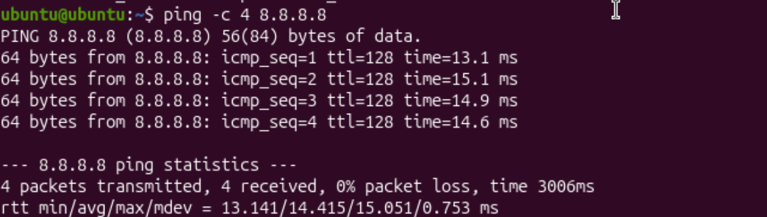

- The whoami command displays the username of the currently logged-in user.
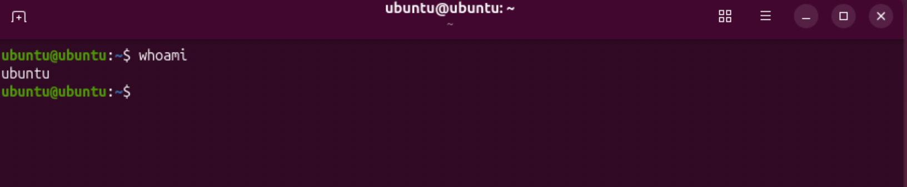

- The id command displays user identity information. The -u and -n options display the current username.
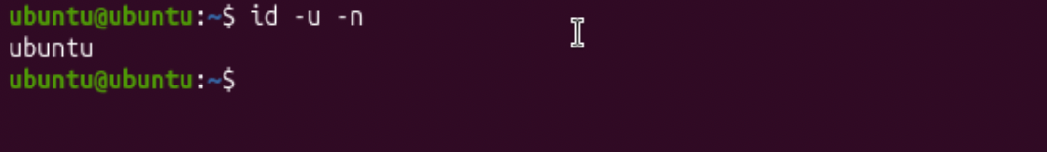

- The crontab -e command opens the user's cron table and allows scheduled tasks to be created or modified.
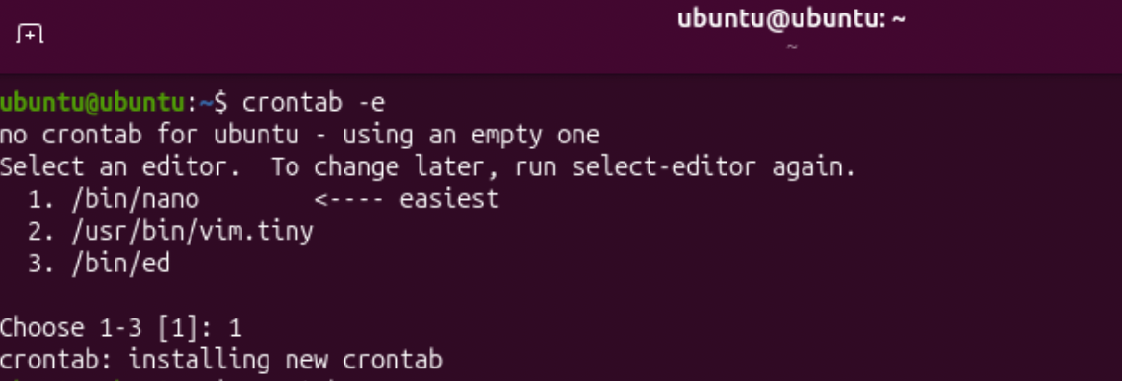
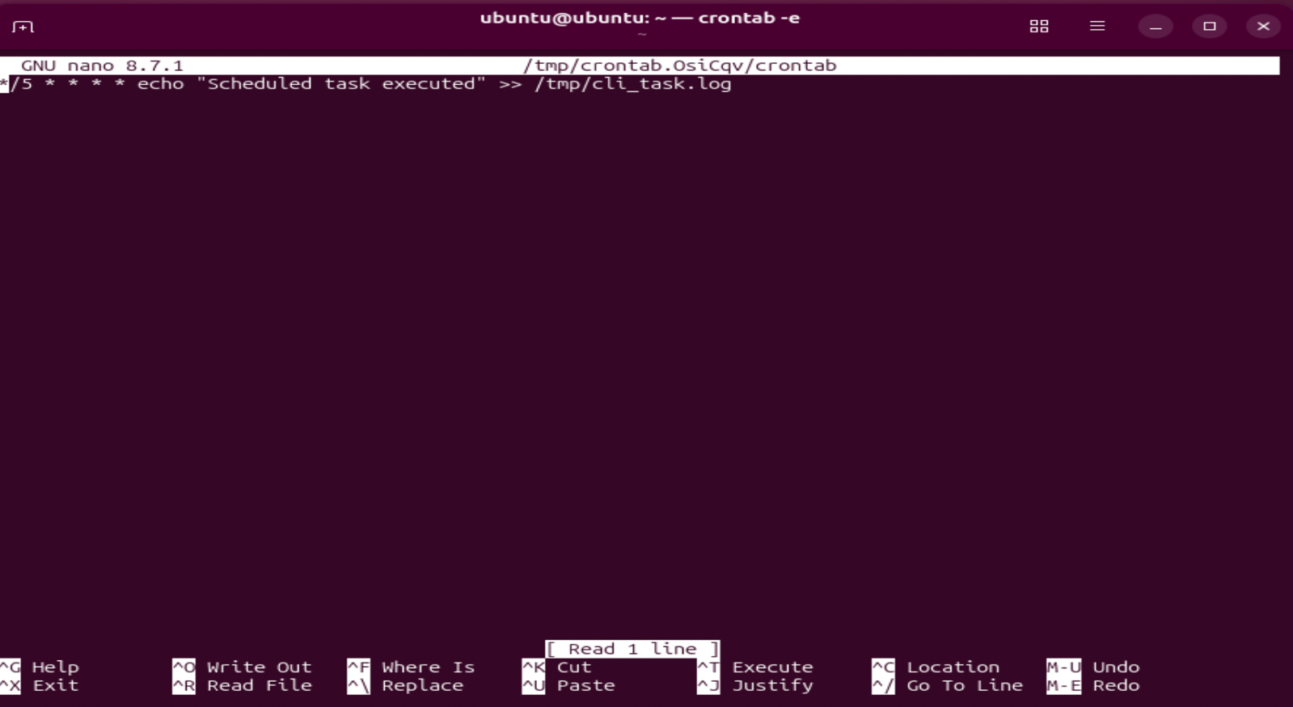

- The crontab -l command displays the scheduled tasks configured for the current user.
This cron job runs every five minutes. The */5 specifies the five-minute interval, while the asterisks represent every hour, day, month and day of the week. The echo command writes the message “Scheduled task executed” to the cli_task.log file. The >> operator appends the output without deleting previous entries.
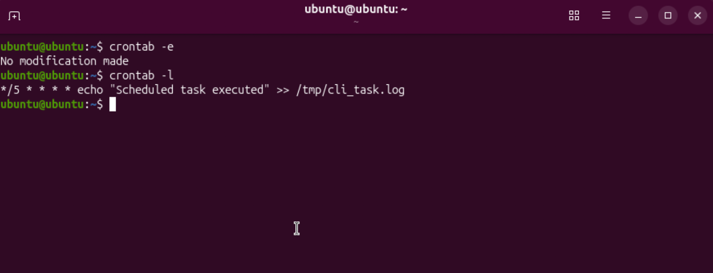
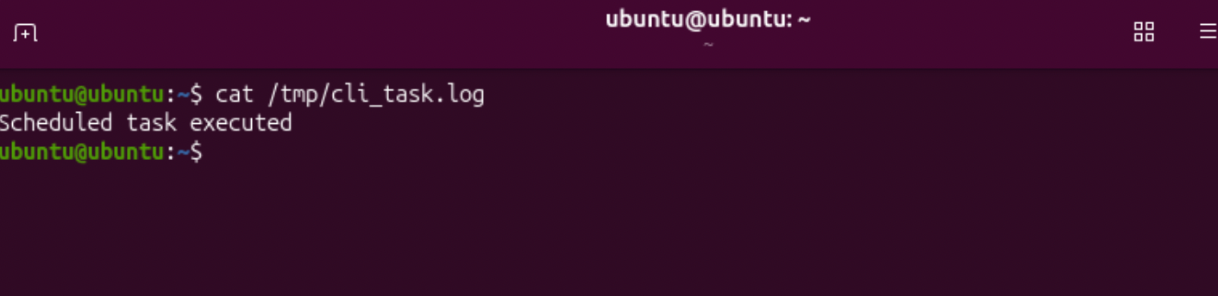

Use of Windows OS Scripts.

Windows OS Script 1

File Backup Script, this batch script was created to automate a simple file backup process. The set /p command collects the file name from the user and stores it in a variable. An if exist conditional statement checks whether the specified file exists. If found, the script automatically creates a Backup directory when required and copies the file into it. If the file cannot be found, an error message is displayed. This demonstrates the practical use of variables, user input and conditional statements in Windows Batch scripting.

Step 1 — Create a working folder, create the Batch file, create a test file
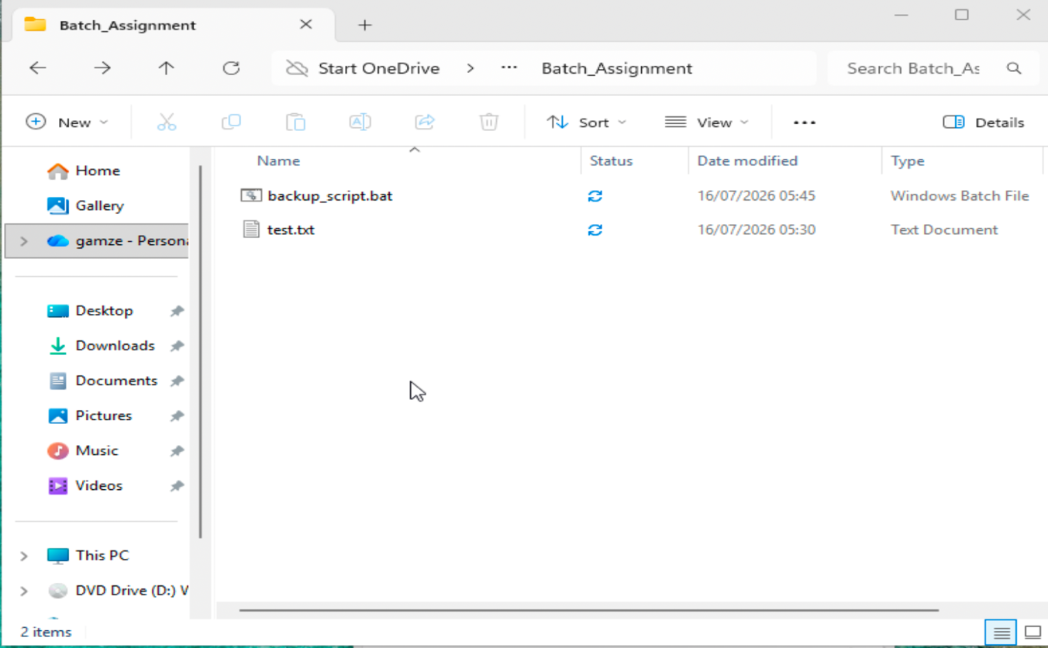
Step 2 — Add the Batch code
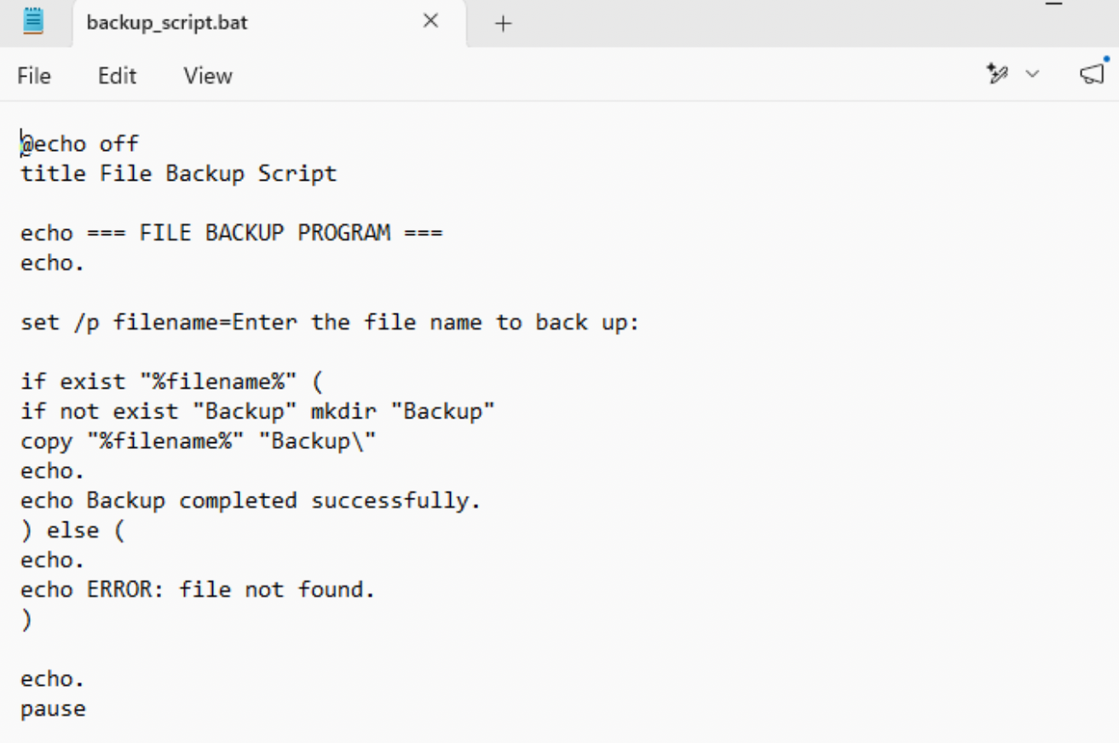
Step 3 — Run the script and get error
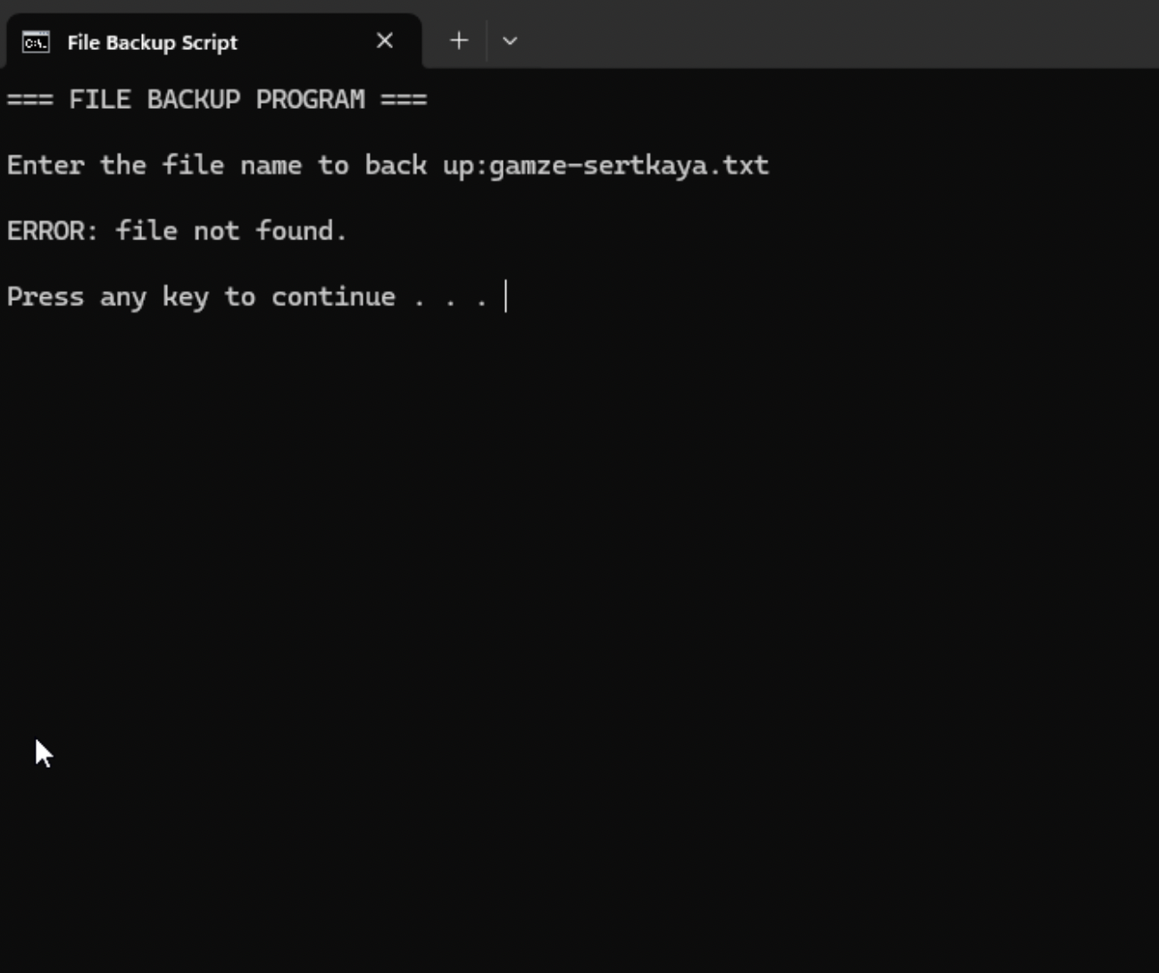
Step 4 — Run the script and get success
]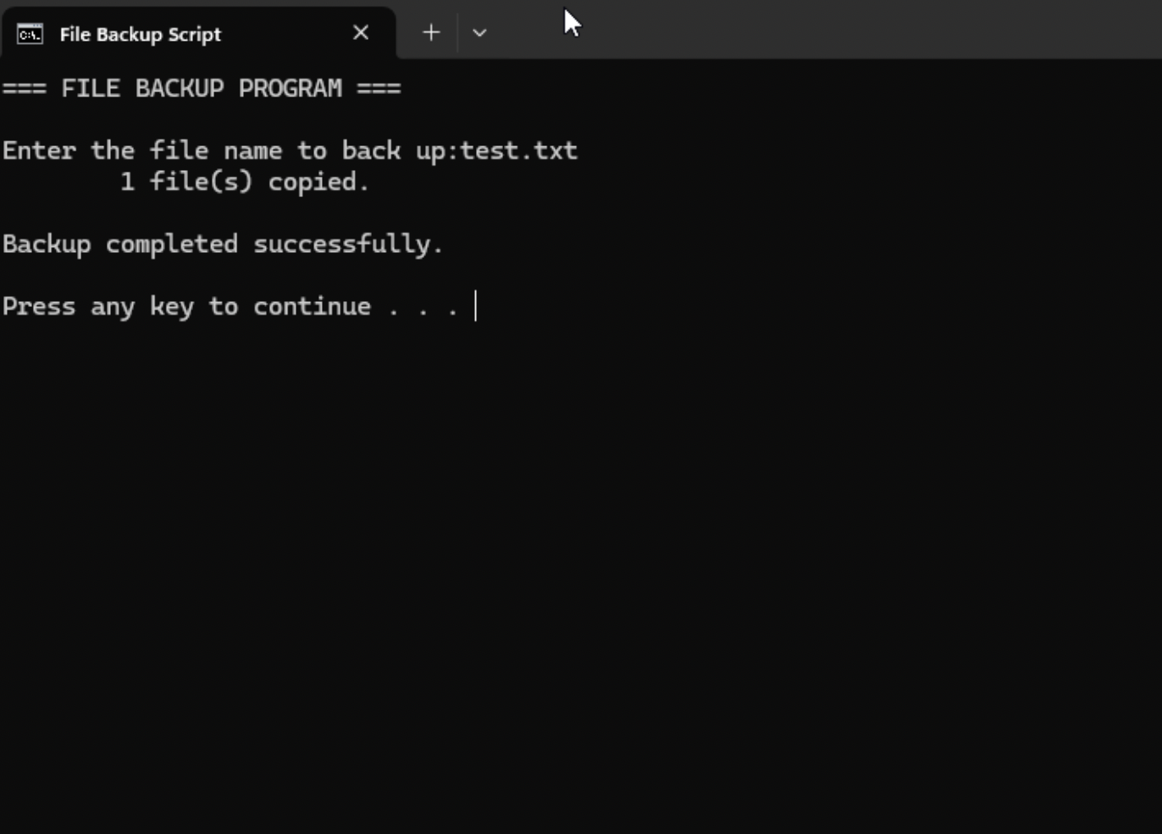
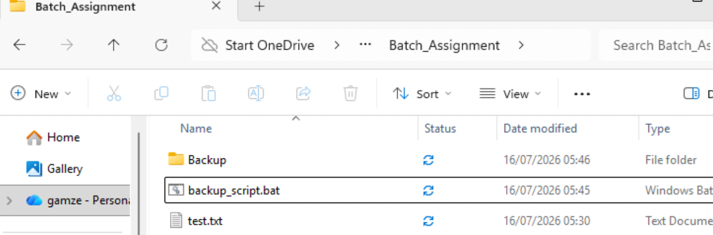

Windows OS Script 2

Number Calculator Script, this batch script demonstrates the use of variables, user input, mathematical operations and a loop. The set /p command asks the user to enter a number and stores it in the limit variable. The for /L loop then counts from 1 to the entered number. During each iteration, set /a performs an arithmetic operation by adding the current number to the total variable. Finally, the calculated total is displayed. This demonstrates how Batch scripting can automate repetitive calculations efficiently.
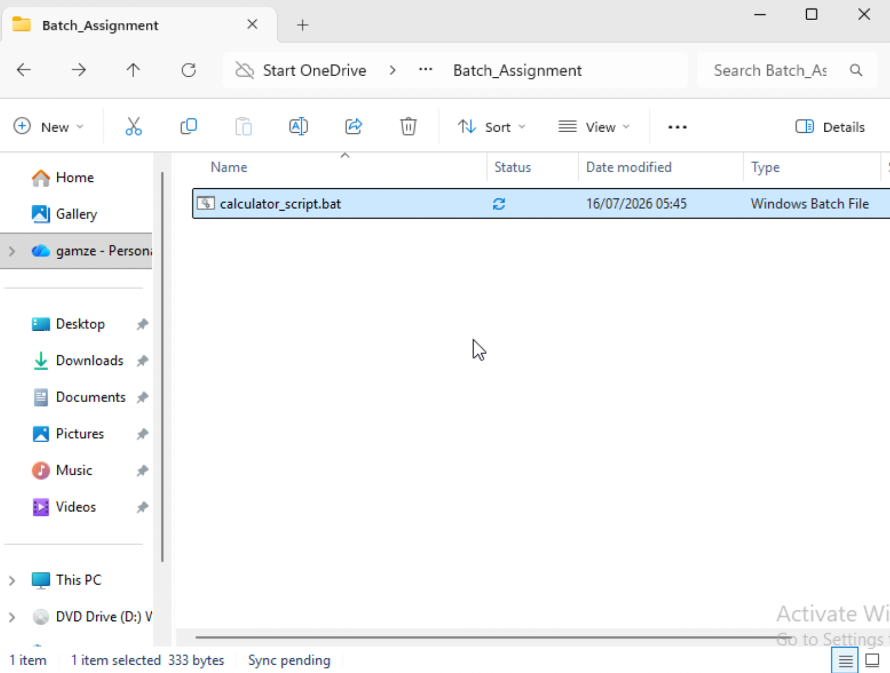
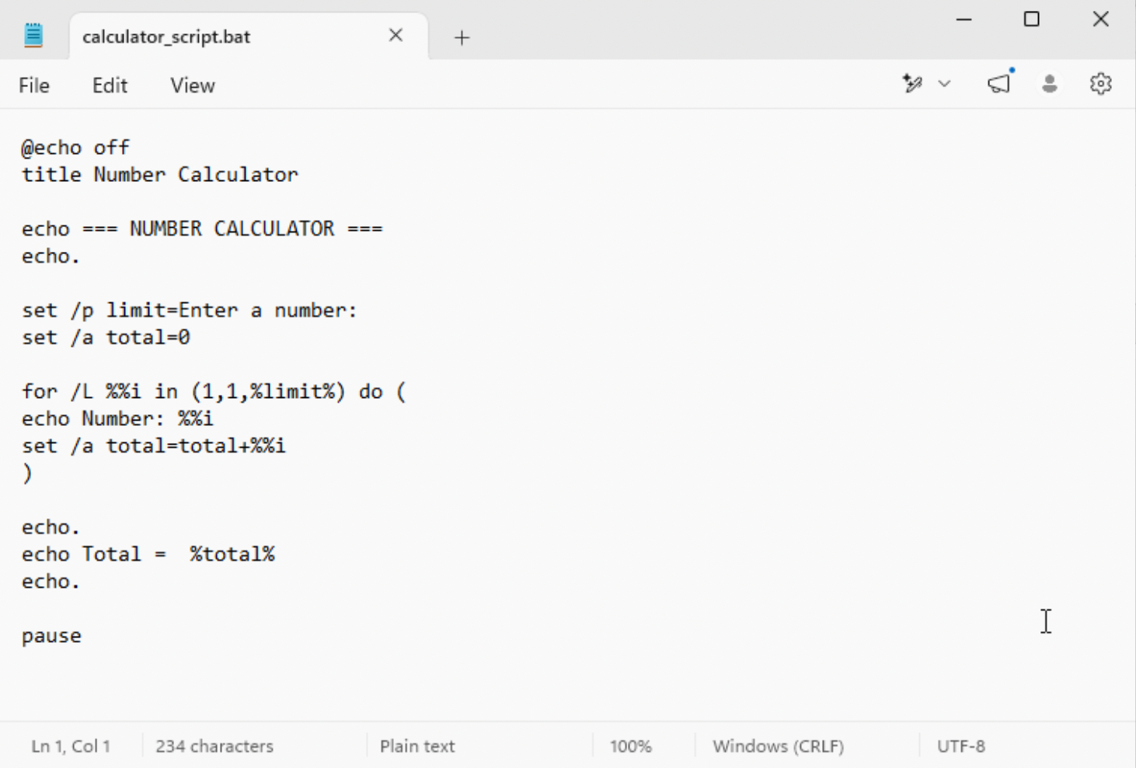
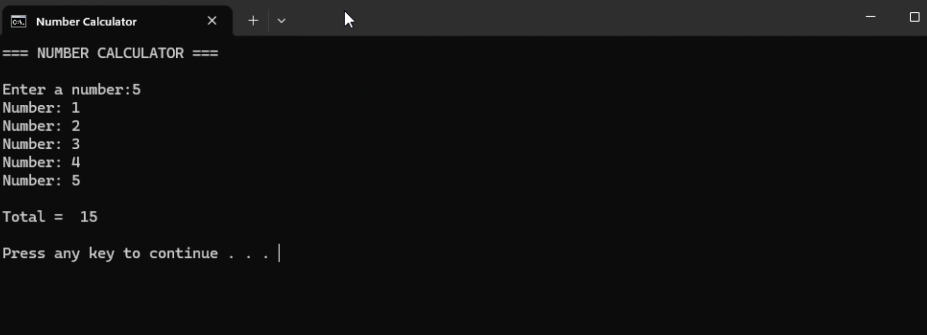

Use of Linux OS scripts.

Linux OS Script 1

File Backup Script, this bash script automates a simple file backup process. The read command collects the filename from the user and stores it in a variable. An if conditional statement checks whether the file exists. If the file is found, a Backup directory is created and the file is copied into it. Otherwise, an error message is displayed.
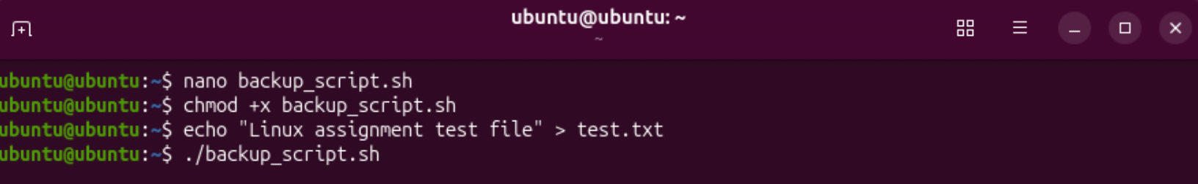
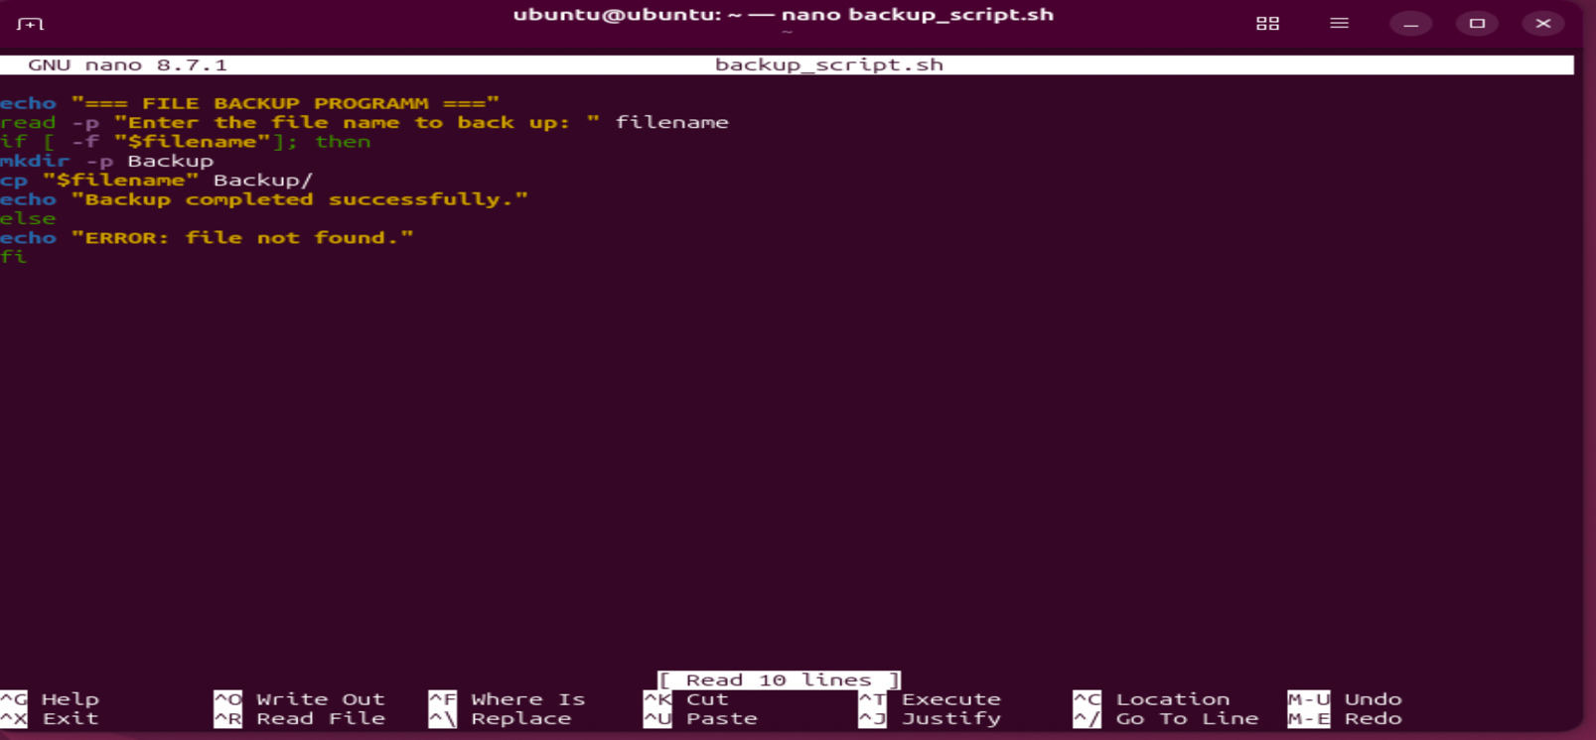
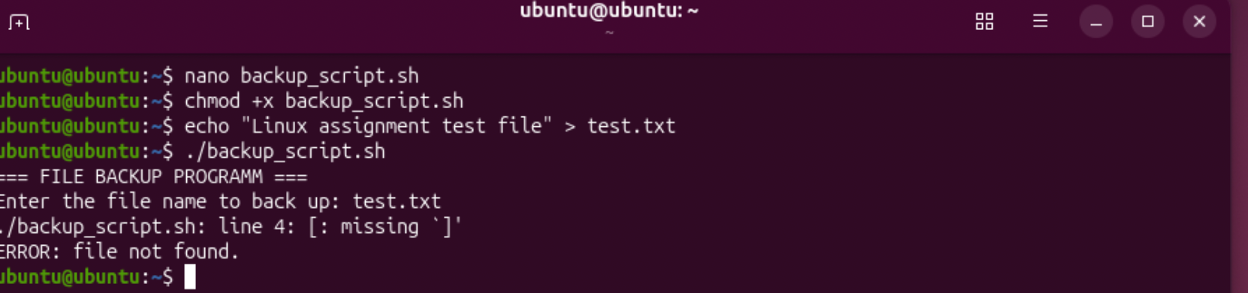
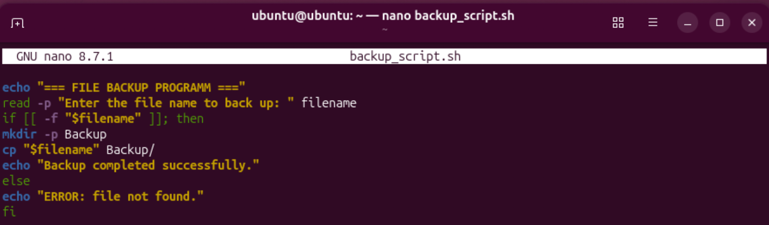
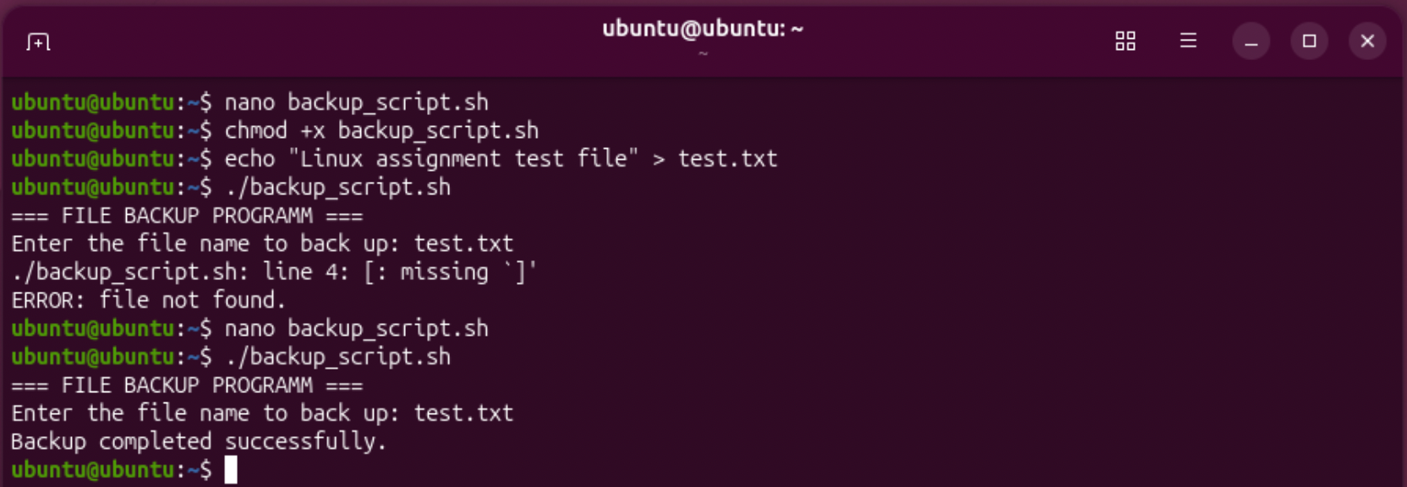

Linux OS Script 2

Number Calculator Script, this bash script demonstrates variables, user input, arithmetic operations and a for loop. The user enters a number, which is stored in the limit variable. The loop counts from 1 to the entered number, while an arithmetic operation calculates the total. Finally, the result is displayed in the terminal.
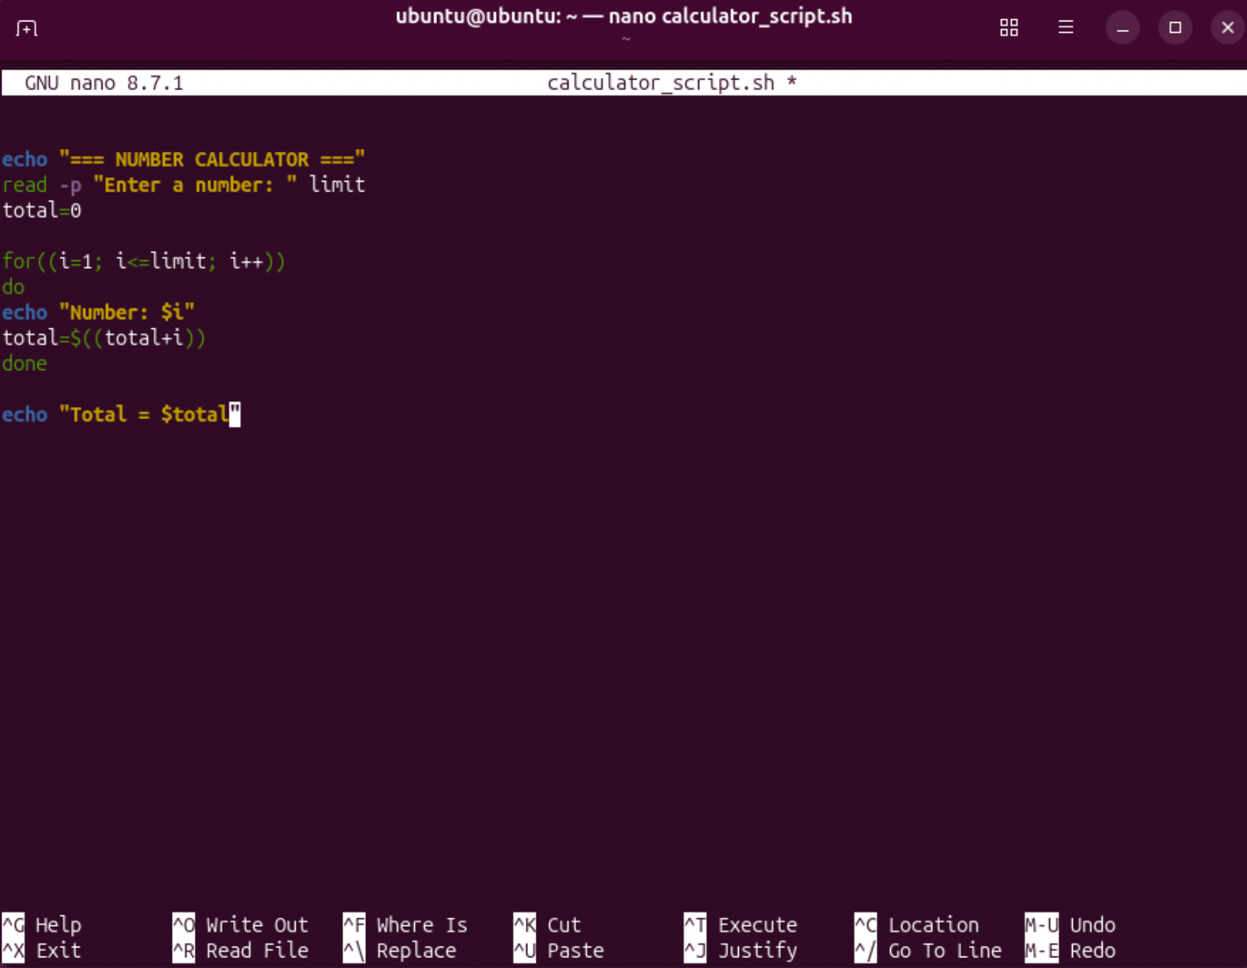
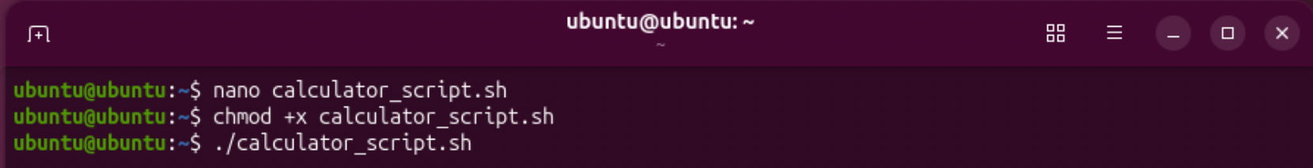
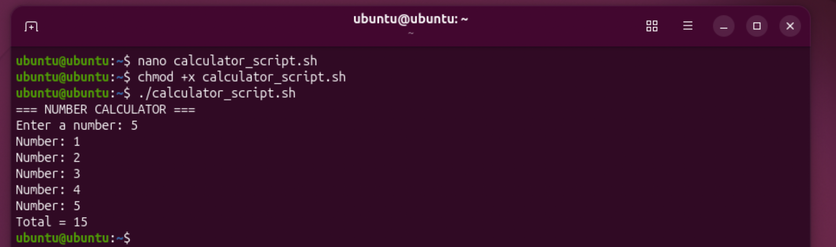

Conclusion
This assignment provided practical experience in using both Windows and Linux operating systems. Different command-line tools were used for process management, file and directory management, network testing, user management and task scheduling. This helped demonstrate the similarities and differences between Windows PowerShell/Batch commands and Linux Bash commands.
In addition, Batch and Bash scripts were created to demonstrate automation using variables, user input, loops, conditional statements and arithmetic operations. Overall, the practical activities improved my understanding of operating system administration, command-line tools and basic scripting.

References
[1] Microsoft, “System configuration tools in Windows,” Microsoft Support. [Online]. Available: https://support.microsoft.com/en-us/windows/experience/system-configuration-tools-in-windows. [Accessed: Aug. 10, 2026].
[2] Apple, “View information about Mac processes in Activity Monitor,” Apple Support. [Online]. Available: https://support.apple.com/en-gb/guide/activity-monitor/actmntr1001/mac. [Accessed: Aug. 10, 2026].
[3] Microsoft, “Memory Performance Information,” Microsoft Learn. [Online]. Available: https://learn.microsoft.com/en-us/windows/win32/memory/memory-performance-information. [Accessed: Aug. 10, 2026].
[4] The Linux Kernel Documentation, “Memory Management,” Linux Kernel Documentation. [Online]. Available: https://docs.kernel.org/admin-guide/mm/. [Accessed: Aug. 10, 2026].
[5] Apple, “View memory usage in Activity Monitor on Mac,” Apple Support. [Online]. Available: https://support.apple.com/en-gb/guide/activity-monitor/actmntr1004/mac. [Accessed: Aug. 10, 2026].
[6] Microsoft, “Windows Client Networking,” Microsoft Learn. [Online]. Available: https://learn.microsoft.com/en-us/troubleshoot/windows-client/networking/networking-overview. [Accessed: Aug. 10, 2026].
[7] Microsoft, “Access Control Overview,” Microsoft Learn. [Online]. Available: https://learn.microsoft.com/en-us/windows/security/identity-protection/access-control/access-control. [Accessed: Aug. 10, 2026].

Appendices

Appendix 3 – Online Certified Course Evidence

Course provider: Microsoft Learn
Course / learning path: Understand the Command Syntax in Windows PowerShell
I completed the “Understand the command syntax in Windows PowerShell” training module provided by Microsoft Learn. The course helped me understand the structure of PowerShell cmdlets, the use of command parameters, tab completion, and PowerShell help resources. It also included a module assessment to test the knowledge gained during the training




