Unit Code: BMMB7026
Module Title: Managing Marketing Change
Tutor’s Name: Gwyneth Jones
Report Title and Purpose: A report critically evaluates the role and activities of the marketing department within Nike that outline their future developments (what their marketing plan will be) to address sustainability challenges.
Programme Name: MBA
Student’s Name: Shivani Ashokkumar Khanna
Student number: 2307484

Table of Content
Title | Page Number
Executive Summary | 3
- Introduction | 4
- PESTLE | 6
- Porter Five Forces | 8
- SWOT | 9
- Force Field Analysis | 13
- STDP | 15
- Key Marketing Channels | 18
- Marketing Mix (7 Ps) | 18
- SOSTAC | 20
- Conclusions | 24
- Recommendations | 25
References | 26

Executive Summary:

In this report, Nike has been chosen as a company to analyze the key driver of change in that organization from the marketing view point. The identified driver for change which has been recognized is sustainability. Nike, which was founded on 25th January 1964 by Bill Bowerman and Phil Knight has come a long way since its inception. It has seen all kinds of changes but based on recent trends, sustainability has emerged as the biggest influencing factor for all major corporations to change their operational path and think about consumer preference and perception about them.

‘Customer is a king’. They have the power to drive the sales and the company’s brand reputation depends upon the liking of the customer. By analyzing the micro and macro environment of Nike, the tools it uses for promoting its product and understanding its market positioning, this report evaluates the plan that suits the future market development for Nike. There are some recommendations that could improve the marketing strategy of Nike and help them to beat the future competition.

- Introduction:

- Marketing Definition: According to Kotler et al. (2020), Marketing is “engaging customers and managing profitable customer relationships. The goal of the marketing is to attract new customers by promising superior value and to keep up with the growth of the current customers by delivering value and satisfaction”.

- Company: Nike Inc.
According to Wikipedia (2019), Nike, Inc. is the USA based sportswear company, which is headquartered near Beaverton, Oregon, United States. It was founded as ‘Blue Ribbon Sports’ by Bill Bowerman and Phil Knight on 25th January 1964. It became Nike, Inc. officially on 30th,1971. It holds the largest market share when it comes to sports shoes and apparel. It is one of the biggest manufactures of sports equipment. According to Tighe, (2022), in the financial year 2023, Nike generated a global income of over 51 billion U.S. dollars.

- Identified Issue: The impact of Sustainability

- Sustainability: People, Planet and Profitability

Thiele, (2013) feels that the definition of sustainability by practitioners which says it is meeting the current requirements with keeping in mind the future well-being, does not specifically mention who’s future well-being and hence, deemed it incomplete.

Therefore, the definition according to the United Nations, (1987), which says sustainability is “meeting the needs of the present without compromising the ability of future generations to meet their own needs”, seems to be more appropriate.

According to Mollenkamp (2023), sustainability has three pillars, economic (profitability), environmental (planet) and social (people). In the upcoming report we will evaluate Nike’s marketing activities from these three pillars of sustainability.

- Nike’s Marketing Resources:
According to RocketReach (n.d.), Camilo Andrade is the Vice President of Asia, Pacific and Latin America. He leads the marketing team of 1629 employees.

According to Tighe (2022), in the financial year 2023, Nike invested 4.06 billion U. S. dollars in advertising and promotions against the world-wide income of 51 billion U. S. dollars. This means it generated almost 12.5 times income compared to their marketing expenditure.

According to LinkedIn (n.d.), Neol Kinder is the Chief Sustainability Officer in Nike from 2018.

- Popular Marketing Campaigns by Nike:
Over the period of time, Nike has run many successful marketing campaigns, www.linkedin.com, n.d. mentions some of them, like:
- "Find Your Greatness" campaign (2012), is about ordinary people achieving ‘greatness’ by stretching their limits to attain regular fitness goals.

- “Unlimited you” campaign (2016), is about triumphing over difficulties to achieve the goals.

- “Equality” campaign (2017), is about equality based on race, gender and ability in sports.

- “Dream Crazy” campaign (2018), is about motivation one can get by overcoming their personal hurdles.

- “Just Do It” campaign from 1988 is ever-popular and it is about positive action by taking one step forward towards the goal.

- Similarly, Booker (2020) highlights successful marketing essence used by Nike’s marketing team:
- It focuses on ‘real people, real stories’, showing real life heroes (sheroes) who challenge their limits to create their own mark in sports.

- Then, touching ‘pure emotions’ of people like fans’ attachment to late basketball star Kobe Bryant and with the slogan, “Don’t do it”, to create awareness against racism.

- Nike focuses on ‘sporting legends’ and how they work hard everyday towards achieving their sports goal.

- It uses the essence like, ‘championing the underdog’, by talking about equality in sports, whether it is LGBTQ community or other racial minorities.

- They focus on, ‘fusing sports and culture’ by bringing in several artists, musicians and creative people together to make impactful visual-audio advertisements.

- PESTLE

According to Morrison, (2020), PESTLE is an analytical tool that gives us an outlook on the macro business environment based on factors like, Political environment in which the company operates, economic situation surrounding its operations, social/cultural factors that affects its operations, technology it utilizes to operate, the law/policy it abides by in a set geographical location and the environment it affects due to its business activities.
Marmol & Feys, (2015) points out that his analysis allows the understanding of major macroeconomic elements that shapes the progression of the business.

1. Political Factors:
Regulatory Compliance: In www.nike.com. (2018), Nike is making its consumer aware of how it ensures to adhere to global and local regulations on sustainability.
Nike is aiming to achieve the 12th goal from the 17 sustainable development goals defined by the United Nations in United Nations (2023), that is, responsible consumption and production.
2. Economic Factors:
Consumer Spending: According to Remes et al. (2021), the economic conditions influence consumer spending especially after pandemic. Sustainable promotions may resonate better in economically stable environments, where consumers prioritize ethical and eco-friendly brands.

3. Social Factors:
Consumer Awareness: Whether it is Advertising campaigns supportive Native Americans as mentioned in Sanders, Phillips, & Alexander, (2017), or a case study in Grow, (2008), about Nike using popular females to promote brand image for years, or according to Brody, (2023), creating awareness about the vulnerable sections of the society, along with the ‘Equality’ campaign mentioned in www.linkedin.com. (n.d.), shows Nike’s promotional strategies revolving around social issues affecting consumer preferences making it in alignment with societal values, emphasizing people aspect of sustainability.
Social Media Impact: Standaert, (2022) mentions, leveraging social media for sustainable campaigns can enhance brand image of Nike and reach environmentally-conscious consumers.

4. Technological Factors:
Innovative Methods and Materials: Epstein, Buhovac, & Yuthas, (2010) talk about how Nike has used advanced sustainable materials and environmentally friendly innovative production methods that has enabled it to develop eco-friendly items, such as recyclable packaging, or clothing made from recycled materials. Marketline, (2021) mentions Nike’s research and development mainly emphasis on improving current products and improving product lifecycle through innovation, making it more sustainable.
Digital Marketing: According to Standaert, (2022), Technology facilitates targeted marketing, allowing Nike to tailor promotions to environmentally conscious consumers through data-driven insights.

5. Legal Factors:
Environmental Regulations: According to Nike aims for zero waste. (2010), remaining compliant with environmental laws is crucial for Nike.
It is targeting its promotional activities via several reports, digital ads and several other channels that are aligned with regulations regarding waste disposal, sustainable sourcing, and other eco-friendly practices.
Advertising Standards: Kobayashi, (2012) perfectly illustrates how Nike considers legal frameworks surrounding different geographical boundaries.

6. Environmental Factors:
Carbon Footprint: Nike (2023a) highlights Nike's commitment to reducing its carbon footprint should extend to promotional activities. Opting for low-impact promotional events and materials can showcase the company's dedication to environmental sustainability.
Supply Chain Sustainability: Sustainable sourcing of materials for promotional products ensures that Nike's environmental efforts are consistent throughout the supply chain.

Conclusion:
In Rittenhouse, (2023), Initiative Global CEO Dimitri Maex points out on winning the promotional projects from Nike outside of North America that Nike is of the fastest moving brands across the cultures and it was his top wish list among the companies to work with.
Nike's promotional strategy, viewed through the lens of sustainability, aligns with a rapidly changing global landscape. Adapting to political, economic, social, technological, legal, and environmental factors is crucial for maintaining a positive brand image. By integrating sustainable practices into promotional activities, Nike not only meets the demands of environmentally-conscious consumers but also contributes to a more sustainable future. Careful consideration of these factors will help Nike stay ahead in the market while upholding its commitment to environmental responsibility.

- Porter’s Five Forces:
Porter, (1998), Competitive strategy: techniques for analysing industries and competitors: with a new introduction talks about the combine power of Threat of New Entrants, Bargaining Power of Suppliers, Bargaining Power of Buyers, Threat of Substitutes and the competitive rivalry finally decides the gaining potential in a particular industry where profits can clearly be seen more in comparison to the money invested.

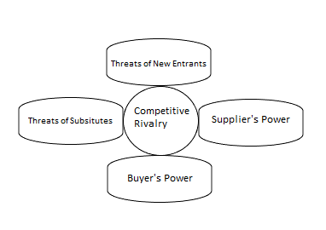

1. Threat of New Entrants:
Low Threat: Establishing a sustainable promotional strategy requires significant financial investment and expertise. Nike's strong commitment to sustainability, demonstrated through initiatives like the "Move to Zero" campaign, creates high entry barriers for new competitors. The extensive supply chain relationships and focus on eco-friendly materials enhance Nike's competitive advantage.

2. Bargaining Power of Buyers:
Moderate Threat: Consumers are increasingly prioritizing sustainable products, giving them more influence. Nike's promotion of sustainable practices in its marketing campaigns, like the use of recycled materials, helps in retaining and attracting environmentally-conscious consumers. However, price sensitivity remains a factor, impacting the level of influence consumers have over purchasing decisions.

3. Bargaining Power of Suppliers:
Moderate Threat: Nike's commitment to sustainability empowers suppliers who align with eco-friendly practices. The company collaborates closely with suppliers to ensure compliance with environmental standards. However, the scale of Nike's operations gives it negotiating power. Suppliers that fail to meet sustainability criteria may face the risk of losing a significant customer.

4. Threat of Substitute Products:
Low Threat: Sustainable promotional strategies contribute to building brand loyalty. Nike's emphasis on sustainability creates a unique selling proposition that is hard for substitutes to replicate. While there are other athletic apparel brands, the integration of sustainability into the promotional messaging and product offerings gives Nike a competitive edge.

5. Intensity of Competitive Rivalry:
High Threat: The athletic apparel industry is highly competitive, and competitors are increasingly adopting sustainability in their strategies. Nike's continuous innovation and strong brand image help maintain a competitive position, but the industry dynamics necessitate ongoing efforts to stay ahead. As pointed in Noby-Williams, (2019), during 2019 when two of the prominent records were broken in marathon, which led to questioning the technological innovation sportswear companies are doing. Nike was able to innovate faster than competitors because of the large spending on research and development, giving them an edge over their competitors.

Conclusion:
From the sustainability point of view, Nike’s strategy is positioned favorably within Porter's Five Forces framework. The company's substantial investments, commitment to eco-friendly practices, and focus on innovation contribute to a strong competitive position. While threats exist, particularly in the face of industry-wide adoption of sustainability, Nike's proactive approach and emphasis on sustainable practices create a robust defense against potential challenges. The ongoing integration of sustainability into its promotional strategy positions Nike as a leader in the industry, appealing to environmentally-conscious consumers and enhancing long-term brand loyalty.

- SWOT

SWOT is an abbreviation that stands for Strengths, Weaknesses, Opportunities and the Threats of a particular company.
According to Johnson, Whittington & Scholes, (2012), SWOT could be an important tool to sum up the main factors that have emerged during the analysis of the business environment and the firm’s capacity to understand the overview of its strategic positioning in the overall industry.





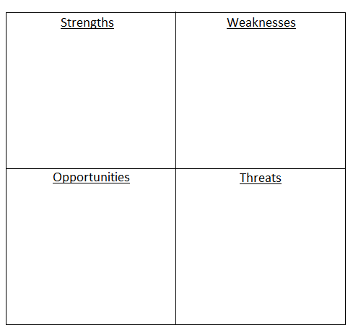

- Strengths:

- Brand Reputation: BCG (2022) shows Nike among the top 50 Most Innovative Companies. This makes it a strong and globally recognized brand, which can enhance the effectiveness of its sustainability-focused promotional messages.

- Innovation in Sustainable Products: DeLong, (2009) shows how Nike has demonstrated commitment to sustainability right from the early stages of this trend. Marketline (2021) mentions how it has shown commitment towards sustainability through innovative products, such as the use of recycled materials and sustainable manufacturing processes.

- Partnerships and Collaborations: Smaller footprints for Nike, (2001) shows that Nike’s participation in collaboration with environmental organizations like World Wildlife Fund's Climate Savers Program to reduce greenhouse gas emissions was looked upon as a positive step towards sustainability.

- Digital Marketing Presence: Nike's robust online presence and social media platforms provide a powerful channel for communicating its sustainability initiatives to a vast audience.

- Weaknesses:

- Cost Implications: Implementing sustainable practices may increase production costs, potentially impacting profit margins and requiring careful management to balance economic and environmental considerations.

- Consumer Scepticism: Some consumers may view Nike's sustainability efforts as greenwashing, necessitating transparent communication to build trust and credibility.

- Limited Sustainable Product Range: Nike's sustainable product range is relatively limited compared to its overall product offerings, potentially hindering the depth of its sustainability-focused promotional campaigns.

- Dependency on Suppliers: The sustainability of Nike's supply chain relies on the practices of suppliers, and any lapses in their sustainability efforts may reflect negatively on Nike.

- Opportunities:

- Growing Consumer Demand for Sustainability: The increasing global awareness and demand for sustainable products present an opportunity for Nike to capitalize on its existing efforts and expand its sustainability-focused promotional campaigns.

- Innovative Partnerships: Nike and Newlight collaborate to research carbon-negative material. (2021), talks about Nike’s collaborations with partnerships with cutting-edge sustainable technology companies to innovate sustainable fashion initiatives, strengthens its credibility and widens its reach in promoting sustainability. This action in the eco-friendly space can further enhance Nike's promotional strategies.

- Awareness Campaigns: Developing awareness campaigns to inform consumers about the positive environmental impact of choosing sustainable products can create a more informed and supportive customer base.

- Threats:

- Competitive Pressure: Competitors entering the sustainable market may intensify competition, requiring Nike to continually innovate and differentiate its sustainability-focused promotional strategies.

- Regulatory Changes: Changes in environmental regulations may impact Nike's operations, necessitating agility in adjusting its promotional strategies to align with new requirements.

- Supply Chain Risks: Disruptions in the supply chain due to unforeseen events or the unsustainable practices of suppliers pose a threat to Nike's ability to maintain a strong sustainability narrative.

- Public Backlash: Any negative environmental incidents or perceived inadequacies in Nike's sustainability efforts may lead to public backlash and damage the brand's reputation.

Conclusion:
Nike's sustainability-focused promotional strategy is poised to leverage its strong brand reputation and innovative products. Addressing weaknesses through transparent communication, expanding sustainable product ranges, and seizing opportunities such as educational campaigns and innovative partnerships can further strengthen Nike's position. Managing threats, particularly in the face of increased competition and changing regulations, will require continuous monitoring and adaptability in its sustainability narrative. Overall, a strategic and well-executed sustainability promotional strategy can enhance Nike's brand equity and resonate positively with an increasingly eco-conscious consumer base.

- Force Field Analysis:
According to Study.com (2022), Kurt Lewin's force field analysis was an analysis that justified the current state of a being. It suggested that a being is at the equilibrium point between two forces pulling in different directions.
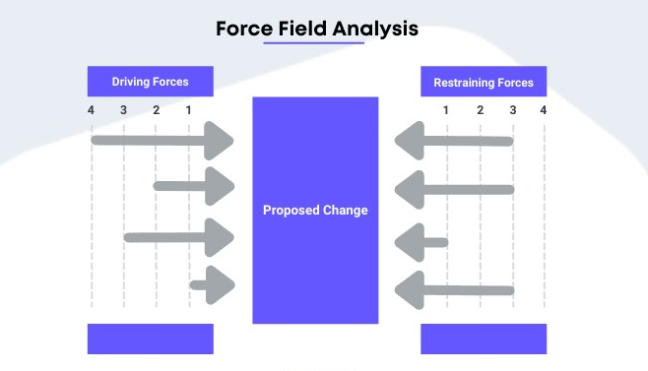
Force Field Analysis for Nike's Promotional Strategy: Sustainability Perspective

- Driving Forces:

- Consumer Demand for Sustainable Products: Increasing awareness and demand for environmentally friendly products in the market.

- Corporate Social Responsibility (CSR) Trends: Growing emphasis on CSR in the business world, encouraging companies to adopt sustainable practices.

- Regulatory Landscape: Stringent regulations and standards promoting sustainability in the fashion and apparel industry.

- Competitive Advantage: Potential to gain a competitive edge by positioning Nike as a leader in sustainable practices.

- Innovation in Sustainable Technologies: Advancements in eco-friendly materials and manufacturing processes providing opportunities for innovative product lines.

- Restraining Forces:

- Cost Implications: Initial high costs associated with transitioning to sustainable materials and processes.

- Supply Chain Complexity: Challenges in aligning the entire supply chain with sustainable practices.

- Consumer Perception and Awareness: Possible skepticism or lack of awareness among consumers about the sustainability efforts undertaken by Nike.

- Industry Norms and Practices: Established industry practices that may not align with immediate implementation of sustainable strategies.

- Equilibrium:
Achieving equilibrium requires Nike to strategically balance driving and restraining forces. Key actions may include:

- Investment in Research and Development: Allocate resources to research sustainable materials and technologies to reduce costs and enhance competitiveness.

- Supplier Collaboration: Forge partnerships with suppliers to ensure the entire supply chain is aligned with sustainable practices.

- Communication and Transparency: Implement effective communication strategies to enhance consumer awareness and trust regarding Nike's sustainability initiatives.

- Advocacy and Industry Collaboration: Actively engage in industry collaborations and advocate for sustainable practices to influence industry norms.

- Continuous Monitoring and Adaptation: Regularly assess the effectiveness of sustainability initiatives and adapt strategies based on market trends and consumer feedback.

- STDP

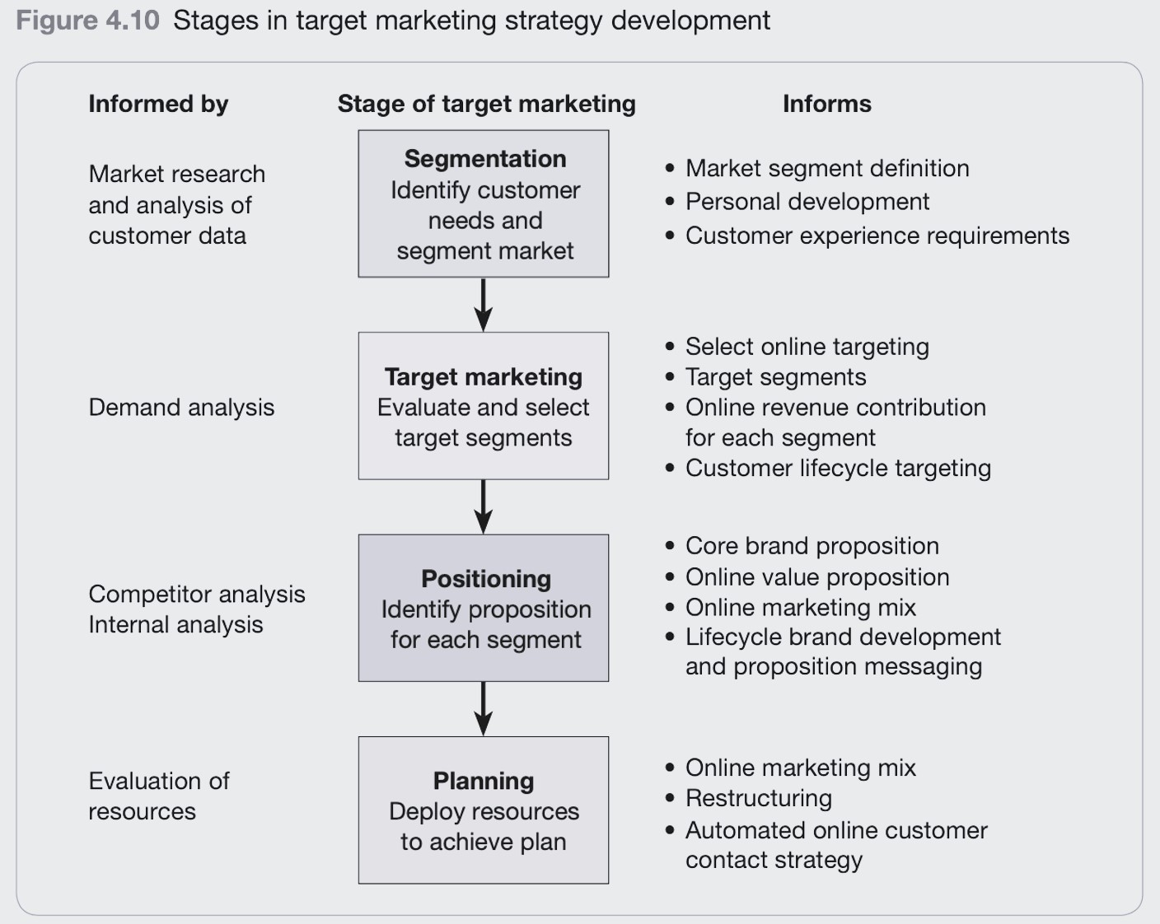

Sustainability-focused Segmentation, Targeting, Differentiation, and Positioning for Nike:

- Segmentation:
Nike recognizes the diverse range of consumers who prioritize sustainability in their purchasing decisions. The market can be segmented into three key groups:

- Conscious Consumers:
  - Characteristics: Individuals who prioritize environmentally friendly products and sustainable practices.
  - Psychographics: Value eco-conscious lifestyles, ethical production, and sustainable sourcing.
  - Demographics: Age group 18-35, urban dwellers, middle to high income.
  - Behaviors: Actively seek brands with a commitment to sustainability.

- Athletic Enthusiasts:
- Characteristics: Consumers who engage in sports and outdoor activities.
- Psychographics: Value high-performance products with an eco-friendly focus.
- Demographics: Active individuals of all ages, sports enthusiasts, health-conscious.
- Behaviors: Seek gear that aligns with both performance and sustainability.

- Global Citizens:
- Characteristics: Consumers concerned with global impact and corporate responsibility.
- Psychographics: Prioritize brands contributing to global sustainability goals.
- Demographics: Diverse age groups, urban and suburban dwellers, globally aware.
- Behaviors: Choose brands actively participating in environmental initiatives.

- Targeting:
Nike will target these segments with a focus on creating sustainable products that align with their unique preferences.

- Conscious Consumers:
- Targeting Strategy: Develop sustainable materials, transparent supply chains, and eco-friendly packaging.
- Product Offering: Eco-friendly athletic wear, recycled footwear, and sustainable accessories.

- Athletic Enthusiasts:
- Targeting Strategy: Merge high-performance technologies with sustainable materials.
- Product Offering: Innovative, performance-driven sportswear made from recycled and eco-friendly materials.

- Global Citizens:
- Targeting Strategy: Communicate global sustainability efforts and partnerships.
- Product Offering: Limited-edition lines supporting global sustainability projects.

- Differentiation:
Nike will differentiate itself in the market through a commitment to sustainability, emphasizing:

- Innovative Materials: Develop and implement cutting-edge sustainable materials, setting industry benchmarks.

- Circular Economy Practices: Establish a closed-loop system for product lifecycles, promoting recycling and upcycling.

- Transparent Supply Chains: Provide detailed information on the sourcing and production processes, ensuring transparency.

- Positioning:
Nike will position itself as a leader in sustainable athletic wear, synonymous with innovation, performance, and ethical practices.

- Brand Promise: "Empowering Your Stride, Sustaining Our Planet."

- Key Messages:
- Cutting-edge sustainable technologies.
- Uncompromised performance with a minimal environmental footprint.
- A commitment to transparent and ethical practices.

- Visual Identity: Incorporate eco-friendly packaging, labeling, and marketing materials.

By aligning with the values of conscious consumers, athletic enthusiasts, and global citizens, Nike aims to lead the market in sustainable athletic wear, reinforcing its commitment to both performance and environmental responsibility.

- Key Marketing Channels Used by Nike:

- Direct Marketing
- Digital Marketing via their own websites and through Google Ads
- Social Media Marketing via platforms like YouTube, LinkedIn, Facebook, Instagram, etc.
- Instore branding

- Indirect Marketing:
  - Influencer Marketing, using social media influencer and popular athletes
  - Through sponsorships of several national and international athletes and sports teams.
  - By supporting and creating social campaigns which are emotional in nature like, ‘Mamba Forever’ as mentioned in Booker (2020), to remember late basketball legend Kobe Bryant.

- Marketing Mix (7 Ps)

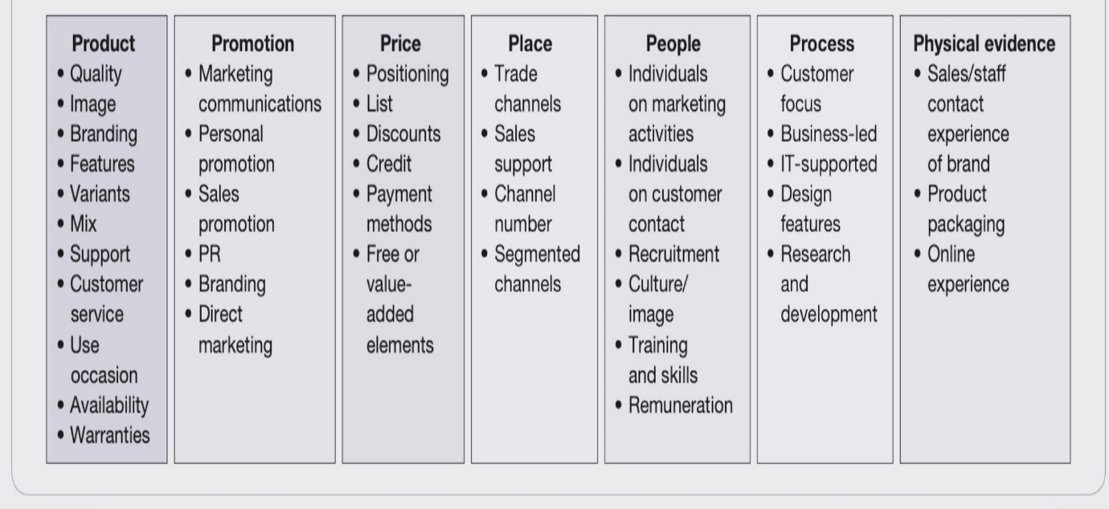
Sustainability-focused marketing mix (7 Ps) for Nike:

- Product:
Sustainable Footwear: According to Nike (2022), Nike has developed and promote a line of footwear using eco-friendly materials, such as recycled plastics and organic cotton, with a focus on durability and recyclability.
Apparel with a Purpose: According to Nike (2019) and Nike (2022), it creates clothing items that use sustainable fabrics, emphasizing fair labor practices throughout the supply chain.

- Price:
Transparent Pricing: Based on Nike (2023), Nike clearly communicate the value of sustainable practices in pricing, showcasing the added environmental and social benefits of choosing eco-friendly products.
Incentives for Recycling: As mentioned on Nike.com (n.d.), Nike has introduced discounts for customers who buy refurbished or get repaired products, promoting a circular economy.

- Place:
Eco-Friendly Retail Spaces: Design and build sustainable and energy-efficient stores, using recycled materials and incorporating green technologies.
Online Sustainability Hub: As on Nike (2023), enhances the online shopping experience by providing information on sustainable practices, allowing customers to make informed choices.

- Promotion:
Green Marketing Campaigns: www.youtube.com (n.d.) showcases advertising campaigns highlighting Nike's commitment to sustainability, showcasing the use of eco-friendly materials and responsible manufacturing processes.
Smaller footprints for Nike, (2001) shows partnerships with Environmental Organizations: Collaborate with NGOs and environmental groups to promote eco-friendly initiatives and spread awareness about sustainable living.

- People:
Employee Sustainability Training: Providing comprehensive training to employees on sustainability practices, ensuring that they are knowledgeable and passionate advocates for Nike's commitment to the environment.
Fair Labor Practices: Nike (2019) shows Nike Emphasizes fair wages and safe working conditions across the entire supply chain, fostering a positive corporate culture.

- Process:
Sustainable Manufacturing: Marketline (2021) highlights the iimplementing eco-friendly manufacturing processes, minimizing waste and reducing the carbon footprint of Nike's products.
Supply Chain Transparency: Nike (2022a) shows enhanced visibility into the supply chain, ensuring that suppliers adhere to sustainable and ethical practices.

- Physical Evidence:
Eco-Packaging: Use environmentally friendly packaging for products, minimizing plastic usage and promoting recyclable materials.
Certifications and Labels: Display relevant certifications and labels on products to assure customers of the sustainability and ethical standards maintained by Nike.

By adopting this sustainability-focused marketing mix, Nike can not only appeal to environmentally conscious consumers but also contribute to a more sustainable and responsible industry.

- SOSTAC

SOSTAC Framework for Nike's Sustainability Strategy:

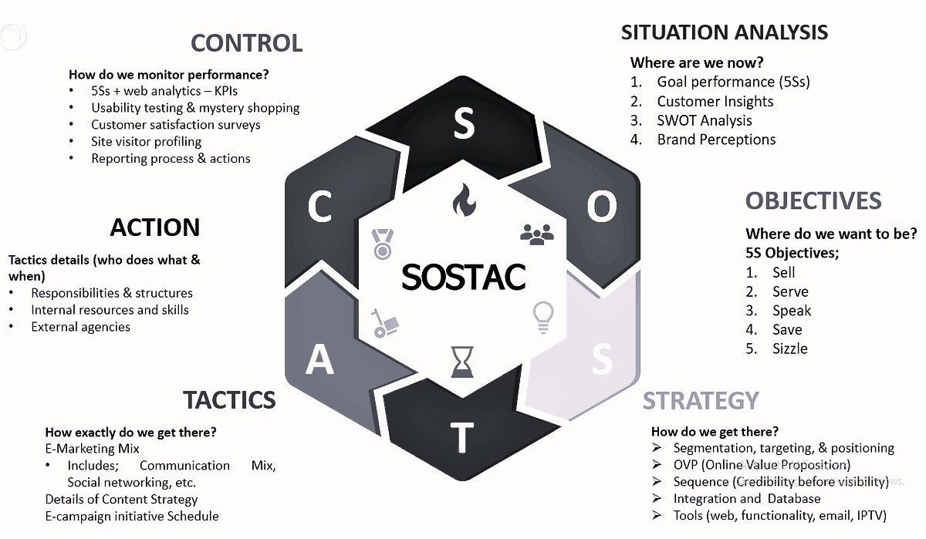

- Situation Analysis:

- s
- Assess Nike's current sustainability initiatives, including environmental and social impact.
- Analyze the company's carbon footprint, waste management, and ethical labor practices.

- Market Trends and Regulatory Landscape:
- Identify emerging trends in sustainable practices within the sportswear industry.
- Analyze global regulations and standards related to sustainability in manufacturing and supply chains.

- Objectives:

- Short-term Objectives:

- Reduce carbon emissions by a certain percentage within the next 12 months.
- Increase the use of sustainable materials in manufacturing by a specific percentage.

- Long-term Objectives:

- Achieve carbon neutrality by a defined future date.
- Establish a closed-loop product lifecycle, promoting circular economy principles.

3. Strategy:
- Product Innovation:

- Invest in research and development for sustainable materials and production methods.
- Design products with a focus on durability, recyclability, and reduced environmental impact.

- Supply Chain Sustainability:
- Collaborate with suppliers to ensure ethical labor practices and reduce the environmental impact of the supply chain.
- Implement a sustainable sourcing strategy for raw materials.

- Carbon Offsetting and Reduction:
- Invest in renewable energy sources to offset carbon emissions.
- Implement energy-efficient practices in manufacturing facilities.

4. Tactics:
- Communication and Transparency:

- Develop a comprehensive sustainability report to communicate efforts and progress transparently.
- Utilize marketing and communication channels to raise awareness about sustainable products and practices.

- Partnerships and Collaborations:

- Forge partnerships with environmental organizations to amplify the impact of sustainability initiatives.
- Collaborate with industry peers to share best practices and drive collective change.

- Employee Engagement:

- Educate and engage employees on sustainability goals and practices.
- Implement internal programs to encourage sustainable behavior within the workforce.

5. Action:
- Implementation Plan:
- Create a timeline for the rollout of sustainability initiatives.
- Assign responsibilities to specific teams or individuals for each aspect of the plan.

- Pilot Programs:

- Launch pilot programs to test the feasibility and impact of new sustainable practices.
- Gather feedback from customers and stakeholders to refine initiatives.

6. Control:

- Monitoring and Measurement:

- Establish key performance indicators (KPIs) to track progress.
- Regularly monitor and assess the impact of sustainability initiatives.

- Feedback Mechanism:

- Implement a feedback loop to gather input from customers, employees, and stakeholders.
- Adjust strategies based on feedback and changing market dynamics.

- Conclusions:

- According to Curtis, & Hansson, (2019), despite the positive intentions behind Nike’s sustainability movements similar to ‘refresh, rethink and recycle’, they might not necessarily have good impact on environment due to the fuel consumption for bring to the Nike shop and resending to the customers emits carbon-dioxide in the atmosphere and polluting it.

- Emotional campaigns b Nike seem to become popular trend bringing a lot of brand value to Nike. The company became successful to create a brand reputation of ‘a brand with a purpose’. It touches the sentiments of its customers by associating with positive motivation and inspiration.

- Compared to its income, Nike is spending merely 8% on marketing. This can be improved by investing more in digital and social media marketing. Because, apart from featuring this area in some of the videos on their YouTube channel, it has not spread much of environmental and sustainability awareness among consumers or to gain a brand reputation in this area. Although having large following on social media, their videos have very limited views.

- ‌According to Feitelberg, (2021), Nike promoted the commitment to increased female workforce participation and include diverse workforce participation. But Waymer, & Logan, (2021) argues that such promotions by Nike comes only after the consumers start expecting it. Hence these campaigns appear to be their promotional tactics more than an actual effort.

- Recommendations:

References:

- BCG (2022). Most Innovative Companies 2022: Are You Ready for Green Growth? [online] BCG Global. Available at: https://www.bcg.com/publications/2022/innovation-in-climate-and-sustainability-will-lead-to-green-growth.
- Booker, B. (2020). The 5 ingredients of a Nike marketing campaign. [online] Attest. Available at: https://www.askattest.com/blog/articles/the-5-ingredients-of-a-nike-marketing-campaign.
- Brody, E. (2023). Branding being true: visibility politics and Nike’s engagement with LGBTQ+ communities. Communication and Critical/Cultural Studies, 20(4), 416–434. https://doi.org/10.1080/14791420.2023.2272834
- Curtis, A., & Hansson, A. (2019). Examining the Viability of Corporate Recycling Initiatives and Their Overall Environmental Impact: The Case of Nike Grind and the Reuse-A-Shoe Program. Case Studies in the Environment, 3(1), 1–7. https://doi.org/10.1525/cse.2019.001974
- DeLong, M. (2009). Innovation and Sustainability at Nike. Fashion Practice, 1(1), 109–113. https://doi.org/10.2752/175693809X418874
- Epstein, M. J., Buhovac, A. R., & Yuthas, K. (2010). Why Nike kicks butt in sustainability. Organizational Dynamics, 39(4), 353–356. https://doi.org/10.1016/j.orgdyn.2010.07.007
- ‌Feitelberg, R. (2021). Nike Evaluates Its Diversity, Sustainability. WWD, 11–11.
- Grow, J. M. (2008). The Gender of Branding: Early Nike Women’s Advertising as a Feminist Antenarrative. Women’s Studies in Communication, 31(3), 312–343. https://doi.org/10.1080/07491409.2008.10162545
- Johnson, G., Whittington, R., & Scholes, K. (2012). Fundamentals of strategy (2nd ed.). Financial Times /Prentice Hall.
- Kobayashi, K. (2012). Corporate Nationalism and Glocalization of Nike Advertising in “Asia”: Production and Representation Practices of Cultural Intermediaries. Sociology of Sport Journal, 29(1), 42–61. https://doi.org/10.1123/ssj.29.1.42
- Kotler, P., Armstrong, G., Harris, L.C. and He, H. (2020). Principles of Marketing. 8th ed. Harlow: Pearson.
- LinkedIn (n.d.). Neol Kinder. [online] Available at: https://www.linkedin.com/in/noel-kinder-148b521b4
- Marketline (2021). Nike, Inc. Value Chain Analysis MLVC002-016. [online] Uwtsd.ac.uk. Available at: https://advantage-marketline-com.ezproxy.uwtsd.ac.uk/Analysis/details/nike-inc-value-chain-analysis-138061.
- Marmol, T. del, & Feys, B. (2015). PESTLE analysis (C. Probert, Trans.). Lemaitre Publishing
- Mollenkamp, D. (2023). What is Sustainability? [online] Investopedia. Available at: https://www.investopedia.com/terms/s/sustainability.asp.
- Morrison, J. (2020). The Global Business Environment: towards sustainability?
- Nike (2019). Fair Labor Association Reaccreditation. [online] Nike.com. Available at: https://about.nike.com/en/newsroom/resources/fair-labor-association-reaccreditation-2.
- Nike (2023). Nike. Just Do It. [online] Nike.com. Available at: https://www.nike.com/gb/.
- Nike aims for zero waste. (2010). Waste & Recycling News, 15(21), 5-.
- Nike and Newlight collaborate to research carbon-negative material. (2021). Shoe Intelligence, 32(35+36).
- Noby-Williams, E. (2019). How Nike Started a Sneaker Arms Race. In Bloomberg Businessweek (Issue 4637, pp. 16-). Bloomberg L.P.
- Porter, M. E. (1998). Competitive strategy: techniques for analyzing industries and competitors: with a new introduction (1st Free Press ed.). Free Press.
- Remes, J., Manyika, J., Smit, S., Kohli, S., Fabius, V., Dixon-Fyle, S. and Nakaliuzhnyi, A. (2021). The consumer demand recovery and lasting effects of COVID-19. McKinsey & Company. [online] Available at: https://www.mckinsey.com/industries/consumer-packaged-goods/our-insights/the-consumer-demand-recovery-and-lasting-effects-of-covid-19.
- Rittenhouse, L. (2023). Ad Age A-List Awards 2023; Initiative’s big bet on performance marketing pays off with Nike, new clients. Advertising Age, 94(4), 34-.
- Sanders, W. S., Phillips, S. G., & Alexander, C. (2017). “Native” Advertising: An Evaluation of Nike’s N7 Social Media Campaign.
- Smaller footprints for Nike. (2001). In Business, 23(5), 8-.
- Standaert, W. (2022). Product digitalization at Nike: The future is now. Journal of Information Technology Teaching Cases, 12(1), 28–34. https://doi.org/10.1177/2043886920963286
- Study.com. (2022). Available at: https://study.com/learn/lesson/kurt-lewin-force-field-analysis.html.
- Thiele, L. Paul. (2013). Sustainability (1st ed.). Polity Press.
- Tighe, D. (2022). Nike ad spend worldwide 2014-2019 | Statista. [online] Statista. Available at: https://www.statista.com/statistics/685734/nike-ad-spend/.
- United Nations (1987). Sustainability. United Nations. [online] Available at: https://www.un.org/en/academic-impact/sustainability.
- Waymer, D., & Logan, N. (2021). Corporate social advocacy as engagement: Nike’s social justice communication. Public Relations Review, 47(1), 102005-. https://doi.org/10.1016/j.pubrev.2020.102005
- www.linkedin.com. (n.d.). 5 Nike Marketing Campaigns That Changed the Game. [online] Available at: https://www.linkedin.com/pulse/5-nike-marketing-campaigns-changed-game-banhisha-kundu.
- www.nike.com. (n.d.). Never Done Inspiring: Ad Revolution. [online] Available at: https://www.nike.com/gb/a/never-done-inspiring-ad-revolution.
- www.youtube.com. (n.d.). Nike - YouTube. [online] Available at: https://www.youtube.com/@nike.

