
University of Wales Trinity Saint David (UWTSD)
Paper Title:
Ludo-Narrative Dissonance can be utilised as part of Game Design

Course of Study: BA(Hons) Creative Computer Games Design
Academic Year: 6
Author: Ben Russell – P141534
Supervisor: Julian Hainsworth
Word Count: 5983

Declaration of Originality
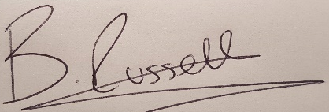
I Ben Russell declare that this submission is my own work and that, to the best of my knowledge and belief, it contains no material previously published or written by another person, except where due acknowledgement is made in the thesis.

Signed ……………………………………………………………………………………………………………………………………

Table of Contents

Table of Contents 2
Chapter 1 - Introduction 3
Chapter 2 - Literature Review 4
Chapter 3 – Research 7
Origins of ludo-narrative dissonance 7
Research/Literature against ludo-narrative dissonance 11
Research/Literature for ludo-narrative dissonance 15
Chapter 4 - Conclusion 19
References 20
Bibliography 22

Chapter 1 - Introduction
The purpose of this study is to identify if the presence of ludo-narrative dissonance can be utilised in a positive way within a games design process. The study was motivated by an interest in the effects the dissonance holds within the games experience, due to the medium of gaming being unique from others as it poses two structures that are mechanics and narrative. Current literature for this topic has been well-established to form the structure and key areas within this study.
The first topic discussed focuses on the first instance where ludo-narrative dissonance was identified, this was from an academic blog critique based upon the video game ‘Bioshock’, in order to understand how its presence within the game had affected the author’s experience.
The second topic focuses on the debates that took place after the critique was published, allowing others within the field to voice their opinions on ludo-narrative dissonance and what effect it holds within games. With the majority of those opinions suggesting to design games focusing on creating harmony between the ludic and narrative structures, therefore eliminating dissonance.
The third topic focuses on a separate opinion to these debates in which arguments are made for ludo-narrative dissonance rather than against. To be purposely influenced within the games design to create deeper immersive narratives that also harmonise with the mechanics.
Although the conclusion that has been reached is not definitive, the research carried out and examined in this study may offer understanding to the subject matter towards the reader and the effects it holds within the media. Recommendations are given for further work that could be carried out in order to develop a definitive conclusion for this topic.

Chapter 2 - Literature Review
The purpose of this study is to identify the hypothesis of whether ‘Ludo-Narrative Dissonance can be utilised as part of game design’, this will be achieved through a range of research into the topic. The information will then be analysed to identify whether the hypothesis can be proven or not.
Firstly, what does the term Ludo-Narrative Dissonance mean?
The term can be broken down into three categories as defined in the Oxford Online Dictionary;
- Ludology - is the study of games and gaming,
- Narrative - is a spoken or written account of connected events, a story
- Dissonance - a lack of agreement or harmony between people and things.
(Online Oxford Dictionaries, 2000)
With this definition focused on game designs, it is when the mechanics of the game being its ludic structure is dissonant with its narrative structure therefore relaying conflicting information to the player and so breaking emersion from the experience in a negative way.
This study will try to identify if ludo-narrative dissonance can be purposely used within the game design phase in a way to improve game experience in a positive factor.
It is stated that Neumann & Morgenstern (1994) were the first to discuss games from a research prospective in the form of science through a mathematical foundation of economics. However, this form was later ignored within the field for half a century due to the nature of the task being unknown. (Lennart, 2009). With the time passing a new form of researching games as a media was used to study this field, the form of literary theory and narratology from the published Finnish version in Parnasso, Helsinki (1999). This was used to help understand cyber texts along with video games. There were several perspectives taken that have been used to study the subject from Aristotelian Poetics (Laurel, 1993) to Russian Formalism (Porush and Hivner, n.d) to Post-structuralism (Landow, 1992). This way of researching games is used as it shares some aspects in comparison to narrative or drama in the form of sharing elements of characters and chained actions of events among others. However, there is one fundamental issue with this way of analysing. As video games are unlike any other, due to them holding two forms of structures being the mechanics and the narrative, separate but together within one. With this in mind it makes researching the new media challenging as Espen Aarseth states;
"To claim that there is no difference between games and narratives is to ignore essential qualities of both categories. And yet, as this study tries to show, the difference is not clear-cut, and there is significant overlap between the two." (Aarseth, 1997)
Therefore the area of study has adapted its own terminology to specifically focus in the field of video games study, from which the term Ludology has driven by Gonzalo Frasca in 1999. Frasca states
“[…] narratology has to be invented to unify the works that scholars from different disciplines were doing about narrative. The research about games and play is in similar situation…we will propose the term ludology […] to refer to the yet non-existent discipline that studies game and play activities”. (Frasca, 1999). The term ludology was driven from the Latin word ludus meaning game and the Greek word logos which in turn has multiple meanings but the focus would be translated to reasoning, science and measurement. In this context, for this thesis the term ludology will be used as a scientific measurement of activity within video games based on experimental data.
The concept of ludology is used to identify the relationship between the mechanics and narrative in video games by identifying similarities and differences between the both structures. Ludology states a defined set of events that must be achieved for progression within the game and, that these events can be translated to different players from different diversities to understand. Without these events there would be no structure, an example that Gonzalo Frasca utilises is football. The flow of such events would be based upon:
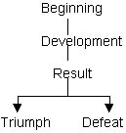
(Frasca, 1999)

This form of flow event would be the basis of the ludology for the beginning to give the player the knowledge of the games rules to achieve the triumph state, this being a football game would be the player with the highest score determined by goals. The next phase of development would be the section in which the main part of the game is being played following the beginning rules to achieve the highest score in order to reach the last stage of results. This will identify which player followed the games rules and achieved the triumph result, leaving the other player with the defeat result.
This foundation of rules and events are the structure for games, this would then be compared to the ‘Agent Scheme’ of Claude Bremond’s “Logique du recit” (Bremond, 1973). In turn his work that was a continuation of the character theory thesis by the author, Vladimir Propp, stating that every character in the narrative falls within 7 functions out of the 100 tales he analysed. This was then utilised by Bremond through the means of focusing on the minimal elements within the narrative. He bases his work on the different narrative roles within the agent scheme, this flow suggests the possible narrative choices for the agent;
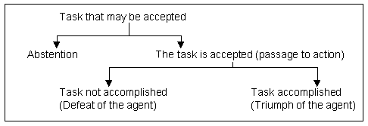
(Frasca, 1999)

Comparing both flow charts of the ludology and the narrative there are noticeable similarities with the exception of the abstention branch which could be used in the ludic flow as a form of the player not intending to play further.
Firstly the Bremond agent scheme does not represent the narrative itself but merely the possible narratives that are available to the author whilst creating the story. There is only a narrative to a story once the author has decided which path of the entire scheme is taken and from that the sequences of the narrative can be chosen and built. In comparison to the ludology scheme, the player is given a choice of paths thus changing the possible outcomes of narrative within.

Chapter 3 – Research

Origins of ludo-narrative dissonance
The terminology of ludo-narrative dissonance was first stated and coined by an academic writer/directive, originally the creative director for Lucas Arts in 2010 and now a creative director for Ubisoft Toronto, Clint Hocking. On his personal blog site ‘Click Nothing’ in a segment titled ‘Ludonarrative Dissonance in Bioshock’ of which is his critique based upon the first person shooter, video game ‘Bioshock’ published in 2007, (Hocking, 2007) The game was developed by 2K Boston (later Irrational Games) and 2K Australia and published by 2K Games in August 2007 (2K.com, n.d). Hocking states;
“Bioshock seems to suffer from a powerful dissonance between what it is about as a game, and what it is about as a story […] all but destroys the player’s ability to feel connected” (Hocking, 2007)
This in turn addresses the presence of dissonance between the narrative structure compared with its ludic structure based on his own game experience that other players may have too. This presence as said by Clint Hocking “destroys” the players immersion by having the both structures contradict each other therefore, pulling the players self out of the games situation to reflect from self-perspective as an external entity of the game rather than from the games character. How the game does this will be described later on but for the first half of the game the player experiences it in the form of self-interest ideology by controlling the games player character known as ‘Jack’ in his objective to escape the games world known as ‘Rapture’. He achieves this by eliminating enemies in his way that pose a threat to his survival. This form of self-interest is the utilised and common form within the industry as it’s a simple conveyance of survival for the player. Hocking states;
“Bioshock is a game about the relationship between freedom and power. It is […] criticism of Randian Objectivism” (Hocking, 2007).
Randian Objectivism is a philosophical system developed by Russian-American writer Ayn Rand of rational individualism in her novels such as ‘The Fountainhead’ and ‘Atlas Shrugged’. Ayn Rand states the meaning of Objectivism is;
“My philosophy, in essence, is the concept of man as a heroic being, with his own happiness as the moral purpose of his life, with productive achievement as his noblest activity, and reason as his only absolute." (Rand, 2010).
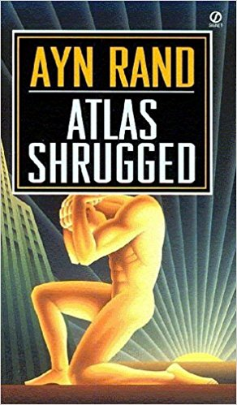
(Rand, 2010)

Therefore, the core of the term lies with the ideology that all of humanities moral purpose is the pursuit of self-interest, by pursuing one’s own happiness referred to as ‘Rational Self-Interest’ and that the social constructs humanity have put in place are only there to help us achieve that. The word ‘Objectivism’ derives from the idea that all of humanity’s knowledge and values are objective. Their existence is based upon humans own reality of thought and that the individual’s goals are determined by one’s own knowledge and values. Referring this back to the game Bioshock, it could be stated that the game is a direct reference to Ayn Rands novel ‘Atlas Shrugged’. Since in her novel we follow the path of a character known as ‘John Galt’, a genius engineer who proposes that the world’s industrialists leave their roles to escape from the socialist ideology that does not care for the hard work they have individually achieved. Galt and the other industrialist retreat to a state known as ‘Galt’s Gluch’, this could be interpreted that this location is the embodiment of ‘Rapture’, which is the games environment and therefore, Andrew Ryan as the embodiment of John Galt. Another link would be the character’s name ‘Andrew Ryan’ suggesting an anagram of Ayn Rand and again with the title of the novel being Atlas Shrugged and in turn the second primary character within the game being known as ‘Atlas’. Atlas character within the game poses as an unknown figure guiding the player through Rapture in order to escape, but only if the player aids him in rescuing his family from capture (Sunderman, 2016). Thus with the overall similarities regarding the games source material it would be suggested that the ideology the player has within the game follows an objective approach from the ludic structure.
As part of the ludic structure there are sections within the game that allow the player the option on how to proceed. This is done through the form of harvesting or saving the characters known as the ‘Little Sisters’. By harvesting them the player will receive in-game currency known as ‘Adam’ in which the player is able to purchase upgrades and other items, this also follows the same ideology that the player’s character would pose of self-interest following the objectivism approach. But the player is also given the choice to save them in return for items later on, although this would be contradictory to how the player characters ideology stand on self-interest. However, it could be argued that it is justified due to the game allowing the player the choice between the two actions.
Yet the games narrative structures overall purpose is to aid Atlas in order to escape Rapture. Hocking states;
“There are three fundamental problems with this being the narrative contract of the game […] First, this contract is not in line with the values underlying Randian rational self-interest […]”. (Hocking, 2007).
This statement identifies that helping someone else is a contradiction to the objectivism ideology of self-interest, in which the player has been following thus far by eliminating enemies that pose as obstacles and by harvesting the little sisters for more ‘adam’. Therefore, helping Atlas would go against the starting principles the player has been taught by the game.
“Second, Atlas is openly opposed to Ryan […]” (Hocking, 2007).
Following from the knowledge that Ryan shares the same ideology of objectivism as the player has adopted from the mechanics and overall objective to leave. This is then conflicting as to why helping another like Atlas would be to the players best interest. The game states that helping Atlas will help you to escape Rapture but at no point does it feel that the player has a choice whether they wish to help him or not, which is the case in this game.
“Thirdly, I don’t have a choice […]” (Hocking, 2007)
Comparing the two structures being the ludic and the narrative within the game. The ludic structure allows the player with the freedom of choice whether they would continue with the objective ideology by harvesting the little sisters or to follow their own particular approach through saving them. That choice is available to the player, but compared to the narrative structure in which to begin with, followed the same objective approach through the player maintaining survival by eliminating threats to then reverse the character approach to aid another. The negative effect this has on the overall experience that Hocking is stating is due to the fact the player does not have a choice in the matter, their freedom to choice the narrative path does not exist. Forcing the player to either accept the change even if they are against it, in which most players would be. Or as Hocking states “[…] I can stop playing the game, but that’s about it.” (Hocking, 2007).
It is then identified to the player that Atlas had been manipulating the player all along through a hypnosis that triggers when the phrase ‘Would you kindly’ is being said. From which the whole purpose of this was for Jack to kill Ryan under Atlas’ command. So with the game not allowing the player the choice for the narrative structure forcing them to follow on even if felt otherwise, to then have the game openly mock the player for following that exact same structure that was dictated to them, it becomes insulting towards the player for willingly suspending their disbelief to progress to then be mocked for it. It’s even worse within the media of games due to players spending countless hours to reach the end of a game with an average time of 15 hours to complete Bioshock (Gamelenghts.com, 2014) to then be mocked by it.
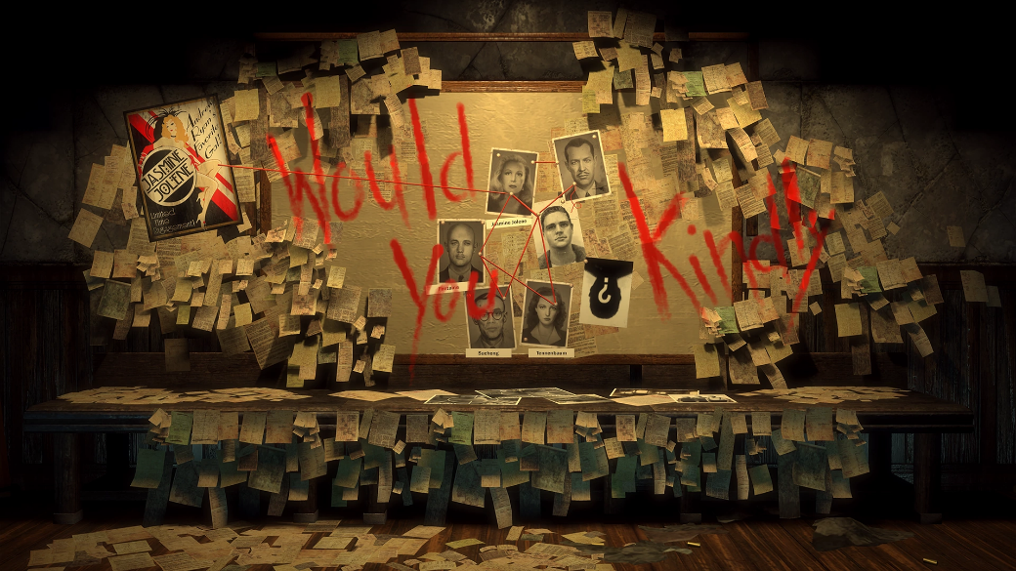
(Bioshock, 2007)

This negative form of dissonance has painted the view for most readers of the effects it can have within a game due to this being the first evidence of its term and thesis. This then lead to several literatures voicing their opinions on the thesis and what should be done about it.

Research/Literature against ludo-narrative dissonance
Following Hockings critique, there has been several debates and research from others across different fields giving their point of view on the effects that ludo-narrative dissonance holds within the games industry and, how it can be addressed. Hockings ideology influenced a negative approach to the field. This may have led to the reason why the majority of literature produced surrounding this subject has a negative reflection. In some cases the term ludo-narrative dissonance has been mocked and shunned by the industry and in the academic field.
An example of this can be seen in a ‘Eurogamer’ blog post written by news editor/writer Jeffery Matulef where he points out that developers ‘Naughty Dogs’ popular game ‘Uncharted 4: A Thief’s End’, has an achievement that players are able to achieve after killing 1000 enemies. The title for this achievement is called ‘Ludo-Narrative Dissonance’. This comes as a direct response to the complaints the game has been under through the act that Nathan Drake (the protagonist) portrayed as an all-around stand up, jovial kind of guy is able to effortlessly kill countless enemies without any effect on the characters state. An interview with Neil Druckman the Creative Director (alongside Bruce Straley) of ‘Uncharted 4: A Thief’s End’ states;
“I told all the people on the team, “This is my proudest moment […]” (Druckman, 2016)
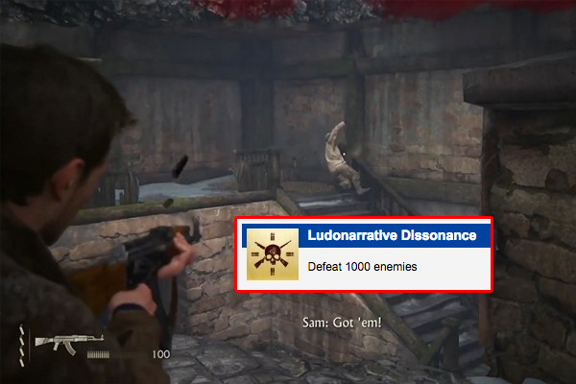
(Uncharted 4: A Thief’s End, 2016)

The fact that he states it’s his “proudest moment” suggests that to him, it’s presence within the game has no impact or real effect to the overall experience of the game, due to it still being successful within the industry and with consumer sales. Bearing in mind, the presence of dissonance was seen in its first instalment back in 2007 to give a period scale to the issue. This gives a basic understanding on how the ludo-narrative thesis is perceived within this companies games with a basic acknowledgement of it being within their franchise, however don’t believe it will change anything about it but do embrace it through mockery.
Brett Makedonski managing news editor for the Destructoid blog post, has points on ludo-narrative dissonance that follow the same suit as Hocking but believes it could be a state of emersion that is triggered by a semiotic mismatch between play and narrative, compared to Hockings who states that there is a clear opposition between the two structures. Makedonski states;
“Therein lies the biggest roadblock to ludo-narratively consistent games: the developers, themselves.” (Makedonski, 2012)
He believes that ludo-narrative dissonance should be avoided by all cost and that the future for games should focus on creating ludo-narrative harmony, in turn, the opposition of dissonance. His example of such a game is Dead Space, of which is a science fiction, survival horror game where the player controls an engineer who fights reanimated human corpses on a mining starship in order to escape. Both the gameplay and the narrative are in sync as the gameplay conveys the sense of fear and terror through its mechanics, whilst the narrative poses as a base for those emotions. It also focuses on a liner fashion therefore minimising the affect the player has on external choices to lower the risk of the dissonance. According to Makedonski, future developers have two options to utilise in order to minimise the occurrence of this dissonance within their games.
The first option being a game in which every players actions has a response within the games mechanics and narrative, therefore there wouldn’t be any pre-made narrative created by the development team, but by allowing the players actions to create their own individual narrative. This follows the thesis of the ‘Butterfly Effect’, a concept invented by Edward N. Lorenz to highlight that small causes may have momentous effects (Tech Talk, 2008). As great as this sounds, this solution is near impossible with the current software and technical limitations. Let alone the fact that every aspect of a possible narrative would need to be thought of by the developers, meaning every possibility that could occur in any given order would need to be planned and made possible within the games mechanics. It would take years for a game with so many possible outcomes to be developed.
The second solution is for the game to give the player little to no control over any decisions within the games narrative to ensure that what the developers had intended to portray is the only outcome possible. With this solution the player is restricted to the path the developers have planned for them, regardless of their ideology or beliefs and therefore solely down to the developers to ensure that the dissonance would not occur. This solution would be achievable but as Makedonski states
“Is it worth taking the freedom of decision […] all in the name of eliminating ludonarrative dissonance?” (Makedonski, 2012).
Ultimately both solutions have no real positive impact into tackling the presence of ludo-narrative dissonance without either being impossible to implement with current technology limitations or, by removing player freedom of choice along with it. Therefore how its presence could be tackled? Could this be the time for implementing it within the games designs to utilise its presence to unite and form a better alternative?
Another point on this thesis comes from managing news editor for the GameCloud blog post, Nick Ballantyne. He explains that there are two forms of dissonance that are often mistaken with each other that is causing conflicting ideas on the subject matter, those terms being cognitive dissonance and ludo-narrative dissonance, he states;
“When confronted with cognitive dissonance (i.e., our beliefs and actions not lining up) […] people can cope in a few ways. If someone’s actions conflict with their beliefs, they can change their beliefs, […], but ludo-narrative dissonance […], it’s about the system’s imposed beliefs.” (Ballantyne, 2015)
Reinforcing the same ideology, Hocking has stated that with cognitive dissonance the person (player) has the choice of which approach they wish to follow, yet if you were to compare this form with ludo-narrative dissonance you as the person would have to adopt the play style the game has already chosen for you, therefore you are at the mercy of the game rather than being in control.
Ballantyne expresses similarity to Hocking, the player is able to justify the dissonance within the game by simply giving excuses for it, “it’s an intentional purpose for that there” “Well it’s not game breaking...” but that then leaves the player to justify its existence by simply avoiding it because they are not given the chance to do anything otherwise. Ballantyne states;
“[…] we’re left to justify the dissonance, something we might not have the patience or tolerance to do.” (Ballantyne, 2015)
And so majority of the literature surrounding this term gives a negative reflection of its presence within games and in so have given paths to remove or avoid it being present in further games. But could all these pieces of work have a bias form?
Federic Seraphine a PhD candidate for game design wrote about the possible biases within the literature surrounding ludo-narrative dissonance, he states;
“[…] most of the articles making this assumption also seem to suffer from what could be called the “avatar bias”.” (Seraphine, 2016)
An avatar as defined by the Online Oxford Dictionary is “an icon or figure representing a particular person in a video game, internet forum, etc.” (Online Oxford Dictionary, 2000) meaning that the literature that is suffering from this avatar bias is stating that the character the player controls within the video game is considered always as the player themselves. This can be seen throughout the specific wording from the literature. With Ballantyne stating;
“[…] your avatar is mulling over the loss of his companions […] Five minutes later, you’re blowin’ dudes up without hesitation […].” (Ballantyne, 2015)
The clear connection between the “your avatar” and “You’re blowin’ duded up” statements are suggesting they are the same entity, that the player is the avatar within the game. The same goes for Makedonski stating;
“[…] if the player wanted to act purely out of their own self-interest, they simply couldn’t […] anyone in this position had to merely accept that […]” (Makedonski, 2012)
Even within Hockings critique of which originated the term and talks, Hockings literature is full of self-referral with statements of;
“[…] it is best if I do what is best for me […].”
“[…] until I find myself […]”
“[…] If I reject that approach […]”
(Hocking, 2007)
For first person games this could be justified as you play from the prospective of the avatar and would suggest that all actions are done through yourself such as the case in Bioshock. But for other forms of games such as third person games playing from the behind prospective, does the player still feel as if they’re the avatar? If the player separates themselves from the avatar would the ludo-narrative dissonance presence still be there? And if it doesn’t then this would be classed as a cognitive dissonance instead. Therefore the negative assumption of the term could be classed from these avatar biases and in doing so tainted the meaning and understanding of it. So would a game that purposely utilises ludo-narrative dissonance within their design be such a bad thing?

Research/Literature for ludo-narrative dissonance
Although Ballantyne talks about the negative impact ludo-narrative dissonance has within the game towards to player’s experience, he also states;
“Then again, it might not be the worst thing in the world to, you know, be forced to think why it’s there.” (Ballantyne, 2015).
The media of video games is unlike any other due to the fact that there are two distinct structures, those being the ludic and the narrative. With the games having two structures its unlikely other forms of media are able to create dissonance regarding the player beliefs. Yet the industry does not utilise this unique key factor, Ballantyne states;
“[…] game designers have been reluctant to take advantage of ludonarrative dissonance as a storytelling tool.”(Ballantyne, 2015).
The purpose of using the thesis as a narrative impactor could be in the case of placing the player in uncomfortable situations, therefore to effect the player themselves. Although in theory this is a possibility, it also highly depends on the players themselves and how they react to the dissonance, as every person would react differently depending on the individual. This would require the development team to determine the exact response the player will have to those situations. Too noticeable and the player would feel mocked, too ambiguous and the element may be lost.
Another form of dissonance Ballantyne states that has successfully been used are ‘Faux Glitches’. Faux Glitches as defined from the Oxford Online Dictionaries, Faux meaning “Not genuine; fake or false.” and Glitches as “A sudden, usually temporary malfunction or fault of equipment.” (Online Oxford Dictionaries, 2000). These are instances in games where the development team have intentionality implemented fake malfunction to disconnect the player. An example of this can be seen in the game ‘Eternal Darkness: Sanity’s Requiem’ developed by ‘Silicon Knights’, published by ‘Nintendo’ in ‘2002’ (IGN, n.d). The use of faux glitches were determined by the games sanity level, this level represents the player avatars sanity within the game. This level decreases when the player is in certain situations that would cause stress to the avatar, such as darkened rooms, or being noticed by enemies. As the sanity level decreases the faux glitches start to appear with different representations more frequently the lower the level, such as;
- The game crashing with a blue screen error.
- Volume decreasing showing the Television properties.
- Deleting all saved data.
- The player’s avatar able to shoot bullets at the screen.
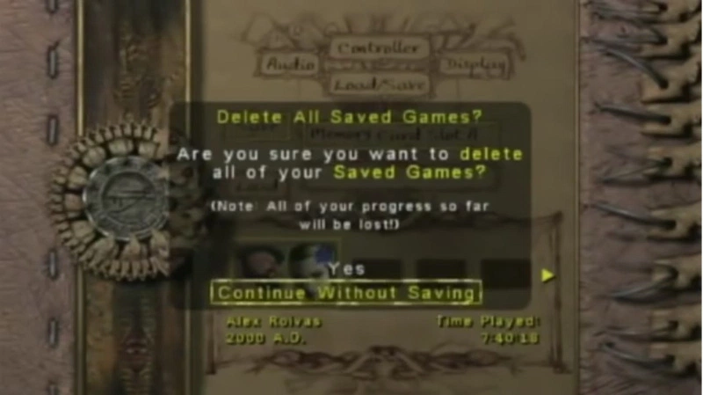
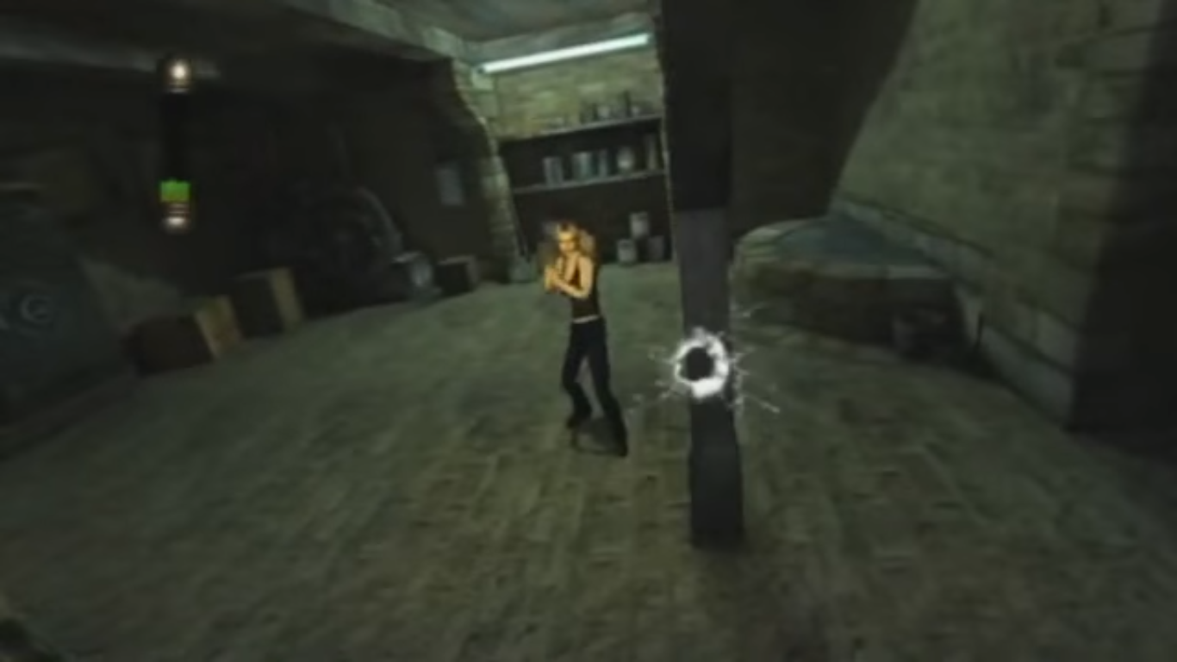
(Eternal Darkness: Sanity’s Requiem, 2002)

These instances within the game add another level of depth of experience for the player to feel truly a part of the games features as if their own sanity is affected. Although the game did not commercially succeed, its design features had won the game several awards including the ‘Outstanding Achievement in Character or Story Development’ awarded at the 6th Annual Interactive Achievement Awards in 2003 (Web.archive.org, 2008) along with other rewards. Therefore, with the success from these faux glitches perhaps the use of ludo-narrative dissonance could pose that same emerged experience to create more compelling narratives within games. Ballantyne states;
“[…] I can smell the storytelling potential. […] Mind you, when it’s bad, it’s obvious, […]” (Ballantyne, 2015).
Frederic Seraphine published an article in 2014 titled; “The intrinsic semiotics of video-games: in search of games’ narrative potential” which analyse how games handle their narratives. A section within focuses on the design perspectives of these semiotics within games, Seraphine gives an example of conveying meaning through gameplay that changes and evolves with further progression, he states;
“What if this ability to shoot depend on other parameters? […] Parameters that would tell something about the personality of the character?” (Seraphine, 2014)
These parameters could pose the dissonance between the player and avatar through differences of choice. For example if the player tries to shoot an animal that the games avatar personality would not typically do, then the game would restrict the player from shooting that animal. This would then indicate to the player that the avatars personality has a specific set of rules that the player must acknowledge in order to progress efficiently. Therefore, separating the player from the avatar within this games experience. Although this comes back to the previous point made by Ballantyne that the player is left at the behest of the game, and that the development team would need to ensure that the justification the player decides is exactly what they had planned, which in itself is a tricky task to design.
Serahpine also mentions that the parameters used could also factor as a challenge element within the game. If the avatars morals state that they will not kill women, yet the enemy units are women characters, how would the games avatar overcome this? Would they reconsider their morals at this point? Or would the player need to overcome this challenge keeping the avatar morals in mind? (Seraphine, 2014).
Another outlook on this, focusing on the player and the games avatar being one follows the case study by Karen Stanley for her degree, titled ‘Ludo-narrative Dissonance: Interlacing the Narrative and Ludic Structure Together In ‘The Last of Us’’ (2014).
She speaks about how the player and the avatar are the same entity and how the player is growing more knowledgeable with the world along with the avatar known as ‘Joel’, she states;
“For Joel we play out his emotions, his actions are our actions […], but for Ellie we must find our connection to her through Joel” (Stanley, 2014)
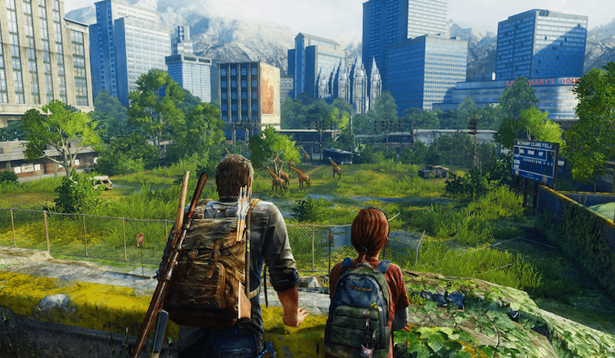
(The Last of Us, 2014)

The character ‘Ellie’ is an artificial intelligence (AI) companion of Joel’s that the player grows closer with as the game progresses, creating a relationship with the player and avatar. As the game progresses the player can see from Ellie’s body language that the character is growing more comfortable with Joel being further relaxed in his presence. Stanley suggests that scripted events are the most current form to solve ludo-narrative dissonance effects to which was stated by Jamie Kuroiwa in his blog post titled ‘Unscripting The Scripted Event’
“Scripted events are […] the current solution for gameplay versus story “dilemma”” (Kuroiwa, 2009)
These scripted events layout a structure for the players to notice how the relationship between Joel and Ellie is growing over time through the narrative and also the ludic structures. The instance within the game that emerges the player is through a mechanic that the player is taught and uses through the game, being to lift Ellie at a specific locations for her to aid in progressing.
Since the player is automatically aware of the mechanic, it comes naturally to them that Ellie would head over to help, yet in one sequence when Joel calls for Ellie she does not come. This is due to point in the narrative where Ellie is saddened and hurt by Joel, this sequence emerges the player from the game, wondering why this recurring mechanic is no longer working, and that Ellie’s lack of response must mean that there is something wrong. This leads to the player instinctively heading towards Ellie without any given prompts by the game.
This sequence is exactly the outcome the developers intended the player to feel and do through tying the relationship between Joel and Ellie with the player. This sequence only occurs once in the game therefore had not truly implemented dissonance throughout, but proves the point that it is possible to hide the games narrative directives within the ludic incentives by forcing the player to head towards Ellie without any indication. The player does this purely through emotion towards the character which also helps support the narrative, therefore tying the ludic and narrative structure as one through this instance of dissonance.
Both points offer a different perspective on implementing the dissonance, however they have one thing in common, which is to utilise the dissonance as an emotional trigger in the experience. As Ballantyne theorised to purposely put the player in uncomfortable situations, the same way faux glitches had done to break the immersion, which ties the players own self-identity into the game.
With ‘The Last of Us’ using a recurring mechanic stopping at a certain point within the game to emerge the player, the developers had intentionally planned for the player to react in that certain way. This is all achieved by using the player’s emotions as the trigger for the dissonance but also maintaining harmony with the ludic and narrative structure. As David Cage founder and CEO of ‘Quantic Dream’, stated during a panel at GDC Europe in 2013;
"You'll hear a lot of people telling you the future of games is technology, […] the future of games is emotion […]” (Cage, 2013 cited by Corriea, 2013).

Chapter 4 - Conclusion
This research was inspired by an interest to understand the impact both narrative and ludic have on a player experience as an entire media. The study sought to answer if ludo-narrative dissonance could be utilised as part of the game design process. The research uncovered a dive within the field of how it should be treated, in chapter 3 of which majority of the literature opinion is based, most advocate the termination of any dissonance within the experience by focusing on creating games that harmonise between the ludic and narrative structures as suggested by Makedonski. Yet in chapter 4 there are some within the field that advocate the purposely use of the dissonance to tell more interesting immersed narratives based from the games mechanics or through parameters of morals and decisions. With this section of conclusive research being relatively small there cannot be a clear answer to this studies question other than it has been done but to such a small scale it cannot truly be answer that it was the deciding factor, but the debate that took place over it has definitely had influence on how we perceive games as a medium.
Further research and work would need to be carried out in order to identify this studies answer. A form of primary research could be carried out following the release of an upcoming game called ‘Vampyr’ for 2018, in which the games avatar is a doctor by trait but also is a vampire who is forced to kill others to feed and survive. It could be seen as the game posing the dissonance between the characters traits through the directives of saving lives as the doctor, whilst also creating incentives of gameplay that may force the player to kill too survive. (Seraphine, 2014)

References
- 2k.com. (n.d.). 2K - Games - BioShock. [online] Available at: https://2k.com/games/bioshock [Accessed 24 Oct. 2017]

- Aarseth, E., 1997. Cybertext: Perspectives on Ergodic Literature. Baltimore. John Hopkins University Press.

- Bremond, C., 1973. Lógique du récit. Paris. Editions du Seuil.

- Click Nothing. (2007). Ludonarrative Dissonance in Bioshock. [online] Available at: http://clicknothing.typepad.com/click_nothing/2007/10/ludonarrative-d.html [Accessed 24 Oct. 2017]

- Corriea, R, A. (2013). The future of games is 'more meaning,' says David Cage. [online] Available at: https://www.polygon.com/2013/8/20/4639376/motion-capture-creates-more-emotionally-compelling-characters-says. Last accessed 01.11.17. [Accessed 04 Dec. 2017]

- Frasca, G., 1999. LUDOLOGY MEETS NARRATOLOGY: Similitude and differences between (video)games and narrative. [online] Ludology.org. Available at: http://www.ludology.org/articles/ludology.htm [Accessed 17 Oct. 2017].

- Gamelengths.com. (2014). GameLengths - Average Play Times for BioShock. [online] Available at: http://www.gamelengths.com/games/playtimes/BioShock/ [Accessed 26 Oct. 2017].

- IGN. (n.d.). Eternal Darkness: Sanity's Requiem. [online] Available at: http://uk.ign.com/games/eternal-darkness-sanitys-requiem [Accessed 24 Nov. 2017].

- Kuroiwa, J. (2009). Unscripting The Scripted Event. [online] Gamasutra.com. Available at: https://www.gamasutra.com/blogs/JaimeKuroiwa/20090515/83949/Unscripting_The_Scripted_Even [Accessed 01 Dec. 2017]

- Landow., George P., 1993. The convergence of Contemporary Critical Theory and Technology. London. The John Hopkins University Press.

- Laurel, B., 1993. Computers as theatre. n.l. Adison-Wesley Publishing Company.

- Lennart, E, N., 2009. Affective Ludology: Scientific Measurement of User Experience in Interactive Entertainment. Karlskrona. Blekinge Institute of Technology.

- Makedonski, B. (2012). Ludonarrative dissonance: The roadblock to realism. [online] Destructoid. Available at: https://www.destructoid.com/ludonarrative-dissonance-the-roadblock-to-realism-235197.phtml [Accessed 26 Oct. 2017].

- Palumbo, A. (2016). Naughy Dog Doesn't Get Ludonarrative Dissonance; Uncharted 4 Flashbacks Not Part of Original Pitch. [online] Wccftech. Available at: https://wccftech.com/naughy-dog-ludonarrative-dissonance-uncharted-4-flashbacks-part-original-pitch/ [Accessed 14 Nov. 2017].
- Porush, D., Todd, H., n.d. GÉNÉRATION DE RÉCIT ET THÉORIE DU JEU. VIKTOR SHKLOVSKY ET GAMEWORLD. No longer available: http://www.refer.org/textinte/littinfo/2_porush.htm

- Rand, A. (1957). Atlas shrugged. 1st ed. Random House.

- Oxford Online Dictionaries. (2002). English Dictionary, Thesaurus, & grammar help | Oxford Dictionaries. [online] Available at: https://en.oxforddictionaries.com/ [Accessed 04 Dec. 2017].

- Schneider, P. (1998). The Legend of Zelda: Ocarina of Time Review - IGN. [online] IGN. Available at: http://uk.ign.com/articles/1998/11/26/the-legend-of-zelda-ocarina-of-time-review [Accessed 30 Nov. 2017].

- Seraphine, F. (2014). The Intrinsic Semiotics of Video-Games: In search of games’ narrative potential. [Kindle version] KDP. DOI: 10.13140/RG.2.2.19968.02560/1

- Stanley, K. (2014). Ludonarrative Dissonance: Interlacing the Narrative and Ludic Structure Together in The Last of Us (Bachelor Dissertation, University of Hertfordshire). [online] Kazperstan.co.uk. Available at: http://kazperstan.co.uk/wp-content/uploads/2015/01/StanleyKaren_LastofUs.pdf [Accessed 1 Dec. 2017]

- Sunderman, P. (2016). Bioshock proved that video games could be art. [online] Vox. Available at: https://www.vox.com/culture/2016/10/3/13112826/bioshock-video-games-art-choice [Accessed 26 Oct. 2017].

- Tech Talk. (2008). 52nd ed 24Num. MIT Tech Talk, p.2.

- The Atlas Society. (2010). What is Objectivism?. [online] Available at: https://atlassociety.org/objectivism/atlas-university/what-is-objectivism/objectivism-101-blog/3366-what-is-objectivism [Accessed 24 Oct. 2017].

- Web.archive.org. (2002). GameSpot Presents: The Best and Worst of 2002 - GameSpot. [online] Available at: https://web.archive.org/web/20031124085527/http://www.gamespot.com:80/gamespot/features/all/bestof2002/gc3.html [Accessed 28 Nov. 2017].

- Web.archive.org. (2008). AIAS Annual Awards. [online] Available at: https://web.archive.org/web/20081220183659/http://www.interactive.org/awards/annual_awards.asp?idAward=2003 [Accessed 28 Nov. 2017]

Bibliography
- D'Argenio, A. (2017). Gameplay, narrative, and dissonance in 2017. [online] Gamecrate.com. Available at: https://www.gamecrate.com/gameplay-narrative-and-dissonance-2017/16748 [Accessed 6 Dec. 2017].

- Everybody's Talking at Once. (2013). A Brief History of Ludonarrative Dissonance as an Actual Thing. [online] Available at: https://etao.wordpress.com/2013/09/18/ludonarrative-dissonance/ [Accessed 6 Dec. 2017].

- Giant Bomb. (2017). What examples of "Ludonarrative dissonance" have you found? - General Discussion - Giant Bomb. [online] Available at: https://www.giantbomb.com/forums/general-discussion-30/what-examples-of-ludonarrative-dissonance-have-you-1484866/ [Accessed 6 Dec. 2017].

- The Escapist. (2012). The Escapist : Forums : Gaming Discussion : Essay: Ludonarrative Dissonance Explained and Expanded. [online] Available at: http://www.escapistmagazine.com/forums/read/9.389092-Essay-Ludonarrative-Dissonance-Explained-and-Expanded [Accessed 6 Dec. 2017].

- YouTube. (2013). LUGOSCABABIB DISCOBISCUITS (Jimquisition). [online] Available at: https://www.youtube.com/watch?v=W4Oe0ev8bjA&list=WL&index=4 [Accessed 6 Dec. 2017].

- YouTube. (2015). Errant Signal - The Debate That Never Took Place. [online] Available at: https://www.youtube.com/watch?v=xBN3R0m31bA&list=WL&index=1 [Accessed 6 Dec. 2017].

- YouTube. (2017). Great Video Games Use Ludonarrative Dissonance. [online] Available at: https://www.youtube.com/watch?v=dOFsDuhecuI&list=WL&index=9 [Accessed 6 Dec. 2017].

- YouTube. (2017). Ludonarrative Dissonance. [online] Available at: https://www.youtube.com/watch?v=04zaTjuV60A&index=3&list=WL [Accessed 6 Dec. 2017].

