Global Business Challenges (BMSP4001)

Coronavirus effect on Businesses

Victoria Beecham

Lector Anthony Burns

2.11.21

Global Challenging during
Covid 19
Coronavirus is a contentious topic that frequently splits people's opinions. “Covid 19 has quickly spread over the world since its discovery in China in December 2019, reaching over 200 countries.” (1) Covid 19 made its appearance in the British Isles in January 2020. Thousands of lives were lost as a result of the pandemic. Many people have grown unwell or have experienced the death of a loved one. In this piece, I will be discussing how Covid 19 has affected businesses around the world.

During the pandemic many Governments made the decision to put their citizens into lockdown in an attempt to prevent the spread of the deadly virus within their countries and thereby overwhelming their Health Services.
This resulted in only essential shops being allowed to remain open, and all other non-essential shops had to close.
The effect of this on the economies of these countries and on such industries as Retail, with essential shops such as supermarkets who saw a growth in their profits while those non-essential retail and industries such as Travel & Tourism saw the opposite, with some business being unable to continue and closing their doors for good.
Below is a graph which shows the comparison of gross earnings of the top 10 Food Retails pre and post Covid 19. (2)
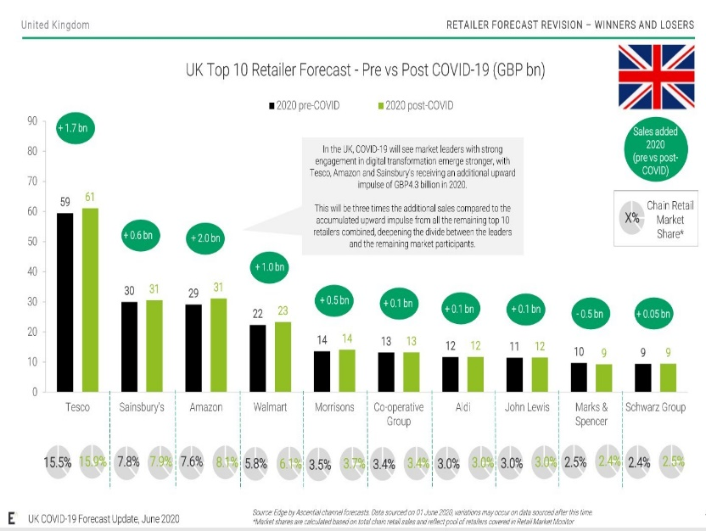

When news of the Pandemic and lockdown broke and due to human nature of being afraid of, and unable to control, the unknown many people started panic buying and stocking up on whatever essential goods that they could. This meant that they could stay in their homes and reduce the risk of contracting the virus.
This resulted in shops running out of goods and not being able to replenish them as prior to the pandemic and lockdown.
There are numerous reasons why the supply chains were not able to get their goods to the supermarkets on time, including having staff who had to self-isolate due to health conditions, the factories in which they operated were not large enough to be able to have all staff in at the same time, staff being caught out and being on holidays in other countries and unable to come back to the UK and staff who had already caught Covid 19 and where themselves ill at home or in hospital.
Even though supermarkets were thriving with their sales, they had to keep their staff and customers safe. Personal Protective Equipment (P.P.E), was required in all stores to ensure that all staff were kept safe, along with social distancing signage, hand steriliser, clear plastic screens and disinfecting spray to help control the virus.
Ways also need to be found and put in place to control the number of people coming into their premises, additional artificial intelligence equipment(self-scan) was introduced to enable customer to serve themselves which help with the queuing systems.
A member of staff was required to be on hand to control the flow of customers into the stores as there was a limit on the number allowed into premises at the same time.
Supermarkets found that their online services were being swamped every day by people trying to arrange home deliveries thereby reducing their need to go out to shop for themselves. That has resulted additional staff being hired, buying more vehicles and the equipment in their vans.
As Butler S (24 aug 2020) said Tesco’s has revealed that it has hired 4,000 permanent staff since the start of the pandemic, in addition to over 40,000 temporary workers to help cope with increased demand and cover for those forced too self-isolate. They have also brought in four hundred extra vans and changed shopping hours to allow more orders to be picked in stores, allowing the company to expand its online service to nearly 1.5 million customers per week.(3)

For staff of non-essential shops which were closed during the pandemic and placed onto the furlough scheme,
The government has stated “By midnight on the 14 September 2021, 11.7 million employee jobs had been furloughed through the Government’s job retention scheme, at a cost of £69.3 billion” (4)

Some of these businesses adapted their business by going online, but unfortunately As Partington R (Tues12 Jan 2021) “Last year, the UK retail sales dropped by the most in 25 years, as the closure of non-essential stores during lockdowns exceeded the online shopping surge fuelled by Covid-19. While internet sales increased during the lockdown as people kept away from the high streets, sales of non-food items in physical stores plummeted by 24%.” (5) Some stores struggled during the pandemic which has resulted in the stores closing down for good. Borland H(15 jun 2020) 16,073 businesses closed permanently in 2019. 143,128 jobs were lost (15)

The closure of Hospitality sector took a dramatic turn for the worse during the pandemic, losing staff and profits. Pubs and restaurants diversified and began doing takeaways to help gain back some of the money they have lost through the pandemic. Takeout places also tried bringing back their customers during lockdown with discounts to help the NHS staff that work long hours and to say thank you for their help. As Foley N Hutton G (Tues March 2021) “Economic output in the hospitality sector was down 90% in April 2020 compared to February 2020”. (6)

The agricultural sector has had a major impact from when the pandemic Started back in 2020. Celal C, Bulent A and Meltem G said Agricultural output is always more vulnerable to natural events for than other industries due to its nature. Even in pre-pandemic times, agricultural production has been identified as a sector with a high-risk rate when compared to other industries, as a result, farmers are bearing the brunt of the pandemic's economic implications. Covid 19 and the restrictions imposed on its spreading have had a significant impact on the agricultural workforce and threatened food security.(7)
“During the first weeks of the coronavirus crisis with the shutdown of public life in many EU countries and the closure of borders, many farms and enterprises were quick to react and have been actively searching for labour” (Lakner S 6 April 2020) (8)
In the United States of America there farming sector has a concern of what covid 19 is doing to their industry, With the social distancing and restrictions on traveling, along with restaurants and other food premises being forced to close or people being too scared to eat out, this has resulted in a massive drop in the market value of their goods.
Supply chains slowdowns and shortages can also have an impact on the American farming industry as workers may need to stay at home due to illness or because they care for a family member which could be an adult or child. (9) Some farmers had to diversified during the hard times and come up with something different to help them survive through the pandemic.
For example, a local dairy farm situated in Wales, United Kingdom, llaeth Beynon dairy, specialised in milk, the milk used to go to hospitality sector which include, coffee shops, railways, airlines, and hot drinks facilities Ough T (11/05/2021) stated. When the pandemic hit and non-essentials shops closed there was no not as much need for their milk. They had to pour 7,000 litres of milk a day down the drain as a result, their business was not making enough money to survive.
The family made a decision to diversify and to sell the milk themselves without the need to rely on other business, they purchased a vending machine to enable them to sells milk and different flavours of milk to the general public from their farm premises. The vending machine has become popular it is now open 24 hours a day and a decision has been made to locate a second vending machine in the Swansea area.
Since lockdown restrictions have lifted Llaeth Beynon dairy is now supplying the hospitality sector again, as well as the popular vending machines. (10)
Supply Chains has had a huge affected on business around the world, for example The medical supplies were very demanding from every country in the world. These supplies were Personal Protective Equipment, Testing Supplies and Equipment and Ventilation-Related Product.
Khot N. U (22,apr2020) had said Shortages of raw material has resulted in prices going up. For example, the price of isopropyl alcohol which is a ingredient in hand sanitizers has gone up from $1000 to $3160 per metric tonne. (19)
There are a lot of steps that formed the supply chain to work, but if factory’s close or staff may only have half the team that they would due to social distancing or truck drivers become short of staff or stuck behind the borders due to border closure, there will be a collapse in the supply chain.
90% of global trade happens via sea, rise of the demand the rise of the cost of shipping. (20)
“Travel and tourism had become one of the most important sectors in the world economy, accounting for 10 percent of global GDP and more than 320 million jobs worldwide. (not paraphrased) When the global pandemic began to spread and business had to close an estimated of one million jobs was at risk. ”(11)
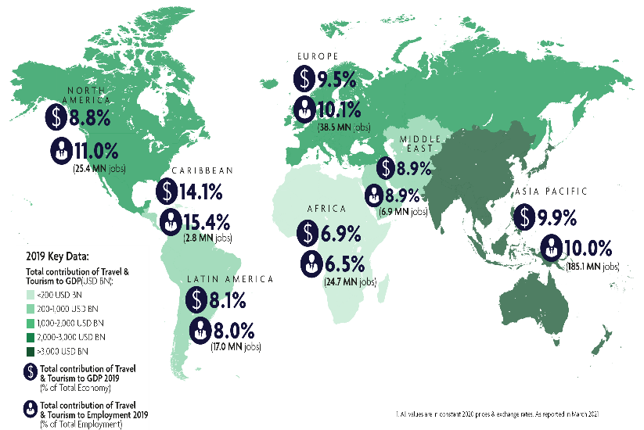

This images on the left is the countries in 2019 when the tourist was at a high before the pandemic hit and how countries rely on tourism to contributes to the gross domestic product.

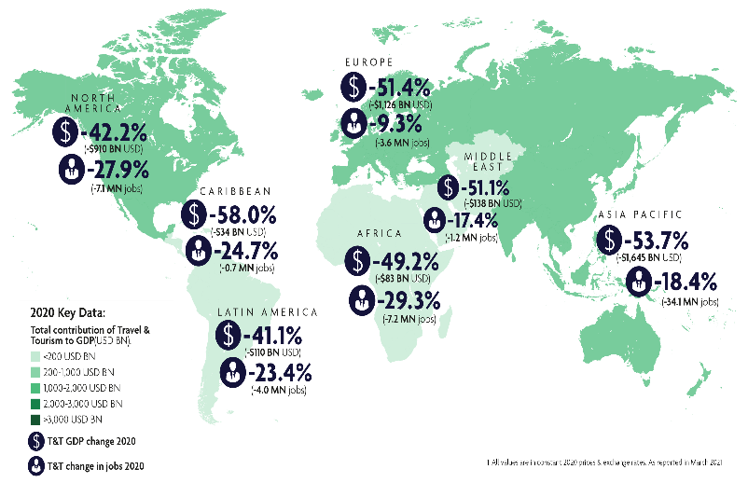

The image on the right is after the pandemic hit in 2020 and how losing tourist has affected these counties.
“The Travel & Tourism sector in America has suffered a loss of almost US$4.5 trillion to reach US$4.7 trillion in 2020, with the contribution to GDP dropping by a staggering 49.1% compared to 2019; relative to a 3.7% GDP decline of the global economy in 2020. In 2019, the Travel & Tourism sector contributed 10.4% to global GDP; a share which decreased to 5.5% in 2020 due to ongoing restrictions to mobility.” (not paraphrased)(11)
The Travel and Tourism sector in Australia are struggling with short staff. A survey was giving to 500 businesses in the tourism sector, 32% forced to let staff go, 24% now don’t have enough staff to open back up fully. And 55% have been impacted by the lack of inexperience staff. The tourism industries have loss more than 40% of their staff during the pandemic as most of their staff were from other countries and they wanted to go back home. Unfortunately, these people are not allowed back in the county. (16)
Maskiell L (20 oct 2021) has said Australia closed their borders last march2020 when the pandemic hit but it still hasn’t opened back up for international to visit or for the people in Australia to leave. To boaster the travel and tourism sector the government came up with $530 million support package. This package is a stay and rediscover for the millions of residents to receive $50 voucher to spend on accommodation anywhere in the country. They also announced a $250 million boost to have a dine and discover voucher to spend on local food. They are hoping these vouchers will boost and bring back business to the entire country. (17)
No name (11 march) said Australia is also offering half price flight to their citizen to boost tourism. The offer is between April and July to try and encourage locals to visit other parts of the country. This can also help people keep their jobs in the hospitality sector as well as keeping business from closure. (18)
The Travel and tourism sector is still being effect by these changed around the world and it will take several years to get back what they have lost. Some of the restrictions have been lifted so they can allow tourist back into their countries, however, there are a few things that travels need to do before they can travel so that they can prevent the spread of the virus. Such has having a Covid test and providing results at the airport before being allowed to board the airplane.

References
- www.verywellhealth.com/coronavirus-covid-19-timeline-4798671
- Gragh https://mma.prnewswire.com/media/1193688/UK_Top_10_Retailer_Forecast.jpg?p=publish
- Sarah Butler Mon 24 Aug 2020 /www.theguardian.com/business/2020/aug/24/tesco-gives-permanent-jobs-to-16000-staff-taken-on-in-covid-crisis
- Coronavirus Job Retention Scheme: statistics - House of Commons Library (parliament.uk)
- ://www.theguardian.com/business/2021/jan/12/uk-retail-sales-biggest-fall-since-1995-impact-covid-lockdowns-online-boom Richard Partington Tuesday 12 january 2021
- Hospitality industry and Covid-19 - House of Commons Library (parliament.uk) Tuesday march 2021 Georgina hutton niamh foley
- sustainability-13-05186.pdf page 2 of 18 Celal Cevher 1,* , Bulent Altunkaynak 2 and Meltem Gürü 3
- https://www.arc2020.eu/effects-of-coronavirus-on-agricultural-production-a-first-approximation-part-2 sebastian lakner april 6, 2020
- Six possible impacts of COVID-19 on farming (agriculture.com) 3/16/2020
- I was pouring 7,000 litres of milk down the drain... until our farm set up a 24-hour vending machine (msn.com) Tom Ough 11/05/2021
- Impact of the Pandemic on Tourism – IMF F&D
- Travel & Tourism Economic Impact | World Travel & Tourism Council (WTTC)
- Pandemic impact 'yet to be felt' on High Streets - BBC News
- Changes to ‘red list’ requirements from 4 October 2021 - International Students House (ish.org.uk)
- The shops that have closed for good during lockdown and won't be reopening (thesun.co.uk) Hollie Borland
- 11:12, 15 Jun 2020
- Staff shortages create chaos for tourism operators | Coronavirus | 9 News Australia - YouTube 1.11.21
- NSW business groups applaud $530 million tourism and events package (smartcompany.com.au) Lois Maskiell October 20 2021
- Australians to be offered half-price flights to boost local tourism - BBC News 11 march
- Navigating Healthcare Supply Shortages During the COVID-19 Pandemic | Circulation: Cardiovascular Quality and Outcomes (ahajournals.org) umesh n. khot 22 apr 2020
- 90% of global trade happens via sea, rise of the demand the rise of the cost of shipping. 1.11.21

