
UK-India Comparisons:
Cultural Differences in International Communication

International Business Communication (BMBM6021)

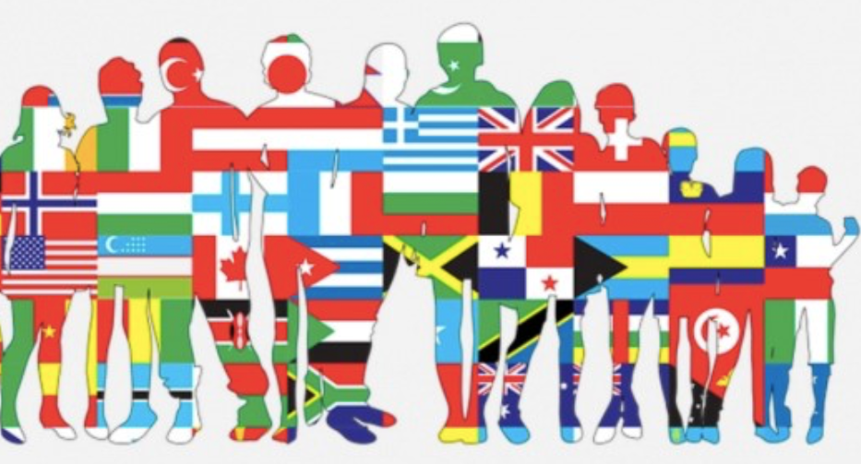

Professor's Name:Gwyneth Jones
Student's Name：Xiaotong Feng
Student ID:2224462

Introduction
Businesses operating in international contexts have to deal with multiple communication challenges, especially those resulted from cultural and social differences. According to Szkudlarek et al. (2020), language patterns, differences in religious systems, and different behavioral modes could hinder the effectiveness in communication because of the lack of mutual understanding. Thus, for business practitioners, it is crucial to be aware of such impacts on their business practices when they operate in cross-cultural conditions. For an UK-based enterprise, if it operates in a different country of different cultural characteristics, such as India, the practitioners will have to consider the associated issues. India is typical for its spiritual characteristics and its clear social hierarchy. Indian society is structured into social hierarchies known as castes, a division that is primarily dictated by birth, making it nearly impossible to alter (Gupta, 2000). Besides, India is renowned for its deep spiritual roots, characterized by a lack of an official state religion. Hinduism holds the majority, with over 80 percent of the population adhering to this faith. Additionally, approximately 13 percent of Indians practice Islam (Lipner, 2012). The religious landscape further includes Buddhism, Sikhism, and Jainism, all originating within India. This essay aims to help clarify and discuss the associated communication issues arising from cultural differences (between UK and India) for the practitioners, typically from the perspectives of business structure, cultural dimensional differences, and communication styles. It will firstly discuss the situations asking for effective communications. Then, it will discuss the possible communication failures that could occur. Thirdly, recommendations will also be offered in this essay.

Situations asking for Effective communications
International businesses realize the importance of effective communication in many different situations, the most important of which contain business negotiation situations and partnership situations. First for negotiation, it involves multiple parties (eg. UK representatives and Indian representatives) collaborating to achieve a mutually agreeable end goal (Groves et al., 2015). One party articulates its position, and the other party may either accept the terms or propose alternative conditions. This process continues until a resolution is reached or negotiations reach an impasse. The success of negotiations is closely tied to effective communication; and the quality of communication can directly influence the outcome of the negotiation (Fells & Sheer, 2019). Discussion, a key component of negotiation, does not aim to arise conflict but rather the exchange of ideas, thoughts, and opinions, according to Fells and Sheer (2019). Proficiency in communication is thus essential for fostering a healthy and successful discussion. Effective communication in negotiation is crucial because without effective and smooth sharing thoughts and ideas via communication, the other party remains unaware of one's perspectives, as the intricacies of one's mind are not visible to the opposite (Zhang & Zhou, 2008). The manner in which thoughts are communicated plays a significant role in the overall negotiation process because it clarifies each party’s positions and propositions, and effective communication also helps to enhance mutual understanding. Effective communication helps the negotiation parties achieve win-win outcomes based on established trustworthy (Zhang & Han, 2007).

In addition to negotiations, effective communication is crucial in international human resource management, especially in situations like expatriate communication. This involves staff from different cultural backgrounds, such as the UK and India, working together. In scenarios where expatriates from the UK collaborate with local Indian colleagues, discussions on work processes and project plans are essential. A shared understanding forms the basis for effective collaboration, and achieving this shared understanding requires effective communication (Adler & Aycan, 2018). Without effective communication, collaboration can become challenging. Cultural differences may lead to misunderstandings, thereby impacting the effectiveness of teamwork. For instance, in India, there exists a strong notion of gender inequality (Sharma, 2017). When female workers from the UK encounter discrimination from local Indian employees, resolving such conflicts becomes a significant issue. In these situations, effective communication becomes paramount to address and resolve the conflicts arising from cultural differences. The situations, and the other similar, indicates that effective communication plays a critical role to help formulate better work outcomes. Specifically, there are many differences between India and UK regarding the business structure, cultural contexts and communication styles, which are worthwhile to clarify further. These differences may lead to communication failures.

Communication failures that could occur
India stands as one of the globe's significant economies, characterized by rapid growth rates primarily driven by its service sector with its modern business structure, and technology. Currently experiencing an unparalleled period of economic advancement, India is actively fostering international direct investment by enhancing access to its vast and diverse market. Similar to various other business sectors in other countries like UK, India offers diverse business structures, including the one-person company (sole proprietorship), partnership enterprise, public limited company, among others (Kanakkupillai, 2022). Besides, India enjoys its advanced technological environments. According to Kanakkupillai (2022), acknowledging Bengaluru's inclusion among the top 10 global tech innovation hubs, India now stands alongside leading tech giants such as the US, UK, China, and Japan. Furthermore, the UK possesses traditional strengths in science and innovation that can contribute to the establishment of a sophisticated science and technology ecosystem in India, steering the country in a progressive direction (India Global Business, 2018). The enduring history of successful collaboration between the two countries, with the UK consistently being the largest G20 investor in India and India holding the fourth-largest number of investment projects in the UK, underscores the pivotal role of technology in their partnership (India Global Business, 2018). Therefore, the similar ground base in business structure and technology contexts may serve as positive factors to reinforce communication effectiveness for UK business practitioners to operate in India, whether in negotiation contexts or in business collaboration situations.

However, negative situations could come from other factors such as government restrictions, cultural business customs and communication styles. First for governmental restrictions, India presents significant opportunities for international investors, but entering this expansive and intricate market requires careful navigation for successful outcomes (TMF Group, 2021). The process of company formation and incorporation in India is intricate due to its complex and multi-layered requirements, which could add burden for UK business practitioners to operate in India. These include mandates for a local director's presence, the legalization of foreign documents (when a foreign company aims to incorporate in India), and obtaining prior government approval (particularly if the investment originates from a restricted country). Despite the complexity, the Indian government has actively pursued initiatives to streamline the business environment. According to the World Bank's 'Doing Business 2020' report, India is ranked 63rd globally for the 'ease of doing business,' reflecting improvements (World Bank, 2020). However, the enforcement of contracts remains a notable concern, with India ranking 163rd on the 'enforcing contracts' indicator, taking an average of 1445 days, as highlighted in the same report (World Bank, 2020). Such is a big problem because of the poor work efficiency. The governmental regulatory contexts add barriers for the UK operators to smooth their communication proficiency and communication effectiveness.

Second for cultural business customs, the Indian contexts enjoy huge differences with that of UK. Following Hofstede’s cultural dimensional model, the cultural differences between UK and India can be characterized. As shown in the following data in Figure 1, the huge differences between the two countries exist in aspects of power distance (India 77, UK 35) and individualism (India 24, UK 76). According to Daniels and Greguras (2014), in high power distance culture of India, people tend to make decisions in centralized manner with authority figures taking a leading role. The subordinates may not feel empowered to contribute significantly to decision-making, so when UK staffs may want to communicate more equally with Indian leaders, it may be difficult and conflicts could occur. Centralized decision-making mode in India could also hinder team inputs and equal contribution from team members (Budhwar & Khatri, 2001). Low individualism of India indicates that Indian people may prefer to use more implicit cues rather than direct ways for communication as preferred by UK people (Gupta & Sukamto, 2020). Indian people may feel uncomfortable when UK people express their opinions directly. For example, in cross cultural business negotiaiton, if the UK negotiator expresses her/his opinions directly, the Indian negotiator may feel that impolite or rude, which could hinder the real negotiation effectiveness. Thus, different communication modes could also lead to communication failure.

Figure 1: Cultural differences between UK and India
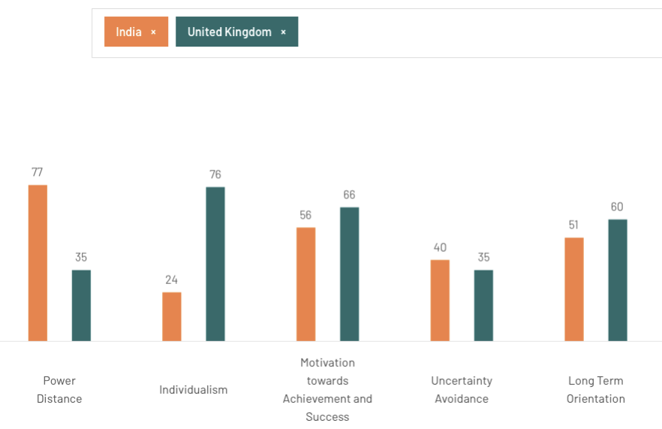
Source: Hofstede Insight, 2024

Another important factor is the different communication styles between UK and Indian people as the former belongs to low-context communication mode while the latter is more of high-context communication style. As argued by Hall (1976), communication variations among people from diverse countries often result in misunderstandings. India, as compared with UK, can be categorized as high-context cultures, whereas UK exhibits characteristics closer to a low-context culture. Hall's theory is supplemented by Hofstede's (2011) individualism vs. collectivism dimension. In cultures with high context communication, such as India, messages are often conveyed with nuances left unspoken (Nishimura et al., 2008). A few carefully chosen words can encapsulate a complex message, relying on the shared understanding of thoughts, ideas, and expectations implicit between communicators (Hall, 1976). Beyond verbal expressions, shared background information, gestures, sighs, and even silences play crucial roles in effective communication (Finnegan, 2014). Face-to-face meetings are preferred by high-context communicators over relying solely on documents, as building relationships is deemed essential for genuine understanding (Yang et al., 2021). However, to a communicator from a low-context culture like UK, the communication style of a high-context communicator may seem ambiguous or reserved, potentially giving the impression of untrustworthiness (Maude, 2017). For example, in the cross-cultural business cooperation or expatriates human resource management contexts where UK staffs have to work coordinately with Indian workers, if Indian staffs like to express their opinions indirectly without clarity, the UK people will feel a great ambiguity. It is because the UK staffs may unable to comprehend the implicit cues of the Indian staffs, eg. some body gestures or certain implicit facial expressions. Communication conflicts could then occur, which will also negatively influence the business teamwork effectiveness. Therefore, the different communication modes in high-context culture or low-context culture between UK and India also serve as a critical factor that could lead to communication failure.

Strategies to overcome these failures
Communication failures could happen, as discussed above, so it is crucial to come up with the associated strategies to overcome these failures. First of all, enhancing staffs’ global mindset and cross cultural competence will be workable for practitioners from UK and India. Cross-cultural competence, often abbreviated as 3C, is conceptualized as a collection of knowledge, skills, and affect/motivation that empowers individuals to effectively adjust in cross-cultural settings (Abbe et al., 2007). The knowledge aspect of 3C involves an awareness of broad, universal dimensions or patterns that underlie most cultures (e.g., Hofstede, 2011), as opposed to specific "facts" or behavioral scripts applicable only to certain groups or situations. Such universality of cross cultural competence will enable staffs from different cultural contexts like India or UK to better understand each other’s differences in a broader manner. Similarly, the skills component in cross cultural competence encompasses both cognitive and metacognitive processes like perspective-taking, emotion regulation, and hypothetico-deductive reasoning (Johnson et al., 2006). These processes enhance performance and adaptation, particularly in unfamiliar environments or situations where cultural information is limited or unavailable. To comprehend variations in the mechanisms influencing successful and unsuccessful thinking and behavior in cross-cultural contexts, the well established cross cultural mode captures the skills promoting performance in negotiation and daily work cooperation for both UK staffs and Indian staffs working together. Therefore, enhancing staffs’ global mindset and cross cultural competence is important to overcome the communication failures.

In order to strengthen and reinforce staffs’ cross-cultural competence, it will be practical to implement relevant cross cultural training programs as training is a solid way to improve staffs’ performance. As argued by Setti et al. (2022), cross-cultural training serves as a method to prepare and educate individuals within an organization for the international business activities undertaken by the organization. Its aim is to improve intercultural communication, awareness, and understanding, ultimately enhancing the efficiency of business operations among staffs coming from different cultural contexts (Setti et al., 2022). The primary objective of cross-cultural training is to equip employees with strategies that empower them to better adapt to business environments where a singular set of rules or behaviors is not applicable (Chua et al., 2023). There are some activities that are worthy to take care. The first is to inform staffs about the cultural differences, enabling staffs from both UK and India understand cultural differences between them, and engage with individuals from foreign cultures. Besides, the training program may also be delivered through role-playing and situational exercises, conflict resolution is a focal point in many cross-cultural training programs conducted by internationally operating companies. Staffs also be trained through instructing individuals on how to adjust to a foreign culture, whether for a brief trip or an assignment spanning several years.

Conclusions and Recommendations
In conclusion, effective communication is important for business success in international contexts, particularly when the operations cross multiple cultural conditions. This essay has explored the challenges faced by UK-based enterprises venturing into India, a country characterized by profound spiritual roots and a rigid social hierarchy. Understanding the scenarios demanding effective communication, the essay emphasized the role of communication in business negotiations and partnerships. Negotiation success hinges on the ability to articulate positions, exchange ideas, and foster mutual understanding. Similarly, in the area of international human resource management, particularly in collaborations between UK expatriates and Indian colleagues, effective communication becomes essential to bridge cultural gaps and achieve shared understanding. However, the essay also shed light on potential communication failures arising from the complex Indian business environment. While shared technological advancements provide common ground, government restrictions, intricate business structures, and contrasting cultural customs pose challenges. The disparities in power distance, individualism, and communication styles between the UK and India were explored, highlighting potential pitfalls in communication effectiveness.

To address these challenges, the essay proposes strategies centered on enhancing staff's global mindset and cross-cultural competence. The concept of Cross-Cultural Competence (3C) is introduced, emphasizing the importance of knowledge and skills that facilitate effective adaptation in cross-cultural settings. Implementing cross-cultural training programs is recommended, incorporating activities to inform staff about cultural differences, utilizing role-playing for conflict resolution, and instructing on adaptation strategies. In essence, the journey of effective communication between the UK and India necessitates not only an awareness of cultural disparities but a proactive commitment to developing the skills and mindset required for successful cross-cultural collaboration. Practitioners, through embracing these strategies, can bridge the gaps, fostering understanding, and fortifying communication effectiveness in the intricate tapestry of global business interactions.

References

Abbe, A., Gulick, L. M., & Herman, J. L. (2007). Cross-cultural competence in Army leaders: A conceptual and empirical foundation.

Adler, N. J., & Aycan, Z. (2018). Cross-cultural interaction: What we know and what we need to know. Annual Review of Organizational Psychology and Organizational Behavior, 5, 307-333.

Budhwar, P. S., & Khatri, N. (2001). HRM in context: Applicability of HRM models in India. International Journal of Cross Cultural Management, 1(3), 333-356.

Chua, S. W. Y., Sun, P. Y., & Sinha, P. (2023). Making sense of cultural diversity’s complexity: Addressing an emerging challenge for leadership. International Journal of Cross Cultural Management, 23(3), 635-659.

Daniels, M. A., & Greguras, G. J. (2014). Exploring the nature of power distance: Implications for micro-and macro-level theories, processes, and outcomes. Journal of Management, 40(5), 1202-1229.

Fells, R., & Sheer, N. (2019). Effective negotiation: From research to results. Cambridge University Press.

Finnegan, R. (2014). Communicating: The multiple modes of human communication. Routledge.

Groves, K. S., Feyerherm, A., & Gu, M. (2015). Examining cultural intelligence and cross-cultural negotiation effectiveness. Journal of Management Education, 39(2), 209-243.

Gupta, D. (2000). Interrogating caste: Understanding hierarchy and difference in Indian society. Penguin Books India.

Gupta, M., & Sukamto, K. E. (2020). Cultural communicative styles: The case of India and Indonesia. International Journal of Society, Culture & Language, 8(2), 105-120.

Hall, E. T. (1976). Beyond culture. Anchor.

Hofstede Insight (2024). Country comparison too, [Online] Available at: https://www.hofstede-insights.com/country-comparison-tool?countries=india%2Cunited+kingdom [Accessed 1 January 2024]

Hofstede, G. (2011). Dimensionalizing cultures: The Hofstede model in context. Online readings in psychology and culture, 2(1), 8.

India Global Business Staff (2018). How technology is enabling the India-UK relationship to grow from strength to strength. India Global Business, [Online] Available at: https://www.indiaglobalbusiness.com/igb-archive/how-technology-is-enabling-the-india-uk-relationship-to-grow-from-strength-to-strength-india-global-business [Accessed 1 January 2024]

Johnson, J. P., Lenartowicz, T., & Apud, S. (2006). Cross-cultural competence in international business: Toward a definition and a model. Journal of international business studies, 37, 525-543.

Kanakkupillai (2022). Different types of business structures in India, [Online] Available at: https://www.kanakkupillai.com/learn/different-types-of-business-structures-in-india/ [Accessed 1 January 2024]

Lipner, J. (2012). Hindus: Their religious beliefs and practices. Routledge.

Maude, B. (2017). Managing cross-cultural communication: Principles and practice. Bloomsbury Publishing.

Nishimura, S., Nevgi, A., & Tella, S. (2008). Communication style and cultural features in high/low context communication cultures: A case study of Finland, Japan and India. Teoksessa A. Kallioniemi (toim.), Uudistuva ja kehittyvä ainedidaktiikka. Ainedidaktinen symposiumi, 8(2008), pp.783-796.

Setti, I., Sommovigo, V., & Argentero, P. (2022). Enhancing expatriates’ assignments success: the relationships between cultural intelligence, cross-cultural adaptation and performance. Current Psychology, 41(7), 4291-4311.

Sharma, S. (2017). Relationship between culture and gender inequality in India. Journal of Humanities and Social Science, 2(10), 30-35.

Szkudlarek, B., Osland, J.S., Nardon, L. and Zander, L. (2020). Communication and culture in international business - moving the field forward. Journal of World Business, 55(6), 101126. https://doi.org/10.1016/j.jwb.2020.101126

TMF Group (2021). Requirements for doing business in India, [Online] Available at: https://www.tmf-group.com/en/news-insights/articles/2018/may/requirements-doing-business-india/ [Accessed 1 January 2024]

World Bank (2020). Doing business 2020, [Online] Available at: https://documents1.worldbank.org/curated/en/688761571934946384/pdf/Doing-Business-2020-Comparing-Business-Regulation-in-190-Economies.pdf [Accessed 1 January 2024]

Yang, X., Hou, J., & Arth, Z. W. (2021). Communicating in a proper way: How people from high-/low-context culture choose their media for communication. International Communication Gazette, 83(3), 238-259.

Zhang, T., & Zhou, H. (2008). The significance of cross-cultural communication in international business negotiation. International journal of business and management, 3(2), 103-109.

Zhang, Z. X., & Han, Y. L. (2007). The effects of reciprocation wariness on negotiation behavior and outcomes. Group Decision and Negotiation, 16, 507-525.

