Customising MapInfo with MapBasic

We can extend and control the MapInfo environment by building add on MapBasic programs.

The literature suggests that if you have used any kind of Basic programming environment including Visual Basic then you should find programming with MapBasic familiar. However the text editing environment is very basic and not visually driven.

We could use MapBasic to Develop:

- Turn-Key applications designed as a complete solution
- Utilities to automat tedious tasks
- Extensions add new operations to the basic functionality of MapInfo

The MapBasic Window

The MapBasic window is another type of window that can be opened in native MapInfo. If you open the window you can see simple MapBasic commands appearing in the window as you invoke tasks.

In MapInfo under Options choose show MapBasic window. From you training_data (tutorial data ) folder open the states map and then open the browser window for that map.

You should see a screen resembling the following:-

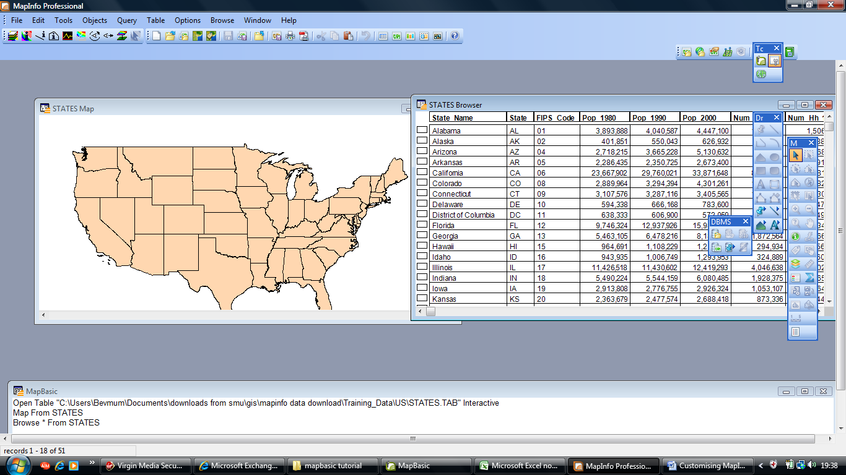

And the commands, depending on your directory hierarchy should look something like this:-

Open Table "C:\Users\Bevmum\Documents\downloads from smu\gis\mapinfo data download\Training_Data\US\STATES.TAB" Interactive
Map From STATES
Browse * From STATES

Try out some other command sequences to see what happen. Build a thematic map for example.

Which will probable generate something like this depending on the range choices you make:

shade window 176649800 1 with Pop_2000 ranges apply all use color Brush (2,16719904,16777215)
400000: 1300000 Brush (2,14474495,16777215) Pen (1,2,0) ,
1300000: 2900000 Brush (2,14725328,16777215) Pen (1,2,0) ,
2900000: 5100000 Brush (2,15761552,16777215) Pen (1,2,0) ,
5100000: 8200000 Brush (2,15749216,16777215) Pen (1,2,0) ,
8200000: 33900000 Brush (2,16719904,16777215) Pen (1,2,0) default Brush (2,16777215,16777215) Pen (1,2,0) # use 1 round 100000 inflect off Brush (2,16777215,16777215) at 2 by 0 color 1 #
set legend window 176649800 layer prev display on shades on symbols off lines off count on title auto Font ("Arial",0,9,0) subtitle auto Font ("Arial",0,8,0) ascending off ranges Font ("Arial",0,8,0) auto display off ,auto display on ,auto display on ,auto display on ,auto display on ,auto display on
Create Cartographic Legend From Window 176649800 Behind Frame From Layer 1

Don’t be alarmed as all of this is usually generated within the workspace save option. So basically the workspace is a collection of MapBasic commands that are save so you can recreate the environment that was saved.

Open up a workspace that you have recently created and have a look at the commends saved.

It will probably start of something like this

!Workspace
!Version 500
!Charset WindowsLatin1
Open Table "C:\Program Files\Common Files\Microsoft Shared\Datamap\Data\Eurairpt" As Eurairpt Interactive
Open Table "C:\Program Files\Common Files\Microsoft Shared\Datamap\Data\Eurcitya" As Eurcitya Interactive
Open Table "C:\Program Files\Common Files\Microsoft Shared\Datamap\Data\Eurcityb" As Eurcityb Interactive
Open Table "C:\Program Files\Common Files\Microsoft Shared\Datamap\Data\Eurhiway" As Eurhiway Interactive
Open Table "C:\Program Files\Common Files\Microsoft Shared\Datamap\Data\Europe" As Europe Interactive
Open Table "eurohols" As eurohols Interactive

The MapBasic Development Environment

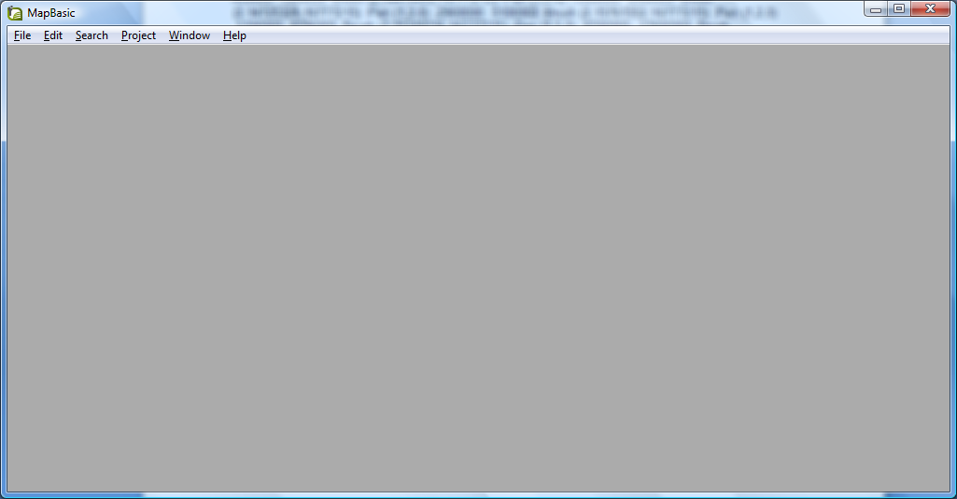

To familiarise yourself with this environment try out this simple program that loops and printout a message box:

'**Declares
Declare Sub Main

'**purpose -- count to ten

Sub Main
Dim x As Smallint

'** Loop to count

For x=1 to 10
Print " The count is " + Str$(x)
Next

'** message to user

Note "Finished counting"

End Sub

Typically a MapBasic program will contain several sub procedures and must contain a main procedure which is declared explicitly through the Sub Main .....End Sub statement.

MapInfo will execute the main procedure and you can call any other procedures from within.

Some statements must be declared outside any procedural sub for example:

Type..End Type
Declare sub statements
Declare Function statements
Define statements
Global statements

These statements are usually followed by main procedure statements and sub procedure statements.

Locate you training date and in particular the US states data. Open up several files and a browser. Save your session to a workspace.

Try out this simple program which can then be run from the MapInfo window using Tools > Run MapBasic program......

'*********************************************************
'* Program: WORK2.MB
'* Purpose: Run the STATES.WOR from this MapBasic app
'*********************************************************

'** Declares
Declare Sub main

'*********************************************************
'* Function: main
'* Purpose: main control
'*********************************************************
Sub main

'** Run the workspace.
'** Run Application "STATES.wor"
Run Application "C:\Users\Bevmum\Documents\downloads from smu\gis\states1.wor"

End Sub

'** Include header files

Include "mapbasic.def"
Include "menu.def"
Include "icons.def"

Declare Sub Main
Declare Sub Newmen
Declare Sub ByeBye
Declare Sub layer1

Sub Newmen

Create Menu Bar as "File","Ranges","map","test graph","Printer","Tools","graph"
Create Menu "File" As
"Exit europw hols" Calling ByeBye,
"Run Map Basic Program" Calling M_FILE_RUN

Create Menu "Ranges" As
' "No Ranges" Calling NoRange,
"euro airprts" Calling layer1
Create Menu "Printer" As
"Page Setup" Calling M_FILE_PAGE_SETUP,
"Layout" Calling M_WINDOW_LAYOUT,
"Print" Calling M_FILE_PRINT

end sub

Sub ByeBye
CLOSE ALL INTERACTIVE
Create Menu Bar as Default
end sub

sub layer1
set map redraw off
Set Map Layer 1 Display Graphic
set map redraw on
end sub

Sub Main

Open Table "C:\EData\Eurairpt" As Eurairpt Interactive
Map From EURAIRPT
set map redraw off
Set Map Layer 1 Display Off
set map redraw on

Call Newmen
end sub

Try out the program above with any map table what we are trying to achieve is a change to the standard menu.

Notice the use of the include statements to standard definition libraries.

Exercise :

Try building a simple menu set for you recent workspaces as defined for assignment 1.

