Student Name: Rupa Husnara Begum
Student ID Number: 2423962
Module: Enterprise and Entrepreneurship
Module Code: LCLM4006
Lecturer Name: Shengfeng Mei
Assignment Title: Task 1 – Individual Written Business Plan
Business Plan Title: Smoothie Bar with Yoga and Sauna

Table of Contents
1. Overview of the Business Idea 3
2. Legal Format and Management Structure 4
3. Organisational Structure Chart 5
4. PESTEL Analysis 5
5. Market segmentation: 6
6. Targeting and Positioning: 7
7. Funding Requirements and Sources 8
8. Start-up Cost 9
9. Fixed Cost 9
10. Variable Costs (Over 6 Months) 10
11. Financial Projection (Monthly Sales) 10
12. Financial Forecast for Six Months 11
13. Conclusion 11
14. References 12

1. Overview of the Business Idea
The Smoothie Bar with Yoga and Sauna in Chatham offers fresh organic smoothies, yoga classes, and infrared sauna sessions for a complete wellness experience. Yoga reduces anxiety and improves wellbeing (Cramer et al., 2016), while the sauna promotes relaxation and health. The business will be funded with £65,000 from the owner and a small loan, creating a welcoming space for exercise, relaxation, and healthy refreshments.
Smoothie Bar:
The smoothie bar will provide nutritious, natural beverages designed to support energy, immunity, and overall wellbeing. Fresh fruit and vegetable smoothies, protein shakes, herbal teas, and healthy snacks made with locally sourced and organic ingredients. Option also be available for customers can build their own smoothies using seasonal fruits.
Yoga Studio:
The yoga studio will offer a variety of classes, including Hatha, Vinyasa, Power, etc, and pregnancy/parental yoga. Both group sessions and private lessons will be available, catering to different experience levels and customer needs. Additionally, online classes via livestream will be offered, providing flexible access for customers who cannot attend in person.
Sauna Services:
The studio offers modern and traditional sauna sessions for relaxation, detox, and muscle recovery, available as single sessions or memberships. Aromatherapy oils and a cold plunge pool enhance circulation and reduce soreness. Regular sauna use supports stress reduction and overall health, and together with yoga, provides a complete wellness experience for body and mind.
Membership, Retail, and Online Services:
The studio offers flexible membership plans with yoga, discounted smoothies, and sauna access, plus loyalty and referral rewards. A retail section will sell yoga mats, accessories, eco-friendly bottles, skincare products, and essential oils. Customers can use a mobile app and website to book classes, manage memberships, pre-order smoothies, and access virtual wellness content.

2. Legal Format and Management Structure
The smoothie bar with yoga and sauna will be managed by me, overseeing daily operations, staff coordination, and financial planning. The team will include smoothie bar attendants, yoga instructors, and reception staff to ensure smooth service, class scheduling, and a welcoming environment for all customers.
Position and Role Description
- Managing Director (Owner): Oversees strategy, operations, and finances alongside daily operations.
- Yoga Instructor: Leads group and private classes with another employee to assist with sauna management.
- Cafe Manager: Runs café operations, manages staff, stock, and service quality.
- Smoothie Bar Staff: Prepare and serve drinks, snacks and retail items.
- Receptionist: Manages bookings and customer service.
- Cleaner: Maintains hygiene and cleanliness across all areas of the business.

Legal Structure
The business will operate as a Private Limited Company (Ltd) – limited by shares. This structure protects the owner’s personal finances if the business has debts and makes the business appear professional and trustworthy to customers and investors (GOV.UK, n.d.). Although registration takes time, it provides long-term security and supports future growth.

3. Organisational Structure Chart
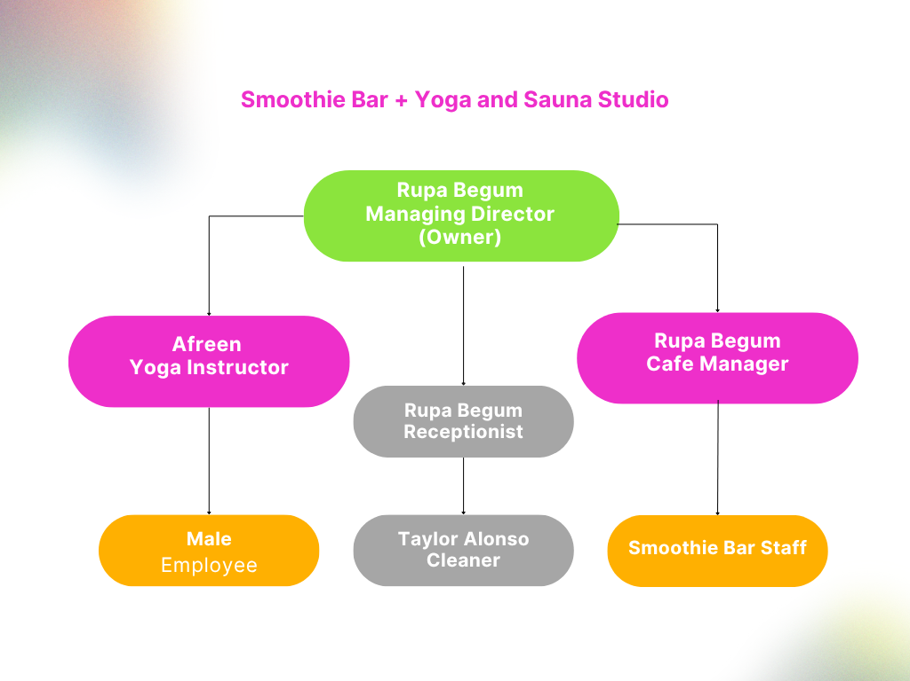

4. PESTEL Analysis
Political:
The UK government supports small business growth through initiatives such as the Start Up Loans Programme, which provides financial help for entrepreneurs (British Business Bank, 2024; Start Up Loans, 2025). The business will also comply with health and safety, food hygiene, and licensing regulations (GOV.UK, n.d.).
Economic:
Despite ongoing economic challenges, the UK wellness and health food market continues to expand. The UK health and fitness sector is valued at over £5 billion, showing strong consumer interest in wellbeing and healthy living (IBISWorld, 2025).
Social:
There is a growing social trend towards healthy lifestyles, mindfulness, and self-care. Many people are now looking for functional-nutrition options, as well as fitness and mindfulness activities such as yoga (McKinsey, 2025).
Technological:
The business will use digital tools such as online booking systems for yoga sessions, secure payment options, and social media marketing to engage customers and streamline operations (Boyarsky, 2025). Technology will also enable contactless orders in the smoothie bar.
Environmental:
Eco-friendly practices will be prioritised by using recyclable cups, biodegradable straws, and locally sourced produce, helping to reduce waste and promote a plastic-free environment (Orderific, 2023).
Legal:
The business will ensure compliance with UK food standards set by the Food Standards Agency, employment laws, and insurance requirements (GOV.UK, n.d.).

5. Market segmentation:
My business offers a complete health, wellness, and relaxation experience under one roof by combining fresh organic smoothies, professional yoga classes, and sauna sessions. Located in a busy city area with strong transport links, parking, nearby shops, and a large local residential community, the studio will be easily accessible and appealing.
The target market includes adults aged 20–50 who value health and wellbeing, especially young professionals and university students (20–35) seeking quick, healthy options and stress relief after work or study, as well as middle-aged adults (35–50) wanting to maintain long-term health and balance. These customers lead busy lifestyles and appreciate the convenience of having exercise, relaxation, and healthy nutrition all in one place.

6. Targeting and Positioning:
The business targets busy, health-conscious individuals seeking physical fitness and mental relaxation. It offers a premium, all-in-one wellness experience with smoothies, yoga, and sauna in a calm environment, convenient location, making it the area’s most comprehensive wellbeing destination.
Demographics:
- Age: 20–50 years
- Gender: Both male and female
- Income Level: Middle to upper-middle income (able to afford wellness services and premium smoothies)
- Occupation: Young professionals, university students, middle-aged adults seeking health improvement
Psychographics:
- Health-conscious individuals prioritising physical fitness and mental wellbeing
- People seeking stress relief and relaxation in busy lifestyles
- Environmentally conscious customers who value sustainable and organic products
Behavioural:
- Regular consumers of health foods and organic products
- Willing to pay for premium wellness services like yoga and sauna sessions
- Active on social media platforms for wellness and lifestyle trends
- Prefer convenient, one-stop solutions for health, fitness, and relaxation

Promotion:
The business will attract and keep customers through online and in-person marketing. This includes a website, social media (Instagram, Facebook, TikTok), launch events with free yoga trials and smoothie samples, and loyalty cards, student discounts, and regular updates. Premium but fair pricing will reflect the quality of services and help build a strong, lasting customer base.
Pricing:
A value-based pricing strategy will be used based on market research.
- Smoothies will cost £5–£7 each
- Yoga sessions £10 per class or £25 for a weekly membership
- Sauna access £12 per session or included in premium packages
- Monthly combo membership at £60 (includes all three services with discounts)

7. Funding Requirements and Sources
The estimated startup funding requirement is £65,000 to cover equipment, rental deposits, marketing, and staffing before revenue generation.
- Personal Savings (£10,000): Demonstrates commitment and personal investment.
- Government Startup Loan (£25,000): Offered by the British Business Bank with low interest rates.
- Angel Investors (£30,000): To secure additional funds in exchange for small equity (up to 20%).

8. Start-up Cost
Item | Estimated Cost (£)
Café equipment & furniture | 20,000
Studio renovation/deposit | 11,500
Yoga equipment (mats, props) | 10,000
Sauna installation | 14,500
License, insurance & legal fees | 2,000
Initial ingredients & stock | 3,000
Marketing & advertising | 4,000
Total | £65,000

9. Fixed Cost
Expenses | Cost (£)
Rent | 2,500
Staff wages | 10,000
Marketing and advertising | 1,500
Maintenance and cleaning | 400
Insurance and licenses | 300
Accountant | 200
Technology upkeep | 800
Miscellaneous | 300
Total (Month 1) | 16,000

10. Variable Costs (Over 6 Months)
Month | Ingredients & Supplies (£) | Utility Costs (£) | Total Variable Costs (£)
January | 1,400 | 500 | 1,900
February | 1,450 | 500 | 1,950
March | 1,500 | 550 | 2,050
April | 1,550 | 550 | 2,100
May | 1,650 | 600 | 2,250
June | 1,750 | 650 | 2,400
Total | 6,750 | 3,350 | 12,650

11. Financial Projection (Monthly Sales)
Service | Units per Month | Price (£) | Monthly Sales (£)
Smoothies | 1,350 | 6 (avg) | 8,100
Yoga classes | 275 | 10 | 2,750
Weekly yoga membership | 65 | 25 | 1,625
Sauna sessions | 100 | 12 | 1,200
Monthly combo membership | 25 | 60 | 1,500
Retail section | 150 | 12 (avg) | 1,800
Total Sales | - | - | 16,975

12. Financial Forecast for Six Months
Month | Revenue (£) | Fixed costs (£) | Variable costs (£) | Profit / Loss (£)
January | 16,975 | 16,000 | 1,900 | -925
February | 17,315 | 16,000 | 1,950 | -635
March | 17,660 | 16,000 | 2,050 | -390
April | 18,100 | 16,000 | 2,100 | 0
May | 18,825 | 16,000 | 2,250 | +575
June | 19,950 | 16,000 | 2,400 | +1,550
Total (6 Months) | 108,450 | 96,000 | 12,650 | +175

Total investment needed = £65,000 + £1,950.
Breakeven point after 4 months.
Summary:
The business expects steady growth, with profits increasing continuously as customer loyalty improves and the brand is established. In the summer months, from June, footfall is expected to increase even further as more people are motivated to go out and take part in sessions or buy cold drinks.

13. Conclusion
The Smoothie Bar with Yoga and Sauna is a modern health business that fits the growing wellness trend in the UK. By offering fitness, healthy food, and relaxation in one place, it can attract many customers. With good management, marketing, and eco-friendly practices, the business can become profitable and successful. The £65,000 investment will cover setup, equipment, and marketing to help launch the business smoothly. This plan shows the business has good potential and a strong long-term vision for investors and customers.

14. References
Boyarsky, Katherine (2025) How Much Does it Cost to Open a Smoothie Shop?. Available at: https://pos.toasttab.com/blog/on-the-line/how-much-does-it-cost-to-open-a-smoothie-shop (Accessed: 26 October 2025).
British Business Bank (2024) Start Up Loans Programme. Available at: https://www.startuploans.co.uk (Accessed: 28 October 2025).
Cramer, H., Lauche, R., Anheyer, D., Pilkington, K., de Manincor, M., Dobos, G. and Ward, L. (2016) ‘Yoga for anxiety: A systematic review and meta-analysis of randomized controlled trials’, Depression and Anxiety, 35(9), pp. 830–843.
GOV.UK (n.d.) Write a business plan. Available at: https://www.gov.uk/write-business-plan (Accessed: 28 October 2025).
IBISWorld (2025) UK Health and Fitness Industry Statistics. Available at: https://www.ibisworld.com/united-kingdom/market-research-reports/health-fitness-industry (Accessed: 28 October 2025).
Orderific (2023) Trends in Eco-Friendly and Sustainable Juice Bars. Available at: https://orderific.com/blog/sustainability-5/ (Accessed: 28 October 2025).

