Visual or Physical Reality:

When One Rises The Other Falls.
  - Idea for Dissertation
Connor Furneaux | Creative Computer Games Design | 05/05/2018

Context.

Virtual reality is an up and coming form of gaming experience. It allows the user to ravel themselves in a world of make belief, either that being in a visual simulation or a more hands on approach. it simulates experience through senses and perception. Immerses the user in a controlled and designed environment. This can be like the real world or it can be anything a human can imagine. Allowing for experiences not possible in our very own physical reality. However, when does virtual reality step over the line? From harmless immersion to granting a life so wonderful that reality is not worth going back for. By virtual reality allowing the user to escape issues and problems. This not intentionally, creates its own intrinsic issues. When given the ability to visualize a perfect life knowing its unreachable truly tests one’s forbearance. Allowing falters in the simulation to allow compromise in the verisimilitude or risk trapping the users mind.

Verisimilitude
“Verisimilitude (or truth likeness) is a philosophical concept that distinguishes between the relative and apparent (or seemingly so) truth and falsity of assertions and hypotheses. The problem of verisimilitude is the problem of articulating what it takes for one false theory to be closer to the truth than another false theory.” (En.wikipedia.org, 2018)
In this instance the “apparent” being the virtual reality. Through allowing the technology to create another reality and control all input is on the borderline of playing God. If you remove all errors, no disruptions in the verisimilitude, a pure world immersion becomes reality. Creators must allow for some breaks in the immersion. Looking into virtual reality as a design standpoint, if your creating something that is replicating an object or everyday occurrence that exists in our physical reality such as simulations for jobs, buildings, cars etc. Then any form of disruption to the verisimilitude of the product will cause it to be obsolete to the original in the physical reality. The need for the simulation to be authentic to whatever its mimicking is essential for it to be labeled as an authentic simulation. With virtual reality that breaks the laws of physics and allows access to the weird and wonderful, it doesn’t take into consideration the compromising of the verisimilitude within its own reality. However, when that reality becomes everything the consumers ever wanted no matter their undeniable knowledge they are in an augmented reality created by another. The compromise or uphold of verisimilitude to the physical reality won’t matter because by that point the physical reality is the last place the consumer wants to be. Removing all forms of object or occurrence that resembles a truth or likeness of the physical reality from the virtual world in theory would allow for an easier transition from the virtual to the physical. With a simulation based of something within the physical reality the realization that this is already possible takes of the edge of possibility, even if your experiencing something you have never experienced before. When being face to face with the impossible, walking away and going back to a reality where what you just experienced may never be possible causes this want for and desire for more of the impossible.
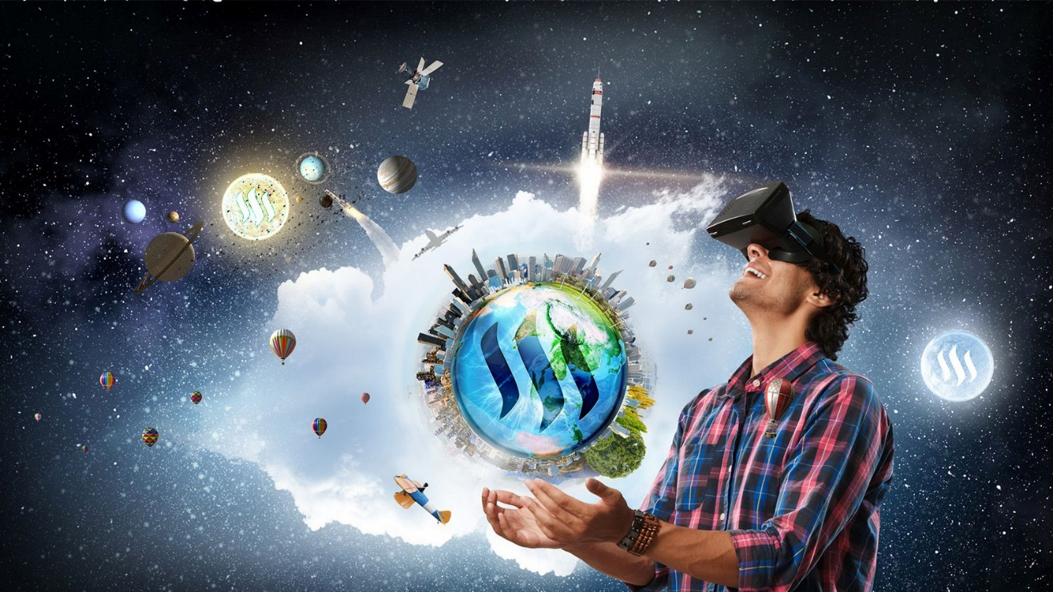
(Steemit.com, 2018)
This image from a Finnish startup company “Varjo ” (Varjo.com, 2018) depicts a man through the use of virtual reality having the whole world in his hands and being surrounded by some of the great feats discovered and perfected by humanity. These include flying a plane, launching satellites and spaceships. Implying that all this can be achieved in the palm of your hand using virtual reality. Even though these are moments created by humans not many can say they have experienced them. If virtual reality allows you to travel to another planet and experience a new life, is there anymore powerful way of feeling like you have left all issues attached to our physical reality behind.
Forbearance
Patient self-control, restraint and tolerance are all key aspects of being able to safely delve into virtual paradise and return to the physical reality, without constantly needing to return. Addiction to the unique and wonderful is the number one issue that would occur if virtual reality becomes its greatest form. That being a full outer body experience where the conscious mind is take within a simulation of something else. It would create an experience so life realistic it would feel like real life. Stopping the amount of exposure to the virtual realm would be one way of controlling the possibility of addiction. All pleasures require a sense of self control. How to make sure the consumers of virtual reality keep there’s in check is a whole other matter. Commercializing virtual reality into a product, forcing the consumer to have to pay for a timed duration into the virtual world like on “total recall” (Total Recall, 2012).
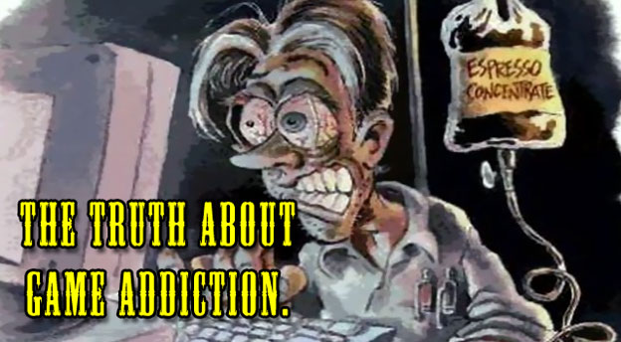
(Cheatcc.com, 2018)

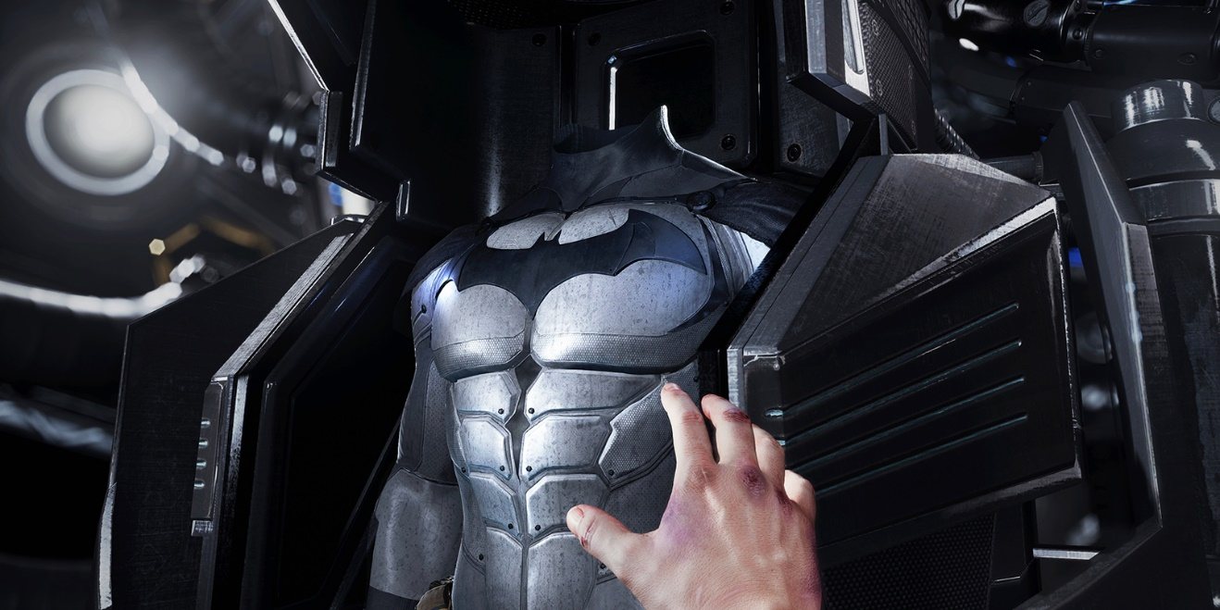
Everyone has their own personality. Filled with unique quirks and aspects of them that other people when they look at or hear use to recognize that person not only through there facial features. Imagine a world where everyone was the same. No uniqueness, no individuality just a world of clones. Granted not everyone likes who they are, some may find that they are not successful enough or do not look how they want to. With virtual reality there are no limitations on who you can become especially in the physical sense. Already even now in this age of simple virtual reality you can place a headset on and become “Batman”. How many people in the world would accept the opportunity of leaving their current lives and become “Batman” no matter how strong your self-control, restraint and tolerance is this would be a no brainer for some.
(Clark, 2018)
Being tossed between realities would also be a hard strain on your body as well as your mind. Imagine living as a 6ft 5inch 21-year-old man for 4 months rock climbing and sailing, to then return to reality where you’re a middle aged 5ft 5inchs office worker that’s never left his hometown. Even though there would be no effect on your physical body except some loss in muscle for being still for so long, the altering back to normality of your “real life” and accepting you are never going to be a 21-year-old 6ft 5inch man would take a lot of tolerance to be able to do that on a regular basis and carry huge emotional strain. You would need to be in a good mind set and physical shape to be able to withstand the constant changing of realities if this ever does become a possibility.

Escapism
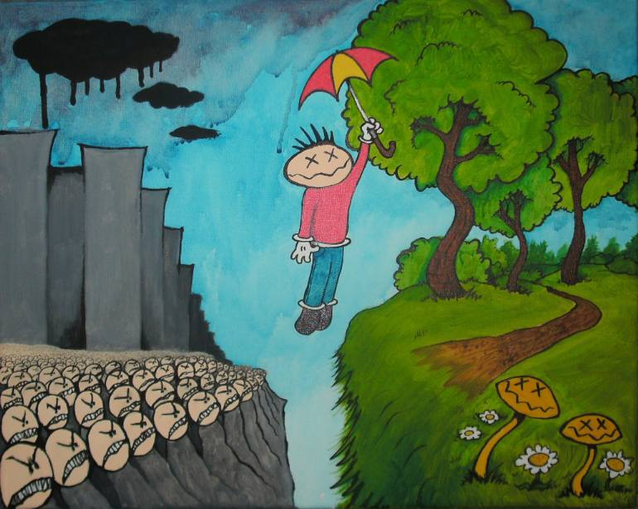
“Escapism is the avoidance of unpleasant, boring, arduous, scary, or banal aspects of daily life. It can also be used as a term to define the actions people take to help relieve persisting feelings of depression or general sadness.” (En.wikipedia.org, 2018)
Through life humans will go through many forms of emotions. Happiness, sadness, loneliness etc. now these can be caused by good or negative events in life such as child birth, debt, death. Through virtual reality the option of removing the negatives from life becomes a reality. Allowing the user to escape from the hardships and only experience the joys. Be that memories or new experiences.
(Saatchi Art, 2018)

This painting created by Ross Hendrick labeled “Escaping the Rat Race” depicts perfectly what essentially virtual reality will be offering the user. Allowing the user to immerse themselves in such authentic simulations can be when used correctly a very helpful tool for very serious aspects in the world. Why place people at harm when creating real life training simulations when you create them in virtual reality. With virtual reality training, simulation and education, difficult and dangerous situations can be dealt with safely. Police officers, coastguards, Firemen can be equipped to handle emergencies with tough training on a simulator where no harm can occur. Pilots can be trained through simulator so that when they fly a plane, the situation is less dangerous. This can be both used for military grade flying or commercial travel.
Research into the natural events of this world could be conducted without the waiting around for the natural phenomenon to occur. With scientifically accurate simulations, studies into volcanos, tornados and tsunamis can be conducted whenever the research needs to be. If an issue arises within a machine for instance, if all machines are built with a digital map a simulation of the machine can be run and the problem could be fixed before the mechanic even places a hand on the machine. Virtual reality could be a tool for serious use not just a way to escape from the physical reality with the intention of harmless fun. Architects could design and build buildings without spending a single pound and run weather simulations to see if the design holds up. Trying different materials for cost cutting and reliability. The possibilities that virtual reality could offer are endless.
Creating something within the virtual reality must be immersive or issues can occur. If within virtual reality and movement is off this can cause very serious motion sickness. To many personal references to the users life in the physical reality can cause issues when differentiating the realities.

The Question
Through researching and experiencing virtual reality, the realization that the human race is not far off creating another reality, so real and customizable to each individual needs has really sunk in. Allowing humans to bend verisimilitude of the reality that they wish to escape into, fleeing all the negatives of the physical reality. This will cause the downfall of “real life”. Who would ever want to live in a life with consequences, restrictions and fear when an option for a customizable reality becomes available. The only thing stopping the end of physical reality is the issue of preserving the body while the mind Is taken elsewhere. One question being is this a good thing or bad? Is allowing humans to live any life they wish a sign that the world leaders have lost control. In a world where each human creates their personal reality to live in, what’s the point of leaders in the physical reality. Will corporations and politicians transform our physical reality into a more appealing life to try and battle the aura of the impossible becoming possible in virtual reality? Trying to keep the minds within physical reality not just the bodies. If to much attention is brought to the uprising of virtual reality the illegalizing of it may become a possibility. Just like any form of item illegalized if there’s demand there’s always a more illegal way of obtaining it. The true question is:
“If virtual reality transforms into its peak form, will this be the downfall and possibly the end of our physical reality?”
Sub questions being:
- “What is virtual realities peak form?
- “How could physical reality counter its virtual cousin?”
- “What are the negatives of virtual reality”
Bibliography
Texts used:
En.wikipedia.org. (2018). Verisimilitude. [online] Available at: https://en.wikipedia.org/wiki/Verisimilitude [Accessed 5 May 2018].
Varjo.com. (2018). The Resolution Revolution is on. [online] Available at: https://varjo.com/ [Accessed 5 May 2018].
Total Recall. (2012). [film] Directed by L. Wiseman. Hollywood.
En.wikipedia.org. (2018). Escapism. [online] Available at: https://en.wikipedia.org/wiki/Escapism [Accessed 5 May 2018].
Techtyche. (2018). 10 Benefits of Virtual Reality - Techtyche. [online] Available at: https://techtyche.com/benefits-of-virtual-reality/ [Accessed 5 May 2018].

Images Used:
Steemit.com. (2018). [online] Available at: https://steemit.com/life/@sirwinchester/revolutionizing-vr-this-virtual-reality-headset-promises-70-megapixel-human-eye-resolution [Accessed 5 May 2018].
Cheatcc.com. (2018). The Truth About Game Addiction - Cheat Code Central. [online] Available at: http://www.cheatcc.com/extra/thetruthaboutgameaddiction.html [Accessed 5 May 2018].
Clark, B. (2018). Batman: Arkham VR is Amazing(ly short). [online] The Next Web. Available at: https://thenextweb.com/gaming/2016/10/07/batman-arkham-vr-amazingly-short/ [Accessed 5 May 2018].
Saatchi Art. (2018). Saatchi Art: Escapism Painting by Ross Hendrick. [online] Available at: https://www.saatchiart.com/art/Painting-Escapism/152958/2806816/view [Accessed 5 May 2018].

