ACCA4023_web_sem2
Code completion website report
Gareth John Bryant (0150226)
2022
Contents
Design and Proposed functionality 3
Site diagram 4
Wireframes 4
Main Concept for Pages 4
Main Content Sections 4
Report Section 3
Introduction 3
An abstract 3
Objective 3
Methods 3
Results and Conclusions 3
Requirements 4
Purpose 4
Subject Matter 4
Target Audience 4
Implementation 5
Actual Webpage 5
Index.html 5
Products_and_services.html 5
Testimony.html 6
About.html 6
Contact.html 7
Policy.html 7
HTML validation 8
Index.html 8
Products_and_services.html 8
Testimony.html 8
CSS Validation 9
Main.css 9
Evaluation 10
Analysing the Quality of the Website 10
Usability and Utility 10
Accessibility 10
SEO 11
Analysing Code Completion 12
Usability and Utility 12
Accessibility 12
SEO 14
Conclusion 14
References 15
References Images on Website 16
Appendices 17
Index.html 17
Products_and_services.html 20
Testimony.html 24
About.html 27
Contact.html 29
Policy.html 32
Main.css 34

Design and Proposed functionality

With C.R.A.P in mind, I will be aiming for a: -
- Consistent layout flow
- Contrasting font sizes, element shapes and colours
- Consistent font typeface, colour scheme between pages, same elements on different pages should be the same
- Consistent style of language
- There will be a mix of edge alignment for flowing text elements and centre alignment for menus and the logo / title.
- The webpage will be split into sections where applicable so that related elements can be contained for organisation.

Site diagram

Wireframes

Main Concept for Pages

Main Content Sections

Home page

Products and services

Testimony.html

About.html

Contact.html

Policy.html

Report Section

Introduction

An abstract

Objective
The function of this report is to detail the methods and consideration undertaken when designing and attempting to create a website. The website must be visually pleasing for the demographic it is aimed at, accessible to people with certain conditions, information must be concise and easily absorbed, and it must function well with bots try to crawl through your site collecting search engine and marketing data. We highlight these areas as we need to utilise the framework that will be promoting our website through search engine results and stimulate the desire for the product in our demographic.

Methods
- Design a website for testing and comparison against initial research findings.
- Make a list of design flaws in the site.
- Remove floors and compare again.
- Once we are satisfied that we have satisfied the visual flaws (colour matching, picture quality, accessibility measures etc …) an analysis on the validity of the script code should be performed to iron out any faults that are lurking / not visible in the current browser / do not conform to good web standards.
- Now we must consider search engine bots and make sure they are getting a full plate when they come to visit.

Results and Conclusions
We should be aware of our own weaknesses, and our results and conclusion will have some reflection on this. The design of the site is going to be limited due to art and design being a lesser strength of mine, I do however expect to see a functional site with no errors.
In conclusion, a professional site has more than just information, there are many factors that need fulfilling to attract and provide for different visitors. Therein there should be many people contributing to the design of these site to maximise its potential.

Requirements

Purpose
The design is mainly aimed at making people want to know more about the product and pique their interest about the content of the packages. The site should attract enquires about the product at which time more sales and marketing techniques can be used when in contact. We shall attempt to gain confidence through a clear and informative design, client testimony, and providing / selling a good deal.

Subject Matter
The site deals with the sale of knowledge and the time of those that have knowledge and experience in employing it. So mainly the subject matter is programming knowledge and wisdom, and the delivery method is work packs supported by our ‘Experts’.

Target Audience
Anyone that wishes to start or progress in coding, addressing clients with learning difficulties will need to be done at the evaluation stage prior to issuing work packs and is not a concern for the website other than to have testimonials stating that we were accommodating.

Implementation

Actual Webpage

Index.html
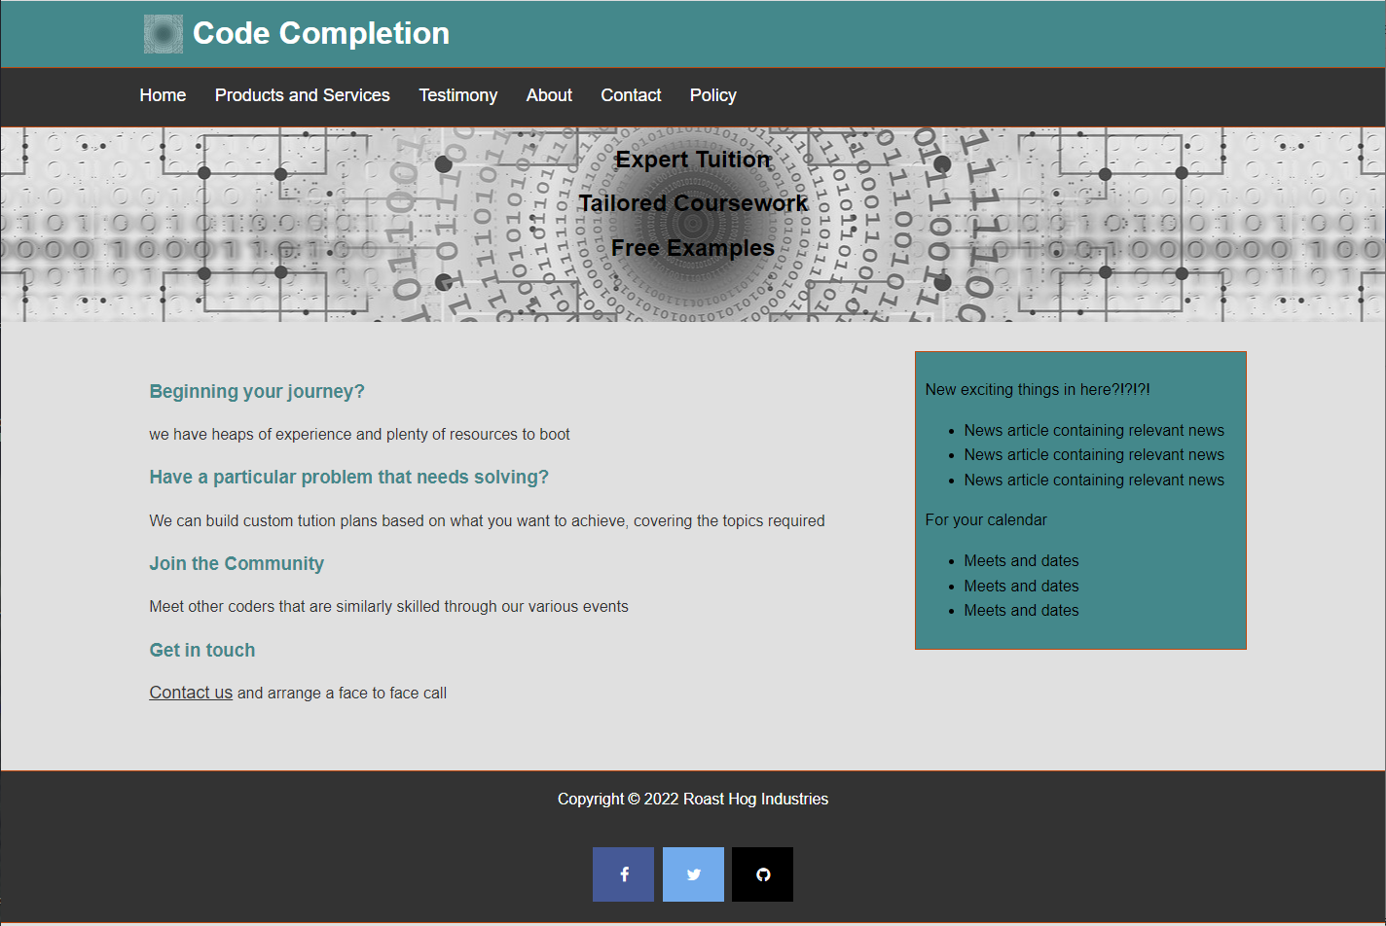

Products_and_services.html
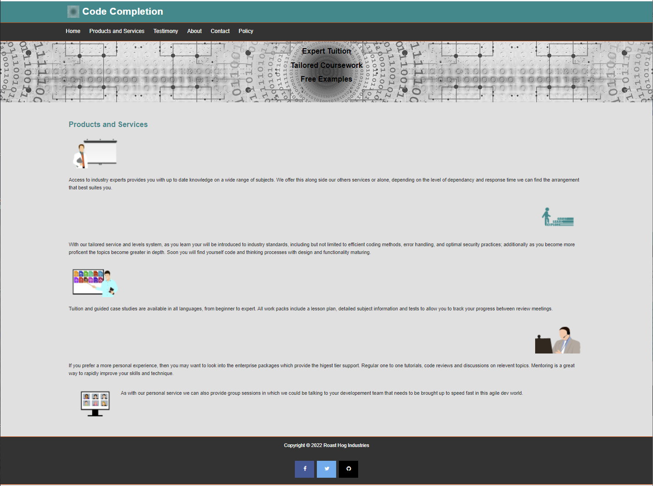

Testimony.html
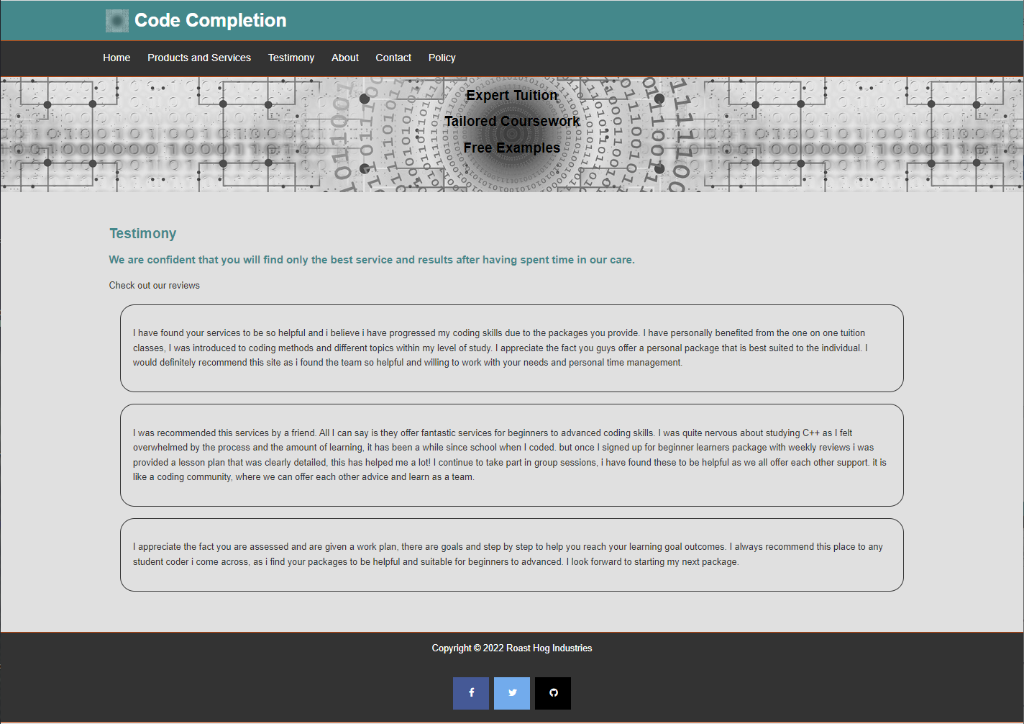

About.html
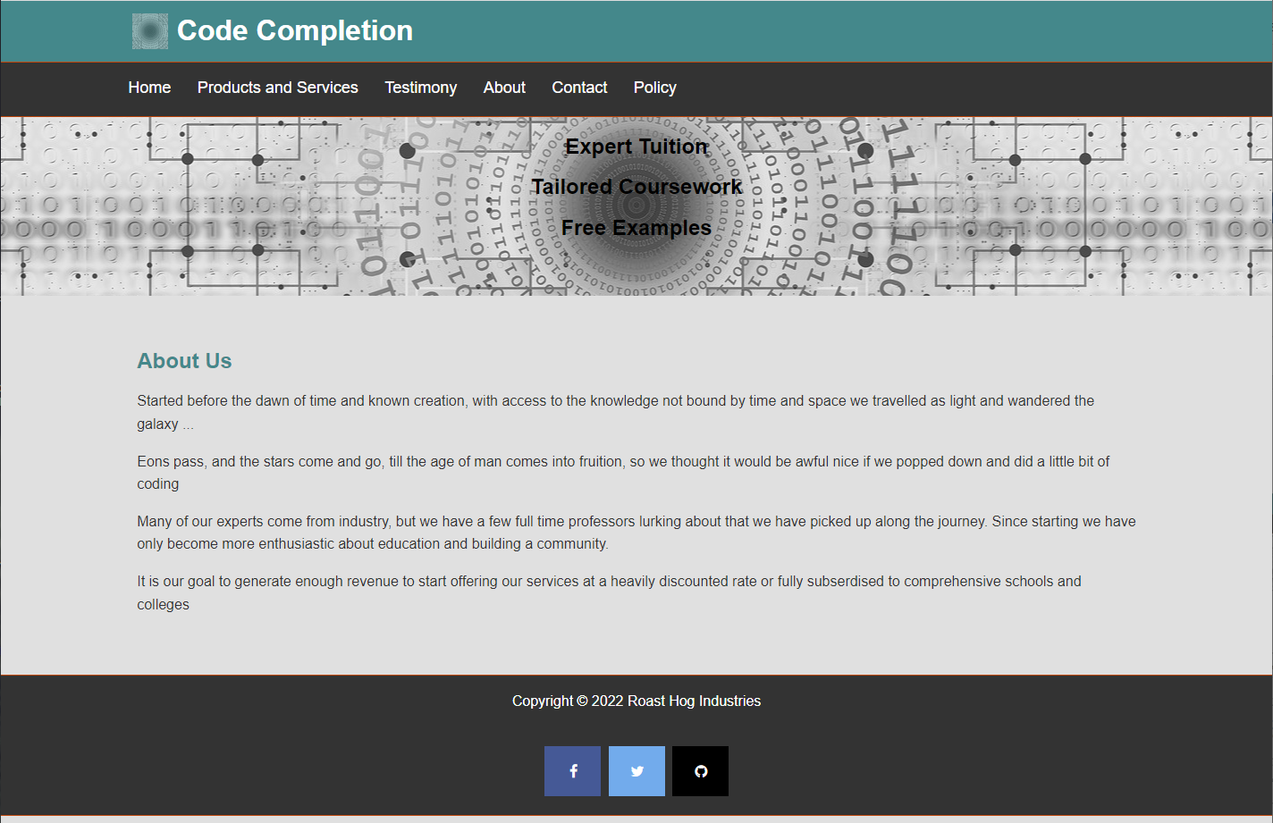

Contact.html
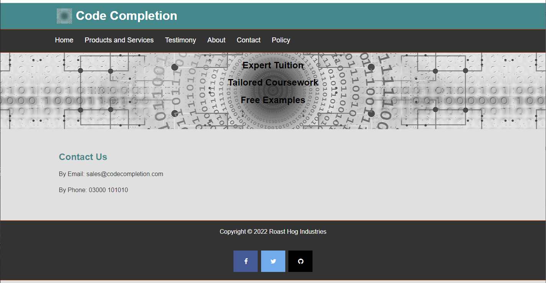

Policy.html
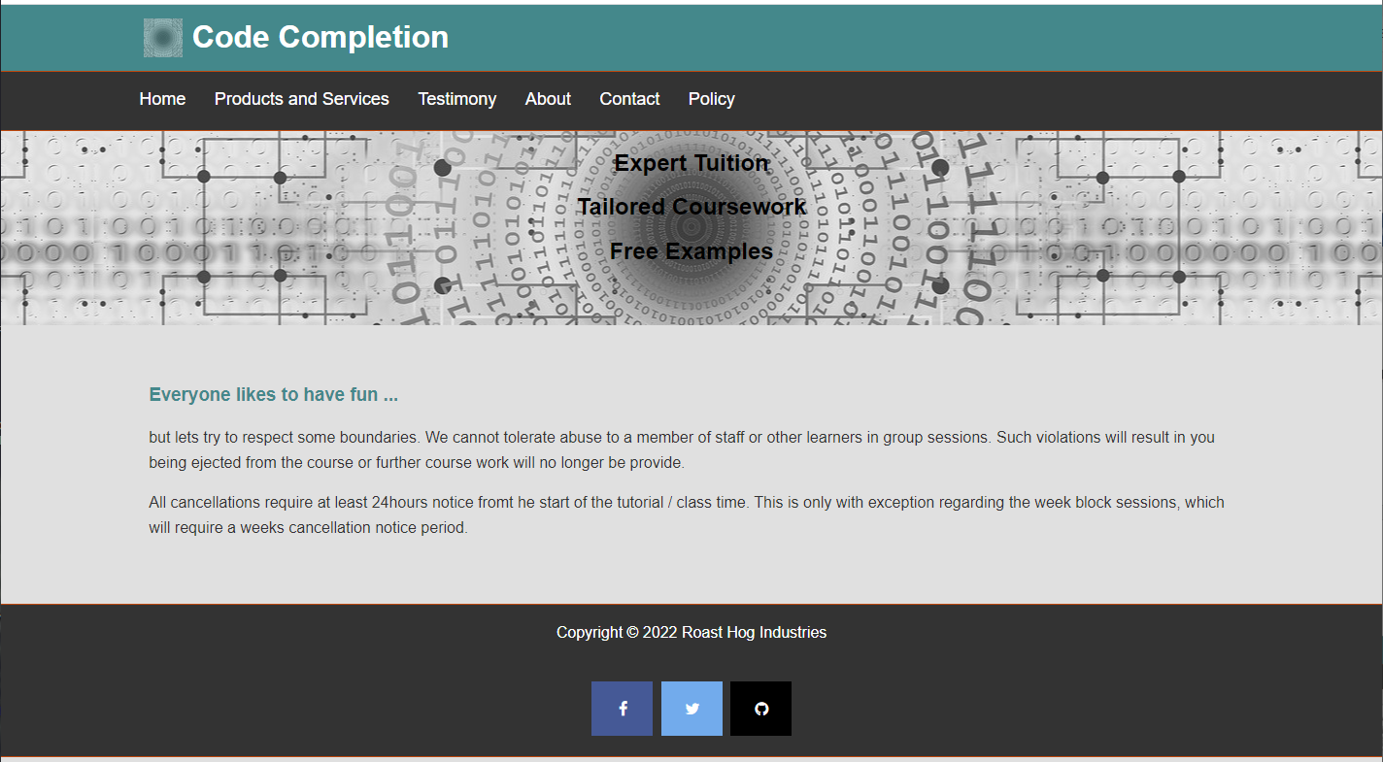

HTML validation

The validator was provided by http://validator.w3.org/.
After each validation, if the same block of code / tag existed in the pages that were yet to be tested I fixed those as well so that the errors and warnings would not be repeated.

Index.html
Warning: Consider adding a lang attribute to the html start tag to declare the language of this document.

To fix this I had to add ‘ lang="en" ‘ to the html tag as below:

<html lang="en">

Products_and_services.html

Errors (4) · Hide all errors · Show all errors
Duplicate ID service_text. (4)
Warnings (5) · Hide all warnings · Show all warnings
The first occurrence of ID service_text was here. (4)
Section lacks heading. Consider using h2-h6 elements to add identifying headings to all sections, or else use a div element instead for any cases where no heading is needed.

The errors were fixed by turning the id tag into a class tag, and also modifying the CSS to match.
The first 4 warnings are a result of the errors.
The last warning was resolved by adding a heading inside the section tag body.

Testimony.html

Warning: Consider using the h1 element as a top-level heading only (all h1 elements are treated as top-level headings by many screen readers and other tools).

I changed this to <h2> tag to resolve the warning. The link provided discusses why, and we will also be discussing why in the SEO and accessibility report section.

CSS Validation

Using the http://jigsaw.w3.org/css-validator/ validator, only one issue:

Main.css

URI : TextArea
106 |  | Value Error : margin Parse Error 5px 2px 5px 2px

To fix this I added a semicolon after the margin keyword:

Margin: 5px 2px 5px 2px;

Evaluation

Analysing the Quality of the Website

Usability and Utility
A usable website as stated in [1], the CBU International Conference, is such that the user does not have to spend time learning how to navigate, access data, and use functionality. The task that they have come to accomplish should be apparent and the user’s focus should be on the accuracy and quality of the task.
Further to this, Nath et al‘s research on, amongst other factors, the importance of good web design with focus on usability, states that the desirable flow / formal / informal / level of technical ability etc… change depending on the intended audience and therefore the usability should target the users. Research by SAME REF, whom also take their data from Jakob Nielsen, has shown that for ecommerce site in particular benefit greatly from thoughtful implementation of usability. [2]

Accessibility
Predominately concerned with making a website usable for those that have a diminished functionality that would impede normal site usage.

‘Disability is an ambiguous and multidimensional notion.’ [3]

As stated in the introduction to an article researching the accessibility of a state-owned website (eluding to the vast audience they wish to accommodate for). As also stated in [3], the concept of the web or the interface in severe cases cannot be approached with software design alone, other hardware peripherals would be required in these cases for interpretation and is beyond scope.
To address this, there is a standard that is unanimously approved and adopted by most of the commercial developers (or any developer that wishes to target the maximum audience / aimed at a certain demographic). This standard is called WCAG and is maintained by the w3 web consortium. This standardisation helps 3rd party hardware to aid users that would otherwise be impeded.
The WCAG has laid out 13 guidelines underpinned by 4 principals. Briefly the principals: -
- Perceivable
- Operable
- Understandable
- Robust
The guidelines can be found at https://www.w3.org/TR/WCAG21/#dfn-conform, whether or not your site is considered to support a guideline is dependent on the success criteria which is attributed to each guideline.
Broadly, these are to give the best possible chance that the information on the site can be accessed via the utilities and functions provided by the site. That is to aid: -
- Visual impairment
- Mobile impairment
- Auditory impairment
- Cognitive impairment

SEO
Exactly as the name suggests the Search Engine Optimisation, is the art of relevance. Even though you could say that black hat SEO is cheating relevance and only white hat methods give actual relevance you would be thinking from the wrong perspective, as it is the relevance to the search engine not the user performing the query and getting the SERP (Search Engine Result Pages) after the search engine crawler has done its job.
Example black hat methods: -
- Hidden text
- Fake content links
- Bogus keywords
- Repeating information
- Paid traffic

Example white hat methods: -
- Relevant keywords
- Good site structure (semantic tags, headings, internal navigation)
- Genuine links from relevant pages
- Organically obtained traffic

Even though we like to think that the white hat techniques can’t be abused, however as stated, and further explored by Berman et al [4]. They conclude that the large businesses have the monopoly as they can pay for SERP access for their products. This in turn favours their organic results which complements their marketing and SEO teams / departments.

Helping the crawlers
Sitemap.xml
This is to allow the crawler to immediately have the structure of your site so that it can find all the pages and pages that would require some input to reach.
Robots.txt
This kind of acts like the http.access file for the crawler and specifies what the crawler should and shouldn’t index. These are not mandatory and should not be used to restrict access to site as it is not the same as the http.access file and is just there to help and may not even be used. This is dependant on the search engine crawling your site.

Analysing Code Completion

Usability and Utility
There appears to be methods for evaluating usability, however, considering the usability is based upon the users that will be using the site I would need a reasonable number of testers to give a good average score. Having said that …
Even if a little on the simple side and missing some functionality that would come from a webserver,
i.e. login forms, access control to resources, content rich pages personalised from login profile.
The flow is obvious.
The layout is clear and simple to follow / find where you want to go to next.
The information is under the relevant headings / menu items.
There is as stated about little utility as no server / backend logic.

Accessibility

WAVE Evaluation results

Index.html
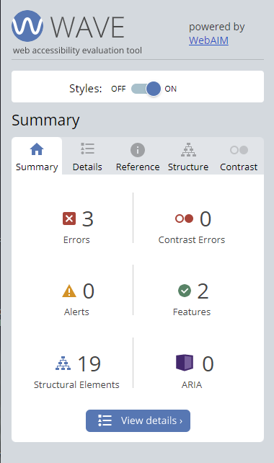

Products_and_services.html
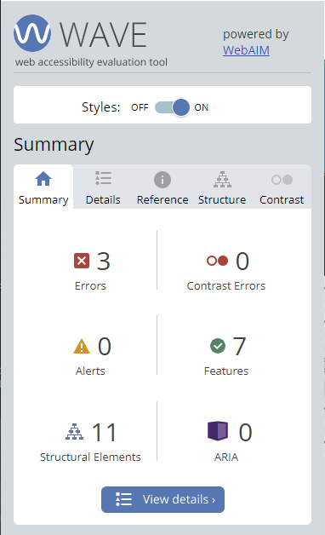

Testimony.html
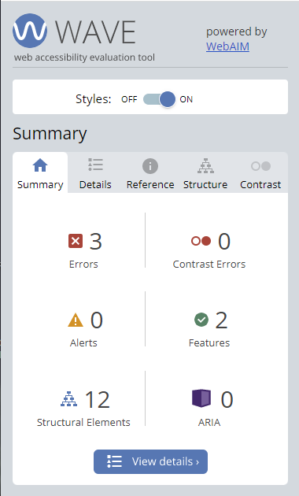

About.html
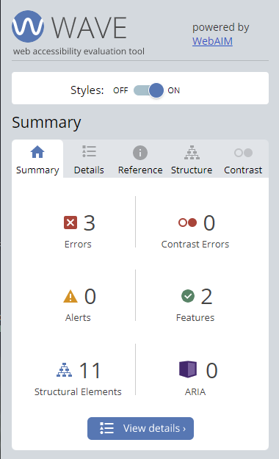

Contact.html
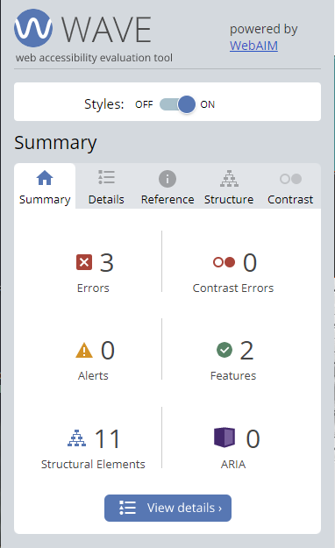

Policy.html
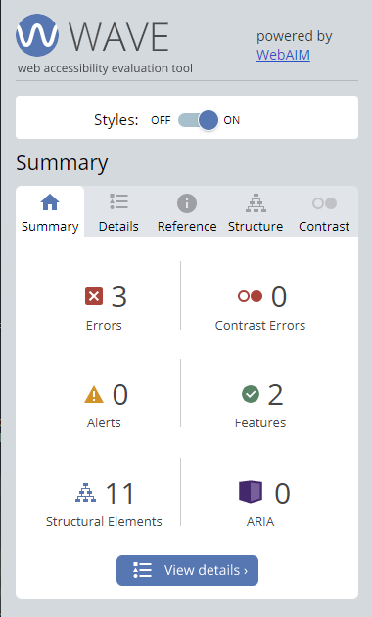

SEO
Site is responsive
The pages are unique
The structure is simple
Heading tags are structured
Keywords are relevant
Non-text elements have alternate text
Sitemap.xml is present
Robot.txt is present
Alt tags present

Conclusion
The site is well structured but simple.
The colours work well but I am not an artist.
There is little utility, but I feel it is out of scope currently.
The images are … free.
The site show a clear accessible structure and is free from contrast issues.
The site seems to conform well to SEO, but needs to find ways of driving traffic. Social media icons linked but no profile on the media platforms exists for this project due to feasibility / scope.

References

[1] | T. Kvasnicová and I. Kremeňová, “THE USE OF EYE TRACKING TO ASSESS THE USABILITY OF UNIVERSITY WEBSITE,” in CBU International Conference Proceedings, Central Bohemia University, 2015-09-19.
[2] | R. J. Nathan and P. H. P. Yeow, “Crucial web usability factors of 36 industries for students: a large-scale empirical study,” Electronic commerce research, vol. 11, no. 2, pp. 152-154, 2010.
[3] | K. K. a. D. Zdonek, “Local Government Website Accessibility—Evidence from Poland,” Administrative sciences, vol. 10, no. 2, pp. 1-5, 2020.
[4] | R. Berman and Z. Katona, “The Role of Search Engine Optimization in Search Marketing,” Marketing science (Providence, R.I.), vol. 32, no. 4, 2013.

References Images on Website
These images are free and not copyrights, however as a courtesy I have provided the ‘give recognition link’: -

banner_home.jpg - https://pixabay.com/illustrations/web-network-programming-3706563/

teacher_list_subjects - Image by <a href="https://pixabay.com/users/mohamed_hassan-5229782/?utm_source=link-attribution&amp;utm_medium=referral&amp;utm_campaign=image&amp;utm_content=3329995">mohamed Hassan</a> from <a href="https://pixabay.com/?utm_source=link-attribution&amp;utm_medium=referral&amp;utm_campaign=image&amp;utm_content=3329995">Pixabay</a>

expert_white_board - Image by <a href="https://pixabay.com/users/mohamed_hassan-5229782/?utm_source=link-attribution&amp;utm_medium=referral&amp;utm_campaign=image&amp;utm_content=4568023">mohamed Hassan</a> from <a href="https://pixabay.com/?utm_source=link-attribution&amp;utm_medium=referral&amp;utm_campaign=image&amp;utm_content=4568023">Pixabay</a>

learn_grow_explore - Image by <a href="https://pixabay.com/users/geralt-9301/?utm_source=link-attribution&amp;utm_medium=referral&amp;utm_campaign=image&amp;utm_content=2128978">Gerd Altmann</a> from <a href="https://pixabay.com/?utm_source=link-attribution&amp;utm_medium=referral&amp;utm_campaign=image&amp;utm_content=2128978">Pixabay</a>

video_conferencing - Image by <a href="https://pixabay.com/users/mohamed_hassan-5229782/?utm_source=link-attribution&amp;utm_medium=referral&amp;utm_campaign=image&amp;utm_content=5310229">mohamed Hassan</a> from <a href="https://pixabay.com/?utm_source=link-attribution&amp;utm_medium=referral&amp;utm_campaign=image&amp;utm_content=5310229">Pixabay</a>

one_to_one - Image by <a href="https://pixabay.com/users/mohamed_hassan-5229782/?utm_source=link-attribution&amp;utm_medium=referral&amp;utm_campaign=image&amp;utm_content=3307293">mohamed Hassan</a> from <a href="https://pixabay.com/?utm_source=link-attribution&amp;utm_medium=referral&amp;utm_campaign=image&amp;utm_content=3307293">Pixabay</a>

Appendices

Index.html
<!DOCTYPE html>
<html lang="en">

<head>

<meta charset="utf-8" />
<meta name="description" content="When you want quality content and information, delivered by expert programmers in industry, personalised and tailored workpacks, tutorials and lessons, we've got your covered">
<title> Code Completion - personal and group tutor sessions, personalised workpacks, coding help </title>
<link rel="stylesheet" type="text/css" href="css/main.css">
<link rel="stylesheet" href="https://cdnjs.cloudflare.com/ajax/libs/font-awesome/4.7.0/css/font-awesome.min.css">

</head>

<body>

<header id="main-header">
<div class="indent-container">
<img class="inline_me" id="logo_small" src="images/logo_small.jpg" alt="CC logo" />
<h1 class="inline_me"> Code Completion </h1>
</div>
</header>

<nav class="outline-top-bottom" id="top-nav">
<div class="indent-container">
<ul>
<li><a href="index.html">Home</a></li>
<li><a href="products_and_services.html">Products and Services</a></li>
<li><a href="testimony.html">Testimony</a></li>
<li><a href="about.html">About</a></li>
<li><a href="contact.html">Contact</a></li>
<li><a href="policy.html">Policy</a></li>
</ul>
</div>
</nav>

<section id="showcase">
<div class="indent-container">
<h2> Expert Tuition </h2>
<h2> Tailored Coursework </h2>
<h2> Free Examples </h2>
</div>
</section>

<div class="indent-container">

<section class="main" id="main_with_sidebar">
<h3> Beginning your journey? </h3>
<p> we have heaps of experience and plenty of resources to boot </p>
<h3> Have a particular problem that needs solving? </h3>
<p> We can build custom tution plans based on what you want to achieve, covering the topics required </p>
<h3> Join the Community </h3>
<p> Meet other coders that are similarly skilled through our various events </p>
<h3> Get in touch </h3>
<p> <a href="contact.html">Contact us</a> and arrange a face to face call </p>
</section>

<aside class="outline" id="sidebar">
<p> New exciting things in here?!?!?! </p>
<nav id="news-nav">
<ul>
<li><a href="#" class="sidebar_item">News article containing relevant news</a></li>
<li><a href="#" class="sidebar_item">News article containing relevant news</a></li>
<li><a href="#" class="sidebar_item">News article containing relevant news</a></li>
</ul>
</nav>
<p> For your calendar </p>
<nav id="upcoming_dates-nav">
<ul>
<li><a href="#" class="sidebar_item">Meets and dates</a></li>
<li><a href="#" class="sidebar_item">Meets and dates</a></li>
<li><a href="#" class="sidebar_item">Meets and dates</a></li>
</ul>
</nav>
</aside>
</div>

<footer class="outline-top-bottom" id="main-footer">
<p> Copyright &copy; 2022 Roast Hog Industries </p>
<nav id="footer-nav">
<div class="indent-container">
<ul>
<li><a href="#" class="fa fa-facebook"></a></li>
<li><a href="#" class="fa fa-twitter"></a></li>
<li><a href="#" class="fa fa-github"></a></li>
</ul>
</div>
</nav>
</footer>

</body>

</html>

Products_and_services.html
<!DOCTYPE html>
<html lang="en">

<head>

<meta charset="utf-8" />
<title> Demo Site </title>
<link rel="stylesheet" type="text/css" href="css/main.css">
<link rel="stylesheet" href="https://cdnjs.cloudflare.com/ajax/libs/font-awesome/4.7.0/css/font-awesome.min.css">

</head>

<body>

<header id="main-header">
<div class="indent-container">
<img class="inline_me" id="logo_small" src="images/logo_small.jpg" alt="CC logo" />
<h1 class="inline_me"> Code Completion </h1>
</div>
</header>

<nav class="outline-top-bottom" id="top-nav">
<div class="indent-container">
<ul>
<li><a href="index.html">Home</a></li>
<li><a href="products_and_services.html">Products and Services</a></li>
<li><a href="testimony.html">Testimony</a></li>
<li><a href="about.html">About</a></li>
<li><a href="contact.html">Contact</a></li>
<li><a href="policy.html">Policy</a></li>
</ul>
</div>
</nav>

<section id="showcase">
<div class="indent-container">
<h2> Expert Tuition </h2>
<h2> Tailored Coursework </h2>
<h2> Free Examples </h2>
</div>
</section>

<div class="indent-container">
<section class="main" id="main_without_sidebar">
<h2>Products and Services</h1>

<img class="float_left_clear_left service_image" src="images/expert_white_board_e0e0e0.png" alt="Experts" />
<div class="service_text">
<p class="float_left_clear_right">Access to industry experts provides you with up to date knowledge on a wide range of subjects. We offer this along side our others services or alone, depending on the level of dependancy and response time we can find the arrangement that best suites you. </p>
</div>

<img class="float_right_clear_right service_image" src="images/learn_grow_explore_e0e0e0.png" alt="Learn Grow Explore" />
<div class="service_text">
<p class="float_right_clear_left">With our tailored service and levels system, as you learn your will be introduced to industry standards, including but not limited to efficient coding methods, error handling, and optimal security practices; additionally as you become more proficent the topics become greater in depth. Soon you will find yourself code and thinking processes with design and functionality maturing. </p>
</div>

<img class="float_left_clear_left service_image" src="images/teacher_list_subjects_e0e0e0.png" alt="Range of Subjects" />
<div class="service_text">
<p class="float_left_clear_right">Tuition and guided case studies are available in all languages, from beginner to expert. All work packs include a lesson plan, detailed subject information and tests to allow you to track your progress between review meetings. </p>
</div>

<img class="float_right_clear_right service_image" src="images/one_to_one_e0e0e0.png" alt="Personal Video Sessions" />
<div class="service_text">
<p class="float_right_clear_left"> If you prefer a more personal experience, then you may want to look into the enterprise packages which provide the higest tier support. Regular one to one tutorials, code reviews and discussions on relevent topics. Mentoring is a great way to rapidly improve your skills and technique. </p>
</div>

<img class="float_left_clear_left service_image" src="images/video_conferencing_e0e0e0.png" alt="Group Video Classes" />
<div class="service_text">
<p class="float_left_clear_right">As with our personal service we can also provide group sessions in which we could be talking to your developement team that needs to be brought up to speed fast in this agile dev world. </p>
</div>

</section>
</div>

<footer class="outline-top-bottom" id="main-footer">
<p> Copyright &copy; 2022 Roast Hog Industries </p>
<nav id="footer-nav">
<div class="indent-container">
<ul>
<li><a href="#" class="fa fa-facebook"></a></li>
<li><a href="#" class="fa fa-twitter"></a></li>
<li><a href="#" class="fa fa-github"></a></li>
</ul>
</div>
</nav>
</footer>

</body>

</html>

Testimony.html
<!DOCTYPE html>
<html lang="en">

<head>

<meta charset="utf-8" />
<title> Demo Site </title>
<link rel="stylesheet" type="text/css" href="css/main.css">
<link rel="stylesheet" href="https://cdnjs.cloudflare.com/ajax/libs/font-awesome/4.7.0/css/font-awesome.min.css">

</head>

<body>

<header id="main-header">
<div class="indent-container">
<img class="inline_me" id="logo_small" src="images/logo_small.jpg" alt="CC logo" />
<h1 class="inline_me"> Code Completion </h1>
</div>
</header>

<nav class="outline-top-bottom" id="top-nav">
<div class="indent-container">
<ul>
<li><a href="index.html">Home</a></li>
<li><a href="products_and_services.html">Products and Services</a></li>
<li><a href="testimony.html">Testimony</a></li>
<li><a href="about.html">About</a></li>
<li><a href="contact.html">Contact</a></li>
<li><a href="policy.html">Policy</a></li>
</ul>
</div>
</nav>

<section id="showcase">
<div class="indent-container">
<h2> Expert Tuition </h2>
<h2> Tailored Coursework </h2>
<h2> Free Examples </h2>
</div>
</section>

<div class="indent-container">
<section class="main" id="main_without_sidebar">
<h2>Testimony</h2>

<h3> We are confident that you will find only the best service and results after having spent time in our care. </h3>
<p> Check out our reviews <p>

<div class="testimonial">
<p> I have found your services to be so helpful and i believe i have progressed my coding skills due to the packages you provide. I have personally benefited from the one on one tuition classes, I was introduced to coding methods and different topics within my level of study. I appreciate the fact you guys offer a personal package that is best suited to the individual. I would definitely recommend this site as i found the team so helpful and willing to work with your needs and personal time management. </p>
</div>

<div class="testimonial">
<p> I was recommended this services by a friend. All I can say is they offer fantastic services for beginners to advanced coding skills. I was quite nervous about studying C++ as I felt overwhelmed by the process and the amount of learning, it has been a while since school when I coded. but once I signed up for beginner learners package with weekly reviews i was provided a lesson plan that was clearly detailed, this has helped me a lot!
I continue to take part in group sessions, i have found these to be helpful as we all offer each other support. it is like a coding community, where we can offer each other advice and learn as a team.
</p>
</div>

<div class="testimonial">
<p> I appreciate the fact you are assessed and are given a work plan, there are goals and step by step to help you reach your learning goal outcomes. I always recommend this place to any student coder i come across, as i find your packages to be helpful and suitable for beginners to advanced. I look forward to starting my next package. </p>
</div>

</section>
</div>

<footer class="outline-top-bottom" id="main-footer">
<p> Copyright &copy; 2022 Roast Hog Industries </p>
<nav id="footer-nav">
<div class="indent-container">
<ul>
<li><a href="#" class="fa fa-facebook"></a></li>
<li><a href="#" class="fa fa-twitter"></a></li>
<li><a href="#" class="fa fa-github"></a></li>
</ul>
</div>
</nav>
</footer>

</body>

</html>

About.html
<!DOCTYPE html>
<html lang="en">

<head>

<meta charset="utf-8" />
<title> Demo Site </title>
<link rel="stylesheet" type="text/css" href="css/main.css">
<link rel="stylesheet" href="https://cdnjs.cloudflare.com/ajax/libs/font-awesome/4.7.0/css/font-awesome.min.css">

</head>

<body>

<header id="main-header">
<div class="indent-container">
<img class="inline_me" id="logo_small" src="images/logo_small.jpg" alt="CC logo" />
<h1 class="inline_me"> Code Completion </h1>
</div>
</header>

<nav class="outline-top-bottom" id="top-nav">
<div class="indent-container">
<ul>
<li><a href="index.html">Home</a></li>
<li><a href="products_and_services.html">Products and Services</a></li>
<li><a href="testimony.html">Testimony</a></li>
<li><a href="about.html">About</a></li>
<li><a href="contact.html">Contact</a></li>
<li><a href="policy.html">Policy</a></li>
</ul>
</div>
</nav>

<section id="showcase">
<div class="indent-container">
<h2> Expert Tuition </h2>
<h2> Tailored Coursework </h2>
<h2> Free Examples </h2>
</div>
</section>

<div class="indent-container">
<section class="main" id="main_without_sidebar">
<h2>About Us</h2>

<p> Started before the dawn of time and known creation, with access to the knowledge not bound by time and space we travelled as light and wandered the galaxy ... </p>
<p> Eons pass, and the stars come and go, till the age of man comes into fruition, so we thought it would be awful nice if we popped down and did a little bit of coding </p>
<p> Many of our experts come from industry, but we have a few full time professors lurking about that we have picked up along the journey. Since starting we have only become more enthusiastic about education and building a community. </p>
<p> It is our goal to generate enough revenue to start offering our services at a heavily discounted rate or fully subserdised to comprehensive schools and colleges </p>

</section>
</div>

<footer class="outline-top-bottom" id="main-footer">
<p> Copyright &copy; 2022 Roast Hog Industries </p>
<nav id="footer-nav">
<div class="indent-container">
<ul>
<li><a href="#" class="fa fa-facebook"></a></li>
<li><a href="#" class="fa fa-twitter"></a></li>
<li><a href="#" class="fa fa-github"></a></li>
</ul>
</div>
</nav>
</footer>

</body>

</html>

Contact.html
<!DOCTYPE html>
<html lang="en">

<head>

<meta charset="utf-8" />
<title> Demo Site </title>
<link rel="stylesheet" type="text/css" href="css/main.css">
<link rel="stylesheet" href="https://cdnjs.cloudflare.com/ajax/libs/font-awesome/4.7.0/css/font-awesome.min.css">

</head>

<body>

<header id="main-header">
<div class="indent-container">
<img class="inline_me" id="logo_small" src="images/logo_small.jpg" alt="CC logo" />
<h1 class="inline_me"> Code Completion </h1>
</div>
</header>

<nav class="outline-top-bottom" id="top-nav">
<div class="indent-container">
<ul>
<li><a href="index.html">Home</a></li>
<li><a href="products_and_services.html">Products and Services</a></li>
<li><a href="testimony.html">Testimony</a></li>
<li><a href="about.html">About</a></li>
<li><a href="contact.html">Contact</a></li>
<li><a href="policy.html">Policy</a></li>
</ul>
</div>
</nav>

<section id="showcase">
<div class="indent-container">
<h2> Expert Tuition </h2>
<h2> Tailored Coursework </h2>
<h2> Free Examples </h2>
</div>
</section>

<div class="indent-container">
<section class="main" id="main_without_sidebar">
<h2> Contact Us </h2>
<p> By Email: sales@codecompletion.com </p>
<p> By Phone: 03000 101010 </p>
</section>
</div>

<footer class="outline-top-bottom" id="main-footer">
<p> Copyright &copy; 2022 Roast Hog Industries </p>
<nav id="footer-nav">
<div class="indent-container">
<ul>
<li><a href="#" class="fa fa-facebook"></a></li>
<li><a href="#" class="fa fa-twitter"></a></li>
<li><a href="#" class="fa fa-github"></a></li>
</ul>
</div>
</nav>
</footer>

</body>

</html>

Policy.html
<!DOCTYPE html>
<html lang="en">

<head>

<meta charset="utf-8" />
<title> Demo Site </title>
<link rel="stylesheet" type="text/css" href="css/main.css">
<link rel="stylesheet" href="https://cdnjs.cloudflare.com/ajax/libs/font-awesome/4.7.0/css/font-awesome.min.css">

</head>

<body>

<header id="main-header">
<div class="indent-container">
<img class="inline_me" id="logo_small" src="images/logo_small.jpg" alt="CC logo" />
<h1 class="inline_me"> Code Completion </h1>
</div>
</header>

<nav class="outline-top-bottom" id="top-nav">
<div class="indent-container">
<ul>
<li><a href="index.html">Home</a></li>
<li><a href="products_and_services.html">Products and Services</a></li>
<li><a href="testimony.html">Testimony</a></li>
<li><a href="about.html">About</a></li>
<li><a href="contact.html">Contact</a></li>
<li><a href="policy.html">Policy</a></li>
</ul>
</div>
</nav>

<section id="showcase">
<div class="indent-container">
<h2> Expert Tuition </h2>
<h2> Tailored Coursework </h2>
<h2> Free Examples </h2>
</div>
</section>

<div class="indent-container">
<section class="main" id="main_without_sidebar">
<h3> Everyone likes to have fun ... </h3>
<p> but lets try to respect some boundaries. We cannot tolerate abuse to a member of staff or other learners in group sessions. Such violations will result in you being ejected from the course or further course work will no longer be provide. </p>

<p> All cancellations require at least 24hours notice fromt he start of the tutorial / class time. This is only with exception regarding the week block sessions, which will require a weeks cancellation notice period. </p>
</section>
</div>

<footer class="outline-top-bottom" id="main-footer">
<p> Copyright &copy; 2022 Roast Hog Industries </p>
<nav id="footer-nav">
<div class="indent-container">
<ul>
<li><a href="#" class="fa fa-facebook"></a></li>
<li><a href="#" class="fa fa-twitter"></a></li>
<li><a href="#" class="fa fa-github"></a></li>
</ul>
</div>
</nav>
</footer>

</body>

</html>

Main.css
body
{
background-color: #e0e0e0;
color: #ffffff;
font-family: Arial, Helvetica, san-serif;
font-size: 16px;
line-height: 1.6em;
margin: 0;
}

.indent-container
{
width: 80%;
margin: auto;
overflow: hidden;
/*border: 1px solid black;*/
}

#main-header
{
background-color: #008B8B;
color: #ffffff;
}

#top-nav
{
background-color: #333333;
color: #ffffff;
border-top: 1px solid rgb(212,57,0); /*rgb(211,84,0);*/
}

.outline
{
border: 1px solid rgb(212,57,0);
}

.outline-top-bottom
{
border-top: 1px solid rgb(212,57,0);
border-bottom: 1px solid rgb(212,57,0);
}

#top-nav ul
{
padding: 0;
list-style: none;
}

#top-nav li
{
display: inline;
font-size: 10px;
}

#top-nav a
{
color: white;
text-decoration: none;
font-size: 18px;
padding-right: 25px;
}

#top-nav a:hover
{
color: yellow;
}

#footer-nav
{

}

#footer-nav ul
{
padding: 0;
list-style: none;
}

#footer-nav li
{
display: inline;
}

#footer-nav a
{
padding-right: 18px;
}

#upcoming_dates-nav a
{
color: white;
text-decoration: none;
}

#news-nav a
{
color: white;
text-decoration: none;
}

#upcoming_dates-nav a:hover
{
color: yellow;
}

#news-nav a:hover
{
color: yellow;
}

#upcoming_dates-nav a
{
color: black;
}

#news-nav a
{
color: black;
}

/* Style all font awesome icons */
.fa {
padding: 20px;
font-size: 30px;
width: 25px;
text-align: center;
text-decoration: none;
margin: 5px 2px 5px 2px;
}

.fa:hover {
opacity: 0.7;
}

.fa-facebook {
background: #3B5998;
color: white;
}

.fa-twitter {
background: #55ACEE;
color: white;
}

.fa-github {
background: #000000;
color: white;
}

#showcase
{
background-color: #e0e0e0;
color: #000000;/*#ff0099;*/
background-image: url("../images/home_banner.jpg");
opacity: 1.0;
background-position: center;
min-height: 200px;
margin-bottom: 30px;
text-align: center;
line-height: 1.6em;
}

#logo_small
{
background-color: #e0e0e0;
color: #ff0099;
opacity: 0.5;
background-position: center;
margin: 5px 5px -10px 5px;
}

.inline_me
{
display: inline-block;
}

.float_left_clear_left
{
float: left;
clear: left;
}

.float_right_clear_right
{
float: right;
clear: right;
}

.service_image
{
display: inline-block;
height: 100px;
width: 150px;
margin: 10px;
}

.service_text
{
display: inline-block;
}

.float_left_clear_right
{
float: left;
clear: right;
}

.float_right_clear_left
{
float: right;
clear: left;
}

.testimonial
{
border-radius: 25px;
border: 2px solid #333333;;
padding: 20px;
margin: 20px;
}

.main
{
background-color: #e0e0e0;
color: #008B8B;
float: left;
padding: 10px;
box-sizing: border-box;
display: inline-block;
}

.main p
{
color: #333333;
}

#main_without_sidebar
{
width: 100%;
}

#main_with_sidebar
{
width: 70%;
}

#main_with_sidebar a
{
color: #333333;
/*text-decoration: none;*/
font-size: 18px;
}

#main_with_sidebar a:hover
{
color: white;
}

#sidebar
{
background-color: #008B8B;
color: #000000;
float: right;
width: 30%;
padding: 10px;
box-sizing: border-box;
margin-right: 0px;
}

#main-footer
{
background-color: #333333;
color: #ffffff;
text-align: center;
/*padding: 20px;*/
margin-top: 40px;
}

@media (max-width: 600px)
{
#main
{
width: 100%;
float: none;
}

#sidebar
{
width: 100%;
float: none;
}

#top-nav li
{
display: block;
}
}

