
APPENDIX GA36c

LEVEL 6 ASSESSMENT SPECIFICATION
Student name: | Elise Cox | Student ID number: | 1805509
Programme: | Outdoor Adventure Education
Module: | Critical Incidents in Adventurous Activities
Module code: | BMOE6001 | Contribution to Overall Module Assessment (%): | 50%
Lecturer: | Graham Harvey | Internal Verifier: | Denise Leonard
Assignment Title: | Critical Incident Portfolio | Word count (or equivalent): | 2,500
Submission deadline: | 15th January 2021 | Return date of provisional marks & written feedback: | 22nd February 2021
Submission method: | All written assessments, where practical and possible, must be submitted via Turnitin unless otherwise instructed by the Lecturer. (Please DO NOT put this assessment specification into Turnitin or it will match many similarities with other students’ submissions.)  Alternative submission method (if applicable):  Late submission of the assessment will result in a late penalty mark. Penalties for late submission: Up to one week late, maximum mark of 40%. Over one week late, 0%. Only the Extenuating Circumstances Panel may approve a change to submission dates.
Academic honesty / referencing: | Academic honesty is required. In the main body of your submission you must give credit to authors on whose research and ideas your work is based. Append to your submission a reference list that indicates the books, articles, etc. that you have used, cited or quoted in order to complete this assessment.

Student FEEDBACK FORM

This section details the extent to which the assessment criteria are demonstrated by you, which in turn determines your mark. The marks available for each category of skill are shown. Lecturers will use the space provided to comment on the achievement of the task(s), including those areas in which you have performed well and areas that would benefit from development/improvement.

Generic Assessment Criteria | Marks available | Marks  awarded
1. Engagement with Literature Skills  . | 10
Refer to a good range of technical and academic literature to support your critical analysis of the critical incident
2. Knowledge and Understanding Skills | 20
Clearly demonstrate your critical appreciation of Reason’s Swiss Cheese model (1990). Demonstrate your knowledge and understanding of the dynamic environment of “combined water rock activities” as described by AALA in note 6.06 (2016) and the guidance notes from other governing bodies that might be considered relevant to this incident.

3. Cognitive and Intellectual Skills | 30
Explore this critical incident with reference to Reason’s Swiss Cheese model (1990), Critically analyse the key responses to the incident and the impact the incident has had on the organisation/ delivery of adventurous activities in Switzerland. Highlight parallels and notable differences between how the Swiss operate and current UK system.

4. Practical Application Skills | 30
Identify and critically analyse the contributory factors that led to the incident.
Make explicit links between these factors and control measures that you would promote to mitigate these factors
With reference to the current Swiss system of regulating adventurous activities, and other relevant technical and environmental considerations, indicate whether you think that the contributory factors can be mitigated against so that this activity can be safely undertaken.
5. Transferable Skills for Life and Professional Practice | 10
Highlight how your critical examination of this incident might relate to your own practice of outdoor adventurous activities, from the perspective of a member of activity staff, as a commissioning agent or participant.

Assessment Mark (Assessment marks are subject to ratification at the Exam Board. These comments and marks are to give feedback on module work and are for guidance only until they are confirmed. ) | Late Submission Penalties (tick if appropriate) |  | %
 | Up to 1 week late (40% Max) |  | %
 | Over 1 week late (0%) |  | %

1999 Saxetenbach Canyon Disaster

  - Section 1
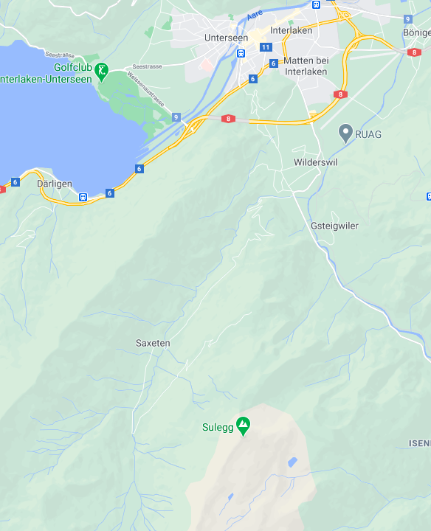
The Canyon Disaster was located in Saxetenbach Gorge, Saxeten, south of Interlaken in Switzerland.
The city of Interlaken is a popular site for extreme sports whilst being surrounded by the beautiful scenery of the Swiss Alps. Adrenaline enthusiasts flock to the city to experience adventurous activities such as skydiving, paragliding and canyoning (Leland, 1999).
Saxetenbach gorge provides the perfect location for canyoning, which involves traveling down the gorge by jumping and swimming through and around waterfalls, boulders and pools. Take a look at the video below to get an idea of what canyoning in
The Activity Provider - Adventure World
The Company was started in 1992 by Georg Hoedle a former Swiss mountain guide, Peter Balmer and Stephan Fridedli. Shortly after David Erikson and Jeff Clarke were employed to set up the canyoning and rafting programs on the gorge. At the time Adventure World was the largest adventurous activity provider in Switzerland. They went from running three canyoning trips a day to taking up to 500 people out a day. With the increase in business there were concerns over the safety of the clients. To cope with the amount of clients more inexperienced guides were being employed. These guides were more willing to go out in bad weather conditions.
(Jenkins, 1999; Bell and Bale, 1999; Leland, 1999)
Saxeten looks like.
(VIDEO) Canyoning at Saxeten (Bazz Goes, 2016)
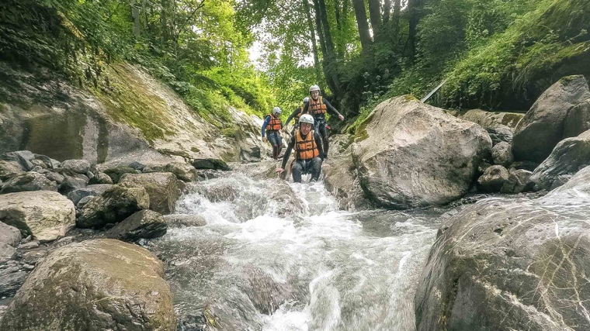
https://www.youtube.com/watch?v=jXVeW1Ybnks

(Interlaken.ch, No Date)
``This is a trip which has been done many times by us. In fact 35,000 people have gone on this excursion and we have never had an accident.''
Georg Hoedle, cofounder of Adventure world (Bell and Bale, 1999)

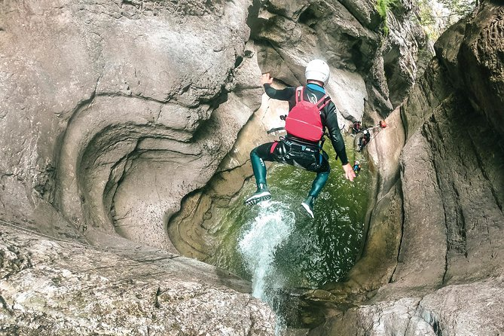
Who was involved?
- 8 Guides.
- 7 out of 8 were first year guides.
- 45 young tourist all paying $60 each for a 90 minute session.
- split into 4 groups with two guides per group.
- Tourists were from Australia, United Kingdom, South Africa, Canada, America and Switzerland.
- 18 tourists and 3 guides died.
(Leland, 1999)

(Viator.com, 2021)

  - Section 2
What Happened?
The accident took place on the 27th July 1999.
Before the group entered the gorge it started to rain, however, the guides reassured the group that there were several exit points along the gorge.
At 4pm Hienz Loosli from the Alpine raft company decides the weather is too dangerous to go canyoning and cancels his clients’ trip (Leland, 1999)
A fire official, Martin Seemtater, warned the group of the storm that was upstream, but they took no notice and replied with “We know what we are doing. We know our job” (Leland, 1999).
At 4.30pm Adventure World’s guides and clients head to the Saxeten Gorge. There are short bursts of rain, however, they are unaware that a flash flood was racing down the gorge, causing a natural dam to burst which flooded the canyon and was fast approaching the group of canyoners.
By 6pm the flood had hit and a search and rescue mission had started.
(Leland, 1999; Bell and Bale, 1999; Fröhlicher and Wienand, 2019)

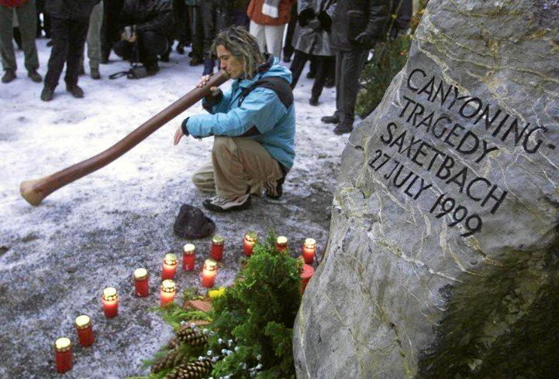
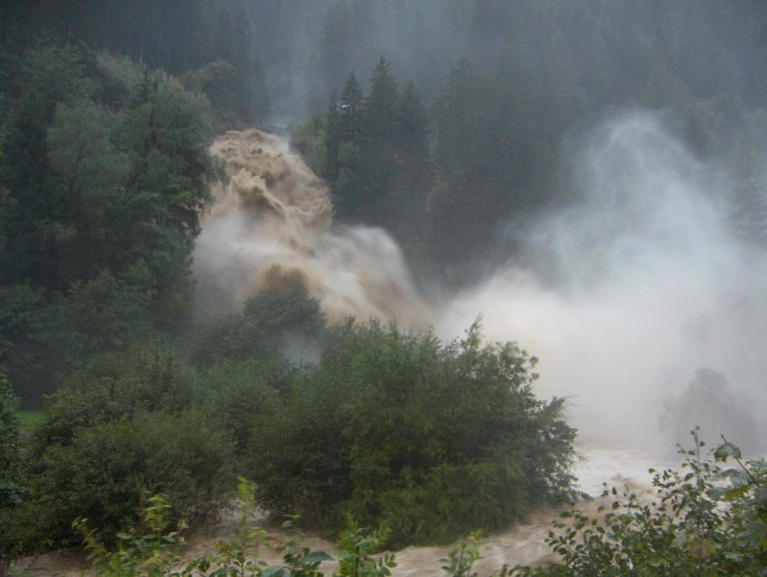
(Giroud, 2019)
(Johnson, 2019)
Key factors that were instrumental to this accident.

The weather.
The company failed to take notice of the storm which was forecast a couple of miles upstream for that day. The weather forecast for the site of the canyoning was clear skies, however, an experienced guide would have assessed the weather that would affect the site and surrounding areas. Bell and Bale (1999) stated that in storm conditions Saxeten stream was notorious for rising to dangerous levels. This should have been something the company would have been aware of as they used the gorge daily. Leland (1999) reported that as they were in the bottom of the canyon they would have had a limited view of the weather conditions upstream. However, a detailed weather report would have indicated that there was a storm on its way. Leland (1999) also explained how the company usually photograph activities for the clients, however, on this particular day the photographer was cancelled. Was this because the company knew they should not have run the canyoning session in these conditions?

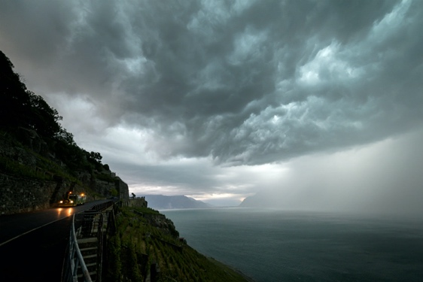
(Thelocal.ch, 2020)

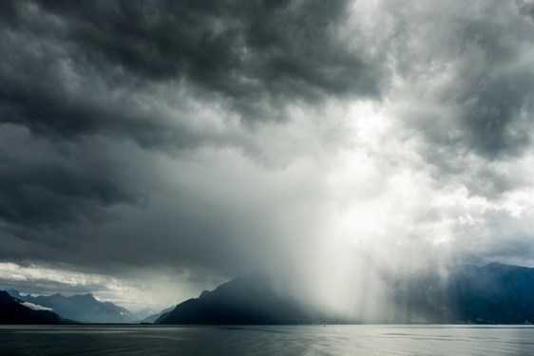
(Thelocal.ch, 2020)

Employing inexperienced staff.

Of course, all outdoor practitioners have to start somewhere, and working for outdoor adventure companies is a good way to gain valuable experience. However, in this particular incident 7 out of the 8 guides were first year guides. Jenkins (1999) explained that when the company started all the guides had up to seven years’ experience and the company had high standards. However, as the company grew, more inexperienced staff were being employed who could also be hired for less money than experienced guides.

How to become a guide with Adventure World.
- Experience in river sports
- One week intensive course in Corsica where they are trained in rescue, leadership, first aid and rope handling.
- 20 to 50 trips down Saxeten River with an experienced Guide.
(Jenkins, 1999)

"They were pushing younger, inexperienced people into the canyons to work," he was quoted as saying. "An experienced guide knows when to get out."
Dave Erikson, former employee of Adventure World
(Leland, 1999)

Money, Money, Money.
Inexperienced guides are more likely to say ‘yes’ to impress management and to not disappoint clients. Barton (2006) explains that trying to please people in adventurous activities can lead to poor decision making and not prioritising the safety of the clients.
With each client paying $60 each for a 90 minute session the company would make $2700. This factor could have been the reason why the company decided to ignore weather warnings and go ahead with the trip anyway.
(Swedish Nomad, No date)

Assuming everything will be okay.
Adventure World had been running canyoning sessions on Saxeten Gorge for a number of years and claimed to have taken 35,000 people on the same canyoning excursion with no injuries more serious than a broken leg (Leland, 1999). Guides also stated that they “know what they’re doing” and they “know their job” (Leland, 1999). Could this have led to them neglecting risk and safety procedures because they had ran the trip so many times that nothing could possibly go wrong?
Morgan and Dimmock (2006) discuss how injuries and accidents are more likely to occur when there are environmental risks present at the same time as human factors. In this case the environmental risks are storm forecasts further upstream and rising water levels, while the human factors were the guides were inexperienced and taking risks.

Safety procedures
It was stated that Adventure World did not keep a record of the names and nationalities of the people who were on the trip (Lashmar, 1999). Fröhlicher (2019) also stated that many of the clients were unaware of what canyoning was and mistook it for canoeing. This could lead to the possibility that clients did not receive or complete an activity information form. Survivors of the disaster stated that the trip felt hurried and the trip had not been properly explained to them (bbc.co.uk, 2001)
There was a 100m stretch where there were no escape routes. They could have put an escape route in using a rope or a ladder. Did they have an emergency procedure in case an accident happened in this 100m stretch?


“When it comes to being on the water, being in the gorge, you need to do what is required, not what your boss tells you,”
Guides “need to be empowered and allowed to make the right decisions for the safety of their guests and their fellow guides”.
Katrin Blumberg, president of the Swiss Outdoor Association
(Giroud, 2019)



The Swiss Cheese Model

What is the Swiss Cheese Model?
The Swiss Cheese Model was invented by James Reason. It is a metaphor to explain how accidents happen and can be used for risk management, risk analysis and prevention. Each slice of cheese is a hazard and acts as a defence for things going wrong. Hazards are prevented from causing harm by a series of barriers. The more slices of cheese means there are more layers of safety. Barriers could be physical (e.g. equipment) or behavioural (e.g. inexperience). Holes in the cheese represent the weaknesses in these barriers and if holes line up in multiple slices, the defence layers will have been broken which can increase the chances of a critical incident.
(Perneger, 2005; Thimbleby, 2014; Reason, 2006)

The Swiss Cheese model in relation to the Saxetenbach Canyoning Disaster

Risk Assessments (Dynamic, Site Specific & Generic)

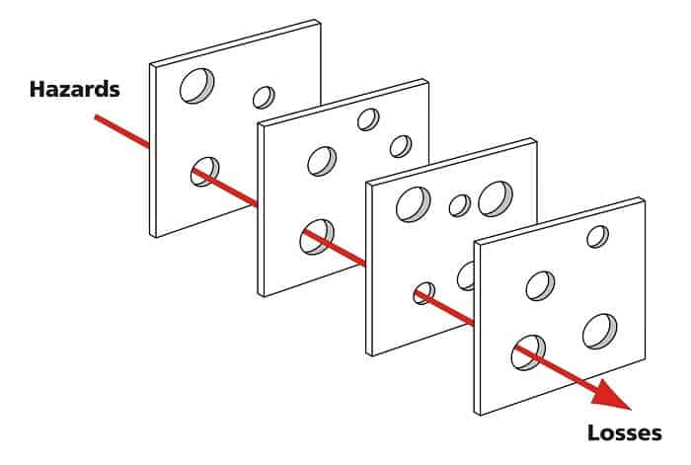
Detailed Weather Reports

Inexperienced Guides

Emergency Procedures & Written Safety Protocols

The decisions made before and throughout the incident are the holes in the slices of cheese which aligned to cause the incident. Not obtaining a correct weather forecast, ignoring advise from locals and not undertraining a dynamic risk assessment (as did the other company who cancelled their trip). They had inexperienced guides who lacked local knowledge and were possibly under financial pressure to go ahead with the canyoning trip (Jenkins, 1999).

(Baruah, 2019)

  - Section 3

The immediate response and long term implications of the incident.
“Judge Thomas Zbinden told the Interlaken court that safety measures taken by now defunct Adventure World were totally inadequate - with no proper safety training for the employees.”
(BBC.co.uk, 2001)

Sentences
Six members of Adventure World were found guilty of negligent manslaughter. The three directors of the company were given a five month suspended prison sentence and a large fine, whilst the company’s lead guide and two other senior managers were given shorter prison sentences and smaller fines (BBC.co.uk, 2001; The Sydney Morning Herald, 2002)



High Water Alert System
After the canyoning disaster Adventure World wanted to develop a high water alert system that would combine near term and long term weather predictions in the hope that it would make trips on the canyon safer. However, there were disagreements on whether the alert system was necessary, and that people who work and venture into nature should not rely on alert systems and take responsibility for themselves (Giroud, 2019). The concept fell through as other outdoor companies were not interested in investing in the alert system. Later, Adventure World declared bankruptcy due to another accident that happened under Adventure World’s supervision.

Call for industrial regulations on safety
After the incident, Switzerland put in place legislation on mountain guides and organisers of other high-risk activities, however, this was not put in until 2014. Companies are required to develop a concept specific to their needs and undergo annual audits to ensure they have complied. Companies must produce risk assessments and are required to have training specific to each activity. In 2019 tour operators were required to have a permit (Giroud, 2019).
In 2000 the safety in adventure voluntary certification programme was put in place, but as this was voluntary few companies participated (Giroud, 2019). These regulations were put in place to protect tourists with no experience in the activity.

“Adventure World had an almost flawless guiding record. Now it has become a symbol of the disasters that lurk when the explosive popularity of high-risk recreation undermines simple safety standards.”
(Jenkins, 1999)
Learning from mistakes
With such a tragic accident occurring you would hope that Adventure World would put everything in place to prevent any further accidents from happening. Unfortunately this was not the case. Less than a year later the company were responsible for the death of a man who was attached to a bungee jumping rope which was too long. Hody (2000) stated that they were experienced instructors, however, they were replacing another team that day. The instructors had picked up the wrong rope and failed to test it. This accident led to the company being closed down declaring bankruptcy (bbc.co.uk, 2001).



  - Section 4
My own personal reflection of the incident
There are many key factors that led up to this incident: not having a good weather report being one of the main causes of the incident. The main key factor that I feel is important to reflect upon is the lack of experience and local knowledge of the area that the guides had and the arrogance of the guides when people warned them of the storm. I believe this is the fault of Adventure World as they have the responsibility to ensure that staff are properly trained and have good local knowledge; for example, knowing that the canyon is notorious to rising to dangerous water levels when in storm conditions. I also believe that it is the duty of a company to set profit aside and ensure that guides will have back up if they decide the conditions are too dangerous to continue with the activity. I had hoped that more safety legislations would have been put into practice after this incident to prevent any more critical incidents from happening. For example, a canyoning guide qualification that was more in keeping with white water safety and emergency procedures. However, these legislations are in place in the United Kingdom as we have the Adventure Activities Licencing Authority 1996. This ensures that adventure activity companies practice good safety management which can prevent death or life threatening injuries (HSE.gov, No Date).

How it affects my own approach to outdoor adventurous activities.
I realise the importance of ensuring all safety procedures are in place. When working for a company I will take it upon myself to check all health and safety procedures and risk management thoroughly. Doing this will make sure I am not relying on what the company tells me. I will also ensure that I have back up from my management team when I decide conditions are too dangerous for an activity to take place. I will always produce a detailed weather report for: before, during and after the activity, I will obtain this information from various sources and not rely on just one weather report as this will help prevent any unknown sudden change in the weather. I also feel it is important to stay alert throughout the activity and look for signs that might cause harm.

Reference

Barton, B. (2006). Safety, risk and adventure in outdoor activities. London: Sage.

Baruah, 2019. What Is The Swiss Cheese Model?. [online] Planning Tank. Available at: a [Accessed 13 January 2021].

Bazz Goes. (2016). Canyoning Saxeten, Interlaken, Switzerland 2016. [video] Available at: <https://www.youtube.com/watch?v=jXVeW1Ybnks> [Accessed 10 January 2021].

bbc.co.uk. (2001). BBC News, Six Guilty In Swiss Canyoning Trial. Available at: <http://news.bbc.co.uk/1/hi/world/europe/1704669.stm> [Accessed 13 January 2021].

Bell, S. and Bale, J. (1999). Probe On Canyon Horror. The Independent. Available at: <https://www.independent.ie/world-news/probe-on-canyon-horror-26145675.html> [Accessed 8 January 2021].

Fröhlicher and Wienand. (2019). 'I Just Surrendered': How An Aussie Survived Disaster And Found Closure 20 Years On. SBS Your Language. Available at: <https://www.sbs.com.au/language/english/i-just-surrendered-how-an-aussie-survived-disaster-and-found-closure-20-years-on> [Accessed 11 January 2021].

Giroud, T. 92019). Safety Still A Question 20 Years After Interlaken Canyoning Accident. SWI swissinfo.ch. Available at: <https://www.swissinfo.ch/eng/risk-sports_safety-still-a-question-20-years-after-interlaken-canyoning-accident/45105312> [Accessed 10 January 2021].

Hody, P. (2000). Sentences Suspended In Bungee Death. AP NEWS. Available at: <https://apnews.com/article/95b70d0d34e842c3534171ccba5c1862> [Accessed 14 January 2021].

Hse.gov.uk. (No Date) General Information On The Adventure Activities Licensing Scheme - HSE. Available at: <https://www.hse.gov.uk/aala/general-information.htm> [Accessed 11 January 2021].

Interlaken.ch. (No Date) Canyoning. Available at: <https://www.interlaken.ch/en/experiences/poi/canyoning> [Accessed 9 January 2021].

Jenkins, M. 91999). Urban River Tubing Is Just One Reason Colorado Is The Best. Outside Online. Available at: <https://www.outsideonline.com/2418782/keeping-colorado-chill-tubing-downtown-denver> [Accessed 11 January 2021].

Johnson, T., (2019). The Swiss Canyoning Disaster. www.tiffanyjohnson.com. Available at: <https://tiffanyjohnson.com.au/the-swiss-canyoning-disaster/> [Accessed 11 January 2021].

Lashmar, P. and karacs, I., (1999). Swiss River Disaster: Black Wall Of Water Swept Down The Gorge, The Independent. Available at: <https://www.independent.co.uk/news/swiss-river-disaster-black-wall-of-water-swept-down-the-gorge-crushing-everyone-in-its-path-1109256.html> [Accessed 9 January 2021].

Leland, J. (1999). A Wall Of Black Water. Newsweek. Available at: <https://www.newsweek.com/wall-black-water-165758> [Accessed 8 January 2021].

Morgan, D. and Dimmock, K. (2006). Risk management in outdoor adventure tourism. Tourism in Turbulent Times: Towards Safe Experiences for Visitors, Amsterdam: Elsevier, pp.171-184.

Perneger, T. (2005). The Swiss cheese model of safety incidents: are there holes in the metaphor? BMC Health Services Research, 5(1).

Reason, J., Hollnagel, E. and Paries, J. (2006). Revisiting the Swiss cheese model of accidents. Journal of Clinical Engineering, 27(4), pp.110-115.

Swedish Nomad. (No Date) Currency In Switzerland – Info About Swiss Francs, Atms & Money. Available at: <https://www.swedishnomad.com/currency-switzerland/> [Accessed 13 January 2021].

The Sydney Morning Herald. (2002). Convicted Swiss Drop Their Appeals Over Canyon Deaths. Available at: <https://www.smh.com.au/world/convicted-swiss-drop-their-appeals-over-canyon-deaths-20020908-gdfm5v.html> [Accessed 10 January 2021].

Thelocal.ch. (2020). Storm To Hit Switzerland. Available at: <https://www.thelocal.ch/20200212/new-storm-to-hit-switzerland-on-thursday> [Accessed 12 January 2021].

Thimbleby, H. and Li, Y. (2014). Hot cheese: a processed Swiss cheese model. The Journal of the Royal College of Physicians of Edinburgh, 44(2), pp.116-121.

Viator.com. (2021). Chli Schliere Advanced Canyoning Experience From Interlaken. Available at: <https://www.viator.com/tours/Interlaken/Chli-Schliere-Advanced-Canyoning-Experience-from-Interlaken/d5011-6891CANYONCHLI> [Accessed 13 January 2021].

