STUDENT : Ana Maria Moaca (1908539)
MANAGING PEOPLE ASSESSMENT 1 (LCBB5004)
TEACHER : Mushfiqur Rahman

ASSIGNMENT

Executive Summary
Organization development cannot happen overnight. The business organizations like Vectair Holdings can benefit from the different findings from global experience. HR management can be more benefitting when it is understood that the companies are adept enough to understand priorities. This has been addressed that sound HR policies can be carved out from study based upon examples. A practical approach to the study tells that workplace development is possible when the organization is able to make use of its internal resources properly.

Table of Contents

Task 1 3
Task 2 7
Introduction 7
Discuss in Detail the Organizational Objectives of HR (Planning Recruitment and Selection) 7
Theory and Models on HR 8
Current practices on HR techniques (Present Perspective) 9
Compare own experience regarding HR roles and objectives (Current or Previous Employer) 11
Benchmarking HR Practices by providing Real world case examples 11
Conclusion 12
References 13

Task 1
Evaluating the concept of HR professional under the backdrop of CIPD professional map
HR professionals in a company are responsible for the recruitment, Screening and Interviewing of People in Business organizations. An HR professional is also offered different responsibilities like Training, Benefits as well as payroll.
Organization Goals
Vectair Holdings is one of the most prominent SMEs operating in the UK and now they are aiming to expand in some other markets. Vectair Holdings understands the changed economic perspective Post COVID pandemic. They have now revised their organization Goals.
1. Opening a new manufacturing plant in Asian Subcontinent
2. Offering training to the newly recruited Employees
3. Holding around 30% of the Hygiene related product in the Local Market
Core Knowledge | Core Behaviour | Specialised Knowledge
The HR Team of Vectair Holdings needs to bring in new policies in order to recruit and train these new employees. | There is a need to study core objectives in alignment with the market. | Orienting new employees with the Vectair Holdings work culture
People Practice  Hygiene related products are in demand and the company needs to offer specific training to its employees. | Ethical Practice  Legal teams need to be hired. | Employee Experience  Focus on collective Learning and secure future through Increased salary packages
Culture and Behaviour  Vectair Holdings needs to study in depth the culture and behaviour of the place and design the training methodology accordingly. | Professional Courage  Aggressive campaigning needs no alternative. | Employee Relation  Team based work processes need to be developed through training.
Business Acumen  Focus on New Products and Services. | Valuing People  Focus on Social and Cultural values. Understanding Hygiene from local perspective | Diversity Inclusion  English Tutorials for all the employees (new employee) so that Complexities internal to the organization gets lessened.
Analytics and Creating Value  Extensive Marketing needs focus. | Working Inclusively  Promote work culture and developing upon inclusivity upon a perfect product and service. | Learning and Development  Play acting and practical evaluation
Digital Working  Drive for digital internal to the organization. | Commercial Drive  Investment on Commercials | Organization Development  work - culture
Change  Vectair Holdings should be psychological ready for change. | Passion For Learning  Increased Research and Development. Vector Holdings needs to bring in new technology that will support passion for learning. | Peoples Analytics  Increasing resource application.
 | Insight Focussed  Compressive Growth through market behaviour | Resourcing  Vocal for Local
 | Situational Decision Making  Operational values need to be Flexible | Reword  New Payroll and Reward System needs to be developed.
Talent management
Inclusive Development through extensive training and development. Promoting better work culture through latest development.
Table 1: CIPD professional map
(Source: Inspired from Abdullah et al. 2020, p.60)
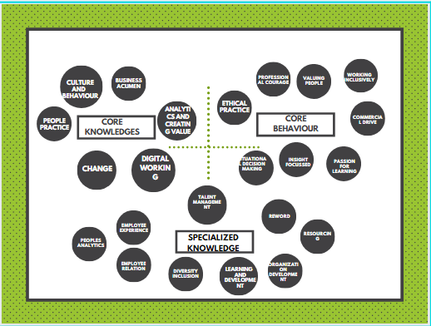
Figure 1: CIPD professional map
(Source: Inspired from Abdullah et al. 2020, p.60)

Extracting core benefits from the aforementioned networked it can be said that strategic planning and recruiting follows a whole lot of internal analysis. The main objectives of strategic planning depend upon the ways the management carves out implementation policies. This is a critical and crucial stage keeping in mind the present business environment.

Task 2

Introduction
The role of HR professional is becoming increasingly complex with the passage of time. The economy is scrunching and antithetical there is entry of new companies into the markets. It has been mentioned that Vectair Holdings needs to understand the social values, work culture and markets in order to fulfil Growth and development objectives. From this aspect the role to be played by Vector Holdings HR Department can be expressed and analysed.

Discuss in Detail the Organizational Objectives of HR (Planning Recruitment and Selection)
Vectair Holdings management has chalked out a visionary plan of capturing 30% of the Subcontinent market. They have decided to construct a new manufacturing Unit. The organization is well aware of the physical resources and possibilities they are going to get from the local market. Their Hr Plan consists of Recruitment. The management is intended to recruit Professionals and focus is on recruiting local people (Barren-Martinez et al. 207, p.23). Vectair Holdings management has also focussed quite a lot on building internal partnership through training.
While recruiting the professionals, HR management needs to constantly study the abilities and disabilities of the workforce so that alignment with the nucleic values becomes convenient (Hollenbeck et al. 2017. p.231).
Selection of the Candidates will be based on the different criteria set against each type and kind of jobs. Focus will be laid on recruiting both Experienced People and young as balance between both helps attaining a better control over management. Old and experienced candidates have lesser urge to try other jobs and they help the company with gained experience. They can even teach young people on the spot. Newly recruited work force come with a lot of commitment.

Theory and Models on HR
Human Capital Theory
Human Capital Theory by Schultz suggests that the Organization needs to provide constant training to its workforce in order to increase Productivity. This not only carves out financial benefits for the company but also works to enrich the employees (Margin son, 2019, p.301). That is why it can be said that the Organization when recruiting and training people must be aware of its main objectives and vision.
Institutional Theory
Institutional theory is built on the doctrine that an organization needs to be aware of its creative spirits and that is why focus is being laid on creating a better workforce. The employees that are newly recruited need to be constantly made aware of the rich cultural lineage and history (Roehl, 2019, p.11260). This can be done through Innovative Structures. They need to be told that any legitimization and irrationality can't be tolerated. This increases concentration and devotion towards work.
The 8 Box Model by Paul Boselie
The model shows different internal and external factors that tend to influence the effectiveness of the HR.
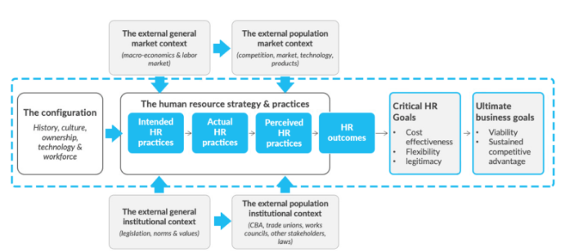
Figure 2: 8Box Model by Paul Bolelie
(Source: Kyhyräinen, 2019, p.36)
There are external forces that cater to the requirements of Recruitment. When the market has abundance of talent the Institutional context also changes with time (Day to day impact of HR)
Why choose the theories and Model
Vectair Holdings management understands the hardworking nature of the workforce of the Subcontinent and that is why they have selected the place for opening a new manufacturing Plant. This group of people are highly productive. Examples can be cited in the name of the different company. Barkley’s have made a dramatic turnaround by becoming the best company with Cleanest Balance sheet.
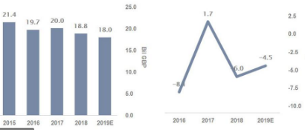
Figure 3: Barclays Economic Performance
(Source: Sˇušnjar et al. 2016, p.120)
This has happened because Barkley’s offered more of an impetus on training and development of the employees. Mention may also be made of JCB where the company has managed to add in increased revenue of around 5,550 cores in 2014 and also added hundreds of cores in 2017. This has been possible because the Internal and external factor to comprehensive development has been under prime focus.

Current practices on HR techniques (Present Perspective)
The HR management of Vectair Holdings needs to conduct inclusive research and analysis on the different HR practices shaped under the present economic perspective. Presently the markets are experiencing a draught in terms of demand into the market. Competition is increasing in leaps and Bounds. This is important to note that Hygiene products have an extremely strong market base and the value becomes close to around 130.81 billion Dollars. According to a review the market is going to increase around 5.56 (2025 projection) (Gorman et al. 2017, p.202). Vector Holdings must keep in mind the contemporary Practices.
1. Providing Security the employees
HR practices must be aligned with the recent technologies and up gradation programs so that best candidates are selected. Vectair Holdings HR department can follow the different HR recruitment policies of Global Companies like Apple Inc, Vedanta groups, Tata and others so that proper guidelines can be sought out (Sung and Choy, 2018, p.1442)
2. Selective Hiring: Hiring the right people
Inclusive criteria must be adhered to while chalking out policy frameworks. The subcontinent employees are extremely hard working by nature and that is why the management should consider a mix of mental ability and leadership qualities as a standard base for recruitment.
3. Self managed effective teams
An ambience of democratic leadership needs to be developed internal to the Organization. Specific examples can be cited in the form of Google. Google has devices for the company workforce by integrating the company employees in the form of Integrators and Segmentation. According to a survey 31% of the employees internal to the Google business are semesters (Sundiman, 2017, p.23).
4. Fair performance based compensations
The success of a business enterprise depends quite a lot open performance engagement. From this analysis it can be overviewed that the Vectair Holdings HR department needs to draw out mechanisms in order to read different physical and psychological tendencies. This enables a better understanding of fair performance. Google Follows gDNA measures to study employee engagement. Other top grade HR practices include Updated training and Easy access to information.

Compare own experience regarding HR roles and objectives (Current or Previous Employer)
A juxtaposition of the traditional HR management and the modern will be extremely effective in understanding the best techniques and ways of employee management. Employee management over the years have undergone huge transformation. This is inferred from the different new ways and techniques that slowly crepe into the frame of Understanding.
Traditional HR Practice
The employees are given extensive sessions on employee development and this has focussed a lot on understanding the root cause of development of the organization. Previously, advertisements were placed in different companies offering the core specifics required for a particular role. Question Answer sessions then followed. During Economic stagnancy employees are terminated in huge numbers.
The most debatable aspect of Traditional way of HR practice is that the employees do not get proper chance to mingle with the prospective employees. Under new rules and regulations employees are put into a disciplined framework. Different closed surveys have pointed out that the employees suffer psychologically from a regimental office ambience and this hampers their overall work ambience (Sung and Choi, 2018, p.1336).
Strategic HR management
Under this framework the entire aspect of recruitment is seen and contrasted from a broad level analysis. Under this level of understanding the Recruiters follow long term goals in order e to prepare its employees. Much of a focus is given on training and development. The most positive aspect of strategic recruitment is that the companies do not tend to go for bulk employee slashing. Instead they go for salary curtailment and other ways and treatments.

Benchmarking HR Practices by providing Real world case examples
Strategic Benchmarking has been one of the most important aspects of setting in with new infrastructure. It requires mention that Vectair Holdings management operates with a set of elements conducive for organizational development. The company needs to thoroughly study the recruitment policies that are followed in different management companies. In order to mention the different core objectives it needs to mention that the company needs to align with the necessary developments (Kyhyräinen, 2019, p.132). From the strategic point of view it requires mention that the following development needs to be aligned with business objectives. This can be said that the Employees need to be provided with a whole lot of training and development. From the aspect of strategic development it can be mentioned that English teaching is one of the core aspects to workplace management. Like the strategy of Unilever the present management focuses a lot upon linguistic integration. Vectair Holdings management can bank upon a strategic organization in order to cater to a better workplace development.

Conclusion
In order to conclude it can be said and analysed that Vector Holdings management can make the best out of the available resources and carve out development strategies. Any expansion plan is materialised when there is a proper framework. In order to understand the root cause of development certain core areas are focussed open. There are many ways in which organizational development can be done but the company needs to closely study their requirements and then chalk out development plans.

References
Abdullah, P.Y., Zeebaree, S.R., Jacksi, K. and Zeabri, R.R., 2020. An hrm system for small and medium enterprises (sme) s based on cloud computing technology. International Journal of Research-GRANTHAALAYAH, 8(8), pp.56-64.
Barrena-Martinez, J., López-Fernández, M. and Romero-Fernandez, P.M., 2018. Drivers and barriers in socially responsible human resource management. Sustainability, 10(5), p.1532.
Gorman, C.A., Meriac, J.P., Roch, S.G., Ray, J.L. and Gamble, J.S., 2017. An exploratory study of current performance management practices: Human resource executives’ perspectives. International Journal of Selection and Assessment, 25(2), pp.193-202.
Kyhyräinen, J., 2019. Human resource management as a tool for SME employee engaging. Case: Company X.
Marginson, S., 2019. Limitations of human capital theory. Studies in Higher Education, 44(2), pp.287-301.
Noe, R.A., Hollenbeck, J.R., Gerhart, B. and Wright, P.M., 2017. Human resource management: Gaining a competitive advantage. New York, NY: McGraw-Hill Education.
Roehl, M.T., 2019, July. The Impact of Environmental and Institutional Pressures on HR-System Fit. In Academy of Management Proceedings (Vol. 2019, No. 1, p. 11260). Briarcliff Manor, NY 10510: Academy of Management.
Sˇušnjar, G.S., Slavic, A., Berber, N. and Lekovic, B., 2016. The role of human resource management in small and medium sized companies in Central-Eastern Europe. Economic Development and Entrepreneurship in Transition Economies: Issues, Obstacles and Perspectives, p.205.
Sundiman, D., 2017. Human resource management in the enhancement processes of knowledge management. Binus Business Review, 8(3), pp.167-173.
Sung, S.Y. and Choi, J.N., 2018. Building knowledge stock and facilitating knowledge flow through human resource management practices toward firm innovation. Human Resource Management, 57(6), pp.1429-1442.

