Assignment tips
Maybe create a main menu form

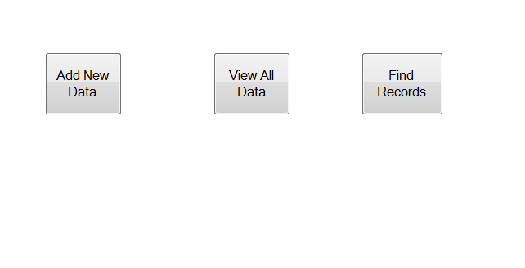

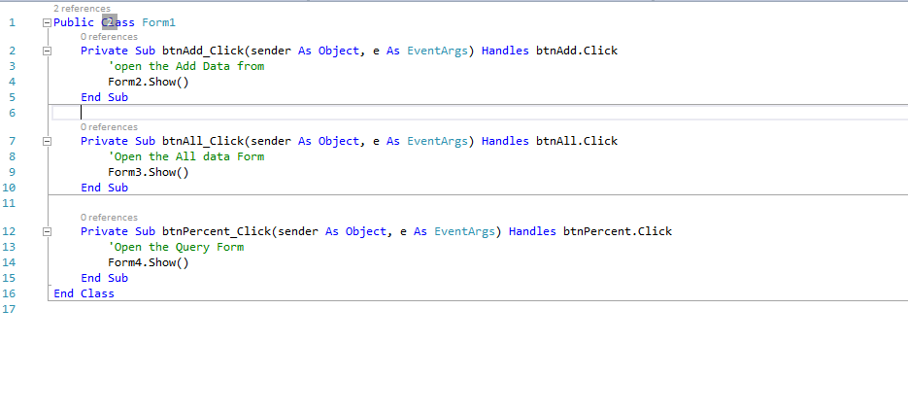

You then have to add data to a grid. Set out some text boxes to allow the user to complete and then a button to add then to a data grid.

The following code sets up the link to the excel spreadsheet
Imports Excel = Microsoft.Office.Interop.Excel
Public Class Form2
'Tellign teh Programme where my Excell SpeadSheet Is
Dim excellocation As String = "C:\Users\sc-bf\Documents your directory path …”

Dim myss As String = "C:\Users\sc-bf\Documents\ your directory path …. "

'Declaring the Variables
Dim ds As DataSet
Dim tables As DataTableCollection
Dim source1 As New BindingSource
Dim APP As New Excel.Application
Dim worksheet As Excel.Worksheet
Dim workbook As Excel.Workbook
Dim ColumnIndex As Integer = 0

The following code will allow you to send data to the data grid and clear any variable you have defined to enable additional input

Private Sub btnAdd_Click(sender As Object, e As EventArgs) Handles btnAdd.Click

'Transfer data from text boxes, to the data grid view
DataGridView1.Rows.Item(0).Cells("StudentID").Value = txtID.Text()
DataGridView1.Rows.Item(0).Cells("Comp1").Value = txtComp1.Text
DataGridView1.Rows.Item(0).Cells("Comp2").Value = txtComp2.Text
DataGridView1.Rows.Item(0).Cells("Comp3").Value = txtComp3.Text

'Clear the Text Boxes
txtID.Clear()
txtComp1.Clear()
txtComp2.Clear()
txtComp3.Clear()
End Sub

The form should look something like this

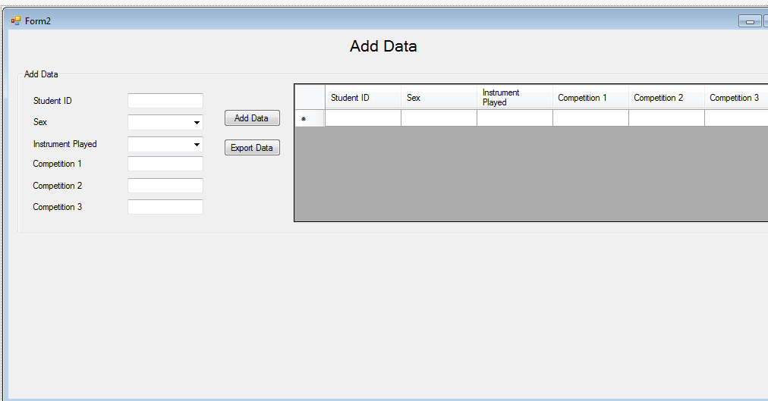
Hope this helps

