The topic was to pick a town in your area and describe the features of that certain building. I chose Neath Abbey because I wanted to look at it before it became ruins and the different elements within the abbey. The other building, I chose was the Tabernacle in Penclawdd because I wanted to see how different these two buildings are. I will be looking at key areas: how light enters the building, what the building was used for, and many more.
Neath Abbey was founded in 1130 and become part of the Cistercian Order, by the 13th century it became one of Wales’s wealthiest abbeys, it was home to about 30 monks coming from northern France. In 1405 the abbey was repeatedly attacked by the Normans. By the 1920-the 30s the abbey was evacuated and then into care in 1944. It is a Gothic abbey church with some signs of decorated gothic. It has a flying buttress and Rib Vaulting, Thin columns. The Nave was covered with rib vaults which separated the lower side Ailes from the high central nave. In the 16 century, the vaults above the church were covered with polychromes and heraldic shields, the floors were highly decorated covered in 14-century tiles with heraldic motifs and Tracey patterns-- (Burton J., 2015).
The Tabernacle Chapel in Penclawdd was completed in 1911-12 and it was the first Calvinistic chapel to open in Penclawdd. It is a gothic-style chapel with a corner tower and spires. It has a stone-walled graveyard at the front with cast-iron railings on a plinth wall and has cast-iron gates to the front of a modern manse and house, it is now a grade 2 listed building as a fine gothic chapel with a well-designed interior— (Cooper, 1995-1998)

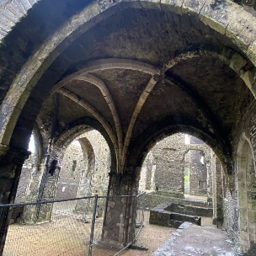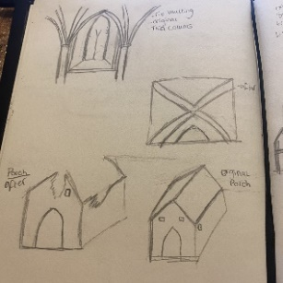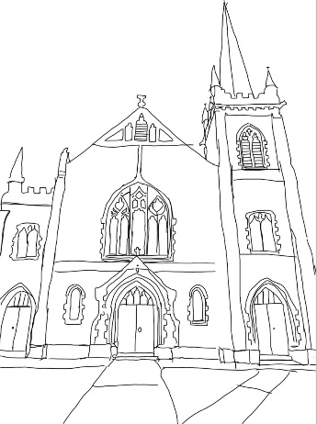
Figure 1 Figure 2- – (Bethan Davies 2021) Figure 8– (Bethan Davies 2021)

The plan for neath abbey is split into three sections, you have the top, middle, and bottom shown in figure 4. At the top of the plan, this would be the church which would have a west-facing Nave which would have had two high buttresses as well it has a presbytery and quire. The middle section would be the garden area which is called the cloister where people would communicate and have conversations, from the cloister it leads you into a library and it would lead you into the church. The bottom section shows the kitchen where you would cook your food, the Education room, and a warning room. Figure 3 shows the ruins of the abbey, it has a sketch which is placed on top of the ruins to show what the construction would be like before it was destroyed, and how you would enter the building. There is some rub vaulting in the design, but most was destroyed.
The plan for Tabernacle chapel in Penland was, On the ground floor it has semi-carved back seats which would have 10 people maximum allowed to sit as you look towards the front it has a pulpit where the victor or other people would stand and do their speeches, the pulpit is a tall and wide with broad symmetrical stairs projecting towards the front of the room with broad handrails. It has a set fawr which is two steps above the general floor level and has two doors on each side of it. — (Cooper, 1995-1998) On the first floor, it has rows of semi-carved back seats with a pew design at the end of the seats, at the end of the seats towards the back above the set fawr is a manual organ which was brought in from Norman and Beard in 1912. Two doors at either end of the ground floor led you to stairs that go it the first floor. The ceiling is deeply covered which has lights hanging from the ceiling.

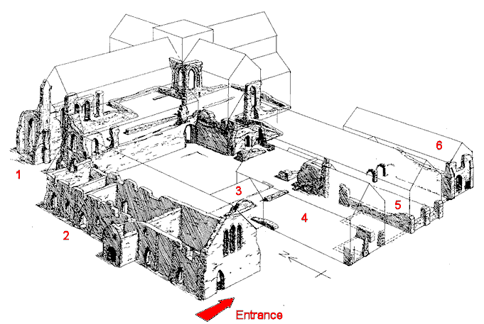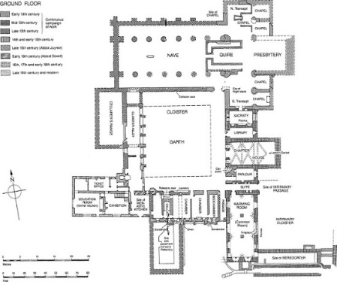
Figure 3- (Borrow, 1803-18881) Figure 4- (Burton J., between 2006-2015)
Neath Abbey was made from stone because it was easy to construct. Light plays a big part in neath abbey because above the door is has a large ogival tracery window with a smaller window above the main entrance. The interior of the church has two rows of ogival windows, on the southern aisle windows were smaller than the northern ones. It was surrounded by buttresses on the west side of the building, but the abbey has Tudor windows as seen in figure 5.
The tabernacle in Penclawdd is constructed of local limestone with stone. It has a large decorated-style window with an ogee- arch. The central door is flanked by a small lancet window. On the right tower of the building, it has two-light traceried louvered openings, and the inside of the chapel has a small vestibule with five-panel windows and a four-panel door with coloured glass.
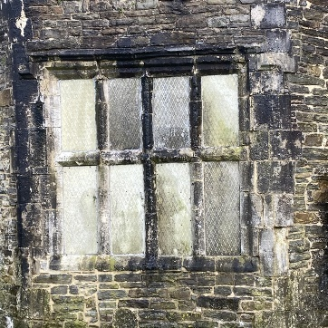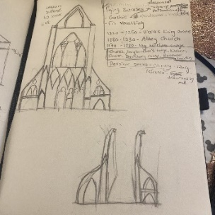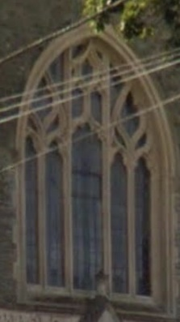
Figure 5 Figure 8 – (Bethan Davies 2021) Bethan Davies 2021)

Before the abbey was used for industrial purposes, it was used by the Monks for praying and sleeping in, but the monks weren’t allowed to mix with the other people, the lay brothers also used the abbey. When it was excavated in the 1920’s they removed a load of debris including copper slag and then in the late 18th century, an iron foundry was opened near the abbey and owned by the price and fox families. There weren’t a lot of public areas, the only public area was the garden area. The monks were only allowed to use the night stairs, which you can see in Figure 6 which would reach the church for prayers and lead to their dormitory.
The use for tabernacle in Penclawdd was used as a chapel where local people would do their prays on a Sunday and a weekly bible study and people from the community go for choir singing. Figure 7 shows what the interior of the chapel looks likes.
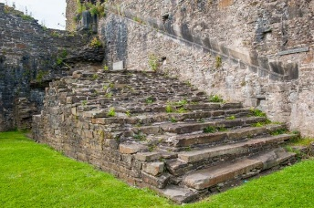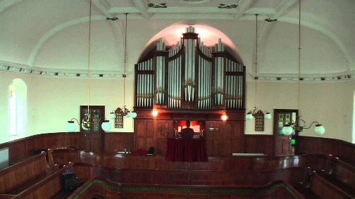
Figure 6-(Davies, B., 2020) Figure 7- (Author, n.d.)

In conclusion, Neath Abbey and Tabernacle chapel in Penclawdd are different because neath abbey is in ruins and was home to 40 monks, it was one of the wealthy abbeys in Wales, whereas Tabernacle Chapel in Penclawdd wasn’t very wealthy but the local people would go to the chapel for Sunday services, weddings and choir singing. It has helped me look at building differently because I didn’t know much about neath abbey or even tabernacle chapel in penclawdd, so my knowledge has grown and I can show/ spot gothic style from a church, abbey.
(Cooper, 1995-1998)

References
Author, U., n.d. Tabernacle Calvinistic Methodist Chapel, Pen-clawdd, Llanrhidian Uchaf; Llanrhidian Higher.
Borrow, G., 1803-18881. The Abbey, Neath Abbey, near Skewen, Glamorgan. s.l.:s.n.
Burton J., S., 2015. Neath- Cistercian Abbey. Ancient and Medieval Architecture.
Burton J., S. K. H. S. R. D. D. S. M., between 2006-2015. NEATH – CISTERCIAN ABBEY. Ancient and medieval architecture.
R N Cooper, J. Newman. a. N., 1995-1998. Listed Buildings in Swansea. s.l.:s.n.

