

By Florenta Anisoara Chistol Student ID 2422978

Lecturer: Zarah Ahmed

6st of July 2026

Programme: BSc Health and Social Care
Module: Changemakers: Creativity and Value Creation
Module code: BMHP5014
Table of Contents

- Task 1. Concept Map
- Task 2. Self-Reflection of the Convergent/Divergent Thinking Paperclip Activity
- Task 3. Case Study of a UK innovation – Telemedicine in the NHS
- Task 4. Research. Current Issue in Health and Social Care – Mental Health Stigma
- Task 5. Podcast
- Task 6. NHS Leadership Framework Analysis. Summary of the NHS Leadership Framework
- Task 7. Self-Reflection Journal Entry
- References

Task 1. Concept Map
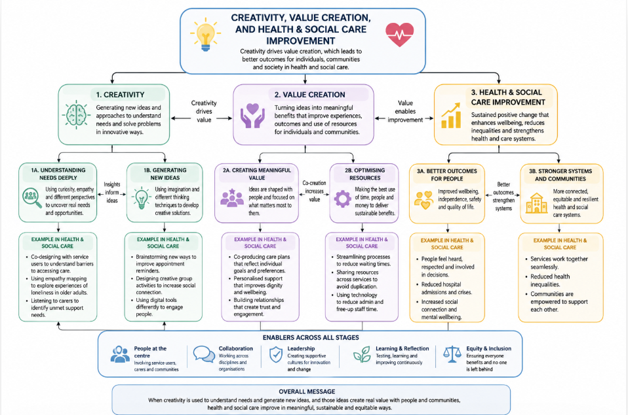
Figure 1: Concept Map
The concept map that I have created illustrates the connection between value creation, creativity, and the advancement of health and social care. Because it inspires professionals to think creatively, solve issues, and create novel concepts that address the needs of people and communities, creativity is the foundation. Understanding people's experiences, applying empathy, and creating services that enhance wellbeing and quality of life are all examples of innovation in health and social care.

These creative ideas lead to value creation, which means turning innovative solutions into meaningful benefits for service users, carers, healthcare professionals, and organisations. Value is produced by delivering person-centred care, enhancing patient experiences, optimising resource use, and guaranteeing the efficacy, efficiency, and sustainability of services. Collaboration with service users and interdisciplinary teams helps guarantee that the solutions developed address actual needs and deliver meaningful outcomes.
Value creation then contributes to health and social care improvement by providing better results for individuals and improving healthcare systems. Improvements include higher patient satisfaction, enhanced safety, reduced waiting times, improved mental and physical wellbeing, and greater equity in access to services. Communities become more cohesive and resilient when health and social care organisations form stronger collaborations.
The concept map also underlines critical aspects that promote every stage of this process, including person-centred care, cooperation, effective leadership, continual learning, and equity. These facilitators guarantee the successful implementation and long-term sustainability of innovation.
Overall, the map demonstrates how innovation produces fresh concepts, value creation turns these concepts into useful advantages, and ongoing development guarantees improved health and social care services that address the evolving needs of people, families, and communities.

Task 2. Self-Reflection of the Convergent/Divergent Thinking Paperclip Activity (Gibbs' Reflective Cycle)

During the paperclip activity, my group was asked to suggest as many alternate uses for a paperclip as possible before selecting the most practical ideas. Using a paperclip as a bookmark, phone stand, keyring, zipper pull, cable organiser, SIM card extractor, and plant support are just a few of the fifteen ideas I offered. I took an active part in the brainstorming process and then assisted in determining whether concepts were practical and safe.
Initially, I found it difficult to imagine beyond the paperclip's initial use. However, as other group members expressed their suggestions, I became more confident and creative. I liked listening to many viewpoints and collaborating with others.
During the brainstorming phase, everyone offered ideas without any judgment, which made the session successful. As a result, we were inspired to think creatively and were able to come up with numerous ideas. I contributed to the evaluation of the concepts during the convergent thinking phase by taking potential value, safety, and practicality into account. This illustrated how, while making decisions, creativity and critical thinking must be matched.
This experience taught me that divergent thinking entails coming up with a wide range of ideas without passing judgment on them right away, whereas convergent thinking concentrates on analysing and choosing the best course of action. These methods are extremely applicable to the health and social care sectors, as practitioners must use innovative problem-solving techniques while simultaneously making evidence-based choices that guarantee safe, person-centred care (Gibbs, 1988).
If I had to redo this exercise, I would push myself to think more creatively right away and urge the more reserved group members to share their thoughts. My comprehension of how creativity and critical analysis collaborate to foster innovation and wise decision-making has been reinforced by this encounter.

Task 3. Case Study of a UK Innovation – Telemedicine in the NHS

Telemedicine is one of the most major advancements adopted within the National Health Service (NHS). It entails the use of digital technology, such as video and phone consultations, to allow medical practitioners to evaluate, diagnose, and assist patients at a distance. Although telemedicine existed before the COVID-19 pandemic, its use expanded swiftly to guarantee patients could continue getting safe healthcare while limiting face-to-face contact (NHS England, 2023).
Redesigning the conventional healthcare model is what makes telemedicine innovative. The NHS created innovative methods of providing care through safe digital platforms rather than mandating that all patients attend in-person visits. This cutting-edge method eliminates the need for needless travel by enabling medical personnel to interact with patients virtually, discuss symptoms, offer guidance, and schedule follow-up care. By utilising technology to remove obstacles to healthcare access and enhance service delivery, it shows innovative problem-solving (The King's Fund, 2022).
Telemedicine has provided major benefits for both patients and healthcare providers. Patients, especially those who live in rural regions, have mobility issues, or are managing long-term health conditions, benefit from increased convenience, reduced wait times, and simpler access to healthcare services. Remote consultations also cut travel expenses and minimise disturbance to work or family life, increasing the overall patient experience (NHS England, 2023).
This innovation has also helped the NHS. Healthcare providers can better utilise clinical time, organise appointments more effectively, and ease the burden on outpatient services with the help of digital consultations. Telemedicine promotes a more sustainable healthcare system while upholding high standards of patient care by reducing needless hospital stays and boosting flexibility. Additionally, the technology makes it easier for interdisciplinary teams to communicate, which helps to improve coordination between social and health care services (The King's Fund, 2022).
This case study shows that creativity includes more than just developing new technologies; it also entails coming up with creative methods to rethink healthcare delivery. By enhancing accessibility, boosting productivity, and improving patient experiences, telemedicine has revolutionized the delivery of healthcare. Telemedicine will continue to be a significant innovation in providing high-quality, person-centred, and sustainable healthcare throughout the United Kingdom as the need for healthcare services rises.

Task 4. Current Issue in Health and Social Care – Mental Health Stigma

A significant issue affecting health and social services in the United Kingdom is mental health stigma. Stigma may discourage people from getting help, cause treatment delays, and worsen health outcomes. According to research, people with mental health issues are still impacted by social attitudes, discrimination, and unequal access to resources.
Lowther-Payne et al. (2023) conducted a systematic mapping assessment of 152 papers to investigate disparities in adult mental health treatment access within the United Kingdom. Many patients encounter obstacles before they ever get access to mental health services, the study discovered. Stigma, prejudice, and trouble getting the right assistance are some of these obstacles. The assessment also emphasised how a person's age, social status, and ethnicity can affect whether they seek assistance or receive prompt care. The authors stated that decreasing stigma and revamping services to promote accessibility are vital to addressing inequities in mental healthcare (Lowther-Payne et al., 2023).
In their second study, Brohan et al. (2010) examined studies that measured the stigma experienced by individuals with mental illness. The authors discovered that stigma could take many different forms, such as self-stigma, experienced discrimination, and perceived stigma. Because they are afraid of being evaluated or treated differently, these experiences frequently make people less confident when seeking professional assistance. The review also shown how stigma has a detrimental impact on social interactions, career prospects, and mental health rehabilitation. According to the researchers, creating treatments that enhance mental health outcomes and service accessibility requires an awareness of the various types of stigmas (Brohan et al., 2010).
Overall, both studies show that stigma around mental health issues is still a significant problem in UK health and social care. Research demonstrates that lowering discrimination, expanding public awareness, and enhancing service accessibility are critical elements in guaranteeing that people with mental health disorders receive prompt, fair, and person-centred care.

Task 5. Podcast

Task 6. NHS Leadership Framework Analysis
Summary of the NHS Leadership Framework

A framework for fostering leadership development at all NHS levels is offered by the NHS Healthcare Leadership Model. It acknowledges that everyone involved in providing health and social care has a responsibility to exercise leadership, not just managers. Inspiring Shared Purpose, Leading with Care, Evaluating Information, Connecting Our Service, Sharing the Vision, Engaging the Team, Holding to Account, Developing Capability, and Influencing for Results are the nine essential components of effective leadership, according to the framework (NHS Leadership Academy, 2013).
These factors promote person-centred care, cooperation, constant learning and innovation. The framework helps executives to establish healthy workplace cultures where personnel feel respected, supported and motivated to enhance services. Better decision-making, increased employee engagement, and better patient outcomes are all facilitated by effective leadership. By promoting collaboration and creativity, the framework helps organisations respond to changing healthcare requirements while maintaining high standards of safety, quality and compassion (NHS Leadership Academy, 2013; NHS England, 2022).

Leadership Component: Engaging the Team
Engaging the Team is a key element of the NHS Leadership Framework. Open communication, teamwork, and shared decision-making are all encouraged by leaders who engage their teams. Leaders may foster creativity and innovation by establishing an inclusive workplace where employees feel valued and comfortable sharing ideas. Members of the team are more likely to point out issues, offer solutions, and take part in creating fresh approaches to providing care. Encouraging interdisciplinary teams to exchange diverse viewpoints, for instance, can enhance patient-centred treatment and produce creative answers to healthcare problems. This collaborative leadership style improves teamwork, boosts employee motivation, and supports ongoing quality improvement in all NHS services (NHS Leadership Academy, 2013; NHS England, 2022).

Task7. Self-Reflection Journal Entry

Throughout this module, I have developed a greater understanding of how creativity, innovation and leadership contribute to improving health and social care. At first, I thought innovation was only the introduction of new technologies. However, completing the portfolio helped me recognise that innovation also involves generating innovative ideas, rethinking services and improving patient experiences through cooperation and evidence-based practice.
Investigating mental health stigma and creating the MindConnect technology were two of the most worthwhile educational experiences. This exercise illustrated how person-centred care may be supported while increasing access to healthcare through digital technologies like telemedicine and artificial intelligence. It also highlighted how crucial it is to use research findings to comprehend healthcare issues before putting forward novel remedies.
My comprehension of successful leadership was significantly improved by learning about the NHS Healthcare Leadership Model. I came to see that effective leaders foster creativity by involving team members, encouraging fresh concepts, and establishing supportive work cultures that foster invention. This has demonstrated to me that everyone, not only those in management roles, has a responsibility to exercise leadership.
When I think back on what I've learned, I think I've become better at using academic research, critically analysing healthcare issues, and successfully communicating concepts. If I were to finish this portfolio over, I would devote more time to investigating a greater variety of cutting-edge medical technology and assessing their long-term effects on patient outcomes.
All things considered, this module has given me more confidence to apply originality and ingenuity to actual healthcare problems. These abilities will help me provide safe, efficient, and person-centred care throughout my future career in health and social care.

References

Brohan, E., Slade, M., Clement, S. and Thornicroft, G. (2010) ‘Experiences of mental illness stigma, prejudice and discrimination: a review of measures’, BMC Health Services Research, 10(80). Available at: https://doi.org/10.1186/1472-6963-10-80 (Accessed: 29 June 2026).
Gibbs, G. (1988). Learning by Doing: A Guide to Teaching and Learning Methods. Oxford: Oxford Polytechnic.
Lowther-Payne, H.J., Ushakova, A., Beckwith, A., Liberty, C., Edge, R., Lobban, F. et al. (2023) ‘Understanding inequalities in access to adult mental health services in the UK: a systematic mapping review’, BMC Health Services Research, 23, 1042. Available at: https://doi.org/10.1186/s12913-023-10030-8 (Accessed: 29 June 2026).
NHS England (2022) Our leadership way. Available at: https://www.england.nhs.uk/leadingchange/about-the-programme/our-leadership-way/ (Accessed: 29 June 2026).
NHS England (2023) Next steps on the NHS response to COVID-19. Available at: https://www.england.nhs.uk/coronavirus/ (Accessed: 29 June 2026).
NHS Leadership Academy (2013) Healthcare Leadership Model. Available at: https://www.leadershipacademy.nhs.uk/resources/healthcare-leadership-model/ (Accessed: 29 June 2026).
The King's Fund (2022) The future of remote consultations. Available at: https://www.kingsfund.org.uk/publications/future-remote-consultations (Accessed: 29 June 2026).

