

ASSESSMENT 2- REPORT

Student Name: | Sandra Johanna Jimenez Vergara
Student Number: | 2024741
Module No: | BMHP5003
Module Title: | Introduction to Physiology
Lecturer: | Laila Surani

Table of Contents

Introduction 3
Anatomy and Physiology of Digestive System 4
Obesity 5
Health and lifestyle routine mesures 7
Health and Social Care Practice 8
Recommendations 10
Conclusions 11
References 12

Introduction

In the World Health Organization's European Region, obesity is the most common reason for disability, and current trends indicate that in several nations, obesity may soon surpass other risk factors to become the leading cause of cancer. Additionally, persons who are obese frequently struggle with their mental health (EuroHealthNet, n.d.). If current trends continue, it was predicted that there will be 2.16 billion overweight adults and 1.12 billion obese individuals worldwide by the year 2030 (Kelly et al., 2008). In the UK, obesity is rising. Obesity is more prevalent in less affluent areas, and it is associated with a number of health issues (health.org.uk, n.d.). Obesity has become a global problem that threatens to overwhelm medical resources (Bray, 2004).
Estimating morbidity and mortality can also be done using obesity measures. Body mass index (BMI) has been employed to diagnose people who are overweight or obese. Nevertheless, waist measurement is a better indicator of metabolic diseases including diabetes, hypertension, and dyslipidemia than any other anthropometric measure of visceral fat.
Considering that obesity is caused by inadequate intake rather than by the quantity of food consumed, the digestive system and food processing are closely related. Food is broken down by the digestive system producing nutrients like proteins, lipids, and carbs. The organism can utilise them for fuel, growth, and restoration after they are absorbed into the circulatory system. Feces are used to dispose of waste products (Australia, 2021).
This report aims to know the digestive system's anatomy and physiology, obesity's relationship to lifestyle choices, and the role of health and social care in promoting lifestlye routine mesures using the policies, procedures, standards comforming to the law.

Anatomy and Physiology of Digestive System

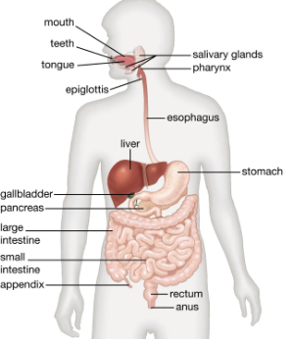
(Dworken, 2018).

The mouth, oesophagus, stomach, pancreas, liver, gallbladder, small intestine, large intestine, and anus are the digestive system's organs. The digestive system runs from the mouth to the anus. It consisted mainly of the mouth, also known as the oral cavity, which has teeth for crushing food and a tongue for mixing food and saliva; the throat, also known as the pharynx; the oesophagus; the stomach; the small intestine, which is made up of the duodenum, the jejunum, and the ileum; and the large intestine, which is made up of the cecum, a closed-end sac linking with the ileum; the ascend The salivary glands, the gastric glands in the stomach lining, the pancreas, the liver, and the liver's supporting organs—the gallbladder and bile ducts—all contribute digestive fluids. The both physical and chemical breakdown of digestive process and the final evacuation of non - digestible wastes both are promoted by all of these organs and glands (Dworken, 2018). The mechanism of digestion is employed by the body to transform food into a form that can be taken in and converted into energy (hopkinsmedicine.org, n.d.).

Obesity

Adipose tissue, or body fat, which is the pathophysiology of obesity, increases. This illness is more than just an aesthetic issue. It is a clinical issue that poses a significant threat to the development of other illnesses, including those linked to the heart, diabetes, high blood pressure, and several types of cancer. Along with food and lack of exercise, the causes include physiological genetic, and environmental variables (Mayo Clinic, 2018).
An underactive thyroid and Cushing's disease are two medical diseases that may increase the risk of being obese, and also some individuals inherited a huge appetite from their relatives. Furthermore, some pharmaceuticals, including some corticosteroids and antidepressants, can contribute to weight gain. The notion that fat is brought on by a slow metabolism, however, is not supported by scientific research. The vast majority of the time, it can be avoided (omron-healthcare.co.uk, n.d.).
BMI (Body Mass Index) is a measurement of a person's weight in relation to their height. An adult's typical BMI is, healthy weight range is between 18.5 and 24.9 overweight if is 25 to 29.9 and 30 to 39.9 indicates obesity and BMI of 40 or higher indicates extreme obesity (NHS, 2019).
A significant public health issue is childhood obesity. Obese children are more likely to develop chronic illnesses that endure into adulthood, such as high blood pressure, high cholesterol, and diabetes. The government unveiled Childhood Obesity: A Plan for Action in 2016, which outlined a series of initiatives with a primary focus on lowering sugar intake and raising children's levels of exercise. The government goal was to "reduce obesity in children and eliminate the obesity difference between children from the most and least poor districts by 2030," according to an update to the action plan that was issued in June 2018 (Nuffield Trust, 2019).The rise of obesity is a direct result of the drastic lifestyle shifts we've experienced in recent years. These comprise, more people owning and using cars, more people are eating out and ordering takeout than they are preparing meals at home,increased food portions, Affordable manufactured foods with a high amount of sugar are readily available, increased use of industrial robots and other mechanised devices as well as laptops at work and at home. the international migration from rural to urban places(omron-healthcare.co.uk, n.d.).
Obesity can be classified into two categories the first results in osteoarthritis and sleep apnea due to the increase in fat mass brought on by the behavioural reactions it causes. The second is a result of the dangers brought on by the metabolic modifications brought on by too much fat. These include several types of cancer connected to being overweight, diabetes mellitus, gallbladder disease, hypertension, cardiovascular disease, and others (Bray, 2004).

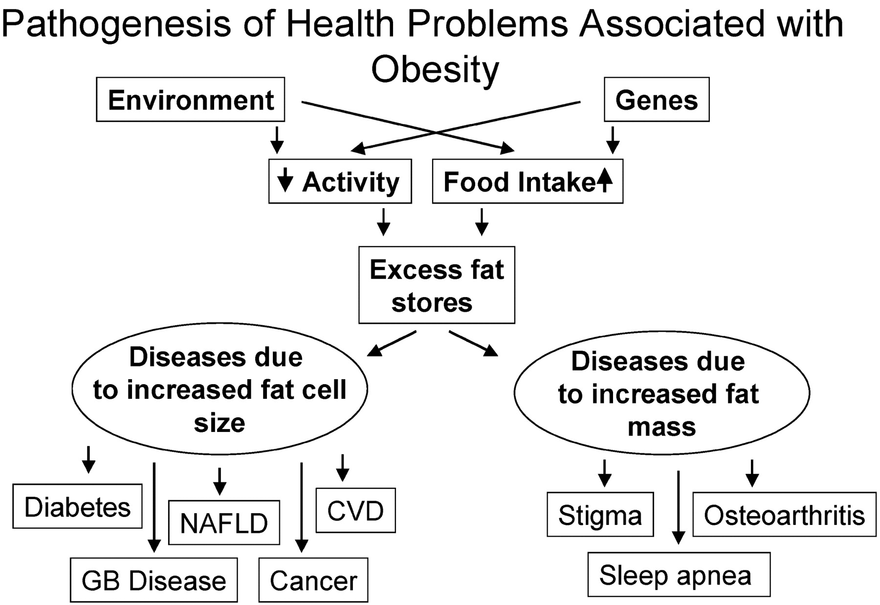
(Bray, 2004).

Health and lifestyle routine mesures

Here are some measures to maintain a healthy lifestyle and reduce obesity

- Follow a healthy, calorie-restricted diet as advised by a dietician or GP who specialises in weight reduction management.
- Participate in a neighbourhood diet group.
- Start engaging in 150–300 minutes (2.5–5 hours) of intense walk, running, swimming, or tennis per week.
- Eat moderately and keep away from circumstances in which you may be inclined to overeat.
- Receiving psychological support from a qualified healthcare expert to assist in changing one's eating and food-related thoughts.
- A medication could be suggested if weight loss with adjustments to one's lifestyle is unsuccessful.
- Surgery for weight loss could be suggested in specific circumstances.
- The good thing is that just a small amount of weight reduction can help or avoid health issues caused by obesity.
- Weight loss can be facilitated by a healthier diet, more physical activity, and behavioural adjustments.

Health and Social Care Practice

The NHS's goal for people who are overweight and want to reduce weight is to empower them to change and make the greatest choices for their health. The following are some of the main government policies:
- Tackilng obesity empowering adults and children to live healthier lives

The main objective of this campaign, which debuted on July 27, 2020, is to inspire all obese individuals to take action and advance forward into a healthier lifestyle by providing them with tools and applications that are supported by research and offer guidance on how to lose weight without gaining it back. Also the NHS works hard to increase the number of weight management services that are accessible through the service network in order to direct the greatest number of individuals who require assistance in losing weight. (Department of Health and Social Care, 2020).
Related of regulations is requiring that all food vending businesses, including cafeterias, restaurants, and takeaways, with more than 250 employees, to label food with its calorie content, this regulations also intended at preventing supermarkets from approving marketing of products with high sugar and salt contents, as well as preventing the placement of these in areas that are visible to customers and may promote their acquisition (GOV.UK, n.d.).

- 5K Training Plan NHS

The 8-week 5K training programme is intended to push individuals, enhance general fitness levels, and develop the stamina necessary to run the distance. The 5k training plan works on general cardio and strength training to help increase muscle mass and stamina in addition to running. There are several advantages to running, including improved heart and respiratory health and weight loss when paired with a healthy diet.
According to studies, running increases bone density, which may offer protection against conditions like osteoporosis. Benefits for mental health include preventing stress and depression (NHS, 2022).

- Childhood Obesity: a plan for action

This policy aims to lower the prevalence of obesity in children and adolescents in England between the ages of 2 and 15 over the following ten years. One of the things this strategy does is impose a tax on soft drink producers, The development of initiatives to promote healthy eating and exercise is the policy's second goal, Additionally, a strategy for lowering sugar in the foods that kids eat the most will be developed. Support cutting-edge technological initiatives that encourage a healthy diet,
Bonus distribution to low-income families and the introduction of required physical education in primary schools (Department of Health and Social Care, 2017).

- Obesity and weight management for people with learnung disabilities

This guide contains a wide range of initiatives designed to help caregivers, families, and professionals reduce obesity and overweight among people with learning disabilities, those are describing below:
For families and the broader public, NHS Change4Life offers support, activities, and practical guidance. Although it is not specifically for those with learning impairments, this website is helpful for healthcare workers to recommend to those with learning disabilities and their family caregivers since it has vibrant and interesting visuals and is written in clear English (GOV.UK, n.d.).
Nutritionist guidance regarding how to consider the lifestyles of the individual with learning disabilities , how to maintain a healthy balanced diet, and how to incorporate additional physical exercise if necessary are all a part of managing weight with a learning disability. There are also links to resources and movies (NHS, 2021). A new subject is covered in the 12 Month Challenge Workbook every month to assist individuals with learning difficulties learn more about healthy food, exercise, and behaviour modification while also motivating them to make tiny adjustments and track theirsuccess (Nationalarchives.gov.uk, 2016). Weightwise is an intervention programme for adults with learning difficulties that includes great advice and illustrations from some of the materials created for participants. Wheelchair-using individuals who want to lose weight are given dietary and exercise recommendations (nhs.uk, 2021). Wheelchair scales come with two informational pages for weighing individuals.

Recommendations

The development of a well-organized strategy that influences sugar consumption through information and education from all educational sectors, including nurseries,schools and universities.

Monitoring the initiative to reduce sugar in foods and beverages on a consistent and honest approach.

Ensure that all public facilities, such as hospitals, hotels, community centres, and recreation centres, strictly adhere to government purchasing requirements for food and beverages.

Encourage and inform individuals about the harmful impacts of sugar use, including including health care professionals, businesspeople, food producers, industries, and the general public.

Ensure that everyone working in the food and fitness industries receives ongoing education about the advantages of a balanced diet and a reduction in sugar.

Promoting food and beverages healthy and encouraging kids to make healthy decisions are goals shared by the government, business, educational institutions, and the public sector.

Conclusion

The clinical and public health consequences of being overweight and obese are significant on a global scale.

A top priority in public health should be national initiatives for the treatment and prevention of obesity, overweight, and the comorbidities and fatalities that are connected to these conditions.

A two-year sustained weight loss programme lowers blood pressure, normalises excessive lipid levels, and lowers the chance of developing hyperglycemia.

The quality of food consumed has a greater impact on weight and obesity than the quantity of food consumed.

Taking on childhood obesity early on would lower the likelihood of becoming obese as an adult.

References

Australia, H. (2021). Digestive system. [online] www.healthdirect.gov.au. Available at: https://www.healthdirect.gov.au/digestive-system#:~:text=The%20digestive%20system%20breaks%20down%20food%20into%20nutrients%20such%20as. (Accesed: 02 Dec. 2022).
‌Bray, G.A. (2004). Medical Consequences of Obesity. The Journal of Clinical Endocrinology & Metabolism, [online] 89(6), pp.2583–2589. doi:10.1210/jc.2004-0535. (Accesed: 01 Dec. 2022).‌

Bray, G.A. (2004). Medical Consequences of Obesity. The Journal of Clinical Endocrinology & Metabolism, [online] 89(6), pp.2583–2589. doi:10.1210/jc.2004-0535. (Accesed: 02 Dec. 2022).

‌Department of Health and Social Care (2017). Childhood obesity: a plan for action. [online] GOV.UK. Available at: https://www.gov.uk/government/publications/childhood-obesity-a-plan-for-action/childhood-obesity-a-plan-for-action. (Accesed: 02 Dec 2022).

Department of Health and Social Care (2020). Tackling obesity: government strategy. [online] GOV.UK. Available at: https://www.gov.uk/government/publications/tackling-obesity-government-strategy. (Accesed: 02 Dec. 2022).

Dworken, H.J. (2018). Human digestive system. In: Encyclopædia Britannica. [online] Available at: https://www.britannica.com/science/human-digestive-system. (Accesed: 09 Dec.2022).

‌Dworken, H.J. (2018a). Human digestive system. In: Encyclopædia Britannica. [online] Available at: https://www.britannica.com/science/human-digestive-system. (Accesed: 09 Dec.2022).

‌EuroHealthNet. (n.d.). Launch of the WHO European Regional Obesity Report 2022. [online] Available at: https://eurohealthnet.eu/publication/launch-of-the-who-european-regional-obesity-report-2022/?gclid=Cj0KCQiAnNacBhDvARIsABnDa6-qwDE2RwlnAEoLRcflmhuqvapWimO8eQ6bknJJ5tt15igE3_cCswsaAuTPEALw_wcB (Accessed 03 Dec. 2022).
GOV.UK. (n.d.). Obesity and weight management for people with learning disabilities: guidance. [online] Available at: https://www.gov.uk/government/publications/obesity-weight-management-and-people-with-learning-disabilities/obesity-and-weight-management-for-people-with-learning-disabilities-guidance#further-resources (Accessed 13 Dec. 2022).

GOV.UK. (n.d.). Tackling obesity: empowering adults and children to live healthier lives. [online] Available at: https://www.gov.uk/government/publications/tackling-obesity-government-strategy/tackling-obesity-empowering-adults-and-children-to-live-healthier-lives#giving-everyone-a-fair-deal. (Accesed: 02 Dec. 2022).

health.org.uk. (n.d.). What should nanny do next? The government and obesity. [online] Available at: https://www.health.org.uk/news-and-comment/podcast/episode-02-the-government-and-obesity?gclid=Cj0KCQiAnNacBhDvARIsABnDa6_l_r-imcwZf-GFiwv-ggCPUHS6F4NbFUIMSIrsYNNOhhMvE-tou3AaAgtYEALw_wcB (Accessed 11 Dec. 2022).

‌Kelly, T., Yang, W., Chen, C-S., Reynolds, K. and He, J. (2008). Global burden of obesity in 2005 and projections to 2030. International Journal of Obesity, 32(9), pp.1431–1437. doi:10.1038/ijo.2008.102. (Accesed: 10 Dec. 2022).

‌Mayo Clinic (2018). Obesidad - Síntomas y causas - Mayo Clinic. [online] Mayoclinic.org. Available at: https://www.mayoclinic.org/es-es/diseases-conditions/obesity/symptoms-causes/syc-20375742. (Accesed: 09 Dec.2022).

‌Nationalarchives.gov.uk. (2016). [online] Available at: https://webarchive.nationalarchives.gov.uk/ukgwa/20160704190713/https://www.improvinghealthandlives.org.uk/adjustments/index.php?adjustment=388. (Accessed 13 Dec. 2022).

‌NHS (2019). Obesity. [online] www.nhs.uk. Available at: https://www.nhs.uk/conditions/obesity/. (Accesed 09 Dec. 2022).

‌NHS (2021). Managing weight with a learning disability. [online] nhs.uk. Available at: https://www.nhs.uk/live-well/healthy-weight/managing-your-weight/managing-weight-with-a-learning-disability/. (Accessed 13 Dec. 2022).
‌NHS (2022). Get running with Couch to 5K. [online] nhs.uk. Available at: https://www.nhs.uk/live-well/exercise/running-and-aerobic-exercises/get-running-with-couch-to-5k/.(Accesed: 02 Dec. 2022).

‌nhs.uk. (2021). How to lose weight in a wheelchair. [online] Available at: https://www.nhs.uk/live-well/healthy-weight/managing-your-weight/how-to-lose-weight-in-a-wheelchair/. (Accessed 13 Dec. 2022).

Nuffield Trust (2019). Obesity. [online] The Nuffield Trust. Available at: https://www.nuffieldtrust.org.uk/resource/obesity#background. (Accessed 10 Dec. 2022).
‌omron-healthcare.co.uk. (n.d.). Obesity: why is it a problem? [online] Available at: https://www.omron-healthcare.co.uk/health-and-lifestyle/heart-health/underlying-conditions/obesity-why-is-it-a-problem.html?gclid=CjwKCAiAv9ucBhBXEiwA6N8nYMszbqiH2FUM04YzmUjCH6JSUVBPgU-YAUYGLGcUyMcJSdyLehW4DhoC7jYQAvD_BwE (Accessed 13 Dec. 2022).
‌omron-healthcare.co.uk. (n.d.a). Obesity: why is it a problem? [online] Available at: https://www.omron-healthcare.co.uk/health-and-lifestyle/heart-health/underlying-conditions/obesity-why-is-it-a-problem.html?gclid=CjwKCAiAv9ucBhBXEiwA6N8nYMszbqiH2FUM04YzmUjCH6JSUVBPgU-YAUYGLGcUyMcJSdyLehW4DhoC7jYQAvD_BwE (Accessed 13 Dec. 2022).

‌

‌

‌

