Learning in the Digital Era

Lecturer: Rhiannon Sandy
Student name: Daniel Dorneanu
Student ID number: 2233954

Table of Contents
Introduction 3
Task 1-Written summary 4
Task 2- A mind map 5
Task 3-Two-minute video presentation 6
Task 4-word reflection 6
Conclusion 8
References 9

Introduction
Learning in the present era has drastically changed how learners perceive the system of attaining knowledge. The intervention of technology in the educational context has been a major factor in the development of the learning process. Digital technology has highly changed the way in which education is being obtained (Rahmatullah et al., 2022). Huge transformations have been identified for the development of the learning process and it has been necessary for academic institutions to implement technology. The following e-portfolio will discuss the concept of learning in the digital era and would present a mind map that demonstrates the concepts and aspects related to it. A video presentation related to personal identity that helps in being a team player along with a reflection based on Borton’s Reflective Model will be presented.

Task 1-Written summary
Preparing for higher education requires a student to become more aware of his/her surroundings. Many concepts are included while preparing for higher education. The first major aspect that is related to this term is that referring to career guidance counsellors in academic institutions might be very helpful. Since taking the step for higher education is highly imperative for students, good career advice from a career counsellor might be very helpful. This would also enable the students to become acknowledged of the lifestyle that they would be demanded in the process. Another major concept that is integral to higher education knows the requirements that the higher educational institution demands (Sudibjo et al., 2019). This would also help the students to know about the expectations and requirements that their chosen educational institution has towards them. To understand the importance and influence of this aspect, students might have to become engaged in tests that would determine the expectancies and requirements first-hand.

Fig.1- Preparing for higher education.
Source: (iSTUDENTglobal, 2019)

Engaging in higher education would also require the students to become highly communicable which would help in building relationships with others in the same educational setting. It is highly integral for students in the higher education context to build an effective rapport with the teachers and module leaders who are engaged in the process. Having good relationships with teachers and module leaders is highly integral to keeping the flow of information effective since interactions would be increased in the setting (Almazova et al., 2020). Keeping the finances aligned and managed is also included as one of the major aspects related to higher educational settings. Having the financial aspect sorted out and managed will highly help the students to become more aware of their demands. Financial aspects such as loans and scholarships are highly integral for keeping higher education more aligned.

Task 2- A mind map
Digital learning is one of the most relevant concepts in the educational context which has helped shape the current system of education. There are different forms of concepts that are related to digital learning. The first thing that relates to digital learning is time. Students and teachers have highly benefitted from the introduction of digital learning in which they have been able to access the learning and development program. The main process of learning can be accessed anytime by the learners, be it in the classroom or in their own home setting (Poultsakis et al., 2021.). Time is very crucial for the development of students in the process as they require a very strict allocation for their learning process. Moreover the proper use of the time helps to learn the diverse skills in the life and helps in the overall development of the people. Diverse famous mentors of the world are successful due to their proper use of the time. Being punctual is the most significant part of the digital learning process. Moreover it is necessary to gather the proper knowledge and skills of the diverse digital platforms such as the computer skills and so on. Moreover through means of the digital learning the person can upgrade the skills and aptitudes in the faster process. Through means of the digital or the pictographic learning the learners can easily understand the learning process and helped to grab the information in the proper manner. Hence the digital learning is the most effective process of the digital learning process respectively. Individual has the opportunity to grab the information in the easier and the faster manner respectively.

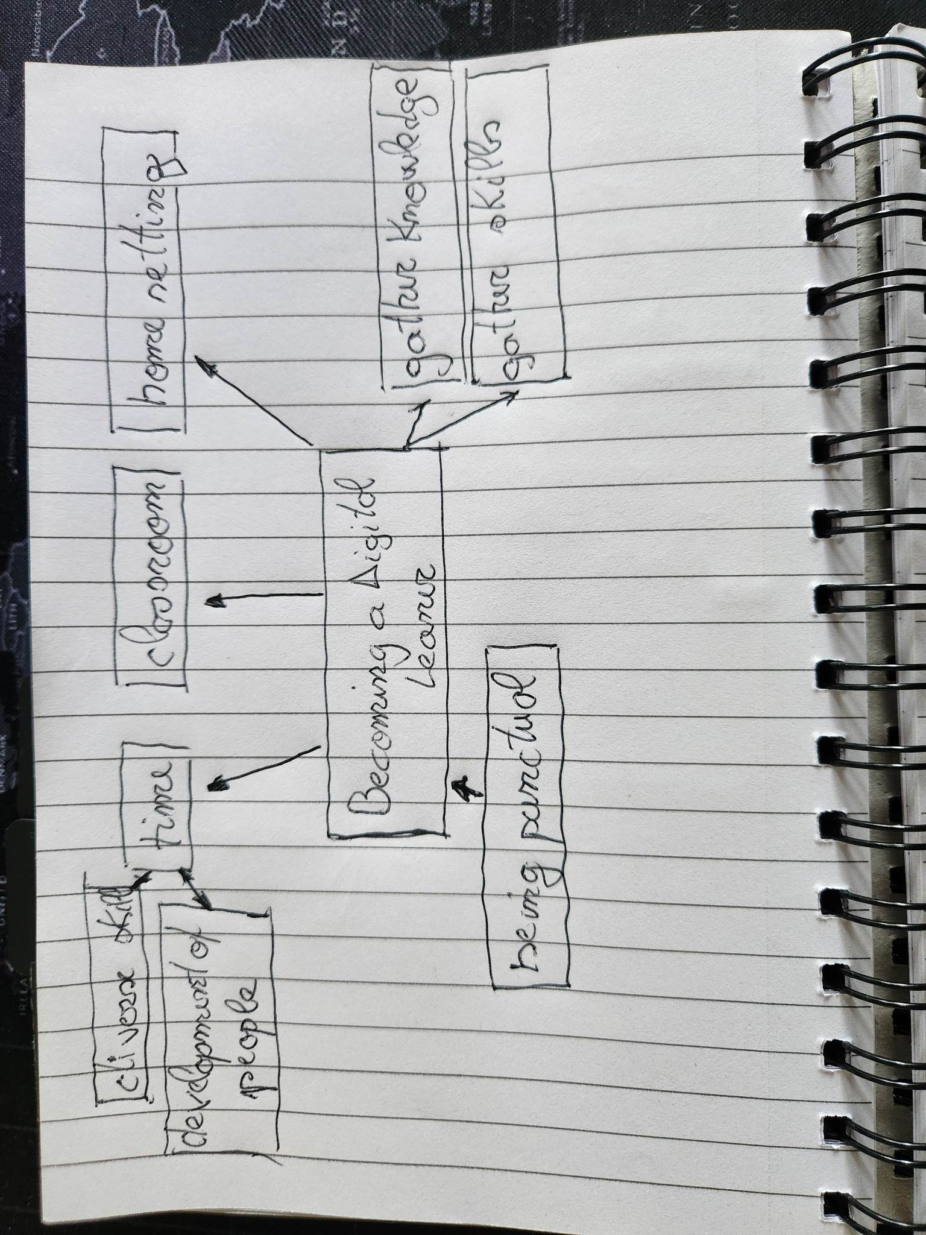

Task 3-Two-minute video presentation
Being a team leader is a significant part of life as it helps to guide the team members properly. I must cultivate good moral values and ethics for the overall development of the teams respectively (Sousa et al., 2022). It is necessary to have good communication skills as I have to communicate properly with my team members respectively. Through means of proper communication, I can understand the opening of the team members respectively. Through means of proper communication, I can establish the proper relationship with the team members respectively. It will help to establish good relationships with others respectively. Moreover being a team player must communicate with the team members in the proper manner respectively my values and ethics have shaped my personality in the proper manner and have helped me to be a good team player. It has helped me to win the heart of the diverse members of the team and has helped me to cooperate in the proper manner. Moreover, my communication skills have helped me to cooperate and communicate with the team members and have helped me express my opinion (Sailer et al., 2021.). Similarly, I can cooperate with my team members and suggest my ideas and aptitudes for the effective functioning of the team. Moreover, it has also helped me to get support and cooperation from team members. Being part of the team I have carried out my roles and responsibilities in the proper manner and helped the team to accomplish its aims and objectives. Moreover, my critical thinking skills have helped me to find out innovative solutions to issues within the teams and have helped me to solve challenging issues within the team respectively. Moreover, it has helped me to participate actively in the team discussion and meetings respectively. Similarly, my values such as sincerity, self-confidence and self-esteem have helped me to win the trust of the team leader. I have also found that working in a team is the most effective process as it can help to find out the solution in a faster and more effective way respectively.

https://www.youtube.com/watch?v=tjZ7pmjb6sI

Task 4-word reflection
With the help of Borton’s Reflective Model, I have been able to develop a good knowledge of behavior and performance in the higher education context. The first stage of the model has helped me to underline what I have felt and experienced. I have analyzed that since I joined the classroom, it has been a completely new journey for me in which I have identified that it has been a highly comprehensive measure. I have seen that classrooms are highly integrated with digital technology that is highly interactive and informative for the students (Crawford et al., 2020). The students already started to become more engaged towards the program in which digital technology is highly interconnected. The teachers and module leaders were also included in the learning and teaching process as they have been highly included with technological tools.
The next stage, So What has been highly comprehensive in which I have seen that I also started to feel more included in the learning process. I also felt more encouraged in the classroom since I have developed a good knowledge of digital tools. My feeling towards the learning process in higher education has changed drastically due to the fact that it included me on a high note with the implementation of digital tools (Sundgren et al., 2021). I have been able to develop group projects and assignments with the help of tools such as MS Word, MS Excel and MS Power point. The last stage, Now What has also helped me to identify what I would do further in the classroom. The most influential thing that I have learned from this reflection is that I have started to grow along with my peers in the classroom.

Conclusion
The report has discussed the diverse digital learning which is the most significant part of the learning process in the modern world. Digitalization is the most significant part of the learning process and has offered a faster and more effective process for gaining of information. Diverse educational bodies have incorporated the digital learning process and have helped to carry out education in the proper manner respectively. Similarly, the Borton models have helped to understand good knowledge and behavior which are the significant parts of the learning process.

References
Almazova, N., Krylova, E., Rubtsova, A. and Odinokaya, M., 2020. Challenges and opportunities for Russian higher education amid COVID-19: Teachers’ perspective. Education Sciences, 10(12), p.368.
Crawford, J., Butler-Henderson, K., Rudolph, J., Malkawi, B., Glowatz, M., Burton, R., Magni, P. and Lam, S., 2020. COVID-19: 20 countries' higher education intra-period digital pedagogy responses. Journal of Applied Learning & Teaching, 3(1), pp.1-20.
iSTUDENTglobal (2019) Preparing for higher ed: 4 things every student should know, iSTUDENTglobal. Available at: https://i-studentglobal.com/student-lifestyle/preparing-for-higher-education-4-things-every-high-school-student-should-know/ (Accessed: March 4, 2023).
Korlat, S., Kollmayer, M., Holzer, J., Lüftenegger, M., Pelikan, E.R., Schober, B. and Spiel, C., 2021. Gender differences in digital learning during COVID-19: Competence beliefs, intrinsic value, learning engagement, and perceived teacher support. Frontiers in Psychology, 12, p.637776.
Poultsakis, S., Papadakis, S., Kalogiannakis, M. and Psycharis, S., 2021. The management of digital learning objects of natural sciences and digital experiment simulation tools by teachers. Advances in Mobile Learning Educational Research, 1(2), pp.58-71.
Rahmatullah, A.S., Mulyasa, E., Syahrani, S., Pongpalilu, F. and Putri, R.E., 2022. Digital era 4.0: The contribution to education and student psychology. Linguistics and Culture Review, 6(S3), pp.89-107.
Sailer, M., Murböck, J. and Fischer, F., 2021. Digital learning in schools: What does it take beyond digital technology?. Teaching and Teacher Education, 103, p.103346.
Sousa, M.J., Marôco, A.L., Gonçalves, S.P. and Machado, A.D.B., 2022. Digital learning is an educational format towards sustainable education. Sustainability, 14(3), p.1140.
Sudibjo, N., Idawati, L. and Harsanti, H.R., 2019, December. Characteristics of Learning in the Era of Industry 4.0 and Society 5.0. In International Conference on Education Technology (ICoET 2019) (pp. 276-278). Atlantis Press.
Sundgren, M.K., Millear, P.M., Dawber, C. and Medoro, L., 2021. Reflective practice groups and nurse professional quality of life. TheAustralian Journal of Advanced Nursing, 38(4), pp.49-67.

