Gwyndaf Charles Rees

HND Computing

Web Development

Lecturer: Ian

Student P Number: P1603201

Word Count: 963 (without titles, or references)
Contents
Introduction 2
Research 2
Implementation 2
Evaluation 3
Bibliography 3
Reference List 5
Appendix 6

Introduction
This report describes the potential developmental practices for creating a dynamic website in PHP which includes the management of a database created to third normal form (3NF), using database calls to generate website content, manipulating data with SQL queries and website controls, the issues inherent in these practices, and possible methodologies to remedy any problems including security vulnerabilities, an issue of great importance when dealing with databases of potentially valuable and sensitive data.

Research and Implementation

Security
The primary threat to security involved in a dynamic website with an SQL database is the possibility of SQL injection. SQL injection is a security exploit in systems that interact with SQL databases and involves inputting strings of SQL into text inputs that are then used in queries executed on the target database. It “takes advantage of poor input validation in code and website administration” and therefore input validation is the primary area of focus when attempting prevent SQL injection attacks. Well optimised server-side scripts are the best option for such important validation as they can’t be manipulated by the attacker as client-side scripts can, such as through Cross-site Scripting (XSS) and Cross-site Request Forgery (XSRF) which, if executed on an account with high user privileges, could be devastating for a system’s database security, potentially resulting in “user data theft, account tampering, fraud and more”. Client-side scripts such as JavaScript could still be used for user feedback when validating, such as checking for empty fields and preventing form submission to prompt the user to complete the form.✓
The ‘BigPicture’ system uses the PHP trim and mysqli_real_escape_string functions to sanitise user input text used in queries to aid in avoiding SQL injection. The system could be further improved by applying the same logic to session data and variables passed between pages as these could potentially be manipulated by a user and then modify the database when used in a query. Valid point
Another common security issue is the lack of SSL and the transmission of sensitive data over clear text channels. This is a simple vulnerability to resolve by simply purchasing an SSL certificate to enable HTTPS instead of the standard HTTP, a fix that would be applied on the ‘BigPicture’ system when it’s launched.

Scalability
Systems that rely on a database for dynamic content generation have the primary scaling issue of querying data once the database has grown beyond a size manageable by standard techniques. Database partitioning is one technique which is widely used to tackle this issue, involving the compartmentalisation of table fields into new tables and databases. Logic is then used to decide which table or database to query, greatly decreasing the number of results handled by a single query. Often large databases will use Not Only SQL (NoSQL) to handle portioned databases. NoSQL are generally used for “large-scale data storage and for massively-parallel data processing across a large number of commodity servers and use non-SQL languages to interact with data”. ✓
AJAX can be used to reduce server calls, which allows for better server performance for other users, however its reliance on JavaScript makes its server calls easily visible to the user which could aid in a SQL injection.
This method is usually only required for the largest systems in the world such as Google or Facebook and is therefore not applicable for the ‘BigPicture’ system, however database partitioning may be required in the future in the event of a large user base or many image uploads.

Usability
Usability is arguably the most important aspect of a system as if its unusable it is useless. It is important to be as inclusive as possible, including alt tags on images or other media, and accommodating different devices and screen sizes. Navigation should be clear and “the purpose of each link can be determined from the link text alone”.
The ‘BigPicture’ doesn’t account for all WCAG guidelines due to time constraints, however, due the websites purpose for image sharing, all relevant images have a dynamically generated alt or title attribute and the navigation links are minimal and obvious with the home page containing a link to each area of the website the user has access to, allowing for ease of navigation and avoiding complicated paths to reach the desired destination. The system uses Bootstrap to improve usability on mobile devices as it allows for better responsiveness with its flex-box grid system using “utility classes that allow you to manipulate elements in a responsive manner”.

Conclusion and Evaluation
The ‘BigPicture’ system is a good foundation for a secure, scalable and usable website, however many changes and further development is required to reach the point of release for public use including additional SQL injection protection and protection from other attacks, such as disallowing the upload of non-image files; a more robust database structure; and better feedback to the user when check criteria isn’t met instead of redirecting to an error page with no clarification. As the website grows, more features will be added such as? as currently only the basics are implemented and with the increase of features, further administration options would need to be included too. For a current list of features see Appendix 1.

Bibliography
- Ullman, L. PHP and MySQL for Dynamic Web Sites: Visual QuickPro Guide. 4th ed. Peachpit Press, 2011
- PHP.net, PHP Manual. http://php.net/manual/en/index.php
- Shehu B. Xhuvani A. International Journal of Computer Science Issues, A Literature Review and Comparative Analyses on SQL Injection: Vulnerabilities, Attacks and their Prevention and Detection Techniques, Vol. 11, Issue 4, No 1, July 2014
- Moniruzzaman A. B. M, Hossain S. A. International Journal of Database Theory and Application, NoSQL Database: New Era of Databases for Big Data Analytics - Classification, Characteristics and Comparison, Vol. 6, No. 4. 2013
- Jakobus B. Marah J. Mastering Bootstrap 4. UK: Packt Publishing Ltd. 1st ed. 2016

Reference List

Appendix
Appendix 1 – Feature List:
- User Registration (Appendix 2)
- Image Upload (Appendix 3)
- View Image Page (Appendix 4)
- Categorisation
  - View all Categories (Appendix 5)
  - View individual Categories (Appendix 6)
  - Random Category Feature on the Home Page (Appendix 7)
- Search (Appendix 8)
- ‘My Uploads’ Edit and Delete (Appendix 9)
- Admin Panel
  - Category Add, Edit and Delete (Appendix 10)
  - User Role set (admin, non-admin) and Delete (Appendix 11)
Appendix 2 – User Registration:
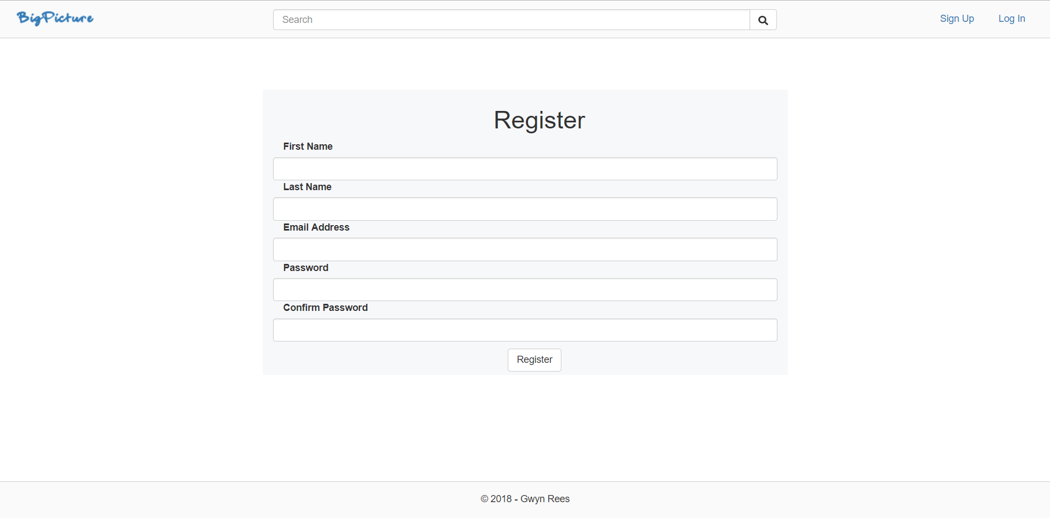
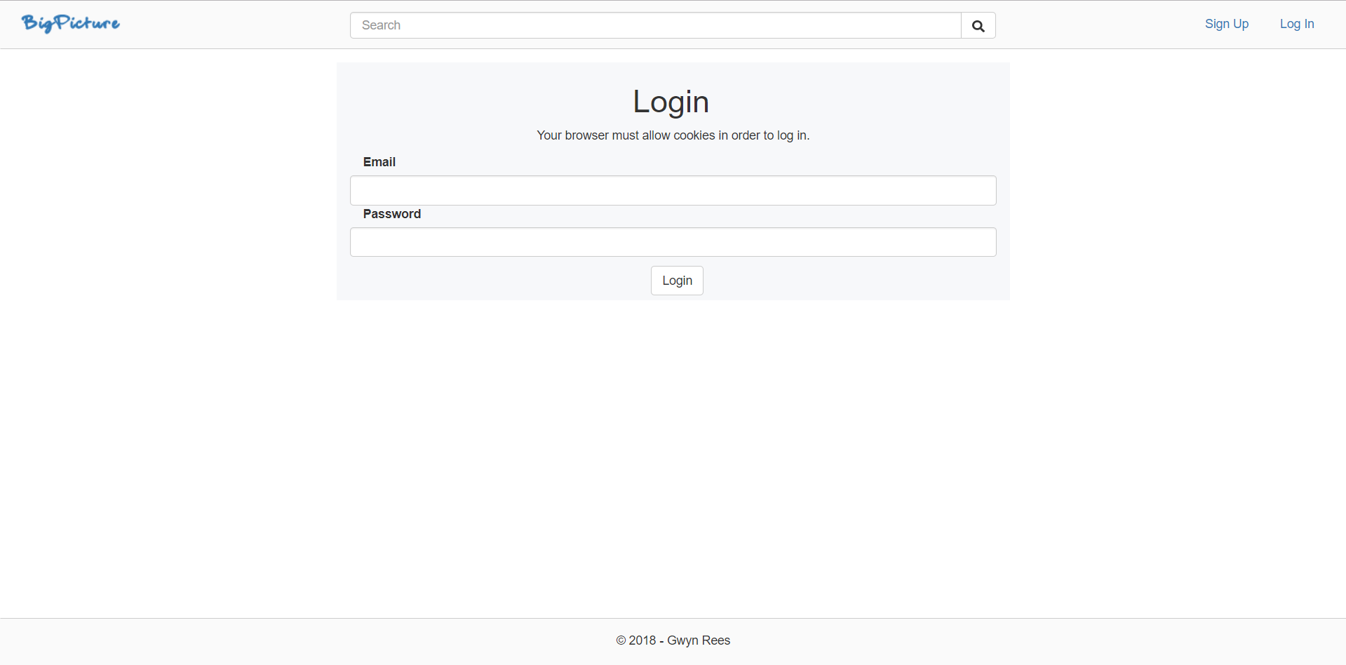
Appendix 3 – Image Upload:
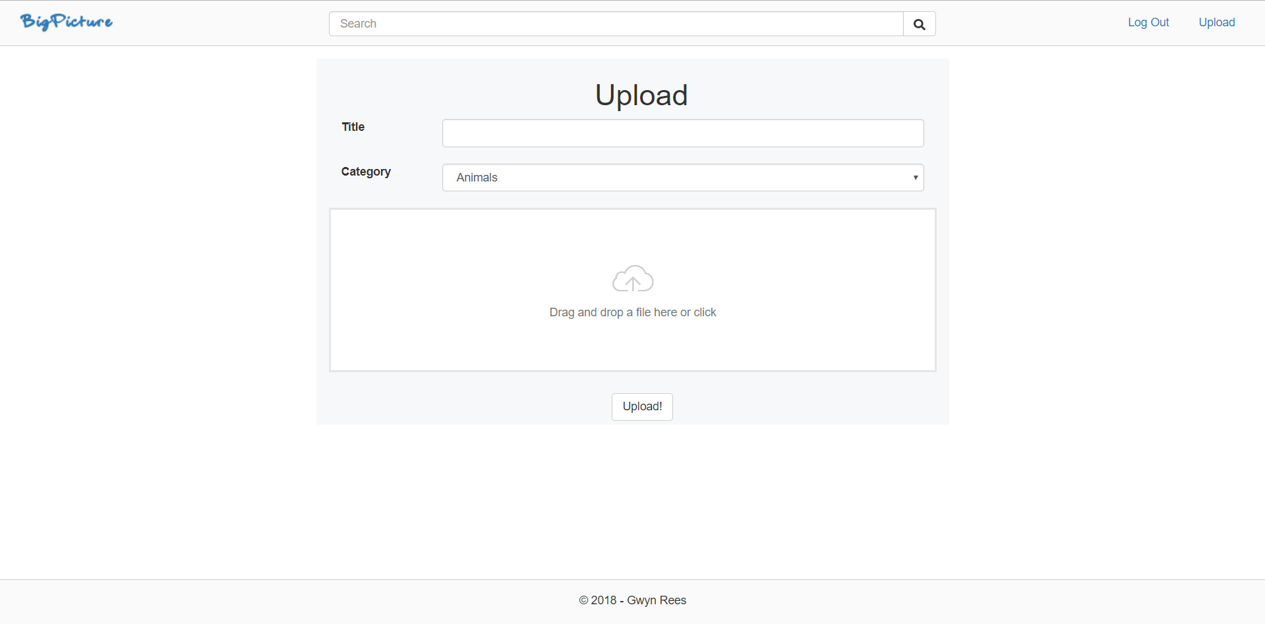

Appendix 4 – View Image Page:
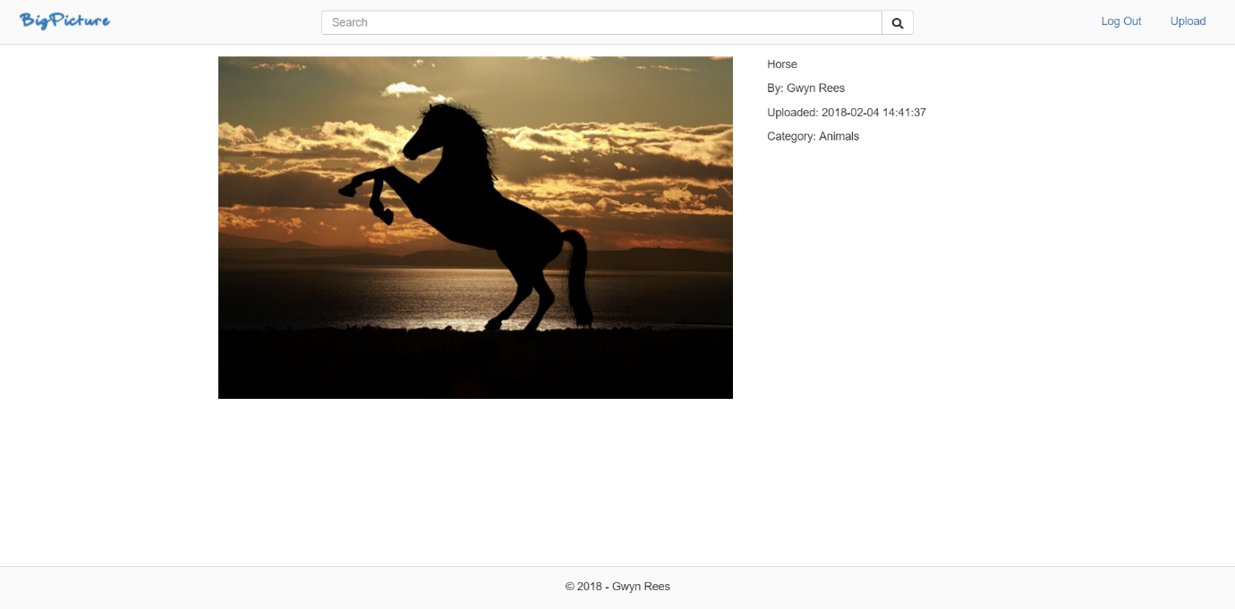
Appendix 5 – View all Categories:
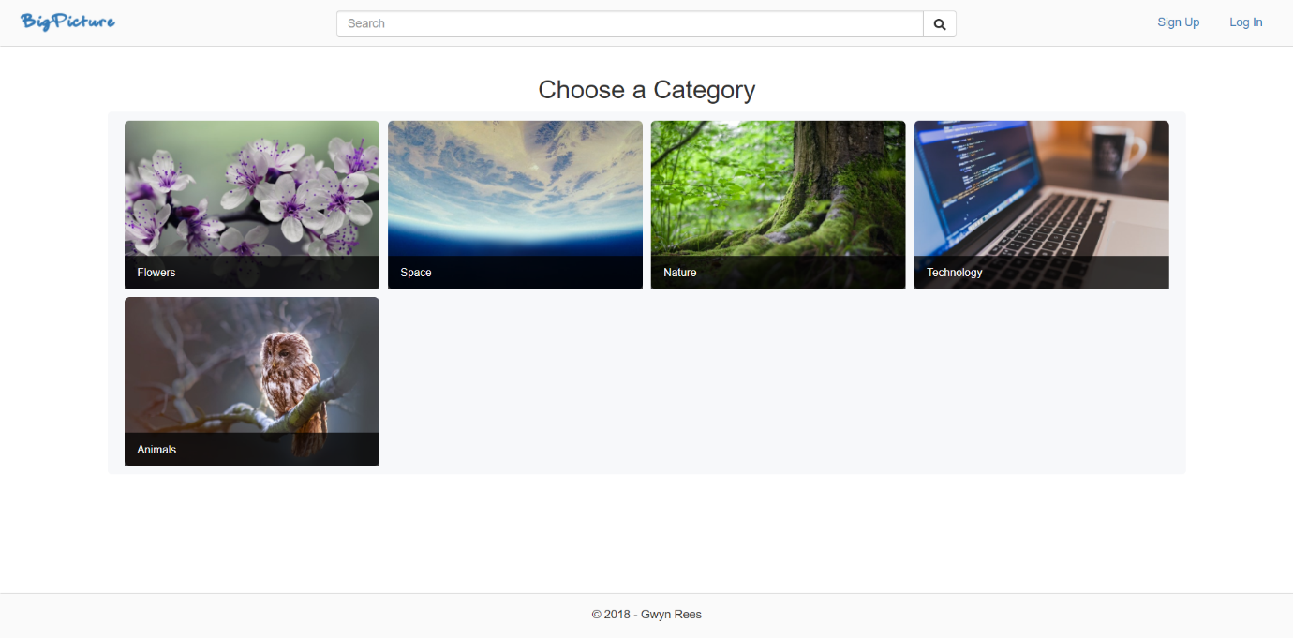

Appendix 6 – View Individual Categories:
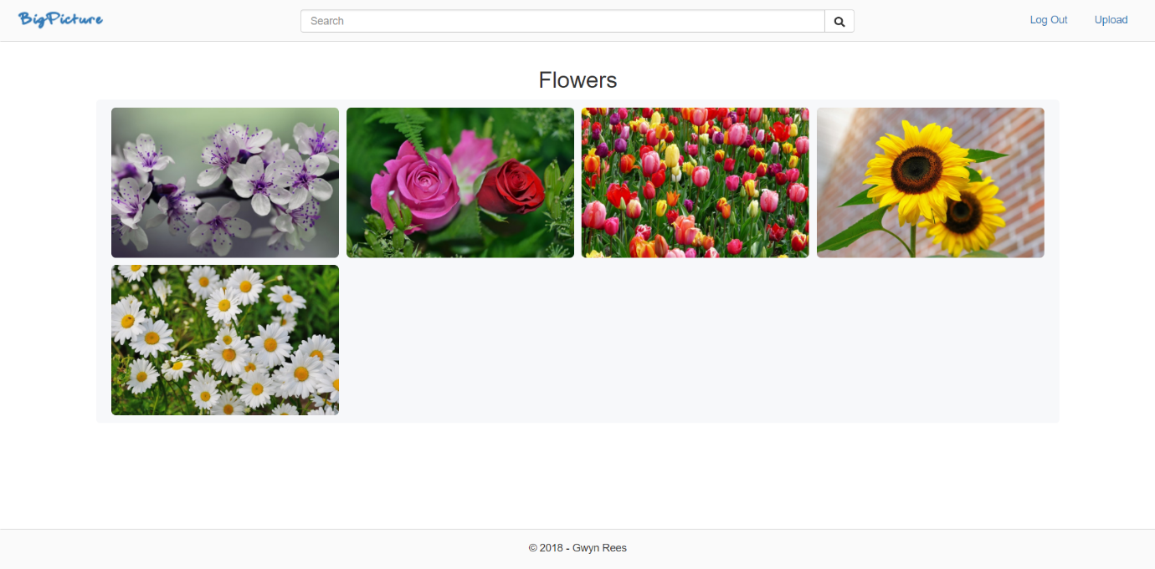
Appendix 7 – Random Category Feature on the Home Page
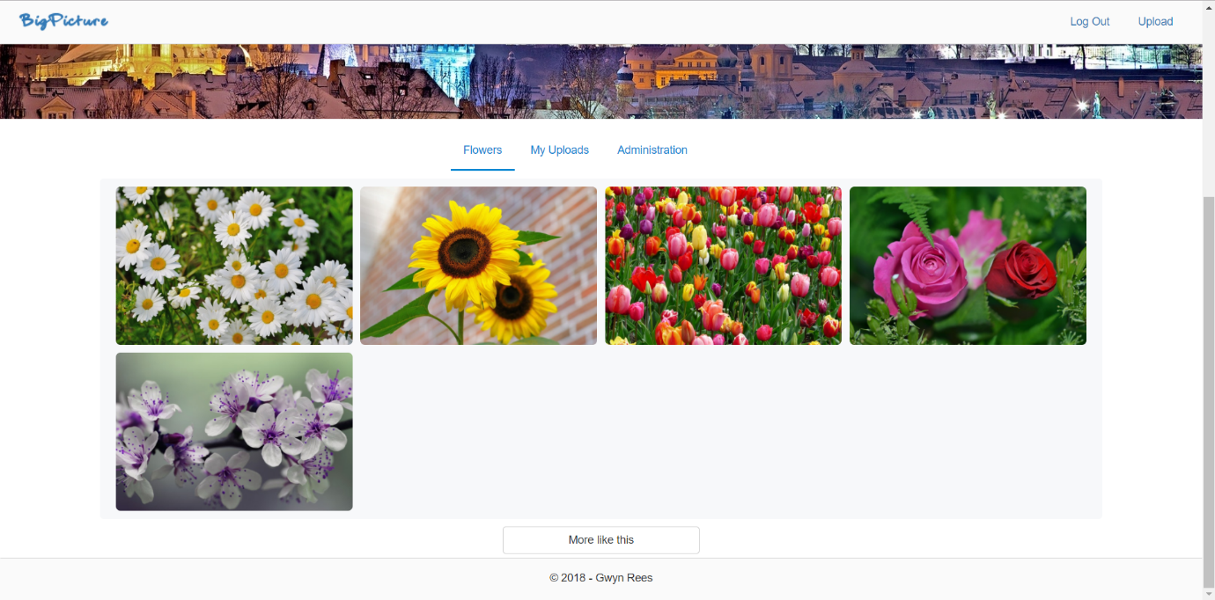

Appendix 8 – Search:
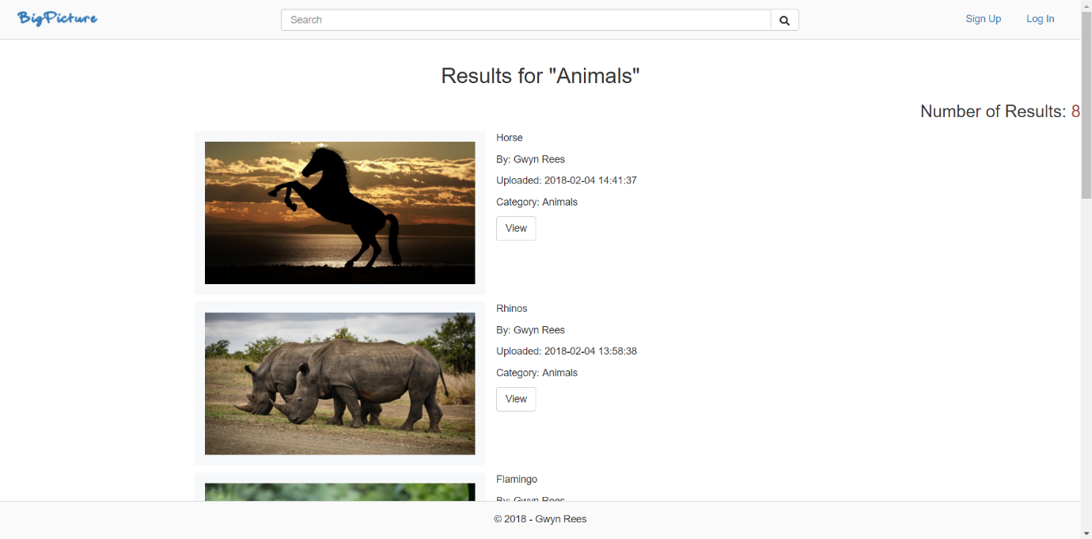
Appendix 9 - ‘My Uploads’ Edit and Delete:
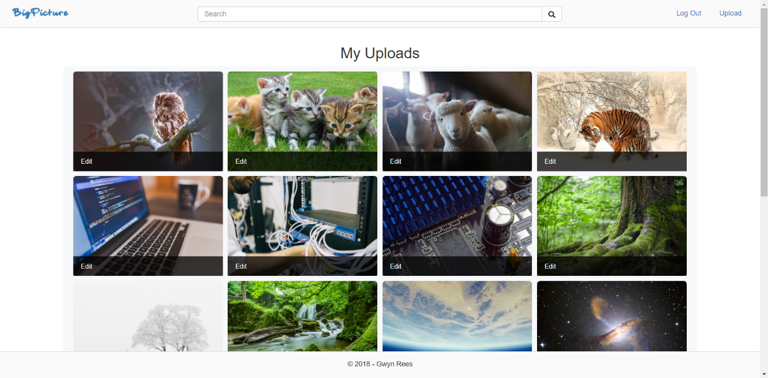
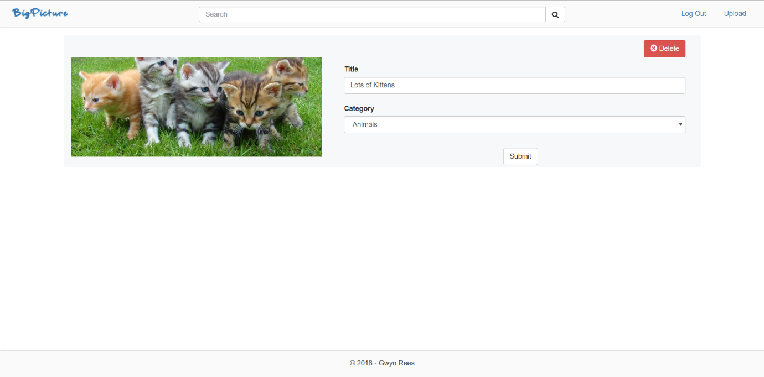
Appendix 10 - Category Add, Edit and Delete:
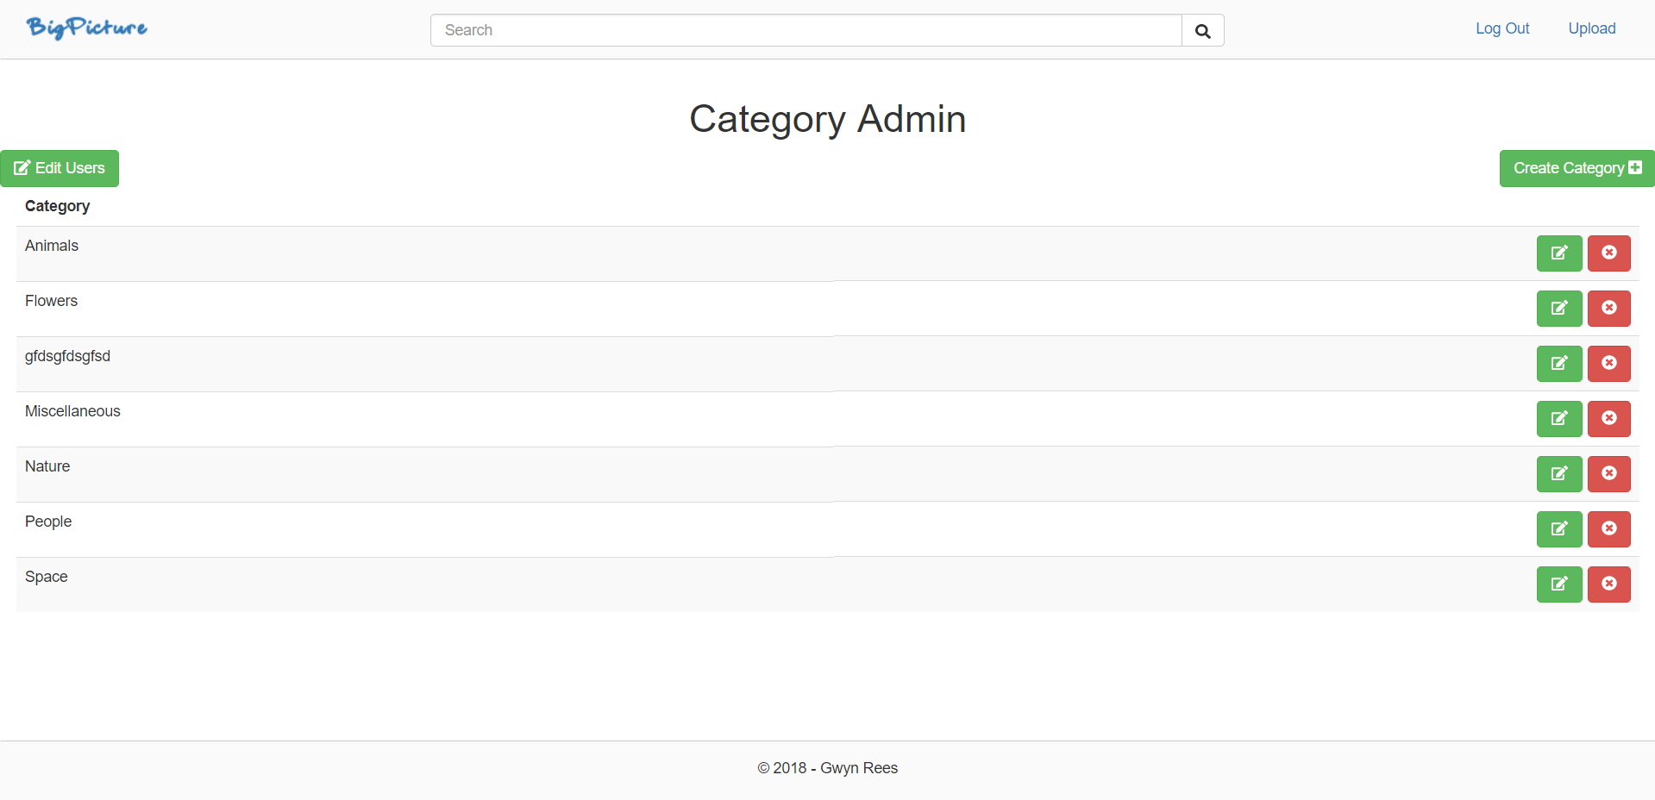
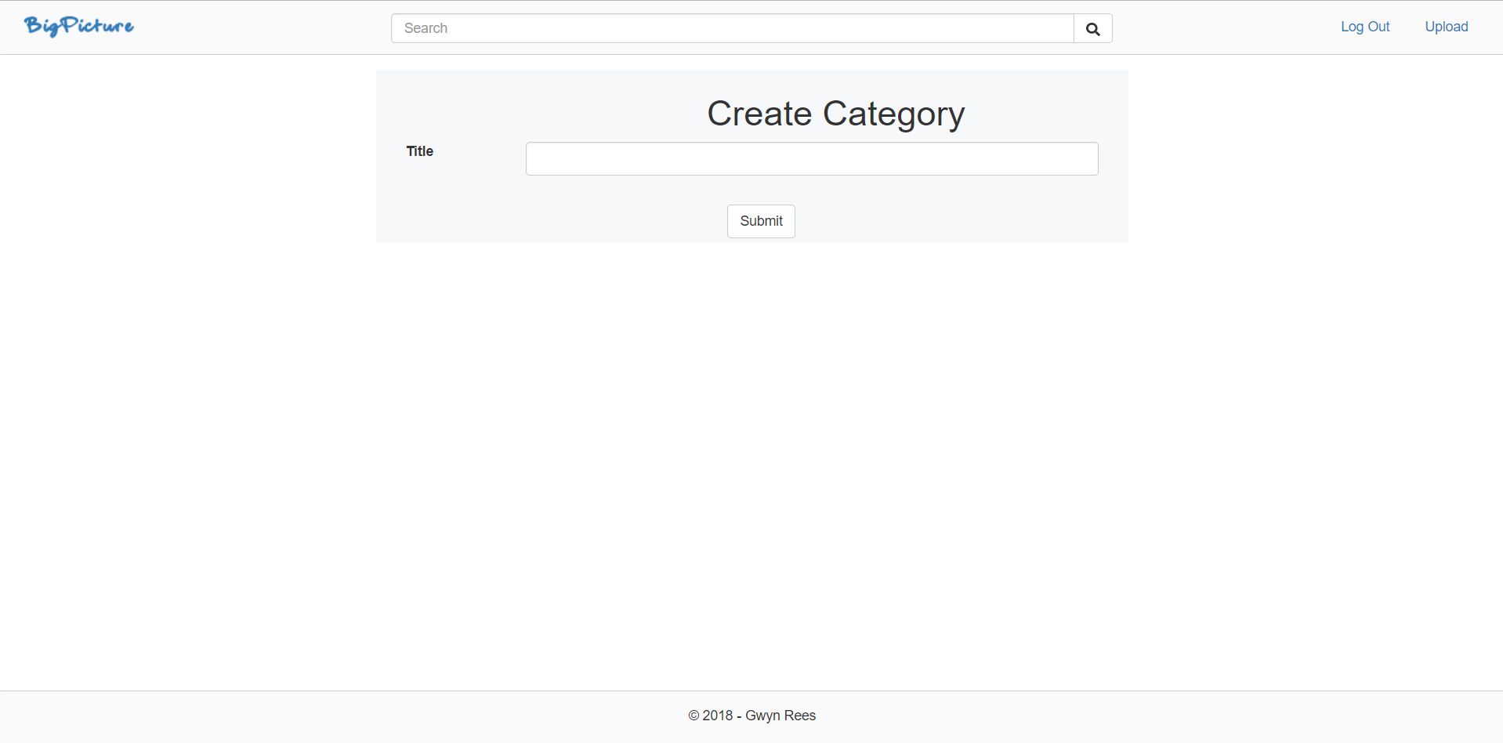
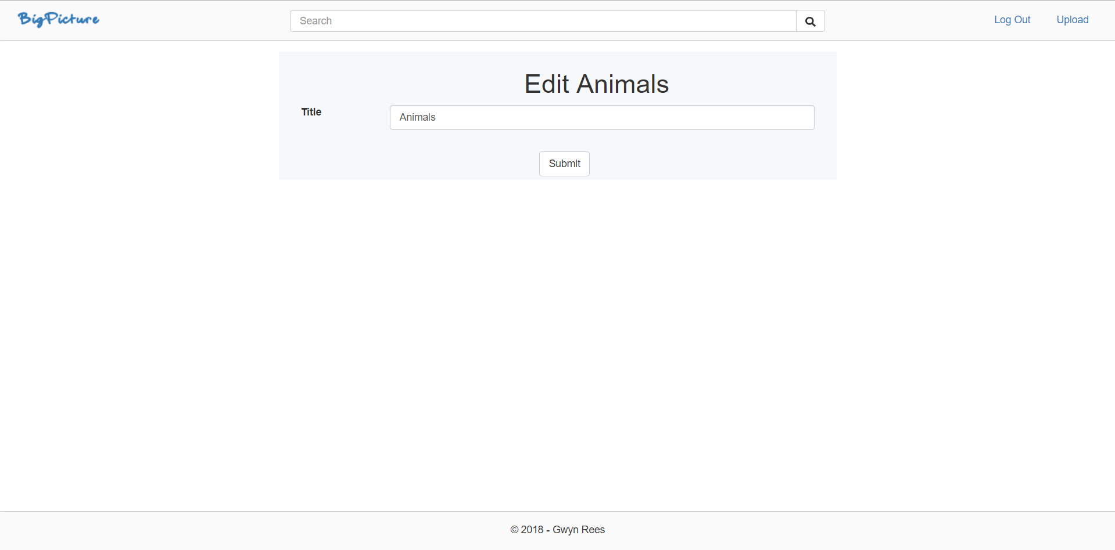

Appendix 11 - User Role set and Delete:
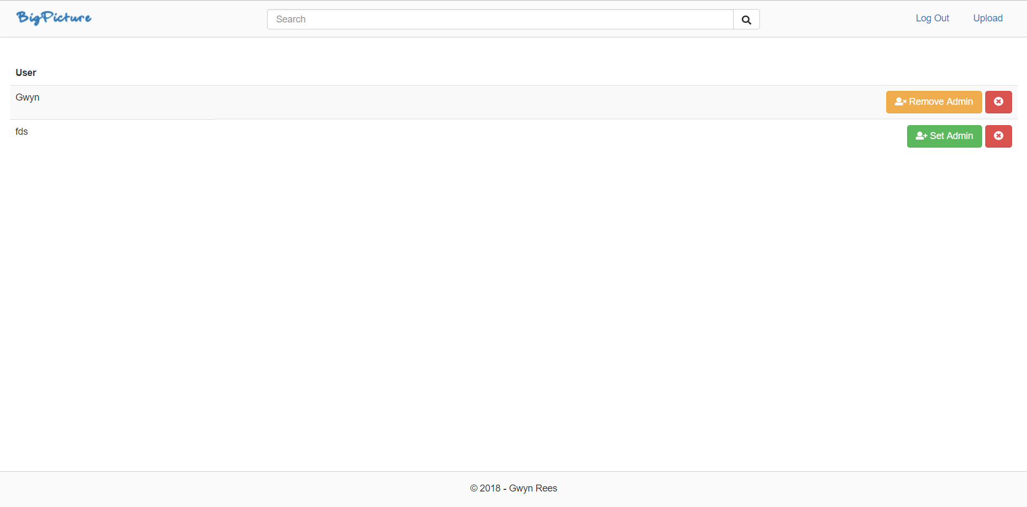

Shehu B. Xhuvani A. International Journal of Computer Science Issues, A Literature Review and Comparative Analyses on SQL Injection: Vulnerabilities, Attacks and their Prevention and Detection Techniques, Vol. 11, Issue 4, No 1, July 2014, pp. 1.
VeraCode. JavaScript Security. https://www.veracode.com/security/javascript-security. Accessed 10th Feb 2018.
Moniruzzaman A. B. M, Hossain S. A. International Journal of Database Theory and Application, NoSQL Database: New Era of Databases for Big Data Analytics - Classification, Characteristics and Comparison, Vol. 6, No. 4. 2013, pp. 1.
W3.org. Web Content Accessibility Guidelines (WCAG) 2.0. https://www.w3.org/TR/WCAG20/. Accessed: 10th Feb 2018.
Jakobus B. Marah J. Mastering Bootstrap 4. UK: Packt Publishing Ltd. 1st ed. 2016, Ch. 1. pp. 10.

