ACCA5034
Data Security and Compliance

Jamie Richards (0852036)
ACCA5034 – Data security and compliance
Table of Contents
1 – Introduction Page – 2
2 – Task 1 – Data Security and Compliance Page – 2
2.1 – Security Frameworks Page – 5
2.1.1 – Components of Security Frameworks Page – 6
2.1.1.1 – Risk Management Page – 6
2.1.1.2 – Monitoring Page - 6
2.1.2 - Security Framework Examples Page – 7
2.1.2.1 – NIST Page – 8
2.1.2.2 – ISO 27001 Page – 8
2.2 – Security Technologies Page – 9
2.2.1 – Firewalls Page – 10
2.2.2 - Antivirus Software Page – 10
2.2.3 – Access Controls Page – 11
3 – Task 2 – Case Scenario Page – 12
3.1 – Plan Page – 12
3.1.1 – Structure Page – 12
3.2.1 – Hierarchy Page - 13
3.2.2 – Roles Page - 13
3.2.3 – Authority Page - 14
3.1.2 - Procedures Page – 15
3.1.3 - Compliance Page – 15
3.1.3.1 – Key Areas Page – 16
3.1.3.2 – CISSP Page - 16
3.1.4 – Security Planning Page – 17
3.1.5 – Risk Management Page – 18
3.1.6 - Contingencies Page – 18
3.1.7 - Protection Page – 19
4 – Conclusion Page – 20
5 – References Page – 21
1 - Introduction

This report in Data Security and Compliance will consist of two tasks, the first part will be research in a few areas such as security frameworks, security technologies and prevention systems.
The second part of this report will be based on a case scenario and will involve suggestions and findings gained from research to be presented to a new company’s information security unit.

1 – Task 1 – Data Security and Compliance

In this section of this report research has been conducted into different areas of data security and compliance, data security meaning different guidelines technologies and procedures used to protect information from unauthorised access. Compliance meaning following businesses and legal standards or processes on how information should be handled and kept safe.
Security is a form of measure taken to allow someone or something to be safe and aware from harm. There can be different forms of security dependant on the situation and environment, in relation to information and computers the security aspect relates to the data stored, who has access to and how its being used.
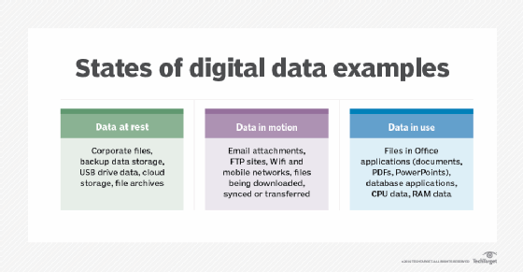
Data can be an integral part of an organization, the data held could be anything from employee’s personal details to customers details, information regarding sales or income, the list goes on.
Data security as the name suggests is the safeguarding of such data.
[1] Figure 1 on the right taken from the tech target website displays and image of the different states of data examples

Committee on National Security Systems or CNSS for short is an organisation where employed professionals in security, computing and law enforcement work to ensure the security measures used in today’s society are maintained, identified and relevant. [2]
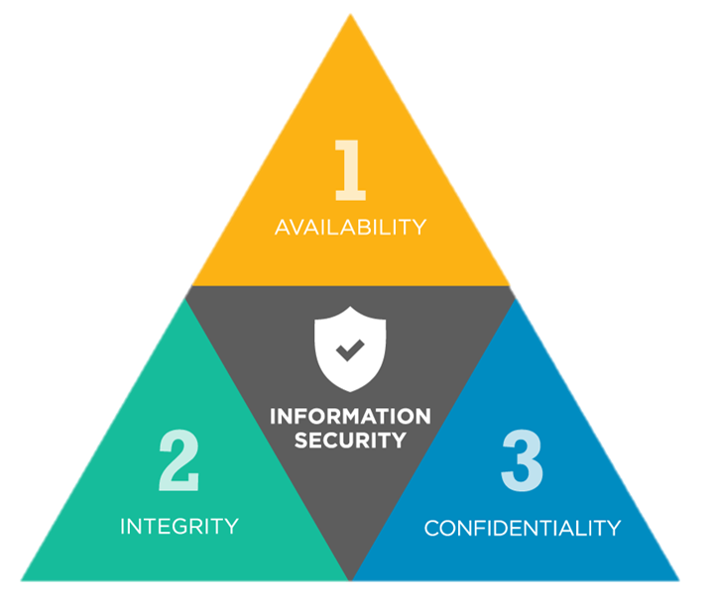
[3]
Figure 2 above shows the CIA Triangle, taken from the it governance website dictates a security model for information security. Split into three sections this model became a global standard for sustaining information security.
Availability – As the name suggestions the information needs to be available to be accessed for its users, an organization would need to place a plan in place in case for some reason users couldn’t access the information such as a fire or accident. An example of tackling this would be to provide a back up on the internet allowing users to access remotely.
Integrity – This is where the accuracy and broadness of the information and data is maintained. Many organisations put a lot of resources in maintaining this aspect of their model because if the information they hold is not correct or up to date then failures and mistakes can easily happen. An example of ensuring this is maintained is by ensuring software, data, policies are updated regularly, even customers information.
Confidentiality – Again like the name suggestions Confidentiality is where the sensitive information is kept sensitive, often businesses will hold customers names, addresses, bank details. Customers would not want anyone to know this outside of the business it is using, therefore it would be the organisations responsibility to ensure this information is kept safe and out of reach to others outside. Multiply ways of preventing this can be used such as the use of passwords, restricting unauthorised access to the information.
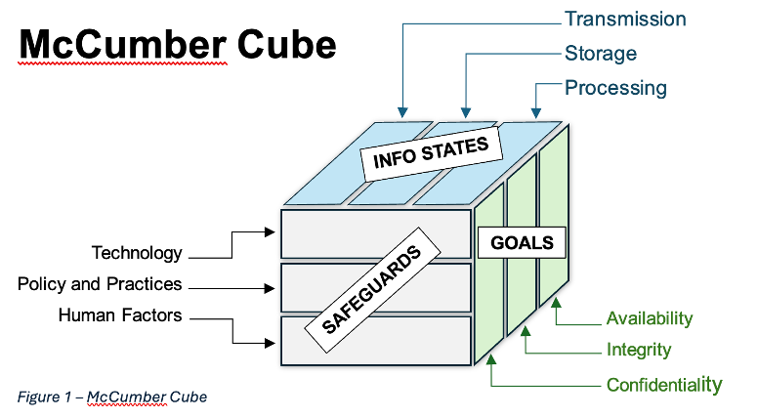
[4]
Figure 3 to the left shows the McCumber Cube, taken from the infosec taskforce website shows an expansion of the CIA Triangle in a more three-dimensional image.
“It is typically represented by a three-dimensional cube showing three sides that represent each of the primary focus groups, with each side having three sections which then represent each of the elements associated with the corresponding aspect” [5]
As described on the infosec taskforce website the statement above explains what the cube displays, the three different groups which highlight the key aspects of safeguarding information.
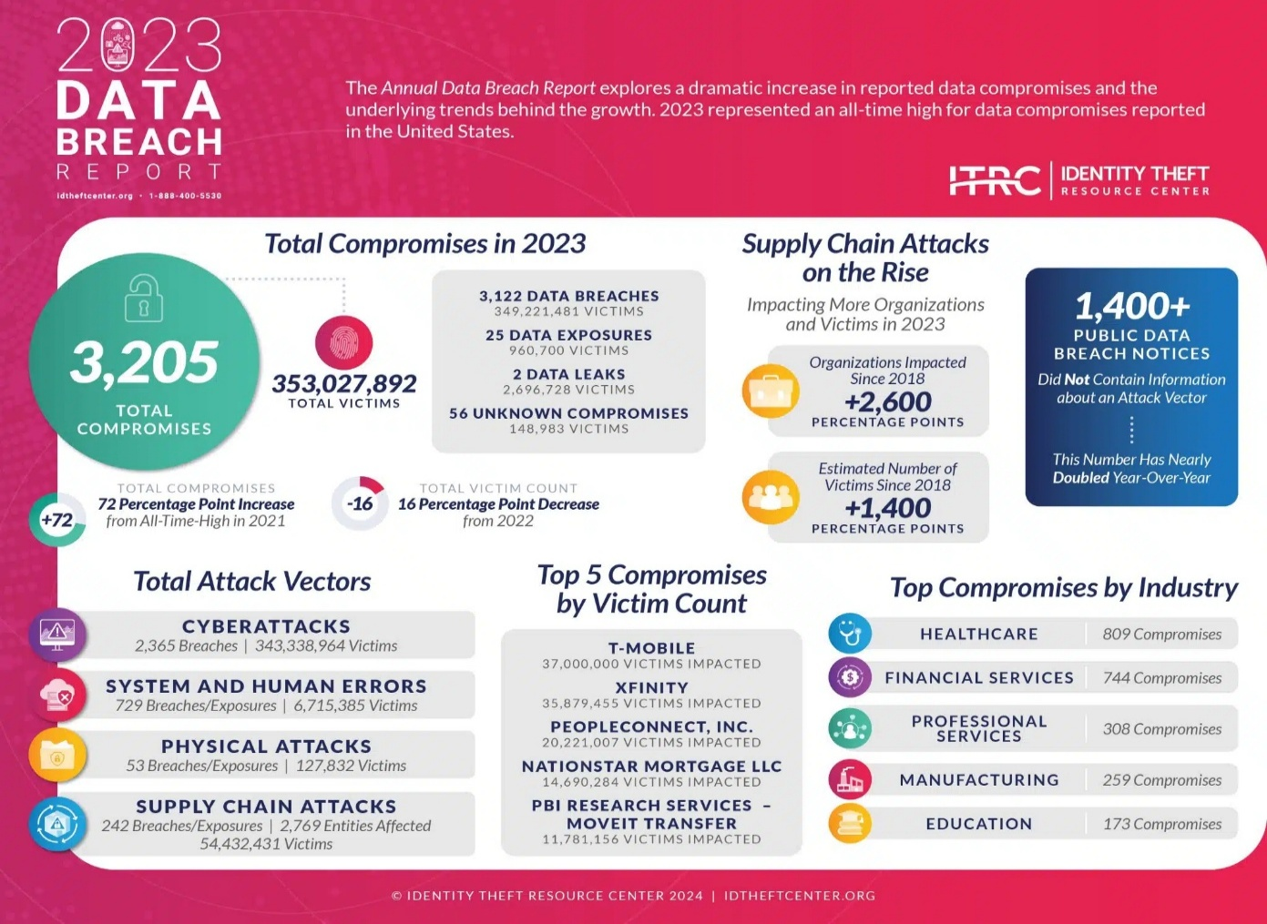
[6] Figure 4 above is a screen shot taken from the it theft centre website and illustrates the 2023 data breach report key highlights. This image displays the different areas of cyber attacks and security compromises which occurs in 2023, staggeringly this report indicate over three hundred and fifty million victims suffered from attacks in 2023 and over three thousand data breaches. Furthermore the report shows a well known telecommunications company being the highest victim to compromises, however on the upside of this information it can be seen there has been an reduction in victim count from 2022 meaning in some aspect the prevention measures being used in todays society has helped in one area.

2.1 – Security Frameworks

Security frameworks like compliance are guidelines or procedures created to help businesses improve their security, in particular cybersecurity. A cyber threat can be anything from a phishing email to a full-blown virus attack, security frameworks are implemented to help counter and prevent these attacks from happening. [7]
In an article titled “a systematic review of information security frameworks in the internet of things” authored by Mohammed Irshad, it is suggested the different security frameworks present in todays society each hold diverse characteristics which allow organisations the decision on what will be successful for them in particular. [8]
2.1.1 – Components of Security Frameworks

There can be many components that build up a security framework however it can be seen some reoccur in each different one making them somewhat more common or even key components, the following are a few of these components.

2.1.1.1 – Risk Management

Businesses in the United Kingdom by law are required to protect their employees and even customers to do this, guideline are set into place to help organizations ensure everyone’s safety. Company management would be responsible for ensuring these guidelines are followed by using several different points such as:
- Identifying dangers
- Assessing risks
- Keeping a record of incidents
A lot of the risks in a workplace come down to everyday things such as fire safety or trip hazards but workers need to be assessed for risk when in front of a computer, poor workstations can result in injury or fatigue. [8]
Strategies need to be conducted and implemented ensuring all aspects of risk are involved to ensure safety and compliance, furthermore these strategies need to be reviewed every so often to ensure they still are relevant and up to date.
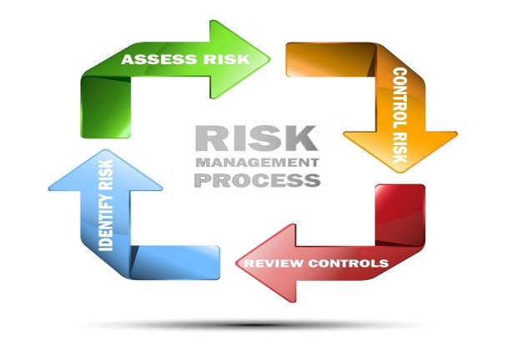
There are many tools available for businesses to assist with risk management for example a automated asset inventory system allows organisations to electronically scan their assets and store them, allowing a more productive management method. This system can then be used to assess risks by identifying devices or assets that have expired such as firewall, an expired firewall would result in
Figure 5 displayed on the left illustrates a basic chart for risk management highlighting the different steps taken during the process. [9]

2.1.1.2 – Monitoring

As briefly touched on in the previous section, once strategies are created and implemented many companies never revisited them again which can cause a risk due to the fact everything evolves, changes or becomes redundant. Some frameworks themselves highlight the importance of for ongoing monitoring and frequent review.
“Risk monitoring is assessing risks and making informed decisions about managing them. It involves regularly reviewing risks and their potential impact on business processes, identifying new threats, and updating plans and strategies as needed. Risk monitoring helps organizations proactively manage risk and minimize its impact on operations. It is an essential component of effective risk management and can help organizations avoid or mitigate losses.” [10]
The above statement citied from an online article by Rob Paredes describes what monitoring risk is, this applies to the risk management component because of the importance of identifying risks early allowing prevention and acting upon them.

2.1.2 - Security Framework Examples

In this section of this report, three examples of current security frameworks will be looked at and briefly described along with their purpose and uses.
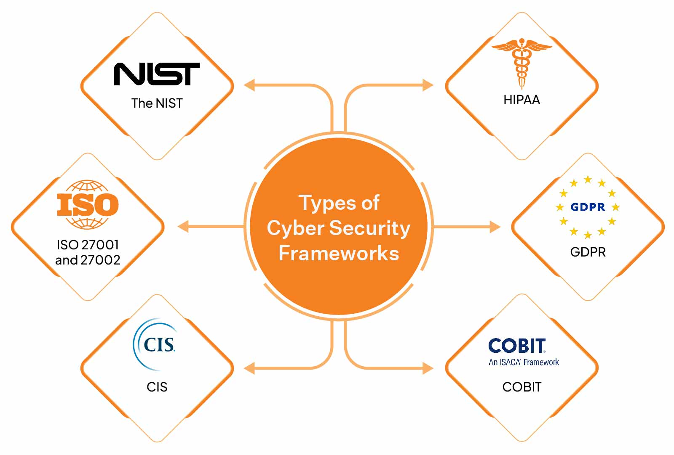
[11] Figure 6 above taken from an online article created by Meeba Gracy on the springto website illustrates six different types of security frameworks.

2.1.2.1 – NIST

The first example is the NIST framework which stands for National Institute of Standards and Technology. Like majority of frameworks NIST is a assembly of guidelines and standards created to aid businesses control and further their cyber security.
This framework has five key functions which are:
- Identify – this is where a threat or risk is discovered.
- Protect – by placing counter messages such as awareness training for staff.
- Detect – this is where monitoring current procedures or tools will be used to detect current or upcoming threats.
- Respond – the businesses would need to take appropriate action against a cyber attack by communicating with staff, law enforcement etc.
- Recover – if necessary, organisations would need to look into their back up plans to recover any loss as a result of an attack and restoring business back to normal. [12]
“Those with a hand in creating the framework knew the importance of creating a “framework to live by” – they shared the same vision. These individuals were sourced from different roles and industries and had varying viewpoints and perspectives on data security and cyber risk management. This crowd-sourcing methodology is precisely what makes the NIST Cybersecurity Framework so robust. It draws from every angle the priorities and uses cases of its creators, resulting in a framework that adds depth and breadth to your organization while being flexible enough to accommodate large and small businesses.” [13]
The statement above taken from the cyber saint security website describes the NIST frameworks benefits and NIST can be seen to benefit any size business from small to large therefore can be seen to be flexible. NIST with is five key functions focuses on detection and recovery which will aid businesses in being more robust to any threats. Although the statement comes across more of a sales pitch than an accurate description of the framework the objective of the statement is clear.

2.1.2.2 – ISO 27000

This security framework is more considered to be a multiple of frameworks, International Organisation for Standardisation abbreviated to ISO is designed to comply with law and manage sensitive information which businesses hold.
The starting point of this framework is the ISO 27000 which is an overview of the family so to speak, the key aspects of this framework is its information security and structure of keep information secure.
The most common is in the family is the ISO 27001 which is implemented by many businesses, certification is presented to businesses who abide by these guidelines which indicates to others the business has measures in place to protect their information.
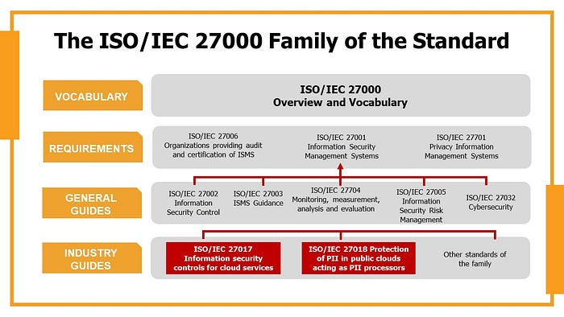
Figure 7 is an image taken from the cfe certification website illustrating the ISO 27000 family and different frameworks. [14]

2.2 – Security Technologies

Security technologies is a vast range of equipment, software and technologies created and used to safeguard data from cyber attacks and threats. The simplest and most common security technology can be viewed as an alarm system. Used to detect when an intruder enters a property their unauthorised to do so, the alarm system notifies the owner allowing them to respond.
“Security technology refers to the components and policies used to protect data, property, and assets. It helps mitigate risk by preventing unauthorized access, identifying potential incidents, allowing fast responses, deterring criminal behaviour and capturing crucial evidence during a breach. “[15]
The above statement stated on the avigion website gives a further description of security technologies.
Below are a few examples of security technologies and their purpose.

2.2.1 – Firewalls

Firewalls are software installed onto computers to monitor incoming data via a network such as the internet, it can be viewed as a barrier preventing threats incoming.
Figure 8 below taken from the Norton website brilliantly illustrates how a firewall works, where a network makes a request to access the internet, the firewall would scan and look through the data ensuring the data is safe, then allowing the user to access the data safely.
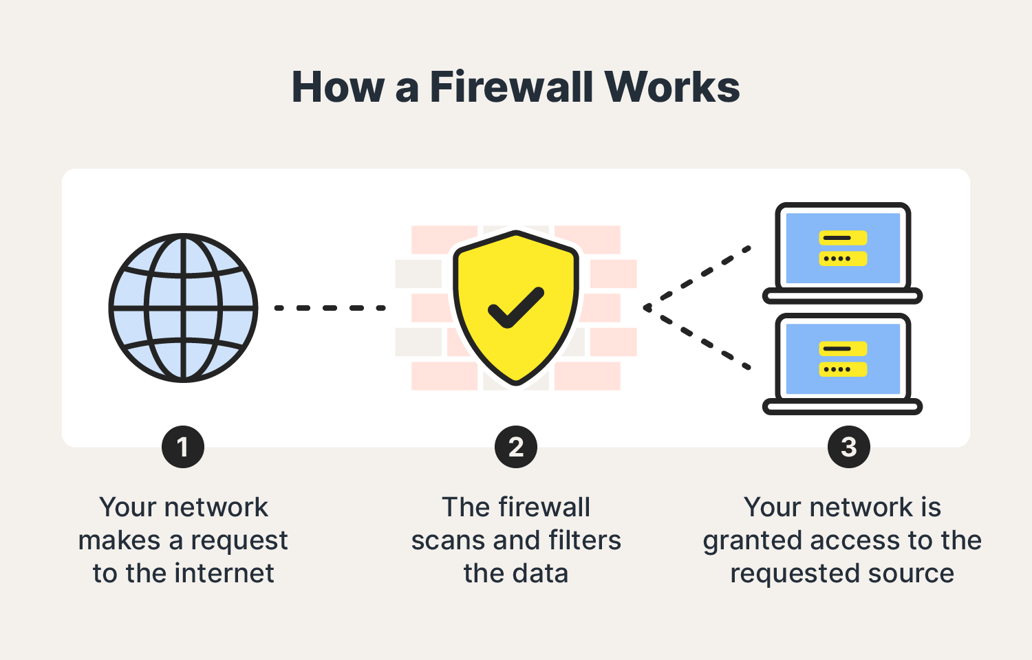[16]

2.2.2 - Antivirus Software

Antivirus also a program which is installed onto a computer, designed to prevent and remove malware. “A malware attack is when cybercriminals create malicious software that is then installed on someone else’s device without their knowledge. This type of attack is to gain access to personal information or to damage the device, usually for financial gain.” [17]
The statement above taken and written from the Norton website describes what malware is, highlighting the key fact that malware is an attack used by criminals.

Antivirus software is created with the purpose to scan computers and remove the malicious software or code which has intruded into the network. One way of doing this is by what’s called a signature detection, where the antivirus software uses a database with known malware signatures and patterns and uses this to prevent those patterns coming into the network.
Businesses which are more vulnerable to attacks due to the sensitive data they hold often find cyberattacks occurring due to expired or out of date software on their systems.[18]

2.2.3 – Access Controls

In simple meaning access controls are technologies that allow the access to individuals who are authorised entry and deny those who are not, there are many ways for an organisation to install one of these access controls, the main purpose for this type of security technology is to prevent trespassing.
Trespassing can be physical or virtual, physical trespassing is where someone goes onto organisations property without their permission, virtual trespassing is where unauthorised to a data source or storage has occurred, for example a hacker gaining access to cloud storage.
For an example the figure 9 shown below which was taken from the sense on website illustrates a chart highlighting how a access control system works, in this case a user would present a keycard onto a reader. The access control system would then process the data on the card to determine if the user is authorised entry or not and output the result.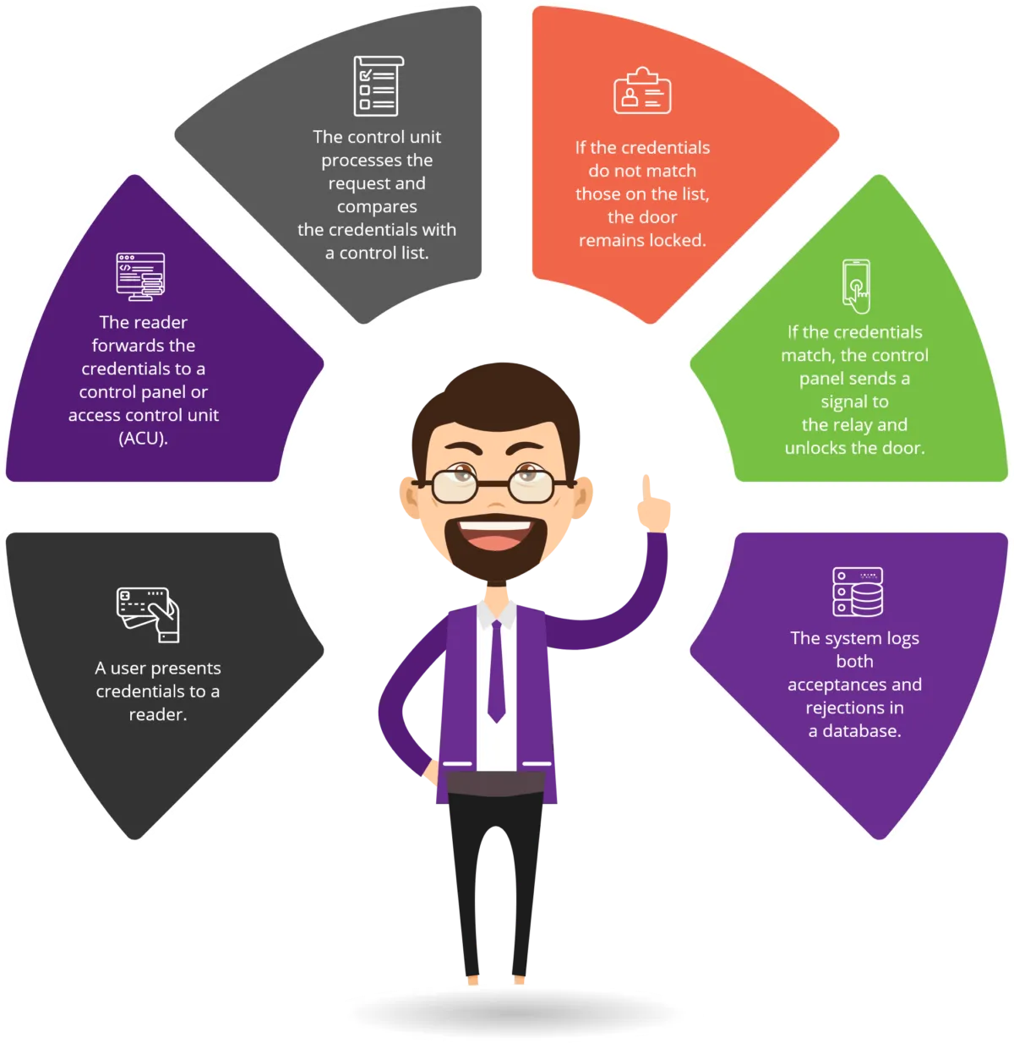
[19]
3 – Task 2 – Case Scenario

Now in this report a case scenario where a new fast-mounting intelligence company named CyStresSoultion or CSS for short has started an information security section within the business and requires further knowledge on its running.

3.1 – Plan

Over the next few headlines, taking into consideration the research what has already been looked at previously in this report, different guidelines will be highlighted in what the business should require to be safe and successful to provide a service to their customer base.
These approaches will be split into the following sections:
- Organisation structure/chart.
- Polices and Procedures.
- Compliance.
- Governance and Strategic Planning for Security.
- Risk Management.
- Contingencies Planning.
- Protection Mechanisms.

3.1.1 – Structure

Every business need’s structure to be maintainable and even successful especially with newly formed businesses. An organisation chart also known as an org chart is a presentation of different key elements such as roles and responsibilities within that business project.
“An organizational structure is a system that outlines how certain activities are directed to achieve the goals of an organization. These activities can include rules, roles, and responsibilities.” [20]
The statement above citied from the invesopedia website, written by Will Kenton reemphasises the meaning of a business structure.
The following points are key conceptions of a organisation structure or chat which should be considered when running the new information security unit in CSS.

3.2.1 – Hierarchy

A hierarchy within a business can also be viewed as a chain of command where the owner or boss sits at the top and employees leading downward, the bosses or senior managers would make decision for the business and pass the orders down to the workers at the bottom of the pyramid or chain. This is known as a pyramid command structure, below is an example of what this would look like.
Owner

Senior Management

Team Leader

Worker

There are also other methods of hierarchy structures such as the flat hierarchy structure which would only be the owner or boss at the top who then passes the company decision down to everyone regardless of position, this looks something like:
Owner

Senior Management Team Leader Workers

The main key highlight with these structures would be the ownership and responsibility of who makes the decisions in the company, it allows managers to monitor tasks given to works and track targets. [21]

3.2.2 – Roles

The roles within a business determine the responsibilities of everyone, also fitting nicely with the hierarchy. The structure charts for this are the same as the hierarchy where the Manger would be a higher than an advisor for instance. Other roles but not limited to can be:
- CEO or chief executive officer
- Associate, usually in sales or advisors
- Relations Manger
- Assistant Mangers
Figure 10 below brilliantly illustrates a hierarchy structure with roles included taken from the quizlet web page [22].
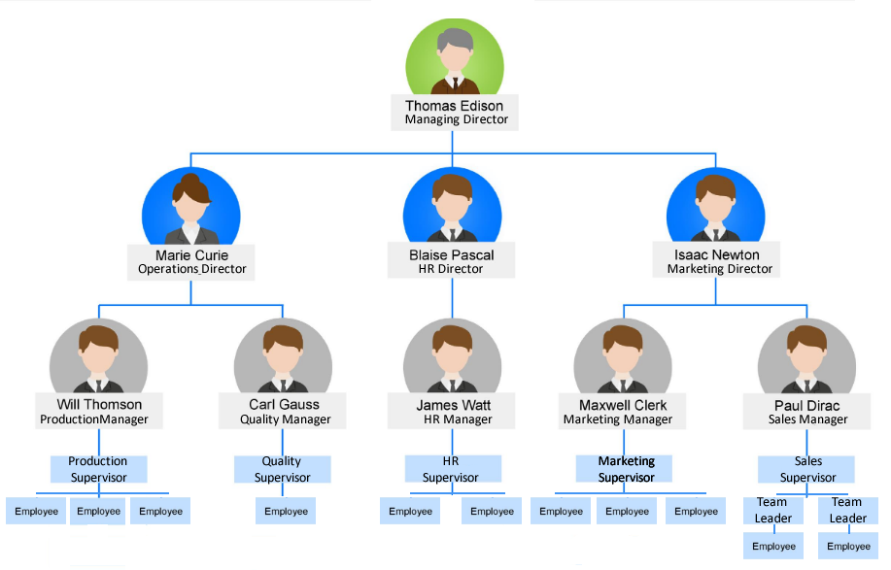
It can be seen that Thomas Edison is the managing director of the this business hierarchy structure example and below him are three employees each with this own employees below them.

3.2.3 – Authority

With each different role within a business comes different authorities or responsibilities, in relation to organisation structures this can be presented in three different key points.

- Top Level – These are the decision makers such as the business owner, CEO or even board of directors.
- Middle Mangers – As the name suggests these manager sit in the middle of the structure taking their orders from top level but have employees below them.
- Lower Lever – Often referred to as operational workers, these employees deal with the day to day running of the business with their orders coming from middle managers or even team leaders.

3.1.2 - Procedures

Procedures often follow or align with policies in a business these are put into place by management to ensure actions are followed in a particular way. The aim of a procedure is to guide an employee of the business to a certain outcome such as making a sale over the phone or resolving problems for customers. A policy in a similar aspect is an outline of the businesses vision or values and explains how it intends to produce that outcome. [23]

CSS will require both procedures and policies in place to ensure staff follows the ideal requirements to meet goal as well as present the business in a formal manner. Policies should not be referred to as laws due to the fact law is enforced by the government and carries legal consequences if broken. Policies are controlled by the businesses they are created in and are often more flexible but still carry penalties if broken such as disciplinaries or even dismissal.

A great example of a policy is a dress code policy where the organisation will require staff to dress a certain way while in the workplace, most commonly smart causal wear, strictly no beach wear etc.

An example of a procedure would be in the banking industry where staff would be required to follow a script when speaking to customers ensuring certain aspects of their procedures are clearly informed to the customers.

3.1.3 - Compliance

Compliance can be viewed as a policy in some ways however as the meaning of the word suggests, compliance is where the adhering of something is needed by a business and its staff.
“Most people will come across compliance in their day-to-day roles at work. Compliance essentially means the following of rules/regulations/orders at work, and they usually vary depending on the industry you work in. It is applicable to all levels of staff e.g. employers, managers, supervisors, employees.” [24]
The statement above citied from the ihasco website by an unknown author describes that compliance is indicating the following of rules or regulations while are work.

3.1.3.1 – Key Areas

There are some key areas in which compliance is important these are:

- Security Compliance – This is where businesses need to follow compliance such as the General Data Protection Regulation or GDPR for short. This is a law that was created to protect sensitive data help within businesses, ensuring customer information such as date or births etc are stored and secure.
- Internal Compliance – This as the name suggests is down in house and is the businesses own compliance like procedures and policies.
- Regulatory Compliance – Can be specific to certain areas of business and can differ, for instance banking and finance compliance would differ to construction compliance where one would be more information security orientated where the other would be more health and safety driven.
- Legal Compliance – Linked with laws these rules are in relation to businesses paying tax or following health and safety laws.

3.1.3.1 – CISSP


Figure 11 [25] shown on the right taken from the skymax website is the logo of Certified Information Systems Security Professional or CISSP for short.
Fundamentally a certification which is given to those that follow the set rules and guidelines created to aid businesses in managing security systems.
The certification is a great way to be recognised for the knowledge obtained in the security information systems area, illustrating to others the skill and professionalism gained from this award while promoting it to others. [26].
3.1.4 – Security Planning

All businesses will require a security plan in place to ensure the threat of cyber attacks are detected and even prevented. This is where well-established policies can be put in place to help.

- High Level Policies – These policies when implemented will be the main outline of the businesses approach to security. They’ll need to apply across the board in all areas of the business and be extensive ensuring all aspects of security is thought of.
- Tactical Policies – specifically created to tackle certain security concerns within the business, for instance employee’s duties to undertake on a monthly basis to prevent out of date security technologies. CSS would require this policy for the information security unit as well as a further policy for the main business itself. An example of this policy would be in relation to password use and what’s acceptable as a password, how often should it be changed etc.
- Operational Policies – The main area for the information security team, this policy type is designed solely for specific security systems for instance firewall configuration and antivirus protection.
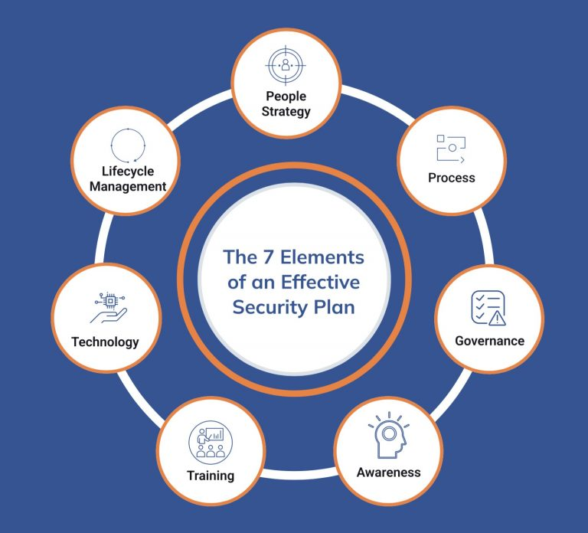
Figure12 [27] on the right taken from atriade website illiterates a chart of the seven different elements in an effective security plan.
One of the elements indicates training which would be essential to ensure staff are aware of the up-to-date policies and requirements in security at that time, there would be no point in having antivirus software if staff were unaware how to scan a computer for a virus.
Furthermore, with the ongoing growth of cyber threats and new techniques used by criminals, awareness is also shown as a key element ensuring employees are aware of the current methods used by cyber criminals.

3.1.5 – Risk Management

For risk management the information security unit within CSS will need to first come up with a plan or aim to approach this subject. One key area would be to identify the risks in the security environment, this can be done by using system technologies or tools but by also brainstorming with staff or research.
There are three categories of risk to consider, these are:
- Preventable risks – as the name suggests these risks are avoidable, an example of this would be trip hazards in the workplace.
- Strategy risks – an example of this would be where a competitor provides the same service or product and produces it for less or cheaper.
- External risks – often out of the businesses control external risks can’t be prevented and will always be present, an example being the force of nature such as storms or blackouts. [28]
Staff within the business would need to be given the responsibility of managing the risk process, more commonly a manager however some roles can be created solely for the purpose of undertaking the risk management duty.
Consistent monitoring would be required and even a register to detail and record identified risks, log what action has been taken to prevent the risk etc. Monthly meetings with the staff responsible, allowing the discission of new and existing risks.

3.1.6 - Contingencies

“A contingency plan is a course of action designed to help an organization respond effectively to a significant future incident, event or situation that may or may not happen.
A contingency plan is sometimes referred to as "Plan B" or a backup plan because it can also be used as an alternative action if expected results fail to materialize. Contingency planning is a component of business continuity, disaster recovery.” [29]
The statement above citied from the web article contingency plan, written by Paul Kirvan on the tech target website briefly describes what a contingency plan is. As highlighted a contingency plan is often referred to as a plan b or backup plan which is implemented in the event of an attack or disaster.
It would be viewed that having a back up plan for unexpected events is a knowledgeable thing to do and especially for new business ventures. A contingency plan will allow CSS to protect its assets and maintain a day to day running in the event of failure.
Below are some examples of strategies that can be used as a contingency plan in the areas of financial, technological and legal.
Cutting expenses – this would be a financial contingency where the company would identify unnecessary costs within the business allowing the overall business expenditure to be reduced, preventing profit lose and potentially bankruptcy. A basic example of this would be researching and switching energy suppliers ensuring the best price is paid.
Back Up – using a service like cloud to back up data is a must, this allows information to be recovered in case of lose or theft. This back up should be regularly updated to allow minimal loss when the worst happens.
Insurance – a legal contingency where the business would insure property and assets from damage or loss, furthermore policies can be put into place to prevent business disruption.

3.1.7 - Protection

The are multiple options for protection in a security aspect from firewalls to remote accessing, one common and effective mechanism however is encryption, below is a description of what encryption is how it works and an example of its use.
Encryption is the process of changing information or data into a mystery format where to readers, is unreadable. This is done using a computer algorithm which changes the way the information is read.

Figure 13 [30] below taken from the Norton website illustrates how an encryption works, where basic text is changed into a puzzle.
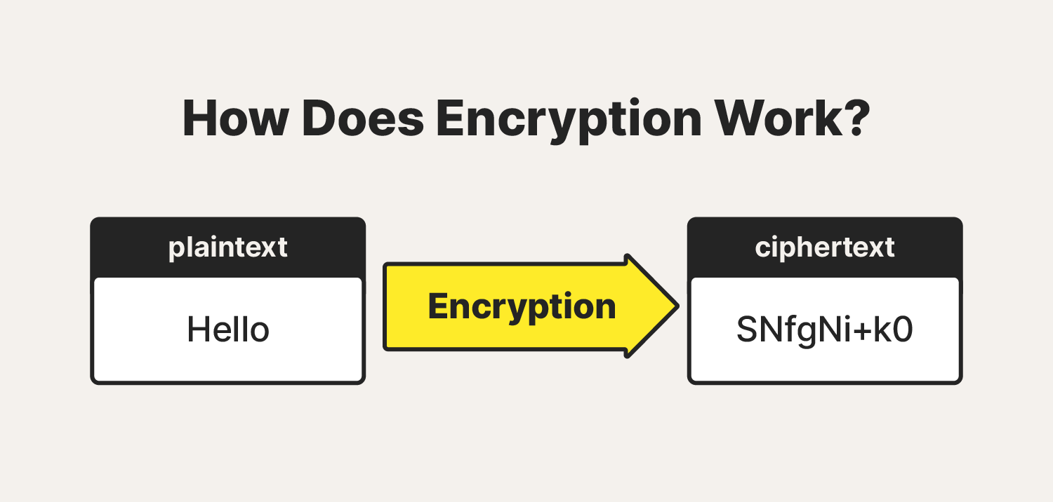
The main benefit from this protection mechanism is the fact that only authorised employees would have access to the information, furthermore the information stored will be untampered with.
4 – Conclusion

In conclusion, the proposed approach to establish the new information security section of the business for CSS, effectively addresses the need for a more robust and proactive security stance.
By implementing a structured framework that incorporates risk management and continuous monitoring, the section will enhance the business’s ability to safeguard sensitive data, comply with law, and tackle emerging threats.
With a successful deployment of this section, the company is better positioned to navigate the evolving landscape of cybersecurity challenges.

5 – References
[1] Anonymous Anonymous Whatis-states_of_digital_data.png (1020×531). Whatis-states_of_digital_data.png (1020×531). Available: https://www.techtarget.com/rms/onlineimages/whatis-states_of_digital_data.png.
[2] Anonymous Anonymous NCSC home. NCSC home. Available: https://www.dni.gov/index.php/ncsc-home.
[3] Anonymous Anonymous Image-2.png (719×603). Image-2.png (719×603). Available: https://www.itgovernance.co.uk/blog/wp-content/uploads/2023/02/image-2.png.
[4] Anonymous Anonymous McCumber-cube.png (776×428). McCumber-cube.png (776×428). Available: https://infosectaskforce.com/wp-content/uploads/2024/04/McCumber-Cube.png.
[5] Anonymous Anonymous The McCumber cube model – InfoSec taskforce. The McCumber cube model – InfoSec taskforce. Available: https://infosectaskforce.com/index.php/2024/04/03/the-mccumber-cube-model/.
[6] Anonymous Anonymous ITRC-DataBreachReport-2023-infographic-H-2048x1583.jpg.webp (2048×1583). ITRC-DataBreachReport-2023-infographic-H-2048x1583.jpg.webp (2048×1583). Available: https://www.idtheftcenter.org/wp-content/uploads/2024/01/ITRC-DataBreachReport-2023-Infographic-H-2048x1583.jpg.webp.
[7] Anonymous . Understanding Security Frameworks: 14 Common Frameworks Explained. Available: https://secureframe.com/blog/security-frameworks.
[8] M. Irshad. M. Irshad. A systematic review of information security frameworks in the internet of things (IoT). A systematic review of information security frameworks in the internet of things (IoT). Presented at 2016 IEEE 18th International Conference on High Performance Computing and Communications; IEEE 14th International Conference on Smart City; IEEE 2nd International Conference on Data Science and Systems (HPCC/SmartCity/DSS). Presented at 2016 IEEE 18th International Conference on High Performance Computing and Communications; IEEE 14th International Conference on Smart City; IEEE 2nd International Conference on Data Science and Systems (HPCC/SmartCity/DSS). 2016, . DOI: 10.1109/HPCC-SmartCity-DSS.2016.0180.
[8] Anonymous . Risk assessment: Steps needed to manage risk - HSE. Available: https://www.hse.gov.uk/simple-health-safety/risk/steps-needed-to-manage-risk.htm.
[9] Anonymous Anonymous 1694461955414 (720×720). 1694461955414 (720×720). Available: https://media.licdn.com/dms/image/v2/D5612AQEHxSjWnhXQ2Q/article-cover_image-shrink_720_1280/article-cover_image-shrink_720_1280/0/1694461955414?e=2147483647&v=beta&t=p0GDk-FPy-yc9gPCwXaaScit3rQJrVr6cs1YDyQycpE.
[10] R. Paredes. (-09-09T14:03:54). Proactive Risk Monitoring to Mitigate Losses. Available: https://safetyculture.com/topics/risk-monitoring/.
[11] Anonymous Anonymous Copy-of-Blog_164_Cyber-security-framework-all-you-need-to-know-in-2023_v-02.jpg (1600×1082). Copy-of-Blog_164_Cyber-security-framework-all-you-need-to-know-in-2023_v-02.jpg (1600×1082). Available: https://sprinto.com/wp-content/uploads/2023/04/Copy-of-Blog_164_Cyber-Security-Framework-All-You-Need-To-Know-In-2023_v-02.jpg.
[12] M. Gracy. M. Gracy. List of top 6 cybersecurity frameworks. List of top 6 cybersecurity frameworks. 2024. Available: https://sprinto.com/blog/cybersecurity-framework/.
[13] E. Bresnahan. . What Are the Benefits of the NIST Cybersecurity Framework. Available: https://www.cybersaint.io/blog/benefits-of-nist-cybersecurity-framework.
References
[14] C. CERTIFICATION. C. CERTIFICATION. The ISO/IEC 27000 family of standards. The ISO/IEC 27000 family of standards. 2021. Available: https://cfecertification.medium.com/the-iso-iec-27000-family-of-standards-2f04697f2e82.
[15] Anonymous . Security Technology Overview & Industry Trends of 2025 + PDF. Available: https://www.avigilon.com/blog/security-technology.
[16] Anonymous Anonymous How-a-firewall-works.png (1500×960). How-a-firewall-works.png (1500×960). Available: https://us.norton.com/content/dam/blogs/images/norton/am/how-a-firewall-works.png.
[17] Anonymous . Malware attacks: What you need to know. Available: https://uk.norton.com/blog/malware/malware-101-how-do-i-get-malware-complex-attacks.
[18] Anonymous . What is antivirus software, and do I need it?. Available: https://uk.norton.com/blog/malware/what-is-antivirus-and-do-i-need-it.
[19] Anonymous Anonymous Systems-operate-1200x1234.png.webp (1200×1234). Systems-operate-1200x1234.png.webp (1200×1234). Available: https://cdn.senseon.com/wp-content/uploads/2019/11/systems-operate-1200x1234.png.webp.
[20] W. Kenton. . Organizational Structure for Companies With Examples and Benefits. Available: https://www.investopedia.com/terms/o/organizational-structure.asp.
[21] P. Sable. (-07-11T12:30:00+00:00). What is Hierarchical Structure? (vs Flat Structure). Available: https://chisellabs.com/glossary/what-is-hierarchical-structure/.
[22] Anonymous . Different Ways of Working and Roles and Responsibilities Diagram. Available: https://quizlet.com/gb/514921900/different-ways-of-working-and-roles-and-responsibilities-diagram/.
[23] B. Q. Consultancy. (-05-25T14:13:00+00:00). Understanding the difference between policies, procedures, protocols, and guidance, PPPGs. Available: https://bettal.co.uk/understanding-the-difference-between-policies-procedures-protocols-and-guidance-pppgs/.
[24] Anonymous . What is compliance and who does it apply to?. Available: https://www.ihasco.co.uk/blog/what-is-compliance.
[25] Anonymous Anonymous Cissp.png (560×360). Cissp.png (560×360). Available: https://skymax.ng/images/cissp.png.
[26] Anonymous Anonymous Skymax | CISSP. Skymax | CISSP. Available: https://skymax.ng/cissp.
[27] Anonymous Anonymous Esp-1-768x696.jpg (768×696). Esp-1-768x696.jpg (768×696). Available: https://atriade.com/wp-content/uploads/2022/04/esp-1-768x696.jpg.
[28] R. M. Kaplan Anette. R. M. Kaplan Anette. Managing risks: A new framework. Managing risks: A new framework. 2012. Available: https://hbr.org/2012/06/managing-risks-a-new-framework.
[29] P. Kirvan. . What is a Contingency Plan?. Available: https://www.techtarget.com/whatis/definition/contingency-plan.
[30] Anonymous Anonymous How-does-encryption-work.png (1500×716). How-does-encryption-work.png (1500×716). Available: https://us.norton.com/content/dam/blogs/images/norton/am/how-does-encryption-work.png.

