Marie Wilkinson

MDes Surface Pattern Design

Creative Venture: M7X01792

Creative Venture Report CW2

Student Number: 1702271

Word Count: 4039

Executive Summary

As a designer, I continuously find that I am trend-driven and process-led which allows me to be versatile in my practice, with the ability to use several different methods to create work from digitisation to traditional screen print.
The aims of my Creative Venture were to build self-confidence and enhance my portfolio through the addition of a diverse collection that uses a hybridised way of working. The motifs used are medicinal wildflowers, to enhance the underpinning focal point of wellbeing as I apply the concept of biophilic design to a collection of printed textiles for womenswear. The collection is inspired by the notion of comfort textiles, whilst being visually engaging as I draw from natural elements. I have used a combination of digital processes and traditional print-led knowledge to inform the collection.
My natural curiosity for materiality has informed the multi-sensory dimensions to the body of work, alongside a variety of soft substrates and processes to subtract and add texture, such as the implementation of needle-punched and engraved materials.
The collection encompasses a variety of floral and organic geometric patterns that encapsulate a feeling of warmth and comfort, gently nodding at the importance of the physical and the sense of touch.

Research Methods and Communication

With an interest in applying wellbeing to materiality, I used floral motifs to apply the concept of biophilia to print for fashion. I gathered imagery from the National Botanical Garden of Wales, and two books; ‘The Witch’s Garden’ and ‘Medicinal Plants’, both publications by Kew Gardens. The use of wildflowers allowed me to create florals that appeared free and uncultivated, and the medicinal element was an informant of how flowers can be used to benefit wellbeing. We feel an innate connection to florals as human beings – alongside their biophilic benefits, they provide familiarity in a time where most things seem uncertain.
Despite my interest in biophilic design, I wanted to add depth to my Creative Venture by including the addition of warmth as a factor in relation to wellbeing.
Throughout the pandemic, it has become clear that the simpler pleasures of life have been appreciated on a larger scale than pre-pandemic – one of these being the warmth of the sun. Societally, we have taken comfort in the outdoors and taken the time to slow down and appreciate nature, and a lift in mood has been forged by the sunshine.
The supplementation of Vitamin D from the sun benefits mental health and can help towards fighting mental health conditions such as depression, which increased societally after the first lockdown announcement (Mohdin, 2020). From personal experience, I felt more grateful for the warmth of the sun as it allowed our time outside to become a more enjoyable experience, in a time when the only options were to be at home or out in the open. Sunlight further increases productivity which is beneficial for our wellbeing.
I wanted my Creative Venture to introduce wellbeing to print for fashion, and reflect the joy of the warmth felt by the sun through the use of bold colour and materiality.
The colours I have chosen to use emit warmth, with an exploration of oranges and reds alongside subtle spring-like hues of pinks and lilacs to radiate the feeling of hope that we experience when we feel the first rays of the sun. Through context-focused trend research, I found this colour story via Premiere Vision for the SS22 season, discussing the harmony between purple and orange for a harmonious yet dynamic colour trend (Premiere Vision, 2020).

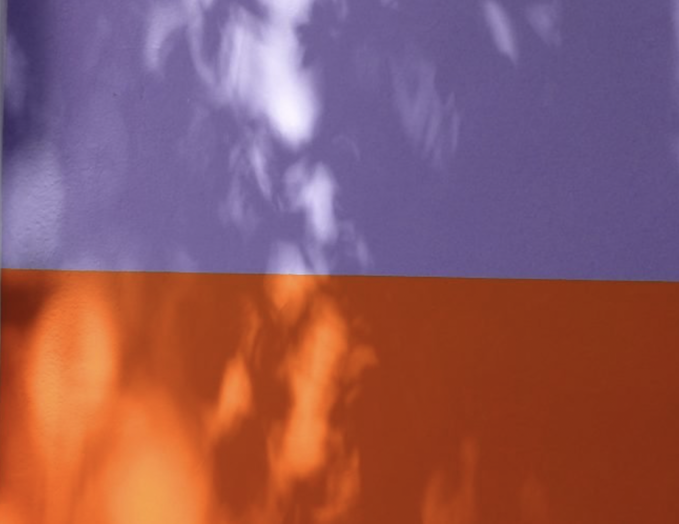
Figure 1|Colour Trends by Premiere Vision

Although the pink and purple tones I have used feel cool, they gently accompany the confidence of the warmer hues and pull them back to a spring-like warmth, as shown in the reference above when paired with warmer colours.
Warm colours are reminiscent of the sunlight and heat, whilst also providing a blanket of comfort in those winter months.

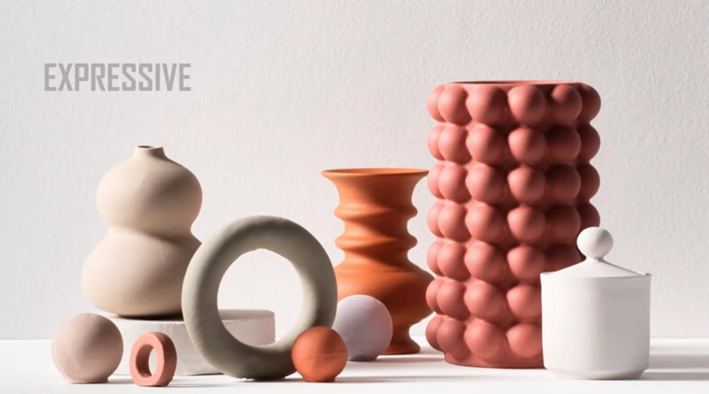
Figure 2|Dulux 2021 Colour Stories 1
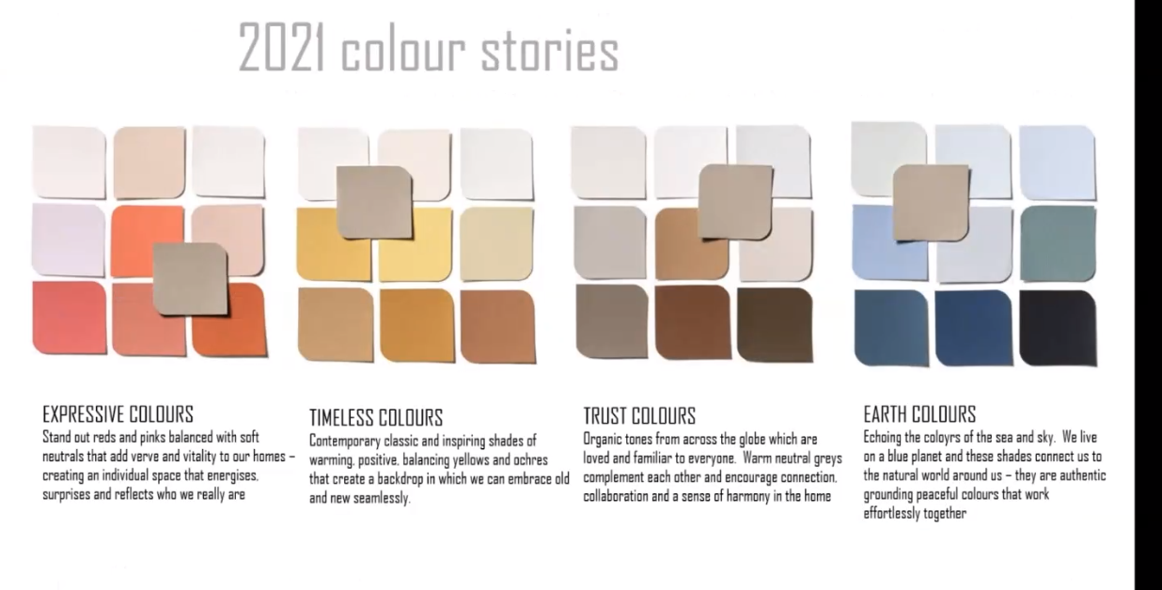
Figure 3| Dulux 2021 Colour Stories 2
My colour palette falls under the category of expression in Dulux’s 2021 Colour Stories, as Marianne Shillingford discussed the need to nurture earth tones within the home (Shillingford, 2021) as nature has been one of the few factors that have remained consistent for us throughout the pandemic, and there is an innate comfort in that. Our expression has been compressed throughout the lockdown and forced us to express ourselves in ways unbeknownst to us.
Influenced by our environment, the relationship we hold with our interior surroundings is reflected in our garments. Our need for earth tones is reflected in sunny oranges and rose-like pinks, exuding a comforting positivity to carry forward to SS22 (Vision, 2021).
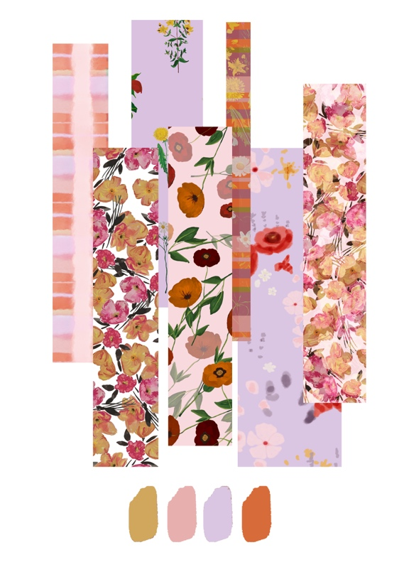
Figure 4| 'Warmth and Wellbeing' Colour Story 1
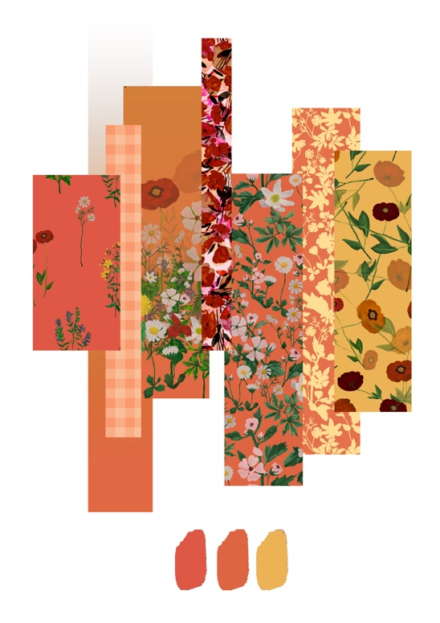
Figure 5| 'Warmth and Wellbeing' Colour Story 2
My own colour stories from developmental patterns for the collection discuss warmth through hue. The orange-toned colour story shows strength in warmer colours, yet the pink-toned story shows subtlety in warmth.
There has been a heightened need for tactility, as it was safer to abandon our human nature to touch, which I wanted to introduce as a multi-sensory element of wellbeing to my collection. Classen states that the sense of touch is one of our most important (Classen, 2005), and by using design methods that encourage touch, we engage the user in a physical manner that heightens wellbeing. Through process-led research, the exploration of puff binder and needle punched materials encourages tactility and optical depth in the collection, playing with multi-sensory elements. Before gaining access to the facilities at university, I played with subtle texture in paper collage to determine what print design elements would look best elevated.
I have trialled the idea of a collection that spans both the spring/summer and autumn/winter fashion seasons to explore the boundaries of materiality and create further depth within both the collection and my portfolio. Although the colours and motifs used are the same, they provide different purposes at both ends of the year through material choices.
The benefits of a trans-seasonal collection emerges from the rise in awareness of sustainability issues within the fashion industry. Throughout lockdown, many people have turned to layering, re-wearing and utilising clothes for multi-purpose wears across the year. Clothes have been painted, tie-dyed and re-made in an effort to fall back in love with our wardrobes as we hibernated.
This DIY trend has allowed fashion houses to re-evaluate how the seasons within fashion work, with a newfound focus on trans-seasonal garments and how these can be styled within capsule wardrobes. As DIY becomes a luxury, it begs the question as to whether sustainability is the new luxury as the resurgence in small businesses that have an environmental conscious encourages consumers to shop responsibly – which can often come at a higher price point.
Financially valuable items are often perceived as being precious, as we feel more responsible for their care. The benefits of trans-seasonal wardrobes gives our cherished items a higher usage rate, with few investment items being purchased in contrast to large volumes of trend-driven garments at a lower price point. Our wardrobes will no longer be rotational, but interwoven as we discover new print combinations and forward-thinking silhouettes.
By analysing the catwalks as the autumn/winter collections emerged, I could identify which substrates were suited to which season. Silks hold the shimmer of the summer, as wools and velvets encapsulate the need to nurture the feeling of warmth. Lightweight materiality is more suited to the summer months, but is also easily layered to form a trans-seasonal wardrobe through the use of heavy-weight materials such as woollens and knits.
To further increase the gauge of comfort within the designs, I used coarser drawing tools such as oil pastels to formulate an organic geometric texture reminiscent of crocheted blankets and heavier substrates used to trap warmth in the winter months. The addition of pattern from structural comfort textiles increases awareness of autumn/winter materiality and the effect produced by drawn pattern.

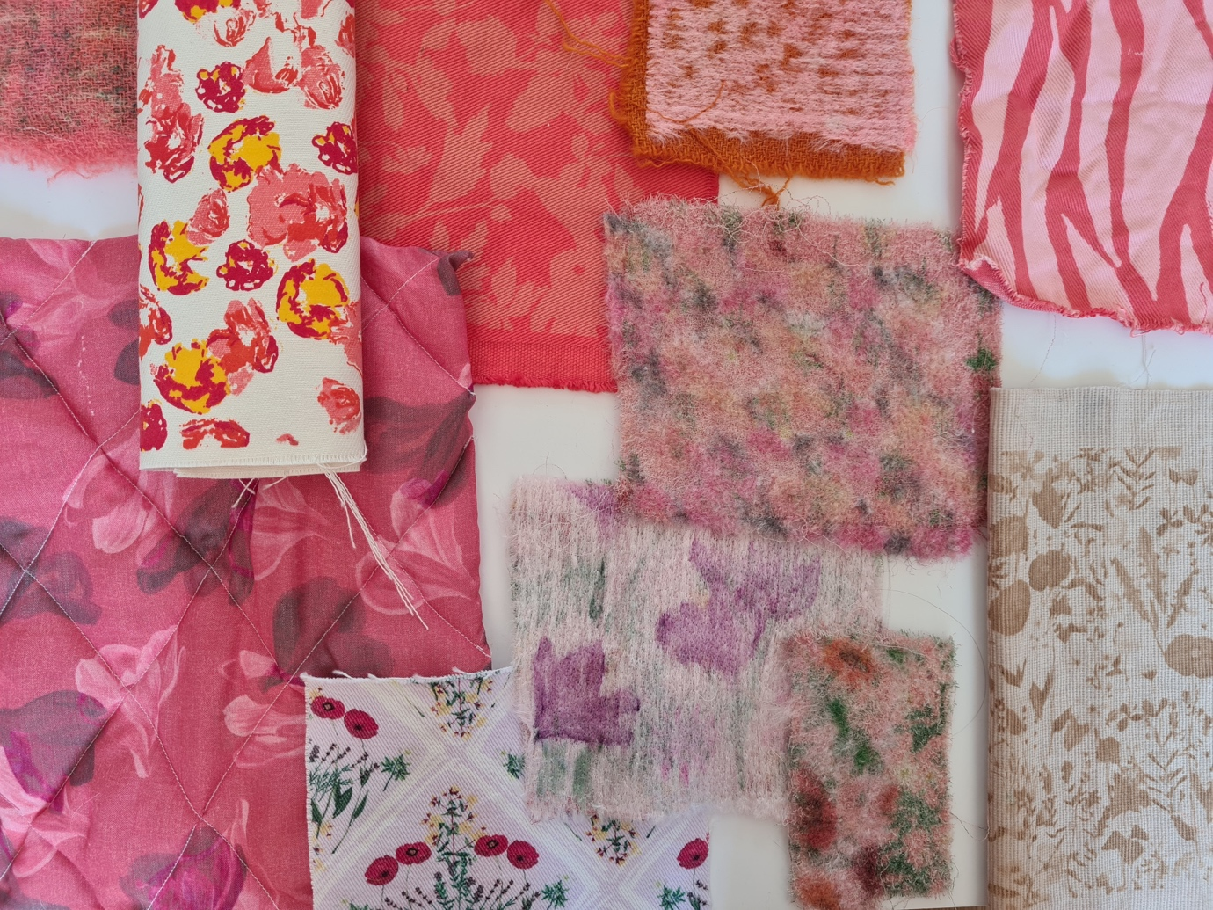
Figure 6| A/W Material Moodboard

When considering Autumn/Winter materiality, I studied heavier materials such as cotton drills and corduroy alongside substrate manipulation through process by using quilting and needle punching methods.
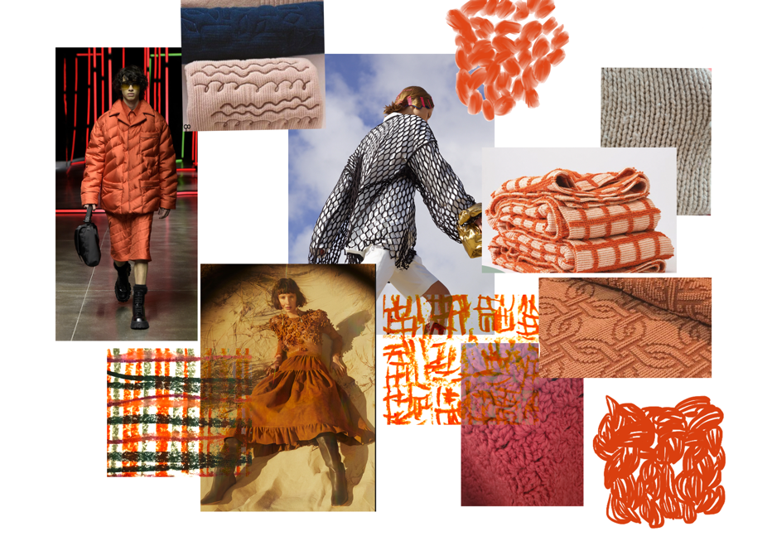
Figure 7| Comfort Textiles A/W Material Moodboard

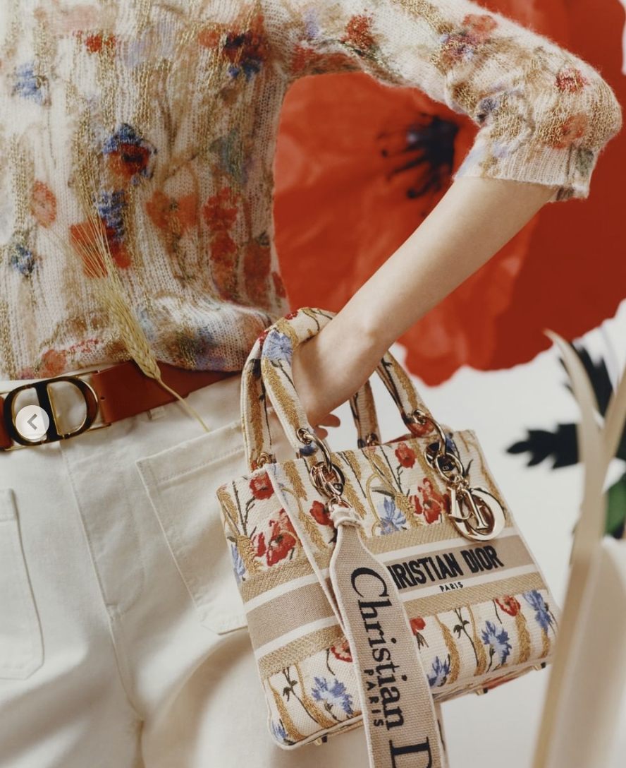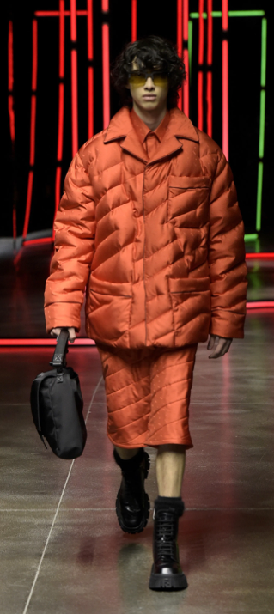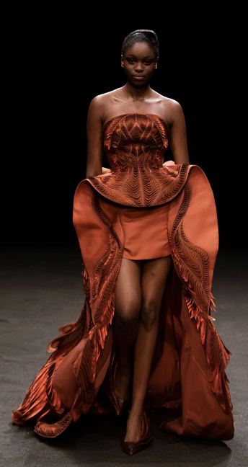
Figure 8| Christian Dior Figure 9|Fendi Figure 10| Iris Van Herpen

Christian Dior, Iris Van Herpen and Fendi explored materials that eluded warmth, through colour and texture alone. I considered how gentle fabric manipulation could subtly exhibit the idea of warmth, without directly discussing it. I adopted the strength of orange as a joyous indicator of warmth into the colouration of my prints.
Through both addition and subtraction methods of creating prints, I considered the depth of tactility within a womenswear context. The juxtaposition of a digitally printed silk with flock or puff binder allows accessible engagement for a user, as when anxious we often look to touch as a distraction or calming technique, such as the use of stress-reducing items like stress balls. Materiality is instinctive (Brown, 2020) and would allow a subconscious physical benefit to our mental health.
It has been found that our use of smartphones is linked to depression and anxiety, and as a result, there is a stronger need for touch in those that consider themselves addicted to their smartphones (Elhai, et al., 2016). As screen-time has been our only form of connection outside of our household, societally mental health needs have risen alongside the need for touch.
Textural print design would allow a user to engage their sense of touch and use the print as an aid to benefit their mental health. Alternatively, needle punched substrates allow a larger surface area of texture that engages the user by surprise as the process of needle punching allows the fabric to appear coarse but is often soft to the touch. It also provides a cosier feel, nodding towards how the collection should feel in alignment with its concept.
I am keen to keep traditional methods such as screen printing alive, as modern mechanisms such as digital print are unable to withhold the textural elements further than the material it has been printed on. Despite this, I like to use a hybridised approach to align with the current trends and introduce traditional elements to print. I believe that the visual and textural depth applied to physical print design triggers greater interest and physical engagement in humans than its counterpart.
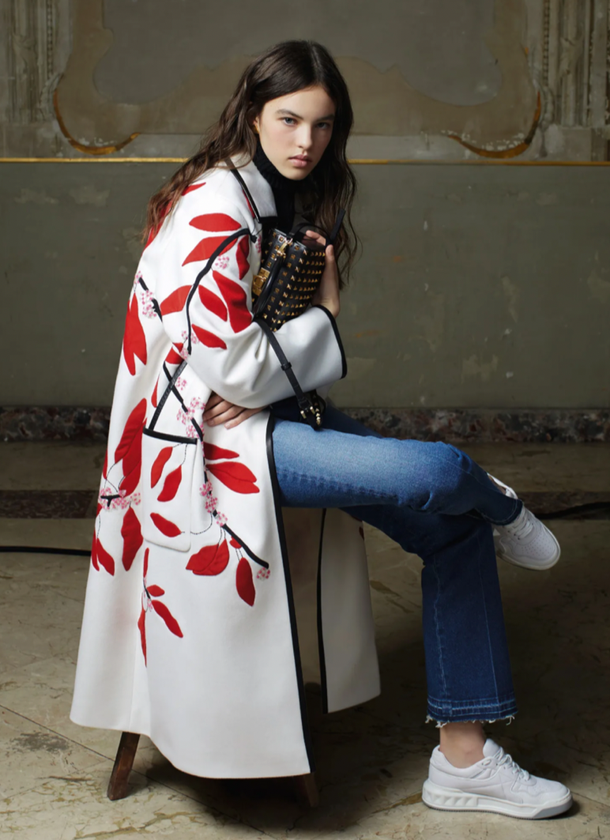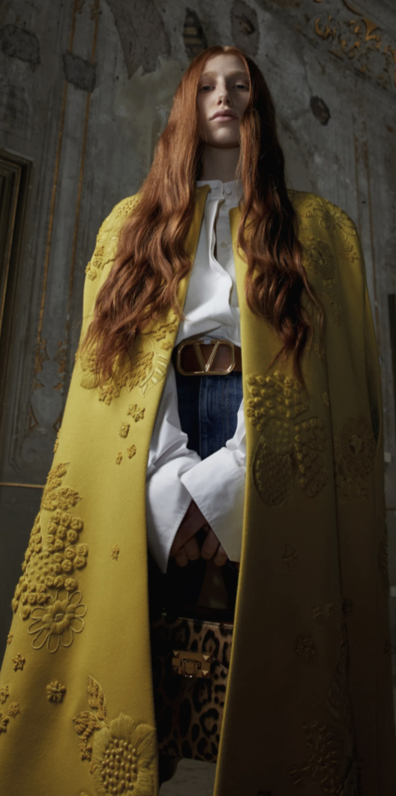
Figure 11|Valentino Pre-Fall 21 Figure 12|Valentino Pre-Fall 21

The embellishments within these Valentino pieces intrigue me more than that of a digitally printed fabric due to their texture, whether it be through applique, embroidery or screenprint. The alternate dimensions to the cloth have sensory intrigue that runs deeper than that of a flat cloth. The engaging elements of devore and puff binder accommodate this, whereas digital print needs a subtraction method, or additional element to create a multi-textural surface.

Creative Enterprise and Practice Strategies

As a designer, I consider myself to be versatile and this has only been heightened over my MDes year as my digital skills have improved. I have focused my design methods through Adobe Photoshop and digital drawing using a Wacom digital drawing tablet, and feel that I am in a stronger position to work digitally If needed. I have learnt to combine my love for traditional fabric dyeing, technical screenprint knowledge and digital skills to forge a collection that encapsulates my concept.
My time at RMJ Print and Textile Studio felt like the start of an understanding as to what I enjoy doing and where I fit as a designer. I love analysing current trends and building my interpretation through individual research and practice-based methods, and creating prints that push trend forward. At the time, I was unsure as to how I felt about drawing and digitising as the only ways to create prints, but now that my digital skills have improved I feel much more confident about being employed in a professional studio environment in the future. The versatility in my ability to produce prints and the work that needs to be distributed from a studio compliments one another and could be another asset to studio-based employability.
Despite initially working conceptually, I am able to commercialise my work and apply it to a womenswear context. The live brief with Patternbank allowed me to consider commercialisation within womenswear print design, which I have carried forward into my Creative Venture by exploring the scale of motifs and engineered placement.
My love for working with physical fabrics, tactility in-process and exploratory methods have paved the path for me to continuously be in the print room creating traditional prints. I have felt my confidence grow in the print room over the past two years, and although partially due to experience, I also believe that this can often be due to the number of people printing alongside me. I can be easily overwhelmed if I am continuously surrounded by large groups of people, and feel that I work best either in small groups or by myself. Employment in this type of environment would be where I can see myself thriving and continuing to grow as a designer. I am also a thorough planner and I feel that this works to my advantage.
The Society of Dyers and Colourists brief in my third year enhanced my technical knowledge and design skills, allowing me to consider my interest in materiality and how this could be applied to future briefs and ambitions.
My design identity comes down to being process-driven, trend-led and fuelled by concept, but able to digitally commercialise. A studio where I am able to verbally translate digital prints to different substrates and processes for clients and partake in trend research could allow the better parts of my design identity to thrive. I have found an interest in Fairbairn and Wolf’s brand identity, however, I have struggled to find any companies that also create traditional print for fashion that work outside of London.
I see value in creating commercial prints through screen printing as slower mechanisms can often be more sustainable, and the rise in awareness of sustainability in the fashion industry has increased significantly over the pandemic. The current climate encourages a need for touch, and physical screen prints can accommodate this.
I have applied to have my work exhibited nationally with Elysium gallery in a paper format, through their ‘Without Borders’ exhibition that discusses the societal connection formed over lockdown. Despite being a paper-based exhibition, I felt that it aligned with my concept and would be a good opportunity for my work to be exhibited widely, both physically and digitally, to later remain in an archived book within the gallery. Externally, I also hope to submit to a variety of the New Designers briefs, across multiple contexts such as textiles for fashion and stationery.
The specific New Designers briefs I am interested in are:
- The Clothworker’s Company Printed Textiles Award
- The Romo award for innovation in design and colour
- The Wilko retail design award: surface pattern and textiles
- The Mollie Makes Award
- The John Lewis and Partners Award for Design and Innovation: Week 1 Disciplines
I believe that I can tailor the sub-collections of my Creative Venture to a variety of briefs as I explore a multi-market concept and traditional screenprint alongside my collection of digitally printed designs. Through responding to the Wilko’s brief, I will be adding another dimension of context to my portfolio as I explore versatile surface opportunities for my Creative Venture.
I would like to continue exploring the boundaries of my Etsy store, and despite the knowledge that this is not feasible financially long-term, I feel that the Wilko’s brief can aid the formation of ideas, alongside pushing my print design portfolio to companies that work for a print for fashion context. Using these briefs I hope to cast my net far and wide to gain the most out of the opportunity.
My social media presence on Instagram has gained strength in that I have taken part in community hashtags such as #MarchMeettheMaker, and I also found that increased engagement happened over the course of the last New Designers briefings. During #MarchMeettheMaker, I created a post that was specifically about how I use my hands within my practice. This is the post that resonated with me the most as I reflected on my day-to-day practices and what I physically do within my work. It gave me an overview of my practice in a factual yet reflective format.
Social Media has presented opportunities in that I have had my work published in small start-up magazines, written articles about my work, had freelance opportunities, had my work shared by Ted Baker and made sales of my work online through both Instagram and Facebook. This has proven that social media has been an effective marketing strategy, in both marketing my work and myself. I hope to continue this whilst increasing my presence on LinkedIn and The Dots as I search for opportunities and employment that will generate enough income to allow me to live comfortably.
I hope to use my Creative Venture to expand my print design portfolio, alongside creating a trend book to showcase my research in a visual format that heightens its importance within my brief.

Future Trajectory

My proposed trend book will encapsulate my hybridised process as I adopt narration of both modernised and traditional ways of working to discuss conceptual ideations. I thoroughly enjoy browsing the endless catwalks as they are released on Vogue and collating my own trends before looking at others’ trend stories such as Patternbank and &Elle Studio. My spotted trends often naturally align with what has already been produced by other studios.
If working for a digital-led print design studio, my knowledge of process and materiality can be useful in how print is applied – I could input on what process could elevate designs, colour separations for screen print and finishing details further than the digitisation of a design.
My multi-market collection addresses the ability to work in a studio environment, alongside my interest in how high-fashion houses produce their trend-leading garments.
In terms of high-end designer case studies, I am interested in companies such as Tanya Taylor and Stine Goya: those that create an empowering, colourful aesthetic for their target audiences.
Tanya Taylor pride themselves in creating both in-house prints, and working alongside freelancers such as Helen Dealtry.

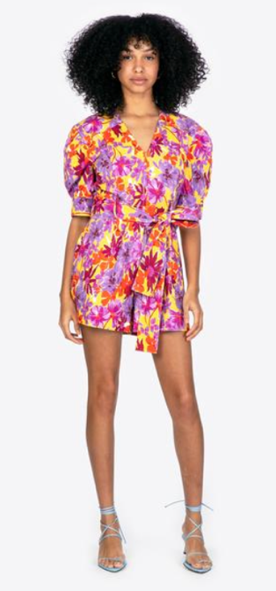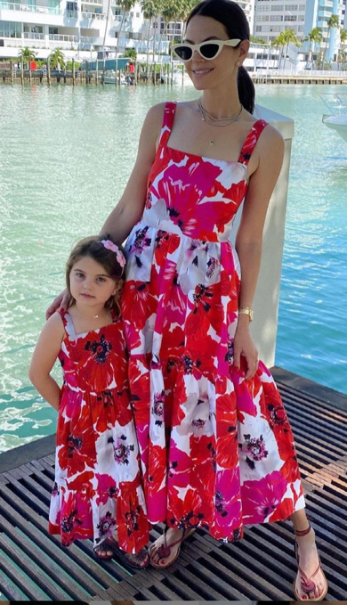
Figure 13| Tanya Taylor Figure 14|Tanya Taylor
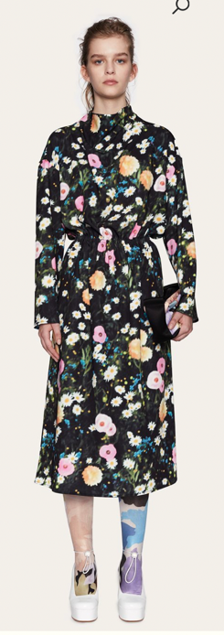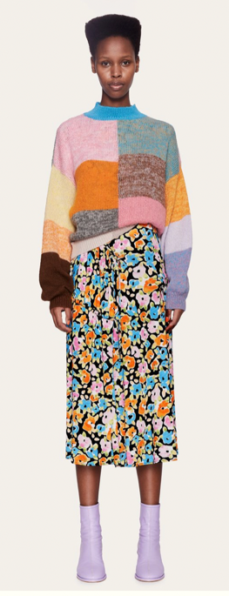
Figure 15| Stine Goya Studio Figure 16| Stine Goya Studio

Personally, I am in a position where I have to move from one house to the next as my contract ends in July, whereas most graduates find themselves moving back to their family homes. This increases the pressure to have a solid foundation by the time I graduate, therefore my exit strategy is to update and refine my website and CV to create a public digital portfolio, and a PDF portfolio to send via e-mail to accompany job applications or express interest in a brand before graduation.
I have started applying for entry-level jobs and paid internships, and developed a list of studios and companies that I would like to approach as I either feel that they align with the way that I work, or they have a good representation for working with graduates. These include Fairbairn and Wolf, &elle studio, Detour Design Studio, Karolina York Studio and revisiting RMJ Studio. I would also like to target trend-leaders such as WGSN and TrendBible to address my love for research. I feel that I have to approach employment from both an ambitious yet realistic angle.
I have had outreach from Rosie at RMJ Studio about working as a freelancer, but with the knowledge that I was still in education, this opportunity was not further discussed. I am hoping to contact her and pick this up again once I have graduated, with the hopes of contacting a variety of studios to do similar work if I do not find myself in regular full-time employment in the design sector. In May, when communicating with Rosie I was offered a trial of her new platform ‘Swatch Editor’ for visualisation purposes, and she confirmed that freelance work would be a possibility in the future.
Upon graduation, I will apply for roles within both the print design and trend forecasting industry. I have a formal presentation of trend research and print collections formulated for the brand Wacoal as part of an interview for a role in their head offices in early June. If this goes unsuccessfully, I intend to contact the aforementioned series of print design studios immediately with the premise of freelancing, or permanent work. My time working from home over the lockdown has allowed me to gain confidence in the possibility of working remotely as a freelancer. I would also like to re-work elements of my trend book to add more depth whilst remaining succinct, to contact trend-led agencies such as TrendBible to discuss career opportunities.
If unsuccessful within the industry, I have considered what other sectors would benefit my career ambitions. Working within the retail industry on the high-street would allow me to remain aware of trends, and introduce me to retail fashion giants within an employment role, whilst gaining confidence in a social environment.
I am aware that I will be in need of a role by the end of the summer at the latest, therefore this is a realistic target for me if initially unsuccessful – to garner a role in another sector whilst continuing to work on my ambitions.
I am interested in continuing to expand my etsy store to explore various surfaces for my work as a multi-purpose designer. This is a personal endeavour that is less reliant on others and my employability status, and still allows me creative freedom to explore my interests and apply them to products.

Critical Appraisal

My Creative Venture shows a breadth of digital and practical skills and knowledge, displayed through physical and virtual prints alongside research and trend analysis. The addition of this to my portfolio will heighten commercialisation, conceptualisation, digital skills and trend research, with the aim of formulating a well-rounded portfolio that does not appear disjointed.
My final trend book comprised of 56 pages of research and analysis, summarising my understanding of four trends and their relationship to my developmental work and final collection. I would like to carry the visual showcase of my research forward, with scope to expand each trend as the book ‘trendspot’ briefly glanced into each trend, rather than delved into the concept, visuals and multiple contexts that are available to explore.
To do this in an accessible format, I would like to create a blog or use a social media platform such as Instagram to keep myself engaged with current and future trends as a means to remain involved within the industry, despite the multiple possibilities of my employment outcomes. This would enable me to continue to utilise my skills and maintain a standard of work that was relevant and progressive.
I would also use my trend book as a means of a portfolio in itself, to display and discuss the research methods and process of my way of working. This would allow any potential employer to visualise my research methods and ability to encapsulate trends, whilst discussing my sources of inspiration: Patternbank, Textile View magazine and what I discover on the catwalk via the Vogue website. I would hope this would enable me to provide others with a better view of my abilities as a designer.
The formatting of my portfolio has allowed me to apply for print design roles whilst in a pandemic, despite my focus on materiality and physical work. I have secured a second stage interview using the portfolio created for my Creative Venture, alongside portfolio pages encompassing my third year final major project and the Patternbank live brief. I have found that I am able to speak of the importance of colour and a material focus, whilst showcasing the aid of my digital skills and portfolio to deliver my design identity in a verbal and visual format. I am able to show how I think and create conceptually, underpinned by an ability to deliver print suitable for commercialisation.
I have overcome a need to screen print as my intention for this year was to utilise the print room as much as possible – instead, I have utilised it whilst increasing my digital skills to become well-rounded and confident. Using hybridised processes I have been able to create a collection that is forward-thinking and trend-led, as I explore trans-seasonal concepts across multi-market ranges in the current climate, where discussions of expression and bold colouration are happening across upcoming trends for the years 21/22.
I have achieved a greater understanding of my abilities as a designer and which areas of a brief I feel most comfortable fulfilling digitally and physically, and how to communicate this. My love for colour and concept drives the authenticity within my practice and has a strong influence over each brief I complete.
I feel like I have fulfilled my aims as a designer with what I intended to do with my MDes year. The hybridised processes used within my collection allowed me to fulfil the playful elements of design, and what I enjoy: screen print, playful process creation and research, whilst heightening useful skills, specifically my digital skills. Having to work from home has broadened my skill set, and I feel more confident in creating prints using various processes and techniques.

Bibliography
Brown, C. (2020) Making with Glass. Internal UWTSD Lecture. Unpublished.
Classen, C. (2005) The Book of Touch. Berg Publishers.
Elhai, D. J., Levine, J. C., Dvorak, R. D. & Hall, B. J. (2016) 'Fear of missing out, need for touch, anxiety and depression are related to problematic smartphone use', Computers in Human Behaviour, 17 (03), Issue 63, pp. 509-516.
Mohdin, A. (2020) Rise in depression and anxiety day after UK lockdown announced - study. [Online]
Available at: https://www.theguardian.com/world/2020/mar/31/rise-in-depression-and-anxiety-day-after-uk-lockdown-announced-study-coronavirus
(Accessed 7 04 2021).
Premiere Vision (2020) The Star Duo of the SlS22 Season: Mauves-Oranges. [Online]
Available at: https://www.premierevision.com/en/magazine/the-star-duo-of-the-sls22-season-mauves-oranges/?
(Accessed 30 01 2021).
Shillingford, M. (2021) Does colour have the power to make life better? Society of Dyers and Colourists.
Premiere Vision (2021) S/S 22 Colour Decoding: Casual Wear. [Online]
Available at: www.premierevision.com/en/magazine/p-e-22-decryptage-couleurs-casual/
(Accessed 22 May 2021).

