
Reflective rewove of learning journey

Monika Ptrycja Owczarzak
20th June 2019
UNIVERSITY OF WALES TRINITY SAINT DAVID

This assignment is a reflecting review of leaning journey thought study to achieving or actually planning to ache set goal. During this work I will be using different methods and model in order to understand myself. Carrying on self-assessment thought SWOT analysis to recognize my strengths and weakness, setting my goal SMART and understanding that is never too late to GO MAD. I will be also speaking how to recognize personality and leaning style become more aware of who I am, what I really want in my life and how to achieve it.

At some point it comes to time that people make decisions about changes in the lives to improve its value for this purpose, I created a goal to become an accountant have made my career development plan. To do so I set myself the time line of three years to accomplish my goal. The first step of becoming accountant is right education in the subject witch is necessary to the job. University of wales trinity saint Davis gave me the opportunity to join the level 4 skills of work place course. Passing the first year with a good great I will be able to continue study and direct my education in the specific subject on second and third year. So far during the course very important information has been thought. To develop career self-awareness and conducting self-assessment is very important to become aware of who we are and what is our goal and that is the beginning of success. And the course is teaching us how to acknowledge your self-awareness. “Self-awareness is the first component of emotional intelligence-which makes sense when was consider that they're Delphic oracle gave the advice to “know thyself” thousands of years ago. self-awareness means having a deep understanding of one's emotions strengths weaknesses needs and drives.[….] people who have high degree of self-awareness recognize how their feeling affect them, other people, and their job performance” (Goleman, 2018) Self assessment is another very important factor thanks to which you can better get to know yourself and your own possibilities, because we can see our progress in study, and the awareness of our abilities and shortcomings will help us focus on correcting mistakes. To master self-awareness and carry on yourself self-assessment during my course I have lean many useful theory and analyses methods like SWOT, I knew how to make my ogle SMART, which leaning type I am, and how to make a difference to achieve what I desirer.

My first step to self-awareness is analysing, to see what I’m good at it what isn’t my strong side what are my advantages and recognizing what can threats my plans to do so I will be using SWOT analysis. The aim of the SWOT analysis is to define the strengths and weaknesses of a person and the op-port unities and threats. Having recognized these factors, strategies are created that can build on the strengths, eliminate the weaknesses, exploit the possibilities or counter the threats. The strengths and weaknesses are recognized by an inner assessment and by an external assessment of the possibilities and threats. (Dyson,2002)
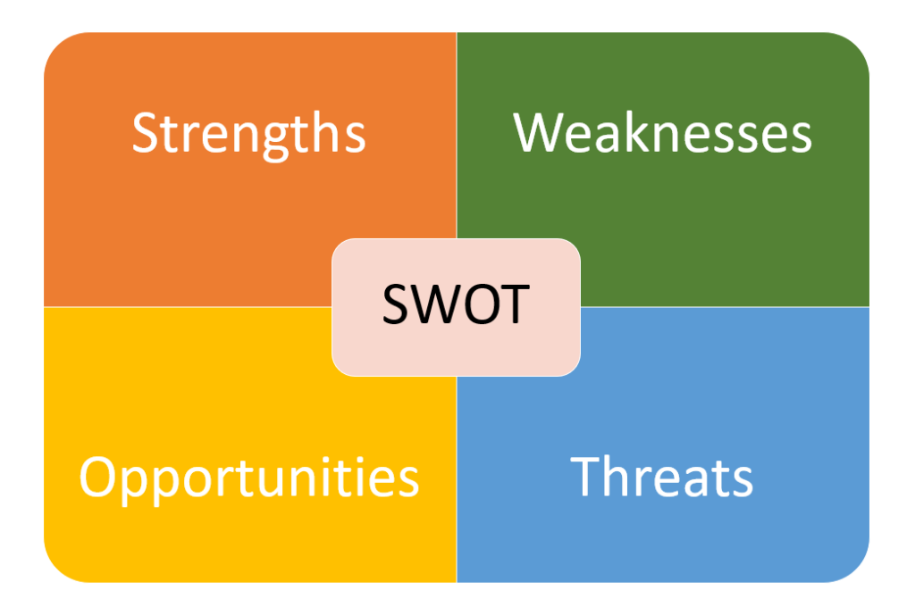
During the course we been showed how to conduct swot analysis on ourselves. According to my goal of becoming an accountnent I analogised myself through SWOT and based on this actual job and the outcome is:
-STRENGTHS: helpful, good with numbers, loyal, determinate to make change in my life.
-WEAKNESSES: not having right education, scared to take risk, overthinking, loosing motivation, not believing that I can manage to achieve my goal.
-OPPORTUNITIES: starting study at university of wales trinity saint Davis, many vacancies for accounting job, working hours are perfect to fit around child care and private life, good earnings.
-THREATS: language barrier, fear of not being able to finish my education, big competition on the market.
In order to archive ogle at first the goal has to be SMART during my classes I have learn how to set up my goal to make it SMART. The SMART expression and visualization tool show the basic methods needed to achieve enhanced motivation and increases the likelihood that our stated goal will actually be achieved. the main drivers of smart goal are (Rubin, 2002):
-Specific.
-Measurable
-Achievable.
-Relevant.
-Time Bound.
My specific goal is becoming an accountant, I will finish my education graduate with good score which will give the opportunity to get right job offer I will be measuring my progress thought passing subjects and knowledge about the job. My goal definitely is available with the right motivation and hard work. I have been finding accounting very interested for me, helping my partner to understand the process of his company taxes and understanding the proses very easy made me to realise that it can be my future job this why in 3 years’ time I will be finishing may education and starting my new career. (mindtools)

The next stop on my learning journey was GO M.A.D not exactly going mad but learn how to make difference. How to make difference in our life how to motivate and achieve our set goal. Go MAD model has been established by Andy Gilbert and Ian Chakravartyh is their purpose is "To improve the world through better thinking” The best way to GO MAD is through the framework they created (gomadthinking)

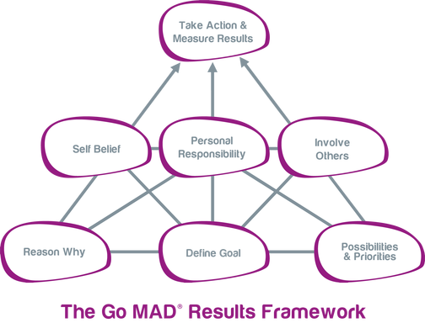
In order to make a difference I will be using Andy Gilbert and Ian Chakrvorty.
- My reason to become accountant is to give my child better future and support my partner
- Finishing my education to become an accountant
- Achieving a good score after first year will open my doors to continue my study in allocated subject, to get good results I need to dedicate more time to my study.
- I do believe that I have courage to change my life, I have the strength and motivation to do so!
- To execute my plan, I need organized child care so my son so I can attend to classes, I will be asking my partner and my best friend to look after him during my homework so I can focus on doing it
- I am responsible for ma actions I will make sure that I finish my education and get good job.
- I will measure my progress thought passing subject and the final will be sitting behind a desk in my office and earning good money.

Knowing your learning style is very important to recognize which way of leaning is best for you, which stimuli have a good and bad influence on your learning and acquiring information. During in classes exercise to become aware of which leaning style I am based on VARK leaning style. VARK learning style has been created by Nail Fleming and Ian Mills (1992) the name VARK means V for visual, A for Aural, R for Read/write and the last one K for Kinaesthetic. These are sensory modalities used to learn. To find out which one you are you can make an easy test, Fleming speaks about 16 questions which will revile the best way to learn for you. Conducting the test my score is 4 for Auditory and 9 for Kinaesthetic I pointed both here as I’m not really sure which is my style as I see myself more like Auditory a person in some aspects as I like to be involved in conversation I do speak very loud as well and I don’t like noise environment so for example to do my homework at library in quiet place or in the café I will definitely do it at the library, As I’m getting very easy to distract. I am finding easier to me if I say thing my way to understand better. But then I have many things from Kinaesthetic and my test came out with this result. True is that for me having an example is very important for me to learn(vark-lear.), “either through concrete personal experiences, examples, practice or simulation” (Fleming & Mills, 1992)

Experience new things will definitely be better remembered by me then reading about those things, but according to my research I find information that “Kinaesthetic and tactile learners tend not to be auditory learners.” (childeren1st, 2018)
As the Vark learning style left some question I did conduct another test to recognize myself better which Myers Briggs personality test was. The results of it comes to be ESFP which means I am extraverted, sensing, feeling and perceiving “Entertainers can chat for hours, sometimes about anything but the topic they meant to talk about, and share their loved ones’ emotions through good times and bad”(16personalities) in my personal opinion I think this describe me perfectly. I always trying to support people I love, and feeling are very important for me, I like to be in the centre party time going out is always a performance I want look good. I am enthusiastic, practical and observant but I’m also very sensitive easy to hurt and I have difficulties with Long-Term Planning which equerries lots of hard work form I’m if I really want me my goal to come though

Personal plan development is a structured method that impacts on your present training and results and is then formed into a strategy for your future private, academic and professional growth. Through conducting your own personal plan development, you will generally recognize your strengths, weaknesses, possibilities and threats and allow you to develop a plan that defines the best way to satisfy your growth needs through scheduled formal and informal operations. (professional academy)
During my classes I have learn many useful methods to recognise myself and as above I have recognized my strengths and weakness, I made my smart goal, which way of learning will be best for me. All those tools gave me to chance to create my personal development plan so I can make sure that I will bring my plan to life.

Development objective | Specific actions | Blockers and how they will be removed | Support required | How I will know when I have achieved the objective
1.Finishing skills of work place course in order to be able to study an accounting | -will make sure that I always attend to classes  -do my homework and submit all my assignments on time  - dedicate more time to study  - | - language barrier is one of blockers on my way to achieve my objective, to overcoming this barrier I will read more to improve my language skills  -not enough time to study as I have a little baby; I will need to organize extra day of nursery to concentrate on my study.  -looking motivation, to remove I will be always reminding myself why I’m doing this. | - will be asking my lectures question is something to clear for  - attending to student support group if I will have struggles with my study  - | I will be graduated with higher degree in 2022
2.working as an accountant | - I will finish my education with best score I can do to maximize my chances  -I will apply for the positions appropriate to my experience | -Poor CV,  -Not doing well on interview  - not enough experience to get the job | -Recaching and gather information about specific employer  -learn as much during my study so I will not have difficulty to for example make good CV | I will know that I achieved my objective when I will be seating in accounting office as employee

To conclude my learning journey, I can say that I have gather many important information to make a big different in to my life. During classes and thought writing this assignment I become more self-aware. Many useful tools have been taught to me. I have learned how to analyse my personality and how to affectively learn thought recognizing my leaning style. After using SWOT analysis, I can see better what my strengths are and how to use them, what are my weaknesses how to overcome them in order to achieve my SMART goal. And my goal is defiantly smart as fallow the main drives of smart go, I created me to be specific, measurable, achievable, relevant and time bounding.
I do believe that is never too late to make a difference in our life, having good motivation and believing in our strengths we can achieve what we planned, but is important to have the plan this why making a personal development plan is so important to execute set goal.

Bibliography:

-Child1st, Characteristics of Kinaesthetic and Tactile Learners (2018),
Available at:https://child1st.com/blogs/resources/113559047-16-characteristics-of-kinesthetic-and-tactile-learners, (accessed on 16.06.2019)

-Dyson, R. (2004) Strategic development and SWOT analysis at the University of Warwick, European Journal of Operational Research, 152, pp. 631-640
- Fleming, N.D. & Mills, C. (1992), pp. 140-141
-Goleman, D. et al. (2018), Self-Awareness (HBR Emotional Intelligence Series), Harvard Business Press
-Go mad thinking, Vision and Values, Available at: https://www.gomadthinking.com/about/our-vision-values/(acccesed on 17.06.2019)
-Mindtools, Golden Rules of Goal Setting, Available at: www.mindtools.com/pages/article/newHTE_90.htm, (accessed on 15.06.2019
-MindToolsVideos,(2014),Five Rules of Goal Setting: How to set SMART, Motivating Personal Goals[video] available at https://www.youtube.com/watch?time_continue=4&v=aVstw9HYl-o (acceded on 18.06.2019)

-Professional Academy, ADVICE ON CREATING AN EFFECTIVE PERSONAL DEVELOPMENT PLAN, Available at: https://www.professionalacademy.com/blogs-and-advice/-advice-on-creating-an-effective-personal-development-plan--free-template-,(acccesed on 19.06.2019)

-Rubin, S. (2002), Will the Real SMART Goals Please Stand Up? Robert S. Rubin Saint Louis University volume 39(4), pp.26-27

-Vark-Learn, Available at: http://vark-learn.com/introduction-to-vark/the-vark-modalities/ , (accessed on 16.06.2019)

-16 personalities, Entertainer, Available at: https://www.16personalities.com/esfp-personality, (accessed on 16.06.2019)

-Varklean, (2011), What is VARK?[video] available at https://www.youtube.com/watch?time_continue=94&v=Ji38aUS4w2w , (Accessed: 16.06.2019)

