Module: Marketing Essentials
Module code: BMIH4005 REWORK
Title: Travelodge Marketing Plan

Student ID Number: 2221000
Student name: Andreea-Mariana Stoican
University Name: University of Wales Trinity Saint Davis
Submission Date: 19/05/2023

Travelodge Marketing Plan
The essay puts forth a comprehensive marketing strategy for Travelodge, a hotel chain based in the United Kingdom. A comprehensive evaluation of the business environment will be undertaken, encompassing a SWOT analysis, competitor analysis, customer segmentation, and assessment of collaborative partnerships, with the aim of enhancing profitability, expanding the customer base, and fostering favourable brand perceptions. The proposed approach involves the utilisation of essential frameworks to organise the plan, which will provide direction for objectives, approaches, techniques, and implementation strategies. The evaluation of progress will be based on both quantitative and qualitative metrics.
Conducting a situational analysis is an essential component in the development of a marketing plan. Furthermore, the utilisation of a SWOT analysis (in Appendix 1) would prove to be a valuable instrument in the examination of the company.
The segmentation strategy of the company is centred on catering to the needs of both leisure and business travellers who prioritise convenience and cost-effectiveness. Travelodge caters to individuals and families seeking reasonably priced, conveniently situated lodgings that offer a comfortable stay (Kotler et al., 2014). The primary demographic focus of the company is individuals with limited financial means. The company's target demographic comprises individuals aged between 30 to 50 years, who seek serene and conventional lodging options (Hipwell, 2020). Additionally, the company also caters to couples and families. As per the business analysis and expansion plan of Travelodge, the organisation is situated as a mid-range hotel brand that provides reasonably priced and comfortable lodging alternatives. Premier Inn and Holiday Inn are categorised as budget-friendly lodging options, whereas Hilton, Marriott, and Mercure are considered to be more upscale accommodations (Siguaw and Enz, 2009). The Ibis brand is strategically positioned within the budget hotel segment. Premier Inn, Hilton, and Mercure were found to have received commendable ratings in terms of room quality, cleanliness, and value for money. In contrast, Novotel and Ibis were found to have obtained comparatively lower ratings in the aforementioned aspects. In Appendix 2, the Perceptual Map for Travelodge has demonstrated.
Travelodge has formed strategic alliances with various organisations to provide its customers with supplementary benefits and enhanced convenience. The company has established a partnership with SuperBreak to offer its clientele comprehensive package deals comprising lodging and recreational alternatives (HH, 2017). The aforementioned collaborations exemplify Travelodge's dedication towards offering a holistic customer experience through the utilisation of the competencies of other entities within the industry. Travelodge, a hospitality enterprise, has the capacity to perform a PESTLE analysis in order to recognise the political, economic, social, technological, legal, and environmental factors that have an impact on its business activities. Travelodge's workforce may be affected by alterations in immigration and labour laws and regulations from a political standpoint. From an economic standpoint, the company's profitability may be impacted by variations in both exchange rates and interest rates (Buttle et al., 2016). From a social standpoint, Travelodge ought to contemplate modifying its approach to account for evolving customer preferences and expectations, including the growing desire for sustainable tourism. Travelodge has the potential to improve customer experience through the implementation of digital solutions. Travelodge is obligated to adhere to legal statutes and guidelines pertaining to employment, data confidentiality, and safety (‌George, 2021). Travelodge faces both challenges and opportunities stemming from environmental factors such as climate change and natural disasters. The implementation of sustainability measures, including energy-efficient practices and waste management, is imperative for the company to mitigate its environmental impact. Travelodge's operations are influenced by legal factors, including but not limited to health and safety regulations, employment laws, and data protection requirements (‌George, 2021). Adherence to these regulations is imperative in upholding the organization's standing and circumventing legal complications.
The objective is to achieve a 20% increase in online bookings over the next year for Travelodge, a company operating in the competitive hospitality industry. This will be accomplished through the implementation of targeted digital marketing campaigns, website optimisation, and strategic partnerships. The expected outcomes of this initiative include higher occupancy rates, improved revenue, and enhanced brand visibility (‌Tesseras, 2015).
Travelodge may create a new value proposition to address the issues and recover consumer trust if it wishes to change its brand reputation in response to the negative evaluations it has received (Jovanov, 2015). For strategic purposes, Travelodge may make use of a tool called Ansoff's matrix. Within the current cheap hotel industry, Travelodge may concentrate on enhancing the reputation of the brand. To set oneself apart from the competition and improve its standing, Travelodge may want to provide fresh offerings (Cunill, 2006). Travelodge might reach a larger audience if it marketed to other types of customers or opened hotels in different parts of the world. Travelodge, in a more daring move, could expand its services beyond low-cost motels.

A strategy plan using the RACE (Reach, Act, Convert, Engage) framework may be undertaken to solve the difficulties highlighted in the situational analysis and enhance Travelodge's communications. Use digital advertising strategies that are specifically tailored to the demographics of Travelodge's ideal consumer (Wu, 2021). Use search engine optimisation (SEO) and sponsored search advertising to boost your site's presence online. Boost business awareness and foster customer relationships with social media advertising. Optimise the hotel's website and landing pages to provide a better experience for visitors and prompt them to do the desired action, whether it making a reservation or signing up for a special offer (Jovanov, 2015). Use appealing and convincing information like customer testimonials and USPs to get people to book at Travelodge instead of a rival. Make it simple for site visitors to take action by including call-to-action buttons and forms. Make the online booking procedure easier to follow by removing as many obstacles as possible. Initiate retargeting efforts to get back in touch with site visitors who indicated interest but did not make a reservation. Grow Travelodge's following on social media so that the company can better interact with its consumers, address their concerns, and improve its reputation (Wu, 2021). Analysing Travelodge's present communications require looking at how well they are doing on various platforms, such as social media, emails, and Similarweb. Find places where you can make enhancements, such as: Inconsistent social media consumer involvement and connection (Travelodge, 2022). Low open and clickthrough rates are a direct outcome of ineffective email marketing practices, such as using generic or irrelevant content. Missed chances to communicate with customers and get feedback due to a lack of visibility on major review sites and directories.
The objectives of Travelodge's marketing plan include boosting recognition, encouraging more reservations, and encouraging a more favourable outlook on the company (Travelodge, 2019). The marketing campaign will use both online and offline methods to spread its message far and wide. SEO and SEM are used to boost search engine rankings, while social media ads, display ads, and email marketing are used to spread the word about sales and promotions.

Gantt Chart: (Author)
The marketing channels schedule of Travelodge has been formulated with the aim of augmenting brand recognition, stimulating reservations, and cultivating favourable dispositions towards the brand (George, 2021). The marketing strategy devised for Travelodge will comprise a social media initiative, focused email marketing, content generation, market analysis, and a customer retention scheme.
As per a report published by Insider in 2019, Travelodge has set its sights on gauging its achievements by prioritising the acquisition of fresh clientele and augmenting its financial gains. The hotel chain has demonstrated success in this aspect, as evidenced by its reported growth in revenue and profits (Bell, 2023). According to Peter Gowers, the Chief Executive of Travelodge, the company aims to establish itself as the preferred hotel for value in the United Kingdom. To achieve this objective, Travelodge plans to allocate £100 million towards the renovation of its current hotels and the establishment of new ones in strategic locations throughout the nation.
The present marketing strategy for Travelodge, a prominent hotel chain in the United Kingdom, endeavours to enhance revenue generation, entice fresh clientele, and enhance brand image (Barkauskas et al., 2015). The proposed strategy commences with a thorough evaluation of the current circumstances, encompassing a SWOT analysis, customer segmentation, competitor analysis, and scrutiny of its partners. The marketing mix is assessed and a strategic approach is formulated through the utilisation of Bowman's strategic clock.

References
Barkauskas, V., Barkauskienė, K., and Jasinskas, E., 2015. Analysis of macro environmental factors influencing the development of rural tourism: Lithuanian case. Procedia-Social and Behavioral Sciences, 213, 167-172.
Bell, L., 2023. The UK’s best and worst hotel chains - Which? [online] Which? Available at: https://www.which.co.uk/reviews/uk-hotel-chains/article/best-and-worst-uk-hotel-chains-aaVVF4u1jZpe [Accessed 19 May 2023].
Buttle, F., Bowie, D., Brookes, M., and Mariussen, A., 2016. Hospitality marketing. Routledge.
Cunill, O.M., 2006. The growth strategies of hotel chains: Best business practices by leading companies. Routledge.
George, R., 2021. Market Segmentation, Targeting, and Positioning. In Marketing Tourism and Hospitality: Concepts and Cases (pp. 221-246). Cham: Springer International Publishing.
‌George, R., 2021. The Tourism and Hospitality Marketing Environment. In Marketing Tourism and Hospitality: Concepts and Cases (pp. 183-219). Cham: Springer International Publishing.
HH, 2017. Travelodge: Comprehensive Business Analysis and International Expansion Plan. [online] ToughNickel. Available at: https://toughnickel.com/industries/Travelodge- Comprehensive-Business-Analysis-and-International-Expansion-Plan [Accessed 19 May 2023].
Hipwell, D., 2020. Travelodge Hotels May Be Under Threat From Rival. [online] Bloomberg.com. Available at: https://www.bloomberg.com/news/articles/2020-07- 11/travelodge-hotels-under-threat-from-rival-telegraph-reports [Accessed 19 May 2023].
Jovanov, T., 2015. Principles of marketing: Setting goals and marketing strategies.
Kotler, P., Bowen, J.T., Makens, J.C. and Baloglu, S., 2014. Marketing for hospitality and tourism.
Siguaw, J.A. and Enz, C.A., 2009. Best practices in marketing. Cornell Hotel and Restaurant Administration Quarterly, 40(5), pp.31-43.
‌Tesseras, L., 2015. Travelodge CEO on its £25m push to target ‘value seekers’. [online] Marketing Week. Available at: https://www.marketingweek.com/travelodge-ceo-on-its-25m-push-to-target-value-seekers/ [Accessed 19 May 2023].
Travelodge, 2019. Affiliate programme - Travelodge. [online] Available at: https://www.travelodge.co.uk/about/affiliate-programme/ [Accessed 19 May 2023].
‌Travelodge, 2022. Our company - Travelodge. [online] Available at: https://www.travelodge.co.uk/about/our-company/ [Accessed 19 May 2023].
Wu, S.Y., 2021. A Study on Promotion Strategies and Purchase Intention during the epidemic situation-In the Travelodge Industry.

Appendix 1: SWOT

Figure 1 SWOT analysis of Travelodge / Source: (Author)

Appendix 2: Perceptual Map for Travelodge
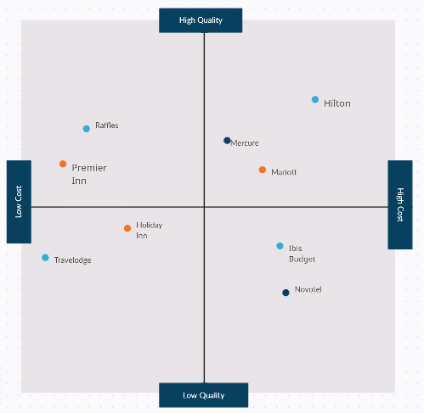
Figure 2 Perceptual Map for Travelodge / Source: (Author)

Appendix 3: Power-point Presentation
Slide 1
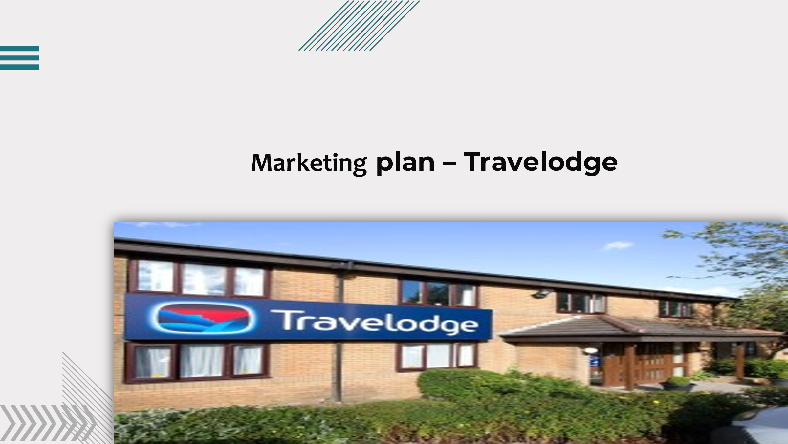
Slide 2
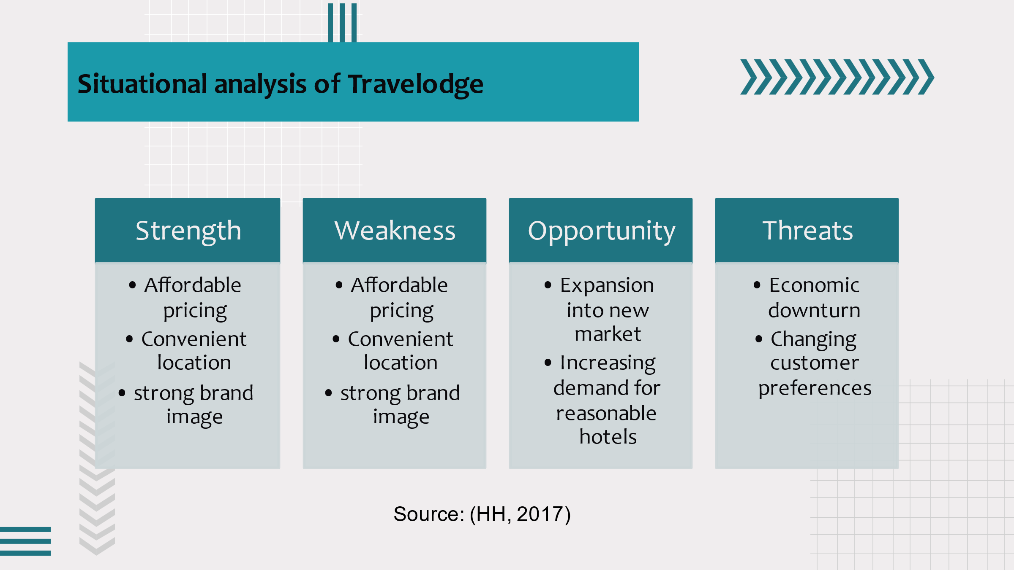
Slide 3
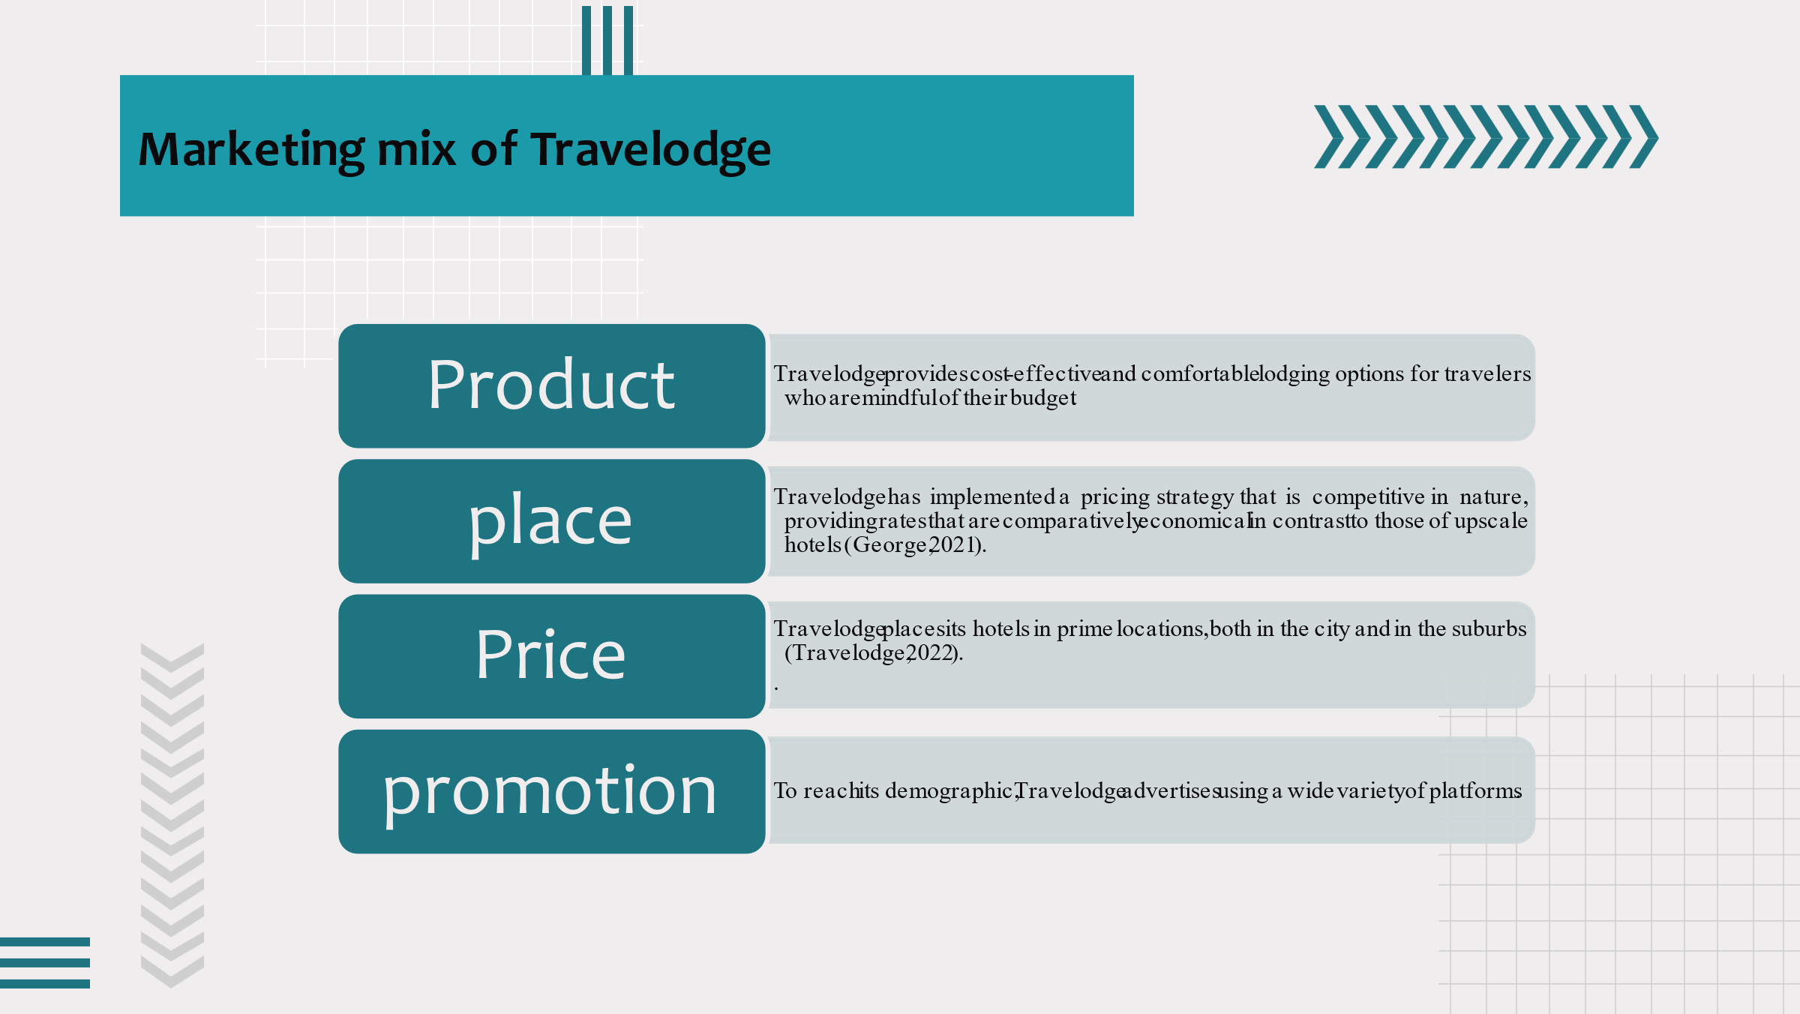
Slide 4
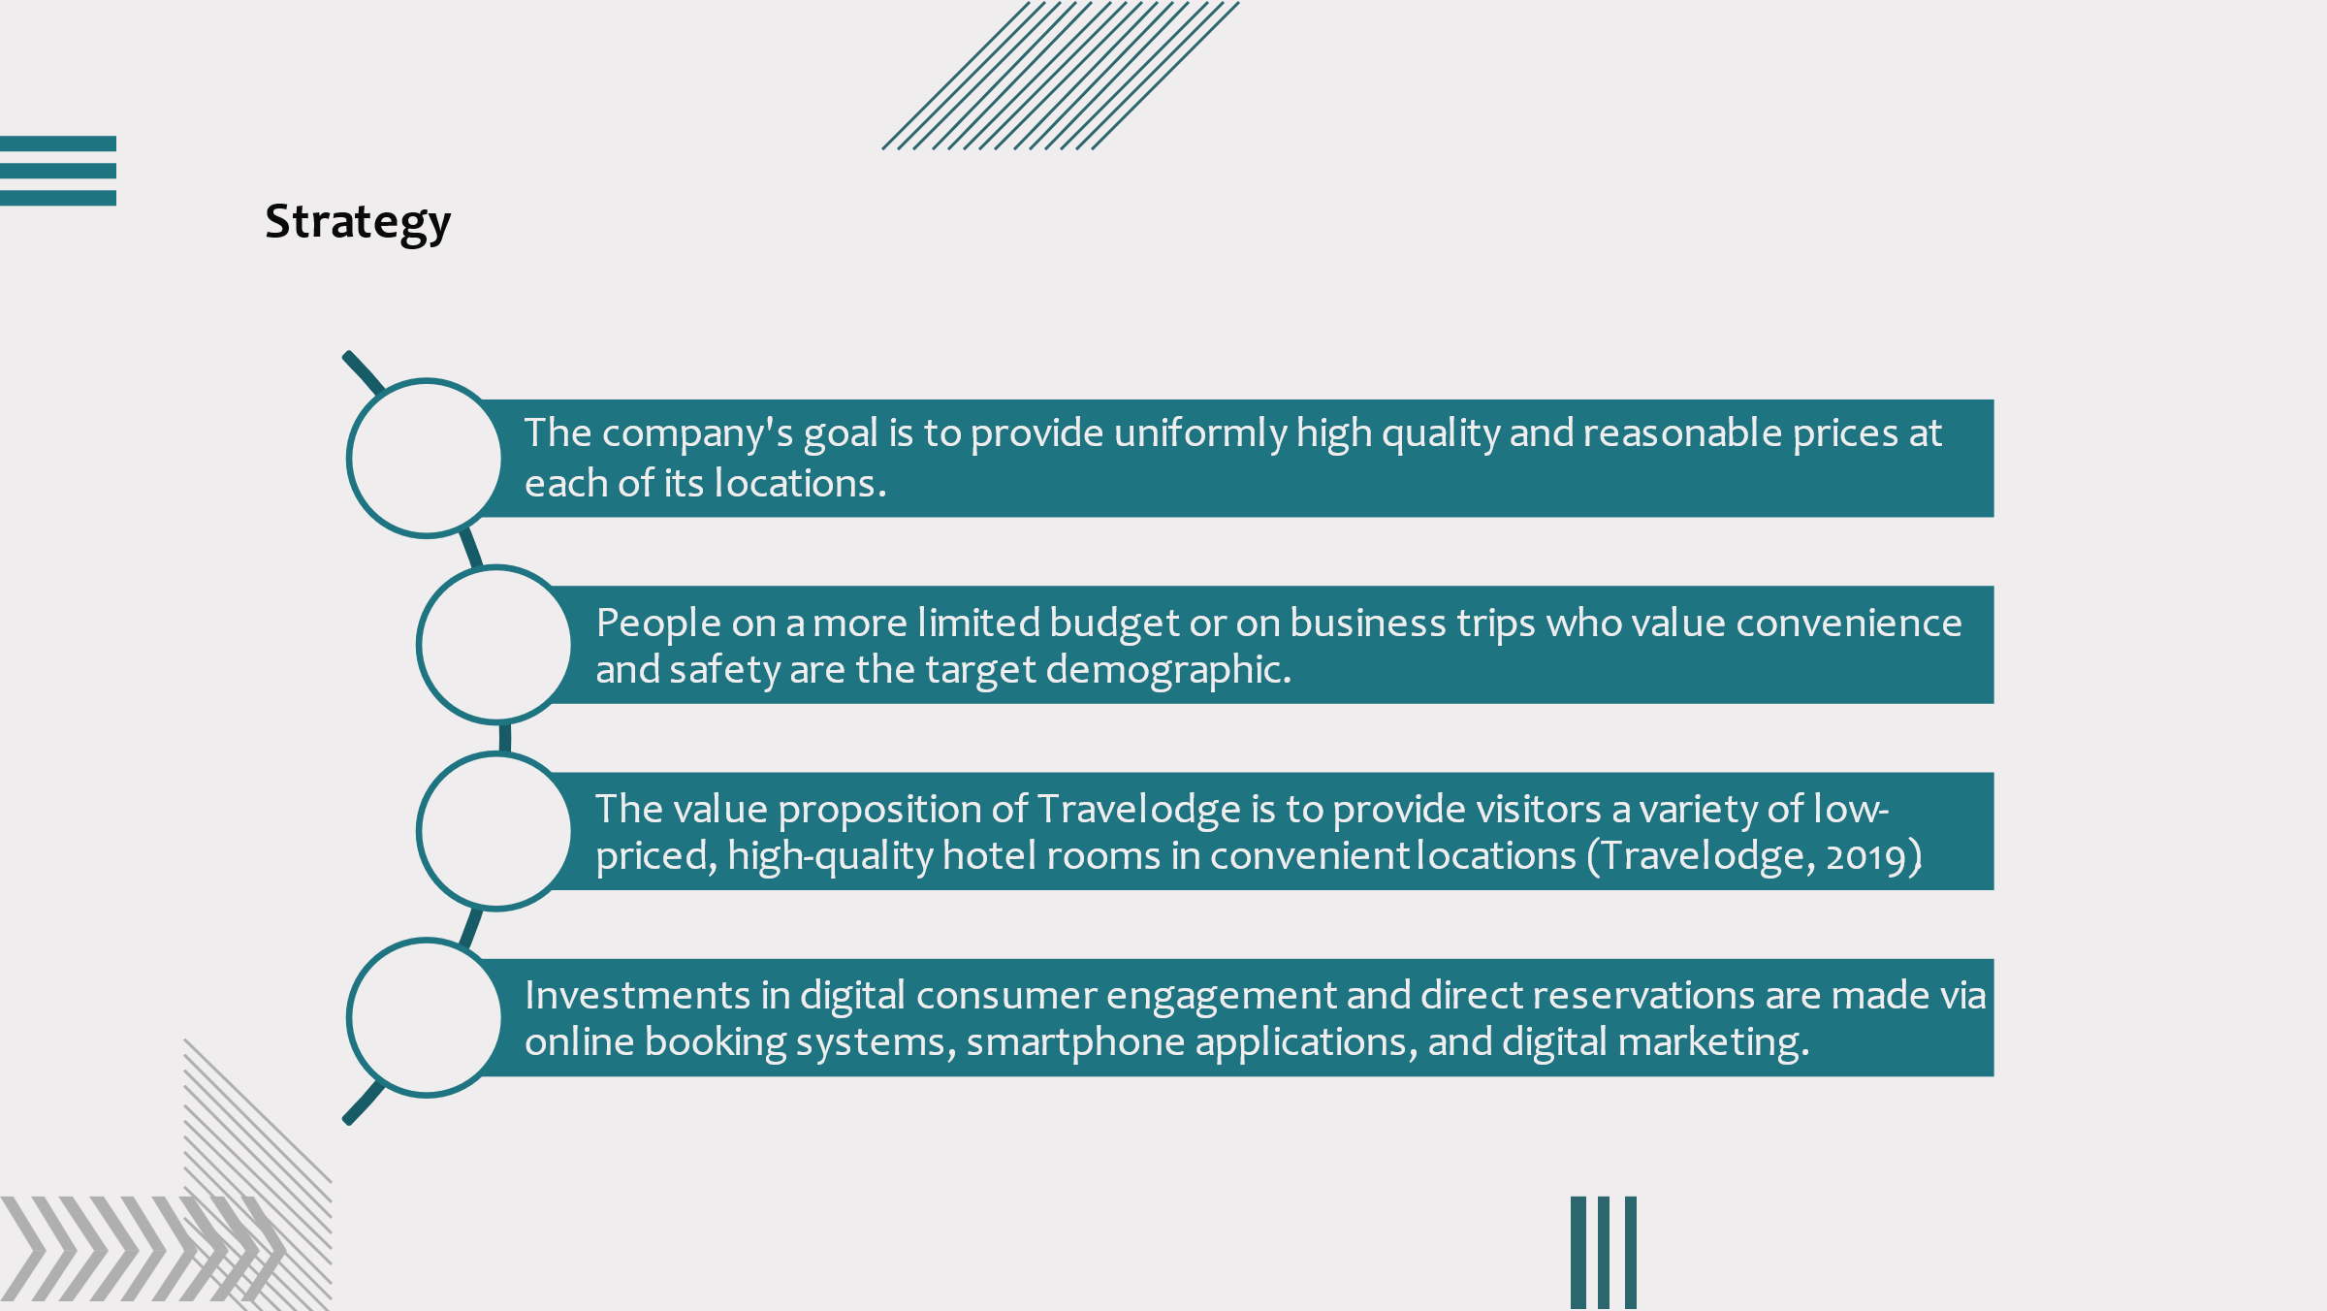
Slide 5
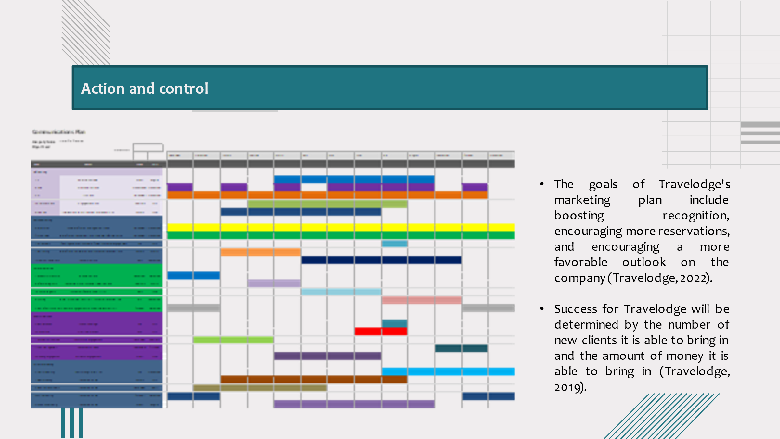
Slide 6
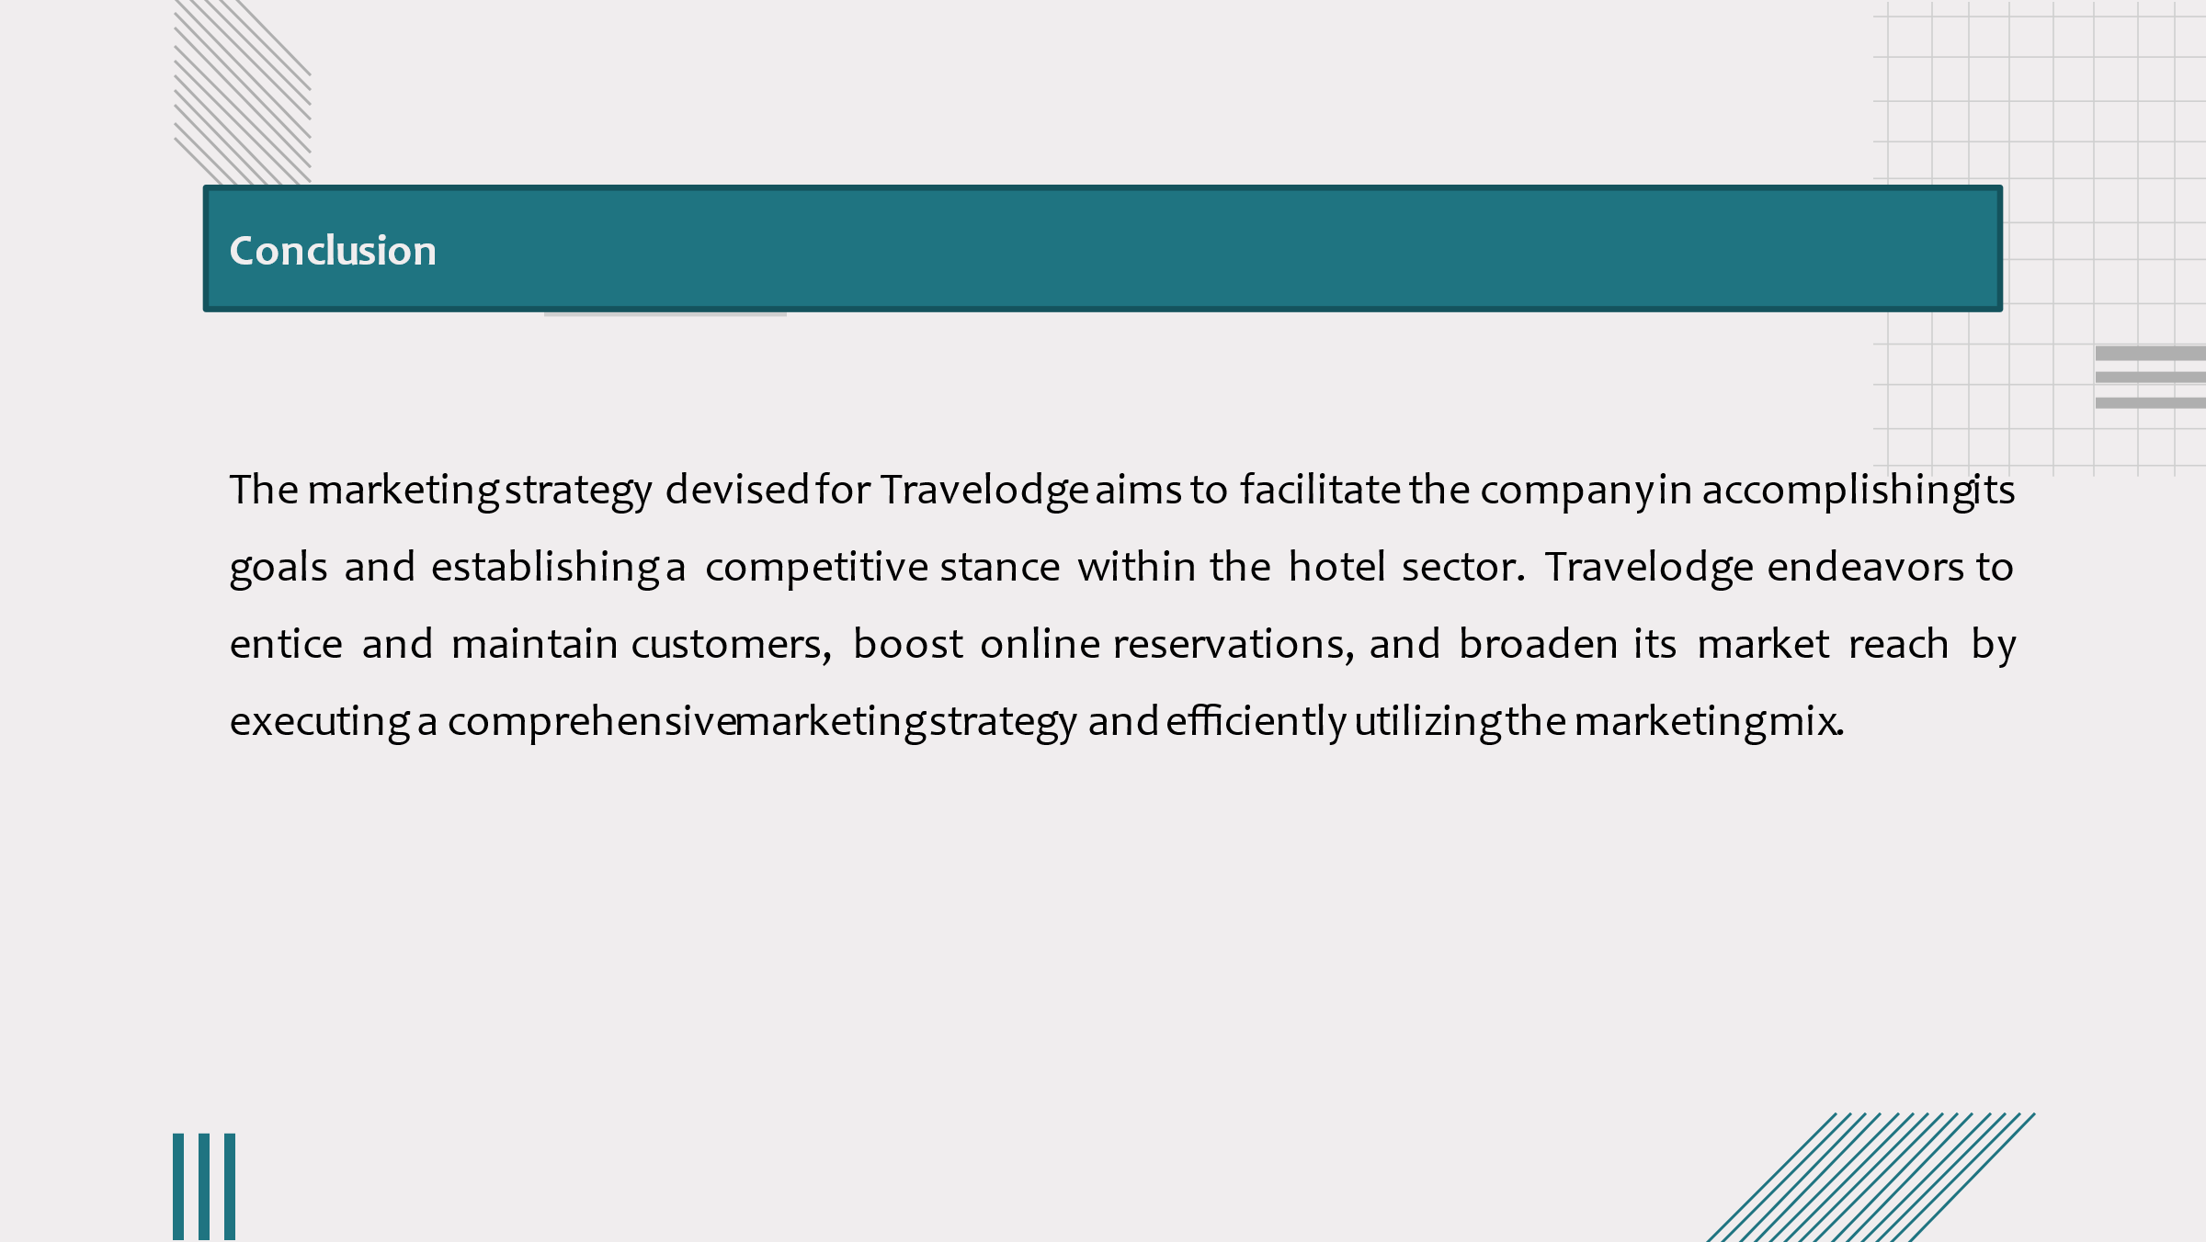
Slide 7
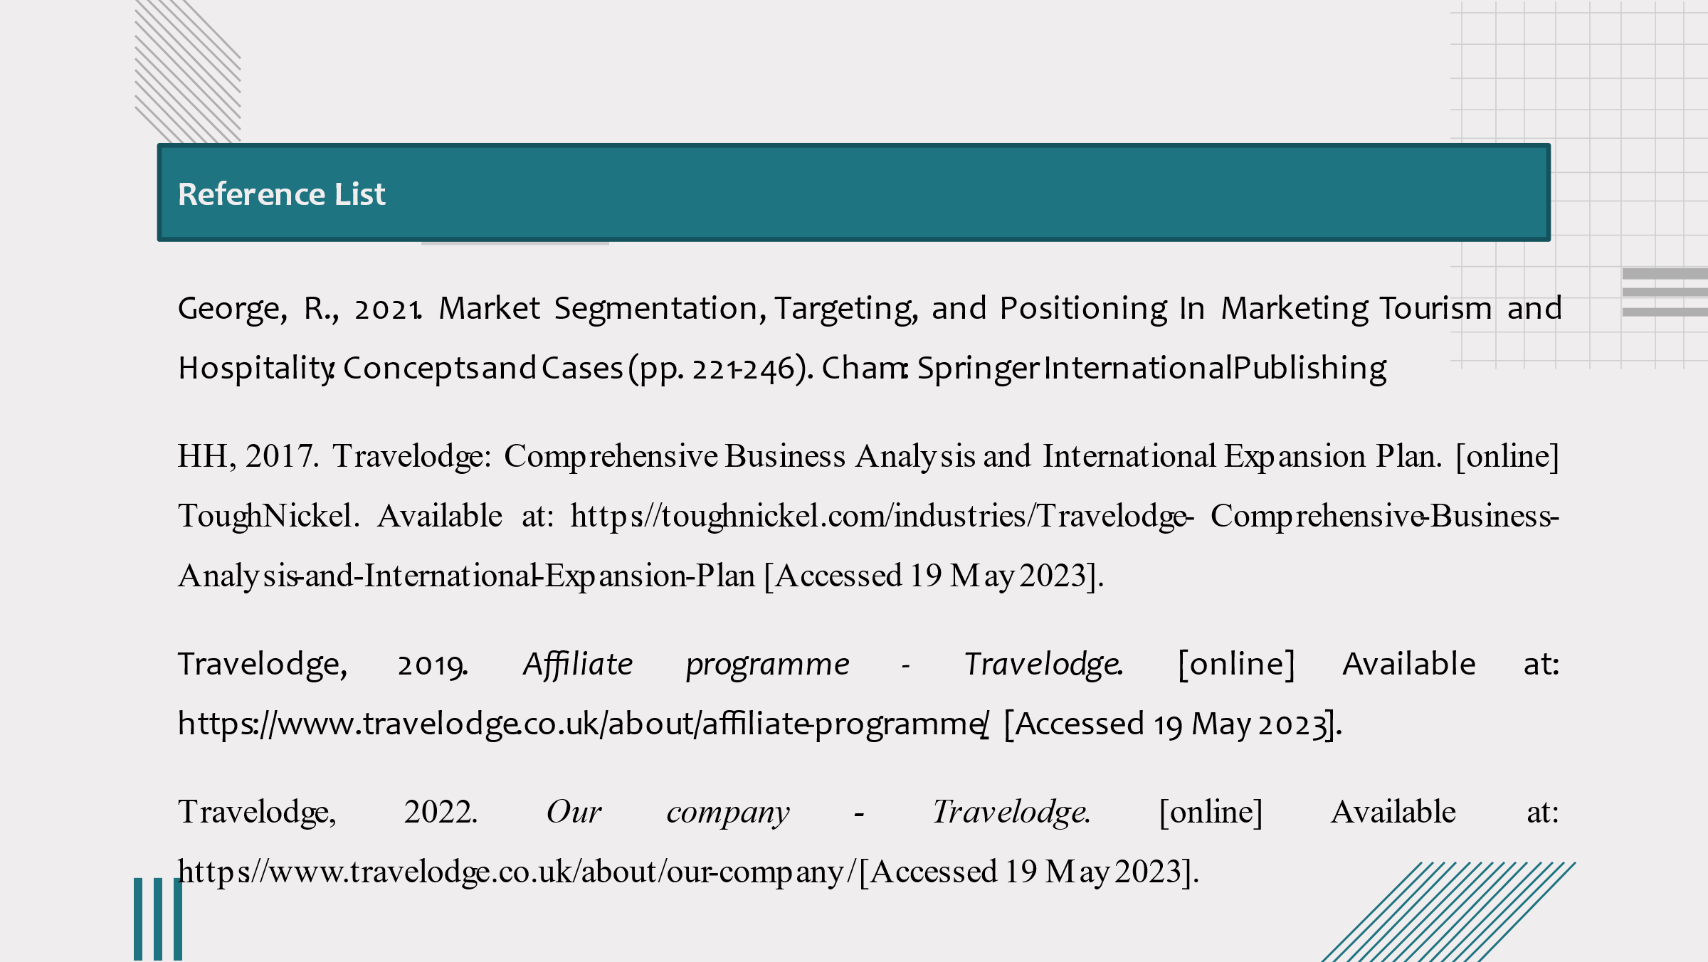
Slide 8


