
Student Name: Lauren Buckley
Student Number: 1707395
Course: Inclusive Education
Module: Classroom Management: Resource Pack
SJIE6005

Contents

Rationale 3 - 8
Instructions 9
Appendices 10 - 15
References 16 - 18

‘If you are looking for reasons behind student disengagement, then it maybe helpful to consider the teaching techniques that are being applied in classrooms’ (Earl,2017). As stated by TES, a study conducted in 2017 underlined the influencing factors which cause poor attainment, lack of concentration, general classroom disruption observed by supply teachers. The findings presented clear evidence which indicates teacher expectations are considerably higher than what pupil’s consider achievable without support from a specialised practitioner. It has been voiced that students who felt incapable of meeting set goals were less enthusiastic, withdrawn from learning and appeared to display problematic behaviour which in turn negatively impacted pupil capability and attention. To secure student participation teachers must prepare students with an overview of subject content, the lesson objective, discuss its relevance to curriculum and provide ample opportunity to activate prior knowledge with the aim to expand their understanding (Earl, 2017).
Active learning is an umbrella term for learning and teaching methods which put the student in charge of their own learning through meaningful activities. They think about and apply what they are learning, in a deliberate contrast to passive learning (Leicester University, 2020).

Active learning was first recognised by Bonwell & Eison (1991, p.2) who believed ‘anything that involves students in doing things and thinking about things they are doing’ can boost pupil knowledge, sustain a positive classroom environment. Active learning can be broken down into two separate categories doing and thinking. Within this rationale I aim to directly focus on pupils actively participating in a more vocal and physical context. There is sufficient evidence which reinforces that children achieve greater when classrooms provide high levels of classroom discussion. Activities such as classroom discussion, debate, creating thought showers provide opportunity for students to apply their existing knowledge, recall ideas, analyse and synthesize ideas, negotiate with peers to create new, reformed ideas. Jean Piaget (1952) a constructivist theorist played a vital role in shaping our understanding of cognitive development. He stressed that ‘knowledge was no longer seen as something to be transmitted passively to children, but rather was actively constructed by children themselves through hands on and concrete experiences’ (Pope-Edwards, 2002, p148). Piaget claimed, for students to develop and progress to their maximum potential teachers should develop a more modernised teaching method based on high levels of interaction, ensuring lessons are highly stimulating and motivating. Piaget believed that a child’s development and learning can be majorly influenced by others around them. ‘A key component of that role involved observing and guiding children to build their own knowledge’ (Halpenny and Pettersen, 2014, p.149). Therefore, teachers must strive to become the facilitator rather than previous lecturing methods to ensure they create a learning environment adequate to guide and shape their future generations success. They must provide appropriate scaffolding tools, models of learning, additional learning materials, instigate conversation, encourage questioning to enhance the students understanding. Piaget’s modern approach has significantly encouraged the evolution of a child centred approach. His pedological concept transformed our understanding of how pupil’s play a vital role in their own development. He states failing to provide stimulating learning experiences maybe detrimental to their future success. As acknowledged by Halpenny and Pettersen (2014, p.150) Hayes states:
Such pedagogy presumes that all minds are capable of holding ideas and beliefs: and through discussion and interaction, it can be moved towards some shared frame of reference and is child-sensitive, less patronising and more respectful of children’s role in their own development.

Discussion can be utilized to maximize growth and development in both a social and emotional context for all abilities of learners. This flexible tool was recognised by a social constructivist theorist Vygotsky (1962) who believed that this simple resource could not only improve pupil attainment but also narrow the gap between learners whilst also positively impacting behaviour. Just like Piaget and other theorists like Bruner (1980) Vygotsky placed emphasis on language as the root to all learning achievements. As acknowledged by Browne (2007, p.44)
The most sustained and productive conversations come from pairs of children working together. In these situations, children exchange and develop ideas. They often listen to each other and build on each other’s suggestions.

As noted by Bruner (1980) it is important that we allow children to converse with other students when completing an interactive activity led by a teacher as their conversations tend to have a lasting effect on their ability to retain what is being taught to them (Brown, 2007).
Just like Browne, Goodwin cited in The Literate Classroom, Laycock (2011, p.25) states ‘Vygotsky showed that essential elements in learning are social and collaborative where learners are enabled to attempt things that are beyond their current developmental stage’. By working with peers more knowledgeable that them this allows the student to access information they would not master alone. Through effective support from others in the class along with scaffolding tools and guidance from the teacher the individual student will become more independently competent and distinguish individualised learning strategies to reach their potential goals.

Learning can be damaging if the work set is not accessible to a range of abilities, dull or repetitive. Responding to students’ diverse needs means teaching styles must motivate but also vary to reflect the level of abilities of all students within the classroom. To enhance learning outcomes for all pupil’s, teachers may integrate a range of scaffolding tools such as auditory, visual aids, kinaesthetic tools to achieve this whilst also making sure the topic content is interesting. As part of the resource pack I have created several short tasks with the aim to keep the students engaged and prevent any unwanted behavioural issues occurring. As cited by Browne (2007, p.121) Braine states teachers ‘may design shorter tasks for children who find it difficult to concentrate or more open-ended tasks or complex tasks for more able children’ to ensure that optimum progression is achieved. With a selection of different activities requiring a range of skills this is intended to allow ample opportunity for all children to have their moment to shine but also to have moments whereby they lend support to one another.

The reformed national curriculum expected to be introduced by 2022 provides an overview of good practice, main aims and states the fundamental skills teachers must encompass during their teaching to optimize attainment. Donaldson (2015.p.65) states good teachers must have:
Subject and methodological expertise; sound classroom skills; an understanding of the social and psychological factors that influence learning; the ability to excite and inspire children to want to learn and be able to learn independently.

Just like Piaget, Donaldson highlights the importance of pedagogy, activities set to activate a wide range of skills in order to form clearer understanding of the topic. He believed that students should have opportunities to establish connections between new and previously studied ideas to ensure students gain a rich, well-rounded education, built of skills which are transferable across all areas of learning and beyond the classroom. Donaldson’s Successful Futures report maintains the same perspective as the constructivist approach that students excel when provided with highly stimulating activities built on a social platform of opportunity. (See appendices) Here you can see the vibrant, informative PowerPoint I have devised to support the Humanities lesson based on Tourism. Children are expected to work through the activities outlined in the instructions within small groups following the direction provided by the teacher through a series of tailored, motivational, speaking and listening tasks.

Bloom’s Taxonomy is a framework established in 1956 by Benjamin Bloom, an American educational psychologist. This model was designed with the same purpose as Maslow’s Hierarchy of Needs pyramid to depict the child’s level of cognitive thinking in stages. There are 6 hierarchical classifications; knowledge, comprehension, application, analysis, synthesis and evaluation (Persaud, 2018). It is presumed that each child would automatically progress through the stages as they mature. However, this is not always the case. For some socially disadvantaged students their ability to engage in conversation is limited. Bloom’s believed that in order for these individuals to enhance into greater cognitive functioning, teachers could assist by facilitating effective questioning and discussion. Within the resource pack I have intentionally used various types of questions and sentence starters to deepen the learning experience. Hook questions entice the student to remain focused, motivated and in control of their own learning experience. As encouraged by Bloom, diagnostic questioning is utilized during the lesson objective to explain the success criteria, provide an outline of the set tasks and encourage students to activate their prior knowledge before attempting new schemas. Writing a prediction is created for cause and effect; to get students more able to perform higher levels of thinking, critically analyse and infer from the source provided (Michigan Virtual, 2017). Bloom’s Taxonomy framework has been successfully utilized within School A’s Teaching & Learning Policy to enhance pupil attainment, boost higher order thinking and record progression. They state this will ‘allow pupils to develop and practice higher order thinking skills such as creativity, analysis, problem solving, decision making and application’.

Even after creating a well-planned lesson the teacher must ensure that clear discussion boundaries are formed to prevent escalation of unnecessary noise. By creating a set of rules in partnership with the students not only can we achieve discussion etiquette; getting students to respect other views, take turns to voice opinions but also, they can be referred to when behaviour declines. This simple classroom management tool can positively impact the learning environment and remind students to respect one another and develop inner self-discipline. William Glasser, an American psychiatrist (1998) published extensive work on behavioural psychology and educational techniques to provide an overview on how people behave and what can motivate them to proceed in a positive manner. His Choice Theory highlights ‘there is one thing that we can offer to other people in an attempt to influence their behaviour is information, allowing other people to make their own choices’ (Health Research Funding, 2020). Guided learning provides scope for individuals to take an independent attitude towards learning and take responsibility for their achievements.

Another aspect which can impact an interactive lesson is the teacher’s position in the classroom. It is evident when observing good practice that when teacher’s expect children to take control of their learning, working in collaboration with peers under their supervision, the teacher must not stand at the front of the class as this can sometimes add confusion and translate as a passive teaching method. In order to facilitate a guided learning approach, the teacher should intermingle through the class, occasionally taking a seat with a group to provoke a questioning response, take a backward position within the classroom so that students acknowledge they are leading the activity.

To form a clear judgement on how successful a lesson has been, track progression and identify if the tools used to support the learning experience has positively impacted the students, we can look at the children’s commitment to the tasks set and observe the behaviour demonstrated by the students. Another way of tracking and monitoring pupil involvement is creating a plenary to question their understanding. A quiz was added to the final stage of the lesson to create data analysis of student input and knowledge which would then highlight to the teacher any discrepancies in the understanding which could be recapped in the follow up session. This process of recapping can ensure the information is retained and the learner can utilize the skills learnt in other lessons.

One of the only criticisms was that not all children have the confidence, self-esteem to actively take part in a speaking and listening task. For the minority of the class, those with additional learning needs or poor social skills due to a disadvantaged upbringing this could present a huge barrier to their learning. For these individuals who maybe at crisis point, lacking the social and emotional capabilities others have, anxiously awaiting their turn to speak this may result in the child becoming disengaged, acting out with inappropriate behaviours, failing to meet the learning objective, resist involvement or become the ‘class clown’. To prevent unnecessary issues unfolding, teachers must consider the dynamics of the students working in collaboration. By evenly distributing the class whereby more knowledgeable students are placed with students lacking confidence or understanding this will hopefully encourage the weaker students to imitate their peers’ behaviours, question their current understanding and retain information provided by others. Failure to do so could result in the individual feeling overwhelmed, drowning in information and through lack of support could cause the child to act out or display a negative perspective on learning. This academic failure, rejection from others could lead to further issues of poor mental health, frustration, low self-worth if the teacher ignores the signs of distress. To support these individuals with additional learning needs visual aids have been created to frame the learning tasks. However, these heavily structured learning tools can negatively impact progression, hinder individuality in relation to writing skills and stifle creativity of the high achievers. Therefore, teachers must cater for all abilities when preparing a lesson, encourage those able to form predictions, make associations, evaluate their findings to advance into higher level of thinking.

Instructions.

- Open the PowerPoint and click on slide 2- RECAP the impacts of tourism. Please provide time for students to activate prior knowledge by discussing with peers on their table. Slide 3 contains questions related to the images.
- Provide sort card activity to each table and ask them to place them in the appropriate column. Once this is completed, using the hand worksheet get students to place the comments in the appropriate hand.
- See slide 5- Discuss the learning objective.
- Get students to write a prediction.
- Press play on the hyperlink on slide 6 and get students to create a mind map of ideas based on the video.
- See slide 7- complete the Sustainable Tourism statement in books and write down 3 ways to achieve this.
- Discuss slide 8 and using the active white board complete the statements as a class. Provide students a worksheet to copy the reasons from the board and stick in their books. Students will use this for follow up activity next lesson.
- Plenary- quiz
- Lesson 3- Using the information learnt in prior lesson children will work in groups of 6 to create their own sustainable company. ALN pupils will be provided with a writing frame to aid this.

Appendices
PowerPoint

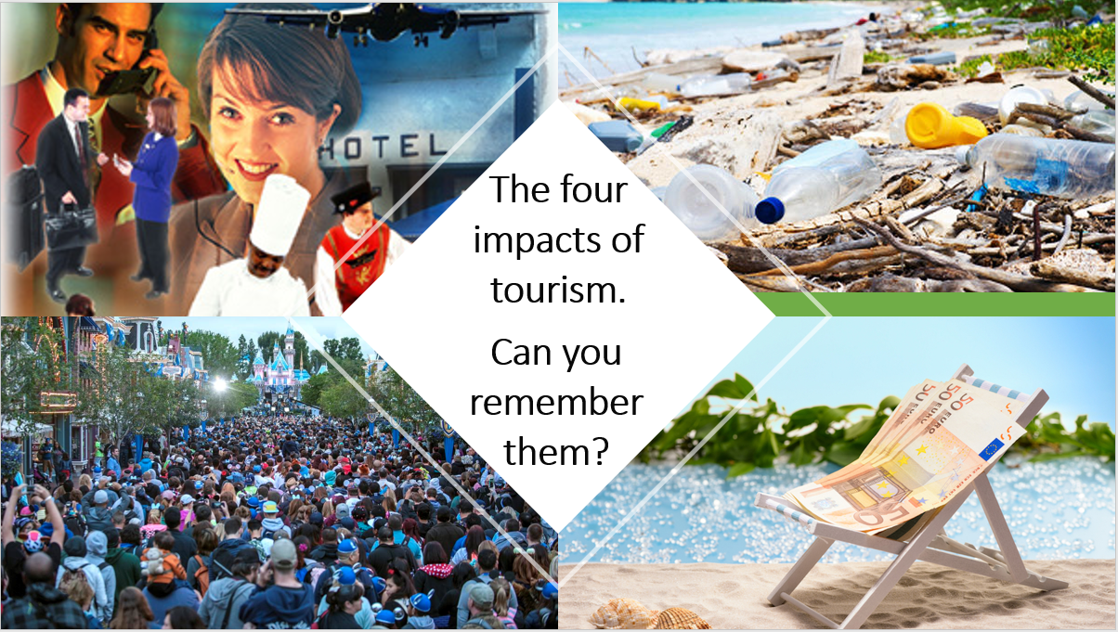
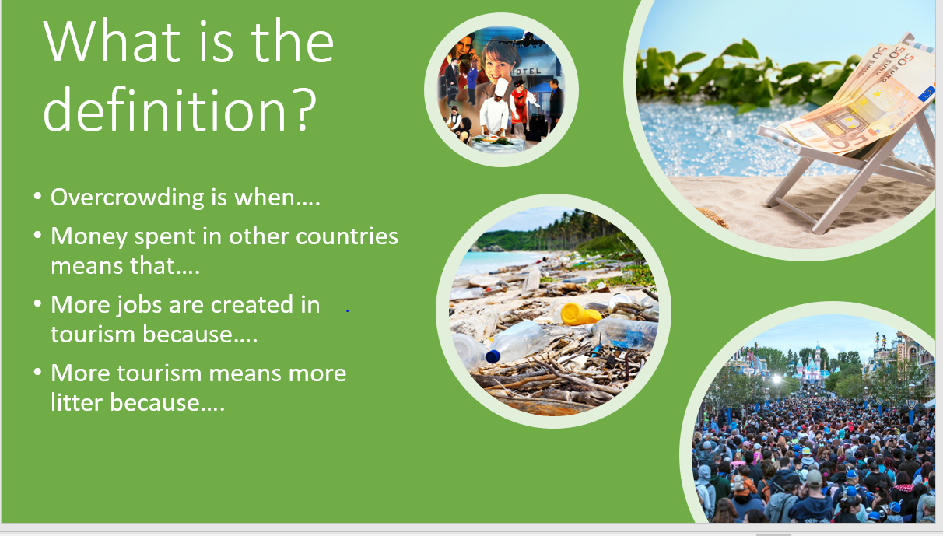
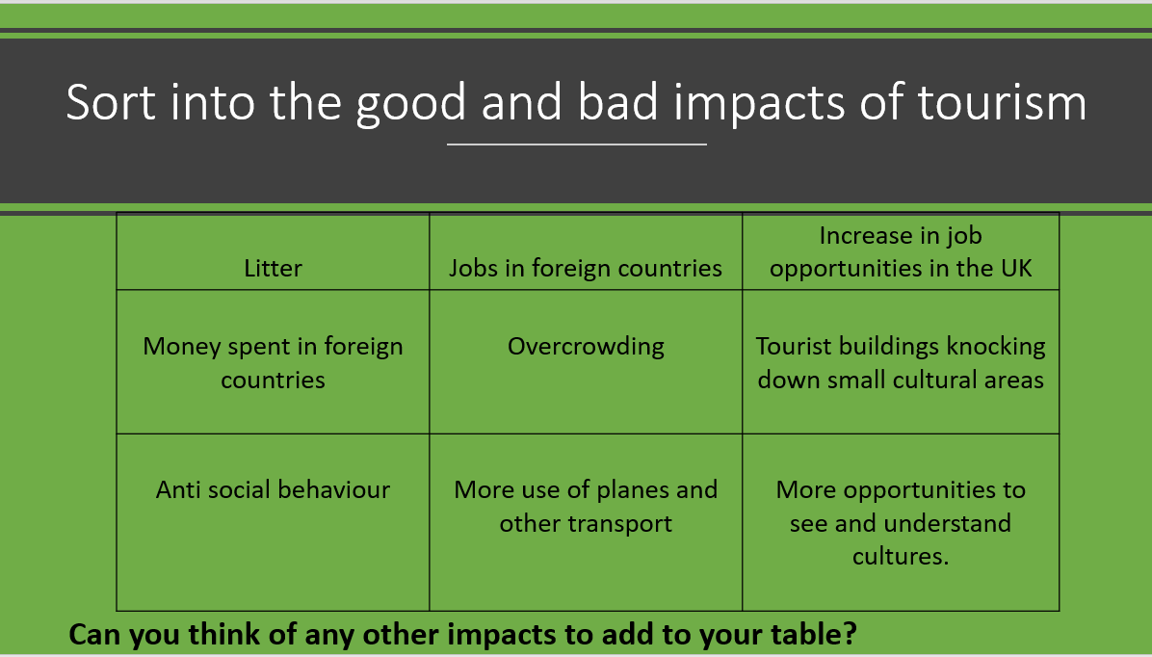

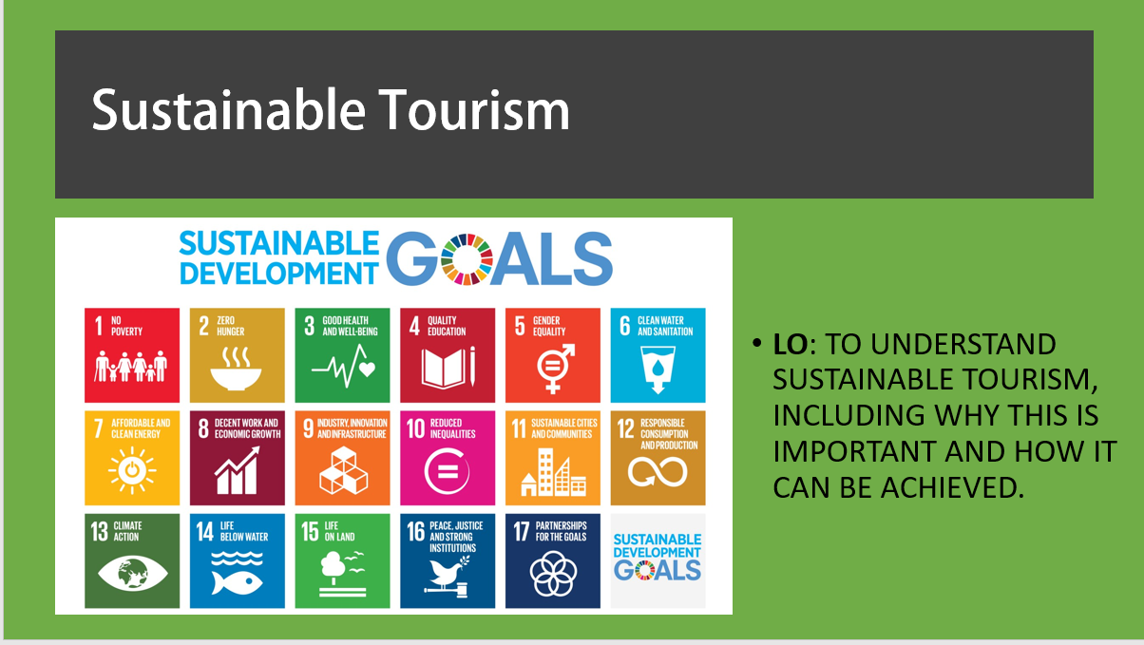





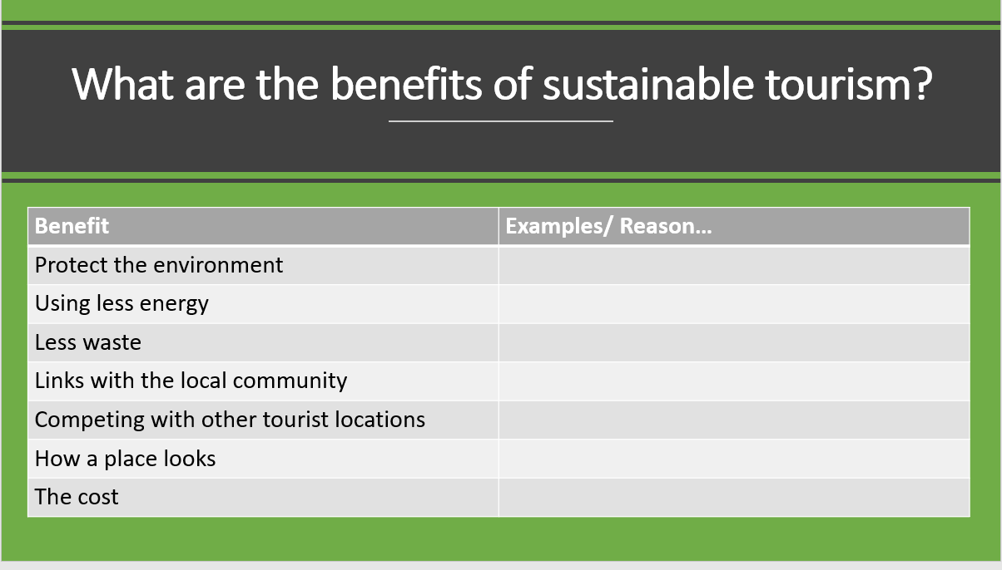

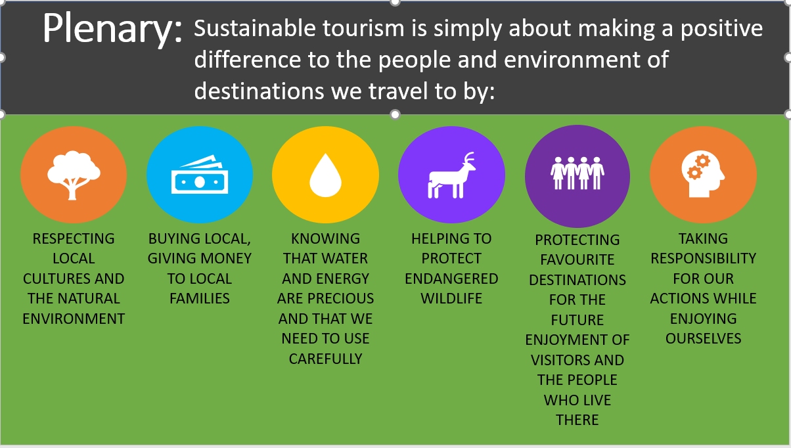



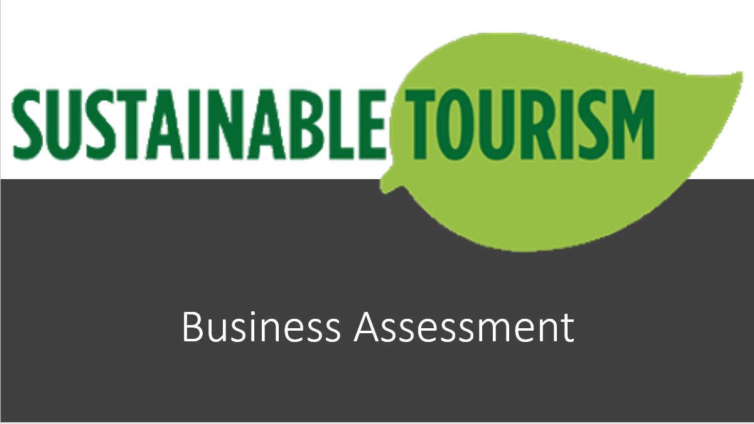

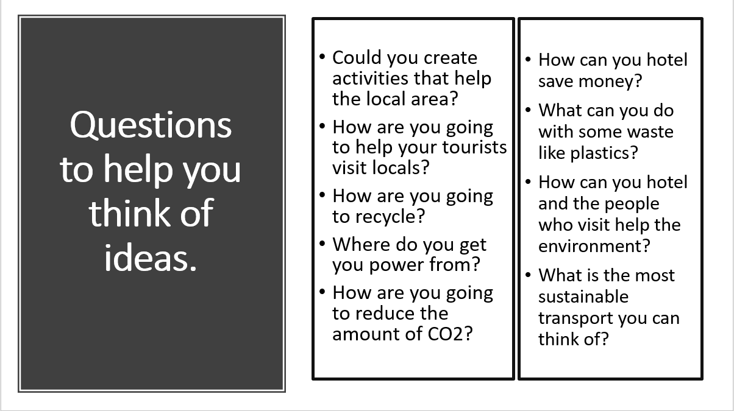

Scaffolding tools
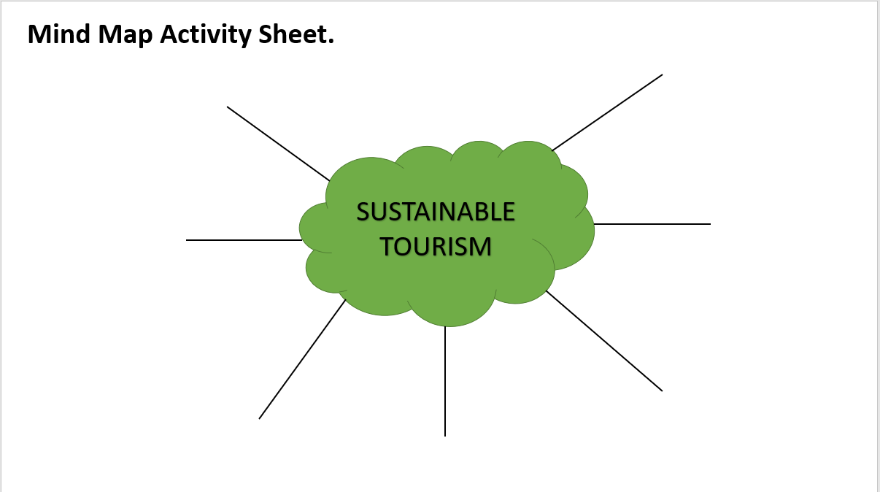

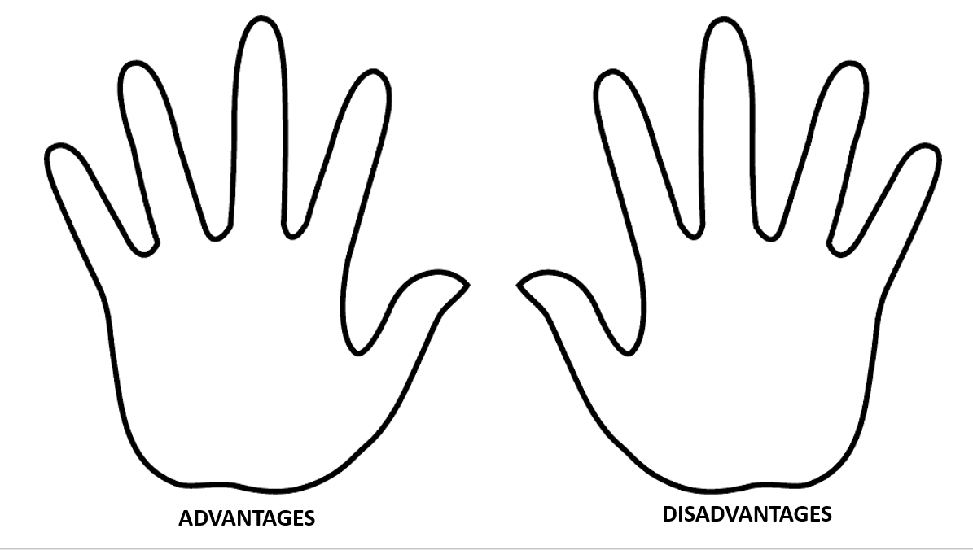
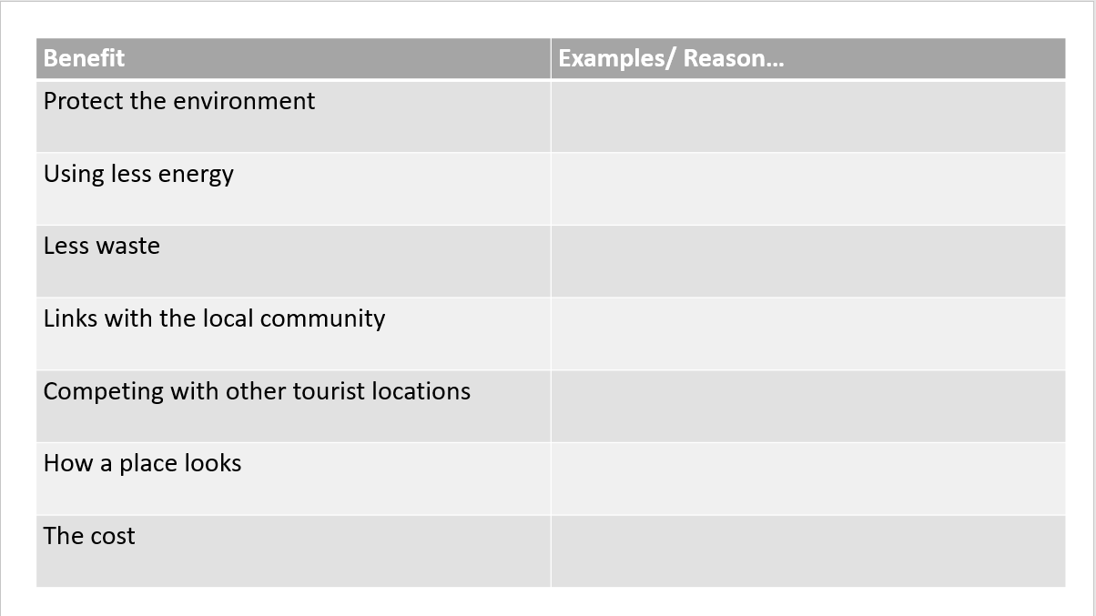

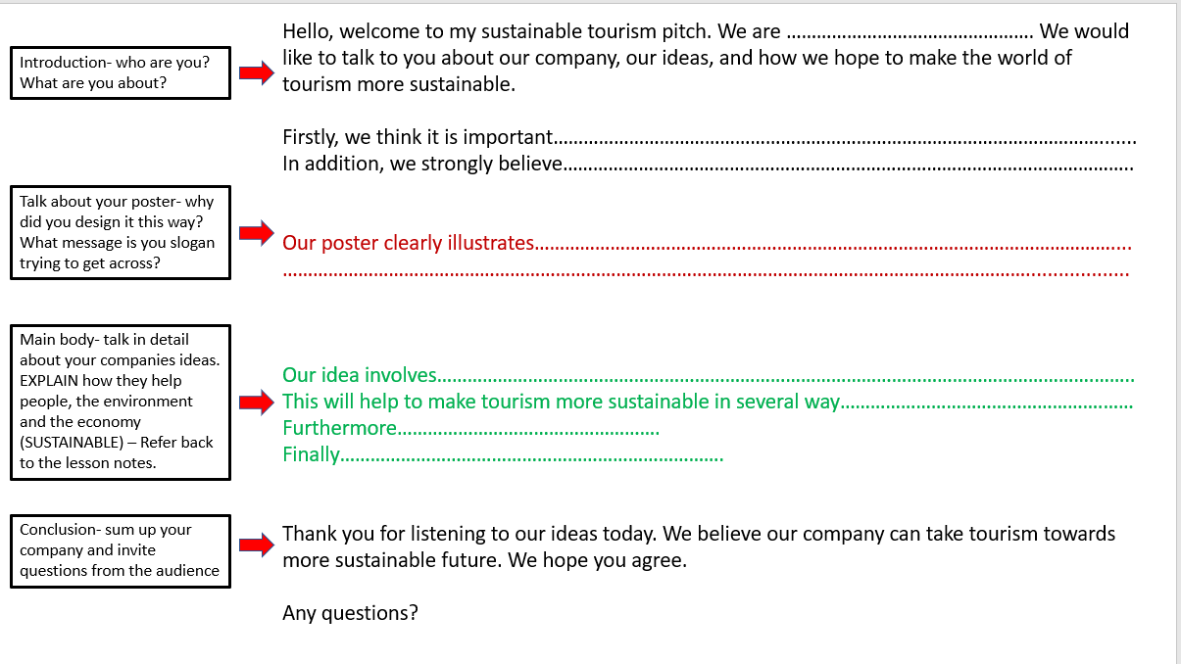

References

Bonwell, C. and Eison, J. (1991) Active learning: Creating excitement in the classroom. Washington D.C.: The George Washington University, School of Education and Human Development.

Blog Stepes (2020) Tourism. [Online].
Available at: https://www.bing.com/images/search?view=detailV2&ccid=P5t8rkeJ&id =8F4F8101AE5829DFA09E6C4846EC744F1C716F2F&thid=OIP.P5t8rkeJmj4wnrYcaSR2cwHaDV&mediaurl=https%3A%2F%2Fblog.stepes.com%2Fwp-content%2Fuploads%2F2015%2F09%2Ftourism20150818-1.jpg&exph=344&expw=764&q=tourism&simid=607988440772905718&ck=3E247C9E2311AEF6419BF87973E1091B&selectedindex=50&form=IRPRST&ajaxhist=0&vt=0&sim=11
(Accessed: 1st August 2020).
Browne, A. (2007) Teaching and Learning Communication, Language and Literacy. 1st Ed. London: Paul Chapman Publishing.

CBS News (2020) Littered American beaches. [Online].
Available at: https://www.bing.com/images/search?view=detailV2&ccid=4IMbPCK4& id=1573D2E0F853D5F03C295E8B8726A7B5296520F0&thid=OIP.4IMbPCK4Ocuzf5KD7_FowHaFj&mediaurl=https%3A%2F%2Fcbsnews1.cbsistatic.com%2Fhub%2Fi%2Fr%2F2011%2F06%2F29%2F441f00d4-a643-11e2-a3f0-029118418759%2Fresize%2F620x465%2F583aa8caaefb84526bfb5f4925cc53e6%2Fdirtybeach_istock_000015037586.jpg&exph=465&expw=620&q=Littered+American+Beaches&simid=608046422744236307&ck=F86FA300EB15D2013B9C66CCD0E47772&selectedindex=8&ajaxhist=0&vt=0&sim=11
(Accessed: 2nd August 2020).

Cliparts.co (2020) Hand outline. [Online].
Available at: https://www.bing.com/images/search?view=detailV2&ccid=5471F ifA&id =10E4FC818723F31F8C8B55DFB9AC31301C91B4DD&thid=OIP.5471FifASco2Z0AMB5a9wHaD8&mediaurl=http%3a%2f%2fcliparts.co%2fcliparts%2fqTB%2fXX4%2fqTBXX4rEc.png&exph=4539&expw=8507&q=hands+outline+&simid=608031759753937148&ck=949AFAF9FBC1BE12D35B17B3ECFF3774&selectedIndex=52&ajaxhist=0
(Accessed: 1st August 2020).

Donaldson, G. (2015) Successful Futures.
Available at: https://gov.wales/sites/default/files/publications/2018-03/successfulfutur es. pdf
(Accessed: 3rd August 2020).

Goodwin, P. (2011) The Literate Classroom. 3rd Ed. Oxon: Routledge.

Halpenny, A.M. and Pettersen, J. (2014) Introducing Piaget: A guide for practitioners and students in early years education. 1st Ed. Oxon: Routledge.

Health Research Funding (2020) William Glasser Choice Theory of Behaviour Management Explained.
Available at: https://healthresearchfunding.org/william-glasser-choice-theory-of-behaviour-management-explained/
(Accessed: 4th August 2020).

Earl, S. (2017) ‘Student disengagement may be down to behaviour management techniques, says academic’, tes, 11th May.
Available at: https://www.tes.com/news/student-disengagement-may-be-down-behavi our- management-techniques-says-academic
(Accessed: 3rd August 2020).

Leicester University (2020) Leicester Learning Institute.
Available at: https://www2.le.ac.uk/offices/lli/developing-learning-and-teaching/enhan ce/strategies/active-learning
(Accessed: 4th August 2020).

Michigan Virtual (2017) Module 3: Questioning and Discussion in the Classroom [video].
Available at: https://www.bing.com/videos/search?q=classroom+discussion&&view= detail&mid=BA41844811BF1E524701BA41844811BF1E524701&&FORM=VRDGAR&ru=%2Fvideos%2Fsearch%3Fq%3Dclassroom%2520discussion%26qs%3Dn%26form%3DQBVDMH%26sp%3D-1%26pq%3Dclassroom%2520discussion%26sc%3D8-20%26sk%3D%26cvid%3DDCE1F
88CCE8B4856AE850AF2F97F342D
(Accessed: 2nd August 2020).

Nahbnow (2015) Quiz time. [Online].
Available at: http://nahbnow.com/2015/07/feeling-quizzical-what-green-home-feature-are- you/
(Accessed: 3rd August 2020).

Persuad, C. (2018) Bloom’s Taxonomy: The Ultimate Guide.
Available at: https://tophat.com/blog/blooms-taxonomy-ultimate-guide/
(Accessed: 3rd August 2020).

Radio Times (2016) Dragons’ Den. [Online].
Available at: https://www.radiotimes.com/news/2016-02-28/where-are-thedragonsden -success-stories-now/
(Accessed: 4th August 2020).

School A. (2014) Teaching & Learning Policy.

The Mercury News (2019) Tourists overcrowding Disney. [Online]
Available at: https://www.mercurynews.com/2019/12/28/disneyland-closes-gates-as-
holiday-crowds-fill-the-park/
(Accessed: 3rd August 2020).

Word Press (2011) Sustainable tourism logo. [Online].
Available at: https://simplytelevison.wordpress.com/category/dragons-den/
(Accessed: 3rd August 2020).

Yale (2020) Effective Class Discussions.
Available at: https://poorvucenter.yale.edu/EffectiveClassDiscussions
(Accessed: 4th August 2020).

