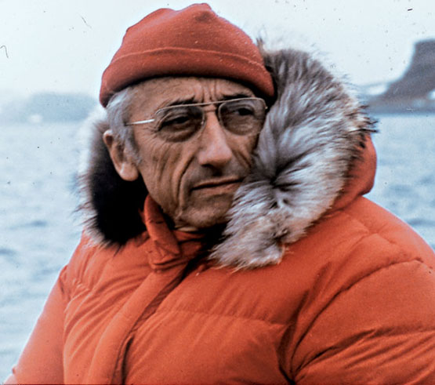

Name: Jacques-Yves Cousteau
Born: June 11, 1910
Died: June 25, 1997 aged 87

Jacques sea career started when he joined the French Naval Academy at the age of 20 and he graduated becoming a gunnery officer, he then started his training to becoming a pilot but unfortunately he had a car accident which quickly ended his naval career. His love for the ocean was still there and began doing experiments under water using his friends swimming goggles, this was the start of a wider interest in what types of plants and animals were living under the water. He wanted to be able to stay under the water for a longer period of time and go to greater depths so he could examine more animals and plants, so he helped to develop SCUBA (Self Contained Underwater Breathing Apparatus) with Emile Gagnan, and in 1943 his dream become a reality when they produced the 2 first prototypes.
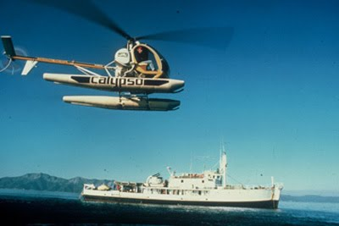
In 1950 Jacques found an old navy Mine-sweeper which was converted into a ferry called the Calypso, he bought it with some financial help and went back to France with it and transformed it in to a Oceanographic Ship (Research Ship). The ships first expedition was to the red sea to study the corals in which he then brought back photographic evidence and samples of the corals only with a few friends and family comprising of the crew. He sailed it all around the world for 40 years which let him see the entire world’s oceans and what different wild life lived in it, he also sailed it up the Amazon River, with even a discovery of an oil field.
To me Jacques-Yves Cousteau not only invented the ways humans can interact with the sea he also delivered it to millions of people by making 115 television films and writing 50 books showing that he not only wants help scientist to understand what’s in our waters but everybody else sitting at home maybe inspiring another generation. This is shown through the fact that ‘’His lifelong motto was IL faut aller voir (We must go ourselves)(Lesley A. DuTemple, 2000, 26)’ showing that he is not just waiting for other people to go he has the drive and the motivation to explore where no one else has gone before.

Information and research: http://www.cousteau.org/about-us/calypso-history, http://www.cousteau.org/about-us/jaques
Picture 1: http://anorakheaven.blogspot.co.uk/2012/07/high-calypso-legacy-of-jacques-cousteau.html#.UHG-l1E_vAw
Picture 2: http://pacific-standard.blogspot.co.uk/2009_11_29_archive.html
Google books Lesley A. DuTemple, 2000, 26: http://books.google.co.uk/books?id=KG1uTLfABQQC&pg=PA26&lpg=PA26&dq=%22+We+must+go+see+for+ourselves.+%22&source=bl&ots=C-vEVMNhdC&sig=WnwvlPp1B04afMVIWcELY_rUq9c&hl=en&sa=X&ei=tZJyUN6rPOWa0QWR3IH4BA&ved=0CDAQ6AEwBA#v=onepage&q=%22%20We%20must%20go%20see%20for%20ourselves.%20%22&f=false

