

Master of Business Administration (MBA)
Module: Marketing Management (LCMB7024)
Assessment Title: Marketing Environmental Analysis for Pioneers and Followers: Netflix (Pioneer) vs Disney+ (Follower) in Subscription Streaming (SVOD)
Lecturer: Laila Maazouz; Taonga Kaonga Sobere-Snithers
Student Name: Ranjit Masaribhai Modhwadjya
Student ID: 2529489
Word Count: 2734
Submission Date: 27 Feb. 2026

Table of Contents
1 Executive Summary 2
2 Introduction 3
3 Approach and Analytical Structures. 3
3.1 Case selection and evidence base. 3
3.2 Frameworks applied 4
4 Context in the Industry Competition: SVOD and Platform. 4
5 Task 1: Macro Environmental Analysis 5
5.1 Macro-Actor A: Technology (AI personalisation, infrastructure, adtech) 5
5.1.1 Opportunities that technology has brought about. 5
5.1.2 Threats posed by technology. 5
5.2 Macro-Actor B: Legal-Political Governance (privacy + platform governance) 6
5.2.1 Opportunities that are brought about by regulation. 6
5.2.2 Threats caused by regulation. 6
5.3 Macro forces and competitive positioning: Netflix vs DISney+. 7
6 Task 2: Tactical Reactions to Sustain Growth (Porter + Ansoff) 7
6.1 Generic Strategies comparison Porters. 7
6.1.1 Netflix: differentiation based on breadth and experience (efficiencies of scale). 7
6.1.2 Disney+: Franchise IP and ecosystem bundling-based differentiation. 8
6.2 Growth Matrix comparison of Ansoff. 9
6.3 Quality of strategic response to the two macro-actors. 9
6.3.1 Technology fit: retention and experience as a competitive weapon. 9
6.3.2 Regulation capability and privacy trade-offs. 10
6.4 STP and Customer Value implications 10
6.4.1 NetFlix (experience based STP). 10
6.4.2 Disney+ (franchise and bundle-based STP). 10
7 Conclusion 11
8 References 11

Executive Summary
The current report critically assesses the impact of the macro marketing environment on competitive positions of a pioneer and a follower organisation in the same industry: Netflix (pioneer organisation in the subscription video-on-demand, SVOD), and Disney+ (follower organisation, with the support of the corporate ecosystem of Disney). Opportunity/threat drivers are considered to be two external macro-actors: (1) technology (AI personalisation, streaming infrastructure and adtech) or (2) legal/political regulation (platform governance and privacy/data enforcement).
Evidence provided by peer reviewers shows that platform value chain and global supplier ecosystems are becoming crucial in the creation of SVOD advantage, with scale providing much quicker capability accretion and more resilient delivery systems (Chalaby, 2025). Technology provides the possibilities of better discovery, retention and new models of monetisation (e.g., ad-supported tiers), but also increases competition and imitation as the capability on a platform is becoming diffuse (Yoon and Kim, 2023; Soren and Chakraborty, 2024). Independent regulation raises the cost of operation and minimises extreme asymmetries in behavioural targeting, driving platforms towards governance maturity, marketing that is privacy-safe and transparent recommender operations (Turillazzi et al., 2023).
The report draws a conclusion that Netflix can maintain an advantage due to the experience-based differentiation with the help of scale learning, and Disney+ can compete due to the presence of the franchise-based differentiation with bundling and ecosystem complementarity. This strategic divergence is at the same time as convergence in monetisation strategies (ad tiers, bundles, account-sharing controls). Firm metrics are applied selectively to frame analysis Netflix has 301.6 million paid memberships at the end of 2024 (Netflix, 2025) and Disney has 132 million Disney+ subscribers and 196 million Disney+ and Hulu subscriptions at the end of the 2025 fiscal year (The Walt Disney Company, 2025).

Introduction
A key input to the strategic marketing management is the macro environmental analysis as external forces have the ability to change consumer behaviour, structure of channels and the viability of competitive advantage. In SVOD, the competitive landscape is shifting very fast: more people are moving between platforms, there is an increase in price sensitivity, and competition is ever-increasing as media companies reshape their value chains around global digital delivery systems (Chalaby, 2025). With the maturity of the SVOD market, churn, subscription fatigue, and content cost increases are all limiting growth, and moving towards retention over acquisition, pricing architecture and optimisation of monetisation, (Yoon and Kim, 2023; Nagaraj et al., 2021).
This report addresses:
- Task 1: Critically evaluate the opportunity and threat by two macro-actors (technology and legal political regulation) to Netflix and Disney+ and evaluates how competitive position is formed by the external forces.
- Task 2: Compare and analyze strategic responses employed by Netflix and Disney+ to continue to grow in these macro forces using Porters Generic Strategies and Ansoff Growth Matrix with support of appropriate marketing concepts (segmentation -targeting- positioning, branding, and customer value/retention theory).

Approach and Analytical Structures.

Case selection and evidence base.
Netflix is viewed as an innovator as it influenced the current state of the SVOD due to the early globalization, platform-first service and data-based commissioning of content. Disney+ is being positioned as a follower of SVOD (although Disney has a long history in the media) since it late entered the competition in the SVOD industry and grew fast through franchise IP, bundling, and ecosystem advantage (Chalaby, 2025).
The primary evidence sources are peer-reviewed studies about competition in the platform, OTT adoption/retention, ad-supported streaming, privacy preferences, and EU SVOD growth dynamics (i.e. Chalaby, 2025; Papathanasopoulos and Varoutas, 2025; Paliński et al., 2025). The factual context is anchored only using sources that are company and regulatory (Netflix, 2025; The Walt Disney Company, 2025; European Commission, 2024a; California Department of Justice, 2024).

Frameworks applied
- PESTLE to organise macro-environmental forces.
- Opportunity-Threat translation with SWOT logic of linking environment with competitive position.
- Porter Generic Strategies to evaluate competitive positioning (differentiation vs cost logic) (Grant, 2021).
- The Growth Matrix proposed by Ansoff to chart the growth strategies (penetration, development, product development, diversification) and the risks involved (Johnson et al., 2020).

Context in the Industry Competition: SVOD and Platform.
SVOD is becoming a more and more competitive platform as the source of advantage is the capacity of a firm to coordinate content creation, distribution logistics, user interface experience and monetisation mechanisms. Chalaby (2025) states that strong-tie streaming players are restructuring television in the context of global value chains where the lead companies coordinate a network of suppliers and allow cross-border scaling and economies of scale. This contributes to the ability of early leaders to maintain advantage, but by redefining consumer value perceptions, followers having unique assets (e.g. franchise IP) may enter and compete.
A combination of content value, convenience, price value, habit, and platform experience are the criteria that determine consumer adoption and continued use, and research has repeatedly demonstrated that content availability and ease/pleasure of use determine intention, satisfaction and commitment (Nagaraj et al., 2021; Polisetty et al., 2023; Soren and Chakraborty, 2024). Retention in fully developed OTT markets is determined by both dedication benefits (personalisation, content variety) and constraint benefits (switching costs include effort, learning and investment) i.e. firms have to deal with both satisfaction and resistance-to-switching at the same time (Yoon and Kim, 2023).
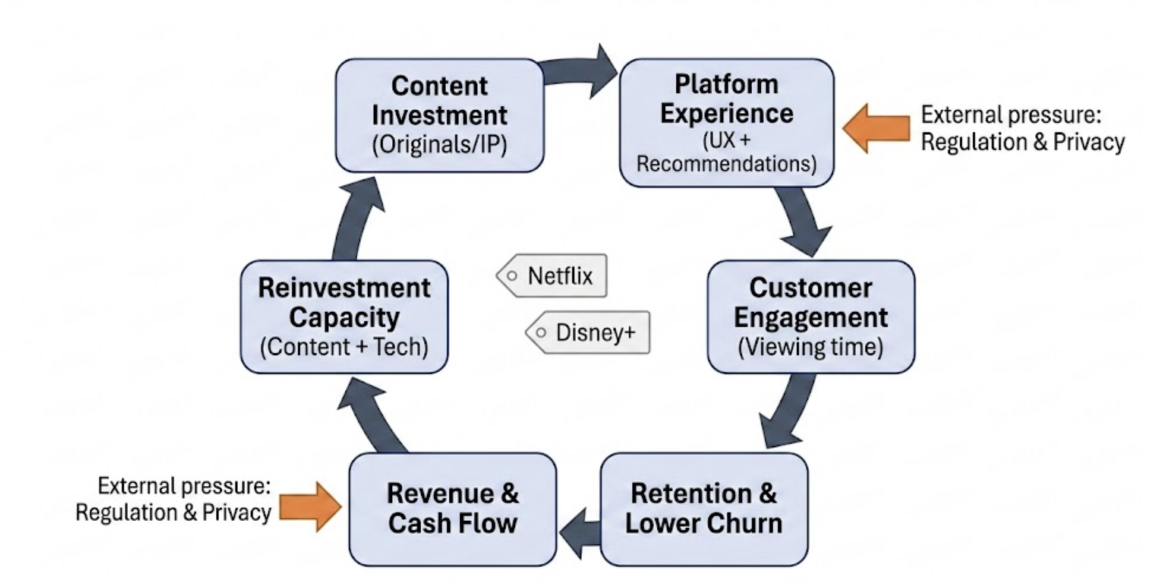

Figure 1. SVOD Competitive System Map(Chalaby, 2025; Papathanasopoulos & Varoutas, 2025)

Task 1: Macro Environmental Analysis

Macro-Actor A: Technology (AI personalisation, infrastructure, adtech)

Opportunities that technology has brought about.
(1) The satisfaction and continuance intention are enhanced by personalisation.
Personalisation and content diversity are found in positive relationships with satisfaction and continuous usage intention in mature OTT markets, which implies that the discovery experience on the platform turns into a marketing feature instead of mere IT (Yoon and Kim, 2023). This is a great advantage to Netflix since personalisation can be used as an ongoing STP process: behavioural segmentation and algorithmic targeting via interface design.
(2) Technology facilitates AVOD/hybrid monetisation and increases addressable demand.
With increased price sensitivity among consumers, ad-based levels enable platforms to fight over value seekers without losing all the revenue potential. Studies regarding AVOD spur the notion that user experience and adoption decisions are influenced by advertising, which means that the quality of ad load execution, relevance/intrusiveness is a competitive variable (Neira, 2025). This is the strategic point of both Netflix and Disney+ to develop value propositions at a tier price-based segmentation with an individualized experience.
(3) Ecosystems of global scaling and delivery empower leaders.
Streaming delivery is based on complicated ecosystems of media delivery and supplier networks. The studies on media delivery and global suppliers indicate that IP delivery and streaming is based on mosaics of technologies and suppliers, redesigning value creation processes and its captor (Chalaby and Plunkett, 2021). This rewards companies with the capacity to coordinate these ecosystems effectively on a global basis.

Threats posed by technology.
(1) Scalability imitation and replication.
With the maturity of streaming technology, follower platforms can be technologically at par with them more quickly (apps, codecs, cloud scaling), differentiating with differences as simple as having streaming. The competitive focus is reduced to content economics, brand meaning, and ecosystem value instead of basic delivery competence (Chalaby, 2025).
(2) Content and costs arms race.
Technology makes consumer expectations (high-definition, streamlined UX, cross-device integration) faster, and the demand to continuously add features and invest in content streams more (intensifying fixed costs and competition) (Papathanasopoulos and Varoutas, 2025).
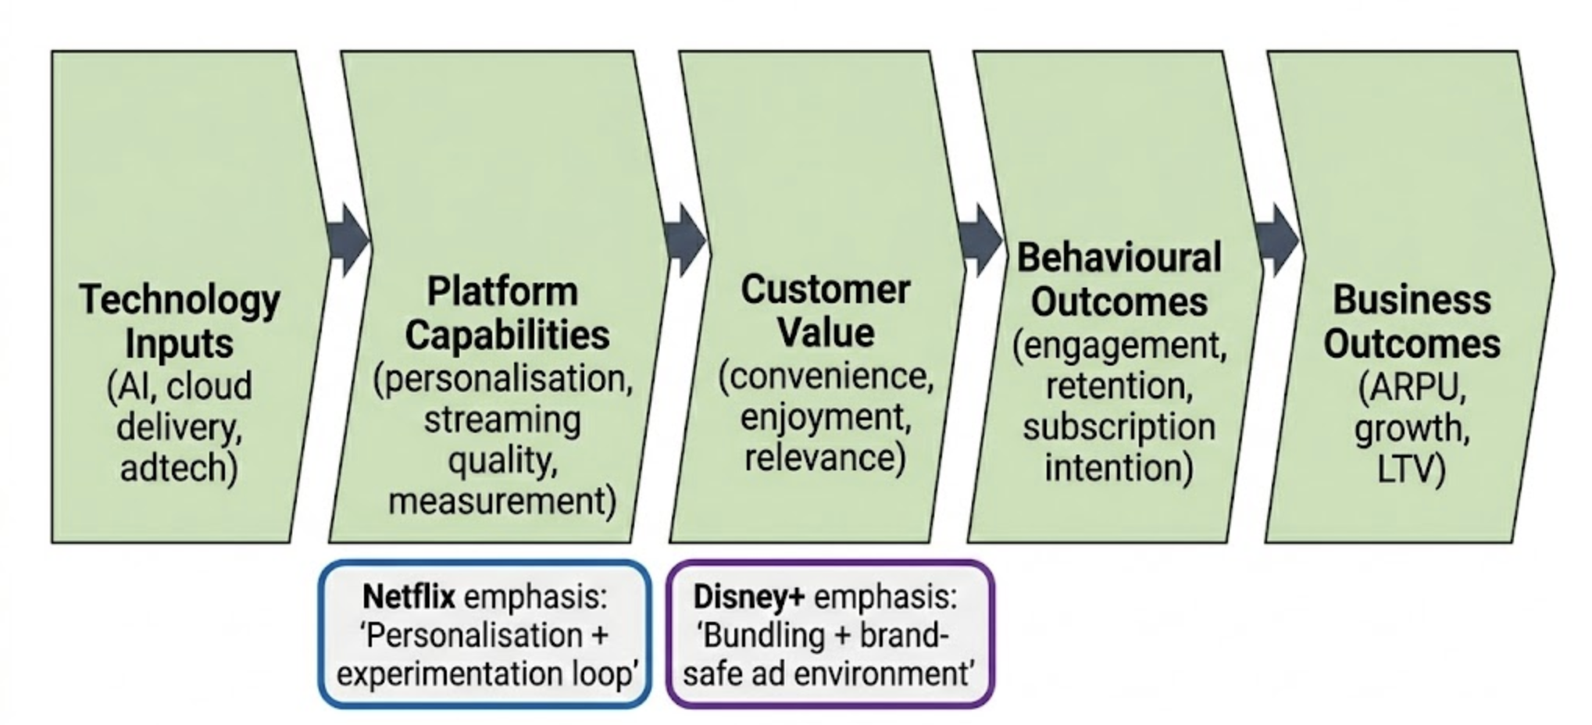
Figure 2. Technology ₕ Value Creation Pathway(Yoon and Kim, 2023; Soren and Chakraborty, 2024)
Figure 2 demonstrates the conversion of the technology into the outcome of the marketing processes: the perceived value and satisfaction through the impact of the personalisation and UX enhancement translate into continuance intention and commitment). AVOD also presents an aspect of monetisation layer in which the quality of ad experience enters the perceived value (Neira, 2025).

Macro-Actor B: Legal-Political Governance (privacy + platform governance)

Opportunities that are brought about by regulation.
(1) Maturity and trust Governance Maturity and Trust become differentiators.
Censorship will elevate the confidence of consumers in the platforms that can enforce a high level of privacy controls and transparent operating behavior, enhancing the trust in brands and the confidence of advertisers. Notably, the privacy vs advertising trade-offs variation among buyers is statistically significant; specific users tolerate data exchange to receive compensation, which means that the transparent value exchange can be strategically controlled (Paliński et al., 2025).
(2) Recommender design and accountability are influenced by platform governance norms.
The regulatory environment established by the EU Digital Services Act (DSA) raises the standards of transparency, risk management and responsible use of platforms (European Commission, 2024a). The academic discourse states that the DSA presents its ethical, legal, and social consequences, which can transform platform governance and accountability and indirectly influence the utilization of recommender systems and advertising (Turillazzi et al., 2023).

Threats caused by regulation.
(1) Costs of compliance and operational limitations.
Regimes of privacy enforcement (e.g. California privacy regulations) raise the expenses associated with consent management, data management and vendor control, and may restrict behavioural profiling in marketing and advertisement (California Department of Justice, 2024). This may clog efficiency of algorithmic targeting and attribution.
(2) More transparency requirement decreases black-box advantage.
With the increase in expectations of transparency and accountability, platforms can be restricted in their aggressive personalisation or offer other recommendation features, diminishing some of the benefits of algorithmic engagement and adding to the paperwork and audit costs (Turillazzi et al., 2023; European Commission, 2024a).
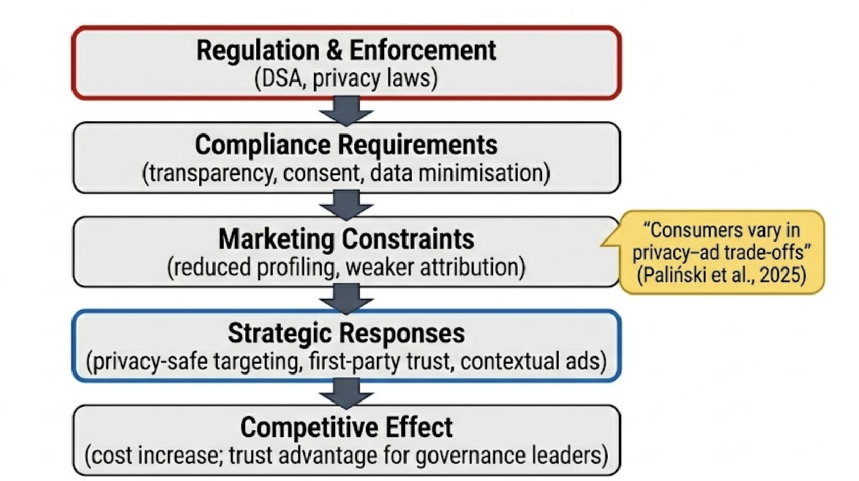
Figure 3. Marketing Impact Chain and Regulation to Marketing Impact Chain. (Paliński et al., 2025; Turillazzi et al., 2023).
Figure 3 visualizes the regulation to marketing outcome mechanism: governance and privacy demands limit data use and profiling, diminishing the power of behavioural targeting and compelling platforms to move towards first-party trust, contextual cues and transparent value exchange, as it is observed in practice in privacy/advertising preference trade-offs in VoD settings (Paliński et al., 2025; Turillazzi et al., 2023).

Macro forces and competitive positioning: Netflix vs DISney+.
The size and learning power of Netflix enhance its capacity to take advantage of technology opportunities (personalisation, global operations), however regulation can shrink the opportunity of data advantage through restricting profiling and enhancing accountability overheads. Technology is an enabler to Disney+, but franchise IP and ecosystem advantage is the main driver; regulation is likely to solidify the brand trust positioning (family-safe perception) of Disney, but it adds compliance costs, nonetheless.
In order to provide competitive scale context: Netflix had 301.6 million paid memberships as of the end of 2024 (Netflix, 2025) whereas Disney had 132 million subscribers to Disney + and 196 million subscribers to Disney + and Hulu at the end of the fiscal 2025 (The Walt Disney Company, 2025). These values portend the scale advantage of Netflix and portfolio/bundling strength of Disney.

Task 2: Tactical Reactions to Sustain Growth (Porter + Ansoff)

Generic Strategies comparison Porters.

Netflix: differentiation based on breadth and experience (efficiencies of scale).
The strategic position of Netflix is mostly in the differentiation: extensive assortment of content, originals worldwide, and an interface that is experience-driven such that the quality of recommendations increases the perceived value and retention. Personalisation and content diversity has been identified in the retention literature to enhance satisfaction and continuance intention (Yoon and Kim, 2023), and adoption literature to support the use of habit and hedonic motivation to drive continued use- supportable with a strategy to maximise engagement loops (Soren and Chakraborty, 2024). It is also true that Netflix enjoys the efficiencies of scale, i.e., amortisation of investment in content and platform over a broader base (Chalaby, 2025).
The strategic responses that are associated with the macro-actors:
- Hybrid monetisation (AVOD) as a way to cover price-sensitive segments without impacting on revenue potential; advertising experience should be handled sensibly since it influences the perceived value and the desire to stay (Neira, 2025).
- Retention focus: in developed OTT markets, retention depends both on satisfaction and switching costs thus Netflix will have to balance experience benefits and limitations (Yoon and Kim, 2023).
- Investment in technology: enhances discovery and engagement based on recommendations, which is in line with platform value-chain dynamics (Chalaby and Plunkett, 2021).

Disney+: Franchise IP and ecosystem bundling-based differentiation.
Disney+ is aligned with differentiation based on franchise IP and brand equity (Marvel, Star Wars, Pixar), and with the help of bundle, cross-business synergies. The study on platform competition proposes that the streaming giants create enormous global value chains; Disney has an upper hand in placing unique IP into the value chains, as well as establishing ecosystem complementarities (Chalaby, 2025). Bundling and portfolio scaling help decrease churn by creating a sense of value and by making implicit switching costs high.
According to peer-reviewed adoption studies, OTT subscription decisions are also influenced by content, convenience, quality, features and price, meaning that Disney+ can maintain value perceptions in terms of franchise depth and bundle level of convenience (Nagaraj et al., 2021; Polisetty et al., 2023). In addition, the studies of privacy and advertising preferences indicate that the user acceptance is conditional upon visible trade-offs; Disney will be able to capitalize on brand trust to render ad levels and ad consent narratives less objectionable (Paliński et al., 2025).
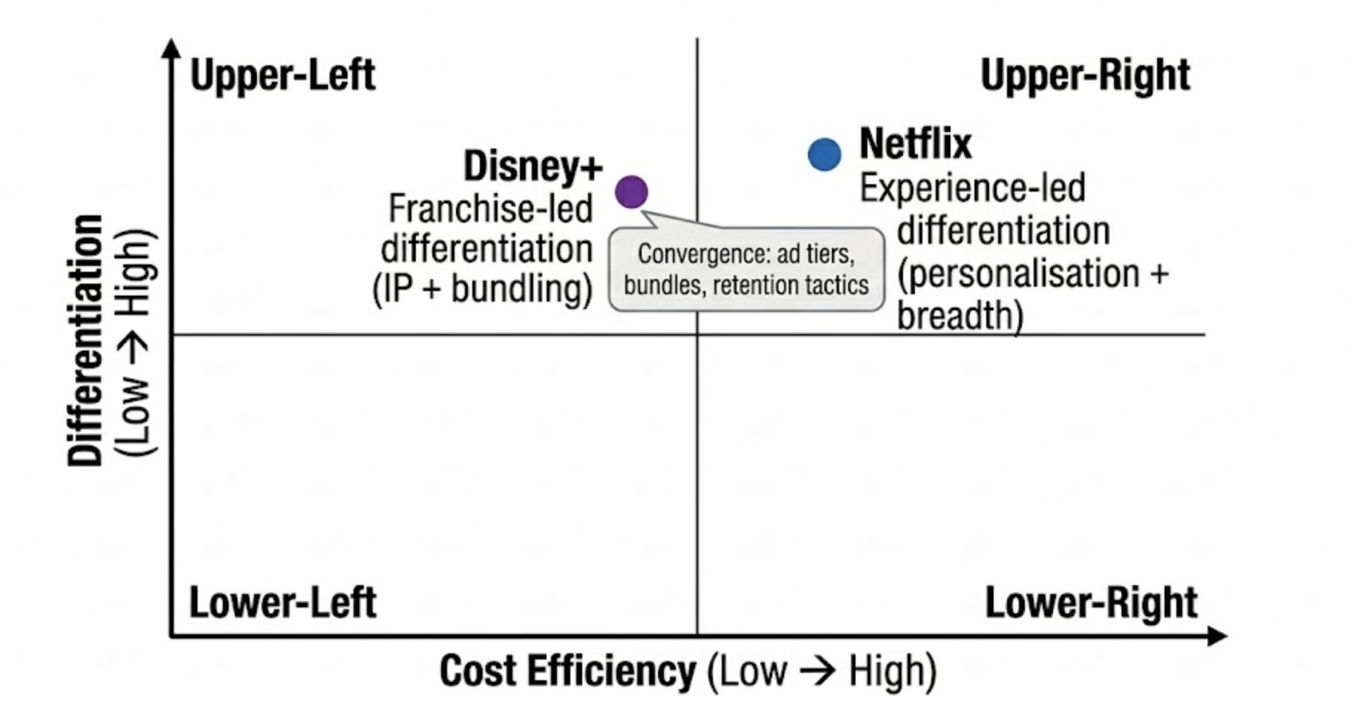
Figure 4. Porter Positioning Map (Chalaby, 2025).
Figure 4 places Netflix and Disney+ as divergent differentiation competitors with varying bases of differentiation: Netflix is experience-led differentiation (personalisation + breadth + product innovation) and Disney+ is franchise-led differentiation (IP + brand equity + ecosystem bundling). They both react to the price pressure through tiered offers, yet value perception is built in a different way (Nagaraj et al., 2021; Yoon and Kim, 2023; Chalaby, 2025).

Growth Matrix comparison of Ansoff.
Table 1. Netflix vs Disney+ Ansoff Growth Matrix Applied.
Ansoff option | Netflix (Pioneer) | Disney+ (Follower)
Market penetration | Retention optimisation, tiered pricing (incl. AVOD), engagement design | Bundling (Disney+ + Hulu), franchise cadence, family segment strength
Market development | International scaling + localisation; expanding addressable demand via tiers | Global expansion using IP brands; portfolio rollouts and bundle expansion
Product development | Platform feature innovation; adtech capabilities; experience improvements | Franchise extensions (spin-offs), tighter portfolio integration and UI enhancements
Diversification | Adjacent entertainment formats/interactive experiments | Corporate ecosystem diversification supports streaming (studio, parks, consumer products)

Evaluation:
Ansoff posture of Netflix is highly skewed towards market development + product development as is synergistic with global value-chain leadership and differentiation in experience. Disney+ focuses on penetrating the market through bundling and developing products through franchising, leveraging the benefits of the ecosystem in minimizing churnover and enhancing customer lifetime value (Chalaby, 2025; The Walt Disney Company, 2025).
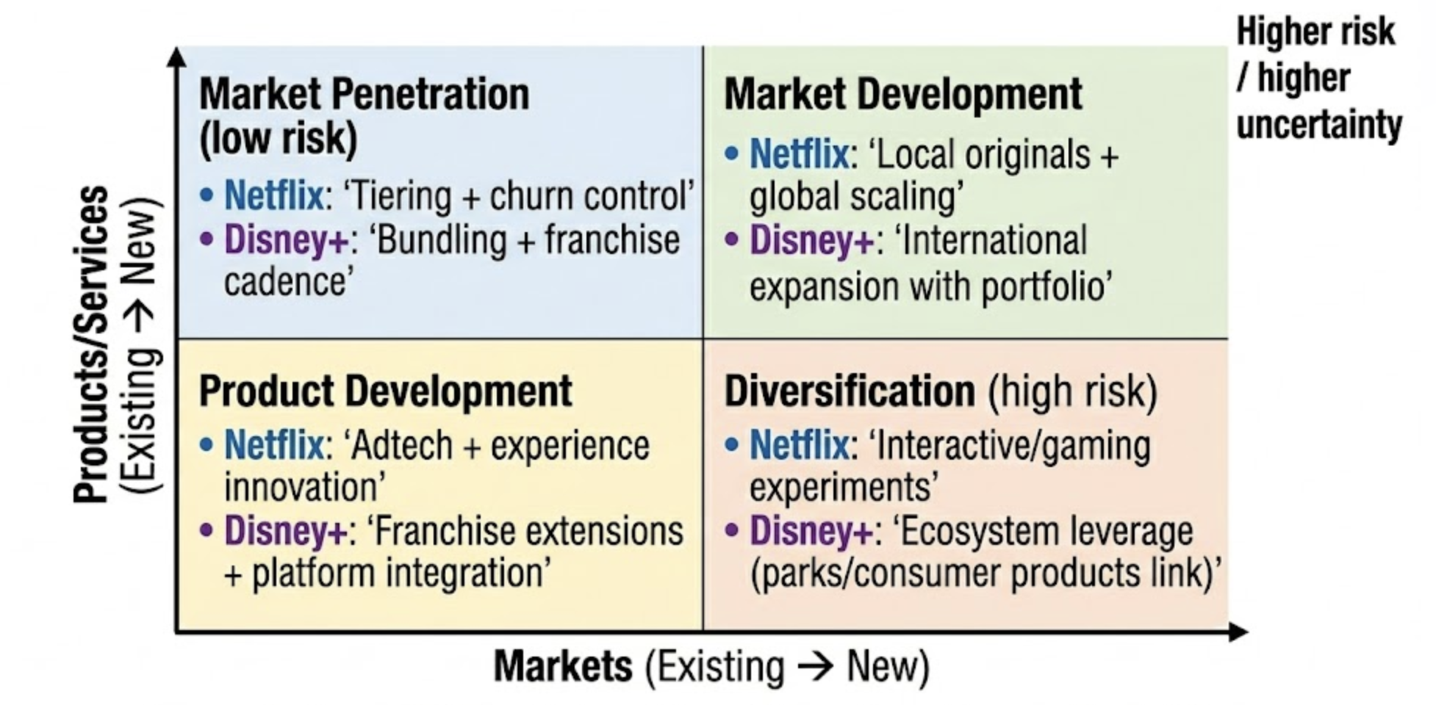
Figure 5. Ansoff Risk- Return View (Conceptual) (Polisetty et al., 2023; Soren and Chakraborty, 2024; Chalaby, 2025).
Figure 5: Strategic risk Figure 5 summarises strategic risk: Netflix market development and product innovation generates growth options at the cost of increased technology/content cost risk; Disney plus mitigates risk through IP leverage and portfolio bundling which can enhance perceived value drivers of OTT adoption and continuance (Polisetty et al., 2023; Soren and Chakraborty, 2024; Chalaby, 2025).

Quality of strategic response to the two macro-actors.

Technology fit: retention and experience as a competitive weapon.
One of the revelations at the key distinction level is that technology is not background but a value-creation process that defines consumer psychology and behaviour. The studies demonstrate that continuance intention is influenced by satisfaction (during personalisation and content diversity) and switching cost (investment and learning effort), so companies have to deal with both advantages creation and switching costs (Yoon and Kim, 2023). The strategy used by Netflix is quite suitable to this mechanism since its brand promise is closely associated with discovery and breadth. Disney+ is a good fit, as it exploits franchise identity (strengthening satisfaction) and bundling (strengthening switching resistance).

Regulation capability and privacy trade-offs.
The pressures on privacy and platform governance force firms to consider compliance a risk management and market signalling. DSA ethical/legal implications involve the change in expectations regarding the way platforms regulate risk and responsibility (Turillazzi et al., 2023). Meanwhile, VoD evidence demonstrates that users vary in their readiness to sell their privacy to discounts/compensation, which means that platforms can strategically design tier and consent architecture as long as value exchange is clear and credible (Paliński et al., 2025). Those strategic resources that are applicable in this environment are Disney family-trust brand and the Netflix scale governance.
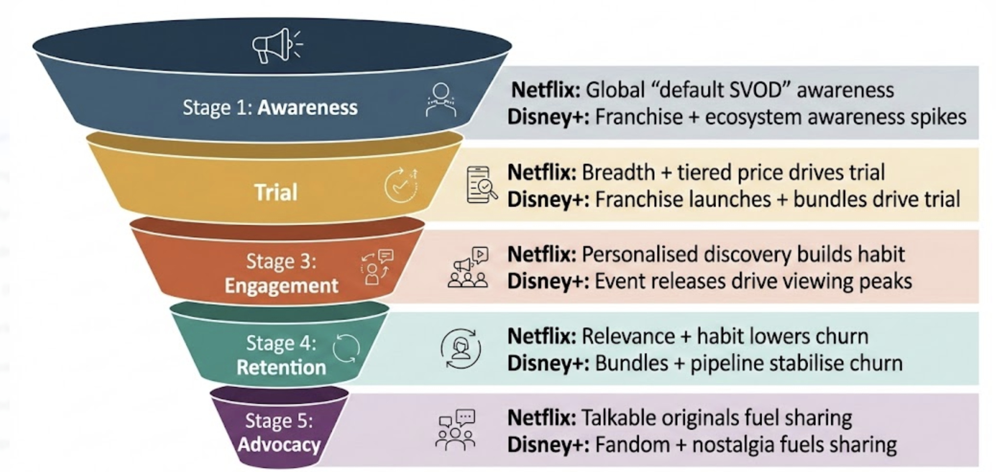

Figure 6. SVOD Customer Journey Funnel(Yoon & Kim, 2023; Nagaraj et al., 2021)

STP and Customer Value implications

NetFlix (experience based STP).
- Segmentation: behavioural segments in accordance with viewing habits and preferences.
- Targeting: algorithmic targeting through customised recommendations and home-page setup.
- Positioning: the convenience + breadth + always something relevant.
This is consistent with peer reviewed proof and support that personalisation and content diversity enhance satisfaction, which contributes to continuance intention (Yoon and Kim, 2023).

Disney+ (franchise and bundle-based STP).
- Segmentation: franchise superfans, value/bundles seekers, families.
- Targeting: franchise lifecycle targeting and portfolio services cross promotion.
- Positioning: quality franchises + family entertainment that is called premium + value-added bundling.
This is consistent with adoption evidence that the two key drivers of subscription are content and convenience (Nagaraj et al., 2021; Polisetty et al., 2023).
Table 2: summary: Who better off than what by which macro-actor
Macro-actor | Netflix impact | Disney+ impact
Technology | Strengthens scale learning and experience differentiation; risk: arms race and imitation | Enables platform parity; advantage mainly realised via bundling and IP-led value creation
Regulation (privacy + governance) | Compresses extreme profiling edge; rewards governance maturity and trust | Reinforces trust positioning; increases compliance costs but can strengthen advertiser brand safety narrative

Conclusion
There exist macro forces in SVOD that bring about expansion and constraint. Technology expands the opportunity by personalising it, enhancing experience design and AVOD monetisation but also hastens imitation and augments cost competition. The regulation increases compliance and transparency levels, restricting exploitative actions of data and aiding the reward of good governance and value exchange with privacy.
Netflix maintains an experience-based differentiation advantage based on scale learning and global value-chain coordination (Chalaby, 2025; Yoon and Kim, 2023). Disney+ has based its growth on franchise-based differentiation, bundling and ecosystem advantage that reinforces perceived value and switching costs (Nagaraj et al., 2021; Soren and Chakraborty, 2024). The competitive advantage will also become one that is most able to match (a) privacy-safe personalisation, (b) the sustainability of content economies, and (c) the reliability of governance—and keep on developing differentiated brand meaning that eliminates churn in developed OTT markets (Turillazzi et al., 2023; Paliński et al., 2025).

References
California Department of Justice. (2024). California Consumer Privacy Act (CCPA). https://oag.ca.gov/privacy/ccpa
Chalaby, J. K. (2025). Streaming giants and the global shift: Building value chains on the streaming market. Journal of Communication, 75(2), 112–132. https://academic.oup.com/joc/article/75/2/112/7927093
Chalaby, J. K., & Plunkett, S. (2021). Media delivery, streaming television and the rise of global suppliers. New Media & Society. https://openaccess.city.ac.uk/id/eprint/24512/
European Commission. (2024). The Digital Services Act. https://digital-strategy.ec.europa.eu/en/policies/digital-services-act
Grant, R. M. (2021). Contemporary strategy analysis (11th ed.). Wiley. https://www.wiley.com/
Johnson, G., Whittington, R., & Scholes, K. (2020). Exploring corporate strategy (12th ed.). Pearson. https://www.pearson.com/
Nagaraj, S., et al. (2021). Factors affecting consumers’ willingness to subscribe to over-the-top (OTT) video streaming services. Technology in Society, 65, 101534. https://www.sciencedirect.com/science/article/pii/S0160791X21000099
Neira, E. (2025). The impact of advertising on the streaming user experience. Communication & Society. https://revistas.unav.edu/index.php/communication-and-society/article/view/52268
Netflix, Inc. (2025). Quarterly earnings and shareholder letters (membership metrics). https://ir.netflix.net/financials/quarterly-earnings/default.aspx
Paliński, M., Jusypenko, B., & colleagues. (2025). Behind the screens: Privacy and advertising preferences in VoD—The role of privacy concerns, persuasion knowledge, and experience. Journal of Business Research. https://www.sciencedirect.com/science/article/pii/S0969698925000128
Papathanasopoulos, A., & Varoutas, D. (2025). Analyzing the dynamics of the SVOD market in the EU-27: Factors influencing user subscriptions and revenue growth. Telecommunications Policy. https://www.sciencedirect.com/science/article/pii/S0308596125002071
Polisetty, A., et al. (2023). Understanding consumer adoption of OTT services through perceived value and convenience factors. Cogent Business & Management. https://www.tandfonline.com/doi/full/10.1080/23311975.2023.2283917
Soren, A. A., & Chakraborty, S. (2024). Adoption, satisfaction, trust, and commitment of over-the-top platforms: An integrated approach. Journal of Retailing and Consumer Services, 76, 103574. https://www.sciencedirect.com/science/article/abs/pii/S0969698923003259
The Walt Disney Company. (2025). Full year earnings for fiscal 2025 (Direct-to-Consumer subscriber metrics). https://thewaltdisneycompany.com/press-releases/the-walt-disney-company-reports-fourth-quarter-and-full-year-earnings-for-fiscal-2025/
Turillazzi, A., Taddeo, M., Floridi, L., & Casolari, F. (2023). The Digital Services Act: An analysis of its ethical, legal, and social implications. Law, Innovation and Technology, 15(1), 83–106. https://www.tandfonline.com/doi/full/10.1080/17579961.2023.2184136
Wu, T., et al. (2025). Explaining subscription intention for video streaming platforms through integrating UTAUT2, perceived value theory, and S-O-R. Frontiers in Psychology. https://pmc.ncbi.nlm.nih.gov/articles/PMC12061175/
Wu, T., Jiang, N., & Chen, M. (2025). The role of cognitive factors in consumers’ perceived value and subscription intention of video streaming platforms. Acta Psychologica. https://www.sciencedirect.com/science/article/pii/S000169182500071X
Yang, J., et al. (2024). Are digital content subscription services still thriving? Evidence from diffusion and resistance perspectives. Journal of Innovation & Knowledge. https://www.sciencedirect.com/science/article/pii/S2444569X24001203
Yoon, J. H., & Kim, H. K. (2023). Why do consumers continue to use OTT services? Electronic Commerce Research and Applications, 60, 101285. https://www.sciencedirect.com/science/article/abs/pii/S1567422323000509

