Task 1
Part A
In the modern digital economy, the academic and professional skills that are fundamental are essential elements in order to become successful [1]. Within computing, the core capabilities, as digital literacy, critical thinking, and successful communication, form the arsenal that one needs to sail and innovate effectively in the sphere.
Digital literacy does not simply mean a level of knowledge about simple use of software [2]. It includes the ability to critically evaluate information received on online platforms, use specialised development and teamwork tools and keeping up with the rapidly changing technological world. It is one of the core competencies required of computing professionals and makes it easy to undertake effective research, ethical practices in code writing, and lifelong learning. Similarly, critical reasoning is also crucial. It consists of the logical analysis of complex issues, debugging of computer programs, testing of the efficiency of algorithms, and contingent decision-making when it comes to system architecture and data interpretation [3]. This method of analysis creates the distinction between an experienced and a novice programmer.
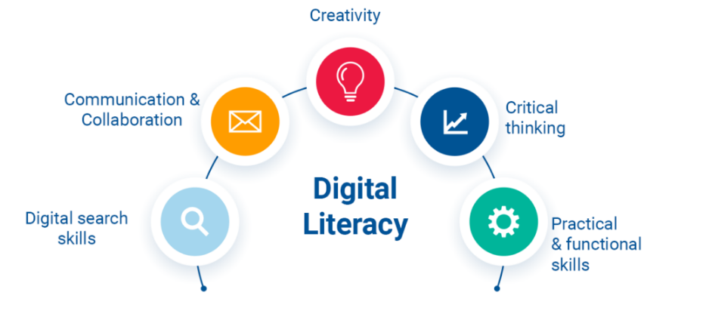
Figure 1: Digital Literacy
Besides, excellent written and oral communication is essential. It is due to the capacity to build code in a transparent way, creating technical reports, discussing the ways to provide solutions to non-technical audience, and collaboration in Agile teams that technical tasks are aligned with the business goal and user needs. These competencies are directly applicable in the case of software development career [4]. It allows exploiting an integrated development environment (IDE) with and without the version control system (Git) and cloud deployment through digital literacy. The process of professional communication ensures success in the involvement in team projects, understandable development of user documentation, and competent contribution at each of the life cycles of the software development.

References
[1] J. Biggs, C. Tang and G. Kennedy, “Teaching for quality learning at university 5e.,” McGraw-hill education (UK)., 2022.
[2] Y. Noh, “A study on the effect of digital literacy on information use behavior.,” Journal of librarianship and information science,, vol. 49, no. 1, pp. 26-56, 2017.
[3] R. Kitchin, “Thinking critically about and researching algorithms.,” The social power of algorithms, pp. 14-29, 2019.
[4] N. Assyne, H. Ghanbari and M. Pulkkinen, “The essential competencies of software professionals: A unified competence framework,” Information and Software Technology, p. 151, 2022.

