International Business Communication (BMBM6021)
Name: Yilong Chen
Student ID: 2100527
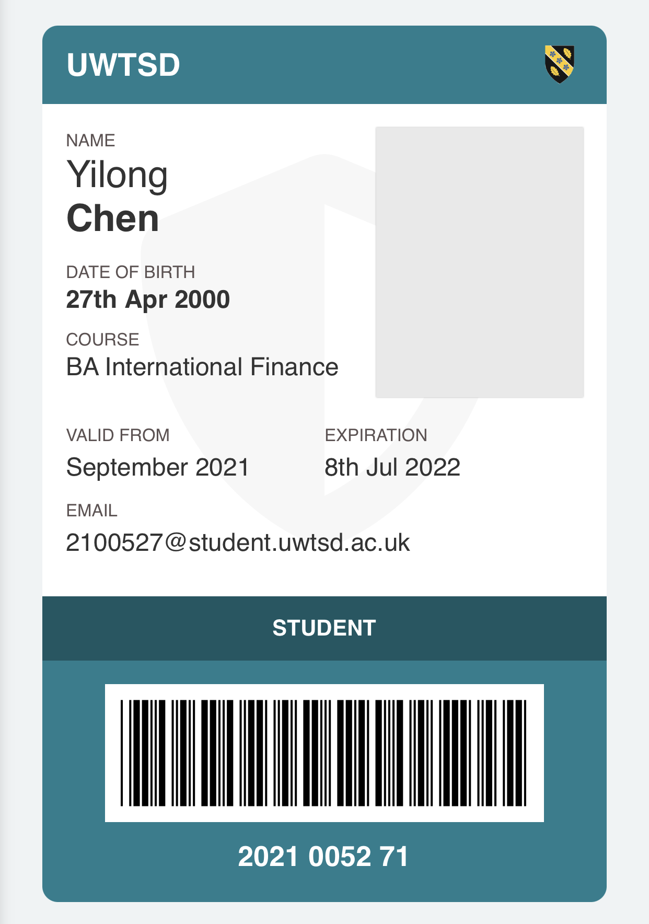
Group Number: 3
The members：Junjie Huang、Dahao Liu、Xiuyu Wu、Yuting Chang
The main body of the report has been submitted by the team leader.

