Assessment 2

Marketing Fundamentals Analysis and Evaluation

Module: Marketing Fundamentals
Module code :LCBB4004

Student’s ID: 2019148

Student name: BOTANOIU MARILENA RALUCA

The role of marketing in creating value
These days, companies are putting their best effort to create and communicate value for the customers. Since the customers have a wide range of choices, they have higher expectations with minimum loyalty to spare if the company cannot meet their demand. Therefore, it can be said that the market is basically a buyers’ market. Before describing the role of marketing in creating value for the customers, we have to understand the term ‘value’ first. Customer value is the satisfaction of what they experience or want to experience by adopting an action associated with a cost in monetary term (Kotler and Keller, 2016). The action which the customers adopt is traditionally buying a certain product, but currently, a sign-up, a vote or a visit are also considered as purchasing action. The cost implies everything a customer must provide to obtain the desired benefit, for instance, money, data, time, knowledge. Value according to marketing is also known as the customer-perceived value which is the difference between the judgement of customer towards the benefits they are getting with a certain cost. More specifically, value is the difference between the benefit and cost of a product or service. This difference between the benefit and cost varies from individuals to individuals. It is mainly a psychological phenomenon where all the customers may not get the same benefit with the same cost. So, customer satisfaction is the key influential factor here which defines how much benefit the customer is getting incurring a certain cost (Guenzi and Troilo, 2018).
Now, how a company can create greater customer value is understanding what drives value for its customers. The first step would be the company has to talk to their customers and conduct a survey to understand their reactions. Simply, the company has to capture information to know what is important for the customers and what opportunities the company has to assist them. After knowing what the customers want, it is time to understand what value proposition the company has to fulfil the demand of the customers. Here, the value is the benefits of an item or service minus its costs which are mentioned in the previous section of the essay (Saunila and Ukko, 2017). The company has to determine what products or services they are offering and in return what prices the customers are incurring to get the product and how much time the customers have to devote to get the product. Now, it is time to select the customer segments where the company can create greater value than its competitors. Various customers will perceive different perceptions of the value relative to the competitors because of the geographical or psychological differences. For instance, a certain attribute of a product may become attractive to one segment which may not be as attractive to other segments. It varies what alternative they have if they want to switch for buying the same product from a different brand (Rock, 2019). Therefore, the company has to set a price for its products which will be a win-win. Setting a price that ensures that the customers are getting higher value relative to the cost incurred maximizes the chances of attracting a more customer base. Satisfied customers who think that the brand is providing a lot of value through the offering are generally willing to spend more, on the contrary, the unsatisfied customers tend to leave the brand even if the company offers the product at a lower price. Most importantly, the company has to focus more on investing in those customers who are the most valuable according to the brand. Allocating the sales force, marketing costs, and research and development efforts for those customer segments that the company thinks that it can serve well and will get greater value in return. The company should also allocate its resources to those products and offerings that serve the customers best (Davenport and Lucker, 2011).

Figure: Customer value (Davenport and Lucker, 2011).
Therefore, a question arises why creating value for a customer is important for a company. Prospective customers do not usually lookout for the company’s products rather the company itself has to approach the customers so that they can be aware of what the company is offering. So, creating customer value is more than the product itself. The customer has to have knowledge about why they should buy the product. When a company is delivering a product, the primary utility of the item does not just change dramatically from customers to customers (BBC Bitesize. 2021). The product may be customised having some additional add-ons, however, the primary functionality of the product remains the exact same. On the other hand, the customer value that a brand delivers may vary dramatically from a circumstance to another. For example, for the customer, quick deliver may provide greater value while for another customer, the value may be the product’s longevity and many other customers may perceive this differently. Since from the business perspective, the primary focus is to provide satisfaction to the customers so creating greater value is the key factor which the company must possess (Breur, 2018).
In this value creation process, marketing plays the most important role since it gets the attention of the target customer segments and generates interest in the company’s offerings. If we think about the objective of the marketing of the new Apple iPhone, the primary objective of the team is to deliver a message to the customers that they have created a new iPhone which has exciting features and the team will also provide information to make aware the customers about the advanced technology they have included in the new iPhone. Therefore, the role of that marketing team is to search for the best and innovating ways to deliver messages to the customers about the iPhone (Spiteri and Dion 2017).
Marketing has numerous role and among them, creating value for the customers is the most vital role. This can be accomplished by delivering the information before launching it and continue this campaign after the introduction of the product as well. Through marketing, a brand communicates to the customers by describing the features a new product possesses and why this is necessary for the customers (Perreault and McCarthy, 2019). While marketing a new iPhone, the brand shows the innovative and creative features available with the new phone. The brand also explains why these features will be beneficial for customers. For example, the new model phone may have a scratch-resistant and anti-reflective screen and the customer will get benefits like the phone will not have any scratches and will be easier to see any elements in the screen especially when the phone is under direct sunlight. After sharing this information, the brand is educating its customers so that they can be aware of the item and can make their purchase decision. This education process is very crucial for generating a high volume of sales. Therefore, marketing is playing its role to create this value for the customers (McCole, 2014).
Marketing also creates needs by making the customers understand why they need the new item. Apple knows that there are many phones in the marketplace which means the customers have a wide range of choices. The job of the marketing team of the iPhone is to assist the customers to believe that they must have an iPhone since the product fulfils their needs. Apple markets the size of the iPhone and how this phone fits flexibly in customers’ hand, its fashionable design and built quality and how it will look when the customers will use it for daily purposes even the faster processing power of the phone. Each of the elements creates customer value and here also the marketing is playing the role to create this value for customers (Denison and McDonald, 2018).
To deliver a certain product to the customer, the company needs information about the targeted customer group, the people who are most likely to the item from the company. The company has to consider various factors when they make their step to reach the customers, for instance, age ranges, income levels, location, education level, and many other factors that determine the prospective customers. Once the marketing team can understand who their customers are, they can generate messages for the customers since one message may not fit all the customers. This also creates value for customers and here also, the marketing is playing the role in creating this value.

Stakeholder engagement and their impact on the marketing activities
Stakeholder engagement refers to the communication by the company with its stakeholders to understand them more clearly. Through this process, the companies become able to know what the stakeholders want and when they want it., to what extent they are engaged and how the organisation is making its planning and actions to ensure their goals. Besides, the companies can ensure improvement in their communication and rethink their strategies that will be beneficial for the organisation in the long run. Every business has two types of stakeholders and they are internal and external stakeholders. Internal stakeholders include investors, employees, customers, supplies, business and local communities. On the contrary, the external stakeholders include competitors, trade associations, media, labour unions, civil society organisation and NGOs, governments, and policymakers (Viglia and Bigné, 2015).
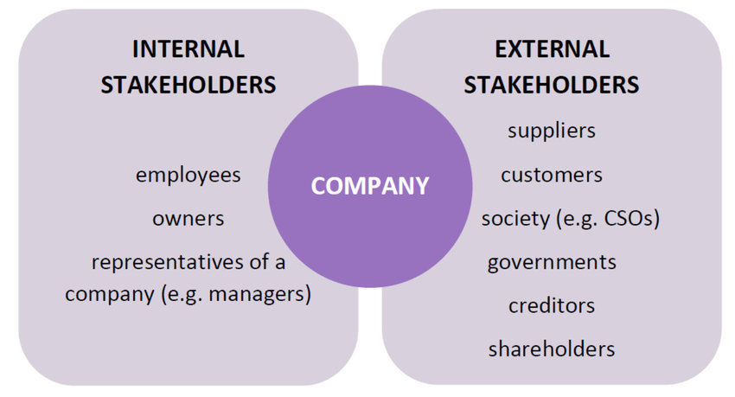
Figure: Different organisational stakeholders (Viglia and Bigné, 2015).
When we talk about the role of different stakeholders in marketing activities, employees’ role will come first since they perform all the marketing activities. Marketing activities become fruitful when all the marketing activities are conducted for the targeted segments effectively. So, here, a lot of strategies are associated that are adopted by the marketing department’s employees. They find out the targeted customer base and start creating value for the segment and finally deliver the value to the customers. Besides, they have to maintain proper communication so that the customers become loyal and spread the good word with other people. Employees have creativity through which they can adopt different strategies. Apart from the employees of the marketing department, employees from other departments also play important role in marketing activities. The HR department recruit’s the necessary workforce for the marketing department and provides a skilled workforce so that they can generate greater customer value to achieve the organisational goals (Armstrong and Kotler, 2016).
The owners of a business are responsible for sales revenue and adopting appropriate marketing campaigns that increase sales. In terms of small and medium business, there hardly any marketing team and so the owner is the sole person to conduct all the marketing activities. Since all the success depends on how the marketing activities are going and if there is any discrepancy, the owner has to take all the responsibility. Therefore, the owners take every possible decision to ensure greater customer value. The owners often initiate marketing activities such as managing campaigns, placing ads, doing email marketing and social media marketing. Currently, most small businesses are conducting their marketing activates by posting ads on different social media platforms that are convenient with lower cost. The owners can accomplish these activates without having any associates. Moreover, the owners are responsible for overall customer satisfaction as well (De Mel and Woodruff, 2013).
The managers of different departments are the key personnel to adopt different marketing strategies for the employees. They find out the ways to solve an issue and the employees accomplish those solutions. For instance, a marketing manager has numerous responsibilities like determining and creating budgets for different marketing campaigns, post them for approval, communicating and working with the ad agencies, involving in negotiations with different clients, creating sales and advertising agreements, and reviewing the ad materials that will be effective in communicating with customers. Other managers, for instance, financial managers provide the necessary funds for different campaigns at the right time (Bianchi and Andrews, 2016).
A fruitful marketing campaign needs a good product to promote. Marketing activities with faulty products will be a wastage of money. In this context, the suppliers have a greater role since they provide the necessary raw materials that are crucial for any businesses. Through marketing, the brand creates value for customers and the value is measured by the benefits they are getting from the product and in return the cost they are incurring for getting the product. So, if the suppliers provide low-quality raw materials, the customers will not get their perceived benefits from the product and so the brand will fail to create customer value. For example, Samsung manages its flagship phone’s processors from Qualcomm, which means Qualcomm is one of their suppliers. If Qualcomm supplies lower quality processors and the customers face any issue, all the marketing efforts of Samsung will in vain. Moreover, suppliers provide information about the raw materials which the marketing team uses to educate the customers (Davenport and Lucker, 2011). So, that is why suppliers have a significant role in marketing activities.
Customers testimonials and recommendations work as a powerful marketing tool. They often generate new customers by giving a product a try. Today, the world is in a digital landscape and here brands have enormous opportunity to ensure more customer engagement so that they can act as an advocate of the brand. The potential customers nowadays look forward to the reviews and about their real-life experiences in different restaurants, physical therapists, dentists, etc. If they find that the reviews are ok, then they attempt to pursue the services from that particular business. Here, the customers are engaging themselves in marketing activities without any cost.

Figure: Customers’ reviews work as marketing tools (Tripadvisor. 2021)
Here in the above figure, the customers have given their real-life experiences and ratings based on their experience through which other potential customers are getting an idea about the restaurant and if they find it better, they go for the service. This way, the customers are playing their role in the marketing activities of a company.
Society provides important information about the needs and wants of the customers so that the companies can adopt strategies to meet their needs and wants. Customers from a particular society have a distinction in product choice and perceived product value due to cultural influences. From the society, the companies collect the necessary information about what elements drive the customers most and they try to include those elements in their offerings. Moreover, based on societal beliefs and customs, the marketer can easily adopt any customer-centric campaigns (McCole, 2014).
The government have their role through different rules and regulations that are applicable in marketing campaigns for different companies. The principles of free speech, competitions are given much priority while making advertisements. Communication through marketing has become an important element in the open market economy through which the marketers are generating innovative ideas having easy access to information. The government ensures healthy competition in the country and so no company can dominate the market with illegal means (Rock, 2019). If any company markets its products with the wrong information, the government takes action against this.
Therefore, it can be concluded that different stakeholders have a different impact on the marketing activities of a company. Not only the internal stakeholders but also the external stakeholders have a significant role in the marketing activities. Their positive engagement increases the product performance which generates greater sales volumes and a higher profit margin. So, when adopting marketing decisions, the companies have to keep all the stakeholders in mind and have to adopt strategies that will ensure greater stakeholder engagement that will assist in marketing activities (Perreault and McCarthy, 2019).

References


