Byblos Site Report

Byblos, on the modern Lebanese coast, is often described as one of the oldest towns to remain inhabited for thousands of years. During the Bronze Age (c. 3000-1200 BC), it grew into an important settlement in the Eastern Mediterranean(Aubet and Turton, 2001). Its position on the Levantine shore, close to a small natural harbour, meant that ships could more easily between Byblos and other coastal communities. At the same time, routes running inland from the coast connected the town to the Beqaa Valley and other parts of the near east(Knapp, 2015). Because of this mix of sea and land links, Byblos became a place where different groups could meet and exchange goods and ideas.
Archaeologists use the term connectivity to describe how places are linked through movement, communication, and shared activities(Horden and Purcell, 2002). Trade usually refers to the movement of goods such as wood, metals, or pottery, while exchange is a wider idea that includes trade but also gifts, shared cultural practices, and even technological ideas(Renfrew, 1975). These ideas are useful for explaining why some Bronze age towns, such as Byblos, became important.
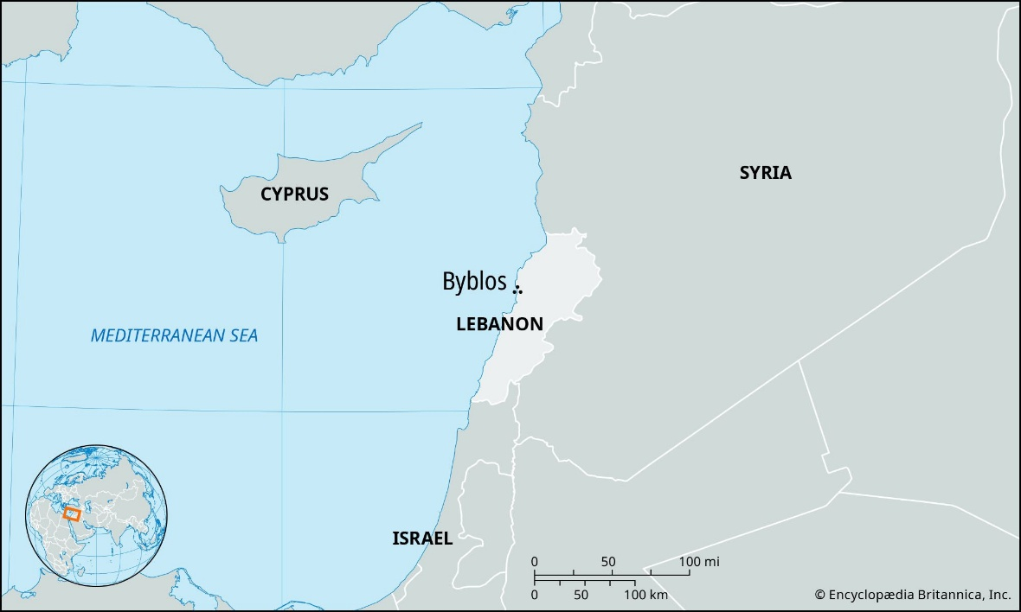
This essay will look at the economic, cultural, and political connections that shaped Byblos during the Bronze Age.
Figure 1 - Location of Byblos on a map
The location of Byblos on the Lebanese coast played a major roll in its development during the Bronze Age. The site sits next to a small but sheltered natural harbour created by rocky outcrops along the shoreline. This harbour was suitable for the types of boats used in the early and middle Bronze Age, and offered a safe point for ships travelling along the Levantine coast (Aubet and Turton, 2001). This made Byblos an accessible stopping point for trade, sailors, and officials moving between Cypress and Egypt, and other Levantine towns.
Behind the town, the landscape rises toward the foothills of Mount Lebanon, an area known in antiquity for its dense forests, echoically cedar trees. Lebanese cedar was in high demand throughout the Bronze Age and was one of the main reasons foreign powers, particularly Egypt, took interest in Byblos(Knapp, 2015). This hinterland also provided agricultural land, water sources, and paths leading inland. These routes connected Byblos to the Beqaa Valley, which acted as a corridor towards Syria, Mesopotamia, and the wider Near East.
Because Byblos had access to both the sea and inland regions, it became a natural link between different economic zones. Maritime routes connected it to long-distance exchange networks, while overland paths allowed goods such as wood, metals, and agricultural products to pass through the city. Environmental stability including reliable water sources and fertile areas nearby, also helped support long-term settlement. Together, these factors explain why Byblos remained an important and prosperous hub for many centuries.
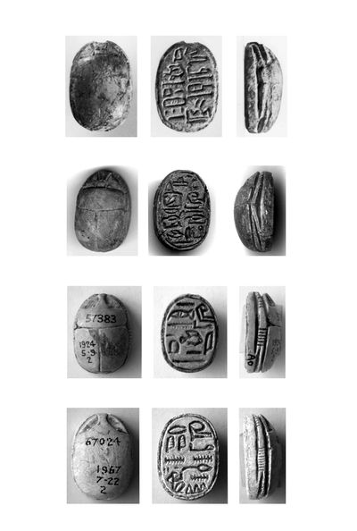
Contact between Egypt and Byblos began very early in the Bronze Age and continued for well over a thousand years. The earliest evidence comes from the early Bronze Age, when Egyptian pottery, stone vessels, and small prestige items began to appear at the site(Aubet and Turton, 2001). Egyptian texts from the Old Kingdom also mentioned expeditions to the to the Levant, with Byblos often implied as a key destination for acquiring raw materials, especially wood. This early interaction set the foundation for a long and close relationship that shaped the development of Byblos throughout the Bronze Age.
Figure 2 - Inscriptions on scarabs found in Byblos
One of the main reasons Egypt was interested in Byblos was the availability of cedar wood from the mountains behind the town. Lebanese cedar was priced in Egypt for use in shipbuilding, elite tomb construction, religious statues, and furniture(Knapp, 2015). In addition to timber, Byblos also supplied goods such as oil, resins, and wine. In return, Egypt sent gold, fine linen, papyrus, and manufactured items including jewellery, tools, and decorated stone vessels. Many of these items have been found in the bronze age tombs at Byblos, demonstrating the movement of Egyptian goods into local elite contexts(Renfrew, 1975).
Archaeological evidence clearly shows the depths of this connection. Scarab’s, amulets, alabaster jars, and other Egyptian-style objects appear often in Byblos tombs, particularly in the Royal Tombs. These fines show not only trade but also the adoption of Egyptian symbols of power and status by the Byblian elites. Egyptian inscriptions also mention Byblos directly. For example, several Middle Kingdom texts described voyages till the Levant in the ships that some scholars associate with the Byblos ship, a vessel depicted in Egyptian art that may reflect the maritime technology of the left(Aubet and Turton, 2001). Byblos even appears in hieroglyphic references as Kbn or Gubla, indicating its recognised status within Egypt’s foreign relations.
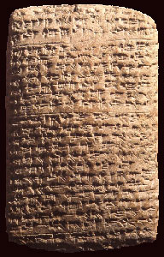
Diplomatic ties also played a major role. The rulers or princes of Byblos maintained formal connections with the Egyptian Pharaohs, exchanging gifts and letters. Middle Kingdom correspondence, along with the later Amarna Letters, show that the king of Byblos acted as a loyal but semi-independent partner to Egypt. These diplomatic exchanges often involved requests for gold or support, suggesting that the elites of Byblos relied heavily on Egyptian prestige objects to maintain their local authority(Donald B. Redford, 1992).
Figure 3 - The Amarna Letters
Egyptian contact also influenced the cultural and religious life of Byblos. Some temples at the site show architectural features that may have been inspired by Egyptian models, and local elites appear to have adopted Egyptian styles in artistic and ritual practises. This suggests that interaction was not limited to trade but extended into identity and political expression. Overall, Byblos strong and long-lasting relationship with Egypt was a major factor in shaping the Bronze Age development.
Although Byblos is best known for its long-standing relationship with Egypt, it was also closely connected with other regions across the Eastern Mediterranean and the Near East. From the early Bronze Age onwards, Byblos interacted with Mesopotamia, Cyprus, and the Aegean world, and these links can be seen in the variety of imported materials recovered from the site. For example, objects made from lapis lazuli - a stone that originated in Afghanistan and arrived via Mesopotamian trade routes - have been found in Bronze Age context at Byblos, showing that the town participated in long distance exchange network stretching far beyond the Levant(Aubet and Turton, 2001). Cooper from Cyprus also reached Byblos, and several types of Cypriot pottery, especially white slip and base ring wares, appear at the site from the middle and late bronze age(Knapp, 2015). These imports indicate regular contact with Cyprus, which was a major centre for copper production during this period.
Byblos position along the Levantine coast made it an important intermediary, acting as a point where goods from inland regions and the wider Mediterranean could be exchanged. Its natural harbour allowed ships to anchor safely, and it's in land connections made it easy for traders to move between the coast and interior routes leading towards Syria and Mesopotamia. Because of this, Byblos played a key role in transferring resources such as wood and agricultural products outward, while receiving metals, ceramics, and prestige items from abroad.
Maritime trade also linked Byblos with other coastal cities such as Ugarit, Sidon, and Tyre. Although these cities grew an importance during the late Bronze Age, Byblos remained part of a wider network of Levantine ports that facilitated the movement of goods and cultural practises around the eastern Mediterranean(Sowada et al., 2021). These harbours formed a chain of stopping points where ships from Cyprus, the Aegean, and Egypt could arrest, resupply, or trade cargo. This coastal interaction helped shape their economic and political landscape of the region.
Cultural exchange accompanied economic trade. One important example is development of writing systems. The so-called Byblos script, used during the second Millennium BC, showed elements borrowed from Egyptian hieroglyphs, Mesopotamia cuneiform, and local Levantine traditions. Some scholars have suggested that early alphabetic writing may have been influenced by these hybrid scribal practises(Kilani, 2019). Although the details remained debated, the presence of multiple writing traditions demonstrates that Byblos was a place where ideas and technologies mixed.
Other forms of cultural diffusion can be seen in artistic motifs, metalworking practises, and religious symbols. Imported items often inspired local craftsman, leading to hybrid styles that blended Egyptian, Levantine, and Aegean elements. Similarly, religious ideas moved across the region, and the major temple complexes at Byblos may show influences from both Egyptian and local traditions.
Overall, the archaeological evidence shows that Byblos was not simply Egypt’s trading partner but a major node in the wider Bronze Age trading world. Its coastal location, harbour, and long-distance connections help shape economic, cultural, and technological interactions across the eastern Mediterranean.
Trade and long-distance exchange had a major impact on the way society developed in Bronze Age Byblos. The steady movement of goods - particularly wood, metals, and luxury objects - helped create a powerful ruling elite who controlled access to commercial networks and managed relationships with foreign states(Aubet and Turton, 2001). This elite appears to have played a central role in organising trade expeditions, protecting caravan routes, and negotiating with foreign powers such as Egypt. Their authority was reinforced through the display of imported prestige items, which signalled wealth and status within the community.
Archaeological evidence for tombs and temples provides an important insight into how exchange shaped Byblian society. The rich royal tombs contained Egyptian stone vessels, gold ornaments, scarabs, and other elite objects, showing that foreign imports we used in burial rituals to express power and identity(Dunand, 1973). Similarly, major religious buildings, such as the Temple of Baalat Gebal, shows signs of foreign influence. Baalat Gebal was considered the patron goddess of the town, but she was also associated with the Egyptian goddess Hathor, suggesting that religious ideas travelled alongside material goods(Charaf, 2024). Egyptian-style motifs found in temple decoration and ritual objects further highlight this cultural bending.
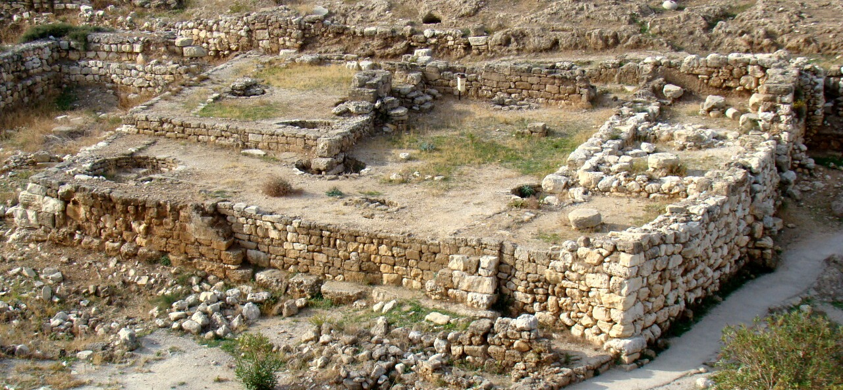
Diplomacy was another important aspect of Byblos’ role in the region. Correspondence preserved the middle and late Bronze Age archives - most famously the Amarna Letters - shows that the rulers of Byblos acted as intermediaries between Egyptian Pharaohs and other Levantine communities(Donald B. Redford, 1992). These letters often discuss political alliances, request for aid, and the exchange of gifts, highlighting the symbolic importance of Byblos in maintaining regional stability. The town's leaders relied heavily on diplomatic relationships to secure economic benefits and strengthen their political position at home.
Figure 4 - Temple of Baalat Gebal
Cultural exchange accompanied these political and economic interactions. Artistic styles in Byblos during the Bronze Age show mixture of Levantine, Egyptian, and occasionally Aegean elements. Local craftsman adapted foreign designs, creating hybrid objects that reflected the towns participation in wider cultural networks. Religious practises also incorporated foreign influences, are seen in iconography, temple rituals, and the adaptation of Egyptian symbols of kingship.
Trade and exchange with deeply intertwined with social hierarchy, political authority, and cultural identity in Bronze Age Byblos. The town's ability to connect different parts of the eastern Mediterranean allowed it to flourish as both a commercial hub and a centre of cultural interaction.
Byblos’ significance during the Bronze Age rested on a combination of geographical opportunity, economic strength, and diplomatic engagement. Its position on the Levantine coast, with access to both maritime and inland routes, allowed it to become a central hub linking Egypt, Mesopotamia, Cyprus, and the wider eastern Mediterranean. The towns control over valuable resources, especially cedarwood, supported a thriving economy and enabled its elite to cultivate far-reaching relationships with foreign powers. Diplomatic exchanges, such as those seen in the Amarna Letters, underline how Byblos acted not only as a commercial centre but also as an important political intermediary.
The archaeological record reveals that Byblos played a key role in early forms of inter-regional connectivity that can be seen as precursors to later globalised systems of trade and cultural exchange. Its hybrid artistic styles, multilingual inscriptions, and imported materials illustrate the depth of its interactions with diverse cultures across the Bronze Age world.

Bibliography
Aubet, M.E. and Turton, M. (2001) The Phoenicians and the West: politics, colonies and trade. 2. ed. Cambridge New York, NY Oakleigh, VIC Madrid Cape Town: Cambridge University Press.
Charaf, H. (2024) ‘The Relations between Byblos and Egypt during the Middle Bronze Age’, in Byblos : A Legacy Unearthed. American University of Beirut Press, p. 123.
Donald B. Redford (1992) Egypt, Canaan, and Israel in ancient times. Princeton University Press. Available at: http://archive.org/details/egyptcanaanisrae00redf (Accessed: 21 November 2025).
Dunand, M. (1973) Fouilles de Byblos....: L’Architecture, les tombes, le matériel domestique, des origines néolithiques à l’avènement urbain. P. Geuthner.
Figue 2, B. (no date) Byblos Ruins, Byblos Ruins. Available at: https://byblosruins.com/artifacts (Accessed: 24 November 2025).
Figure 1 (2025) Byblos | Ancient Phoenician City, Lebanon | Britannica. Available at: https://www.britannica.com/place/Byblos (Accessed: 24 November 2025).
Figure 3 (no date) ‘Amarna Letters | Ancient Egypt Online’. Available at: https://ancientegyptonline.co.uk/amarnaletters/ (Accessed: 24 November 2025).
Figure 4 (2025) ‘Temple of Baalat Gebal’, Wikipedia. Available at: https://en.wikipedia.org/w/index.php?title=Temple_of_Baalat_Gebal&oldid=1296100235 (Accessed: 24 November 2025).
Horden, P. and Purcell, N. (2002) ‘The Corrupting Sea. A Study of Mediterranean History.’, The Journal of Roman Studies, 92, pp. 195–197. Available at: https://doi.org/10.2307/3184867.
Kilani, M. (2019) Byblos in the Late Bronze Age: Interactions between the Levantine and Egyptian Worlds. BRILL.
Knapp, A.B. (2015) ‘The Archaeology of Cyprus from the Earliest Prehistory Through the Bronze Age’, European Journal of Archaeology, 18(2), pp. 361–365. Available at: https://doi.org/10.1179/1461957115Z.000000000121.
Renfrew, C. (1975) Ancient Civilization and Trade. Albuquerque: University of New Mexico Press (School of American Research), pp. 3–60.
Sowada, K. et al. (2021) ‘Early Bronze Age exchange patterns between Egypt and the Levant: a view from First Dynasty Abu Rawash’, Agypten und Levante, 31, pp. 425–449. Available at: https://doi.org/10.1553/AEUNDL31S425.

