

The impact of Virtual Learning Environment Moodle on the learning experience of the students at UWTSD London campus.

Student Name: Abdul Nawade Razak
Student ID: 2020686
Module Name Digital Skills and Research Methods
DSR(BMSW4003) Groupe 2
Lecturer: Ejiro Esohwode

Table OF Contents

1 Abstract 3
2 Introduction 3
3 Rationale 3
4 Research Objectives 3
5 Literature Review 4
6 Methodology 6
6.1 Data collection process 7
6.2 Population 7
6.3 Sample size. 7
6.4 Ethics in data collection 7
7 Findings and analysts 7
7.1 primary data Analysis 7
7.3 Summary of findings. 11
8 Conclusion 12
9 appendix 1 12
9.1 appendix 2 13
10 References 16

1 Abstract

The effect of the virtual learning environment on students' learning experiences at the University of Wales Trinity St David London campus is the subject of this research. It was focused on their survey, which looked at whether using a VLE has a positive or negative effect on student learning.

2 Introduction
Instructors, organisations, and institutions must have a thorough understanding of the advantages and disadvantages of online learning in order for it to be successful and functional. This study is focused on the impact of a virtual learning environment at the University of Wales Trinity Saint David Moodle network, which connects students with learning materials and knowledge.
The main goal is to show the research results using a questionnaire that was provided to different people, as well as to analyse previous articles and data relevant to the questionnaire results using pie and column charts and analysing each one to show the positive or negative effect.

3 Rationale

According to the virtual learning environment Moodle, which is a tool used by most students at university, it is important to keep this tool up to date, particularly at the UWTSD London campus. The best way to do so is to ask its primary users, the students. The aim of this study is to determine the students' knowledge of Moodle and its features.

4 Research Objectives

The aim of this report is to recognise Moodle as an academic forum in which the majority of students considered its structure and recommendations to be simple to use.

5 Literature Review
The exact specific origin of Virtual Learning Environment (VLE) is not fully clear. It has been documented to go as far back as the 1970s where the UK’s Open University were utilising computers to learn. It was not until 2000 when VLE really took off with the advent of commercial computer-based platforms such as, Blackboard. Within ten years Blackboard was being utilised in more than 60 countries and over 3700 educational institutions (Blackboard, 2011). The other competitor in the VLE is Moodle that was first brought to market in 2001, originally developed to help education institutions create online courses through interactive collaboration (Ofsted, 2009). In 2011, Moodle was being used in 212 countries with over 49,000 active sites in 75 different languages (Moodle, 2011).
The use of VLE and technology was encouraged by the UK government to help educators be more effective (Becta, 2010). Ofstead investigated a sample of 34 schools that utilised VLE and the impact of it on students. The report found that over half of the schools in the sample were positive towards the use and impact of VLE on the school’s ability to teach and students learning capabilities. It was also found that in Further Education institutions that 58 out of 281 had VLE and that this helped its students learn (Becta, 2009). A further study conducted by Ofstead (2009) found that VLE was a repository for teaching materials as well as uploading assignments and limited interactive uses. Very few institutions used VLE to help students independent learning. Whereas institutions that utilised VLE for student independent learning believe that technology has contributed to being able to deliver the education more effectively and flexibly.
Scardamalia & Bereiter (1996) report a positive impact of VLEs in student learning in elementary grade students. The use of student – teacher collaboration using VLE was commended and shown to have a positive effect on performance standards in both language and vocabulary and analytical skills as well as depth of understanding through various perspective compared to students that did not use VLE. The authors conclude that VLE helped to maximise student reflection and encouraged progressive thought, development and thinking. Schacter (1999) also displayed that student that had access to VLE such had better result and performance.
Wernet, Olliges and Delicath (2000) surveyed undergraduate and graduates in higher education. Their study investigated whether computer-based technology instruction disadvantaged women, and older non-traditional adults. They found that graduates were more likely to access their studies from home and undergraduates were enthusiastic to use technology to learn. The study concludes that VLE helps non-traditional students and the satisfaction of VLE are from its utility, access and exposure. This study was supported by Diochon and Cameron (2001) that found students have to be active learners while using VLE to benefit most from it and it helped encourage student’s enthusiasm, capacity and confidence. The students created their own learning experience through collaborative experiences that further benefits them to enhance employability skill and competency.
Downing & Chim, (2004) studied higher education as well between student and teacher use of asynchronous discussion. The authors found that usual introverts in classroom behaved more like extroverts when discussing online and were also more actively participating in discussions. This is supported by Rogers (2004), by studying the WebCT on university history students to see whether educational technology helped the quality of cognitive achievement. The study found that 79% assert that VLE had a positive impact, and they were able to understand better whereas 28% preferred more traditional teaching structures.
Ofstead (2009) evaluates the development of VLE in some sample of education settings. They found that VLEs were relatively new to their sample. Higher education made better use of it than primary education institutions. VLE was found to have a positive impact as it allowed for catch up of missied work. However, discussion facilities were used very little. Furthermore, access to broadband was also a limiting factor in how effective they are. It was recommended in their report the VLE should be used and encouraged. Becta (2009) also concluded that courses with VLE had better achievement that only traditional in-person classes. This is supported by Means, Toyama, Murphy, Bakia & Jones (2009) found in their meta-analysis of online learning in the US that students in a blended course structure with both classroom and online learning learned more o average than students in only classroom-based courses.
It can be said to summarise that VLE have a range of positive impact in various aspects, such as promoting reflection, increase enthusiasm, increase confidence and eagerness to learn and meets the needs of all types of students. It has also shown to improve the course performance results.
There have been some studies that report a negative impact of VLEs. Muirhead, (2001), Seabolt & Arends, (2000); and Crook, (2000) all argue that internet-based instructions does not allow for any social and emotional interaction like in traditional classroom learning environment. Piccoli, Ahmad, and Ives (2001) used a longitudinal experimental design of classes using VLE and teacher led classes. Their study found no significant differences in learning performance between the two different environments. However, there was a lack of satisfaction in the participant in VLE. Robertson and Klotz (2002) also agree to this and assert that students in a VLE do not have the opportunity and benefits of being involve in a structured dialogue, debate and a community feel that exits in a traditional on-site classroom structure.
Read, Coles, Frey & Littlefield (2013) argued that VLE use was limited to mainly as repository, facility to set homework and share sites with the students. Very few teachers used collaborative tools to teach and learn. This was attributed down to the time it took to train staff. However, their study does not consider the student experience of VLE.
Demian & Morrice (2012) found in their study of Higher education student’s performance on two final year undergraduate modules. One of it had very little VLE impact whereas on the other had a more moderate impact on their performance. However, both findings were not significant.
In summary, the impact of VLE on student learning and teaching is mixed. While there are obvious benefits of VLE such as improved performance in academic results as well as more subtle benefits such as motivation, enthusiasm and interactive nature as well as helping introverts participate more. There is also a negative impact from it that might not be so easy to spot, such as the lack of classroom-based debate and dialogue, it becomes less interactive with humans, that will impact the development of certain skills required in the real world, such as communication. Therefore, I would conclude while there are benefits of VLEs such as catching up on missed work and make students independent in their studies and learning it is also still very important to have that traditional classroom-based element to help further build on the development and growth of students. Therefore, I would suggest and prefer to see a mixture of both traditional classroom interaction as well VLE to support this.

6 Methodology

research methodology. this is the philosophy or the Journal principle which will guide your research. (Catherine 2009 p14)
qualitative research explores attitudes behaviour and experiences through such methods as interviews or focus groups. (Catherine 2009 p14)
quantitative research generates statistics through the use of large-scale surveys. Research using methods such as questionnaires or structured interviews. (Catherine 2009 p14)
The methodology used in this report contains both qualitative and quantitative data since I designed a questioner with choice-based open and closed ended questions.

6.1 Data collection process
Primary data refers to all information that we collect ourselves, such as by questionnaire surveys or interviews. Secondary data is information that we did not collect ourselves but instead got from other sources like books, the Internet, or newspapers.
I will use both primary and secondary data in this article: primary data from a questionnaire and secondary data from previous and additional literature studies.

6.2 Population
This survey was only conducted among Uwtsd students.

6.3 Sample size.
Students at the uwtsd London campus are the focus of this research. A total of 13 students replied to the survey about Moodle, a virtual learning environment, and its effect on students.

6.4 Ethics in data collection

In order to protect individual privacy, data collection and research policy should adhere to the highest ethical standards. This is important to note because I will be using information and data gathered from their thoughts and answers to the questionnaire.

7 Findings and analysts

7.1 primary data Analysis

I well be analysing all of the questions from the questionnaire in depth in order to find the primary data for this study. Pie and column charts are among the findings.

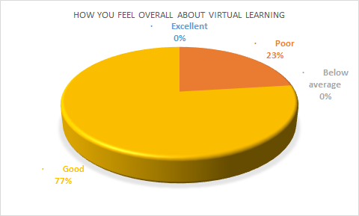

Good | Average | poor | Below average | Excellent
10 | 0 | 3 | 0 | 0

we can see from the first graph that the majority of students enjoy using the virtual learning environment. Most students enjoy this form, but a few do not. There are a few things that could be done to make their experience better.

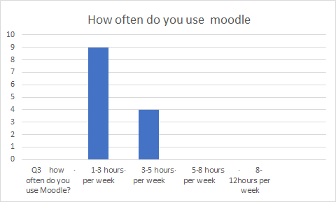

• 1-3 hours per week | 9
• 3-5 hours per week | 4
• 5-8 hours per week | 0
• 8-12hours per week | 0
we can see from the graph that most students use Moodle 1-3 Hours per week
And 4 out of 13 used 3-5 hours per week.

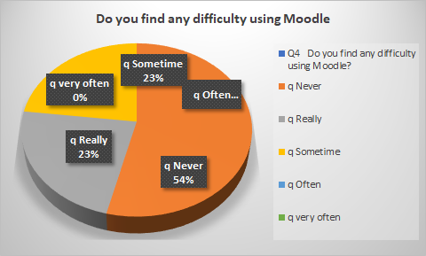

q Never 7
q Really 3
q Sometime 3
q Often 0
q very often 0

On the chart we can see that most of the students do not face any problem.

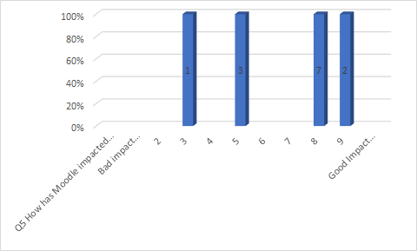

1 | 2 | 3 | 4 | 5 | 6 | 7 | 8 | 9 | 10
0 | 0 | 1 | 0 | 3 | 0 | 0 | 7 | 2 | 0

The results for the question. How has Moodle impacted your virtual study? 9 out of 13 people said they had a positive impact, three said they were in the middle, and one said they had a negative impact. Overall, the students thought it was a good experience.

7.3 Summary of findings.

Summary of findings from my analysis of the questionnaire's closed-ended and open-ended questions Overall, the outcome was positive.
It included open-ended questions like What benefit/disadvantage did you find in your virtual learning experience?
The majority of students reported that the advantages include saving money on travel costs and the ability to learn on their own time, in their own environment, and at their own pace, giving them more flexibility. Connection issues may cause students to miss out on important details, and a lack of engagement can contribute to self-isolation.
The majority of students enjoy using the virtual learning environment, as seen in the first graph.
most of the students do not face Any difficulty using Moodle.
Question about how Moodle has impacted your virtual studies? Nine people out of thirteen said they had a positive impact, three said they were in the centre, and one said they had a negative impact. Overall, the students found the experience to be enjoyable.

8 Conclusion
In conclusion, the virtual learning environment Moodle has had a positive impact at UWTSD because it is an effective system that students are familiar with and that is easily accessible.

9 appendix 1
Q1 How you feel overall about virtual learning?
- Poor
- Below average
- Good
- Excellen
Q2, do you enjoy virtual learning?
- Yes
- No
Q3 how often do you use Moodle?
- 1-3 hours per week
- 3-5 hours per week
- 5-8 hours per week
- 8-12hours per week
Q4 Do you find any difficulty using Moodle?
- Never
- Really
- Sometime
- Often
- very often

Q5 How has Moodle impacted your virtual studies?

Bad impact Good impact
1 | 2 | 3 | 4 | 5 | 6 | 7 | 8 | 9 | 10

Q6 What benefit / disadvantage did you find in virtual learning experience explain?
Q7 Which learning would you prefer class learning or virtual learning?
- Class learning
- Virtual learning
Q8 Did you find virtual library useful?
- Yes
- No

9.1 appendix 2

Q1 How you feel overall about virtual learning?
• Poor | 3
• Below average | 0
• Good | 10
• Excellent | 0

Q2 Do you enjoy virtual learning?
q Yes | 10
q No | 3

Q3 how often do you use Moodle?
• 1-3 hours per week | 9
• 3-5 hours per week | 4
• 5-8 hours per week | 0
• 8-12hours per week | 0

Q4 Do you find any difficulty using Moodle?
q Never | 7
q Really | 3
q Sometime | 3
q Often | 0
q very often | 0

Q5 How has Moodle impacted your virtual studies?
Bad impact 1
2
3 | 1
4
5 | 3
6
7
8 | 7
9 | 2
Good Impact 10

Question 6: What benefit/ disadvantage did you find in virtual learning experience explain.
Most of the students responded by saying they are saving on travelling expenses and is allowing
students to learn on their own time, in their own place, and at their own pace, giving them more flexibility.
Disadvantage
connection issues may cause students to miss out on crucial information, and a lack of contact can contribute to self-isolation.

Q7 Which learning would you prefer class learning or virtual learning?
q Class learning | 8
q Virtual learning | 5

Q8 Did you find virtual library useful?
q Yes | 4
q No | 9

10 References
Cahterine (2009) Introduction to Research Methods.4th Edition: Publisher Constable & Robinson new york
Becta (2009) The impact of digital technology (Coventry, Becta).
Becta (2010) Harnessing Technology Review 2009 The role of technology in further education and skills (Coventry, Becta).
Crook, C. K. (2000) Motivation and the ecology of collaborative learning Rethinking collaborative learning, London, Free Association, 161-178.
Demian, P. & Morrice, J. (2012) The use of virtual learning environments and their impact on academic performance. Available online at: http://www.heacademy.ac.uk/assets/documents/subjects/engineering/Engi neering_Journal/demian_EE_7-1.pdf
Diochon, M. C. & Cameron, F. (2001). Technology-based interactive learning. Active Learning in Higher Education, 2(2), 114-127.
Downing, K., & Chim, T. M. (2004). Reflectors as online extraverts? Educational Studies, 30(3), 265-76.
Means, B., Toyama, Y., Murphy, R., Bakia, M., & Jones, K. (2009) Evaluation of Evidence-Based Practices in Online Learning (US, Dept of Education Centre for Technology in Learning).
Moodle (2011) Moodle. Available online at http://moodle.org/
Muirhead, B. (2001) Enhancing social interaction in computer-mediated distance education, United States Distance Learning Association Ed at a Distance Magazine and Ed Journal, 15(40). Available online at: www.usdla.org/html/journal/APR01_Issue/article02.html
Ofsted (2009) Harnessing technology – transforming learning and children’s services (1296-2005DOC-EN), DfES 2005. Available online at: www.dcsf.gov.uk/publications/e-strategy
Piccoli, G., Ahmad, R. & Ives, B. (2001). Web Based Virtual Learning Environments: A research framework and a preliminary assessment of effectiveness in basic IT skills and training, MIS Quarterly; 25(4), 401-427.
Read, D., Coles, S., Frey, J., & Littlefield, B. (2013) Investigating the use of Virtual Learning Environments by teachers in schools and colleges. Available online at: http://eprints.soton.ac.uk/342377/1/DRead_VLE_report.pdf
Robertson, T. J. & Klotz, J. (2002) How can instructors and administrators fill the missing link in online instruction, Online Journal of Distance Learning Administration, 5(4). Available online at: http://www.westga.edu/∼dist ance/ojdl a/winter54 /roberson54.htm
Seabolt, B. & Arends, B. (2000) Remaining real in a virtual world. Available online at: http://www.webct.com/service/viewcontentframe?contentID=2385857&pag eName=index.html
Scardamalia, M. & Bereiter, C. (1996) Scardamalia & Bereiter’s Computer Supported Intentional Learning Environment (CSILE) Studies (USA, CSILE Learning Gains).
Wernet, S. P., Olliges, R. H., & Delicath, T. A. (2000) Postcourse evaluations of WebCT (Web Course Tools) classes by

