Mariusz Kalasz
1805456 | Game Development
Application Development Assignment

Table of Contents
Introduction 2
Application Development Concepts 2
Requirements 6
Design and Implementation 7
Evaluation 11
Bibliography 14

Introduction
This report will contain all the requirements, design and the implementation of those designs, and the evaluation of the final software which will include testing of the main mechanics. The software is a 2D platformer game called Rabbit Run. The report will also include a research on the current development trends.

Application Development Concepts
Game development is still a growing area with new trends coming out every year, the most recent trends in game development are [1 - 2]:
- Augmented Reality [1]
- Cross-Platform Play [1]
- Mobile Gaming [1]
- Virtual Reality [1]
- Artificial Intelligence [2]
In this report Augmented Reality (AR) will be discussed in more detail, mainly how it can help in education by using AR Interactive Games to make learning more fun.
  - How does AR work
Firstly, it is important to explain what AR is. “Augmented Reality (AR) is the integration of digital information with the user’s environment in real time” [3]. It doesn’t work on the same basis as Virtual Reality (VR) as AR instead of creating a fully digital world for the user to be in it uses the user’s surroundings and overlays new information on top of it. For example, with a mobile device, it uses a live feed from the device’s camera then the app places 3D digital content into that live feed making it seem that they are part of the real world. For the device to understand what it sees, it needs computer vision. Computer vision which uses semantics and geometry to display the digital content the right way, semantics are used to recognise of what the real world object is, this can be an image or a face, geometry is for where the real life object is in the environment, so the device takes the position and the angle which the real life object is at in reference to the device’s camera [4].
The computer vision techniques are quite different from each other. The semantics side has seen a lot of progress recently due to Deep Learning, which is an “artificial intelligence function that imitates the workings of the human brain in processing data and creating patterns for use in decision making” [5], which typically can figure out the real life object without needing the 3D geometry aspect. This on its own enables basic form of AR, as the device recognises the real-life object, but the digital content will be out of place, as it will not be anchored to the real-life object [4]. For it to be anchored to the real-life object it will need the geometric part of computer vision, which is built on concepts of projective geometry, a “branch of mathematics that deals with the relationships between geometric figures and the images, or mappings, that result from projecting them onto another surface” [6], for example shadows cast by opaque objects. So for example for the real-life object the device needs to know its position and orientation respect to the device’s camera to anchor the digital content correctly when it is displayed [4].
To display the digital content some logic needs to be first defined, this will define what to display depending on what real-life object is recognised. In a live AR system, when the real-life object is recognised the rendering module displays the relevant content onto the camera feed. Another way of explaining how AR works is to consider computer vision as inverse rendering, it recognises the 3D world from a 2D image and then it adds the digital content that is then rendered onto the 2D display [4].
  - The Benefits of AR in education
This report also will discuss why AR can help students in education, the benefits of it are:
- Increased content understanding
- Learning spatial structure and function
- Learning language associations
- Long-term memory retention
- Improved physical task performance
- Improved collaboration
- Increased student motivation
[7]
These will be touched on more later, but the benefits of using AR in education are impressive. Many of these benefits work on increased motivation of students as they have more enjoyable learning process, so they look forward to their lessons. Long-term memory retention can be explained by how the AR educational apps are more varied from the standard lessons but again this links in with motivation.
  - The peer reviewed journal
This can be backed up by the research by Taskiran [reference]. The research paper is on “The effects of augmented reality games on English as foreign language motivation” this is where students learn English as a foreign language, the paper was based in Anadolu University, Turkey.
To summarise the study, the author has done multiple tests with 83 randomly chosen students of Anadolu University School of Foreign Languages (AUSFL). 41 of the students were placed in Intermediate level classes and 42 were placed in Lower Intermediated level classes, this was based on a placement test administrated by AUSFL at the academic year of 2016-2017. The tests included 4 different games which each one has different areas of learning; the following are the games and what their learning outcomes were:
- Game 1 (Messy Room) the main purpose of this game was to place all given objects correctly into a messy room by following instructions | Learning outcomes: practicing prepositions of place, practicing newly learned vocabulary, practicing speaking, listening and reading. [8]
- Game 2 (Let’s go to the movies) the main purpose of the game was to fill in movies, showtimes and movie theatre’s schedule correctly | Learning outcomes: scanning, recognizing newly learned vocabulary, practicing listening and reading. [8]
- Game 3 (Treasure Hunt) the main purpose of the game was to reach the destination by following the steps correctly | Learning outcomes: recognizing newly learned vocabulary, practicing listening, speaking and reading, recognizing language structures, retaining and transferring knowledge. [8]
- Game 4 (Fast Reporters) the main purpose of the game was to report what is heard correctly in order to transcribe a speech to text by dictating | Learning outcomes: practicing listening for specific information, practicing reported speech, practicing writing. [8]
The results were taken by using a survey which was based off the Intrinsic Motivation Inventory (IMI).
  - Data Analysis
The Likert-type items are part of the ordinary measurement scale so those were analysed by mode or median, however the Likert scale data were analysed, which are four or more Likert-type items which are combined into one score, this was analysed at the interval measurement scale. [8]
  - Findings
Descriptive statistics were used for the first research question, which observed the EFL learners’ attitudes to their experience of AR-based learning, all the participants answered the questionnaire, which had a scale of 5.00 (highest score) to 1.00 (lowest score) . The findings are as follow:
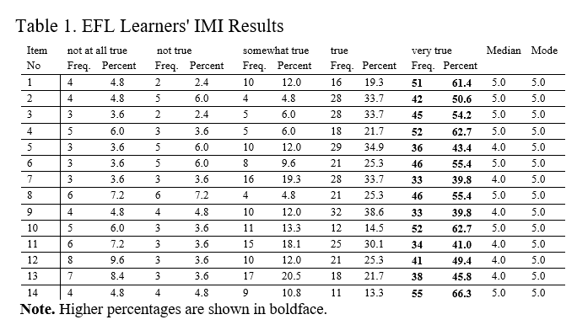
[8]
In table 1, the mode of the answers was “very true” (shown in bold) which was the most frequent score for all questions in the IMI. Question 14 had the highest score with 66.3% and question 12 had the highest “not all true” answer frequency. However, in general the initial scores show that the students have enjoyed the AR learning materials, they enjoyed the application and perceive it as a valuable experience for their learning process.
The second question, which asked if there was a difference between the interest/enjoyment and the value/usefulness of the AR learning materials.
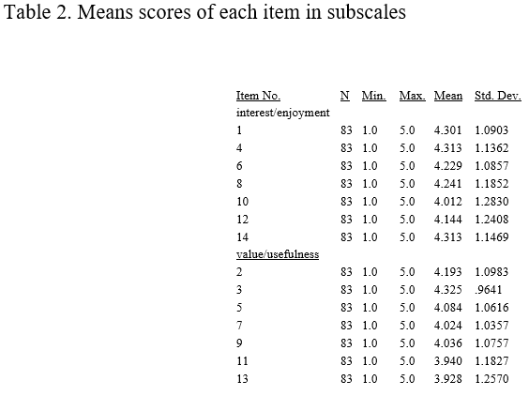
[8]
Table 2 shows the mean scores for each item in each subclass. As shown both subclasses had around a 4.00 score, however questions 11 and 13 did have a slight drop.
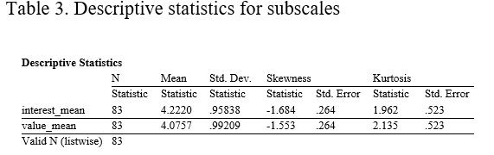
[8]
Table 3 shows the mean score of each subscale. As the results show but subscales scored around 4.00, so the participants appreciated the app and enjoyed the experience. However, the interest/enjoyment subscale has a slightly higher mean compared to the value/usefulness subscale. Table 3 also show the skewness and kurtosis of value for each mean. The interest/enjoyment; skewness: -1.6, kurtosis:1.9. The value/usefulness; skewness: -1.5, kurtosis: 2.1. Therefore, the data was normally distributed.
In order to get a clearer result about the significance of the difference between the mean scores of subscales. So, the means of each subscale were calculated and paired with sample t-test.
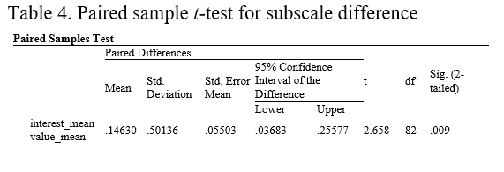 [8]
Table 4 shows the results of paired sample t-test. As the results show, the difference between the two subscales is quite noticeable, since the descriptive statistics box revealed that the interest mean (4.2220) is much higher than the value mean (4.0757), so it can be concluded that the students found the AR games more interesting.
  - Author’s Conclusion
The summery of the author’s conclusion on the study is that the students of EFL found the AR activities enjoyable and motivating, and the scores from the questionnaire show that the activities drew their attention. Therefore, “the AR technology succeeded in providing interest, motivation and joy in English language classrooms” [8].
Furthermore, the value subscale scores show that the students have valued the AR based learning materials for their usefulness and that it helped with their language skills, majority of the students would do the activities again.
“All in all, implementation of AR as a mobile learning experience in language classrooms provides language learners with intrinsically motivating gameful experiences, challenge and joy.” [8]
  - Conclusion
In conclusion AR technology can be very useful for education as shown by the background research and by the results which the study has provided, as AR activities make students more motivated and interested in the subject. Even though the study spoke about EFL learners, AR can be used in all subjects and topics, for example in physics or chemistry, those subjects require more visualisation of particles or other experiments which schools cannot do due to health and safety reasons.

Requirements
Rabbit Run is a 2D platformer where the player plays as a bunny called Bun. The objective of the game is to reach the end whilst collecting the flowers with different score values (some are harder to reach than others) and avoiding evil sparrows which can push the player off the platforms. The game also contains three levels with their own platforming challenges.

The game needs to:
- Allow the player to move in both directions
- Have a minimum of 3 levels
- Have a goal
- Have randomly generated objects
  - Rules of the game:
To play the game the player can use either A or D to move the player left or right respectively, or they can use the left arrow and right arrow keys to do so. For the player to jump they can use the spacebar.
There are two main challenges of the game, avoiding the sparrows and collecting as many flowers as possible. The other minor challenge is not to fall of the platforms. The sparrows themselves are randomly generated so the player needs to have quick reactions to dodge them as it is not entirely sure when they will appear and where. The flowers are set all along the levels with the higher worth ones more hidden or harder to reach places. The platforms are set as well however in certain levels the platforms are more hidden/harder to land on.
There are no termination conditions in this game, the point of it was more of to survive and get to the end. However, this could be added in future development.

Design and Implementation

  - Main Designs
Level 1:
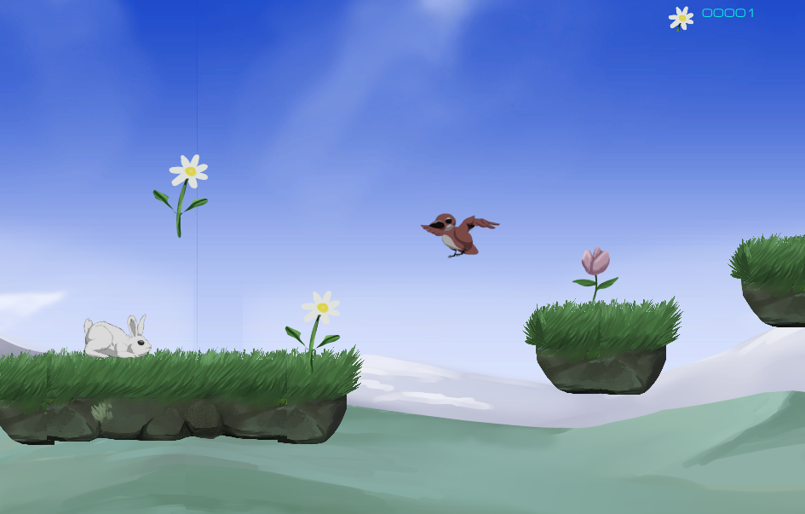
This is the first level of the game, the design for this was making a nice looking and bright level as it makes a good start for the game. There are two kinds of platforms the long platform and short platform, these give a good variety in platforming. There are also 3 collectibles which are the white flower, purple flower and yellow flower (which is not shown in the screenshot). The screenshot also shows the enemy in the game which is the brown bird. The player is the white rabbit.

Level 2:
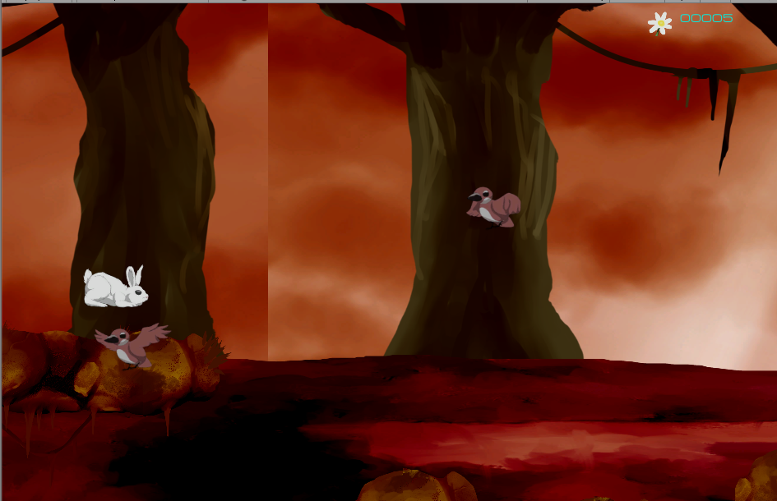
This is the second level which is a bit more dark and same shades of colours, the main challenge here is that the platforms are much lower than normal, some platforms the user will be able to see it a little bit. Also, as the colours are really similar so the platforms camouflage in the background. The collectibles are the same as of level 1.

Level 3:
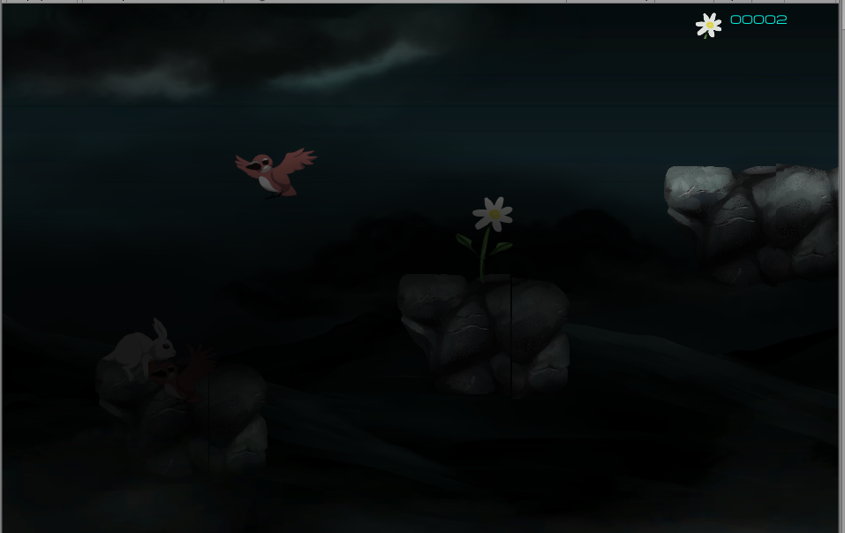
Level 3 is one of the hardest levels, this is due to the additional “mist” effect over the whole level. Therefore, it is hard to see the platforms, the collectibles and the enemies, but the player can still see the outlines of them as they are a bit brighter than the mist and the mist itself is a bit transparent.

Gates:
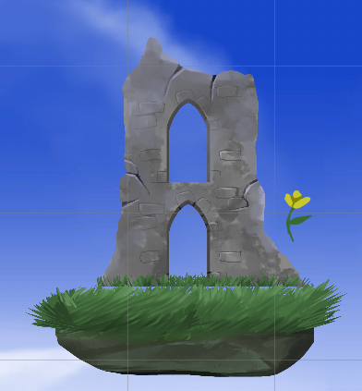
This is the gate; the gates are in all 3 levels and they are the way for the player to continue to the next level. They are all basically the same only difference is that they are different colours, so they fit more to the levels. (The third type of flower is also shown in the screen shot).
Game Completion Screen:

This is the game completion screen which is triggered after the player reaches the final gate in the 3rd level. It is a basic completion screen that congratulates the player.
  - Main Implementations
The main scripts which were implemented are (the solution has more scripts however they were never used):
- BaseCharecter.cs – This is the base script for other character scripts.
- Birbs.cs – this script is used for the birds in the game, it mainly sets up the distance from the player to the object, so it deletes if it’s too far away.
- EnemySpawner.cs – this script is used to spawn the birds in random positions during the level.
- Flower.cs – this script sets up the collectible of the flowers, so the points are collected, and the object is deleted when the player collides with them.
- Player.cs – this script allows the user to control the player character and it script also sets up the health and damage parts which the player character has and receives (however these parts were not really used)
- GameManager.cs – the game manager, manages the game. It was mainly used to keep track of the score.
- UIManager.cs – this manages the UI and it updates the score and health values, it works with the game manager.
- BaseMoveStrat.cs – this is the base script which all movement is based off (except of the player movement).
- FlyHoriz.cs – this script is used only for the birds so they can fly from right to left (or vice versa) it also sets up the speed at which they travel.
- MovePlayer.cs – this script is used for player movement; it includes the input of keys and the flipping of the player sprite if it changes direction.
- TrackTarget.cs – this is used for the bird script for the tracking.
- BasePlayerTrigger.cs – this is the base script for all other triggers (except of the gate collision).
- GateCollison.cs – this script is used for the gates in the game, so when the player enters its trigger collider the next level is loaded up.
- CamraFollow.cs – this script makes the camera to follow the player character.

Evaluation

  - Testing of main features (verification and validation)
Test No. | Test description | Pre-requisite | Test steps | Input | Excepted output | Actual output | Test result
 |  |  | Player | Movement
1 | To test if the character can move right, the animation plays correctly and the sprit flips (if facing the wrong way). | The game is running | Check if the character moves right.  Check if character animations play.  Check if the character’s sprite flips. | Pressing the “D” or right arrow button. | The character moves right with the right animations play correctly.  The sprite will flip to face in the right direction. | The character moved right, and the animations played correctly.  And the sprite flipped in the right direction. | Pass
2 | To test if the character can move left, the animation plays correctly and the sprit flips (if facing the wrong way). | The game is running | Check if the character moves right.  Check if character animations play.  Check if the character’s sprite flips. | Pressing the “A” or the left arrow button. | The character moves left with the right animations play correctly.  The sprite will flip to face in the right direction. | The character moved left, and the animations played correctly.  And the sprite flipped in the right direction. | Pass
3 | To test if the character jumps when the button is pressed. | The game is running | Check if the character jumps.  Check if the character cannot jump multiple times in the air. | Pressing the spacebar button. | The character jumps, and its not able to jump multiple times in the air. | The character jumped and it was not able to jump multiple times in the air. | Pass
4 | To test if the character does not get stuck on the sides of the platforms. | The game is running, and the character hit the side of a platform | Check if the character slides off the side of the platform. | There are no inputs for this test | The character should slide off the side of the platform | The character did slide off the side of the platform | Pass
 |  |  | Collectibles
5 | To test if the collectibles are collected correctly | The game is running, and the player touches the flower. | Check if the collectible disappears after it being collected.  The Hud score gets updated after it being picked up. | There are no inputs for this test. | The collectible disappears after it being touched by the player.  The score gets updated | The collectible did disappear, and the score did update. | Pass
 |  |  | Enemies
6 | To test if the enemies spawn in correctly | The game is running. | To check if the enemies spawn randomly within the set boundary. | There are no inputs for this test. | The enemy spawns in the boundary. | The enemy spawned in the boundary. | Pass
7 | To test if the enemies move correctly | The game is running | To check if the enemies move in the right set direction.  To check if the animations play correctly. | There are no inputs for this test. | The enemy moves in the right direction and the animations play correctly. | The enemy moved in the right direction and the animations played correctly. | Pass
8 | To test if the enemies can push the player off. | The game is running. The player needs to collide with the enemy. | To check if the player reacts to the enemy’s collision box. | There are no inputs. | The player gets pushed by the enemy if collided. | The player got pushed when it collided. | Pass
 |  |  | Level | Transition
9 | To test when the player triggers the gate that the next level loads up correctly | The game is running. The player needs to trigger the gate. | To check if the trigger set up on the gate loads up the next level correctly. | There are not inputs. | The next level loads correctly. | The next level loaded successfully. | Pass
 |  |  | UI
10 | To test if the UI works correctly | The game is running. | To check if the score gets updated on the UI.  To Check if the score is kept when the next level is loaded. | There are no inputs. | The score gets updated,  The score us kept after the next level load. | The score got kept.  However, the score resets after the next level load. | Fail.

To evaluate the final solution, the game is functional but in the bare minimum of it and its usability is that you can play the game normally however it misses some ease of use parts to it, the level and character design is good, the UI is lacking.
In future development it would be good to improve on the ease of use of the game, for example adding a pause menu and a game over screen which allows the user to restart from the beginning of the game instead of the user needing to restart the game itself to start again if they fall off. The design of the UI could be improved as well, for example maybe adding a timer and the end of the game it becomes an addition to the final score depending on how fast the user completed the game, also a health bar would a good addition but the option of the enemies being able to push off the player is more challenging in the author’s opinion. Implementation of additional scripts would be good as well, for example a script which saves the score over all the levels instead of it being reset every next level.

Bibliography

[1] | Swagsoft, “5 Hot Game Development Trends to Watch For in 2019,” Swagsoft, [Online]. Available: https://swagsoft.com.sg/blog/5-hot-game-development-trends-to-watch-for-in-2019/. [Accessed 1 December 2019].
[2] | N. Rue, “Artificial Intelligence & Game Development: Recent Trends,” becominghuman.ai, [Online]. Available: https://becominghuman.ai/artificial-intelligence-game-development-recent-trends-a08a67769a63. [Accessed 1 December 2019].
[3] | M. Rouse, “Definition: Augmented Reality (AR),” WhatIs, February 2016. [Online]. Available: https://whatis.techtarget.com/definition/augmented-reality-AR. [Accessed 1 December 2019].
[4] | Luca, “WHAT IS AUGMENTED REALITY (AR) AND HOW DOES IT WORK?,” blippAR, 28 August 2018. [Online]. Available: https://www.blippar.com/blog/2018/08/21/what-is-augmented-reality-and-how-does-augmented-reality-work. [Accessed 1 December 2019].
[5] | M. Hargrave, “Deep Learning,” Investopedia, 30 April 2019. [Online]. Available: https://www.investopedia.com/terms/d/deep-learning.asp. [Accessed 2 December 2019].
[6] | B. Artman, “Projective Geometry,” Encyclopædia Britannica, 1 June 2018. [Online]. Available: https://www.britannica.com/science/projective-geometry. [Accessed 2 December 2019].
[7] | emily, “The Benefits of augmented reality in education,” QuantumERA, 3 June 2019. [Online]. Available: http://quantumera.com/augmented-reality-in-education/. [Accessed 2 December 2019].
[8] | A. Taskiran, “The effect of augmented reality games on English as foreign language motivation,” 14 December 2018. [Online]. Available: https://journals.sagepub.com/doi/10.1177/2042753018817541. [Accessed 1 December 2019].
[9] | H. Oza, “The benefits of augmented reality in eductation and learning process,” Talk Business, [Online]. Available: https://www.talk-business.co.uk/2018/07/09/the-benefits-of-augmented-reality-in-education-and-learning-process/. [Accessed 1 December 2019].
[10] | D. Wood, “Unity 2D Game Development Tutorials,” YouTube, 10 October 2016. [Online]. Available: https://www.youtube.com/playlist?list=PLGmYIROty-5YhzMWqgAIXlPIRU2_tcz0l. [Accessed 7 December 2019].
[11] | A. Zotov, “How to spawn enemies randomly in Unity 2D game | Unity 2D tutorial,” YouTube, 17 January 2017. [Online]. Available: https://www.youtube.com/watch?v=AI8XNNRpTTw. [Accessed 8 December 2019].

marking criteria and Student FEEDBACK

This section details the extent to which the assessment criteria are demonstrated by you, which in turn determines your mark. The marks available for each category of skill are shown. Lecturers will use the space provided to comment on the achievement of the task(s), including those areas in which you have performed well and areas that would benefit from development/improvement.

Common Assessment Criteria Applied (Assignment 1) | Marks available | Marks  awarded
1. Engagement with Literature Skills

A very good and informative discussion of the chosen application trend and a good summarisation of the related research study. Please note that when summarising results from related research studies you do not have to include all the result information. A summary sentence or two of the main findings will do. (Grade mark: 76.00%) | 25 | 19
2. Knowledge and Understanding Skills

3. Cognitive and Intellectual Skills

A good set of test cases and very good, relative evaluation has been provided. (Grade mark: 67.50%) | 20 | 13.5
4. Practical Application Skills

A good attempt featuring a simple game based on the class tutorial exercise. While trying to implement some additional scripts, you ended up duplicating existing functionality and these scripts often had public fields and unnecessary public methods. The main area for improvement is learning how to use object-oriented coding practices and know when and how to expose fields and also when you should make your methods public. If you need to make fields accessible to the Inspector, then use the SerializeField attribute, if you need to make them accessible to other classes, then make use of properties and not all methods need to be made public. Also, avoid hard-coding game tags and game object names. Yes a lot of sample scripts you see would do this, but there are better ways to implement this and note that some of the Unity Find functions are resource intensive too. Learn how to use the Event system too. As you have stated, there is quite a bit of incomplete functionality e.g. building in a termination condition and handling scenarios when the player character falls out of the game world, as well as the UI functionality. (Grade mark: 59.00%) | 50 | 29.5
5. Transferable Skills for Life and Professional Practice

The report is of a good standard. See your report for suggested improvements. (Grade mark: 60.00%) | 5 | 3

Assignment Mark (Assessment marks are subject to ratification at the Exam Board. These comments and marks are to give feedback on module work and are for guidance only until they are confirmed. ) | Late Submission Penalties (tick if appropriate) |  | 65%
 | Up to 1 week late (40% Max) |  | 65%
 | Over 1 week late (0%) |  | 65%

