PID
  - Consultancy Project

Paige Ford - P146228

TAble of Contents
1.0 Project Justification 1
1.1 Background 1
1.2 Project Aim 2
1.3 Project Objectives 2
1.4 Initial Ideas 3
1.5 Rationale 3
1.6 Scope and Exclusions 3
1.7 Constrains and Assumptions 3
2.0 Business Case and Approach 4
2.1 Potential Benefits and Outcomes 4
2.2 Potential Issues 4
2.3 Approach 4
3.0 Proposed Research Strategies 5
3.1 Research Methodology 5
3.2 Research Methods 5
3.2 Sample 6
4.0 Project Management 6
5.0 Quality management strategy 6
6.0 Comunication Management Strategy 7
7.0 Project Plan 7
7.1 Project Time Scale 8
8.0 Project Controls 8
9.0 Project Reporting 8
10.0 Bibliography 9
11.0 Apendicies 10

1.0 Project Justification

1.1 Background
Make it Happen Events Management are a small events company from the town of Aberbargoed in the South Wales Rhymney Valley. (See Appendix 1 & 2 below). The official launch date for the organisation was in November 2015, making them a relatively new business. However, in the short time the organisation has been active, they have organised an array of events and achieved success in growing a reliable clientele.
Aberbargoed’s neighbouring town Bargoed has held a similar event in the past which was successful for some time. It is unclear as to why this event stopped, however the researcher has a connection with a member of the town council who was involved in the planning and organisation of this event. The researcher intends to conduct a meeting with this contact to investigate what happened to this event and to gain more evidence as to whether the event would be feasible in Aberbargoed. This may also lead to further connections with other members of the council who were involved in the event, and who may want to be involved in the event with Make It Happen.
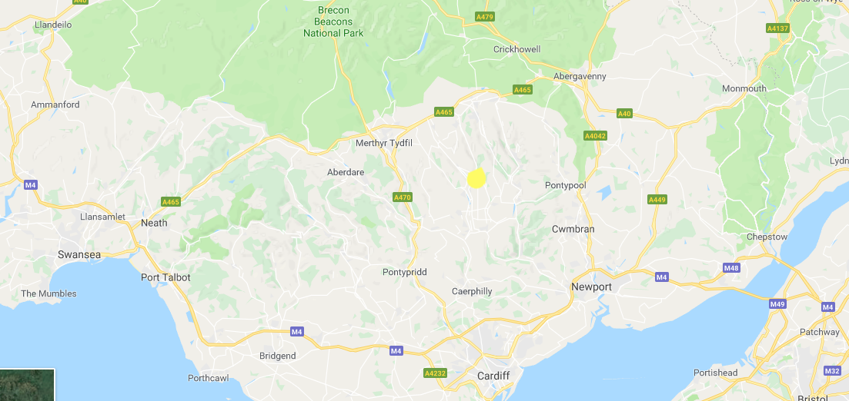
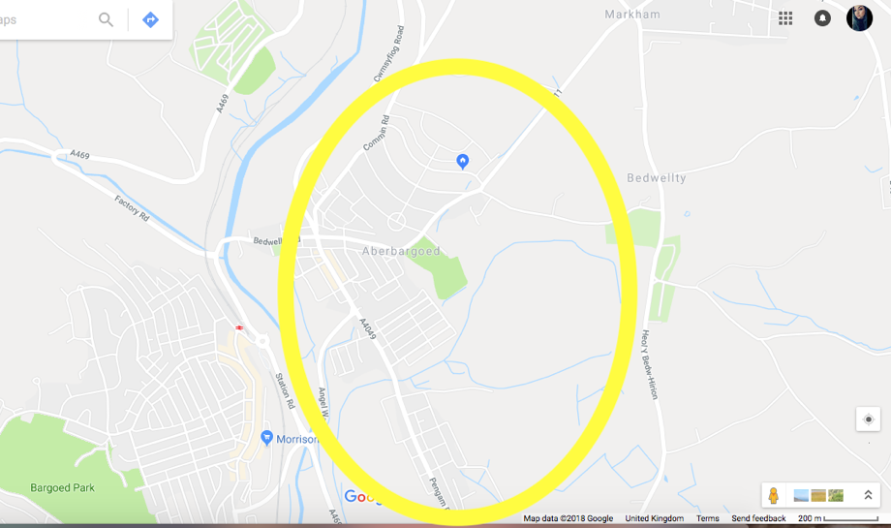

(Appendix 1) (Appendix 2)

1.2 Project Aim
The Aim of this project is to conduct a feasibility report for hosting a family friendly music festival in Aberbargoed.

1.3 Project Objectives
The project objectives are as followed:
- To examine whether the town of Aberbargoed has the infrastructure to host the event. Including;
- Best location
- Road infrastructure
- Car parks
- Accessibility (For children and disabilities)

- To understand the demand for the event and identify the target audience. Including;
- Is there a demand?
- What is the companies target audience?
- Does the event attract to the desired target audience?

- To Speak to local Businesses to understand how this type of event will affect them, and if they would support or reject the event if it were to happen. Including;
- Local government
- Local council
- Business owners on the ‘high street’ (Commercial Road)
- Independent businesses in the surrounding areas.

1.4 Initial Ideas
For this project the initial ideas are to speak to local business and residents of Aberbargoed to build a rapport on behalf of the organisation, and to search for a suitable location that is suitable for the event. As stated previous there is an existing connection between the researcher and a member of Bargoed town council who used to be involved with organising a running a similar event in the neighbouring town. Therefore another initial idea is to arrange a meeting with this member of the council to explore reasons as to why the similar event fell through, and to seek any recommendations for the project and if there are any contacts the researcher can be put in touch with.

1.5 Rationale
The organisation has wanted to host a music festival for quite some time. However, they are a small company with limited manpower and with the existing events they hold, have yet to assort time to researching the area and compiling information that will help them plan the festival. There is already an existing link with one of the directors of the company (From here will be known as the representative), and from this link have the knowledge of how time consuming their current projects are. So, this project will save the company time, and hopefully deliver enough research to begin a plan for a festival. The researcher has close connections with the company and local businesses and the council, also is a resident of the area the project is covering, so the researcher is an ideal candidate to carry out the project on behalf of the company, as there is already trust with the company and knowledge of the area. As well as previously stated credentials, the researcher has a background in tourism and event management, and therefore will be able to apply this knowledge to the consultancy project.

1.6 Scope and Exclusions
The report aims to find a suitable location to host a family friendly music festival in Aberbargoed. The researcher should be capable of carrying out the set objectives, especially if the researcher follows the plan and follows the Gant Chart (Appendix 3) to keep within the time frame for the project. The project only focuses on the location of the event and the opinions of the residents and other significant people. The report will not explore any financial issues or restrictions, as the representative of the company does not want this to be covered in the report. The report may include some hypothetical costs, say for venue hire, but any other costs will not be discussed, to honour the agreement with the client.

1.7 Constrains and Assumptions
The main constrain of the project is time management, even though there is a plan detailing when tasks need to be completed, there is a possibility that interviews will need to be rescheduled, and as some of the research is dependent on other people, this could cause disruption.
In the case of interviews assumptions can be made that people may not be truthful, therefore, it will be made clear that everything said will be private, and for the purpose of the report all participants will be pseudonyms – however if there are any participants who would like to be involved in the future plans for the event, their names will be given to the client.

2.0 Business Case and Approach

2.1 Potential Benefits and Outcomes
The benefits of the project are prodigious. It aims to save the company time. It will gain an insight to the views of the target audience. It will begin to build a rapport with local businesses and residents in Aberbargoed. Plus, it will develop connections to the council and any other relevant organisations.
The desired outcomes would be;
- That the project provides a location that can be fully accessed.
- That the event has a demand from the target audience.
- That the local businesses support the event.
- A relationship is built with the council.

2.2 Potential Issues
There is very little risk in this project, as most of the research will be secondary and all primary research will contain no ethical issues. An ethical approval form will be submitted with this document, and no interviews or surveys will be carried out until the project has received ethical approval.

2.3 Approach
The purpose of the project is to gain a better knowledge of the town Aberbargoed and to find a location to hold a festival. There will not be any costs needed to conduct this feasibility report, however costs for the event will be highlighted in the report, for example, field hire and accessibility support costs if any.

3.0 Proposed Research Strategies
The difference between Methodology and Research Methods is that Methodology refers to the underlying theory and how research should proceed, for example quantitative and qualitative, whereas Research methods are the techniques used to collect data, for example interviews, surveys, focus groups and so on (Sachdeva, 2009).

3.1 Research Methodology
This project will require both quantitative and qualitative data in order to follow out the objectives. Quantitative data can be described as “Research based upon the generation of numerical and statistical data” (Thomlinson, 2010). Whereas Qualitative data is more descriptive in nature and explores opinions in more depth (Plonsky, Gurzynski-Weiss & Fäcke, 2014). Objective 1 and 3 require detailed data that is acquirable through qualitative data and objective 2 requires a large response and less detail, making quantitative more beneficial.
The project will use both primary and secondary research in order to present the most accurate results for the feasibility report.

3.2 Research Methods
To carry out this project numeral research methods will be used to achieve each objective. Face to face-Semi structured interviews will be carried out to gain an understanding of how business owners would feel about the festival and to build a rapport with them on behalf of the organisation. Communication with the council may consist of email correspondence, however it would be beneficial to arrange a face to face interview with an appropriate representative, and if time and scheduling is an issue a telephone interview or further email correspondence will be beneficial. Finally, to collect the quantitative data for objective 2 the best research method will be surveys, to try to reach as many participants as possible.
For secondary research, maps will be used to study the infrastructure of the town and to research the grounds and areas of Aberbargoed.

3.2 Sample
For the Survey the target sample will be residents of Aberbargoed. They will be over the age of 18 in order to comply with the university research ethics guidance (UWTSD, 2017) The sample size is anticipated to be approximately 100 participants. In order to be deemed as valid the size must reach at least 50 participants.

For the Interviews the target sample is Business owners in Aberbargoed or representatives of the business on behalf of the owners. Again, complying with the university research ethics guidance (UWTSD, 2017), anyone spoken to will be over the age of 18. The sample size must reach a number of 6 in order to be deemed valid, although more participants would be favorable.

4.0 Project Management
This project will be managed by one person (Main Investigator). The organisation will have little input to the project due to time management. Other people needed for the project to be successful are;
- Residents of Aberbargoed
- Caerphilly Council Representative
- Bargoed Town Council Representative
- Aberbargoed Business Owners

Quality management strategy
A quality management strategy is “a formal record of an organisations method of managing the quality of its product and services” (Beckford, 2010). The purpose of using a quality management strategy for this project is to ensure that the Make It Happen directors are satisfied with how the project runs. After conversing with the representative of the company it was made clear what the company expect from the report. The aims and objectives were discussed and altered to fit the needs of the company. The information that will be retained will not be sensitive, however there is no need to share the information with anyone other than the company and the university, so the report will be private. As discussed in the research methods section, all names will be replaced with pseudonyms in the final report in order to comply with the university research ethics guidance (UWTSD, 2017). Throughout the investigation, the company will be informed of any restrictions and when certain milestones are met to ensure that the quality of the report is high and to make sure that the report is meeting the demands of the company.

6.0 Comunication Management Strategy
Communication throughout this report will be light and informal. The main point of communication will be conversing online. Mainly through social media. However, there will be a few face-to-face meetings with the representative of the company, scheduling of these meetings is not set as they will have to revolve around the representative of the companies work schedule. Hence why the majority of communication will be online and informal. Though meetings will be slightly harder to arrange, the company has confirmed they will definitely be able to meet at least once face to face during the investigation phase. Due to the scope of the project, communication is not crucial, so a lack of face-to-face meetings is not problematic, as if there are any issues or if anything needs to be reported to the company, social media or a phone call will be sufficient.

7.0 Project Plan
The plan has been developing from the beginning of February 2018. This has included the outline aims and objectives for the project. The research Strategy and reseach methods, and the rest of the titles outlined in this document. There has been a start to secondary research, however the plan will not fully functional until there has been ethical approval from the university. The expected start date is 26th March 2018. The full report will be completed and presented to the organisation and the university on 2nd May 2018. This gives the project a five-week time scale. The next section of this document contains a Gantt chart (Appendix 3) detailing the key dates, activities, resource requirements and control points that must be met by the 2nd May 2018.

7.1 Project Time Scale
The following Gant Chart (Appendix 3) lays out tasks for the following 6 weeks. It identifies key task, such as arranging meetings and when data collection must occur. The Gantt chart does lack some tasks, such as scheduled interviews meetings, this is because these have not been set and dates won’t be identified until the participants have been contacted.

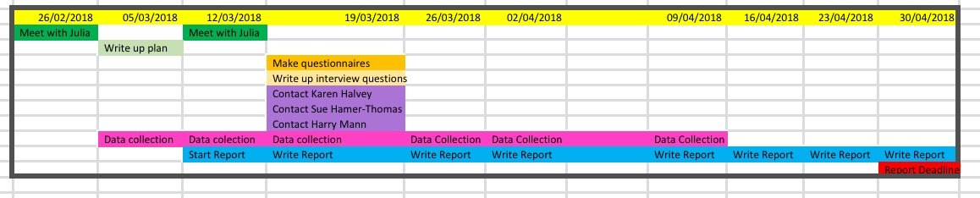

8.0 Project Reporting
As explained in the communication section of this document, most communication will be via email. This makes reporting back to the client much easier, however there are not many tasks that needed to be reported back. During the research phase of the project the researcher will attempt to arrange a face to face meeting with the client just to explain how the project is going and to inform them of any implications that may have occurred. All communication will be documented, with screenshots of online messages or a written summary of phone calls or face to face meetings.

10.0 Bibliography
Beckford, J. (2010). A Critical Introduction, Third Edition . London: Routledge.
Plonsky, Gurzynski-Weiss & Fäcke, C, 2014. Research methods. In Mouton De Gruyter, pp. Fäcke, C, (ed.) Manual of Language Acquisition. (pp. 31–49). Mouton De Gruyter: Berlin, Germany. (2014).
Sachdeva, J.K., 2009. Business research methodology, Mumbai [India]: Himalaya Pub. House.
Tomlinson, A., 2010. research methods. A Dictionary of Sports Studies, pp.A Dictionary of Sports Studies.
UWTSD, 2017. Research Ethics & Integrity Code of Practice

11.0 Apendicies
Appendix 1 – Source Google Maps

Appendix 2 – Source Google Maps

Appendix 3

