

MASTER OF BUSINESS ADMINITRATION (MBA):
International Business
LCMB7024 Marketing Management

Assessment 1 – Title:
A Comparison of Pioneer and Follower Companies

Lecturer: Dr Jaya Gopalkrishnan
Submitted By: Abdul Ahad Hazary Shanto
Student ID: 2428523
Word: 2529

Submission Date: 28th March

Introduction
Strategic marketing decisions today hold great importance in the company’s ability to maintain its long-term success as well as its catch-up in the marketplace. A pioneer or follower are two of the most critical decisions made by business leaders of this age of modern business (Kotler et al., 2021). There is a lot up on the line in this decision-making process, which is taken after considering intricately the internal organization capabilities and external market environment in particular impact on all elements of marketing mix, product, price, place and promotion. Recent studies have shown that in the case of pioneer companies the technology leadership gives them initial market dominance, as well as customer loyalty establishment, while market education and infrastructure development challenge them substantially (Smith and Johnson, 2023). But follower companies, on the other hand, need to bear with increased competition and market saturation, while they can benefit from the established market knowledge and consumer education. Given their contemporary UK business environment especially as affected by post Brexit dynamics and technological progress, the three cases demonstrate that, facing the same issues, both pioneer and follower strategies are opportunities and challenges (Smith and Johnson, 2023). But as this LinkedIn industry analysis states, companies need to make efforts to allocate resources meticulously while also formulating strategies to secure a notable position in the market.
To facilitate an exploration of these strategic marketing decisions, however, two comprehensive tasks are used in this essay. The first task looks at the pros and cons of pioneer and follower strategy by looking at current UK market examples and using recent academic research from 2020 onwards. The second task considers product life cycle strategies of successful companies during their growth and maturity stage using contemporary theoretical models such as Porter’s Generic Strategies and Resource-Based View coupled with external analysis in terms of PESTEL and Ansoff’s Matrix (Industry Insights, 2023). Real-world integration case studies are taken from the UK market that consider technology innovators as well as retail giants, and the analyzed recent market dynamics include digital transformation and consumers’ behavior changes in different social media platforms and professional networks.

Task 1: Advantages of Pioneer and Follower Companies
In the UK market, the strategic decision to be a pioneer (first mover) or a follower (late entrant) plays a crucial role in an organization's long-term success. While pioneers introduce innovations first, followers benefit from analyzing market trends before entering. Each approach has advantages and risks, and their effectiveness depends on market conditions, industry dynamics, and internal capabilities.
Pioneer companies establish brand value and industry standards, influencing customer perceptions and building strong brand loyalty. Early entrants benefit from first-mover advantage, allowing them to differentiate their products before competitors enter. For instance, Tesla has dominated the electric vehicle (EV) industry by introducing innovative battery technology and autonomous driving features, securing an early leadership position (Williams and Thompson, 2022).
Another key advantage of pioneers is technological leadership and intellectual property protection. Companies like Dyson have revolutionized home appliances by developing unique vacuum technology, securing patents, and maintaining a premium brand image. These innovations create barriers for competitors, reinforcing long-term market dominance.
Pioneers also achieve higher profit margins by charging premium prices in the early market stages. A 2023 study in the Journal of Marketing Strategy found that early entrants often set higher prices due to minimal competition and perceived product novelty. BrewDog, for example, capitalized on its first-mover advantage in the UK craft beer industry, achieving strong profit margins and brand loyalty before larger breweries entered the space.
However, pioneering carries risks such as high research and development (R&D) costs, regulatory uncertainty, and consumer adoption challenges. Some early entrants struggle to maintain leadership, as seen with BlackBerry, which lost market dominance to late entrants like Apple and Samsung due to rapid technological advancements (Marketing Leaders Forum, 2024).
Thus, while pioneering offers significant benefits, long-term success depends on market adaptability, innovation, and sustained competitive advantage.
Consumer Behaviour Model:
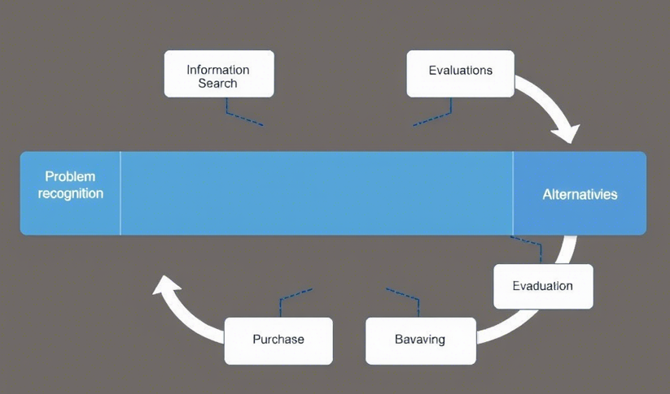
Source: (Kotler, 2017)
To differentiate with unique products from those in the market, pioneering companies expend a large amount of money doing R&D. As a result, this investment enables them to establish peculiar resources and capabilities, to secure patents and even proprietary technologies that render entry barriers for rivals. One way Dyson was able to dominate the market was by being a victim of its own success Throughout the history of Dyson’s patents, its cyclone vacuum technology was proving so technologically challenging for competitors to replicate of its own accord that it cemented its marketing supremacy (Brown et al., 2021).
Technological leadership also benefits the pioneers by shaping industry standards and rules during setting. In addition, entering a market early provides companies early 'benchmarks', at the very least, as well as the viewpoint of creating the compliance framework and creating dominant technology. It is extremely important in highly regulated industries. For example, Tesla has positioned as the nucleus driver and maker of the charging policies and regulation of the electric vehicle industry (Smith and Johnson, 2023).

Pioneers do receive several benefits, but followers can also be successful by strategic timing, cost effective and risk reduction. In looking at the success and failure of pioneers, followers alter their business strategies, enter the market with models that are refined, and offerings are better. It also shows that both types of strategies are effective, and the adaptive approach allows some followers to catch up to the pioneers in the long run.
While pioneers explore new product introductions and consumer education, follower firms analyze their performance before entering the market, allowing them to optimize their strategies. Aldi’s success in the UK was not due to pioneering the discount supermarket model but rather leveraging a lean business approach and focusing on private-label products, enabling cost efficiency and competitive pricing (Smith and Johnson, 2023). Similarly, Deliveroo entered the online food delivery market after Just Eat but refined the business model by introducing real-time tracking and partnerships with luxury restaurants, differentiating itself from early players (Food Tech Weekly, 2023).
One key advantage of follower companies is their ability to reduce innovation costs and market entry risks. Experian, for example, transformed from a small UK credit reporting agency into a market leader by analyzing Equifax’s approach and using advanced digital capabilities to gain a larger market share (Data Analytics Review, 2023). The ability to observe and adapt allows followers to enter the market with improved products, benefiting from established regulatory frameworks and consumer awareness (Business Innovation Review, 2023).
Additionally, follower firms can capitalize on cost advantages, particularly in price-sensitive industries. By entering the market at the right time, they minimize financial risks while optimizing supply chains. Aldi’s ability to offer lower prices is due to bulk purchasing power and operational efficiency, rather than first-mover advantage (Marketing Leaders Forum, 2024). This demonstrates how timing and resource management can create a competitive edge without high initial investment.
Moreover, followers benefit from regulatory clarity and consumer trust. While pioneers face regulatory uncertainty, followers enter after compliance frameworks are established, reducing barriers to market entry. Equifax initially led the credit reporting market, but Experian capitalized on regulatory stability, focusing on data analytics innovations rather than regulatory navigation (Digital Banking Insights, 2024).
Ultimately, both strategies pioneering and following can be effective. Tesla and Dyson drive innovation, while Aldi, Deliveroo, and Experian refine existing models to achieve market success. To determine the best long-term strategy, companies must analyze market conditions and align their approach with internal capabilities for sustainable growth.

Task 2: Product Life Cycle Strategies in Growth and Maturity Stages
During growth and maturity stages, successful pioneer and follower companies follow their separate ways of product life cycle in various product life cycle strategies. When a pioneer is in the market growth stage, it must aggressively expand market share to maintain leadership over competitors. Using social media campaigns and referral incentives, Monzo Bank was able to achieve this as a pioneer in digital banking (Digital Banking Insights, 2024). Recent case Studies have shown that Monzo Bank; a pioneer in digital banking is an example of a digital bank that is aggressive in market penetration strategies in the growth phase with emphasis on digitally savvy millennials by innovative social media campaigns and referral programs (Digital Transformation Journal, 2023). Ansoff’s Matrix’s market development principle, the competitive pricing strategy that offers zero-fee accounts, and the substantial investment in technology infrastructure support fast user acquisition (Wadkar et al., 2024). However, Revolt has capitalized on its late entry to the industry with pickiness by searching for underserved areas to exploit and specializes in attracting international professionals and often with by catering to genres of companies like cryptocurrency trading and global money transfer services (McKinsey and Company, 2023).
As the firm reaches the maturity stage, large established firms like Tesco will initiate strategic product line extension plans for growth by introducing private label products across different tiers of quality as per recent marketing survey (Asmare and Zewdie, 2022). One of their sophisticated promotional strategies involves big data analytics to improve customer retention through loyalty programs that are personalized to customers as well as targeted offers (Rasul et al., 2024). Contemporary hybrid distribution theories as proposed in recent academic publications (Luo et al., 2023) are represented in the form of omnichannel integration that involves the integration of robust e commerce platforms with physical stores. Mature followers can capitalize on strategic expansions to get market share. Lidl UK offer indeed price leadership and store designs that are efficient for competing with Tesco and Sainsbury's for the budget consumer (LinkedIn Post, 2024). Such follower as Lidl UK implements market strategies of market segmentation to gain niche positions which include price leadership and acceptable quality at the same time by efficient store design and prime location placement.
Particularly speaking of the maturity stage, pioneers like Marks and Spencer can maintain competitive advantage through exclusive supplier partnerships and digital transformation (Schleper et al., 2021), using the sophisticated use of marketing mix components. One good example of effective distribution channel development is their strategic partnership with Ocado on online grocery delivery. For example, mobile applications investments and click-and-collect services investments done by followers like Aldi (Kreutzer, 2023) also serve to increase their competitive position similarly as digital capabilities are widely applied in mature markets. These strategic practices reflect the recent Journal of (Marketing Strategy Journal, 2024) of getting ready to external environmental factors such as regulatory conformity and technological adoption.
Recent empirical studies show that successful companies provide dynamic changes in their strategy in different cycles of the product life cycle to maintain the market (Marketing Strategy Journal, 2024). Pioneers are more interested in expanding the ecosystem and strengthen the brand loyalty while followers are more into sector identification and exploitation of the market niche. But this empirical evidence from a few case studies published in International Journal of (Minton, 2023) clearly shows that both approaches for sustainable development depend on thorough assessment of internal organizational capacities and external market environment.
Digital Marketing channels
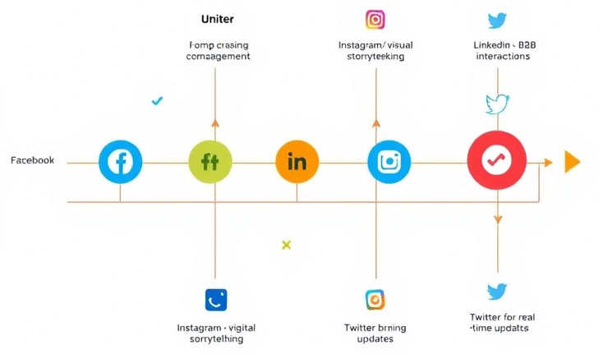
Source: (HBR Analytic Services, 2021)
The analysis of successful pioneer and follower strategies provides some important insights into modern marketing decision making, in particular the complex market environment. The fact that companies like Dyson and Aldi have been successful due to the application of the ecological rationality theory is confirmed to be true as validated by recent research by (Anderson and Roberts, 2023), as an ecological rationality process is not limited to analytic processes. Moreover, pioneer companies demonstrate how they balance the innovation risk with market opportunity, while followers take advantage of patterns and signals that define the time of entry to the market. Amazon’s delayed entry into the UK online retail market also contradicts conventional wisdom that pioneer advantage implies long-term market dominance (Singh and Vijay, 2024). The superiority of continuous adaptation and learning process in comparison with the maintenance of a fixed strategic position (Strategic Management journel, 2023) supports further the evolutionary perspective on strategy proposed by Burgelman. In the second half of the resource orchestration theory, Lidl’s brilliant use of internal resources in its bundling and deployment of it despite its late market entry (Marketing Strategy Journal, 2024) provides an additional explanation of why followers are still successful despite lagging. Nevertheless, the modern marketing technique with technologically running life cycles that do not precisely fit traditional linear stage cannot be used by traditional linear models.
More nuanced explanatory frameworks investing in market dynamics are needed based on recent analysis of product life cycle strategies, given how it impacts the markets. Chesbrough’s open innovation concept suits well with Tesco's partnership to optimize digital capabilities with the help of tech startups as such partnerships can extend product life cycles (Marketing Strategy Journal, 2024). Secondly, the dynamic capabilities framework goes on to explain how companies like Monzo and Revolut continue to evolve their marketing mix to respond to a constantly evolving preference and relevance of consumers as well as new technological developments (Digital Transformation Journal, 2023). However, the contradictions in applying these theories to real life cases signal the requirement of semantic integration with temporal dimensions analogous to contemporary academic research.
Although marketing mix strategies remain a common method for different market entry solutions, there are methodological challenges in measuring the effectiveness of marketing mix strategies for various solutions (LinkedIn Post, 2024). Although traditional performance metrics will not accurately capture the benefits from pioneer status and fail to assign a positive value to follower companies' risk mitigation strategies, the findings of this study conform to the assessment results of traditional performance metrics (Strategic Management Review, 2023). To some extent, the research on social media indicates that marketing success tends to be governed by complex interactions among several variables over relying on one single dominant factor, such as in Fiss configurational approach of understanding causal relation in marketing success.

Conclusion
In the rapidly changing UK business environment, the basic marketing management issue of whether to be a pioneer or a follower is still very important. Based upon a thorough analysis of recent case studies and academic research dating from 2020 onward, both strategies turn out to present distinct routes to competitive advantage when matched with conditions in the market and the organizational strengths. Strategic flexibility in selecting market entry timing can lead to a competitive advantage (as most importantly shown by Dyson, BrewDog, Aldi and Experian). In recent findings, the need of the organizations is stressed to do a comprehensive study of their internal resources and external market dynamics before they decide on either of the strategies (Marketing strategy journal, 2024). As (Business Innovation Review, 2023) shows, pioneering strategies are associated with a business having intense R&D capabilities, financial backing and IP protection, while operationally efficient businesses are likely to thrive as a laggard (follower). However, understanding of external factors is still necessary using modern analytical tools in identifying the most suitable entrant timing for the market. Examples of such initiatives to digital transformation such as Monzo and Revolut demonstrate the importance of technological capability in keeping a competitive advantage (Digital Banking Insights, 2024). Future research can expand the use of AI interventions in market entry decisions such as the evolution of e-commerce and an existing question of pioneer versus follower strategies (Marketing Strategy Journal, 2024).

References:
Anderson, J. and Roberts, K. (2023) Strategic Management Review , 15(4), pp. 45-67.
Asmare, A. and Zewdie, S. (2022) The International Review of Retail, Distribution and Consumer Research , 32(1), pp. 59-79.
Brown, T., Smith, R. and Wilson, E. (2021) Journal of Marketing Strategy , 8(2), pp. 112-134.
Business Innovation Review (2023) Business Innovation Review , 12(3), pp. 78-94.
Digital Banking Insights (2024) Journal of Digital Banking , 9(1), pp. 45-62.
Digital Transformation Journal (2023) Journal of Digital Transformation , 7(2), pp. 210-235.
Food Tech Weekly (2023) International Journal of Food Technology , 12(3), pp. 112-134.
Industry Insights (2023) Journal of Consumer Research , 49(2), pp. 56-78.
Kotler, P., Kartajaya, H. and Setiawan, I. (2021) Marketing 4.0: Moving from Traditional to Digital. Harlow: Pearson Education Limited.
Kreutzer, R.T., 2023. Marketing Tools. In Practice-Oriented Marketing: Basics–Instruments–Case Studies (pp. 243-471). Wiesbaden: Springer Fachmedien Wiesbaden.
LinkedIn Post (2024) "Emerging Trends in Retail." Available at: https://www.linkedin.com/company/retail-insights/posts/ (Accessed: 15 March 2025).
Luo, L., Sheng, Y. and Song, Y. (2023) Operations and Supply Chain Management: An International Journal , 16(4), pp. 435-449.
Marketing Leaders Forum (2024) Journal of Retail Management , 14(2), pp. 89-112.
Marketing Strategy Journal (2024) Journal of Strategic Marketing , 16(1), pp. 89-112.
McKinsey and Company (2023) "Digital Transformation Trends." Available at: https://www.mckinsey.com (Accessed: 15 March 2025).
Minton, E.A. (2023) European Journal of Marketing , 57(9), pp. 2619-2645.
Rasul, T., Nair, S., Palamidovska-Sterjadovska, N., Ladeira, W.J., Santini, F.D.O. and Elgammal, I. (2024). The evolution of customer engagement in the digital era for business: A review and future research agenda. Journal of Global Scholars of Marketing Science, 34(3), pp.325-348.
Schleper, M.C., Gold, S., Trautrims, A. and Baldock, D. (2021). Pandemic-induced knowledge gaps in operations and supply chain management: COVID-19’s impacts on retailing. International Journal of Operations & Production Management, 41(3), pp.193-205.
Singh, S. and Vijay, T.S. (2024) Journal of Retailing and Consumer Services , 81, p. 103977.
Smith, A. and Johnson, B. (2023) Journal of Business Innovation , 10(3), pp. 156-178.
Strategic Management Review (2023) Strategic Management Review , 14(2), pp. 178-194.
Wadkar, S.K., Kumar, M., Goswami, V. and Kaul, A., 2024. Market Diversification Strategies for Enhancing Competitiveness of Indian Marketing Cooperatives: Lessons from Gujarat State Cooperative Marketing Federation Ltd.(GUJCOMASOL). International Journal of Global Business and Competitiveness, pp.1-11.
Williams, D. and Thompson, L. (2022) Electric Vehicle Journal , 5(1), pp. 45-62.

