MODULE CODE: LCBB4012
MODULE: ACADEMIC SKILLS

COMPONENT 2

STUDENT NAME : Rares Constantinescu
STUDENT ID: 2516174

Table of Contents
Introduction 3
Definition of the skills 3
Academic Writing Skills 3
Note-Taking Skills 4
Importance of Academic Writing Skills 5
Importance of Note-Taking Skills 6
Strategies to Improve Academic Writing Skills 8
Strategies to Improve Note-Taking Skills 9
Conclusion 10
References 11

Introduction
Academic skills are the skills and strategies applied by students to study, comprehend and pass the information and convey knowledge in a university. The skills play a significant role in the lives of university students since they help them in their learning, critical thinking, and competent completion of academic assignments, reports, and examinations. The use of effective learning strategies makes academic success highly reliant and enables a student to cope with the information and articulate his/her ideas. One of the most significant academic skills is academic writing skills and note taking skills. Academic writing skills allow students to convey information clearly, formally and structurally in order to argue and analyse information. The use of note taking abilities aids students in taking important points in their notes in lectures, readings and so it becomes easy to revise them and comprehend the essential points. This report aims at studying these two skills, outlining their relevance in academia and the workplace, as well as discussing some of the strategies that can assist students to enhance the skills. In the report, the skills are first defined followed by a discussion about the importance of these skills and how they can be improved.

Definition of the skills

Academic Writing Skills
Academic writing skills can be described as the skill of being able to express ideas, arguments and facts in a clear, well organised and formal way within an academic setting. Academic writing is a formal form of writing that is mostly utilised in universities as well as in research to outline ideas in a logical manner and with valid evidence (Schillings et al., 2023). Academic writing is different compared to informal because it is objective, clear, and organised in presentation. Formal language is one of the most important features in academic writing where one does not use slangs, short forms and too informal language to keep it professional. Critical analysis is another valuable part because students are expected to analyse information, compare various positions and construct logical arguments instead of presenting facts (Fathi, and Rahimi, 2026). Academic writing must also have logical format, usually containing introduction, main body where argument or discussion is provided, and conclusion that summarises the main points.
Moreover, citing and referring are also important in academic writing because a student should provide evidence supporting his ideas by referring to credible and trustworthy academic source such as books, journal articles, or other authoritative sources, taking them into consideration by including proper references (Malik et al., 2023). It should also be clear and coherent so that the ideas should be grouped in logical order and made in a manner that is easy to comprehend by the reader. The most common types of academic writing are essays, reports, and research papers. The essays and reports are frequently utilised to evaluate the cognition and preventative skills of analysing information among students in the upper levels of education.

Note-Taking Skills
Note-taking skills denote the capability to successfully capture, store, and study the valuable information that was gained after lectures, readings, or research process. Note-taking refers to a process of reverse engineering that involves capturing important ideas and crucial information succinctly to aid the comprehension, memorization, and subsequent learning (Salame, Tuba, and Nujhat, 2024). It is a significant one in assisting students in processing the information and organising the knowledge in an important manner. Listening and comprehension is one of the main elements of successful notetaking, as it entails focusing on principal ideas discussed at the lectures or in conversations (Ngwoke, Ugwuagbo, and Nwokolo, 2022). Moreover, another skill that students should have is the ability to distinguish the most important points and the irrelevant data in order to identify major concepts.
The other factor of relevance is summarisation, within which the information is put down in short and clear sentences as opposed to word for word copying. It further needs to be appropriately organised and in this way properly structured notes allow the students to revise the material to learn it more effectively (Gao, Gan, and Wang, 2025). This may involve the application of headings, bullet points or diagrams in order to organise ideas in a logical order. In addition, frequent going through of notes enables the students to consolidate their learning and detect the knowledge deficiencies. A number of strategies on taking notes will lead to the effectiveness of the skill during use such as the Cornell system organises notes based on the main ideas, details, and sums up notes (Al-Sharman et al., 2025). Furthermore, Mind mapping represents a visual way of linking similar ideas with a diagram. Outline method organises information according to hierarchy whilst charting method organises information accorded a table or category to enable easier comparison and analysis.

Importance of Academic Writing Skills
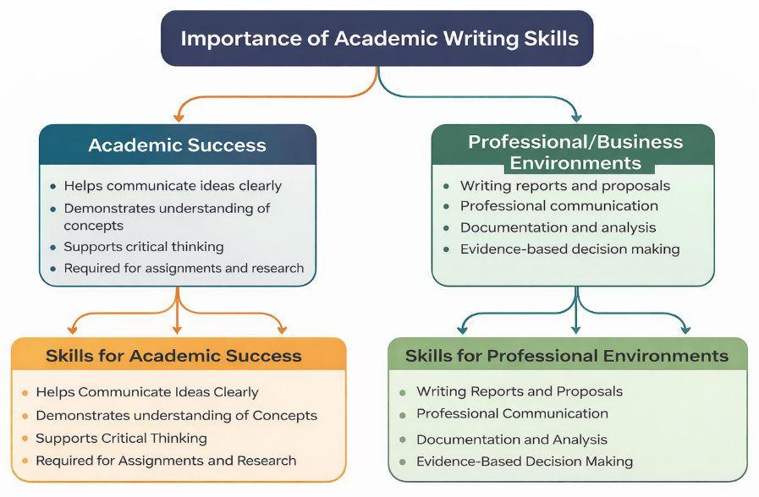
Figure 1: Importance of Academic Writing Skills
(Source: Learner)
The ability to conduct academic writing is very important in attaining academic success and competencies that can be useful even in workplaces. At the academic level, these competencies assist students to express their thoughts clearly and demonstrate their vision of some complicated concepts in order and logical way (Leon, 2023). The tasks of the university frequently demand the student to process information and compose arguments and justify individual position. Academic writing helps students to manage their ideas and give them a clear format that is easily comprehensible by the readers. It further indicates how much a student has mastered the course materials as it involves the student explaining theories, evidence and connecting ideas to one another (Khalifa, and Albadawy, 2024).
Moreover, academic writing helps one learn to think critically, as the students must be able to analyse the information provided by other people, compare views, and reach a well-grounded conclusion. The process promotes in-depth learning, and students will be able to have an analytical skill. In higher education, academic writing is also required to complete different academic assignments like essay, reports, research paper, and case studies among others, which are usually used to evaluate knowledge and intellectual skills of students (Rosdiana et al., 2023). Academic writing skills are also very significant in professional and business settings besides their academic significance. Numerous careers demand that persons prepare coherent and well organised written papers to pass information across clearly. Indicatively, professionals are widely known to have written business report, proposal and analytical documents, which document and provide recommendations to organisational decision making (Schillings et al., 2023).
Moreover, highly developed writing proficiency is associated with professional communication such as emails, project documentation, and internal reports to make sure that the information is presented professionally and correctly (Leon, 2023). Furthermore, the academic writing encourages the use of evidence-based decision making since the professionals in most cases are required to have reliable data and analysis to support their arguments and suggestions. Strong writing skills are also necessary in research publications and professional reports to present the findings and insights to the stakeholders or the community at large.

Importance of Note-Taking Skills
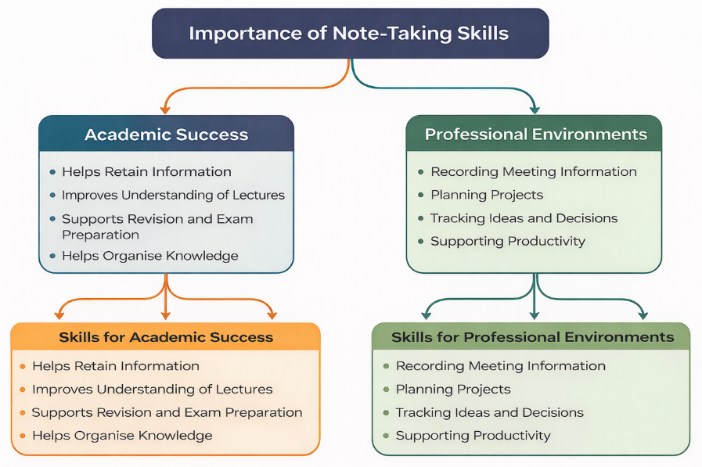
Figure 2: Importance of Note-Taking Skills
(Source: Learner)
The ability to take notes is crucial to not only for academic but also for professional effectiveness as it assists an individual in memorising, sorting, and examining significant data. In educational terms, taking notes will be very useful in enabling students to remember information that was given to them during lectures, seminars and reading session. Writing down the main points and coming up with the main ideas, the students can process the information more actively which helps to memorise and understand it better. Strong note taking skills further enables the students to pay attention to the key things rather than struggle to memorise everything after a lecture (Kitjaroonchai et al., 2025). This enhances understanding since students are able to develop correlation of ideas and to arrange information in a significant manner.
Moreover, organised notes facilitate to revise and prepare exams such as it helps in memorising the key theories, definitions, and explanations, students can go through their notes to remember the significant information during exams (Wong, and Lim, 2023). Furthermore, with the help of organised notes, students find it easier to arrange their knowledge and, therefore, to relate the new information with the already material studied. Note-taking capabilities are also useful in professional culture as they assist people in capturing essential information and keeping clear records. During meetings, professionals normally make notes to document the important ideas, resolutions, and action plans as addressed by team members (Shi, and Yu, 2024). This would assist in keeping in mind critical information and employees can be able to pursue tasks or functions well. Another important use of the note taking is in the planning of projects because it enables the professionals to arrange ideas, plan activities and monitor the project (Jin, and Webb, 2024). In written down discussions and decisions, people can keep track of what has been happening in projects and make sure that the team members stay on track to the organisational objectives.

Strategies to Improve Academic Writing Skills
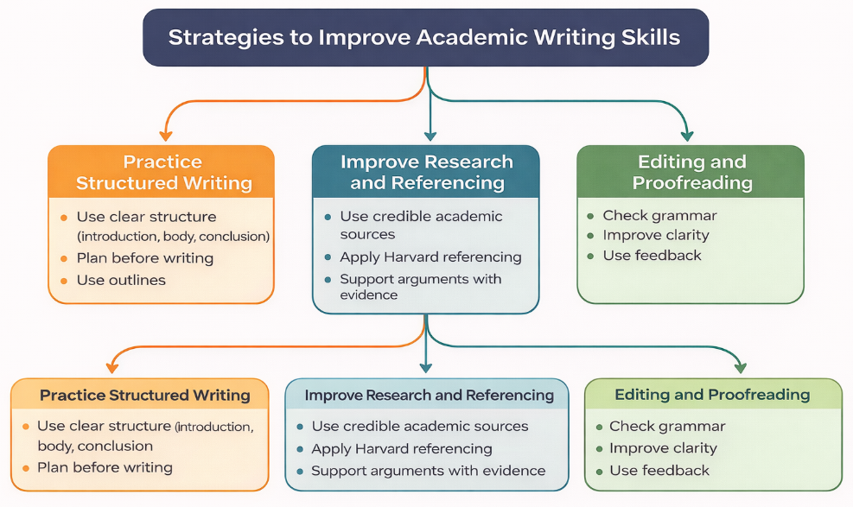
Figure 3: Strategies to Improve Academic Writing Skills
(Source: Learner)
Academic writing skills can be enhanced by formulating effective strategies that enable students to arrange their ideas, back up their arguments with evidence and make information comprehensible. Structured writing is one of the strategies that are important as writing papers must have a logical and clear format, the papers usually consist of introduction, main body and a conclusion (Schillings et al., 2023). The introduction shows the main theme and purpose of the work, arguments, supporting information are discussed in orderly paragraphs, and the conclusion considers the main points. It is also necessary that students plan in advance before they are to write since this helps them to sort out their thoughts and know the main points they wish to state (Djurayeva, 2023). An outline enables to organise the content and present the ideas in logical manner and each section serves the overall argument, which in turn enhances logic and clarity in writing.
Enhancing research and referencing practises is another key tactic that enhances the academic writing capabilities. Academic writing means that credible material, including academic books, journal articles, and other trusted research sources must be used to justify arguments and prove the knowledge of the subject (Nusivera, Hikmat, and Ghani, 2025). Strong sources easily assist students to develop well-presented arguments and makes their work more credible. Further reference should also be taken care of, as it will give credit to the ideas of other writers and prevent cheating in academics. The use of the referencing styles like the Harvard referencing style lists the sources used in the text correctly and in the reference list.
Furthermore, proofreading and editing are good activities, which can be applied towards enhancing the quality of academic writing (Teng, Qin, and Wang, 2022). The practise of reading written work enables the students to detect the grammatical mistakes, clarity of sentences, and coherent presentation of the ideas. The feedback that can be provided by lecturers or peers can further benefit the students in identifying the aspects in which they need improvement and enhancing their writing techniques with time.

Strategies to Improve Note-Taking Skills
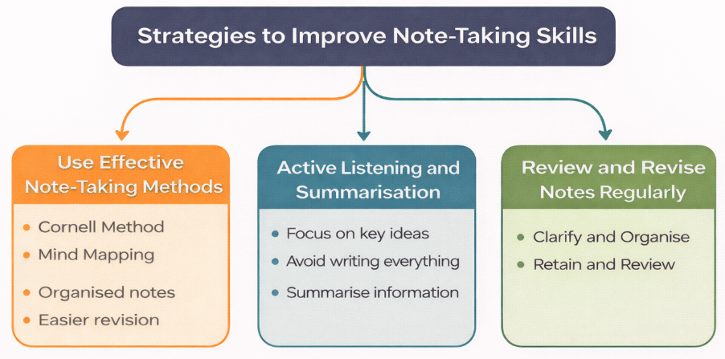
Figure 4: Strategies to Improve Note-Taking Skills
(Source: Learner)
The development of the skill of taking notes needs use of effective strategies that will assist students to capture and organise information in the most efficient way. Applying structured note taking techniques whereby information may be logically arranged in an orderly manner is one of the strategies that can be critical (Jin, and Webb, 2025). Cornell method is very popular as it sub-divides the page into key idea, more detailed and summary. This framework assists the students to revisit information conveniently and establish the ideas that are crucial. Mind mapping is another helpful method, and as such, it consists of visually organising ideas with the help of decking with diagrams that tie together like concepts (Karadağ, Devecioğlu, and Benzer, 2022). This strategy enables the students to understand how various subjects relate with each other and be motivated to actively participate in the content.
Moreover, with the help of these techniques, the notes become more organised and therefore students can make it easier to revise and recall the significant information when it is time to have the exams or the assignments. The other useful technique is active listening and summarising when one listens to a lecture of when reading academic materials. The students are not supposed to write every word given by the lecturer or the writer but they need to concentrate on the main points, key points and significant explanations used by the author or lecturer (Djurayeva, 2023). Active listening will assist the students in discerning the content better and enable students to choose the information that will be the most significant to write in their notes (Belle, Walker, and Rich, 2024). Being able to summarise the information using their own words also makes the students digest and retain the information in a better manner. It is also necessary to write short summaries so that they do not make notes cumbersome and hard to read later.
Furthermore, reviewing and revising notes with consistency is also an effective method, which enhances the ability to take notes. Students must go through their notes after lectures or studying to clear up some vague points, add missing information, and arrange ideas in a more systematic and effective fashion. The practise makes learning easier and helps students retain information for a longer period.

Conclusion
Effective learning and communication in academic and professional settings require academic writing and taking notes. Academic writing allows students to explain their thoughts and ideas and interpret information, whereas notetaking allows resisting and structuring the essential information during lectures or research. Such skills facilitate academic achievement through better understanding, revisions and quality of work. They further assist in effective communication, recording and making informed decisions in the professional profession. Therefore, continuously developing these skills is important for long-term academic and professional growth.

References
Al-Sharman, A., Shalash, R.J., Omran, T.A., Elsayed, R.M., Warfa, I.A., Adawi, W.S.E.A., Aljaberi, A.O., Alabdooli, A.A., Arumugam, A., Ramakrishnan, S. and Saad, N., (2025). Exploring the impact of note taking methods on cognitive function among university students. BMC Medical Education, 25(1), p.1218.
Belle, M., Walker, T.M. and Rich, I., (2024). Assistive technology and note-taking strategies to foster achievement motivation and self-sufficient learning in students with learning disabilities. IJDS, 15(1), pp.1906-1915.
Djurayeva, M.A.Q., (2023). Developing note-taking skills in consecutive interpreting. Academic research in educational sciences, 4(4), pp.232-236.
Fathi, J. and Rahimi, M., (2026). Utilising artificial intelligence-enhanced writing mediation to develop academic writing skills in EFL learners: a qualitative study. Computer Assisted Language Learning, 39(1-2), pp.263-302.
Gao, Y., Gan, L. and Wang, K., (2025). The impact of collaborative versus individual electronic note-taking on academic writing skills among graduate students: A call-based study. Education and Information Technologies, 30(5), pp.6367-6398.
Jin, Z. and Webb, S., (2024). The effectiveness of note taking through exposure to L2 input: A meta-analysis. Studies in Second Language Acquisition, 46(2), pp.404-426.
Jin, Z. and Webb, S., (2025). How do different forms of note‐taking affect second language vocabulary learning?. Language Learning, 75(4), pp.1185-1221.
Karadağ, K., Devecioğlu, M. and Benzer, A., (2022). Secondary school students' habits of using note-taking strategies. Osmangazi Journal of Educational Research, 9(2), pp.51-79.
Khalifa, M. and Albadawy, M., (2024). Using artificial intelligence in academic writing and research: An essential productivity tool. Computer methods and programs in biomedicine update, 5, p.100145.
Kitjaroonchai, N., Marshall, P., Phasook, J. and Thararuenroeng, N., (2025). University students’ perceptions on Note-Taking and its impact on academic performance. JET (Journal of English Teaching), 11(1), pp.1-19.
Leon, L.I., (2023). Teaching academic writing as a method of improving communication skills. Acta Marisiensis. Philologia, 5(5), pp.70-76.
Malik, A.R., Pratiwi, Y., Andajani, K., Numertayasa, I.W., Suharti, S. and Darwis, A., (2023). Exploring artificial intelligence in academic essay: higher education student's perspective. International Journal of Educational Research Open, 5, p.100296.
Ngwoke, F.U., Ugwuagbo, W. and Nwokolo, B.O., (2022). Refocusing on listening skills and note-taking: Imperative skills for university students' learning in an L2 environment. Theory and Practice in Language Studies, 12(7), pp.1241-1251.
Nusivera, E., Hikmat, A. and Ghani, A.R.A., (2025). Improving Students' Academic Writing Skills Through Metacognitive Strategies. JPI (Jurnal Pendidikan Indonesia), 14(2), pp.371-380.
Rosdiana, L.A., Damaianti, V.S., Mulyati, Y. and Sastromiharjo, A., (2023). The role of metacognitive strategies in academic writing skills in higher education. International Journal of Learning, Teaching and Educational Research, 22(6), pp.328-344.
Salame, I.I., Tuba, M. and Nujhat, M., (2024). Note-taking and its impact on learning, academic performance, and memory. International Journal of Instruction, 17(3), pp.599-616.
Schillings, M., Roebertsen, H., Savelberg, H. and Dolmans, D., (2023). A review of educational dialogue strategies to improve academic writing skills. Active Learning in Higher Education, 24(2), pp.95-108.
Shi, Y. and Yu, Z., (2024). The Effect of Laptop Note-Taking on Students' Learning Performance, Strategies, and Satisfaction. Electronic Journal of e-Learning, 22(1), pp.78-91.
Teng, M.F., Qin, C. and Wang, C., (2022). Validation of metacognitive academic writing strategies and the predictive effects on academic writing performance in a foreign language context. Metacognition and learning, 17(1), pp.167-190.
Wong, S.S.H. and Lim, S.W.H., (2023). Take notes, not photos: Mind-wandering mediates the impact of note-taking strategies on video-recorded lecture learning performance. Journal of Experimental Psychology: Applied, 29(1), p.124.

