

Student Name: Samina Bibi
Student Number: 2412887
Module: Changemakers: Building your Personal Brand for Sustainable Employment
Module Code: BMHP5015
Component 1: Portfolio of set Exercises
Lecturer: Olufemi Oluranti
Submission Date: 05/07/2026

Task 1 – Personal Brand
Write about your own person brand and how you could develop this to enable you to reach your employment goals.
Personal branding is a person's personal approach to communicating their values, skills, experiences, and professional attributes (Cham et al., 2022). It assists employers to comprehend what they are strong at, their aims and their dependability, and to have a clear picture of how they can contribute positively within the workplace (Leadbeatter et al., 2023). My personal brand is based on being organized, observant, responsible and purposeful. I want to pursue a career in health and social care working as a care coordinator or health service administrator, with a focus on planning, communication, and diligence. I would like my professional image to demonstrate that I respond appropriately to information and deal with service users with respect and contribute to the effective delivery of care services.
One of my personal values is accountability. Attempt to work out things correctly, complete deadlines and accept personal responsibility. I also appreciate accuracy as this can have an impact on people's safety, their appointments and quality of support in health and social care. One of the other key attributes required is flexibility—care settings can change rapidly, and staff members must be able to respond appropriately, calmly, and practically.
Narrowing down the gaps for my personal brand development is to increase my level of confidence in the professional communication, record keeping, and use of digital systems in care settings. I can do this through gaining work experience, training in safeguarding and data protection and through feedback during placements. I also need to develop a professional network, attend employment events and network with administrative and coordination type people.
By developing these areas, I will be a good, dependable employee and candidate.

Task 2 - Network Map and Rationale
Create a map of your own network considering career, support, social and community dimensions. Additionally, you should provide a supporting rationale explaining and critically assessing this.

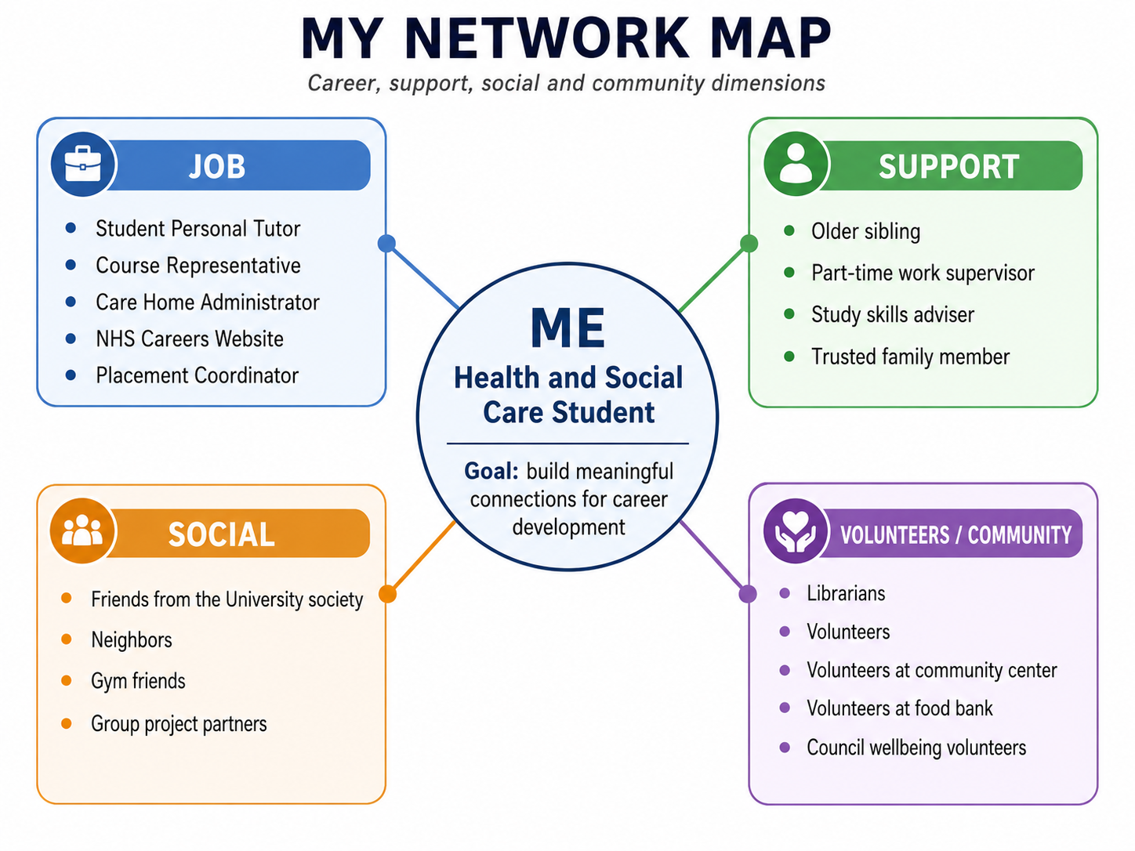
Figure 1: My Network Map

Supporting Rationale:
My network is more selective than others because I do not go out of my way to broaden my network with many contacts but instead stick to a handful of trusted ones. It provides me with stability and allows me to seek counsel when I need it. My best strength is support – there are people who can encourage me emotionally and help me keep my focus during stressful times (Bu et al., 2024).
But the network of my career must be improved further. I have some valuable academic and placement related networks, but not enough direct networks with people in the care coordination, administration, and/or NHS support roles. This restricts my ability to get advice from professionals and jobs.
I have close personal relationships, meaning that my bonding social capital is high. But I have less bridging social capital because I need to reach out to people from various backgrounds and work fields (Gheyassi and Alambeigi, 2024). My social capital in terms of links to managers, employers and service leaders also needs to be enhanced. To help with this, I will be going to employer talks, taking part in professional online groups, volunteering in my local community and asking placement staff about career pathways.

Task 3- Blog
Write a blog exploring a current topic or issue of your choice within the health and social care sector in the UK. The purpose of this is to inform a specific target audience of your choosing.
Staff Burnout in Social Care: Why Families Should Care Too.
- Audiences: Families of people in care homes.
The first thing that people think of when they consider care homes is the residents, the building and the level of the care that is given. One thing that has an impact on the quality of care is staff burnout (Davies et al., 2025). A lot of care workers in adult social care in the UK are under a lot of stress, have a high workload, have low pay and are short of staff. This can cause employees to feel demoralized, devalued, and unable to perform to their best daily.
Burnout is not about going on a long shift and feeling very tired. This can include experiencing fatigue, loss of motivation and a lack of engagement with work. This is important in a care home as staff will be involved in helping residents with their personal care, medication schedules, mobility, meals, and emotional health. Stress can increase the time staff members may need to spend on other responsibilities, and they may not be able to observe any changes in resident health or make an impactful connection.
This is a matter of concern to families as a stable and supported workforce is essential for safe care. Skills for Care (2025) identifies the issues in the workforce for adult social care, such as vacancies, recruitment, and retention. The Care Quality Commission (2025) also mentions that the staffing shortage may impact on the quality and safety of care services (Wilkinson et al., 2023).
Care homes can prevent staff burnout by listening to the staff, giving frequent supervision, making better staffing arrangements, and providing training and a positive attitude. Families can also support by communicating to staff in a gentle way, speaking about issues in a constructive manner and be aware of the emotional nature of care work.
This is not to be interpreted as families ignoring poor care. People who live in care should be cared for safely, with dignity and in a person-centered way. But there must be support for the people who provide care if care is to be improved. Compassionate care is more likely to be consistent and provided by a care home that is a place where workers feel valued, trained and emotionally supported.
Wellbeing of staff and residents is not an either/or situation. Adult social care and the two are very interlinked. To improve the situation of older people, the situation of those who care for them every day needs to be considered.
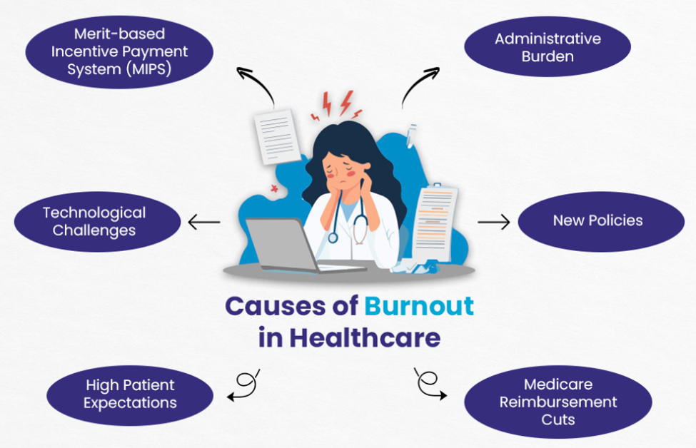
Figure 2: Causes of Burnout in Healthcare (Davies et al., 2025)

Task 4- NHS Equality, Diversity, and Inclusion Quiz (250 words equivalent)
- What is the primary goal of the NHS Equality, Diversity, and Inclusion Improvement Plan?
The primary aim of the NHS EDI Improvement Plan is to increase the fairness and inclusivity of the NHS. The main focus is on ensuring that staff are respected, valued and can belong.

- How does the NHS EDI Improvement Plan propose to tackle the gender pay gap?
The plan supports NHS organizations in assessing gender pay data, closing gender pay gaps and promoting gender equality in the workplace.

- What is meant by the term ‘intersectionality’ as used in the NHS EDI Improvement Plan?
Intersectionality refers to the potential for people to be disadvantaged because of multiple identities, such as gender, ethnicity, disability, age, and so on.

- Why is it important for the NHS to create a psychologically safe work environment?

A psychologically safe workplace is important because employees should feel comfortable to be truthful, talk about problems and seek assistance.

- How does the NHS EDI Improvement Plan suggest improving the experience of internationally recruited staff?

The plan works to support overseas staff with improved induction, welcoming teams, pastoral care and facilitating NHS induction.

- What role does leadership play in advancing EDI objectives according to the NHS Improvement Plan?
Leadership is critical as managers and senior leaders shape the workplace culture. Leaders are expected to have responsibility for progressing the work of EDI and make inclusion ‘business as usual.’

- Identify one way the NHS EDI Improvement Plan aims to reduce health inequalities within the workforce.
The plan sets out to tackle workforce health inequalities in several ways, including helping organizations to recognize the health needs of their staff and respond to unfair inequalities.

- Why does the NHS EDI Improvement Plan emphasize the importance of collecting and analysing data on protected characteristics?
Taking in information about protected characteristics enables the NHS to identify inequalities. This evidence will then be used to inform more equitable decision making and to assess progress.

- Explain how flexible working policies can contribute to equality and inclusion in the NHS workforce.
Flexible working is supportive of inclusion as staff have a variety of personal, health and caring needs. It can make it more likely that more individuals stay in work and move up their careers.

- What is one strategy mentioned in the NHS EDI Improvement Plan to combat bullying and harassment in the workplace?
Examine bullying, harassment and discrimination data and develop clear action plan to minimize problems and make the workplace a safer place

Task 5- A Letter to Yourself
Think of a time in the past when you may have been experiencing issues or difficulties, and after considering what you have learned in this module about emotional intelligence and resilience write a letter to your younger self explaining how these attributes were important at that time and perhaps how developing these areas could have been useful (300 words)

Dear younger me.
During my school days, I went through a challenging time when I felt lonely and bullied by other students. I would say that I was a lot more silent than I needed to be and I did not show my feelings and I tried to deal with it myself because I did not want to be seen as weak. Looking back, if it had been emotionally intelligent and resilient, I would have understood my emotions, sought assistance, and reacted in a healthier manner.
I know that you are feeling hurt and alone in School right now. Being excluded and bullied has made you question your confidence, your abilities and whether you truly belong. You want to look good on the outside, but on the inside, you are feeling hurt, worried, and uncertain if conditions will get better.
Keep in mind, others still do not make you worth it. I would encourage you to identify your feelings rather than judge yourself for having them. It would enable you to see that sadness, fear and/or frustration is a normal response because of being treated unfairly. This would also enable you to express your emotions to someone that you trust, such as a teacher, family member, or friend, rather than keeping your emotions to yourself.
Resilience is also a key consideration because this experience is painful, and it will not last forever. It will help you stay on board, restore your confidence and trust that you can move forward. Resilience is not about ignoring difficulties and pretending they do not exist, it is about acknowledging that support is available and using tough times to learn and evolve.
Have patience and show kindness to yourself. You are worthy of respect, friendship, and encouragement. This experience will assist you in becoming more compassionate, understanding and calm in your support of others in health and social care one day.
From, Your older self
Task 6- GANTT Chart (200 words equivalent)
Compile a Gantt chart which illustrates the tasks you have to complete to achieve your future employment goals
This is a ‘Gantt Chart ‘of the steps that I intend to take to get to my future work goal, that is Care Coordination and Health Services Administration. I will start researching the role of a Care Coordinator and/or Health Service Administrator in January and February 2026.This will enable me to gain an understanding of the roles, skills, qualifications, ,Record Keeping and other digital skills and experience required for these occupations. Discuss relevant training during March-June 2026 such as Safeguarding, Communication, Data Protection, Record Keeping and other professional skills. Following the first training, I will have the opportunity to work in a care or administration environment from May to October 2026.This will help me to become confident and make it easier for me to show what I have learned in my workplace. I will also work on expanding my professional network and LinkedIn Profile from April 2026-October 2026.I will apply for appropriate jobs for September-November 2026.I will be practicing and preparing my answers from October to December 2026 and build my confidence. Lastly, in January 2027, I want to get and get my new job off to a great start.

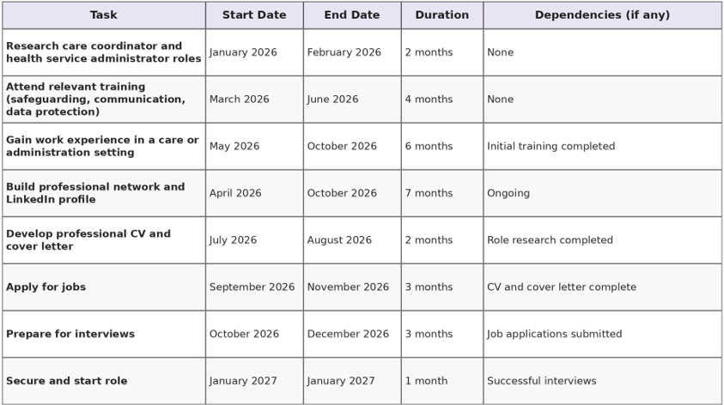
Figure 2: Gantt Chart

Task 7- Making Changes- Report
You are the manager of a care home and want to make changes your workplace. Identify one specific change that you want to implement and write a brief report on how this is going to be achieved considering the necessary skills needed and addressing possible barriers to success. Relevant change models can be highlighted.
- Proposed Change: Introducing Personalized Activity Plans in a Care Home.
As a Care Home manager, I would be introducing individual activity plans to residents to enhance the wellbeing, independence, and social interaction. The change would involve learning about the interests, abilities, culture, and life history of each resident and then using knowledge of this to plan meaningful activities, instead of providing the same activities to all residents.
I would use Lewin's Change Model to make this change. In the unfreeze phase I would explain why personalized activity plans are required, what the benefits would be to the staff and families and listen to any concerns – so people understand the need to change (Hodge et al., 2024). During the change stage, staff would start to be supported and trained with personalized activity plans and activities including music sessions, gardening, gentle exercise, memory boxes, and religious/cultural activities would be trialed. During the refreeze, successful activities will be incorporated into day-to-day activities, staff roles will be defined, and regular reviews will establish the new norm.
For this change to happen, one needs leadership, communication, teamwork, creativity, and emotional intelligence (Misiak et al., 2025). The skills of leadership and organization are vital in helping to lead and sustain the change. Communication is vital in listening to residents and in communicating the benefits to families/staff (Tierney et al., 2023). Emotional intelligence is required too as some residents may be feeling reluctance, anxiety and isolation in their attempts to engage in new activities.
Barriers may include low motivation of residents, resistance to change in routine, limited staff time, and lack of resources. These barriers can be alleviated by involving volunteers, planning more low-cost activities, engaging families, delegating specific responsibilities to staff, and offering support as they move through each phase of the change process (Smith et al., 2024).
In total overall this will help to encourage person centred care with residents feeling valued, included, and respected.

Reference List
Bu, C., Han, C., Kang, T. and Liu, Z., 2024. Research on the Impact of Social Network on the Employment Choices of College Students and Countermeasures. Highlights in Business, Economics and Management, 35.
Cham, K., Edwards, M.L., Kruesi, L., Celeste, T. and Hennessey, T., 2022. Digital preferences and perceptions of students in health professional courses at a leading Australian university: A baseline for improving digital skills and competencies in health graduates. Australasian Journal of Educational Technology, 38(1), pp.69-86.
Davies, S., Pearson, A., Allen, R., Whittaker, W., Cartney, P., Clarkson, P., McPhillips, R., Owens, J., Regan, M., Van Tongeren, M. and Young, A., 2025. 'Living with Covid': Well-being, Burnout, and Moral Injury in England's Adult Social Care Workforce-A Survey Study. Journal of long-term care, (2025), pp.168-181.
Gheyassi, A. and Alambeigi, A., 2024. Social capital and career adaptability: the mediating role of psychological capital. Higher Education, Skills and Work-Based Learning, 14(5), pp.1070-1086.
Hodge, G., Lang, I., Byng, R. and Pearce, S., 2024. Older peoples lived experiences of personalised care in care homes: A meta‐ethnography. International journal of older people nursing, 19(1), p.e12585.
Leadbeatter, D., Nanayakkara, S., Zhou, X. and Gao, J., 2023. Employability in health professional education: a scoping review. BMC medical education, 23(1), p.33.
Misiak, M.M., Bethell, J., Chapman, H. and Sommerlad, A., 2025. How can care home activities facilitate social connection in residents? A qualitative study. Aging & Mental Health, 29(1), pp.25-35.
Smith, N., Damant, J., Hamashima, Y., Jasim, S., McLeod, H., Prato, L., Taylor, J., Ferguson Montague, A., Fitzpatrick, R., Forder, J. and Giebel, C., 2024. Care planning in older adult care homes: a qualitative study of care staff experiences and views. International Journal of Care and Caring, pp.1-18.
Tierney, L., MacAndrew, M., Doherty, K., Fielding, E. and Beattie, E., 2023. Characteristics and value of ‘meaningful activity ‘for people living with dementia in residential aged care facilities: “You’re still part of the world, not just existing.” Dementia, 22(2), pp.305-327.
Wilkinson, K., Lang, I., Thompson-Coon, J., Liabo, K., Goodwin, V.A., Coxon, G., Cox, G., Marriott, C., Abel, C. and Day, J., 2023. The impact of a public health crisis on the well-being of UK senior care home staff: A qualitative interview study.

Appendix
1. My Network Map
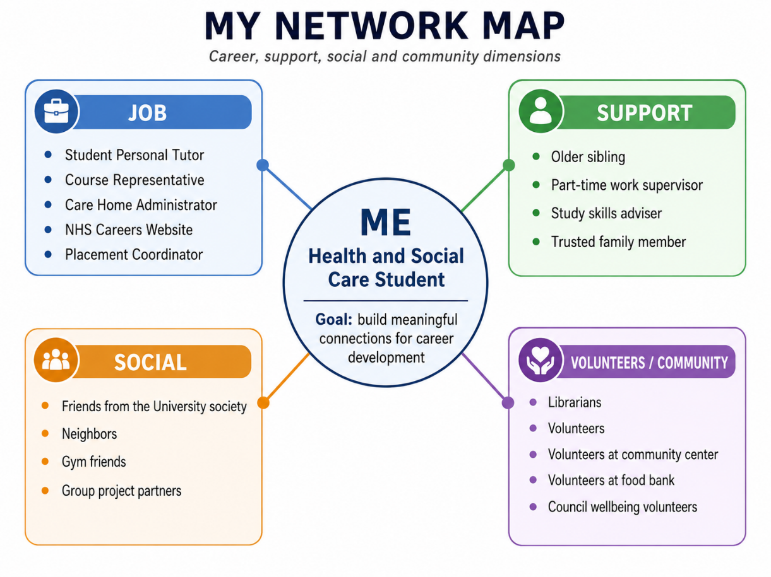

2. Gantt Chart

