Lonyé Browne (2114209)
UWTSD
ACBA4001
ASSESSMENT 2 L4

Ground Floor 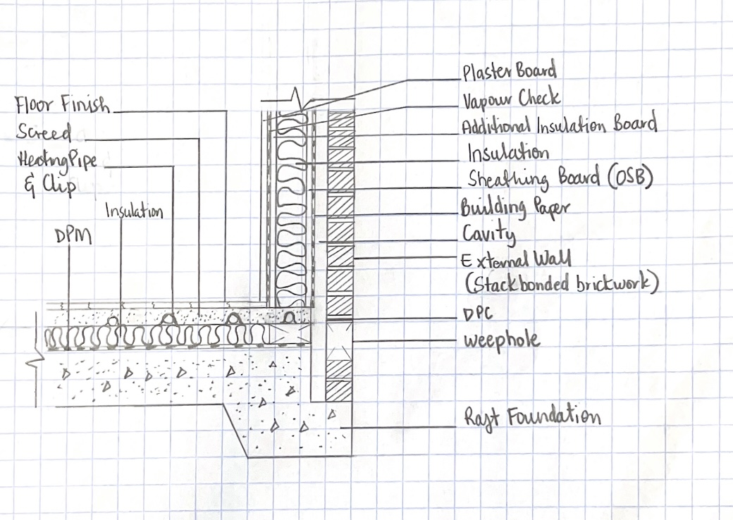

First Floor
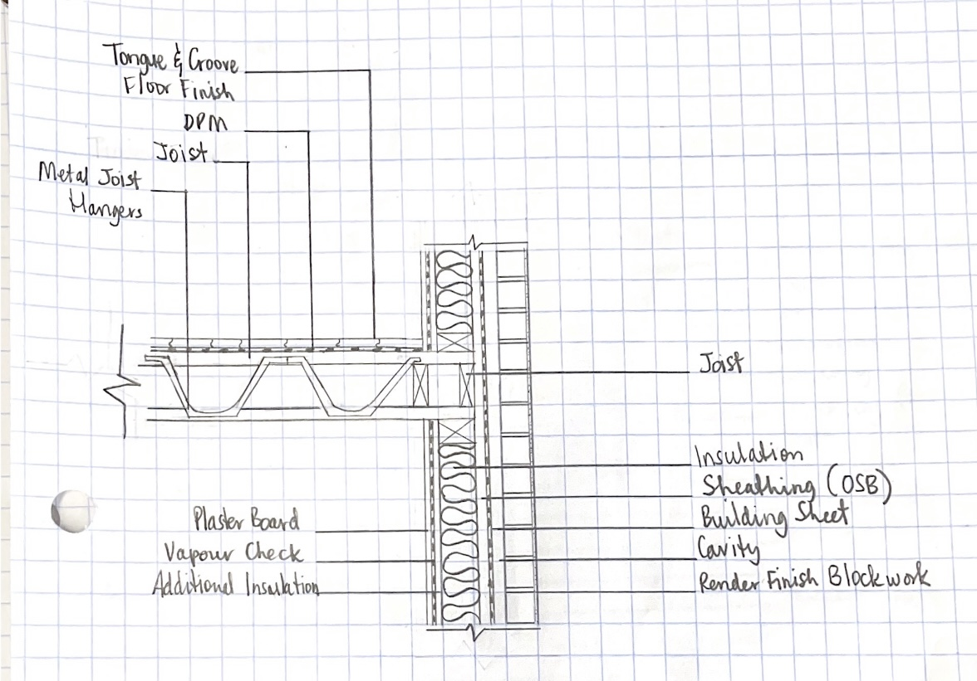

Eaves
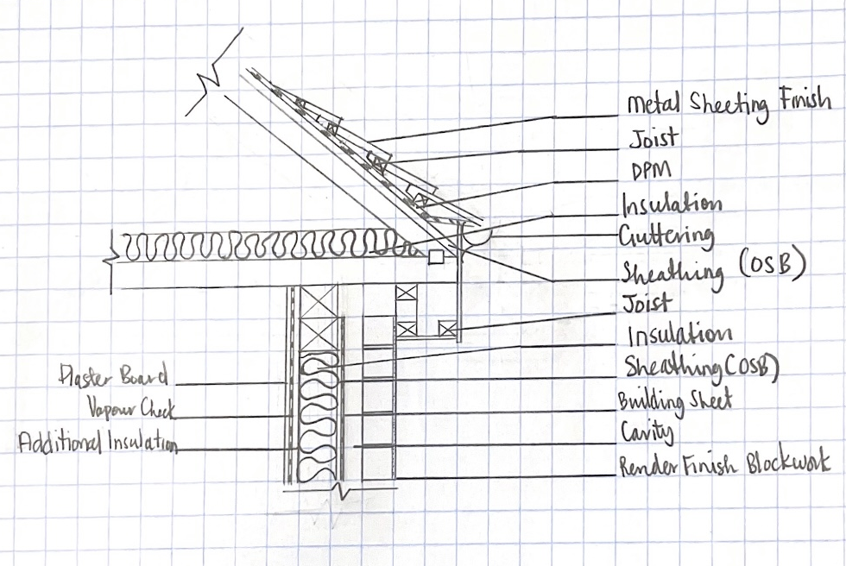

Roof
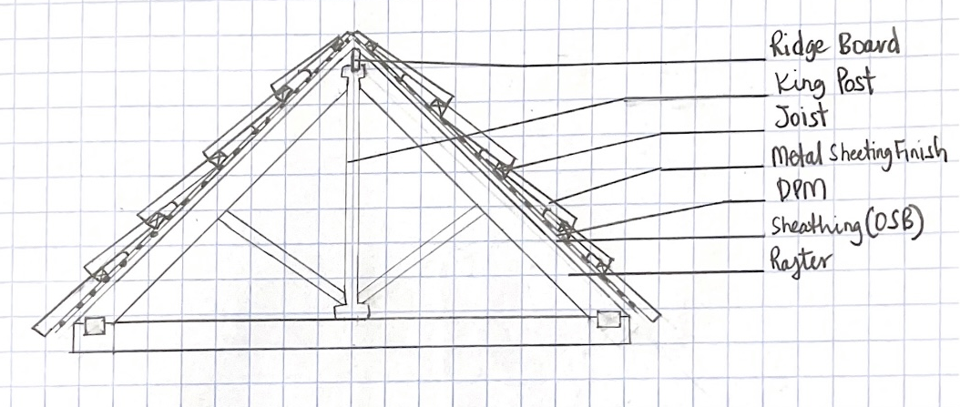

The foundation and wall construction were chosen per part A.
A DPM is needed according to part C.
Insulation is required according to part L.

https://www.gov.uk/government/collections/approved-documents

2. (i) Advantages of a trussed rafter roof:
Cost-Effective & Energy Efficient- Timber is generally cheaper than steel and concrete. Installing timber trusses does not involve heavy machinery because they are light. Timber is also very durable as they are non-flammable and non-corrosive, giving them a longer life span. Timber trusses are excellent insulators, thus reducing energy costs.

Span & Load- timber trusses can have more considerable distances because of the triangular shape. The shape of the trusses also helps support the roof's weight, reducing the weight applied to the floor.

Disadvantages of a trussed rafter roof
Timber can warp- Great consideration must be put into protecting the timber from the elements, and it can change shape slowly and damage the house.

Pests- termites are a risk to timber trusses, and regular inspections must be done as a precaution against an infestation.

Advantages of steel finish roof
Longevity- Steel sheets can last thirty to seventy years and require minimal maintenance. They are also not likely to rust because of their corrosion resistance.

Durability- Steel is a rigid, hardwearing material that is lightweight and will reduce the stress on buildings. These sheets are also quick and easy to install. The outermost layer of the steel sheet is coated with plastisol, which provides more durability and resistance to scratches. Some sheets are also coated with a particular protective chemical which prevents mould growth and mildew. Steel is non-flammable and fire-resistant, which makes it perfect for homes.

Energy Efficient- The steel sheets allow heat to bounce off and reflect when the sun is out (summertime). During the winter, the heat inside the building is then reflected and contained within the house. In all, it saves more money on energy.

Disadvantages of steel finish roof
Replacement and Installation- Replacing a single tile is much cheaper than an entire metal panel. These sheets are priced highly per square foot of installation.

(ii) Alternative Roof- Hip
Advantages- they have four slopes that make them more stable than the other roofs, allowing for better runoff. These roofs allow more ventilation and attic space.

Disadvantages- these roofs are more complex to construct than pitched/trussed roofs, which increases the probability of mistakes in the structure. These roofs are also more expensive.

3. (i) Offsite Construction is a process that involves planning, designing, fabricating, and transporting preconstructed building items and their quick assembly on site.
(ii) The four types of Offsite Construction are
- Panelised Systems- these components can be flat-packed. They include parts of the walls, ceiling, or a roof that can be constructed in a factory and then assembled onsite. The panels can be built with mechanical and electrical services but would have to be connected on-site—for example, in the building- the walls (building sheet to the plasterboard).

- Volumetric Systems- refer to assembling fully enclosed or 3-dimensional modules in an offsite factory, then joining them to construct a more significant component—for example, the washing closet.

- Sub-assemblies and components- refer to any part of the building made in a factory and brought to the construction site. Sub-assemblies can range from door handles to roof trusses. They are mainly used in more onsite focused projects but employ subassemblies for more precision—for example, the joists of the building (first floor).

- Hybrid systems- this method refers to combining different techniques and materials to fulfil a specific function: for example, the sunroom.

References
Cardinal Steel. 2022. Top Five Advantages Of Using Steel Roofing Sheets. [online] Available at: <https://cardinalsteels.com/top-five-advantages-of-using-steel-roofing-sheets/> [Accessed 24 April 2022].
Concretecentre.com. 2022. Hybrid concrete construction. [online] Available at: <https://www.concretecentre.com/Building-Solutions/Framed-buildings/Hybrid-Concrete-Construction.aspx> [Accessed 24 April 2022].
Fisher Lumber. 2022. The Advantages Of Trusses - Fisher Lumber. [online] Available at: <https://www.fisherlumber.com/lumber/the-advantages-of-trusses/> [Accessed 24 April 2022].
GOV.UK. 2022. Approved Documents. [online] Available at: <https://www.gov.uk/government/collections/approved-documents> [Accessed 24 April 2022].
Icrroofingcorp.com. 2022. Blog | Advantages & Disadvantages of Using Metal Roofing Sheet System. [online] Available at: <https://www.icrroofingcorp.com/blog/2017/advantages-disadvantages-of-using-metal-roofing-sheet-system.html> [Accessed 24 April 2022].
Leach Trusses. 2022. Pros & Cons Of Timber Roof trusses - Leach Trusses. [online] Available at: <https://leachtrusses.com.au/pros-cons-of-timber-roof-trusses/> [Accessed 24 April 2022].
Miles, D., 2022. Modern offsite construction techniques: an overview. [online] Atamate.com. Available at: <https://www.atamate.com/atamate-blog/modern-offsite-construction-techniques-an-overview> [Accessed 24 April 2022].
Rebuild Texas. 2022. Advantages & Disadvantages of Various Styles of Roofing | Rebuild Texas. [online] Available at: <https://rebuildtx.com/advantagesdisadvantages-of-various-styles-of-roofing/> [Accessed 24 April 2022].
The Constructor. 2022. What is Offsite Construction? - The Constructor. [online] Available at: <https://theconstructor.org/building/offsite-construction-features-methods/38319/> [Accessed 24 April 2022].

