4.0 Analysis of Results

4.1 Introduction
This chapter aims to analyse the results of the primary research that has been conducted via the online survey outlined in the previous chapter of this research project. It will also aim to display the data gathered in a much easier viewable format by using graphs to show the main findings. This online survey was sent to local current serving police officers as previously stated in the above chapter and has now had 35 responses. This research sample size is enough to get the primary data required to complete this chapter of the project.
A copy of the online survey that was sent to police officers is copied and can be found in Appendix A.

4.2 Data Analysis
The data analysis that will be covered in this chapter will be conducted by organising and gathering the information from the primary data that has been created via the online survey. By completing this, is allows for any patterns or themes to develop. This research will not only show the results of the data but will discuss if the data links back to any previous literature or if these findings show a difference. The data analysis will be set into themes to review each area that the survey covers.

4.3 Method of Analysis
This survey was completed online via Google Forms, which was able to create the survey and quickly disseminate to the sample group required. It is a very simple form with multiple choice answers, allowing persons completing it to stay anonymous which can aide with contribution. Throughout all 35 responses, all questions were answered by all participants and this ensures that the data is of good quality.
There are some drawbacks to using an online form which have been mentioned in the previous chapter. Due to time limitations, the survey did not have enough time being broadcasted as would be desired for this type of research. The other potential downside of this survey was regarding potential biases entering the results. This is impossible to know for sure however when the data is analysed, this point will be discussed.

4.4 Online Survey Findings
The first two questions posed within the online survey were to understand what sample group the survey had reached.
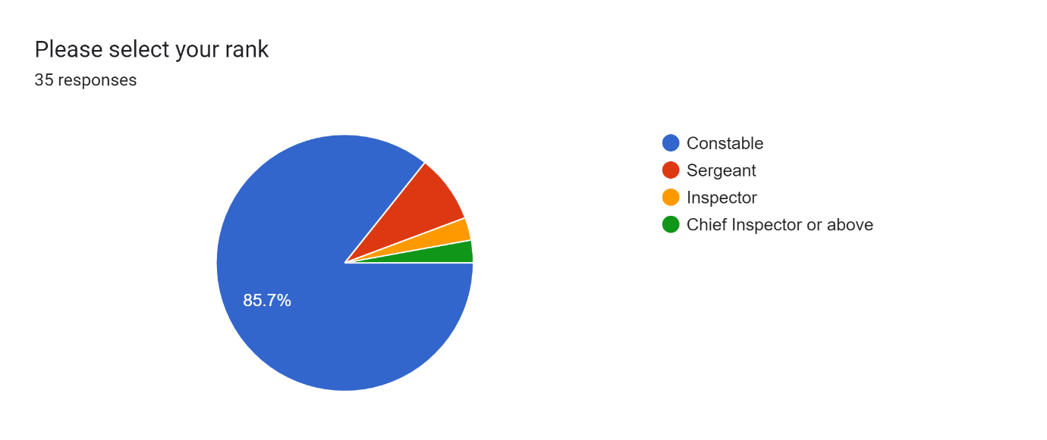
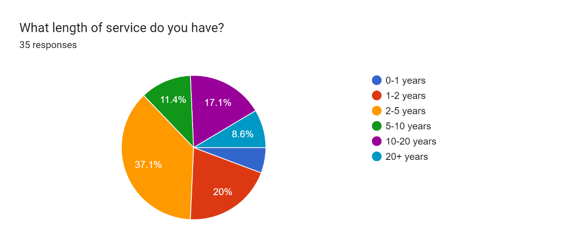
The above data shows that a very high majority of around 86% of the sample group were constables with around 8% stating they were sergeants. The remaining participants were inspector or above. This is what was expected from the research as there are more constables than other ranks and they are often the officers who are on the front line dealing with the calls from persons suffering mental health crises.
The second question regarding length of service was posed to acquire information regarding the differing views of those who have more service against those who have less service. The majority of officers completing the survey had 2-5 years’ service with the second most being 1-2 years service. Again, this was an expected result as officers with more experience tend to move away from frontline policing in favour of other departments.

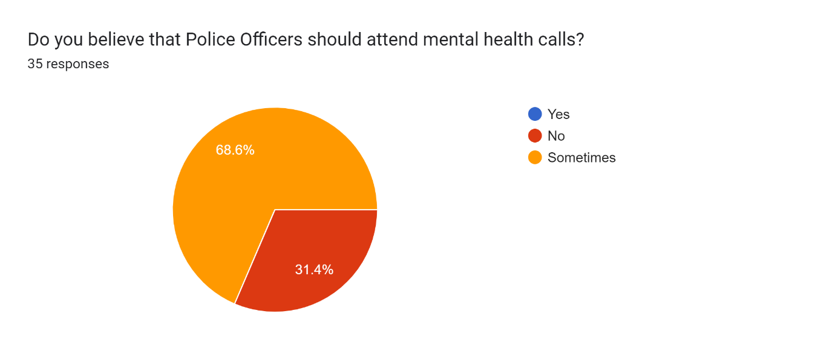
4.4.1 Theme 1 – Do you believe that mental health incidents cause demand on policing?

The above question was posed to question whether Police officers believe that they “should” have to attend mental health calls. The results from the 35 responses were 68.6% of participants saying sometimes and the remaining 31.4% of participants stating no. The above results demonstrate that sometimes a police needs to attend mental health calls agrees with (Morgan and Patterson, 2017) in that it is now part of the role of a modern police officer to deal with these kinds of incidents.

The next three questions shown are able to show actual time that police officers have to invest in to dealing with mental health incidents.

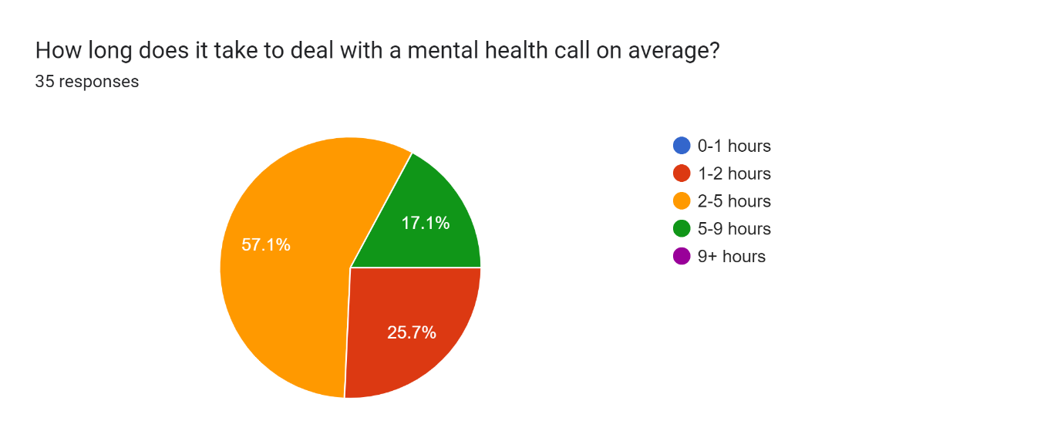
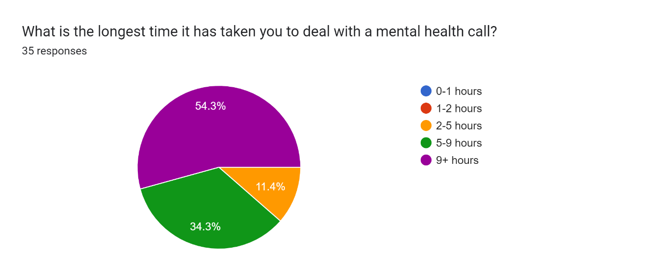

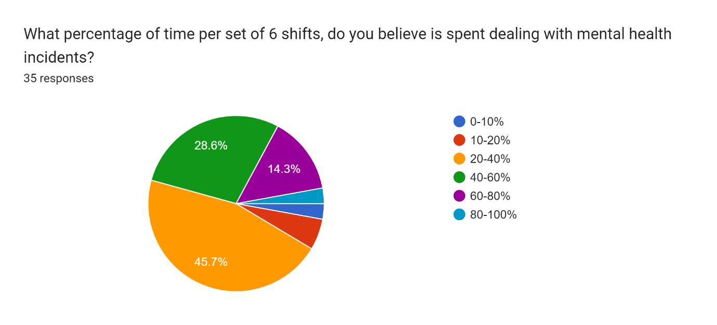
The results from the survey show that 57% of officers believe that it takes an average of 2-5 hours to deal with an incident, with only 25% believing that it takes less than 2 hours on average. This is a huge amount of time and therefore causing heavy demand on policing. The second question also shows that nearly 55% of officers also state that some mental health incidents have taken over 9 hours to conclude. Most response officers shifts are 9 hours and this data is showing that these incidents can continue over an entire shift meaning that police officer cannot continue any other police work whilst this is ongoing.
The final chart shows officers percentage of time spent during with mental health incidents throughout their set of 6 shifts. The consensus with around 45% is that officers spend around 20-40% of their time dealing with mental health incidents. There are further 42% that believe it is more than this as a percentage and is between 40-80% of their time. The consensus of these results agrees with (Adebowale, 2013) as he stated that mental health takes up around 20% of a police officers time. The data also supports (Bendelow, Warrington & Markham, 2019) as there is a continuous need for the policing of mental health incidents.

4.4.2 Theme 2 – Are the Ambulance Service and other healthcare providers needed to do more?
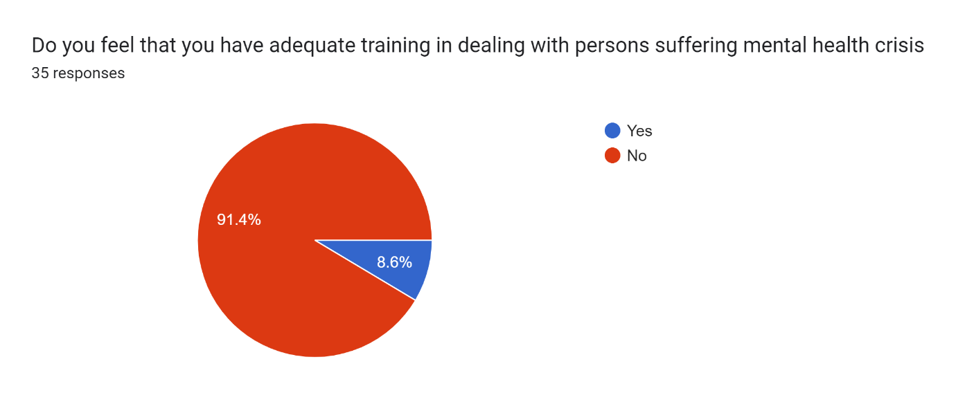
The above question was posed to ask whether police officers feel that they have adequate training when dealing with mental health crisis or whether they feel ill-equipped to deal due to a lack of training. There is an overwhelming response with 91% of police officers stating they do not feel they have adequate training dealing with a person suffering mental health crises. This supports (HMICRFRS, 2018) as that states that police officers are just picking up the pieces that are left by others and this result and results from the previous theme show that officers are attending many incidents, but do not know how to deal with them correctly. This also directly supports (Adebowale, 2013) and his recommendations which stated that police officers needed more specialist training in this area.

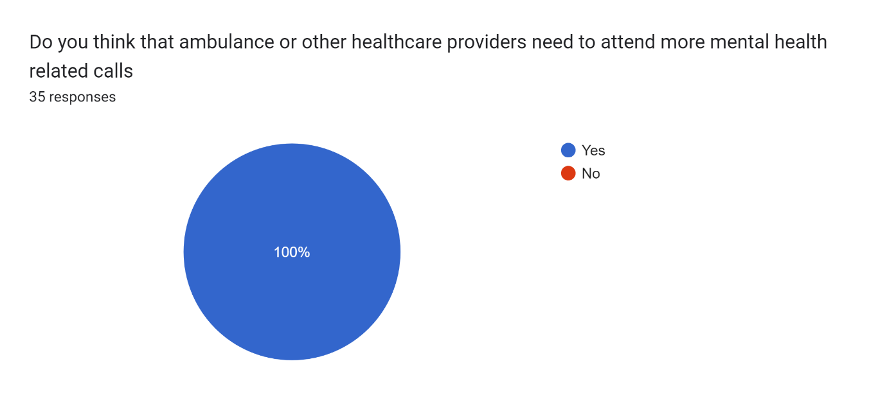

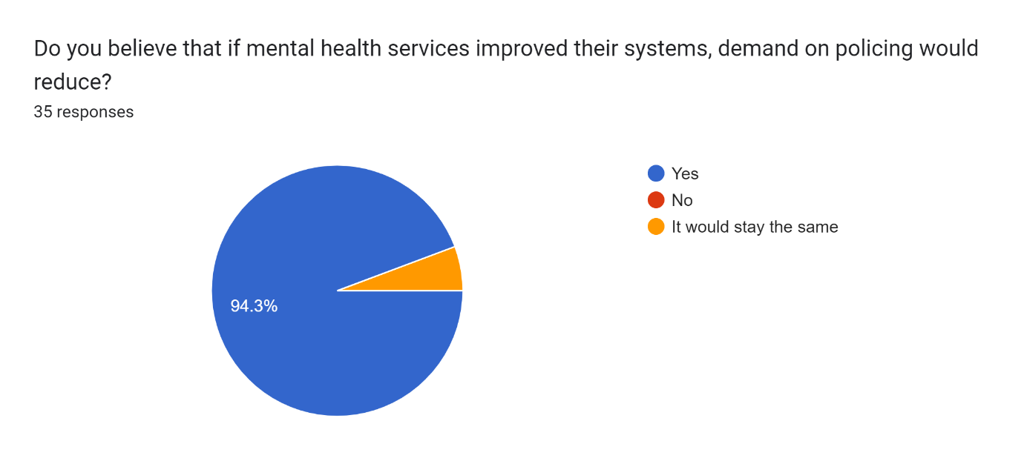
The two charts above are in relation to other mental health services and the ambulance service. Out of all 35 responses, 100% believed that these services need to attend more mental health incidents. These results also show that 94% of officers believed if they improved their services, demand on policing would reduce. These findings directly support that of (Morgan & Patterson,2017) in that other approaches such as street triage help to reduce demand. It also reinforces the view of (HMICFRS, 2018) which stated that partner agencies all need to work together to tackle the demand of mental health incidents.

