Liverpool Travel Blog
The best way of learning about tourism industry is to bring the learning alive. To do so, Liverpool can offer you a very good overview about tourism. The moment we stepped foot onto a very vibrant city we were instantly impressed. The impressive architecture of Liverpool sent us back in time.
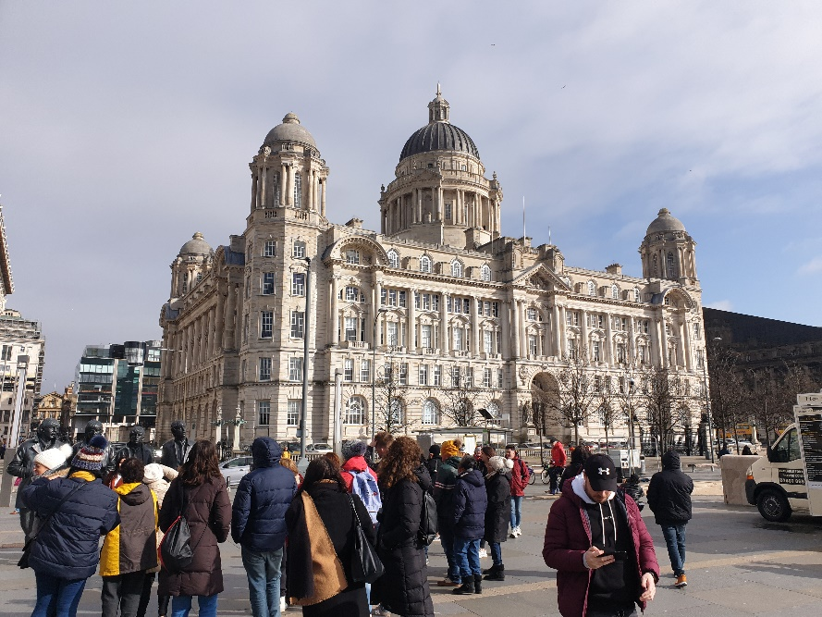

As we were interested in cultural and heritage of the city, we decided to visit the Liverpool Museum. This place gave us a better insight of how people of Liverpool lived theirs lives. In this picture you can see how “The Provincial Grand Orange Lodge of Liverpool” are expressing Liverpool’s identity through the display.
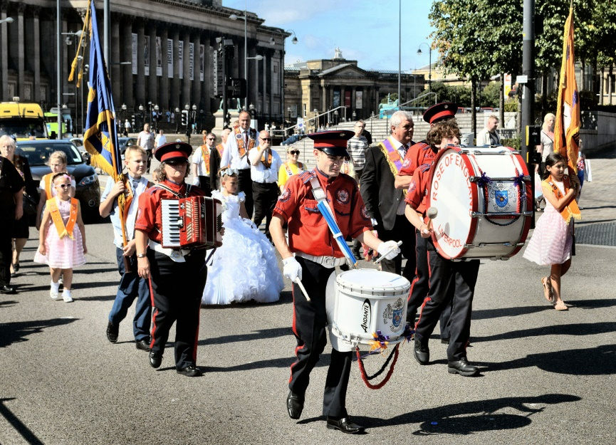

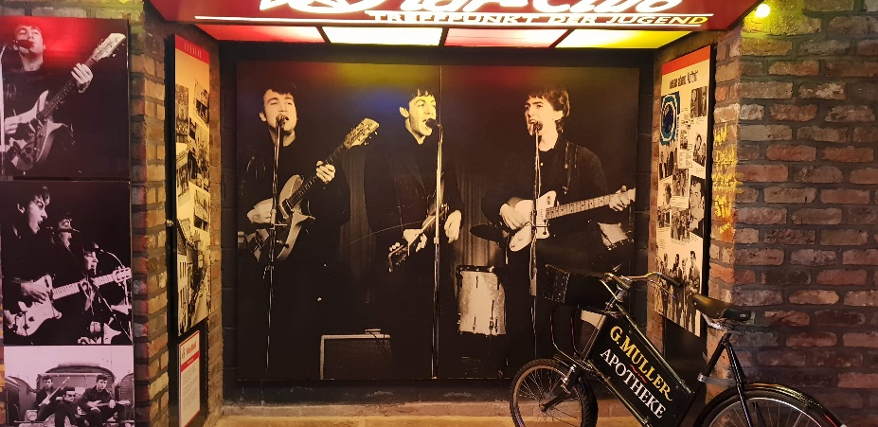
As plan of my itinerary, Beatles museum it was the next place on the list. Located in the “Fab Four’s” hometown of Liverpool on the fabulous UNESCO heritage site at the Royal Albert Dock, the Beatles story took us into atmospheric journey through their lives, time, culture and music of Beatles.
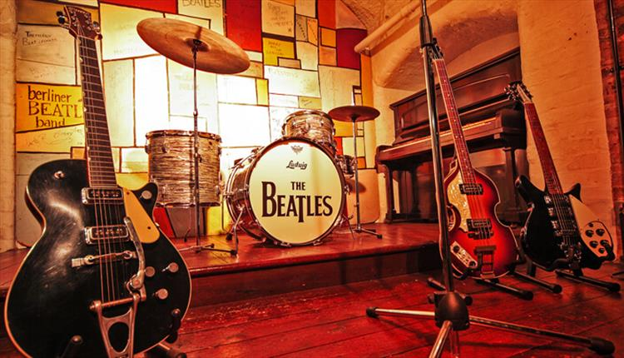

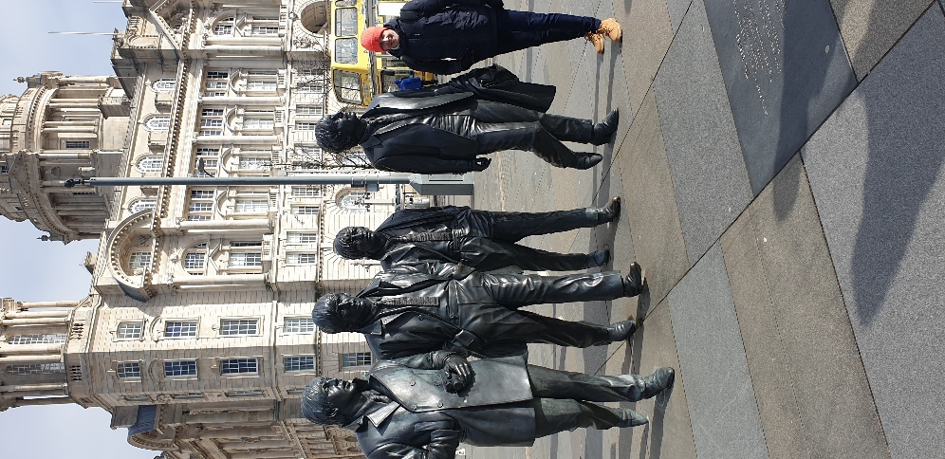
In order to connect even more with the city, we decided to spend a few hours in places were Beatles are still alive among people. At the Cavern Club the bands are playing live the all-era Beatles music every week.



