Business Plan for

Greenhaven

Produced By

Student Name: Suruk Ahmod

Student No: 2121358

Submission Date: 31/05/2024

Module Name: Entrepreneurship Module Code: BMIH5001
Lecturer Name: Charlotte Joyner

---------------------------------------------------------------------------------------------------------------------------------------Business Plan for Page 0

CONTENTS

PAGE

1. Mission Statement

2. The Concept

3. The Team

4. The Market

5. The Marketing Strategy

6. SWOT Analysis

7. Finances and Start-Up Support
………………….

………………….

………………….

………………….

………………….

………………….

………………….

APPENDICES:

Appendix A

Appendix B

Appendix C
………………….

………………….

………………….

---------------------------------------------------------------------------------------------------------------------------------------Business Plan for Page 1

1. Mission Statement
GreenHaven's mission is to revolutionize the UK hotel business sector by combining high-end service with environmental consciousness. The mission statement of the organisation is to offer high-quality services to the customers to satisfy them and practice sustainability to operate business activities. GreenHaven was planned to provide an unrivalled eco-tourism experience by placing guests in the middle of a variety of natural settings. This hotel business stands out from the competition because to its convenient location, use of natural light and breezes, and dedication to environmental sustainability.

---------------------------------------------------------------------------------------------------------------------------------------Business Plan for Page

2. The Concept

Business details
GreenHaven hotel is a boutique hotel that will offer a spectrum of services, including accommodation, tours, teaching, restaurant, and cultural immersion, tailored to diverse customer profiles. The hotel business's unique value proposition lies in its dedication to sustainability, a feature absent in competitors such as Adventure People. (Indajang et al, 2024)
The essence of GreenHaven's sustainability lies in both its structure and daily operations. From eco-friendly construction to embracing green technology, the hotel minimizes energy consumption. Daily activities prioritize waste reduction, water conservation, and biodiversity promotion, aligning with the Blue Ocean Strategy and community-oriented initiatives. (Karim et al, 2019)
What the business doe
Product/service | Features | Benefits
- Accommodation | - Eco-friendly rooms. | - Supports to enhance customer experience.
- Adventure Tours | - With expert guide to ensure better experience. | - Supports to explore new areas
- Teaching | - Proper instructions by the organisation | - Supports to stay aware in new culture
- Restaurant | - Different kinds of foods | - 24/7 food service for the guests
- Organic foods | - Local fresh foods | - Attract food lovers
- Event space | - Enough space and decoration | - Grab the attention of business organisations
- Sustainable transportation | - Electric vehicle support (Panteleiev et al, 2022) | - Supports the environment from pollution

Location
The selected location for the hotel business GreenHaven is Lake District in Cumbria. This location is suitable for the hotel business because of its high demand for tourism and easy accessibility. GreenHaven aspires to revolutionize the UK hotel sector by intertwining opulent service with environmental mindfulness, delivering an unparalleled eco-tourism experience. Strategically located amidst diverse natural settings, this eco-friendly hotel distinguishes itself through its commitment to sustainability, harnessing natural light, and fostering breezy atmospheres.
Aligned with the principles of corporate planning, GreenHaven aims to set new benchmarks in green hotel management, aiming for a £150,000 turnover in the first year. Over the next two years, projected increases of 10% and 5% anticipate customer satisfaction and expenditure growth, targeting turnovers of £165,000 and £173,250 respectively. (Agarwal et al, 2019)

Sustainable/eco friendly
GreenHaven is an eco-friendly hotel business organisation that will bring revolutionary change in the hotel business sector. The sustainability of GreenHaven stems from its structure and daily activities as the organisation applies eco-friendly technologies, reduce carbon footprint from the environment, and ensures proper resource management regularly. The hotel business’s design and construction are thoughtfully crafted to reduce energy usage, with an emphasis on green technology and eco-friendly building supplies. Its activities are intended to minimize their environmental effect by minimizing waste, conserving water, and boosting biodiversity.
Market research reveals a demographic preference for females and a strong appeal to local markets, guiding GreenHaven's marketing strategies. Customer profiles encompass Nature Enthusiasts, Wellness Seekers, Adventure Travelers, and Early Retirees. By understanding customer desires and anticipating a varied market, GreenHaven envisions winning diverse customer groups. (Holloway et al, 2022)
Recognizing potential market risks such as entry challenges, capitalization, economic fluctuations, and legislative concerns, GreenHaven plans to mitigate these by strategic planning and adaptability. The pricing strategy aims to be competitive, considering a range of factors while maintaining profitability. In essence, GreenHaven emerges as a pioneer in the UK hotel industry, marrying luxury with environmental responsibility, poised to reshape the landscape of eco-tourism. (Junianto et al, 2024)
According to the Blue Ocean Strategy, which promotes novel techniques to establish new market spaces for the organisation by focusing on innovation to break free from market boundaries (Kim & Mauborgne, 2004), GreenHaven also participates in community-oriented activities that benefit local economies and cultures and play a crucial role to enhance the brand reputation of the organisation. In keeping with the principles of corporate planning as outlined by Johnson and Scholes (Johnson & Scholes, 2004), GreenHaven seeks to lead the hospitality industry by establishing new standards for service and innovation in green hotel management. Moreover, it is recommended to include detailed sections on sustainability activities (Mahfud et al, 2019)

Business goals
What do you want to achieve in your first year of business? (for example,turnover of £100,000 or trading at breakeven)
The organisation is targeted that it will generate a turnover around £150,000 the initial year of establishment while operating business. The revenue will be increasing gradually when the brand value will be increasing, and more customers will be coming to take the services. There are lots of potentials for GreenHaven to become popular among the eco-enthusiasts which will help us in developing strong customer base for ensuring a sustainable and consistent flow of revenue all over the year. (Panteleiev et al, 2022)
Where do you see your business in 3-5 years’ time?
In 3-5 years, the organisation wants to become a leading environment friendly hotel business organisation of the United Kingdom that will ensure better quality services to the customers as well as support the environment through business activities. GreenHaven organisation will apply the Klofsten's business platform model so that the organisation can bring development in its products, services and customer relationships to bring sustainable growth in the organisation. By following the Klofsten’s business platform GreenHaven will increase investment in sustainable sectors build network in the local area and make partnership with local suppliers to grow the business in future. (Agarwal et al, 2019)

What makes the business different (Value Proposition)
Your product/service is unique or different compared with the competition because:
- It is the perfect mix between comfortable hotel rooms, and beaty of wild nature met on tent camps
- Yurts brought here are at the very top of the latest technology, so that guests can feel them comfortable from beds to wardrobes and sinks (Tra et al, 2020)

Legal requirements
The legal and insurance requirements that apply in your business are:
- The business needs to registration
- Insurance for workers
- Heath safety of employees and guests (Agarwal et al, 2019)
- Intellectual property protection requirements
- Certification for environment
- Business insurances for interruption
- Contractual obedience (Panteleiev et al, 2022)
- Data safety
The legal and insurance requirements will be fulfilled by:
- Ensuring public liability insurance
- Including employees under insurance
- Securing property insurance
- Implementing Health and Safety Executive
- Professional indemnity insurance
- Risk management and legal advice
- Local council licensing
- Ensuring business interruption insurance (Panteleiev et al, 2022).

3

3. The Team
Company name: GreenHaven Ltd

Address:
10 Woolacombe Rise, Woolacombe EX34 7AF

Primary contact method
Ahmod Suruk
M: 07141 701 004

The business will:
The Natural Yurt Hotel business at Khao Woo Lacombe, is located in SW of UK, in Cornwall. The Natural Yurt Hotel business GreenHaven provides amenities, such as a garden and a restaurant. Stay connected with free in-room Wi-Fi. Also perks such as free bottled water.

3.1 Business Owner
Name: Ahmod Suruk
Position/main responsibilities: Financial Director
Experience and knowledge of our industry: Controller Manager for several small hotels during period 2013 to 2021
Previous employment: 1. Waiter, Valahia hotel/restaurant, 2010-2011
2. Receptionist, Ialomita hotel 2011-2012
3. Waiter, Capitol hotel, 2021-2013
Key skills brought to the business: very good inter personal skills within company and with customers, customer oriented attitude, admin tasks management, data oriented on top of Business experience and any training undertaken: vast hotel admin experience, financial controlling in hotel industry extensive experience. MS Office accredited course Excel mainly pointed; basic accounting course.
Academic/professional qualifications: qualified waiter; MS Office (Excel) certificate

3.2 Key personnel
Name: Mr X
Position/main responsibilities: Marketing, Customer relations
Experience and knowledge of our industry: Experience and knowledge of our industry: Extensive hotel management experience in Ghana, Aruba and United Kingdom
Previous employment: Hotel Manager, Divi Hotel businesss, Aruba; Guest Relations Manager, Aruba Surf Club
Key skills brought to the business: Management, Staffing management
Business experience and any training undertaken: Business Owner
Academic/professional qualifications: BA Social Sciences
Salary expectations £ 25,000

Name: Mr Y
Position/main responsibilities: Assistant Manager
Experience and knowledge of our industry: Ensuring a pleasant customer experience, managing reservation, preparing for special event.
Previous employment: Waiter /Restaurant 2010- 2015
Key skills brought to the business: Influencing people & guiding them in achieving a common goal. Improve customer service and sales focused
Business experience and any training undertaken: Managing restaurant business development. Provides excellent customer service and helping to make the budget
Academic/professional qualifications: Level 2 certificate
Salary expectations £ 25,000

Name: M Z
Position/main responsibilities: Housekeeping Manager.
Experience and knowledge of our industry: Managing equipment and supplies. Conducting performance evaluation
Experience and knowledge of our industry: Ensure all cleaning equipment is in proper working condition and make arrangements for repairs as needed.
Previous employment: Mercure Hotel 05/2017 - 08/2019
Days Inn Hotel 08/2019 – 12/2020
Key skills brought to the business: Maintain a cost control system for supplies, linen and cleaning supplies for efficient operation of the hotel.
Ability to anticipate customer needs, change goals and multi-task
Business experience and any training undertaken: At least 2+ years’ experience in hospitality or guest services
Academic/professional qualifications: Level 2 functional skills.
Salary expectations £ 20,000

3.3 Skills Gap & Strategic Alliances
Skill Gap analysis
Skills | Current state | Desired state | Gap | Initiatives
Negotiation | 7 | 9 | 8 | By developing relationships with professionals on business field.
Communication | 8 | 9 | 7 | Increasing interaction with people and focusing more on group activities
Technological | 5 | 7 | 9 | Getting admitted in online technological courses and analyzing different cases.
Problem-solving | 8 | 9 | 8 | Working on analytical skills and analyses previous issues
Researching | 6 | 8 | 7 | Learning different theories and frameworks and taking part in different researching activities (Mahfud et al, 2019)

4. The Market

4.1 Market Environment Considerations

PESTLE
Political: Domestic and geo-political instability can influence the business activities of GreenHaven hotel. Through the network in the marketplace and feedbacks from customers the organisation will know this. The organisation will include professional market researchers in the marketing group of the organisation and maintain strong relationships with the me secure a strong network in the marketplace to get support (Mahfud et al, 2019) | Economic: Inflation, unemployment issue and income level of people can influence the business activities of the organisation. The marketing team of GreenHaven will know this by researching the marketplace The organisation will make a research team and invest on the team so that the team can work continuously about different opportunities and challenges which supported the organisation to know this. For example, conduction survey among customers.
Technology: The dependency of business in modern technology can influence the business and its services (Agarwal et al, 2019). The overwhelming majority of visitors come from the United Kingdom. This indicates a a strong appeal to local markets. However, with 12% of site visitors coming from Spain, USA and Australia we will be considering some international marketing. | Social: Different wants and requirements of people in deferent areas, cultural differences etc. can also make impact (Tra et al, 2020). The age distribution is very diverse, but with a significant percentage within the 25-34 age group. However, we will consider the interests and preferences of all age groups. (Panteleiev et al, 2022)
Legal: Legal changes related to operate hotel businesses can influence the business activities of GreenHaven. The gender distribution indicates a higher percentage of female visitors, suggesting our marketing efforts and hotel business facilities and amenities should cater for female interests. | Environmental: Natural calamities, sustainable business practice, pollution etc. can influence the business and its activities.

4.2 Competition

Profiling competitors
In the marketplace of the UK GreenHaven will face huge competition from existing hotel business organisation of the country. In the marketplace The Green House hotel, Castle Green Hotel, The Pod Cwtch luxury accommodation, the Ritz, and The Savoy hotels will create huge completion for GreenHaven. This will divide the customers and guest in the marketplace and make impact on the performance of the organisation (Panteleiev et al, 2022).
Competitor name | Strengths | Weaknesses
- The Green House | - Strong brand reputation | - Lack of community engagement
- Castle Green Hotel | - Strong social media presence | - Communication gap
- The Pod Cwtch luxury accommodation | - Better services | - High costs

How you can improve on their offer and/or price(s) unique offerings:
- GreenHaven will offer personalised guests services such as in-room spa treatments, pet services, and private dining experiences etc.to successfully meet the unique demands of customers. (Jones et al, 2014)
- The organisation will reduce the price rate and practice sustainability to bring improvement and design the services based on the direction of guests to make the services different from others.
Trends in your chosen market are:
We have looked at two potential competitors Holiday Cottages and Adventure People. Holiday Cottages is a leading aggregator of eco-friendly cottages and homes in the UK. The Adventure People similarly offer guests to reconnect with nature and live in a more sustainable fashion

5. The Marketing Strategy

5.1 Customer Profile
Profiling customers
- Nature Enthusiasts:
Characteristics: All age groups, both genders.
Interests: Eco-friendly practices, outdoor activities, nature exploration. (Khalil et al, 2022)
Offerings: Guided nature walks, sustainable practices, wildlife experiences.
- Wellness Seekers:
Characteristics: Primarily females, diverse age groups but particularly strong from the 24+ age groups.
Interests: Spa treatments, yoga sessions, wellness programs.
Offerings: Spa facilities, wellness retreats, meditation spaces.
- Adventure Travelers:
Characteristics: Primarily younger age groups (18-34), both genders.
Interests: Outdoor adventures, adrenaline activities, hiking, and exploration.
Offerings: Adventure packages, hiking trails, outdoor sports facilities. (Jones et al, 2014)
- Early retirees and seniors Age 55+:
Characteristics: Looking for a peaceful and rejuvenating experience.
Interests: nature walks, gardening workshops, and cultural events.
Offerings: Walks, Tai chi, birdwatching. (Karim et al, 2019)
Your customer research has shown what your customers want is:
- The research shows that customers of GreenHaven organisation wants quality services form the organisation at a low cost.
- Customers also want healthy food and drinking services from the organisation and safe accommodation services. (Khalil et al, 2022)
How you know this:
- The organisation knows it by researching the marketplace and analysing reports of the marketplace.
- Besides this, conducting surveys in social media platforms GreenHaven and its marketing team know this. (Karim et al, 2019)
Number of customers you expect to win in each group and what they might pay:
Group | Number of customers | Price they might pay per unit
Nature Enthusiasts | 250 | £35
Wellness Seekers | 100 | £150
Adventure Travellers | 50 | £100
Early Retirees | 150 | £200

5.2 The Marketing Mix

5.2.1 Price
GreenHaven apply the cost based pricing strategy to successfully calculate the price.
Product/service | Your price(s) | Range of competitor prices (per unit)
Accommodation | £400 | £450-£550
Foods | £150 | £100-£250
Transportation | £200 | £240-£400
Reasons for the difference between your price(s) and your competitors’ price(s):
The cost-cutting strategy applied by GreenHaven organisation and the strategy to using recycling products support the organisation to create differences between competitors’ prices. (Agarwal et al, 2019)
5.2.2 Product
GreenHaven will offer different types of products and services like high-quality accommodation services, safe transportation services, and restaurant and bar services to its customers. Besides this the organisation will offer personalised services to customers by identifying their requirements.
5.2.3 Place
GreenHaven will select a middle position of the London city to offer its business services. This will support the organisation to easily grab the attention of customers and guests. The organisaiton will ensure eco-friendly design inside the hotel and ensure a warming environment for its customers and guests to create opportunities. (Khalil et al, 2022)
5.2.4 Promotion
GreenHaven and its marketing team will promote the products and services of the organisation by applying digital marketing strategy such as email marketing, social media marketing, content marketing etc. The organisation will operate social media marketing campaign; apply influencer promotion in different social media platforms to successfully promote its services and products (Tra et al, 2020).

6. SWOT Analysis
Strengths  - Environment friendly services of the organisation  - Personalised services of the organisation.  - Strong employees of the organisation. | Weaknesses  - Weak financial condition  - Lack of suppliers in the marketplace (Karim et al, 2019).
Opportunities  - Application of modern technologies.  - Different types of services and products.  - Increasing demand of sustainable businesses (Chod et al, 2019). | Threats  - Strong market competition  - Issues like BREXIT and COVID-19 (Panteleiev et al, 2022).

6.1 SWOT Summary
The SWOT analysis of the organisation GreenHaven will support the organisation to use the strengths of the organisation to perform better in the marketplace by grabbing the opportunities of the organisation. Also, it will support the organisation to work on the weaknesses of the organisation and reduce the threats of the organisation form the competitive marketplace (Mahfud et al, 2019).

7. Finances and Start-Up Support

7.1 Finance Summary
The financial plan of GreenHaven is highlighting the expenses, losses and the profits of the organisation. GreenHaven successfully make a strong financial plan that will support the organisation to ensure the best use of resources and investing in right sectors so that that organisation can ensure the best performance and grow the business successfully (Mahfud et al, 2019).

Start-up costs
50,800
* Total from here should be used in 22 Sourcing finance below

Profit and loss forecast
50,800

Staff
Role | Total cost | Necessary experience | Specialist skills and/or qualifications
- Manager | £60,000 | - 5+ years experience in hotel management | - Proven track record of success in leading and motivating teams, excellent communication and
- Executive Housekeeper | ££25,000 | - 3+ years experience in housekeeping | - Ability to maintain a high standard of cleanliness, strong organizational and time management skills, ability to work General Managerindependently (Tra, 2020)
- Head Chef | ££40,000 | - 5+ years experience in professional kitchens | - Proven ability to create and execute high-quality dishes, strong leadership and team-building skills, excellent culinary knowledge (Mahfud and Lastariwat, 2019)
- Receptionist | ££25,000 | - 2+ years experience in hotel reception | - Excellent communication and interpersonal skills, ability to handle multiple tasks simultaneously, knowledge of hotel systems and procedures
 | £

Premises
 | Cost £
Premises required at start-up: Location, building, Interior design | £104,625 (+£50k personal contribution)
Premises required in the future (if different): Additional hotel locations, Spa, restaurant expenses | £320,000

Suppliers
Supplier | What you’ll buy from them | Number of days’ credit
Local food suppliers (Online Retailers, e.g. Eco Food - Monkey Supply) | Naturally sourced food | 30 days
Eco-friendly cleaning products (Seventh Generation) | Biodegradable cleaning supplies | 60 days
Linen and towel suppliers (West Elm) | Sustainable linens and towels | 45 days
Furniture suppliers (IKEA) | Sustainable furniture | 90 days
Building materials suppliers (Lowes, Home Depot) | Sustainable building materials | 120 days
Technology suppliers (Amazon) | Eco-friendly technology solutions | 30 days
Marketing and advertising agencies (Green Marketing) | Eco-friendly marketing and advertising services | 60 days
Legal and accounting services (Earthjustice) | Legal and accounting support | Net 30 days
The management team of GreenHaven will always focus on sustainable sources to operate business activities and ensure the inclusion of different sustainable businesses in its supply chain system to get eco-friendly foods, energy, and other materials. Also, the organisation will make partnership with eco-friendly suppliers to operate further business activities.

Equipment

Resource | When | How funded | Cost £ per unit
- Sustainable furniture ( Chair, table) | - At start-up | - Loan | ££500
- Biodegradable cleaning supplies (Glass cleaner, soap) | - At start-up | - Loan | ££200
- Sustainable linens and towels (Hemp linens and towels) | - At start-up | - Loan | ££100
- Eco-friendly technology solutions (Energy-efficient LED lighting) | - At start-up | - Loan | ££300
- Eco-friendly marketing and advertising services (Eco-friendly printing services) | - Ongoing | - Revenue | ££200
- Legal and accounting support | - Ongoing | - Revenue | ££100
- Business insurance (Property insurance) | - Ongoing | - Revenue | ££50
 |  |  | £

Managing operational risks
Risk | Solution
Staff  • High staff turnover, Lack of qualified staff and Poor employee morale  - Employees sickness absences | • The company will Implement a competitive compensation and benefits package, and offer training and development opportunities. Additionally, it will create a positive work environment (Panteleiev et al, 2022).  • The company will also partner with local hospitality schools and training programs, and implement a comprehensive on-boarding and training program. As per Karim et al. (2019), training will help the employees to stay more engaged with the company
Suppliers  - There are chances of Disruption of the supply chain, Poor quality of supplies and Unreliable delivery of supplies | • According to Chod et al. (2019), diversifying the supplier base will reduce the dependency of the business on any particular organisation. Such a strategy will help them to become resilient to supply chain disruptions.  • Green Haven will have to negotiate with the suppliers regarding shipment tracking and delivery terms. According to Agarwal and Mishra (2019), the company must also develop a comprehensive quality control process establishing clear expectations and conduct

Sourcing finance
Managing financial risks
The risks that you have identified for your financial forecast are:
- The main risk here is that we would have even less sales than forecasted, sales which are anyway not enough to cover the cost. (Jones et al, 2014).
- The second biggest one is the big amount of fixed wages, and this can be clearly seen in P&L where margin related to variable cost is very high 80%, and total margin, after all costs ends up negative (loss). Consequently, we have to take into account to move more towards temporarily labour, so that wages cost would follow much closer revenues, as it should (Khalil et al, 2022).

How you will minimise their impact:
- We have to look for more customers in order to increase sales.
- As stated above, we would think towards variable wages, much closer walking along side sales value (Karim et al, 2019).

Cash flow forecast

Conclusion
As it currently stands, our idea will not work. In order to make it feasible we need to adjust on both sides turnover increase as well as expenditures decrease. Speaking about sales, it has to be on the first place with Mr Ahmod, to work out a better vision for GreenHaven, and then Mr Festus see how marketing can helps next. In point of expenditures decrease, a tough discussion with the agency which sales the land is required leaded by Mr Lupoae as a CFO, and Miss Andrea to work out better deals on supplies. Last, it might be to consider smaller wages for us, owners for a while. Not desired though.

References
Bansal, D., Bhattacharya, N. and Shandilya, P., (2024). Digital Entrepreneurship and Its Transformative Impacts on Business and Society. In Entrepreneurship and Creativity in the Metaverse (pp. 251-263). IGI Global.
Chod, J., Trichakis, N. and Tsoukalas, G., (2019). Supplier diversification under buyer risk. Management Science, 65(7), pp.3150-3173. < https://web.mit.edu/nitric/www/SupplierDiv.pdf > Accessed 17-05-2024
Holloway, J.C. and Humphreys, C., (2022). The business of tourism. Sage.
Indajang, K., Silitonga, H.P., Sianipar, R.T., Putri, J.A., Sembiring, L.D. and Sudirman, A., (2024). Entrepreneurship Interest Training Through Innovation and Creativity for Generation Z at Sultan Agung Private High School. Jurnal Pengabdian Nasional (JPN) Indonesia, 5(1), pp.272-280.
Jones, P., Hillier, D. and Comfort, D., (2014). Sustainability in the global hotel industry. International Journal of Contemporary Hospitality Management, 26(1), pp.5-17. <https://www.emerald.com/insight/content/doi/10.1108/IJCHM-10-2012-0180/full/html> Accessed 22-5-2024
Junianto, P., Heryadi, D.Y. and Diawati, P., (2024). Social Entrepreneurship and Creativity: Building an Innovation Ecosystem for Solving Social and Environmental Issues. EKOMA: Jurnal Ekonomi, Manajemen, Akuntansi, 3(3), pp.1348-1359.
Karim, M.M., Choudhury, M.M. and Latif, W.B., (2019). The impact of training and development on employees’ performance: an analysis of quantitative data. Noble International Journal of Business and Management Research, 3(2), pp.25-33.
Khalil, N., Che Abdullah, S.N., Haron, S.N. and Hamid, M.Y., (2022). A review of green practices and initiatives from stakeholder’s perspectives towards sustainable hotel operations and performance impact. Journal of Facilities Management. < https://www.researchgate.net/publication/366017453_A_review_of_green_practices_and_initiatives_from_stakeholder's_perspectives_towards_sustainable_hotel_operations_and_performance_impact > Accessed 17-05-2024
Kim, J.Y., Grijalva, E., Newman, D.A. and Li, Y., (2024). Entrepreneur weirdness as a double‐edged sword: Effects on product creativity and investor attraction. Personnel Psychology, 77(1), pp.53-80.
Mahfud, T. and Lastariwati, B., (2019). Chef's competency as a key element in food tourism success: a literature review. Geo Journal of Tourism and Geosites, 26(3), pp.1057-1071.- Head Chef.
Muspawi, M. and Yunita, D., (2024). Entrepreneurial Readiness Assessment of Students Based on Creativity, Self-Efficacy, and Motivation. Academia, (34), pp.42-60.
Panteleiev, V., (2023). Application of SWOT analysis to justify the strategy of hotel business enterprises. Technology audit and production reserves, 14(69), p. 17.
Putthiwanit, C. and Taeporamaysamai, P., (2024), February. Entrepreneurship, creativity, and education: Key characteristics of successful female entrepreneur with a case of ‘After You’. In International Conference on Lifelong Education and Leadership for All (ICLEL 2023) (pp. 266-270). Atlantis Press. < https://www.atlantis-press.com/proceedings/iclel-23/125998893 > Accessed 17-05-2024
Sapiro, A., (2024). Entrepreneurship and innovation. In Strategic Management: Fundamental Concepts for Decision Making and Strategy Execution (pp. 373-399). Cham: Springer International Publishing.
Sinha, M., Shekhar and Valeri, M., (2024). How does entrepreneurship education promote creativity and innovation?. International Journal of Technology Enhanced Learning, 16(1), pp.49-73.
Suci, H.C. and Hermawati, S., (2024). The Effect of Attractiveness of Creative Product and Entrepreneurship Subjects through Creativity on Entrepreneurial Interest. Lectura: Jurnal Pendidikan, 15(1), pp.195-206.
Sun, Y. and Liang, C., (2024). Environmental Journalist Migration: How Entrepreneurial Creativity Facilitates Social Entrepreneurship in Taiwan. Journal of Social Service Research, pp.1-12. < https://research.hkbu.edu.hk/research-highlights/research-publications/latest-publications > Accessed 17-05-2024
Supatminingsih, T., (2024). Exploring the Influence of Parental Occupation and Student Creativity on Entrepreneurial Interest Among Vocational Students. KnE Social Sciences, pp.487-502.
Tra, T., (2020). Action plan for training new Housekeeping Employee: case: Hotel Indigo Helsinki. < https://www.theseus.fi/handle/10024/343779 > Accessed 17-05-2024

Appendixes
- Google map of the location of GreenHaven
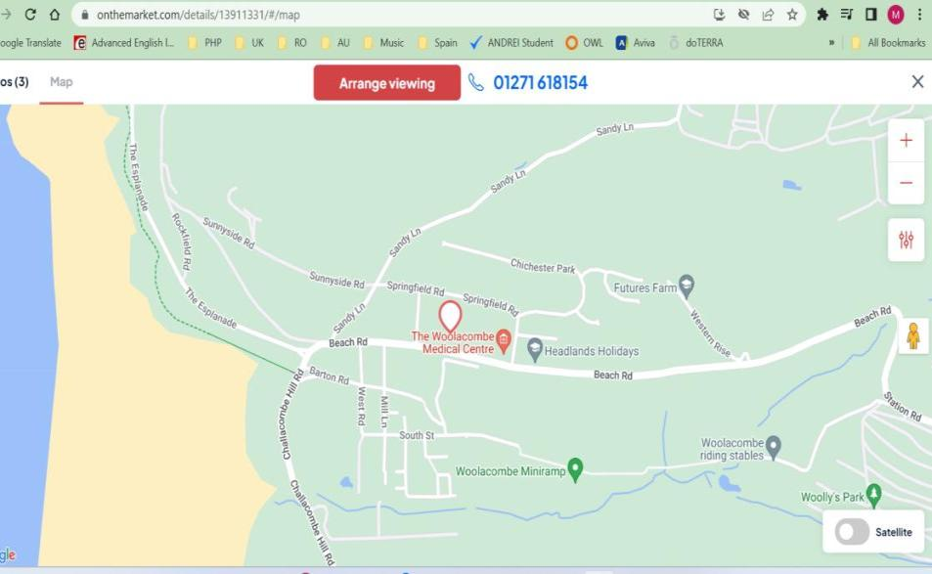
- Yurt prices
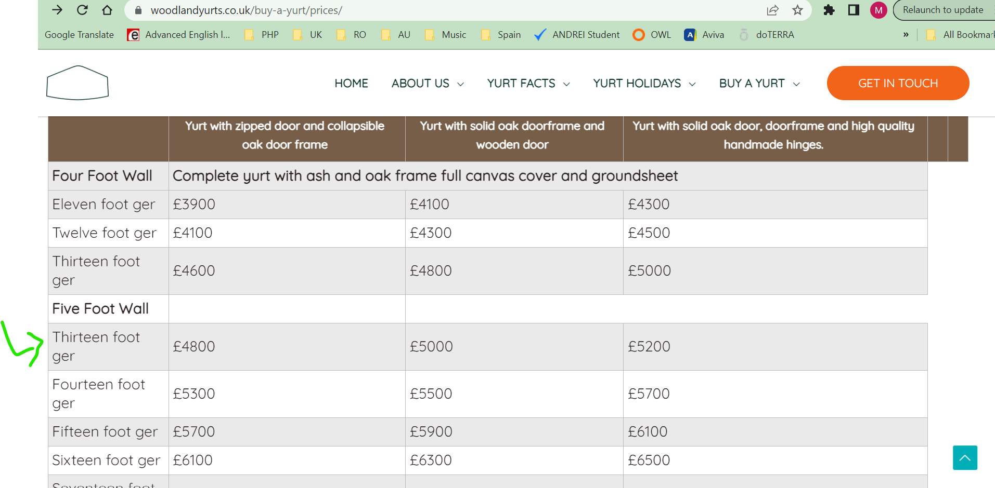

- Price for the property GreenHaven would be built in
- Key Partners  - Local suppliers  - Travel Agents  - Expert guides | Key Activities  -Eco-friendly services  -Ensuring safe foods and drinks  -Promoting environment (Holloway et al, 2022) | Value Proposition  -Diverse services and products  -Customer-centric services  -24/7 services  -Ensuring safety |  | Customer Relationships  -Regular communication  -work on feedbacks  -customised services based on requirements | Customer Segments  -Eco-friendly tourists  -adventure lovers  - Cultural enthusiasts
 | Key Resources  -Staffs  -Natural sites  -Modern technologies |  |  | Channels  -Social media platforms  -Website of the organisation.  -person to person
Cost Structure  -Rent  -purchasing suppliers  -operation costs  -Marketing costs |  |  | Revenue Streams  - Selling services  - Transportation services  -Partnership with other organisations (Tra et al, 2020)
- Business Model Canvas for GreenHaven, by AltexSoft

- (Use the BMC to help explain this section)

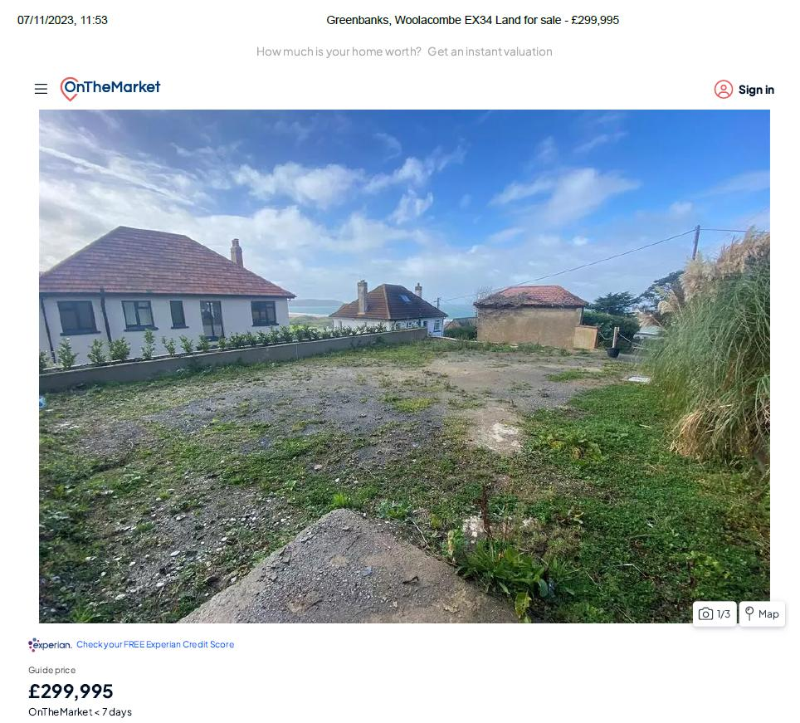
Marketing charts: Gender distribution, geography, and age distribution
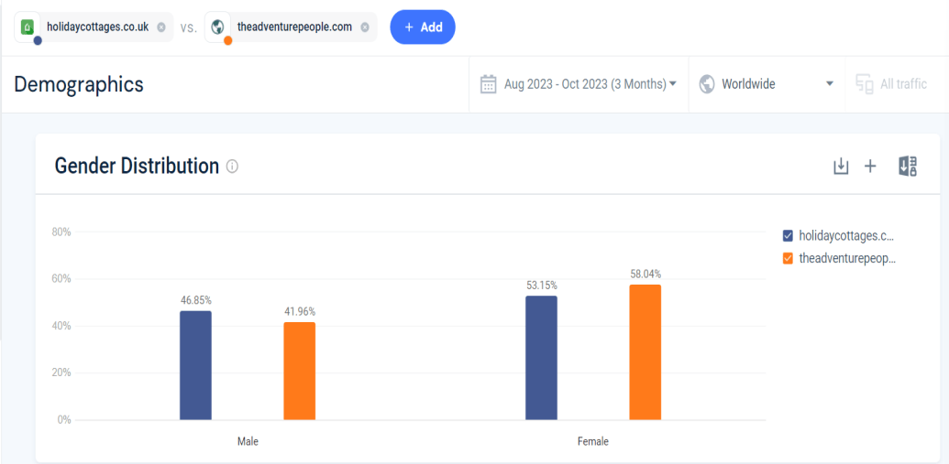

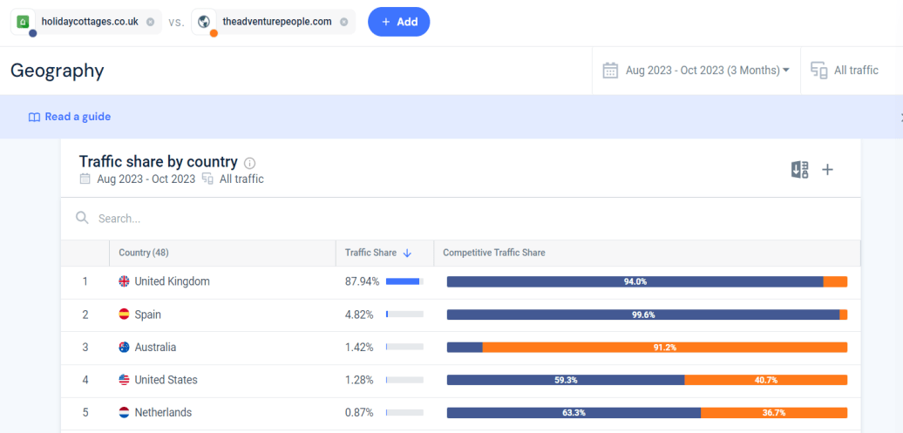

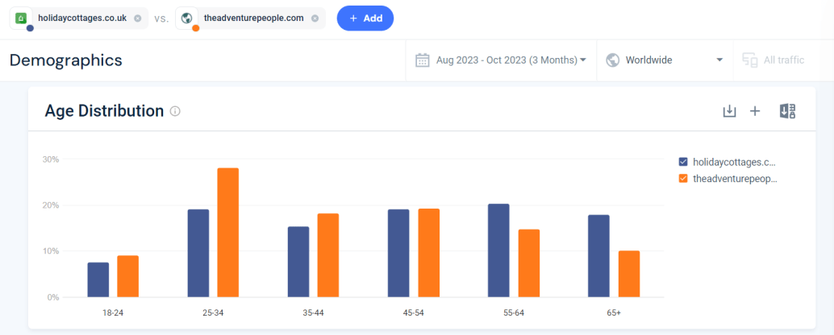
SWOT Analysis
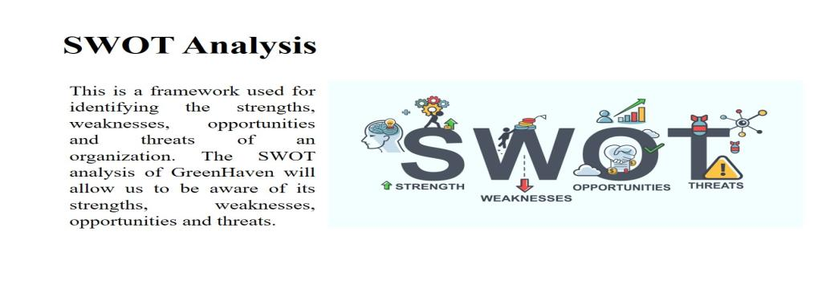

This is a framework used for identifying the strengths, weaknesses, opportunities and threats of an organization. The SWOT analysis of GreenHaven will allow us to be aware of its strengths, weaknesses, opportunities and threats.
- Strengths: Unique ambiance is one of the most significant strengths of GreenHaven that will melt the heart of the customers just by the first glance. The unique and intimate atmosphere at the Yurt hotel business will distinguish GreenHaven from classic accommodation. The customers will enjoy the wildness of yurts as well benefiting of more comfort than into a simple tents camp. The distinctive interior design will be helping us in attracting more customers that loves uniqueness and aestheticism. (Panteleiev et al, 2022)
- Weaknesses: The lack of brand recognition as a start-up business is one of the concerning matters for GreenHaven. There are not much popularity and brand value of the hotel which can be a problem in attracting customers. Besides, the limited resources can be another weakness of GreenHaven.
- Opportunities: The increasing demand for sustainable tourism expands the opportunity of growth which can be a positive sign for GreenHaven. It can expand yurt hotel business into more locations for growing. The digital marketing has significant benefits for promoting business within very short time.
- Threats: The increasing competition in the yurt hotel business industry can become an issue for GreenHaven. It might face negative impact of the competition when more businesses will be entering into sustainable tourism. (Mahfud et al, 2019)

PESTLE
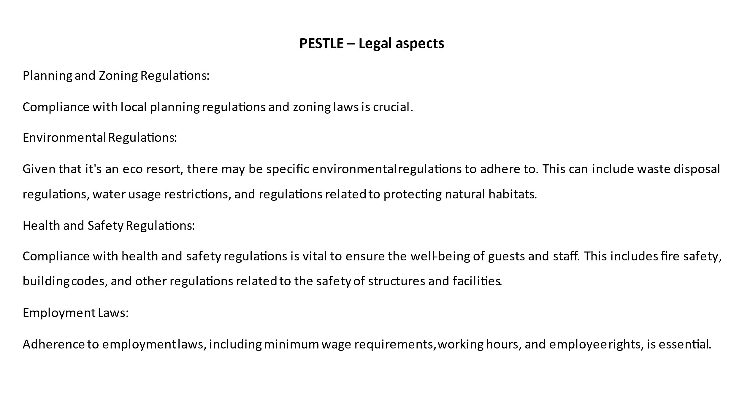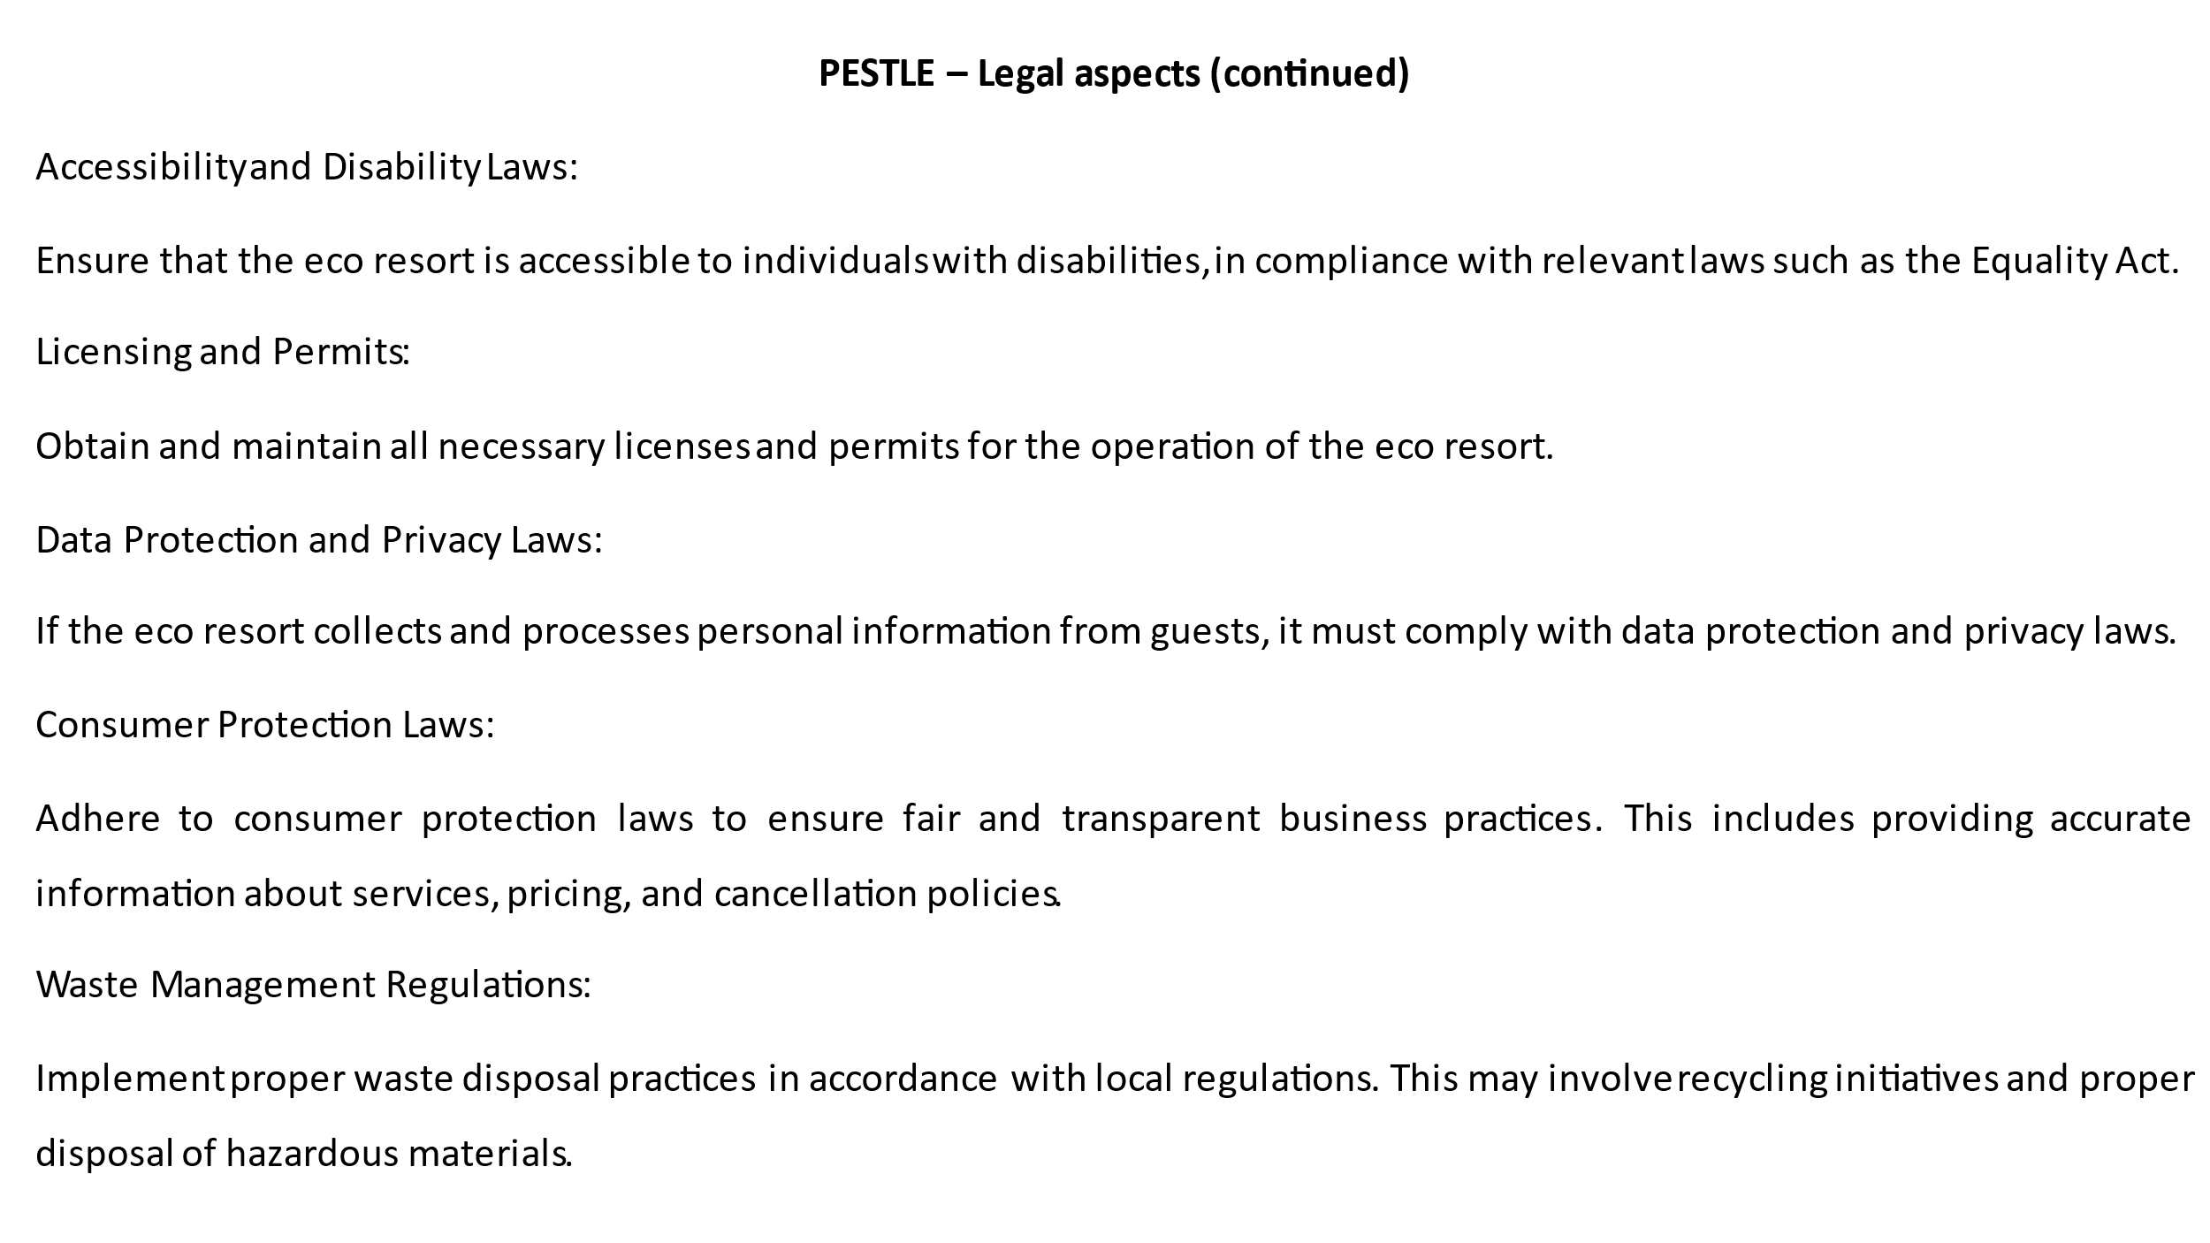

Presentation Slides






