Shenay Ulanova
ID:2121082
Problem Solving and Decision Making
Module code: BMSW4004
Lecturer: Dr. Edu Faizu

Contents:

- Introduction 1p.
- The workplace problem 2p.
- Root cause analysis 2,3,4p.
- Applying situational analyse 4,5p.
- Alternative solutions 5,6p.
- Stakeholders 6,7p.
- Conclusion 7p.
- Appendix 8p.
- Reference 9p.

Introduction
A variety of situations might arise at work that require problem-solving and decision-making skills, these two approaches complement one another and can solve many of the problems. Necessity for problem-solver and decision-maker to have ability like critical thinker. In the Problem solving and decision-making case study I am looking for the complex problem for company Pizza Hut. Pizza Hut is an American restaurant chain and international franchise based in Texas. It offers different styles of pizza along with side dishes. Company operates approximately 34,000 restaurants in 100 countries with delivery-carryout units. Pizza Hut opened his first UK restaurant in Islington over 40 years ago. The company employs 10,000 people in over 260 restaurants throughout the UK, serving over 3 million guests a month.

The workplace problem
Pizza Hut company is struggling with a strength market competitiveness accompanied with customer unsatisfaction and ineffective marketing strategy, also is observed unimpressive menu.

Root cause analysis
It is common for every company to have its own problems. Management and employees face a variety of challenges every day. Addressing the problem at its root is more important than addressing the symptoms. However, it is not always easy to identify the cause of a problem. It helps to identify the cause of a problem using the fishbone diagram. Japanese chemist Ishikawa Kaoru developed the fishbone diagram to help companies find structured solutions to company issues and their causes, or also known as a cause-and-effect diagram. Diagrams are used to illustrate all problems with possible solutions and their corresponding causes. Using the skeleton fish helps to:
- Finding the cause of a problem requires creativity and provide a list of possible causes.
- Create the opportunity to work in a team which opens new possibilities.
- Contribute ideas to the company by encouraging employees.
- Reduce the complexity of the problem.
- Is practical and easy acceptable.

Competitiveness
In the market
Management
Unsatisfied employee.
Uncomfortable atmosphere.

Marketing
Not suggest attractive promotions.
Low quality product.
Not too many deals.

Methods
Malfunction of dough mixer.
No capacity for peaks period.




Personal
Long waiting at pick time.
Late delivery.
Not good taste.
Burned food, cold or wrong pizza delivered.
Trend
Lack of innovative suggestion.
Users want to see discount deals or different taste or healthier.

Environment
No chance to eat there.
Unsatisfied service.

(Hudson, 2017) Pizza Hut keeps high prices due to his brand image, in this way, the company's overall revenues increase, but its items become less affordable. Compared to other competitors pizza company (Papa Johns, Domino’s) Pizza Hut should to increase the client options to tempting menu, should to have option for vegan, veggie lovers, dairy and gluten free. Also, they don’t have option like side salad or on the top fresh rocket, reduced saturated fats option to impress a healthy eater, thus they remain in the fast-food brand, where the competition becomes even greater apart from the other pizza brands (KFC, McDonald’s, Subway and etc). The items can be easily copied by other pizza competitors and are also arrange in different price.
According to Atanasovka (2022) shares in the article that Pizza competitors stand out in front of Pizza Hut with high quality fresh dough, Domino’s pizza ad says that their pizza dough is freshly made it with different type of crust and gluten free options as well, they provide nutritional and allergen information for the products on the website, ensure the people who wants to eat from Domino’s to choose them with track delivery options. Papa Johns is the other popular brands with freshly dough pizza produced with high protein flour and clear-filtered water, innovated with hemp seed option etc. While Pizza Hut staying behind at that time they didn’t have particularity and innovative point to impress the clients, Pizza Hut doesn’t represent anything about dough, even more the articles describe that Reddit user who claimed to work there said that Pizza Hut use frozen dough. Also, the competitors provide to their clients more desert option made it there, while Pizza Hut provide Ice cream. (Vauchercloud, n.d.)The pricing strategy according to three familiar UK pizza brand shows that buying large pizza is better deal, the price between Domino’s and Pizza Hut is approximately same, Papa Johns differs more expensive price, also Papa Johns and Domino’s distinguish with one more bigger size option.
Papa John’s represents attractive deals like giving voucher with discount strategy or variety collection deals with discount.
Applying situational analysis models
Swot Analysis for Pizza Hut
The SWOT analyse tools is described from Albert Humphrey, the planning tool used to understand crucial elements - strengths, weaknesses, opportunities, and threats involved in a company. It involves stating the purposes of the corporation and figuring out the internal and exterior elements that are both supportive to accomplishing the objective. SWOT is frequently used as phase of a strategic or planning process, however, can be applied to help understand an enterprise, and additionally for decision-making for many special situations.
Strengths:
- Food Hygiene Rating with five points which proves the hygiene level is good.
- Famous brand with long history.
- Improved website with widely information for delivery.
- Additional menu for crispy chicken or wings lovers.
- Create individual taste pizza.

Weaknesses:

- Non attractive ad.
- Que during peak time.
- Easily imitated products.
- Keep fast food image.

Opportunity:

- Creating healthy options, low fat, dairy free product, or gluten free.
- Using environmentally friendly and organic products will be increase the consumers.
- Ad with discount sale, loyalty points system, deal with free delivery.
- Collecting customer information for the purpose of provide tempting purchase for their occasional day via email or phone.
- Special apology to unsatisfied customers with proof, not only refund.

Threats:

- Huge range of competitors, as well global market that provide affordable products.
- Marketing scheme and promotional communications are anticipated to neutralize the brand image.
- Government and Policy can influence Pizza Hut.
- Pizza Dominos are in more areas, where the population don’t
have another option.

Alternative solutions
Marketing solutions.
The company should develop better marketing strategy to recovered greater image with promotions and better deals than others company:
- Upgrade online reputation-making system inviting people to share their positive experience online this will involve more people to order Pizza Hut meals.
- Promoting free delivery for attractive meal deals will impress the clients to make a large order.
- Improving the social platform – Text messaging systems for registered members and online pop-up attractive offers to the new client will invite the costumers consume more often from Pizza Hut.
The third solution, also and second decision will involve more competitiveness in the market, because nowadays the social media engage the company with clients. They will promote more often the brand and company will be more active with creating tempting ad.

Low quality product
The brand image related with poor quality can make clients defection and decrease profit, which could be fade away the company. Input the fresh and organic ingredients will ensure the people to choose Pizza Hut regularly.
- Copying the other brands innovative ideas, will keep the company in competitive stage.
- Product development with healthier meals portion pizza with salad side will impress the takeaway or office eater to order Pizza Hut.
- Development of healthier and different type of pizzas from others brand (Domino’s, Papa John’s etc) like example: Organic ingrediency pizza, Keto base pizza, Vegetable base pizza, Sourdough base pizza, Rye or Wholemeal base Pizza will differ the Pizza Hut with more yummy options and better image.
The third option will be increasing the company competitiveness over every type of fast food company and it will make them it difficult to fight in the market to reach the level of Pizza Hut. Additionally, they could be increasing the profit, because this type of pizza could be more expensive than other and to have highly profitable clients.

Methods
The pizzeria needs to improve the kitchen assortment employee to have ability manage efficiently their work and be productive at pick time.
- They can increase the kitchen employee and oven to have ability for peak hours.
- The company could make main restaurant where to make pre-prepared company meals and transport them to the other nearly pizzerias, storing them at fridge, anyway they did not praise with fresh dough pizza.
- The company should evaluate his market demands and expands kitchen with storage pre-preparing pizzas and from the menu, to have ability to be easier at the pick times.
The best option for pizza kitchens is the third option, this will involve the employee ability to cope with their job in busy phase and to hand over excellent quality product, enough quantity pre-preparing meals will reduce the employee stress and increase the product quality to delivered on time.

Management
The good management is the root of the company, when something is not going properly the manager is responsible to find where is the issue and how to solve it.
The customers review shows that they met unfriendly employee at some place, and they reviewed the atmosphere is uncomfortable.
Uncomfortable atmosphere:
- Company can improve the place with innovative style.
- Company can set up few seats space with practical table.
The second decision will make the environment at Pizza Hut to looks more comfortable for clients in their pick time and economical, also can temptation to consume something while they wait, standing straight could be create an idea of a longer waiting.
Unsatisfied employee:
Happy employees give the positive attitude, and every time brings customers back because they know they will be attention, as they expect.
- To increasing bonus system
- To make regularly training not only at the beginning.
- Company can make anonym questionnaire every 4 months to the employee to understand what frustrated them.
The third solution will be more effective and economical to observe where the employee is struggling.

Stakeholders

Meet their needs  Trying to expand market demand.  Development product strategy.  Expand in new areas.  Increasing the quality of service. | Focus  Adapt different type of deals for different consumers.  Improving different and distinctive ingredients meals.  Focus on teamwork improvement.
Low priority  Developing attractive deals inviting new consumers.  Simplify the ordering without registration. | Keep informed  Keep rarely informed consumers and trying make interest.  Inform via general communication: via email, ad, website leaflet.

Stakeholder communication plan

 | Stakeholder | Power/Interest | Key interest and issues | Communication Vehicle | Frequency | Comments
 | Customer | Medium | Leading | App, Email, SMS | Daily | Keep satisfied
 | Employees | High | Supportive | Face to Face | Daily | Keep satisfied
 | Delivery staff | High | Leading | App, Face to Face | Daily | Keep satisfied
 | Local community | Medium | Supportive | Internet, Ad | Daily | Aims to attract
 | Management | High | Leading | Digital devices, Face to Face | weekly | Keep motivated
Government |  | Low | Unclear | Law | quarterly | Innovation by new health recommendation.

Conclusion
Company Pizza Hut established good reputation and profitable image on the market across the world, they been good practise also in United Kingdom, with increasing the market suppliers they it is possible that they will experience a decline, but with improvement on market strategy with unique tactics they could be leader in the fast-food brand. Likewise expanding in new region and menu diversification could be boost them to move on the top. Developing more helpful tools in the workplace will satisfied the employee ability to present the company achievements.

Appendix
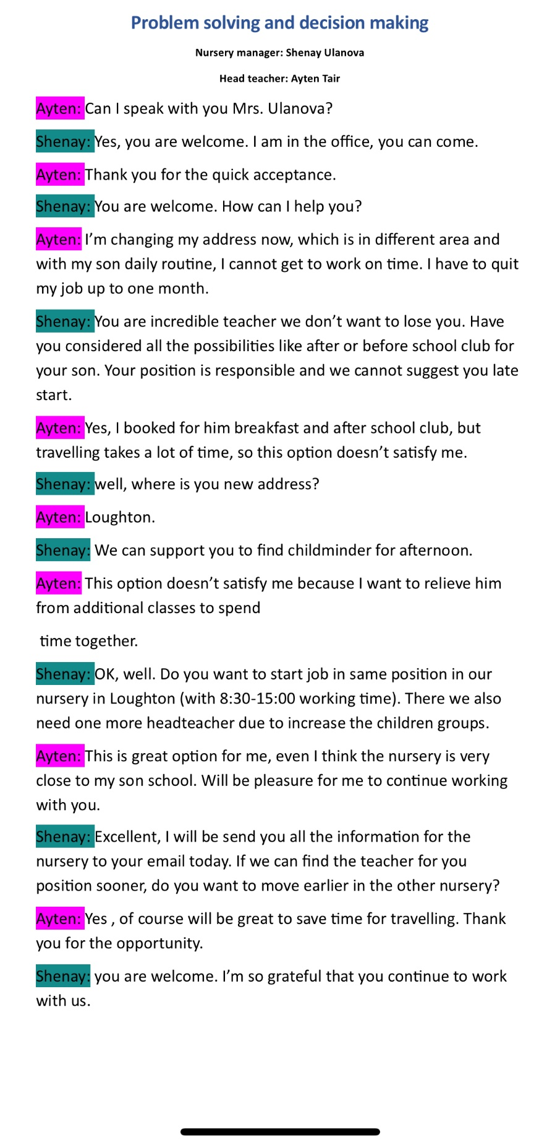

Reference

Hudson, A. (2017) Pizza Hut Case Solution. URL: https://www.essay48.com/13912-Pizza-Hut-Case-Solution
(Accessed (25 December 2022)
Atanasovska B. (2022) What is the Most Popular Pizza Chain in the UK in 2022.
Available at: https://dontdisappoint.me.uk/resources/lifestyle/most-popular-pizza-chain-in-the-uk/
(Accessed 24 December 2022)
Ionos (2020) Fishbone diagram: Solving problems properly.
URL: https://www.ionos.co.uk/startupguide/productivity/fishbone-diagram/ (Accessed 26.12.2022)
Vauchercloud, (no date) Pizza Math - Your Guide to Pizza Prices and Size in the UK.
URL: https://www.vouchercloud.com/resources/pizza-math (Accessed 24.12.2022)

