ACCB6017
Usability Engineering – Component 1 Technical Report

Name: Andreea Ruse

ID: 2108815

Module Tutor: Osman Elgawi

Contents
Introduction 3
Four detailed personas & associated scenarios 3
Usability Issues to be Addressed 7
Initial Wireframe Storyboards 9
Feedback Collection Process on Storyboard Design 9
References 10

Introduction
The Traitors is a type of social deduction game where a group of players collaborate towards a common objective with the secret minority trying to sabotage them. The following report gives the first user research and interface design of a mobile game that is based on this idea at the University of Wales Trinity Saint David (UWTSD). In the suggested game, the virtual gold can be gathered by up to six players who will represent various members of the university community, and Traitors who are within the company attempt to ruin the group during the night. The game will take place within the campuses of UWTSD and will be designed to facilitate short, reusable, sessions that promote socialization between the students and staff.
This initial assignment is not focused on the provision of a finished visual design, but a transfer of the principles of user-centred design and usability engineering to the initial phases of the project. The work is aimed at knowing who the probable users are, in which situations they will be played in, and what limitations and preferences they will have in the game. To fill this, lightweight questionnaires and informal discussions with real UWTSD students and staff were used.
The report captures the personas, research approach, usability, storyboard, and initial usability, which are the basis of the detailed and full-colour design work to be done in the second assignment.

Four detailed personas & associated scenarios
1. Persona 1 – Enkeleda: Time-Pressed Parent and Casual Player
Profile
  - Age: 31
  - Role: Warehouse worker and mother
  - Location: Lives in London, long shifts, childcare responsibilities
  - Gaming experience: Plays simple mobile games occasionally (puzzle games, match-3), not a “gamer”
  - Devices: Mid-range Android phone, often low battery, often uses it in short breaks
- Scenario
Enkeleda finishes a busy shift at the warehouse and has 15 minutes before picking up her child. A friend messages her about trying the “Traitors: UWTSD Edition” game. She downloads it quickly on mobile data and wants to understand the rules without reading long text. She chooses a “Quick Game” option to learn by playing with a guided tutorial.
- Main User & Experience Requirements
  - Usability
    - Very short and clear tutorial with visual cues
    - Simple navigation and large buttons for one-hand use
    - Fast game setup and matches that fit into 10–15 minute gaps
  - Experience
    - Light, fun tone (not too dark or complex)
    - Feeling of inclusion even as a non-student, non-gamer
    - Minimal cognitive load after a tiring workday
2. Persona 2 – Mark: Busy Supervisor and Social Player
Profile
  - Age: 44
  - Role: Warehouse supervisor, husband and father
  - Location: Lives locally, limited free time in evenings
  - Gaming experience: Occasionally plays board games with family; very little mobile gaming
  - Devices: Older Android phone, small screen
- Scenario
Mark hears about the game from colleagues and decides to play during a staff social night. He wants a straightforward way to host a game for a small group, with clear on-screen instructions so he does not need to read the full rules beforehand. He is interested in the social interaction and campus theme but not in complicated controls.
- Main User & Experience Requirements
  - Usability
    - Clear “Host Game” and “Join Game” options
    - Role explanations in plain language, no jargon
    - Readable text and simple icons suitable for a smaller screen
  - Experience
    - Emphasis on group fun and discussion, not competitive esports style
    - A tone that is suitable and respectful for mixed adult groups
    - The ability to complete a game in a single sitting after work
3. Persona 3 – Josh: Neurodiverse Player and Detail-Oriented User
Profile
  - Age: 28
  - Role: Warehouse worker, autistic
  - Location: Lives independently, structured routines
  - Gaming experience: Enjoys video games and may focus deeply on certain titles; prefers clear rules and predictable systems
  - Devices: Modern smartphone, comfortable with technology
- Scenario
Josh is invited by co-workers to join an online game after his shift. He wants the rules and phases (night, day, voting) to be clearly explained, and he appreciates when the game avoids chaotic voice chat. He prefers explicit visual indicators of what is happening and what is expected from him at each step.
- Main User & Experience Requirements
  - Usability
    - Clear, consistent interface with predictable layouts
    - Step-by-step guidance at the start of each phase
    - Options to limit or mute chaotic chat and rely on structured interactions (buttons, prompts)
  - Experience
    - Reduced sensory overload (controlled animations and sounds)
    - Clear feedback when an action is completed or a choice is confirmed
    - Feeling of fairness and structure in the game logic
4. Persona 4 – Dani: Young Construction Worker and Competitive Player
Profile
  - Age: 24
  - Role: Construction worker
  - Location: Commutes to sites, irregular hours
  - Gaming experience: Plays console and mobile games; enjoys competition and strategy
  - Devices: Good-spec smartphone, plays on breaks and evenings
- Scenario
Dani downloads the “Traitors: UWTSD Edition” game at home and wants to play a series of quick but tense matches with friends online. He enjoys bluffing and trying to outsmart others, and he is willing to learn a slightly deeper system as long as the interface is smooth and responsive.
- Main User & Experience Requirements
  - Usability
    - Fast online matchmaking and low waiting time
    - Clear indicators of game state (rounds, roles, remaining players)
    - Responsive interface with minimal lag
  - Experience
    - Strong sense of tension and strategy in night/day phases
    - Light progression system (stats, achievements) to keep him engaged
    - The ability to play multiple rounds back-to-back in one session
5. Persona 5 – Fahim: Student-Worker Bridge to UWTSD Context
Profile
  - Age: 20
  - Role: Warehouse worker and Mechanical Engineering student
  - Location: Balances work and study; limited free time and mental energy
  - Gaming experience: Familiar with mobile and PC games; interested in campus-related content
  - Devices: Smartphone and possibly a laptop
- Scenario
After a long day of work and study, Fahim wants a game that connects to university life but is easy to pick up. He is curious to see UWTSD locations inside the game and might introduce it to his classmates. He sometimes plays during travel or short breaks, so flexibility is important.
- Main User & Experience Requirements
  - Usability
    - Short sessions that can be paused or exited quickly
    - Clear indication of progress, so he can stop and return later
    - Simple reconnection if his network drops
  - Experience
    - Strong UWTSD campus theme (buildings, roles based on student life)
    - Balance between fun and not being too childish
    - Ability to play casually but still feel rewarded
How Information for Personas Was Gathered
The initial personas were based on conversations and informal interviews with real people in my everyday environment, mainly work colleagues and friends:
- Casual discussions during breaks at the warehouse
- Questions about their free time, gaming habits, devices they use, and what they enjoy or dislike in games
- Follow-up questions on time pressure, accessibility needs (e.g., autism in Josh’s case), and how they feel about social, traitor-style games

Usability Issues to be Addressed
The UWTSD digital board game has been designed using the known principles in usability engineering that will make it effective, efficient, and satisfying to the user. The ISO 9241-11 [1] defines usability as the extent to which the specified users can attain specified goals in specific contexts of use. Thus, the main usability problem of the given project is the ability to support a wide range of users of the university, such as students, staff, and those with different digital literacy levels and accessibility requirements.
One of the main problems that are discussed in the storyboards is learnability, especially since the game has a few hidden roles (e.g., Traitors) and a complicated turn-based gameplay. [4] cites learnability as one of the basic usability features. Cognitive overload is minimized through progressive disclosure, i.e. rules are not shown in a thick instruction screen, but they are presented gradually during the onboarding process. This is in keeping with the cognitive load theory [10], which proposes that the working memory is limited and the instruction design has to reduce the extraneous load. Early gameplay screens have tooltips and contextual prompts to scaffold the understanding without overwhelming the users. Visibility of system status is another factor to consider. The heuristics provided by Nielsen [2] also point out that users must be kept informed at all times regarding what is going on. With a multiplayer deduction game, it is easy to lose track of the turn order, outcome of voting or night actions.
As such, the interface has prominent turn indicators, countdown timers, and confirmation messages. According to Brooke [9], clear feedback leads to a decrease in the level of user anxiety and contributes to a more robust conceptual model of system behaviour. In this design, moving effects between the Day and the Night stages are animated to solidify mental models and keep the audience engaged in the narrative.
Another usability issue is accessibility and inclusiveness. The personas are the users who may have visual impairments and neurodiverse characteristics. It is thus designed with high contrast wireframes, scalable text and icon-text pairing. Shneiderman et al. [5] stress on universal usability, which is the ability of systems to be used by individuals with various capabilities and technologies.
Moreover, the interaction targets are of the recommended touch-screen sizing principles to avoid input errors [6]. This minimizes motor load and increases efficiency especially in mobile devices. It is also focused on error prevention and recovery. In social deduction games, unintentional voting or mis- click might have serious impact on the game.
The usability of social interaction should also be covered. As the game involves communication-based and trust-related interactions, the chat interface should be user-friendly and not obtrusive. Dix et al. [4] believe that usability is not a one on one interaction but a collaborative mechanism. As a result, chat windows are set in a way that does not interfere with the actual gameplay and notifications are non-obtrusive. This allows interactivity and utility. Lastly, emotional design has been taken into consideration. The emotional engagement determines satisfaction whereas the usability is concerned with functionality [3]. The interface takes the form of storytelling clues and thematic transitions to keep the audience in suspense without losing focus. The main challenge in design was balancing between dramatic tension and the clear information architecture.
On the whole, the storyboard design incorporates the concepts of the human-computer interaction literature to cover the learnability, feedback, accessibility, error management, and collaborative usability. These are evidence-based choices to make sure that the digital board game is simple, welcoming, and entertaining to the wide range of UWTSD.

Initial Wireframe Storyboards
The wireframe storyboard is an improved prototype of the UWTSD Traitors mobile game. The design is low-fidelity and grayscale so that it focuses more on structure, layout and interaction flow than visual aesthetics. This strategy makes usability and functionality to be considered separately without regard to colour or branding choices. The wireframes were created in relation to mobile screen ratio to indicate realistic usability situations since the major target users of the game are students and staff that access the game through smartphones.
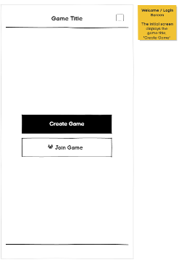
Welcome screen
The Welcome screen presents a simple and focused layout. The game title is positioned centrally at the top, immediately establishing identity and orientation. Beneath this, two primary action buttons — “Create Game” and “Join Game” — are vertically aligned. This clear hierarchy reduces cognitive effort and ensures first-time users understand their options instantly. Buttons are large and touch-friendly to prevent input errors. The minimal design avoids unnecessary elements, supporting simplicity and learnability.
Lobby Screen
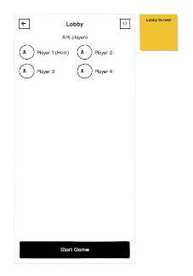
The avatars and names of players are shown in an organized system on the Lobby screen, with an apparent sign of the host. A visibility of system status is given by a player counter (e.g., 4/6 players). Role-based control is shown by a visual emphasis on the button of the Start Game, which is only available to the host. This screen is essential in collaborative awareness, where users can verify who joined before the gameplay commences. Individual spacing between avatars enhances readability and eliminates screen clutter.
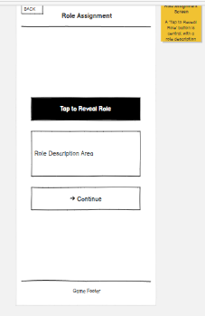
Role Assignment Screen
There is a big tap to reveal Role button in the Role Assignment screen. This action makes sure that sensitive information is not accidentally exposed by the players as they are physically close to each other. Upon tapping, a role description is displayed in a specific text field and then a Continue button would appear. This gradual revelation strategy helps to minimize information overload, as well as make instructions to be processed by the user in manageable pieces. The design is also strategically centred and focused to attract attention to the role information.
Main Game Screen – Day Phase
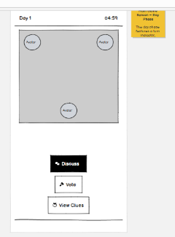
The Day Phase screen is the main interface. The upper bar contains a time display and stage number (e.g., Day 1 -04:59), which constantly informs about the development of the game. The main part comprises a simplified campus map with player avatar marks, which visually curb movement and positioning.
The bottom of the screen has three major action buttons, with the Discuss, Vote, and View Clues buttons, that are rationally organized. This low placement is a standard mobile design technique placing high-frequency actions in the easy thumb location. The strong distinction between the map and action controls will guarantee the users to identify the difference between the display and the interactive features.
Voting Screen
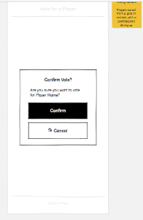
The Voting screen shows the player choices in a grid-like manner with single Select buttons. This hierarchical design eliminates the element of confusion and gives the choices equal visual prominence. Once a player has been selected, a confirm dialogue box comes up which requests the user to confirm or decline. This helps to avoid the wrongful elimination and it promotes the principles of error prevention. To indicate the final decision, the confirmation modal is distinctly separated with the main interface.
Night Phase Screen
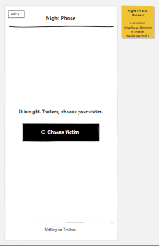
The Night Phase screen is intentionally minimal. For most players, a waiting message is displayed (“Waiting for other players…”). For Traitor roles, a role-specific action button becomes visible. This conditional visibility reduces confusion and reinforces role-based constraints. Limiting available actions during this phase simplifies interaction and maintains clarity.
Chat Panel Screen
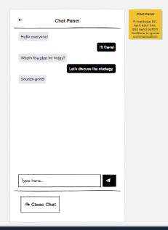
On the Chat interface, there is a scrollable message box and a text input box at the bottom. There is a visual differentiation of messages to separate between players. The send button is also placed adequately beside the input field making communication flow intuitive. The spacing between messages should be suitable in order to be readable on small screens.

Feedback Collection Process on Storyboard Design
To measure the usability of the storyboard prototype, a set of activities and a recorded test session were used to gather feedback in the form of a short user survey, task-based usability testing, and a combination of the two. There were five participants that were recruited to serve as the representatives of the various categories of potential users, being an undergraduate student, a postgraduate student, with one university staff member. This made sure that even the feedback was diverse in terms of experience and digital skills. The sample subjects were requested to perform a few basic tasks on the wireframe prototype, including joining a game, showing their role, the discussion feature, and voting a player.
In the course of the testing, the participants were stimulated to elaborate their minds as they worked with the interface. The method assisted in determining the areas where the users hesitated or became confused. To examine the behaviour and interaction patterns of the users more closely, the whole session was filmed in the form of a short video. Having completed the tasks, participants completed a small survey that was created to evaluate their experience of the interface. The survey covered questions about ease of use and how clear the navigation is, the visual arrangement and how much one enjoyed the gameplay interface. The interface was deemed simple by most of the participants and they liked the basic design and well-defined action buttons. Voting screen and role reveal were also well received because the users found them easy to use.

Survey Questions
1. The interface of the game was easy to understand.
2. Navigation between screens was clear and intuitive.
3. The main gameplay screen layout was easy to follow.
4. The voting process was simple and understandable.
5. The role reveal feature was clear and worked well.
6. The chat panel was easy to use.
7. Buttons and interactive elements were easy to find.
8. The layout works well for a mobile phone screen.
9. I enjoyed the overall user experience of the prototype.
10. What improvements would you suggest? (Open response)

Response Summary (5 Participants)
Question | Strongly Agree | Agree | Neutral | Disagree
Interface easy to understand | 3 | 2 | 0 | 0
Navigation clear | 4 | 1 | 0 | 0
Gameplay layout clear | 3 | 2 | 0 | 0
Voting process intuitive | 4 | 1 | 0 | 0
Role reveal clear | 3 | 2 | 0 | 0
Chat panel easy to use | 2 | 3 | 0 | 0
Buttons easy to find | 3 | 2 | 0 | 0
Mobile layout appropriate | 4 | 1 | 0 | 0
Overall experience enjoyable | 3 | 2 | 0 | 0
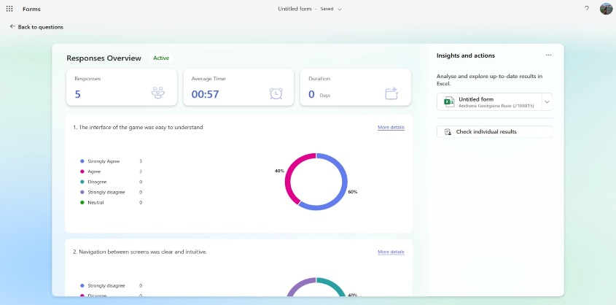

Conclusion
The current report was the first design report of the prototype of the UWTSD Traitors mobile game, based on the principles of the user-centred design and usability. The needs and expectations of the potential users were also identified through formulation of user personas and scenarios and applied in the interface design. The wireframe storyboards showed how the application would be used primarily and favoured simplicity, ease, and easy navigation.
The design included usability factors like error prevention, feedback and constraints of mobile interaction. The user testing and surveys offered feedback that allowed seeing the actual performance of the prototype in practice and the areas that could be improved. All in all, the results show the usefulness of the offered design and can be used as a solid basis to further refinements and complete visualization during the next phase of the project.

References
[1] ISO, ISO 9241-11:2018 Ergonomics of human-system interaction — Part 11: Usability: Definitions and concepts. Geneva, Switzerland: International Organization for Standardization, 2018.
[2] J. Nielsen, Usability Engineering. San Francisco, CA, USA: Morgan Kaufmann, 1994.
[3] D. A. Norman, The design of everyday things, Revised and Expanded edition. Cambridge, Massachusetts: The MIT Press, 2013.
[4] A. Dix, J. Finlay, G. D. Abowd, and R. Beale, Human–Computer Interaction, 3rd ed. Harlow, UK: Pearson, 2004.
[5] B. Shneiderman, C. Plaisant, M. Cohen, S. Jacobs, N. Elmqvist, and N. Diakopoulos, Designing the User Interface: Strategies for Effective Human-Computer Interaction, 6th ed. Boston, MA, USA: Pearson, 2016.
[6] J. Rubin and D. Chisnell, Handbook of Usability Testing: How to Plan, Design, and Conduct Effective Tests, 2nd ed. Indianapolis, IN, USA: Wiley, 2008.
[7] K. A. Ericsson and H. A. Simon, Protocol Analysis: Verbal Reports as Data, Rev. ed. Cambridge, MA, USA: MIT Press, 1993.
[8] J. Lazar, J. H. Feng, and H. Hochheiser, Research Methods in Human-Computer Interaction, 2nd ed. Cambridge, MA, USA: Morgan Kaufmann, 2017.
[9] J. Brooke, “SUS: A ‘quick and dirty’ usability scale,” in Usability Evaluation in Industry, P. W. Jordan, B. Thomas, B. A. Weerdmeester, and I. L. McClelland, Eds. London, UK: Taylor & Francis, 1996, pp. 189–194.
[10] J. Sweller, “Cognitive load during problem solving: Effects on learning,” Cognitive Science, vol. 12, no. 2, pp. 257–285, 1988.
[11] “What is User Interface (UI) Design?,” The Interaction Design Foundation, Jun. 02, 2016. https://ixdf.org/literature/topics/ui-design?srsltid=AfmBOory3o-36bsHXIFqQkEu2tC1EKBFlYRwQ6C0JS20Kc5WEmF83C1M (accessed Mar. 04, 2026).
[12] “BBC One - The Traitors - The Traitors: How the Show Works,” BBC. https://www.bbc.co.uk/programmes/articles/2xRtJpWRbKcwPdXs7bZnxxH/the-traitors-how-the-show-works
‌

‌

