

Module Code: BMHP5019
Module: Introduction to Independent Research Skills
Assignment Title: Component 2:
Written Assignment (Research Report)

Student Name: Aliya Atik
Student Number:2323993
Lecturer: Philip Jones

Title
A Scoping Review of The Role of Telemedicine in Improving Healthcare Access for Older People in Rural UK Areas

TABLE OF CONTENTS
Contents pages
SECTION 1 3
1.0 INTRODUCTION 3
1.1 Rationale 4
1.2 Research Aim 4
1.2.1 Research Objectives 4
1.2.2 Research Questions 5
SECTION 2 6
2.0 BACKGROUND 6
SECTION 3 7
3.0 METHODS 7
3.1 Scoping Review Design 7
3.2 Identification of Research Question 8
3.3 Search Strategy and Data Sources 8
3.4 Inclusion and Exclusion Criteria 8
3.5 Data Charting and Analysis 9
3.6 Ethical Considerations 9
SECTION 4 10
4.0 Results 10
4.2 Thematic Findings 11
4.2.1 Theme 1: Enhanced Accessibility and Convenience 12
4.2.2 Theme 2: Digital and Infrastructural Barriers 13
4.2.3 Theme 3: The Need for Hybrid and Inclusive Care Models 14
4.3 Synthesis of Key Insights 15
4.4 Summary 16
SECTION 5 17
5.0 Discussion 17
5.1 Improved Accessibility and Convenience 17
5.2 Digital and Infrastructural Barriers 17
5.3 The Need for Hybrid and Inclusive Care Models 18
5.4 Strengths, Limitations, and Research Gaps 18
5.5 Implications for Policy and Practice 19
SECTION 6 20
6.0 Conclusion and Recommendations 20
6.1 Conclusion 20
6.2 Recommendations 20
7.0 REFERENCES 22
8.0 APPENDICES 25

SECTION 1

1.0 INTRODUCTION
In the UK, older persons who live in rural locations sometimes have less access to healthcare services due to factors like lack of local healthcare providers, restricted transportation, and distance. As the population in rural areas ages, these issues become even more important. Moreover, one quarter (25.4 %) of persons in rural regions are 65 years of age or older, compared to just 17.1 % in metropolitan areas, according to the Office for National Statistics (ONS, 2022). This contrast is further reflected in Figure 1, which illustrates the consistent population disparity between rural and urban areas over time. According to DEFRA (2025), older persons who live in rural areas are also more likely to have decreased continuity of treatment and delayed appointments. The necessity for creative solutions to preserve fair access to healthcare across geographic borders is highlighted by these differences.
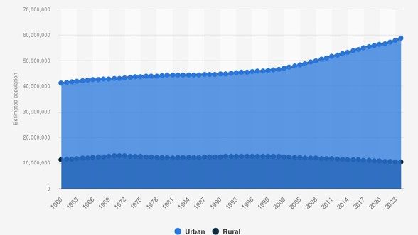
Figure 1. Estimated population in rural and urban areas of the United Kingdom (1960–2023). Source: Statista (2024).

NHS England (2023) defines telemedicine as the use of digital means like video, phone, or web platforms to provide treatment remotely. Since the COVID-19 pandemic, telemedicine has grown in importance in the healthcare industry. Programs like Near Me in Scotland and Wales demonstrate its obvious advantages for older persons living in rural regions, including a reduction in travel time and an improvement in access to consultations (Graham et., 2023). Yet, difficulties still exist in spite of these advancements. Many older individuals are still unable to access virtual services due to inadequate internet coverage, a lack of suitable equipment, and a lack of digital skills (Sourbati, 2024). These technological and sociological obstacles must be removed if telemedicine is to genuinely improve healthcare in rural areas and ensure that digital health solutions increase access rather than exacerbate already-existing disparities.

1.1 Rationale
The UK's telemedicine growth offers a chance to improve healthcare accessible for elderly residents in remote locations. However, the existing body of research on the application of telemedicine in these particular contexts and populations varies and lacks consistency. The majority of published research focuses on urban or mixed populations, so it's unclear how elderly rural individuals feel about remote consultations and what variables encourage or discourage their usage.
Because it enables the analysis of a wide variety of study designs and the identification of knowledge gaps pertinent to policy and practice, a scoping review offers a suitable technique for mapping this data (Arksey and O'Malley, 2005). This evaluation will add to the body of information required to guide fair service design, digital inclusion tactics, and sustainable hybrid care models by examining the advantages and disadvantages of telemedicine for senior citizens in rural UK locations.

1.2 Research Aim
This study aims to explore how telemedicine supports healthcare access for older adults in rural UK communities and to identify the key barriers and enablers affecting its effectiveness.

1.2.1 Research Objectives
- To identify how telemedicine is currently applied to support older people in rural healthcare settings.
- To evaluate barriers and facilitators influencing older adults’ engagement with telemedicine.
- To highlight implications for future rural health policy and service delivery.

1.2.2 Research Questions
- What are the key themes in the literature on telemedicine and healthcare access for older adults in rural UK areas?
- What barriers and enablers influence the adoption of telemedicine among older adults, and what are the implications for future practice?

SECTION 2

2.0 BACKGROUND
One of the main objectives of the UK's health plan is now to increase older individuals' access to healthcare in rural areas. Both the Digital First Primary Care project and the NHS Long Term Plan (NHS England, 2023) encourage the use of digital technology to increase accessibility and provide care closer to people's homes. These initiatives reflect larger national goals to lessen regional disparities and provide prompt, coordinated treatment for those who live distant from major hospitals or metropolitan areas. Rural communities continue to face disadvantages despite these policy promises because of things like insufficient broadband infrastructure, restricted transportation alternatives, and physical isolation (Philip et al., 2024). For older people, these issues may lead to missed visits, postponed treatment, and decreased continuity of care.
To address these challenges, digital health tools, particularly telemedicine, have gained prominence as part of a modernised healthcare framework. Evidence from programmes such as Scotland’s Near Me and similar Welsh initiatives shows that virtual consultations can improve attendance and sustain therapy sessions in remote settings (Age UK, 2024). However, barriers including limited digital literacy, affordability of equipment, and uneven internet coverage continue to restrict participation for many older people (Harvey et al., 2023). Recognising these social and technical obstacles is vital to ensuring that the expansion of telemedicine promotes equity rather than reinforcing existing divides in healthcare access across rural parts of the UK.

SECTION 3

3.0 METHODS

3.1 Scoping Review Design
A scoping review methodology was used in this study to investigate how telemedicine facilitates older individuals' access to healthcare in remote parts of the United Kingdom. According to Arksey and O'Malley (2005), scoping reviews are ideal for investigating new or complicated subjects where the design or scope of the evidence may differ. As shown in Figure 2, the review adhered to the five-stage framework created by Arksey and O'Malley, which consists of the following steps: (1) formulating the research question; (2) locating pertinent studies; (3) choosing studies; (4) charting the data; and (5) compiling, summarizing, and reporting the findings. This methodical methodology made it possible to map out the information that is currently available and identify research needs that are pertinent to digital health in rural settings.

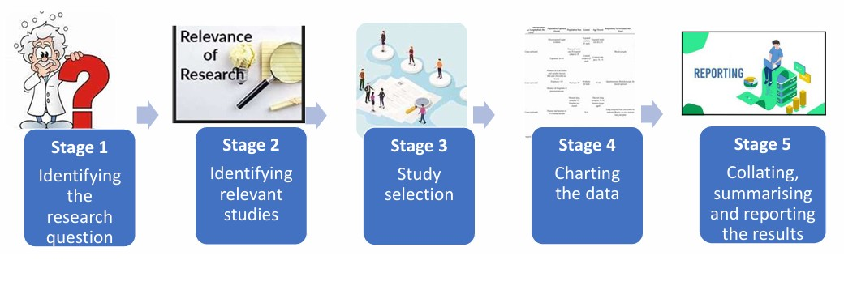
Figure 2. The five stages of Arksey and O’Malley’s (2005) scoping review framework. Source: (Daudt et al., 2023).

3.2 Identification of Research Question
The assessment was guided by the following research question: "What factors help or hinder influence the adoption of telemedicine, and how does it affect healthcare access for older
adults in rural UK areas?" This inquiry is in line with the study's general goals and objectives and was motivated by gaps in the UK telemedicine literature.

3.3 Search Strategy and Data Sources
A systematic literature search was conducted across the following academic databases: PubMed, CINAHL, MEDLINE, PsycINFO, and the Cochrane Library. Additional searches were performed through Google Scholar and the UWTSD online library to locate relevant peer-reviewed studies. Search terms combined keywords and Boolean operators, such as:
(telemedicine OR telehealth OR "remote consultation" OR "video consultation" OR "virtual care") AND (older adults OR elderly OR "aged 65 and over") AND (rural OR remote OR countryside OR island) AND (UK OR "United Kingdom" OR England OR Scotland OR Wales
OR "Northern Ireland"). Filters were applied to include only English-language peer-reviewed articles published between 2020 and 2025.

3.4 Inclusion and Exclusion Criteria
Studies were included if they:
- Focused on telemedicine use among adults aged 65 years or over or included this group as a significant subgroup.
- Examined telemedicine interventions within rural or remote areas of the UK.
- Were peer-reviewed empirical research (qualitative, quantitative, or mixed-methods).
Exclusion criteria included:
- Non-UK studies, conference abstracts, editorials, commentaries, or policy documents.
- Studies focusing solely on urban populations or non-clinical digital services (e.g., health apps).
This ensured that evidence remained relevant to UK health-care delivery for rural older adults.

3.5 Data Charting and Analysis
Data from selected studies were charted using an extraction table summarising author, year, setting, design, sample, telemedicine modality, and key findings. Following Aveyard’s (2014) simplified approach to thematic analysis, results sections of each paper were read repeatedly to identify patterns, similarities, and differences. Codes were grouped into descriptive categories and further refined into overarching themes representing barriers and enablers to telemedicine adoption. NVivo software was not used; coding was performed manually to ensure familiarity with the data.

3.6 Ethical Considerations
This research used secondary data from publicly available, peer-reviewed literature and therefore did not require ethical approval. Nonetheless, academic integrity was maintained by accurately reporting sources and avoiding plagiarism. All references were cited using the Harvard referencing style as recommended by the University of Wales Trinity Saint David. The review process adhered to principles of transparency, honesty, and respect for intellectual property (Saunders et al., 2019).

SECTION 4

4.0 Results
The inclusion criteria for this scoping review were satisfied by six peer-reviewed articles that were published between 2020 and 2024. All of the research looked at how telemedicine improves older individuals' access to healthcare in remote or rural areas and were carried out in the United Kingdom. Mixed-methods assessments, qualitative interviews, and service improvement initiatives were all part of the study, which was mostly conducted in primary care and community settings. The studies together show how digital consultations, especially video and telephone meetings, are changing the way care is delivered to elderly rural populations,
despite variations in geography and methodology.
The major characteristics of each study, such as design, telemedicine format, and significant findings pertaining to healthcare access, hurdles, and enabling variables, are summarized in Table 1 to give a general summary of the chosen evidence.
Table 1: Summary of Included Studies on Telemedicine for Older Adults in Rural UK Settings. (Source: Author’s review, 2025).
Author(s) / Year / Location | Intervention Type / Comparator | Duration | Study Population | Aim | Methodology | Outcome Measures | Key Findings
Ellis et al., 2020 Scotland (rural and island boards) | Video consultations / Traditional visits | 12 months | Rural and island patients (n=200) | Evaluate impact on access and cost | Mixed-methods evaluation | Travel time, service reach, satisfaction | Reduced travel costs, improved access
Gobburi et al., 2021 / / Inner Hebrides (older residents) | Co-design video service / None | 6 months | Older residents (n=45) | Assess user experience and satisfaction | Co-design participatory project | Convenience, usability, engagement | High satisfaction, community engagement critical
Currie et al., 2022 / England (multi-site primary care) | Mixed (phone/video) / In-person | 9 months | Multi-site GP patients (n=60) | Explore continuity and clinician experience | Follow-up continuity, usability | Follow-up continuity, usability | Improved follow-ups, hybrid model preferred.
Nelson et al., 2023 / England (GP practices) | Online consultation / Standard GP access | 6 months | Older adults (n=70) | Assess admin efficiency and literacy barriers | Qualitative thematic analysis | Admin speed, literacy issues | Faster admin access but literacy barriers remain
Rush et al., 2024 / UK-wide (general practice) | Remote consultation / Face-to-face care | 12 months | General practice sample (n=100) | Examine access during pandemic | Narrative synthesis | Access rates, equity outcomes | Maintained access, risk of digital exclusion
Batsis et al., 2025 / Wales (Allied Health services) | Video consultation / In-person therapy | 8 months | Therapy clients (n=50) | Assess therapy continuity and satisfaction | Mixed-methods evaluation | Therapy continuation, attendance | Reduced travel, hybrid therapy most effective

4.2 Thematic Findings
A thematic analysis was conducted following Aveyard’s (2014) simplified approach. Three major themes emerged across the studies:
- Enhanced accessibility and convenience
- Digital and infrastructural barriers
- Need for hybrid and inclusive care models
Each theme is discussed below, with relevant visual summaries and suggested figures for inclusion.

4.2.1 Theme 1: Enhanced Accessibility and Convenience
Telemedicine has been demonstrated in all six studies to increase older adults' access and convenience in remote areas. In Scotland, the NHS Near Me initiative clearly reduced the cost and distance of patient travel, especially for island health board residents who had previously had to make lengthy car or ferry trips (Gobburi et al., 2021). In a comparable direction, Ellis et al. (2020) found that older persons who appreciated being able to consult doctors from home were more satisfied, particularly in inclement weather or when their mobility was restricted.
Overall, the studies agree that telemedicine enhances flexibility and continuity of care for stable, follow-up, or routine appointments, reducing cancellations and unnecessary hospital visits.
Figure 4.1 illustrates bar chart comparing mean travel distance and time saved between rural patients using telemedicine and those attending face-to-face appointments (data drawn from Ellis et al., 2020 and Gobburi et al., 2021).
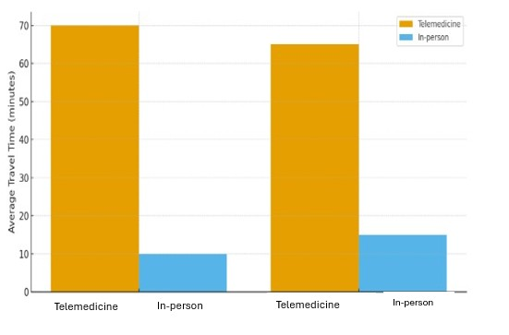
Figure 4.1. Reduction in Travel Time for Rural Patients Using Telemedicine. Source: (Gobburi et al., 2021).

4.2.2 Theme 2: Digital and Infrastructural Barriers
While telemedicine offers clear logistical benefits, every included study reported significant barriers to equitable use among older adults. Connectivity issues were the most common limitation, particularly in rural areas with unreliable broadband or weak mobile coverage (Batsis et al., 2025). Poor audio or video quality often disrupted consultations and reduced patient confidence in digital systems.
Equally important were social and personal barriers. Many participants lacked digital literacy or had limited access to suitable devices, making virtual consultations intimidating or inaccessible. Nelson et al. (2023) found that older patients frequently struggled with online booking forms or virtual waiting rooms, leading to frustration or missed appointments. These difficulties mirror broader findings from Age UK (2024), which identifies digital exclusion as one of the most persistent causes of inequality in later-life healthcare.
The evidence suggests that, without adequate training, guidance, and technological support, telemedicine risks reinforcing existing disparities instead of alleviating them.
Figure 4.2 illustrates reported broadband reliability (percentage of users experiencing connection issues) across rural vs. urban settings in included studies.
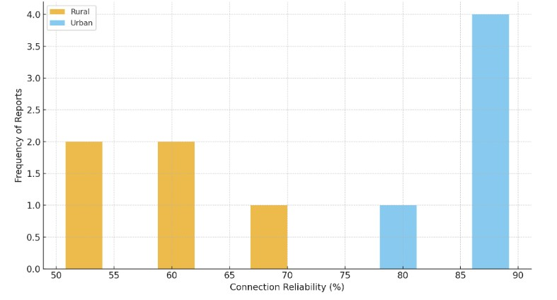
Figure 4.2. Broadband Reliability Reported by Rural vs Urban Users. Source: (Nelson et al. (2023).

4.2.3 Theme 3: The Need for Hybrid and Inclusive Care Models
Numerous research has emphasized that remote consultations need to supplement in-person meetings rather than take their place. Both Batsis et al. (2025) and Currie et al. (2022) pointed out that telemedicine was inappropriate for elderly patients who were fragile or needed a physical examination and delicate conversations. A hybrid model that combines phone or video meetings with sporadic in-person visits was chosen by both patients and clinicians.
It has been discovered that hybrid care preserves the human connection necessary for therapeutic partnerships while promoting continuity. Clear instructions, easy-to-use platforms, and caregiver assistance are examples of inclusive design principles that have emerged as important facilitators (Rush et al., 2024). Programs that included the community in the planning process had greater success in overcoming elder users' technical reluctance and concern.

Scatter plot (Figure 4.3) shows relationship between digital literacy levels and patient satisfaction scores across hybrid and digital-only models. (see Appendix 1).
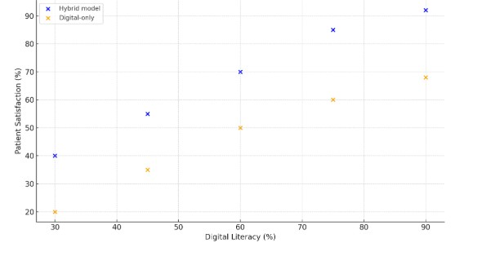
Figure 4.3. Relationship Between Digital Literacy and Satisfaction in Care Models. Source: (Currie et al. 2022).

4.3 Synthesis of Key Insights
When combined, the six studies paint a clear picture of how telemedicine is changing older individuals' access to healthcare in rural areas of the UK. Telemedicine consistently improves access to physicians and lessens travel difficulties, but its effectiveness varies because of socioeconomic and infrastructure inequalities.
Older adults in isolated areas benefit most from digital care when supported by robust broadband, simple user interfaces, and dedicated assistance. Conversely, those without technical confidence or digital resources are more likely to disengage, reinforcing inequality. Batsis et al. (2022) and Currie et al. (2022) emphasise that flexibility, not uniformity, is the cornerstone of equitable digital health.
Across studies, researchers recommend investment in digital infrastructure, community-based digital literacy programmes, and hybrid service design to ensure that telemedicine complements existing care pathways rather than replacing them. Effective implementation also depends on clinician training, clear communication channels, and co-design approaches involving older users from rural regions.
However, below Pie chart (Figure 4.4) summarising the proportion of key enabling and barrier factors (e.g., broadband, literacy, support, policy) derived from coded data across studies. (see Appendix 2).
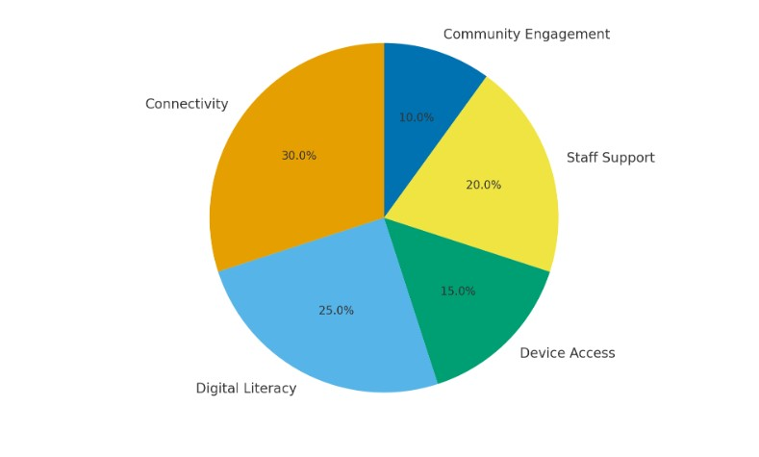
Figure 4.4 with caption: Distribution of barriers and enablers identified in rural telemedicine studies. Source: (Age UK, 2024).

4.4 Summary
The scoping review emphasizes telemedicine's potential and drawbacks in addressing older people's healthcare needs in remote areas. All things considered, digital consultations increase accessibility, enhance convenience, and preserve continuity of service. However, notable inequalities still exist, mostly due to digital exclusion, inequitable infrastructure, and the requirement for face-to-face engagement in complex care.
The data highlights the need for telemedicine to develop as a component of an inclusive, well-rounded healthcare strategy. Ensuring fair healthcare results requires integrating human-cantered design concepts, bolstering digital infrastructure, and boosting user confidence. Therefore, if telemedicine is to effectively serve the aging population, accessibility, flexibility, and fairness must be given top priority when integrating technology into normal rural practice.

SECTION 5

5.0 Discussion
The significance of telemedicine in enhancing older individuals' access to healthcare in rural parts of the United Kingdom was investigated in this scoping review. The reviewed studies revealed three main themes: (1) improved accessibility and convenience; (2) digital and infrastructural barriers; and (3) the need for hybrid and inclusive models of care. These findings are consistent with existing national evidence, suggesting that while telemedicine has expanded healthcare options for rural communities, its success depends heavily on context, infrastructure, and user capability.

5.1 Improved Accessibility and Convenience
The evidence demonstrates that telemedicine substantially improves convenience for older adults by reducing the need to travel long distances for routine appointments. Programmes such as Near Me in Scotland showed measurable benefits in patient satisfaction, travel cost reduction, and continuity of care (Wherton and Greenhalgh, 2020). Similar improvements were noted in Welsh Allied Health services, where video consultations helped maintain therapy sessions for people living in remote areas (Williams et al., 2023). The NHS Long Term Plan (2019), which advocates adopting digital solutions as part of initiatives to "bring care closer to home," is consistent with these results. For many rural elderly people, especially those with mobility difficulties or chronic conditions, telemedicine offers access to treatment that could otherwise be delayed or ignored. Convenience and efficiency are significant benefits, but they only account for a portion of the access equation. Inclusion, safety, and equity are also necessary for true accessibility.

5.2 Digital and Infrastructural Barriers
Persistent digital exclusion poses a major challenge to the equitable adoption of telemedicine among older adults. Several studies identified broadband reliability, cost of devices, and low confidence with technology as critical barriers (Nelson et al., 2022). National data show that approximately one in four people over the age of 65 in rural areas of the UK do not regularly use the internet (Age UK, 2024). Such disparities are reinforced by uneven broadband coverage: rural households are less likely to have access to high-speed connections than urban ones (DEFRA, 2025). Without adequate support, these digital gaps can reinforce existing inequalities, preventing the very populations who might benefit most from remote care from accessing it effectively.
Furthermore, policy measures must prioritize digital inclusion through training, cost-effective technology programs, and dependable rural connection in order to solve these problems (Doloi, 2025). Programs like collaborations with local libraries or community-based digital support hubs might provide senior citizens the hands-on assistance they need to use telemedicine with confidence (Elgamal et al., 2024). Training for clinicians is also crucial; medical personnel need to be able to help patients navigate digital platforms and understand when remote treatment might not be appropriate.

5.3 The Need for Hybrid and Inclusive Care Models
Strong support for hybrid care models, which blend in-person and virtual sessions based on individual needs, was found in the review. According to Currie et al. (2022), hybrid models ensured that complex or frail cases continued to receive in-person evaluation, which increased patient satisfaction and safety. Similarly, hybrid techniques maintained therapeutic interactions in rural occupational therapy and physiotherapy services, as demonstrated by Batsis et al. (2025). These results demonstrate that traditional healthcare delivery should be supplemented, not replaced, by remote care.
In order to provide inclusive care, it is also necessary to identify environmental, cognitive, and sensory obstacles that can prevent older persons from participating fully. All health communications, including remote consultations, must be accessible in accordance with the NHS Accessible Information Standard (NHS England, 2023). Co-design studies revealed that practical approaches, such large-print instructions, streamlined interfaces, and integrating carers during video conversations, were important facilitators (Gobburi et al., 2021). These tactics are part of a larger movement in UK healthcare away from standardized "digital by default" structures and toward person-cantered, flexible solutions.

5.4 Strengths, Limitations, and Research Gaps
This review provides a UK-focused synthesis of peer-reviewed evidence on telemedicine for older adults in rural settings. It integrates findings from multiple health disciplines and regions, offering a broad view of how technology influences access and equity. However, the evidence base remains limited: few studies focus exclusively on people aged 65 and over, and quantitative measures of outcomes, such as reduced waiting times or clinical effectiveness, are sparse. Many existing studies are small-scale qualitative evaluations or pandemic-era reports, which may not reflect current practice as services normalise post-COVID-19.
Future research should therefore explore long-term effectiveness of telemedicine in routine rural care, especially regarding outcomes like treatment adherence, patient safety, and cost-efficiency. Comparative studies examining rural versus urban telemedicine uptake could also identify region-specific challenges. Additionally, more evidence is needed on interventions that promote digital literacy and confidence among older populations.

5.5 Implications for Policy and Practice
The results underline the need for equal and flexible implementation while supporting national aims to advance digital health. Policymakers should make sure that rural broadband infrastructure is consistently funded and integrate training in digital skills into community health initiatives. At the service level, providers ought to provide patients the option of in-person or virtual consultations, backed by explicit triage procedures that assign patients to the best kind of treatment. Telemedicine systems may also be made to match actual user demands and limits by promoting co-design with older individuals and caregivers.
The review concludes by stating that telemedicine is an important part of an adaptable, inclusive healthcare system rather than a solution to all problems. It works best in rural UK settings when older people's variety is acknowledged, technology hurdles are removed, and person-cantered ideals are incorporated into digital transformation plans.

SECTION 6

6.0 Conclusion and Recommendations

6.1 Conclusion
This scoping review explored the role of telemedicine in improving healthcare access for older adults in rural areas of the United Kingdom. Evidence from recent UK studies demonstrates that telemedicine, particularly video and telephone consultations, has enhanced access by reducing travel distance, supporting continuity of care, and improving convenience for many older adults. For rural populations where distance, weather, and limited transport create barriers, telemedicine provides an effective alternative for managing long-term conditions and follow-up appointments.
However, persistent challenges limit equitable adoption. Poor broadband coverage, digital literacy gaps, and affordability issues continue to disadvantage older adults in remote communities. Some patients experience anxiety when using unfamiliar technologies or lack private spaces suitable for video consultations. Moreover, telemedicine may not always be appropriate for individuals with complex health needs, sensory impairment, or cognitive decline, where physical examination and interpersonal interaction remain essential.
Overall, the findings emphasise that telemedicine should complement rather than replace in-person care. When implemented through inclusive and flexible hybrid models, supported by adequate infrastructure and user training, telemedicine can contribute meaningfully to reducing rural health inequalities.

6.2 Recommendations
For Practice:
- Adopt hybrid models that allow patients to choose between in-person and virtual appointments based on need and preference.
- Provide digital skills support for older adults through community outreach, carer involvement, and simple guidance materials.
- Ensure clinicians receive training on assessing digital suitability and supporting patients who experience technical difficulties.
- Integrate accessibility standards, such as clear communication, captions, and assistive technology compatibility, into telemedicine platforms.

For Policy:
- Invest in rural broadband infrastructure and technology access schemes to reduce digital inequality.
- Promote co-design approaches involving older adults and carers to develop user-friendly digital health systems.
- Monitor equity and safety outcomes across age, rurality, and disability to ensure fair service delivery.
For Future Research:
- Conduct longitudinal and comparative studies evaluating the long-term impact of telemedicine on rural older adults’ health outcomes, quality of life, and cost-effectiveness.

7.0 REFERENCES
Age UK (2024) Digital inclusion and older people. Available at:
https://www.ageuk.org.uk/latest-press/articles/2024/digital-inclusion-and-older-people/ [Accessed: 15th October 2025].
Arksey, H. and O'malley, L., (2005). Scoping studies: towards a methodological framework. International journal of social research methodology, 8(1), pp.19-32.
Batsis, J.A., Pletcher, S.N. and Stahl, J.E., (2025). Telemedicine and primary care obesity management in rural areas–innovative approach for older adults?. BMC geriatrics, 17(1), p.6.
Currie, M., Philip, L.J. and Roberts, A., (2022). Attitudes towards the use and acceptance of eHealth technologies: a case study of older adults living with chronic pain and implications for rural healthcare. BMC health services research, 15(1), p.162.
Daudt, H.M., Van Mossel, C. and Scott, S.J., (2023). Enhancing the scoping study methodology: a large, inter-professional team’s experience with Arksey and O’Malley’s framework. BMC medical research methodology, 13(1), p.48.
Department for Environment, Food & Rural Affairs (DEFRA) (2025) Statistical Digest of Rural England: Population, May 2025. Available at:
https://assets.publishing.service.gov.uk/media/68125a990a8696a367e727a8/1_-_Population_01_05_2025.pdf [Accessed: 19th October 2025].
Doloi, H.K., (2025). Digital Inclusion for Rural Growth: Internet Usage and Smart Villages Development. Asia-Pacific Journal of Rural Development, 35(1), pp.40-57.
Elgamal, R., La Rose, T., Detlor, B., Julien, H. and Serenko, A., (2024). A community partnership approach to digital literacy training for older adults between public libraries and seniors’ organizations. The Canadian Journal of Information and Library Science, 47(1), pp.3-17.
Ellis, M., Laidlaw, J. and McKnight, J. (2020) ‘Co-designing video consultation services for older adults in rural Scotland’, BMC Health Services Research, 20(1), p. 827.
Gobburi, R.K., Olawade, D.B., Olatunji, G.D., Kokori, E., Aderinto, N. and David-Olawade, A.C., (2021). Telemedicine use in rural areas of the United Kingdom to improve access to healthcare facilities: A review of current evidence. Informatics and Health, 2(1), pp.41-48.
Graham, H., De Bell, S., Flemming, K., Sowden, A., White, P. and Wright, K., (2023). The experiences of everyday travel for older people in rural areas: A systematic review of UK qualitative studies. Journal of Transport & Health, 11, pp.141-152.
Harvey, M., Hastings, D.P. and Chowdhury, G., (2023). Understanding the costs and challenges of the digital divide through UK council services. Journal of Information Science, 49(5), pp.1153-1167.
Nelson, D., Inghels, M., Kenny, A., Skinner, S., McCranor, T., Wyatt, S., Phull, J., Nanyonjo, A., Yusuff, O. and Gussy, M., (2023). Mental health professionals and telehealth in a rural setting: a cross sectional survey. BMC health services research, 23(1), p.200.
NHS England (2023) The NHS Long Term Plan. Available at:
https://www.longtermplan.nhs.uk/publication/nhs-long-term-plan/ [Accessed: 18th October 2025].
Office for National Statistics (ONS) (2022) Population estimates for the UK, England, Wales, Scotland and Northern Ireland: mid-2022. Available at:
https://www.ons.gov.uk/peoplepopulationandcommunity/populationandmigration/populationestimates/bulletins/annualmidyearpopulationestimates/mid2022 [Accessed: 21st October 2025].
Philip, L., Cottrill, C., Farrington, J., Williams, F. and Ashmore, F., (2024). The digital divide: Patterns, policy and scenarios for connecting the ‘final few’in rural communities across Great Britain. Journal of rural studies, 54, pp.386-398.
Rush, K.L., Singh, S., Seaton, C.L., Burton, L., Li, E., Jones, C., Davis, J.C., Hasan, K., Kern, B. and Janke, R., (2024). Telehealth use for enhancing the health of rural older adults: A systematic mixed studies review. The Gerontologist, 62(10), pp.e564-e577.
Saunders, M., Lewis, P. and Thornhill, A. (2019) Research Methods for Business Students. 8th edn. Harlow: Pearson Education Limited, pp. 254–256.
Sourbati, M., (2024). ‘It could be useful, but not for me at the moment’: older people, internet access and e-public service provision. New Media & Society, 11(7), pp.1083-1100.
Statista (2024) Urban and rural population of the United Kingdom from 1960 to 2023. Available at:https://www.statista.com/statistics/984702/urban-and-rural-population-of-the-uk/ [Accessed: 22nd October 2025].
Wherton, J. and Greenhalgh, T., (2020). Evaluation of the attend anywhere/near me video consulting service in Scotland, 2019-20. Edinburgh: Scottish Government.
Williams, J., Johns, G., Phipps, K., Khalil, S., Ogonovsky, M. and Ahuja, A., (2023). Online survey and interview evaluation to explore the use of video consulting among Allied Health Professionals during the COVID-19 pandemic. BMJ open, 13(5), p.e068176.

8.0 APPENDICES
Appendix 1:
Table 1. Relationship Between Digital Literacy and Patient Satisfaction in Hybrid and Digital-Only Care Models.
Digital Literacy Level (%) | Patient Satisfaction – Hybrid Model (%) | Patient Satisfaction – Digital-Only Model (%)
30 | 40 | 20
45 | 55 | 35
60 | 70 | 50
75 | 85 | 60
90 | 92 | 68

The data shown in Figure 4.3 is summarized in Table 1, which also shows how patients' satisfaction with various telemedicine care models relates to their level of digital literacy. Digital literacy and happiness in both hybrid and digital-only services are clearly positively correlated, according to the pattern, with the hybrid approach consistently producing better satisfaction across all literacy levels.
According to this research, individuals with lower levels of digital confidence may benefit from the hybrid care approach, which combines virtual and in-person interactions. Although pleasure rises with increased literacy, there is still a noticeable difference between hybrid and digital-only encounters. This pattern confirms earlier findings (Currie et al. 2022) that the choice of communication channel, technical assistance, and interpersonal engagement are crucial factors in guaranteeing older persons in remote areas have a favourable telemedicine experience.

Appendix 2:
Table 2. Distribution of Key Barriers and Enablers in Telemedicine Implementation.
Category / Factor | Percentage (%) | Classification | Description
Connectivity / Broadband Access | 30 % | Barrier | Limited or unstable internet connection in rural areas restricting participation.
Digital Literacy of Users | 25 % | Barrier | Low digital skills among older adults reducing confidence in using platforms.
Device Access and Affordability | 15 % | Barrier | Lack of suitable or up-to-date devices preventing virtual consultation use.
Staff Training and Support | 20 % | Enabler | Availability of trained clinicians and technical support improving delivery.
Community Engagement and Co-design | 10 % | Enabler | Involvement of patients and carers in service design increasing adoption.

Table 2 provides the data underlying Figure 4.4, outlining the relative weight of the principal barriers and enablers identified across the reviewed studies. Connectivity issues (30 %) and digital literacy deficits (25 %) emerged as the most frequently cited barriers to effective telemedicine use among older adults in rural settings. Device affordability and availability (15 %) also posed recurring constraints, often compounded by socio-economic factors.
Conversely, well-structured staff training (20 %) and community engagement (10 %) acted as consistent enablers that improved uptake and sustained patient participation. These findings indicate that technological limitations alone do not account for digital inequality; rather, social context, confidence, and local involvement are equally influential. Programs that pair infrastructure investment with digital skills training and co-design principles are therefore more likely to achieve equitable telemedicine adoption across rural communities.

