EFFECTIVE TEAMWORK AND COMMUNICATION
Table of Contents
Introduction 3
Different communication models 3
Types of communication skills 5
Case study analysis 7
Poor communication at workplace 8
Conclusion 9
Reference List 10

Introduction
The purpose of the study is to evaluate the application of different communication models in business organisations and how communication skills improve the organisational performance and efficiency. Nowadays, in our day to day lives is a fundamental part of communication. Benefits of effective communication- build trust, prevent and resolve conflict, encourage team building, increases engagement, improve productivity and many more. Communication typically happens in one of three ways- verbal, non-verbal and visual. It can be aural, visual or even physical. Some barriers are there in effective communication like inability to listen to others, cultural and language differences, lack of transparency and trust and many more things.

Different communication models
Model of communication - Communication is always a learned behavior, it occurs in a variety of different ways. Models to help to identify and understand the components and relationship of the communication process being studied. For effective communication system models represent new ideas and thoughts. An integral part of education is communication, which has made it a better place for students and teachers and also every industry highly depends on the model of communication (Seguin, Tian and Zalesky, 2020). Main communication models are divided into three main categories. The first category of the communication model is linear model, four models under this category.
Linear Model
The most fundamental correspondence model is straight model. Just three elements are involved there, that are a sender, a message and a collector. There is no criticism from the beneficiary. It is one way correspondence which is generally utilized in mass correspondence. Four Models that fall under this classification.
Aristotle's model-One of the most seasoned correspondence models is the aristotle model. In this model the speaker assumes a critical part in communication.Two components are essentially engaged in this model, they are speaker and discourse. The speaker should be extremely cautious with regards to his determination of words and the substance of the model of correspondence. The people need to set up their objective and afterward they will set up their discourse (Arias-Vergara et al. 2018). Then again, the collector assumes a detached part in the correspondence cycle. Here the pioneer or the speaker or the sender is the focal point of fascination and the group just the detached audience members. The five essential components of Aristotle's models are speaker, discourse, event, crowd, and impact.
Lasswell's Model-Next model of direct correspondence is the Laswell correspondence model or Laswell model of correspondence. In the correspondence world Laswell correspondence is viewed as one of the most persuasive correspondence models. The model is well known for its logical strategy for dissecting the correspondence interaction and it is a clear correspondence model.
Shannon-Weaver's Model-One of the mind boggling correspondence models that fall under the classification of direct correspondence models (Daniels-Wells et al. 2020). This model essentially recommends that a message really starts from the individual who gets the idea or has the data. Shannon incorporated the idea of the sender, message, transmitter, encoding, unraveling, the channel of transmission, beneficiary, commotion; etc.In the logical world, this model of correspondence is given the greatest amount of regard.
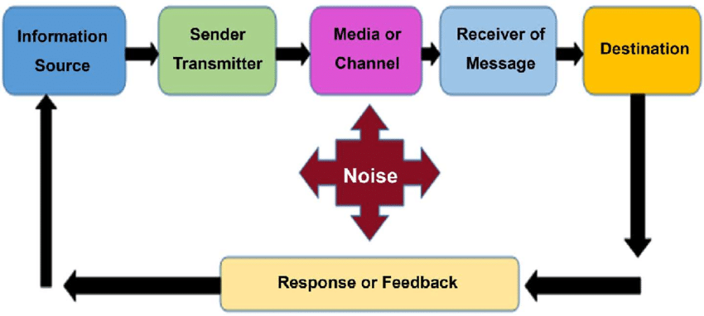
Figure 1: Shannon-Weaver's Communication Model
(Source: Daniels-Wells et al. 2020)
Berlo's S-M-C-R Model-It is the fourth and last correspondence model in the direct correspondence model class. Utilizing four components of correspondence that are
● Sender-is the individual who created the message
● Message-the data that the sender needs to ship off the beneficiary.
● Channel-the medium utilizing which the data is passed on.
● Recipient gets the message and interprets it dependent on his agreement and information.
Interactive model of communication
The intuitive models of correspondence are a high level model than the straight models of correspondence. Both sender and beneficiary are engaged with this process(Rico-Gallego et al. 2019).The intelligent models of correspondence is a high level model than the direct models of correspondence. Two models are there in the intelligent correspondence model.
● Osgood-Schramm Model-It is the easiest correspondence model in the classification of intuitive models. In correspondence ability the sender and the collector have never been separated in this model.
● The Westley and Maclean Model-The model of correspondence gives significance to input. Two settings of correspondence are applied in this model, like mass correspondence and relational correspondence.
The Transactional model of communication
It is the most modern model of correspondence out of all correspondence models. Between the sender and collector correspondence isn't only a trade of messages. It is a cycle that makes real factors comprising of social, social, and social factors.(Avena-Koenigsberger, Misic and Sporns, 2018). There are two models under the class of the conditional model of correspondence, for example, Barnlund's value-based model, Dance's Helical Model.
Types of communication skills
● Verbal correspondence Verbal correspondence is the utilization of words to pass on a message. A few types of verbal correspondence are composed and oral correspondence. It alludes to the utilization of language to pass on data. Various sorts of relational abilities are referenced as follows:
Intrapersonal correspondence This type of correspondence is very private and limited. It incorporates quiet discussions between the sender and beneficiary.
Relational correspondence This type of correspondence happens between two people, Sender and beneficiary to convey in a reasonable way.
Little gathering correspondence This correspondence happens when there are multiple individuals included.
Public correspondence It happens when one individual tends to an enormous social event of individuals. There is generally a solitary sender of data and a few collectors who are being tended to.
● Nonverbal correspondence This kind of correspondence incorporates letters, messages, motions, covering non-verbal communication and some more (Hussain et al. 2018) Learn and focus in non-verbal correspondence. A few kinds of non-verbal correspondence are
Signals These can be deliberate or accidental.
Non-verbal communication When utilizing articulations, individuals as a rule convey through their eyes, eyebrows, and mouth. It is helpful for imparting both data and feeling.
Undivided attention In this ability attentive people are the main part in correspondence. It's not difficult to speak with attentive people.
● Composed correspondence Written relational abilities are those abilities that utilization composed words to convey the focuses. Composed relational abilities use sentence structure, accentuation and words. For a composed correspondence to be successful, guarantee it is clear, succinct, complete and considerate. Compactness, lucidity, tone, dynamic voice, language structure and accentuation and a lot more are in composed relational abilities.

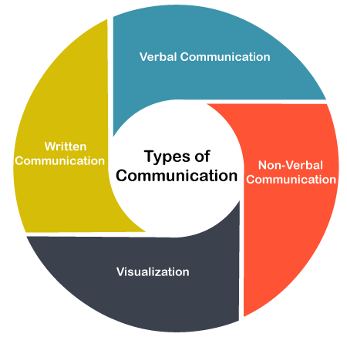
Figure 2: Different types of communication skills
(Source: Hussain et al. 2018)

Case study analysis
Effective communication between different levels of Hierarchy in an organisation is significant to be implemented in order to carry out the business operations and performance management procedures efficiently. Inadequate communication aur communication gap can create conflicts within the workplace and it can decrease the performance level of employees as well as the organisation (Tran, Nguyen and Faught, 2017). There are numerous examples of organisations failing to complete their projects effectively or resulting in a cost of several million dollars. For instance a failure in establishing effective communication between the project managers and the project engineers resulted in in a deadly Hyatt Regency walkway collapse which is discussed as follows
Hyatt Regency walkway collapse has been a warning for the civil engineers as in 1981, 114 people died where 216 were injured when Hyatt Regency Kansas city hotel collapsed. It is considered as the deadliest structural collapse within the USA in history (IE, 2021). The construction of the building started in 1978 and the four storey building opened its doors to the public in 1980 and in the next year the Atrium roof of the building collapsed when connection failed on the Northern side. After investigation it has been confirmed that there were several structural gap when the project was conducted. The main reason for this structural collapse has been estimated as a major communication gap between the project managers and the engineers. It is crucial for any organisation or project team to carry out effective communication between all the project team members and project managers in order to keep the flow of the project on track. Therefore the communication gap between the workers and hierarchies has resulted in such disaster.
The communication gap between the project team members and the project manager can be reduced by applying the communication skills and models within organisations. There are different types of communication skills such as verbal non verbal as well as written communication and a proper application of those skills can not only bridge the gap of communication but also can reduce the conflicts and doubts and enable a flow of information from one Level to another. Different types of communication skills are required for a project team to effectively manage its project activities in different phases of the projects (Tran, Nguyen and Faught, 2017). For instance one of the most significant communication skills that must be present in the project team members is active listening skills. Active listening could have helped the project team members of Hyatt Regency walkway to understand the entire planning and step-by-step approaches for building the structure. It involves listening carefully to others opinions and thoughts and understanding nonverbal signals instructed by the project team leaders and managers.
Another major fundamental criterion of communication skill is building strong relationships with the project team members on the basis of trust and respect for each other. Building a healthy relationship based on integrity and honesty could be helpful for the project team members of Hyatt Regency to develop truthfulness, loyalty capabilities and consistencies in the performance. Another significant aspect of effective communication is setting clear priorities to the tasks and responsibilities (Zare et al. 2018). The manager's ability to convey the strategy for the entire team, setting up goals and prioritizing the tasks is crucial for the project success and all the team members must understand the big picture and the valuable insights as well. Enabling collaborative teamwork was also crucial for the project team to support the other team members and continuous flow of information. Therefore it can be clearly say that lack of communication skills had the most adverse effect on the Hyatt Regency project and it resulted in that disaster.

Poor communication at workplace
Poor communication can be disruptive for business operations and effective performance management of the organisations. Poor communication can be present in any aspect of the business organisations such as communicating with the customers, communication between the project team members and other hierarchies. Poor communication between the employees can not only decrease the operational efficiency and productivity of the organisations but also prevent them from providing and offering streamlined delivery of service to the customers (Tonchia, 2018). It can also be a significant barrier in retaining customers.
A major communication issue that I witnessed in my friend’s company, which is a telecommunication, services Provider Company. It mainly interacts with the customers in order to solve their issues and queries and offer them special discounts and policies. As the main focus of the business operation of the company is interacting with the customers it is crucial for it to interact effectively with the customers and engage them with its business operation. In my opinion, recruitment of efficient employees who have excellent communication skills is crucial for the company. The Shannon-weaver communication model can be useful in this scenario to establish a clear communication between the employees and the customers (Mikkola and Valo, 2020). I have applied the model to develop a flow of communication between the customers and service providers of the organisation. I have used the model to effectively send the messages to their destination and gathered customers’ feedback which has improved the operational performance of the company. Therefore implementing the communication models and providing communication skills training to the Employees can be a productive idea for the company to boost up its performance. Candidates with excellent communication skills and personality must be recruited also in this regard.

Conclusion
From the above study it can be concluded that different communication models are used by different types of organisations and it not only helps them to improve organisational efficiency but also to reduce conflicts within the workplace. The study highlights a case study example where communication gap between the project team members and project manager resulted in a significant disaster. In addition to the app the study also focuses on the organisation custome, Quick Solutions Private Limited that provides telecommunication service to its customers. The communication issues and their consequences have been focused which can be improved by recruiting efficient employees who are excellent in communication and interaction.

Reference List
Arias-Vergara, T., Vásquez-Correa, J.C., Orozco-Arroyave, J.R. and Nöth, E., 2018. Speaker models for monitoring Parkinson’s disease progression considering different communication channels and acoustic conditions. Speech Communication, 101, pp.11-25.
Avena-Koenigsberger, A., Misic, B. and Sporns, O., 2018. Communication dynamics in complex brain networks. Nature Reviews Neuroscience, 19(1), pp.17-33.
Daniels-Wells, T.R., Candelaria, P.V., Leoh, L.S., Nava, M., Martínez-Maza, O. and Penichet, M.L., 2020. An IgG1 version of the Anti-Transferrin Receptor 1 Antibody ch128. 1 Shows Significant Anti-tumor Activity Against Different Xenograft Models of Multiple Myeloma: A Brief Communication. Journal of immunotherapy (Hagerstown, Md.: 1997), 43(2), p.48.
Hussain, S.S., Tak, A., Ustun, T.S. and Ali, I., 2018. Communication modeling of solar home system and smart meter in smart grids. IEEE Access, 6, pp.16985-16996
IE. (2021). Understanding the Tragic Hyatt Regency Walkway Collapse. Available at https://interestingengineering.com/understanding-hyatt-regency-walkway-collapse (Accessed 30 November 2021)
Mikkola, L. and Valo, M. eds., 2020. Workplace communication. Abingdon: Routledge
Rico-Gallego, J.A., Díaz-Martín, J.C., Manumachu, R.R. and Lastovetsky, A.L., 2019. A survey of communication performance models for high-performance computing. ACM Computing Surveys (CSUR), 51(6), pp.1-36.
Seguin, C., Tian, Y. and Zalesky, A., 2020. Network communication models improve the behavioral and functional predictive utility of the human structural connectome. Network Neuroscience, 4(4), pp.980-1006.
Tonchia, S., 2018. Project communication. In Industrial project management (pp. 143-152). Springer, Berlin, Heidelberg.
Tran, D.Q., Nguyen, L.D. and Faught, A., 2017. Examination of communication processes in design-build project delivery in building construction. Engineering, Construction and Architectural Management.
Zare, F., Guillaume, J.H., Jakeman, A.J. and Torabi, O., 2020. Reflective communication to improve problem-solving pathways: Key issues illustrated for an integrated environmental modelling case study. Environmental Modelling & Software, 126, p.104645.

