
Student Name: | Clarissia De Weever
Student Number: | 1810426
Module No: | BMSK4001
Module Title: | Academic and employability skills
Lecturer: | Anita Nan
Skills for the Workplace
Module Assignment Submission
Date of Submission: 7th January 2018
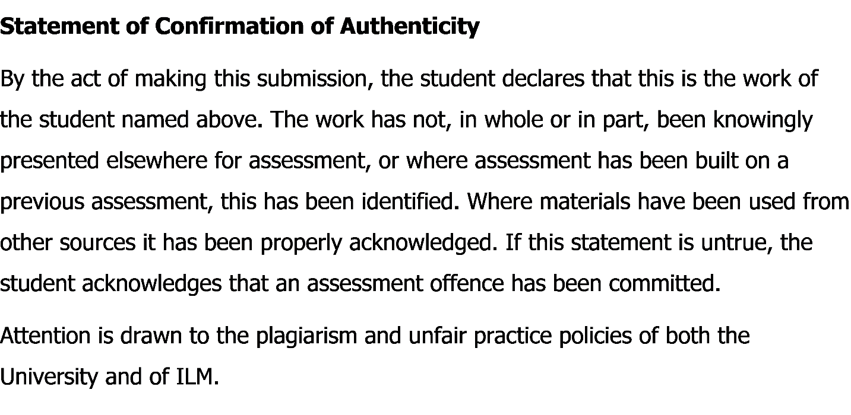
Contents
Introduction 3
Recruitment and Selection process in the context of employment: 3
Skills for employment: 4
Top 5 Employability Skills of mine which will help any employer: 4
Technique to show competency: 4
Developing employability skills 6
Importance of Time Management: 6
Personal time management technique: 7
Importance of Academic life for employment: 8
Recommendation for university to develop employability skill: 9
Conclusion 11
References 12

Introduction

Academic and employability skills are the capability of an individual to demonstrate a quality performance while doing his activities in his respective workplace. It is very much essential to have these skills and abilities as these academic and employability skills are what makes a person ideal to get his desired job and at the same time these enhance his potentials even more. There are a huge number of academic and employability skills which a person can obtain by a number of ways. These skills can be further developed by cultivating and nurturing even when the person has obtained a good position in their willed job. The process of development of these skills and abilities and making them more enriched will bring the ultimate success for that individual.

Recruitment and Selection process in the context of employment:

The recruitment and selection is the processes by which the human resource department of any organization chooses the eligible and potential candidate as their employee and it is the same in case our organization too. The basic and primary step which the human resource department of the institution I work takes is creating the job description and person specification (Cottrell, 2011). The job description gives a clear picture about what is expected from the employee who would be chosen and what the responsibilities of this specific are (Philpot, et al 2013). Person specification is the analysis of the candidates and assessing if they are fit for the role (Mackevic, 2014). The job description created by my institution included all the skills and abilities which will be needed for the job along with a clear indication about the job hours and the offered salary. The employers take a look at all the CVs which come for the job offer and scrutinize them matching with the skills needed. After that, the candidates having potential are asked to come for an interview. Lastly, the right candidate is chosen from them with the help of a person specification chart.

Skills for employment:

There are a number of skills and abilities which a graduate employer looks for in a potential employee. Without having these specific attributes no individual can prove himself/herself to be competent enough for the job (Morgan, 2016). An employer expects an employee to have organizational skills and at the same time a person with critical and analytical thinking. At the same time, it is also expected that an employee would possess vast knowledge and the ability to communicate effectively with everybody (Greetham, 2013). Though it is not possible for an individual to have all those skills and abilities but it is expected that he/she possesses most of those and cultivate the others while working in the workplace.

Top 5 Employability Skills of mine which will help any employer:

From my personal job experience I have gathered quite several skills and abilities which any employer would want.
1. Communication skills
2. Teamwork skills
3. Organizational skills
4. Problem solving ability
5. Ability to work under pressure

Technique to show competency:

The STAR model or technique is a framework which can be used to observe the employability skills of a specific employee (Gravells, 2010). It describes the situation, task, action and the result of that incident. My employability skills can be demonstrated with the help of this method on a specific incident which I experienced in my workplace.
Situation: The incident happened when I was working as a team leader at my institution.
Task: The task which was given to us by the management of the institution was to construct a strategy planning for the development of a new segment of the institution.
Action: Making a strategic planning is a very serious and important work and for this reason, I made sure that the team members whom I have chosen are experienced and hard-working. I made and effective team comprising of 6 members and made a scheme of work which we had to follow during the activities of the making of strategies. I divided those works among all the members and ensured that no one is burdened with a lot of work and the other is remaining free. All the time during the strategic planning making, I remain as much connected as I could with all the team members so that I could learn about the progress of their assigned duties. Even then several situations came when the team members became unable to finish what they had been given to do. When I got knowledge of that, the responsibility came on me as the team leader to finish the tasks and lot of pressure came on me. I did not panic or reacted on my team members, rather kept my head cool and divided those works to them who have completed their respective parts, including me. The pressure of the work increased yet, I finished making the planning in due time.
Result: The management team of my institution was very delighted with the strategic planning I have made with the help of my team members. They also praised me for finishing the work in due time and for my effective leadership. I have learned from this task that I have to be more careful about leading the team members and to determine which task is suitable for whom.

Developing employability skills

In order to develop the employability skills which I have, I need to adopt the Personal Development Plan (PDP). It is a process which will enable me to identify the abilities I contain and the areas which I need to put more focus on (Cottrell, 2011). The first step in this regard is to set a specific goal. I will set my objective which I want to achieve and arrange all the upcoming objectives according to that. To do that, I will need to have clear idea about what my current position is on this path of achieving the targeted goal and the plan of the activities will have to be related to my current position. To assess and find out my current position what I have to do is to examine if I possess the required skills and abilities for the goal which I have targeted. Besides, I have to assess if the goal can be accomplished within the time duration I have assumed. If I find out that I do not have those qualities to complete the task, I will have to acquire and develop those skills and abilities. I will have to extract necessary and relevant information from the resources and use the digital technologies which can help me in building and developing my skills and abilities. Another step which I can adopt is to divide the task into different segments and into different time schedules and finish the activities within that allotted time (Turner, et al 2012).

Importance of Time Management:

Time management refers to the proper allocation of time and the proper use of it while doing any kind of work related activity (Maund, et al 2017). The first step in this regard is to create a list in which all the activities which need to be done should be mentioned with further assumption of the time required to do those activities (Hind, et al 2011). I have to make the list according to the priority or the importance of the works. I need to allocate time for my breaks and refreshments and at the same time I also need to be careful about allocating some time for any kind of critical situations or problem solving. There may come times when some hazardous situation may occur during doing the objectives of my scheme. I have to keep that in mind as well and allocate some time for those situations too. Finally, I have to maintain a mentality that the time management can be changed and re-planned if the situation demands.

Personal time management technique:

An example of my time management is given below-
Time Management: The Eisenhower Method
 | URGENT | NOT URGENT
I  M  P  O  R  T  A  N  T | - Making a scheme for today’s activities.  - Responding to customers.  - Providing proposals to the management.  - Meeting the deadline to finish the client’s issues. | - Making research on specific subjects.  - Making research about competitors.  - Eating and exercising.
N  O  T  I  M  P  O  R  T  A  N  T | - Answering to phones.  - Responding to interruptions.  - Answering to certain emails. | - Gossiping.  - Browsing in the internet for a long time.  - Playing games in my phone.  - Giving time on the social media.

Importance of Academic life for employment:

My degree program is helping me to gain employability skills. Those are:
1. Communication skills: During the course, I have attended a number of trainings which helped me to develop my communication skills. Those involved communicating with my fellow mates of the programme and after all the trainings were completed I had to demonstrate my communication skills by appearing into class presentation.
2. Teamwork skills: To help me to achieve effective teamwork skills, the degree programme held group discussions on different subject matters and also arranged a number of group activities. I was assessed on this matter by scrutinizing my performances during those activities and discussions.
3. Organizational skills: The degree programme held various sorts of trainings and exercises which developed my existing organizational skills and I was assessed by discrete inspection during those exercises.
4. Problem solving abilities: While I was having my course, there were a lot of critical situations which developed my problem-solving abilities and the coordinators assessed me during that situation on how I react and take decisions to solve that problem.
5. Ability to work under pressure: In case of this particular skill, the degree programme arranged occasional breaks during the activities and also arranged several entertainment activities which enhanced my ability to handle the pressure and I demonstrated this ability by finishing my tasks far before the deadlines.

Recommendation for university to develop employability skill:

- In case of communication skills, the programme can further held trainings so that I become succeeded to hold a positive attitude all the time with everyone and the course coordinators can assess this by inspecting me during the course.
- Conflicts are very natural to happen during any teamwork and that is why, the programme can further arrange conflict resolution trainings in the programme to develop this skill of mine. I can be assessed on this by examining how I react on different mock conflictive situations.
- The programme can make a list of the organizational skills which every employee should have and find out which ones of them I lack and the coordinators of the programme can assess this by observing my activities during the course.
- Sometimes, different types of theories and concepts can also help with the solving of the problems. The course can arrange the learning of those theories and concepts. I can be assessed by the coordinators by the help of tests and exercises about my learning of those theories.
- The programme can make a routine or scheme which can be used to finish different tasks which will further help to allocate my time and divide the work pressure according to that. The coordinator can assess my progress and see if I have developed in this skill.

Conclusion

The academic and employability skills are very essential for any employee to have if he/she wants to excel in his workplace. I have already achieved many of those skills and abilities and I have to further develop my knowledge and schemes if I want to achieve the goals and objectives which are set by the institution that I work for along with the development of personal career.

References

Cottrell, S. (2011) Critical thinking skills: Developing effective analysis and argument (Palgrave study skills). 2nd edn. Basingstoke: Palgrave Macmillan.
Gravells, A. (2010). Delivering Employability Skills in the Lifelong Learning Sector. Exeter: Learning Matters Ltd.
Greetham, B. (2013) How to write better essays. Basingstoke: Palgrave Macmillan.
Hind, D. and Moss, S. (2011). Employability skills. Sunderland: Business Education.
Mackevic, V. (2014) From confusion to conclusion. How to write a First-Class essay..2nd edition. Edited by Tom Wild. United States: Createspace.
Maund, A. Schriek, M. and Tinkler, P. (2017). Certificate in Higher Education: Skills for the Workplace Student Yearbook. Sage Publications.
Morgan, P. (2016). The Business Student’s Guide to Study and Employability. Sage Publications
Philpot, S., Curnick, L., Soars, L. and Soars, J. (2013). Academic skills. Oxford: Oxford University Press.
Turner, K., Krenus, B., Ireland, L. and Pointon, L. (2012). Essential Academic Skills. South Melbourne: Oxford University Press.

