Name | Student Number | Date | Lecturer’s Name | Your score
Gheorghe robu | 2440088 | 30/06/2025 | daniel | To be filled by the marker  ___/40
You will have 90 minutes to complete this assessment. It is divided into three sections: note-taking, paraphrasing and writing a paragraph.
---------------------------------------------------------------------------------------------------------------------
1. Take diagrammatic notes from the passage below using the space provided:

The university experience is not just about subject knowledge, but also about developing skills that will equip you for your future life. For starters, it's impossible to graduate without a range of people skills under your belt. You'll meet new people from different backgrounds. You'll also interact with lecturers, tutors and university staff almost daily. Another life lesson that university teaches you is taking responsibility for yourself, your own schedule and learning. A lot of university study is self-directed - it's up to you to plan and organise your work, juggle multiple projects and manage deadlines – you will need to develop self-motivation if you want to succeed. Let’s not forget learning how to overcome obstacles; whether academic, work-related or personal, you'll face your fair share of hurdles as a student, but you will develop resourcefulness and resilience in the process. If you were a bit unorganised before you went to university, you won't be by the time you leave. To successfully navigate student life you'll need to handle a variety of study, work, social and personal commitments and the only way to do this is with organisation and time management. Finally, university provides plenty of opportunities to work on and boost your confidence: you'll work in groups, deliver presentations, complete assessments and maybe even become a class representative.
Adapted from: https://www.prospects.ac.uk/applying-for-university/university-life/7-life-skills-youll-learn-at-university

Space for your notes (max 12 marks):
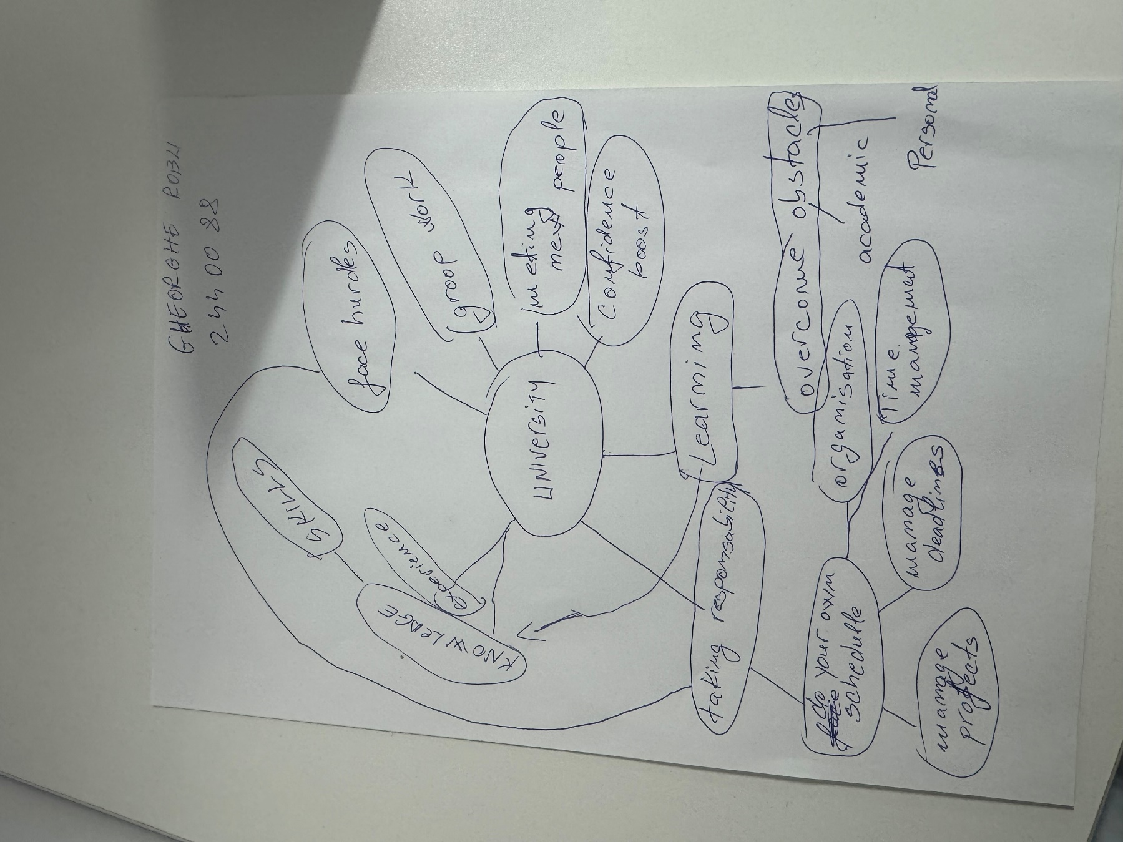

2. Paraphrase the following sentences (max 3 marks for each, max 12 marks in total):

a) To successfully navigate student life you will need to handle a variety commitments.
And the only way to successfully accomplish that would be to have organisation and time management in order to handle study, work, social and personal commitments.

b) You will need to develop self-motivation if you want to succeed at university.
A lot of university study is self-directed, self-motivation is needed in order to organise the work, manage deadlines and manage multiple projects

c) Many students find it challenging to manage stress during assessment periods.
Universities provides plenty of opportunities to work and boost our confidence for example working in groups, complete assessments, deliver presentation perhaps even becoming a class representative.

d) Frequent reading can help you become a more effective communicator.
It also can help developing knowledge and skill that will help in future life but also can help developing
Resources that could be used in the long term and in successfully completing assessments and projects

3. Write a well-structured paragraph (8 sentences) on the following topic:

Effective time management techniques for university students

Your paragraph must be written in full sentences (no bullet points) and in an academic style.

(max 16 marks in total)
There are 4 different time management and efficient techniques that allows university students to successfully manage their tasks and projects. First technique and an efficient one would be To Do List witch I say is one of the most daily used one giving the fact people in general are using it daily and it proves to be extremely efficient. The second one is S.M.A.R.T witch again is a verry good technique as it helps identify Specific Measurable Actionable Realistic Time Bound goals that a student has. The third one is The 4 D strategy witch again helps students prioritise and manage certain goals but also it helps them understand that other things can be done to a lesser standard in order to have more time achieving and overcome academic obstacles. The last one and my personal favourite one is The Eisenhower Matrix witch allows you to set and and achieve the task with the deadlines by scheduled the task and delegate or delete task that will distract from completing the deadline tasks.

